TVBS

data_amount: 124

negative: 27

neutral: 60

positvie: 37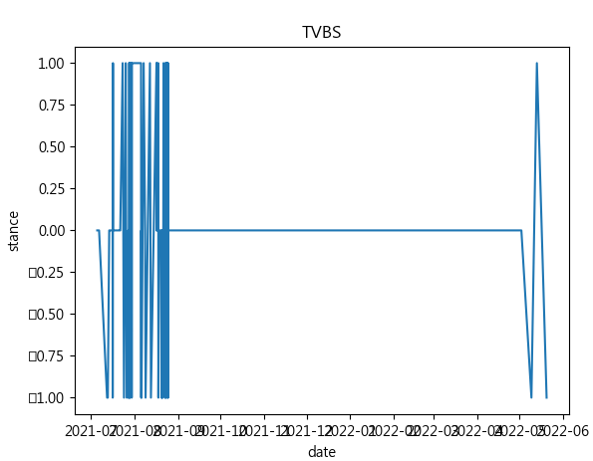

自由時報

data_amount: 353

negative: 34

neutral: 190

positvie: 129

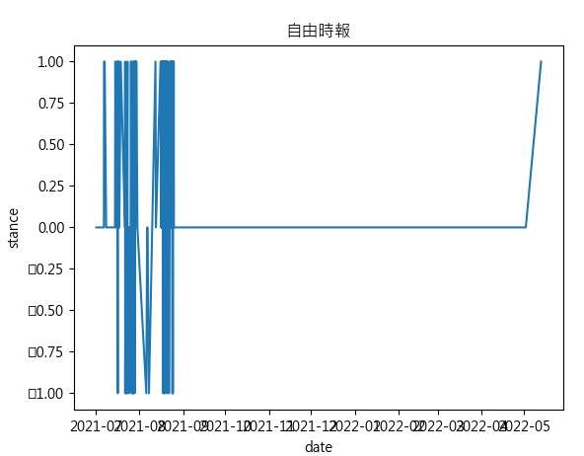

中央社

data_amount: 116

negative: 5

neutral: 64

positvie: 47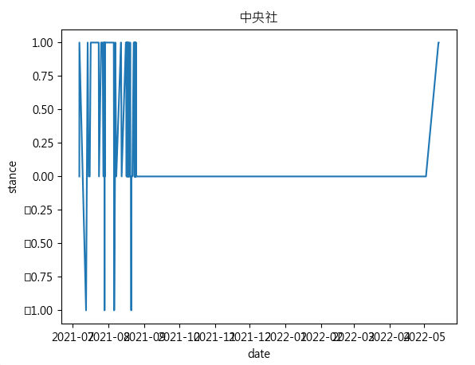

聯合新聞網

data_amount: 291

negative: 76

neutral: 132

positvie: 83

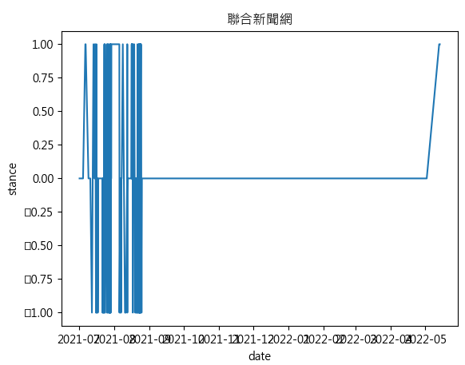

中天快點TV

data_amount: 75

negative: 41

neutral: 17

positvie: 17

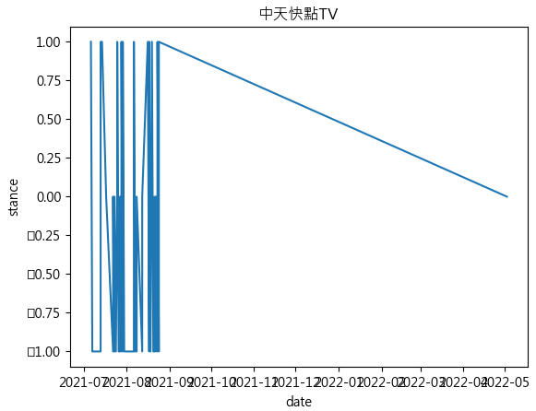

Ettoday

data_amount: 199

negative: 30

neutral: 86

positvie: 83

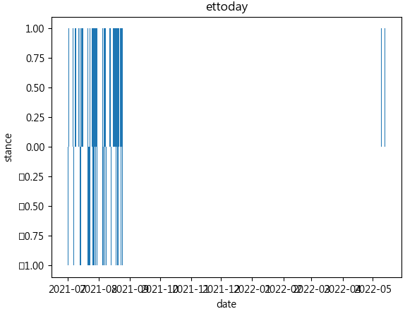

SETN 三立新聞網

data_amount: 97

negative: 5

neutral: 39

positvie: 53

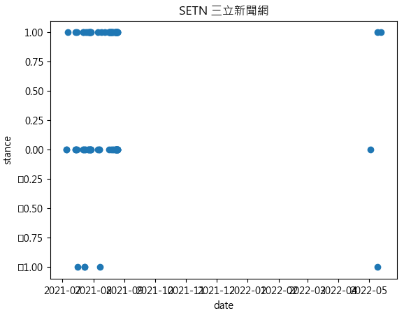

PChome新聞

data_amount: 215

negative: 23

neutral: 115

positvie: 77

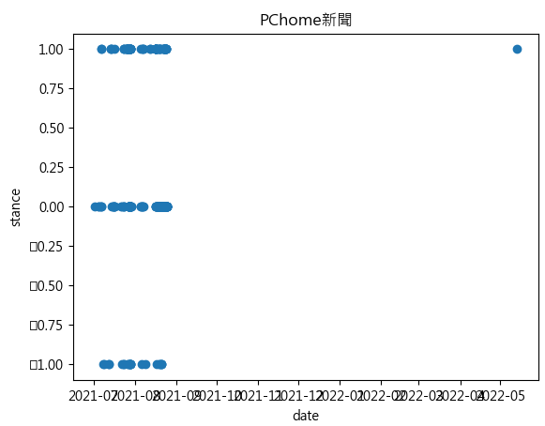

Nownews 今日新聞

data_amount: 78

negative: 13

neutral: 37

positvie: 28

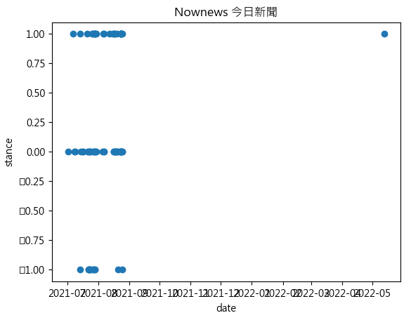

All

data_amount: 1856

negative: 290

neutral: 886

positvie: 680

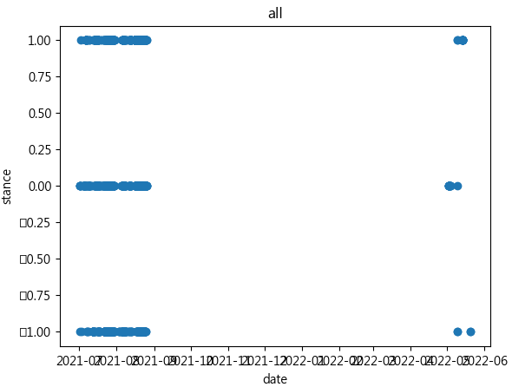

Positive label

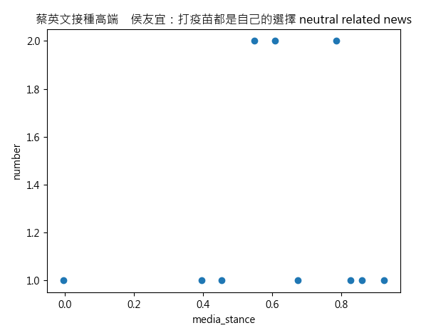

Neutral label

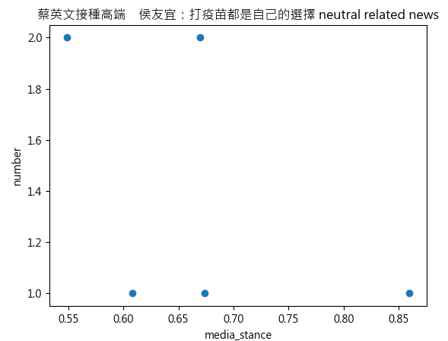

Negative

蔡英文打高端疫苗 江啟臣：這是總統的選擇，也請給人民選擇

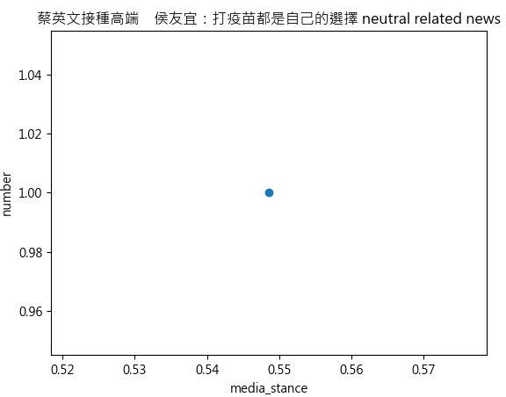

Outlier

