Asymmetric cryptography
Key Exchange
Diffie Hellman key exchange
Creating common (symmetric) key only known to the communication partners

Logarithm
Choose (integer) b and a and calculate y = bª
Given just b and y can you calculate a?
Easy (logarithm): a = log_{b} y
Example:
- b = 7, y = 13841287201, a = log₇ 13841287201 = 12

Discrete Logarithm
Choose integer b, a and n and calculate y = bª mod n
Given just b, n and y can you calculate a?
Example:
- b = 7, n = 1023, y = 439, a = ?
Hard problem: Discrete Logarithm Problem (DLP)
No simple calculation
Only (known) method: test all possible values for a (infeasible for large n)
Result: a = 5

Diffie Hellman Key exchange
Alice and Bob agree on (public parameters):
- Large prime number p
- Generator g (i.e., g is primitive root mod p)
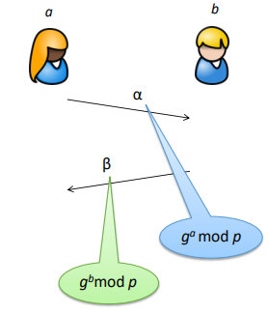
Alice:
- chooses a (secret) random number a
- calculates α = gª mod p
- sends α to Bob
Bob:
- chooses a (secret) random number b
- calculates β = g^{b} mod p
- sends β to Alice
Calculation of common secret:

(Passive) attacker learns:
- g
- p
- g^{b} mod p
- gª mod p
For calculating K the attacker needs additionally a or b
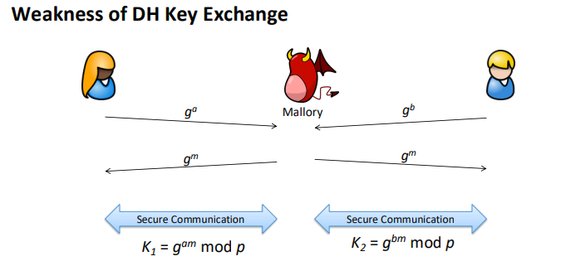
a or b can not easily be derived from the know values (DLP)
Breaking DH
g and p must be chosen carefully
- e.g., p – 1 shall have small prime factors
- otherwise, mathematical “tricks” are possible for breaking DLP
- (details are irrelevant in this course)
Always possible: test all possible values for a (or b)
Which size to choose for p?
- 512 bit → practically broken (2015)
- 1024 bit → estimated costs for breaking: 100 million $
- 2048 bit → secure, but long runtime

Asymmetric Encryption
Problem of symmetric encryption:
- Shared secret must be distributed
Problem of DH key exchange:
- interactive protocol
- both parties must be “online” to start encrypted communication
Asymmetric Encryption:
- Use different keys for de- and encryption
- Public encryption key is published (everyone can encrypt)
- Private decryption key is kept confidential (just owner can decrypt)

Two distinct keys (private key and public key) are used for encryption and decryption respectively

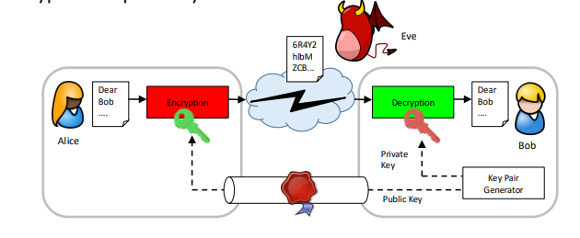
Based on number theoretic problems
- RSA: Factorization Problem
- ElGamal: Discrete Logarithm Problem
RSA: named after its inventors (1978):
- Ronald Rivest
- Adi Shamir
- Leonard Adleman

RSA (Textbook Version)
Key (pair) generation:
- Choose two prime numbers p and q
- Calc n = p · q, m = (p – 1) (q – 1)
- Choose e and d with e · d (mod m) = 1
- Public key: n, e
- Private key: d
Encryption of message M (integer < n):
- C = Me mod n

Decryption of cipher text C:
- M’ = C^{d} mod n
M' = (Me)^{d} mod n = M

Breaking RSA
Attacker:
- Knows n and e
- Factorizes n, i.e., finds p and q
- Calculates m and d

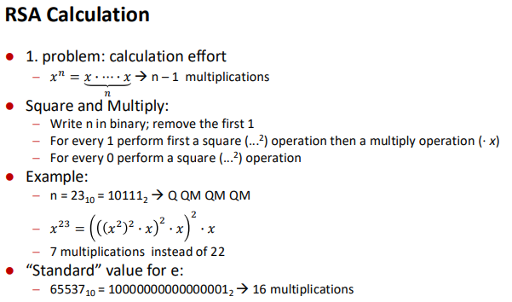

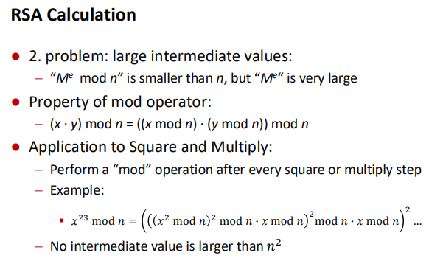
Prime Numbers
How to calculate large (~ 500 - 2000 bits) prime numbers?
2 types of primality tests:
- Deterministic (too slow for large numbers)
- Probabilistic (fast, but not 100% correct)
Example: Solovay–Strassen primality test:
max ½ probability of wrong answer
Algorithm for testing “n prime?”
Repeat k times:
- Choose random number a
- Run primality test (uses number a as parameter)
- If false return „not prime“
Return „probable prime“
Error probability: 1/2^{k} , e.g., 2⁻¹⁰⁰ for k = 100

Breaking RSA
Best known attack on RSA: factorizing n
Competition for factorizing given numbers (created 1991): RSA Factoring Challenge
Consequence: RSA-1024 is not secure any more

Exchange of Public Keys
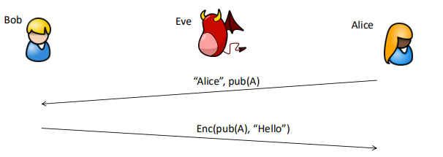
Confidentiality not required →passive attacker can read the public key (no problem)

Integrity highly required → active attacker can modify/exchange the public key

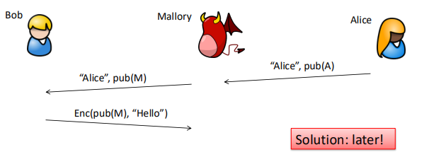

Hash Functions
Integrity testing

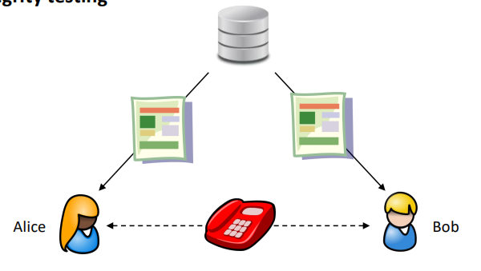

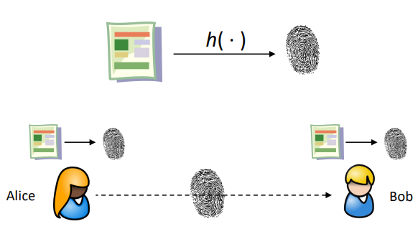

Real life example: Integrity Protection for Dowloads
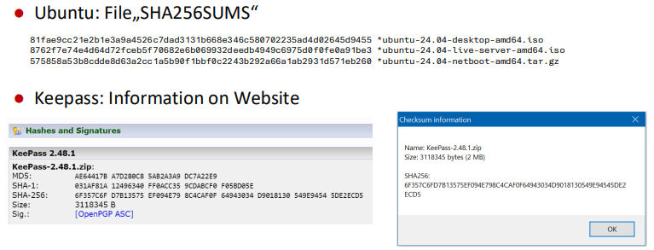
Definition of Hash Function
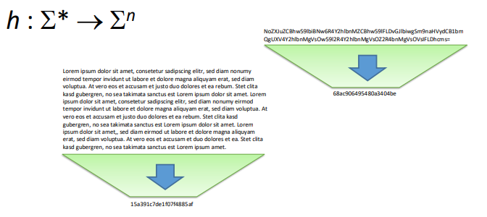

Properties of Hash Functions
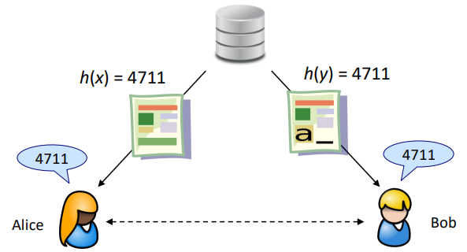

Hash collisions
Collision
- There exists two messages x and y: x ≠ y and h(x) = h(y)
In every hash function collisions exist!
Two types of collisions:
- “accidental”: selecting x and y randomly
- “intentional”: calculating x and y
Reducing the probability of “accidental” collisions:
- Choose co-domain (= length of hash value) large enough
What about “intentional” collisions?

Poor Hash Function
Checksum:
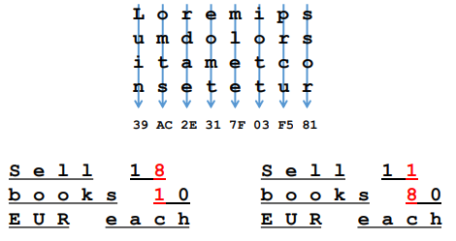

(Strong) Collision resistance
In “good” hash functions it shall be hard to calculate collisions
Collision resistant:
- It is not possible (within “reasonable” computation time) to find a collision i.e., two messages x and y with h(x) = h(y)
Remarks:
- with unlimited computation time of course collisions can always be found
Properties of Hash functions
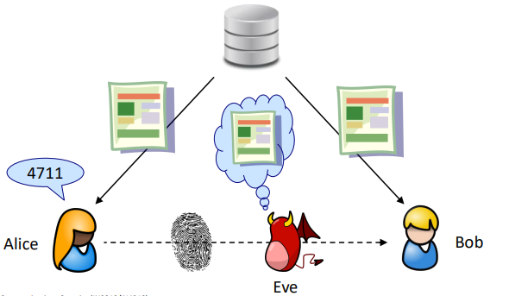

One-way function
One-way property (preimage resistant):
- There exist no (efficient) inverse function for h, i.e.
- it is not possible to calculate message x from its hash value H (with h(x) = H)
h collision resistant -> h one-way function

Common Hash Algorithms
MD5
- Message-Digest-Algorithm (R. Rivest, 1992)
- 128-bit digest
SHA-1
- Secure Hash Algorithm (NIST/NSA, 1994)
- 160-bit digest
SHA-2
- Secure Hash Algorithm 2 (NIST/NSA, 2002)
- Digest sizes: SHA-224, SHA-256, SHA-384, SHA-512

SHA-3
- Secure Hash Algorithm 3 (NIST 2015)
- Digest sizes: SHA3-224, SHA3-256, SHA3-384, SHA3-512

SHA-1 – Internal Structure
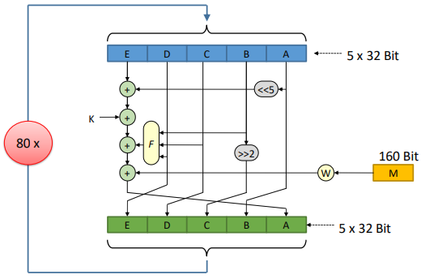

Security of Hash Algorithms
Known attacks on Hash properties
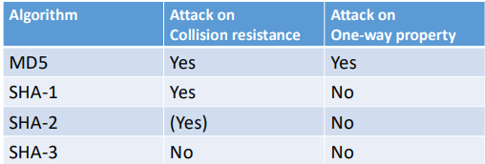

Breaking Hashes
How to find the pre-image of H? (i.e., finding m with h(m) = H)
Brute force attack: testing all possible values for m
- rather simple if the set of “all possible values” is rather small
- Examples:
- m is a short/simple password
- m is an IP address
Variation: Dictionary attack: testing just certain values
- Examples
- typical passwords (“1234”, “admin”, …)
- real world words (“dog”, “car”, …)
Alternative: Lookup in a pre-calculated list of “all” m and h(m)
- Practical implementation: Rainbow Table

Breaking Hashes – Countermeasures
Brute force/Dictionary:
- avoid short/simple messages
- use special resource consuming “hash” functions (e.g., scrypt, Argon2)
Rainbow table:
- avoid short/simple messages
- add a (non-secret) random value to the hash calculation: salt

MAC and Digital Signature
Integrity Protection using Hashes
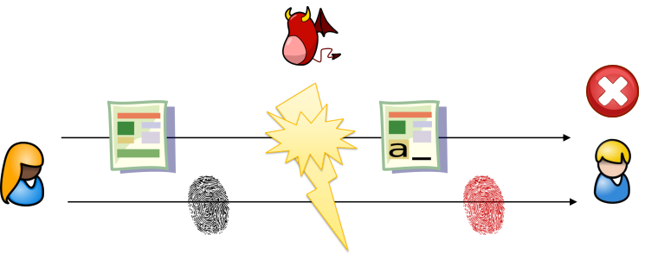

Message Authentication Code
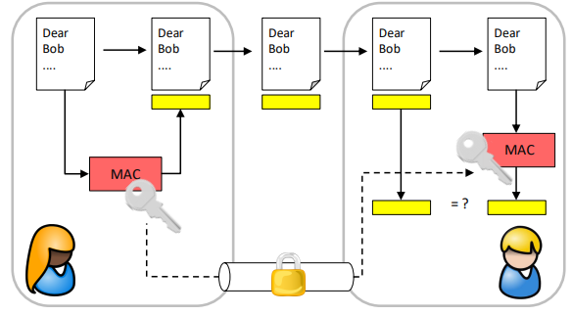
A Message Authentication Code (MAC) is a short piece of information used to authenticate a message
The involved key enables to provide authentication means in addition to integrity
In some contexts a MAC is also called a symmetric signature
First idea for implementation:
- mac_{k} (m) = h(k || m)
(here || is the concatenation operator)
Problem: vulnerable to length extension attack (details not shown here)
Solution:
- HMAC HMAC(m, k) = h(k XOR opad || h(k XOR ipad || m))
with opad and ipad fixed constants:
- ipad = the byte 0x36 repeated B times
- opad = the byte 0x5C repeated B times
- (with B the internal data size in bytes of hash function h; e.g. 64 for SHA-1)

Security services:
- Authenticity
- Integrity
Limitations:
- For verification knowledge of secret key required
- Every owner of the secret key can create the MAC
- → not possible to decide if Alice or Bob created the MAC
- → the actual creator of the MAC can deny the creation
- → no “non-repudiation” property

Digital Signature
Equivalent to traditional handwritten signatures
Properties:
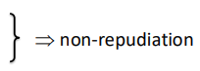
- Only one person can create the signature
- Everyone can verify the signature
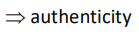
- Can identify the creator of the signature
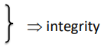
- Is bound to a specific document
- Prohibits changes to the document

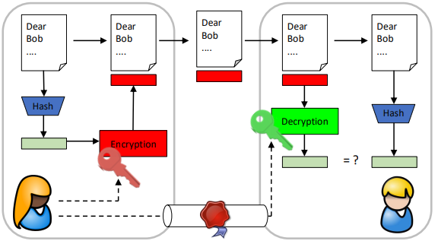
Digital Signature (here: RSA)

Digital Signature
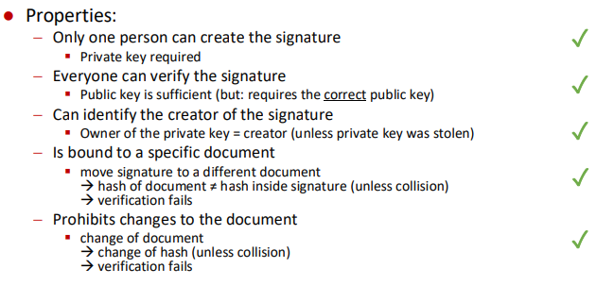

Again: Integrity Protection for Dowloads
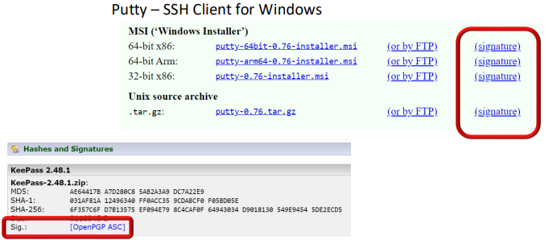

Crypto Primitives and their Usage
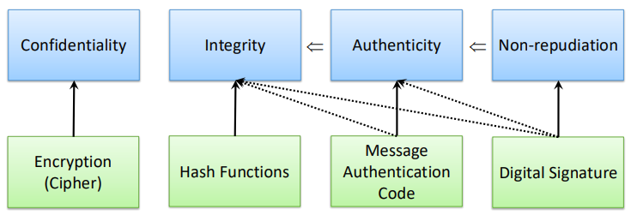
Elliptic Curve Cryptography
DSA and DH are based on modular exponentiation over a (finite) field of integers
One can perform similar operations on an “elliptic curve”
Main advantage:
- same security level with shorter keys
- better performance (runtime up to 10 times faster)
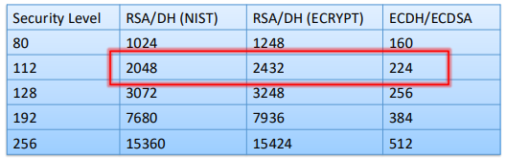
Practical Usage Recommendations
Symmetric Encryption: AES-256, mode: GCM (later)
Asymmetric Encryption: RSA-2048
Key exchange: ECDHE-256
Hash: SHA-256
Message Authentication:
- AES in GCM mode (authenticated encryption)
- Poly1305 (e.g. in combination with ChaCha20)
Signature:
- RSA-2048 with SHA-256
- ECDSA-256 with SHA-256

