Software Vulnerabilites
Vulnerabilites in computer security
A vulnerability is a weakness that can be exploited by an attacker.
In computer security, we can distinguish between different classes of vulnerabilites:
- hardware
- software
- network
- personnel
- physical site
- organizational

Vulnerabilites in software systems
We can distinguish between different categories of vulnerabilites:
Design vulnerabilites flaws in a software systems’s architecture and specifications
Implementation vulnerabilites low-level technical flaws in the actual construction of a software system
Operational vulnerabilites flaws that arise in deploying and configuring software in a particular environment
Course focus is on implementation bugs and design flaws, but let us take a brief look at operational vulnerabilites.

Operational vulnerabilites
Operational vulnerabilites are flaws that arise in deploying and configuring software in a particular environment.
- Issues with configuration of the software.
- Issues with the environment the software runs in.
- Issues caused by automated and manual procedures that surround the system.
- Issues caused by attacks on the users, such as social engineering and theft

Social engineering
Social engineering is the practice of manipulating people into performing actions or divulging confidential information.
There are a wide variety of social engineering attacks, these are only a few:
Phishing sending fraudulent emails tricking people into sharing personal or financial information, opening malicious attachments or clicking on malicious links
Spear phishing a more customized and individualized form of phishing
Tailgaiting seeking entry to a restricted are by following a person who has access
Pretexting creating and using an invented scenario to gain access to information or manipulate the victim into performing an action
Baiting praying on people’s curiosity or greed, by for example leaving malware-infected media in locations people will find them

Agenda
- A taxonomy for software vulnerabilites
- Dangers of abstraction
- Integers
- Buffer overflows
- Input validation
- Type confusion
- Scripting languages
- Race conditions
- Defences

Taxonomy
A taxonomy for software vulnerabilites
Fortify’s A Taxonomy of Software Security Errors tries to categorize different types of software implementation vulnerabilities into seven broad categories.
Other taxonomies exist, and while the one from Fortify is far from perfect, it serves as an illustration of the breadth and variety of software vulnerabilites.

Input validation and representation - security problems resulting from trusting input. Caused by metacharacters, alternate encodings, numeric representations.
Some examples include:
- Integer overflow
- Buffer overflow
- Command injection
- Cross-site scripting
- SQL injection

API abuse - an API is a contract between a caller and a callee. Most common forms of API abuse are caused by caller failing to honor its end of the contract.
Examples:
- Use of dangerous functions
- Unchecked return values

Security features - topics like authentication, confidentiality, cryptography and privilege management.
- Insecure randomness
- Missing access control
- Least privilege violation

Time and state - unexpected interactions between threads, processes, time and information.
- TOCTOU - time of check to time of use
- Deadlock
- Other race conditions

Errors - flaws related to error handling.
- Overly-broad catch block
- Empty catch block

Code quality - poor quality leads to unpredictable behavior.
- Double free
- Use after free
- Memory leak
- Undefined behavior

Encapsulation - drawing strong boundaries between components.
- Trust boundary violation
- Data leaking between users
- Leftover debug code

Abstraction
Preliminaries
When writing code, programmers use elementary concepts like character, variable, array, integer, data & program, address (resource locator), atomic transaction, . . .
These concepts have abstract meanings.
For example, integers are an infinite set with operations ‘add’, ‘multiply’, ‘less or equal’, . . .
To execute a program, we need concrete implementations of these concepts.

Benefits of abstraction
Abstraction (hiding ‘unnecessary’ detail) is an extremely valuable method for understanding complex systems.
We don’t have to know the inner details of a computer to be able to use it.
We can write software using high level languages and graphical methods.
Anthropomorphic images explain what computers do (send mail, sign document).

Dangers of abstraction
Software security problems typically arise when concrete implementation and the abstract intuition diverge.
We will explore a few examples:
- Integer
- Variable (buffer overflows)
- Character and strings
- Address (location)
- Atomic transaction

Integers
Programming with integers
In mathematics integers form an infinite set.
On a computer systems, integers are represented in binary.
The representation of an integer is a binary string of fixed length (precision), so there is only a finite number of “integers”.
Programming languages: signed & unsigned integers, short & long (& long long) integers, . . .

Reference
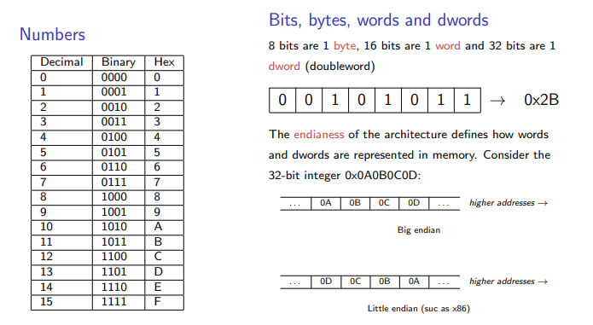
Two’s complement
Signed integers are usually represented as 2’s complement numbers.
Most significant bit (sign bit) indicates the sign of the integer:
- If sign bit is zero, the number is positive.
- If sign bit is one, the number is negative.
Positive numbers given in normal binary representation.
Negative numbers are represented as the binary number that when added to a positive number of the same magnitude equals zero.

Code Example 1
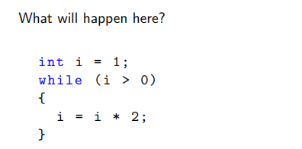

Computing with integers
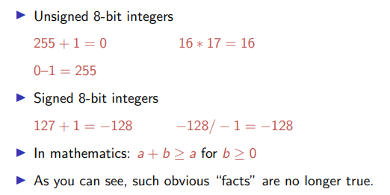

Code Example 2
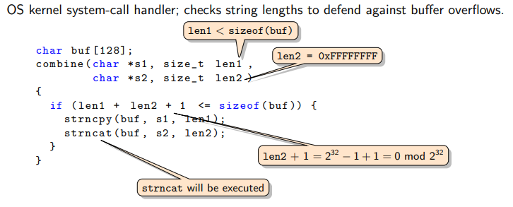

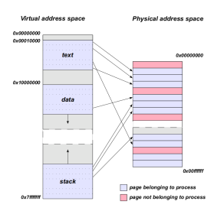
Buffer overflows
- Virtual and physical memory
- For a process, it looks like it has the whole memory for itself
- The process view is of virtual memory
- Virtual memory is mapped to physical memory (RAM)
- The operating system uses page tables to maintain the mappings
- Virtual memory makes the processes isolated from each other, the process has only access to its own memory

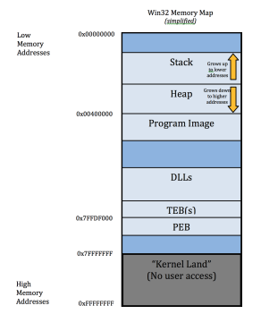
Memory configuration
Stack contains return address, local variables and function arguments; relatively easy to decide in advance where a particular buffer will be placed on the stack.
Heap contains dynamically allocated memory; more difficult but not impossible to decide in advance where a particular buffer will be placed on the heap.

Variables
Buffer: concrete implementation of a variable.
If the value assigned to a variable exceeds the size of the allocated buffer, memory locations not allocated to this variable are overwritten.
If the memory location overwritten had been allocated to some other variable, the value of that other variable is changed.
Depending on circumstances, an attacker can change the value of a sensitive variable A by assigning a deliberately malformed value to some other variable B.

Buffer overflows
Unintentional buffer overflows crash software, and have been a focus for reliability testing.
Intentional buffer overflows are a concern if an attacker can modify security relevant data.
Attractive targets are return addresses (specify the next piece of code to be executed) and security settings.
In languages like C or C++ the programmer allocates and de-allocates memory.
Type-safe languages like Java guarantee that memory management is ‘error-free’.

System stack
Function call: stack frame containing function arguments, return address, statically allocated buffers pushed on the stack.
When the call returns, execution continues at the return address specified.
Layout of stack frames is reasonably predictable.
CPU registers:
- EIP: extended instruction pointer
- ESP: extended stack pointer
- EBP: extended base pointer, aka frame pointer

CDECL calling convention
In the CDECL calling convention the arguments are passed on the stack in right-to-left order, the function’s return value is passed in the EAX register, and the calling functions cleans up the stack.
- The calling function:
  - pushes the arguments on the stack
  - pushes the return address on the stack (done by the call instruction)
  - sets EIP to the start of the called function (also done by the call instruction)
- The called function:
  - saves the calling function’s stack frame pointer on the stack (push ebp)
  - sets its own stack frame pointer (mov ebp, esp)
  - assigns space for its local variables (often implicitly, just by using the stack)
  - executes whatever the function wants to do (maybe calling other functions itself)
  - restoring the callings function’s stack frame pointer (pop ebp)
  - set EIP to the return address in the calling function (ret)
- The calling function:
  - cleans up the arguments on the stack (by adjusting the stack pointer)

Stack frame
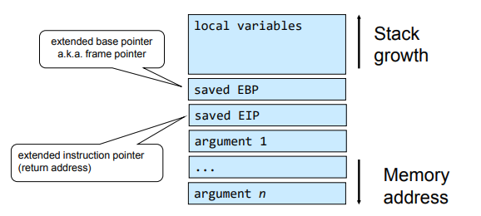
An example
char *strcpy(char *dest, const char *src);
strcpy is a notoriously dangerous function.
The function copies the string pointed to by src, including the terminating null byte (’\0’), to the buffer pointed to by dest. It does not check if dest is large enough to hold the string

An example
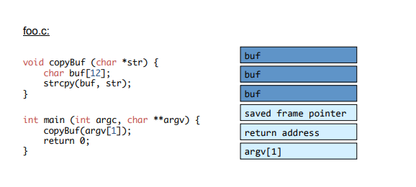

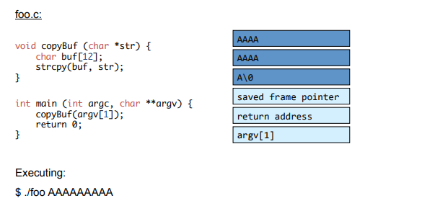
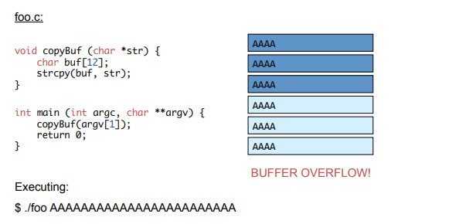
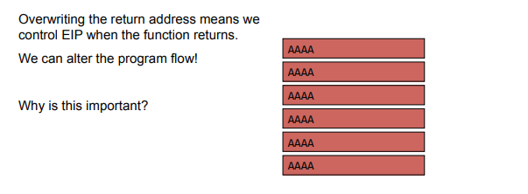
An example

