Certificates and Public Key Infrastructure (PKI)
Motivation: HTTPS usage
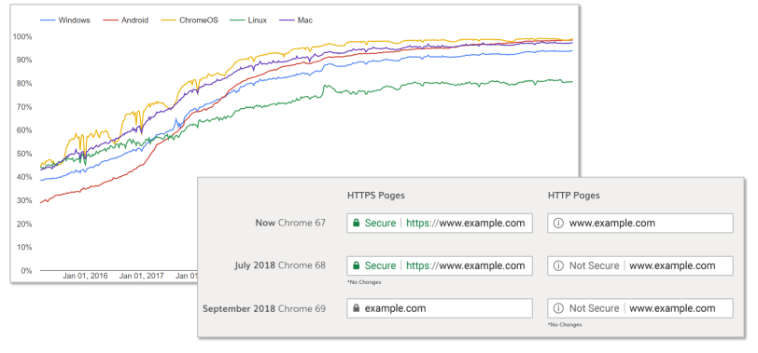
TLS and Asymmetric Cryptography
HTTPS = HTTP over TLS
From RFC 5246 (TLS 1.2):
- When Diffie-Hellman key exchange is used, the server […] use the server key exchange message to send a set of temporary Diffie-Hellman parameters signed with […] RSA […].
- […] the client can verify the […] signature to ensure that the parameters belong to the server.

Recapitulation: Digital Signature
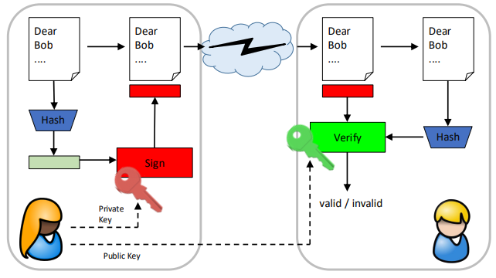
Attack on Key Exchange (Digital Signature)
Exchange of public key:
- Confidentiality not required
- Integrity/authenticity highly required
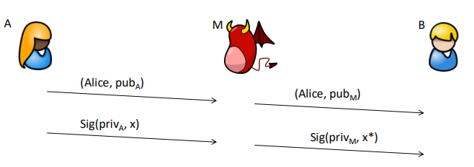

Certificates
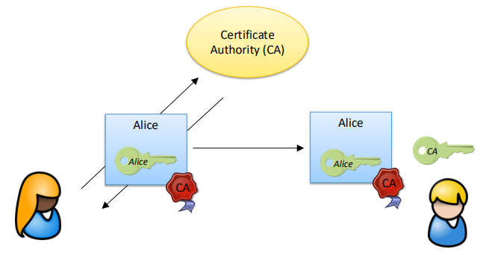
Certificate Trust
How does Bob obtain the public key of the CA?
A set of trusted CAs (root store) is included in the OS or the application (e.g. browser)
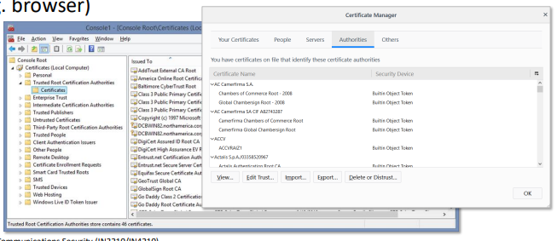

Certificates on the Web
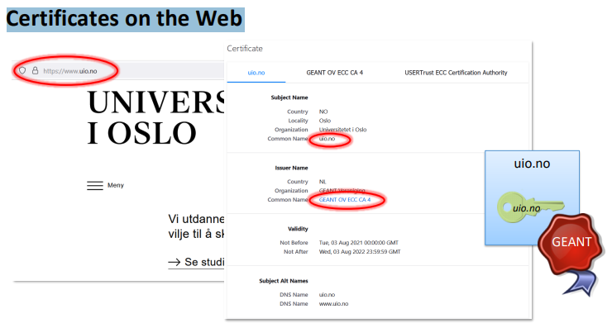
Certificate details
X.509 Certificate
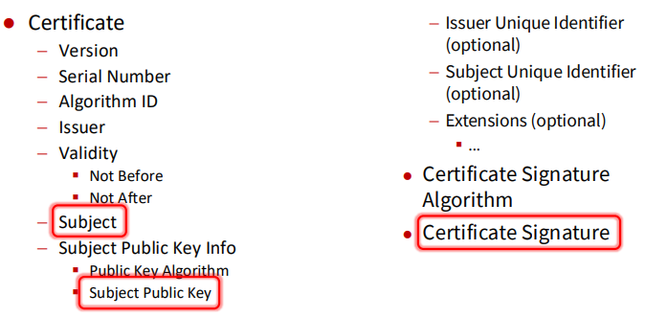
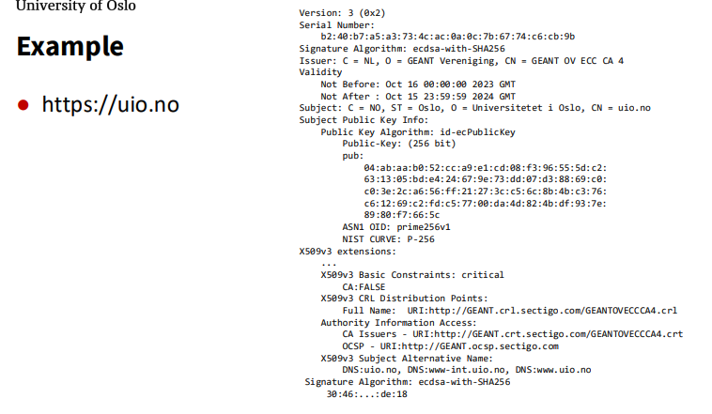
Example – Details
Issuer: C=NL, O=GEANT Vereniging, CN=GEANT OV ECC CA 4
- Issuing certificate authority (X.500 DN)
Validity
- Not Before: Oct 16 00:00:00 2023 GMT
- Not After : Oct 15 23:59:59 2024 GMT
Limited lifetime
- to reduce the risk of misuse
- to incorporate the decrease of security of cryptographic algorithms
Also, an indication when a certificate was created
- some regulation only apply to certificates creates after a specific date
- problem: CA can “cheat” and backdate a certificate

Lifetime of certificates
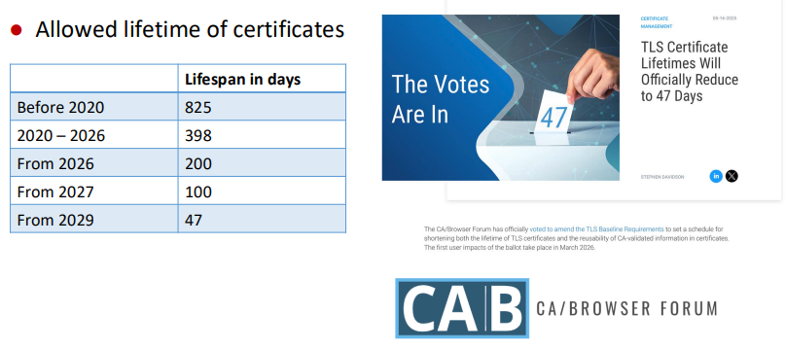
Example – Details
Subject: C=NO, L=Oslo, O=Universitetet i Oslo, CN=uio.no
- Certificate subject (X.500 DN; usually only CN relevant)
- For Web PKI: CN contains domain name
- Domain name might contain a “wildcard”, e.g. *.example.com
Subject Public Key Info:
- Public Key Algorithm: id-ecPublicKey
- Public-Key: (256 bit)
- pub: 04:ab:...:66:5c
- ASN1 OID: prime256v1, NIST CURVE: P-256
Public key of certificate subjects

Signature Algorithm: ecdsa-with-SHA256
30:44:...:54:35
- Digital signature on the certificate created by the CA
- Here: ECDSA with SHA2 algorithm
Public Key Infrastructure (PKI)
Components in a Public Key Infrastructure (PKI)
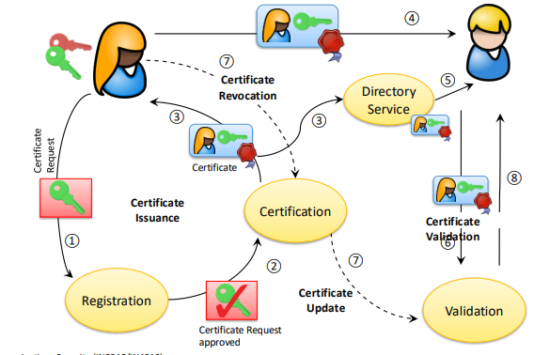
Certificate registration
Requester must prove the identity to be certified
For web certificates:
- Prove ownership of the domain (DV, domain validation)
- Prove organization (OV, organization validation)
- Prove of legal organization registration (EV, extended validation)
Common methods for domain validation:
- Put a CA-provided challenge at a specific place on the Web server
- Put a CA-provided challenge in a DNS record corresponding to the target domain
- Receive CA-provided challenge at a (hopefully) administrator-controlled email address corresponding to the domain and then respond to it on the CA’s web page

Extended Validation Certificates (EV)
EV certificates are indicated by the browser
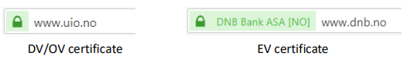
Increased assurance in identity of certificate subject
Phishing attacks harder to accomplish
In case of malicious server → better traceability for law enforcement authorities
However: still no guarantee for honesty of server (e.g. mafia owned company can get EV certificate)

Top Certificate Issuer(s)
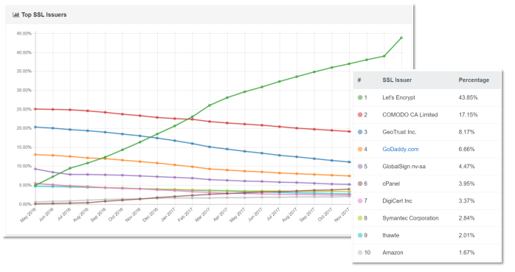
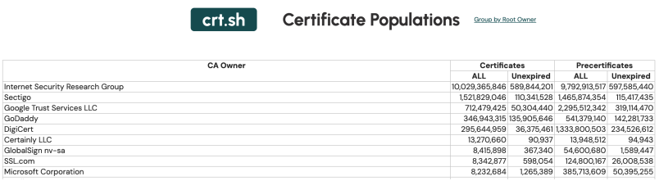
Let's Encrypt Certificates Issued Per Day
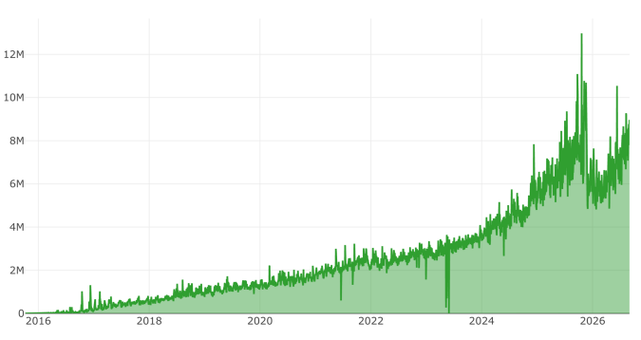
Let‘s Encrypt (LE)
Created by the Internet Security Research Group (ISRG):
- Akamai
- Mozilla
- Cisco
- Google
- Electronic Frontier Foundation (EFF)
Goal: simple and free certificates for TLS
Automatic certificate issuance and renewal processes
- Automated Certificate Management Environment (ACME) protocol
- not feasible for extended validation (EV) certificates

Certificate Lifelime
Let's Encrypt: maximum lifespan 90 days
Reduced potential for abuse in the case of compromised certificates (e.g. stolen private key)
Only possible in the case of automated certificate issuance/renewal
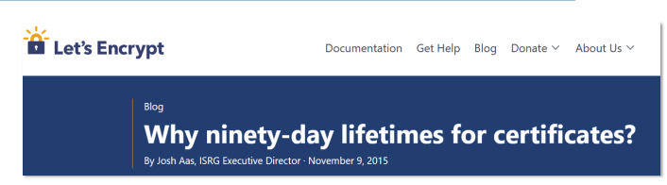
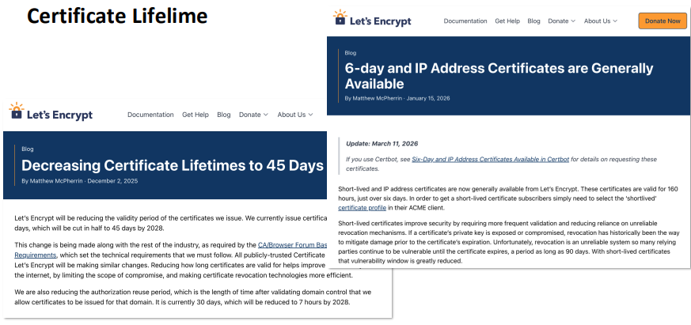

Let‘s Encrypt – The Downside
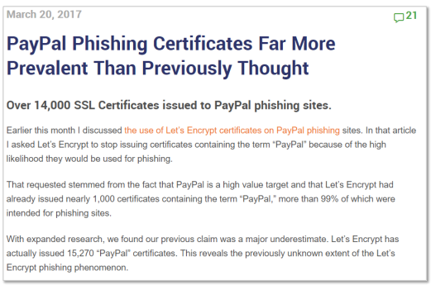
Certificate Trust
Until now: only direct trust (CA → Certificate)
Problem: Every CA must be known to the user
Does not scale for large amount of certificates
Solution: Delegation
- Small amount of Root CAs issue certificates for Intermediate CAs
- Intermediate CAs can issue certificates for other CAs or for end-entities
- Users only need to know Root CAs
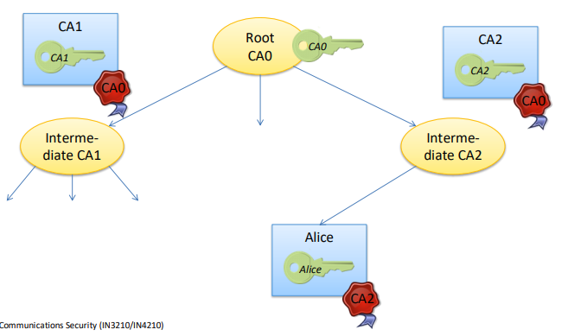
Certificate Trust
When to trust a certificate?
→ there exists a signature chain from a trusted root CA
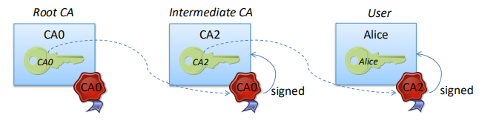
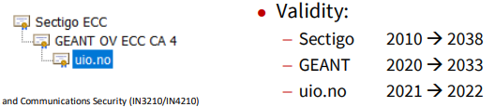
(Web) PKI System
Advantages
- Scales very well
- Either to create a new CA
- Users can choose from many (intermediate) CAs
Problems
- Trust anchor required (trusted root store)
- All certificates (from either CA) are trusted
A single rogue CA can endanger the whole system
Attackers can select the “weakest” CA for creating illegitimate certificates

Flawed Certificate Authority
Compromised Certificate Authority
CA DigiNotar was hacked in 2011
Several illegitimate certificates (e.g. *.google.com) were created by the intruders
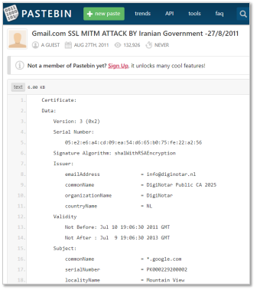

Sloppy Certificate Authority
CA created SHA-1 signed certificates and backdated them
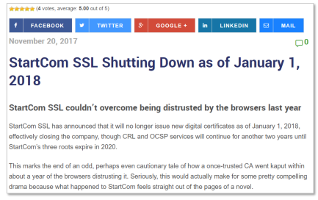

Compromised/Sloppy Certificate Authority
HTTP Public Key Pinning (HPKP)
DNS-based Authentication of Named Entities (DANE)
DNS Certification Authority Authorization (CAA)
Certificate Transparency (CT)

Certificate Transparency (CT)
Idea:
All issued certificates are logged into a public append-only log
These logs can be monitored and audited by CAs, domain owners and clients
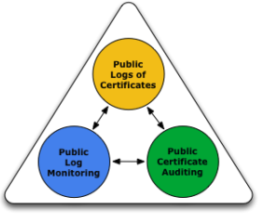
Mistakenly or maliciously issued certificates can be detected (not stopped!)

Certificate Transparency
Typically, CAs add newly created certificates to one or more logs
The log creates a signed certificate timestamp (SCT)
The SCT can be embedded into the certificate (X.509 extension)
If the client receives a SCT, he knows that the certificate is included in a CT log
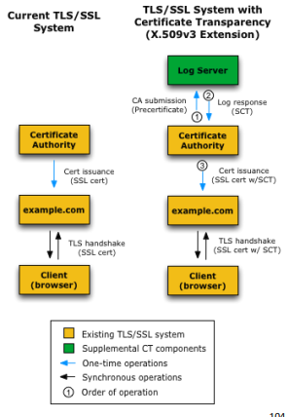

Example SCT (UiO)
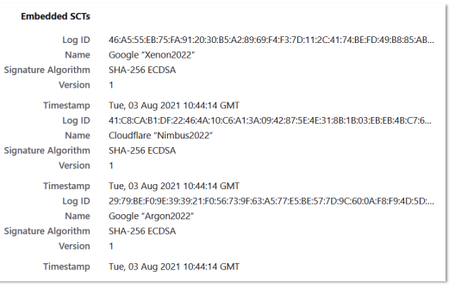
Example Log
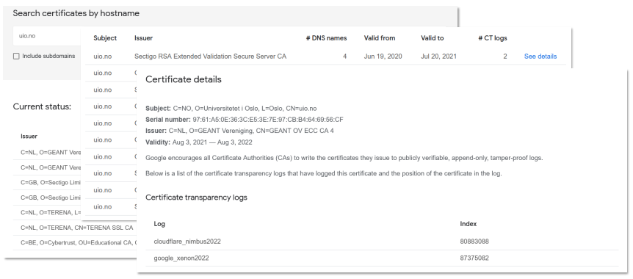

Example Monitor
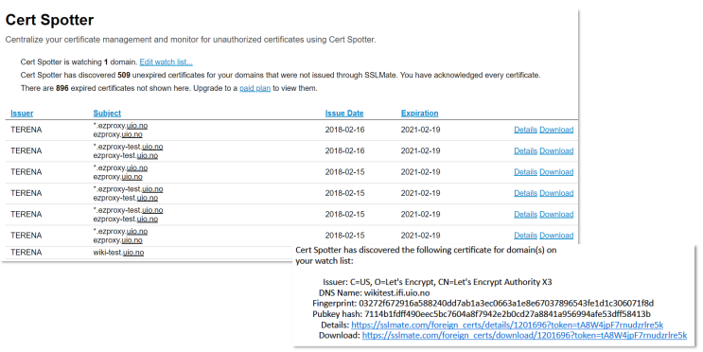
Enforcing Certificate Transparency
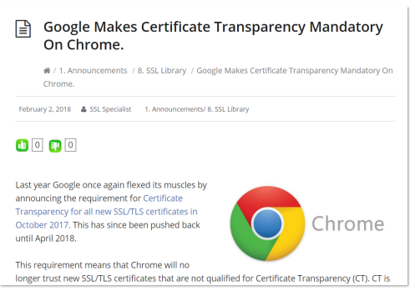

Enforcing Certificate Transparency
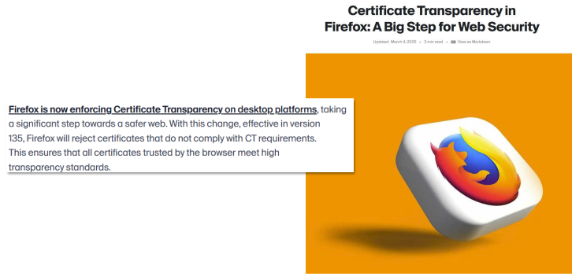
Certificate Transparency
Advantages:
- Simple overview of all issued certificates
- Fast detection of mis-issued certificated and sloppy/rogue CAs
Disadvantages:
- No mechanism for revocation of mis-issued certificates
- Logs reveal (sub) domain names

Summary
Certificates are essential for TLS and for a “more secure Web”
A single unreliable or untrustworthy certificate authority can endanger the whole Web PKI
Still, no perfectly secure and practical solution is available
Certificate transparency is the current candidate favored by the browser vendors

