Wireless LAN (WLAN) security
In wireless networks, unless appropriate security measures are in place, attacks can be performed with low risk at a distance
Passive attacks
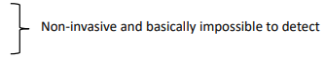
- Eavesdropping
- Traffic analysis

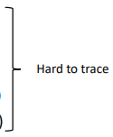
Active attacks
- Masquerade (including rogue AP)
- Replay
- Message modification/injection
- Denial of service (including jamming)
- Unauthorized use (misappropriation)

Higher frequencies generally have shorter range and are therefore more difficult to jam or eavesdrop from a distance
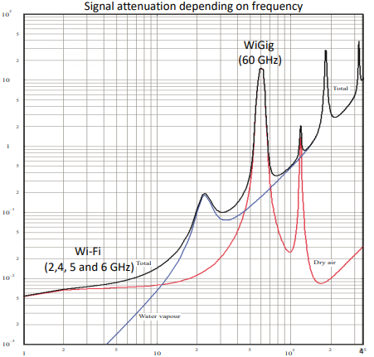

Optical Wireless Communication is limited by line of sight (may utilize reflections)
- LiFi – LED-lamps
- pureLiFis «LiFlame» - Ceiling Unit and Desktop Unit

Emission security is concerned with loss of confidentiality due to unintended compromising emanations
Data may be reconstructed from electromagnetic emanations from monitors, computers, and other digital devices (TEMPEST)
Such emanations may be amplified by a nearby radio transmitter, such as a WLAN or cell phone (NONSTOP)
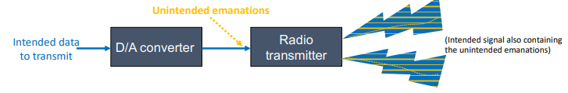
Text signal picked up at 10 m distance through three plasterboard walls M. Kuhn, Compromising emanations: eavesdropping risks of computer displays, 2003 https://www.cl.cam.ac.uk /techreports/UCAM-CLTR-577.pdf
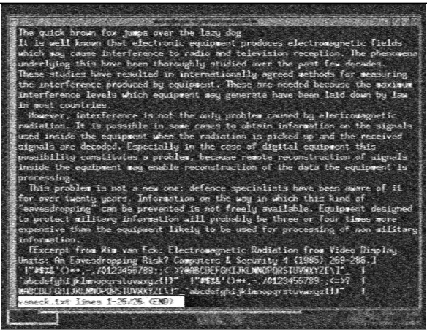
Wireless devices may pose a vulnerability to protected networks by introducing uncontrolled connections
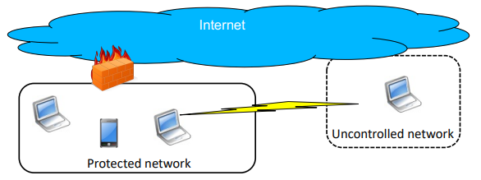
Where relevant, dual connections should be automatically disabled (e.g., through UEFI/BIOS setting)

To what extent does the use of “public” Wi-Fi networks pose a risk, given that most traffic is encrypted at higher layers (e.g., using TLS)?
Passive eavesdropping is no longer as effective (traffic analysis may still be)
Malicious access points (networks) may potentially be used to perform on-path attacks, e.g., exploiting vulnerabilities in endpoints
E.g., potential attack sequence:
User enters web page address for some web site for which HTTP Strict Transport Security (HSTS) is not set (e.g., not previously visited and not on HSTS preload list)
Attacker acts as MitM injecting exploit
- Requires exploitable vulnerability
Alternative approach: Wi-Fi captive portal serves exploit
- The captive portal must be visited before a VPN connection can be established
- Still requires exploitable vulnerability

Zero-day exploits are valuable. Effective exploits for devices with up-to-date security patches are therefore less likely to be used for low-value targets
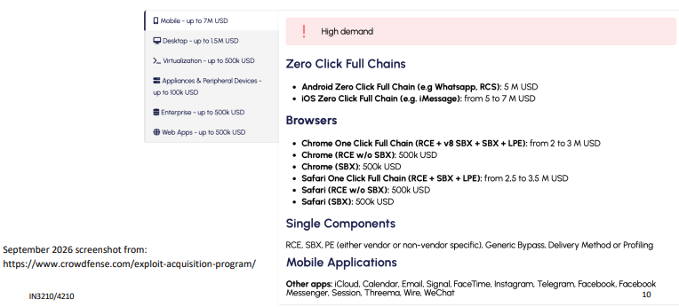

«Predator in the wires: Ahmed Eltantawy targetet with Predator spyware after announcing presidential ambitions» (2023) B. Marczak et al., https://citizenlab.ca/2023/09/predator-in-the-wires-ahmed-eltantawy-targeted-with-predator-spyware-after-announcing-presidential-ambitions/
When visiting certain websites, not using HTTPS, a device at the border of the network redirected him to a malicious website to infect his phone
Found to have exploited three zero-day vulnerabilities (later patched in iOS/iPadOS updates)
A (malicious) WiFi network can enable similar attacks on connected devices without the adversary having privileged access to telecom or Internet infrastructure
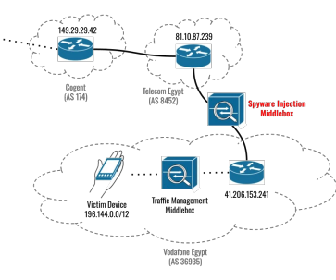

WLAN security evolution from WEP to WPA2/IEEE 802.11i
Wired Equivalent Privacy (WEP) – part of 802.11 standard (1999)
Flawed authentication
Flawed encryption (key reuse due to 24-bit Initialization Vector (IV))
Flawed integrity (RC4 encrypted Cyclic Redundancy Check (CRC))
WPA (Wi-Fi Protected Access) interoperability certification (2003)
Interim solution based on subset of 802.11i draft
Based on WEP, but using Temporal Key Integrity Protocol (TKIP)
IEEE 802.11i standard (2004) – Robust Security Network
Amendment to 802.11 standard (has later become part of it)
CCMP (AES)
WPA2 - interoperability certification for 802.11i implementations (2004)
IEEE 802.11ad (2012) adds support for GCM Protocol (GCMP)
WiGig (60 GHz)
IEEE 802.11ac (2013) extends GCMP with support for 256-bit keys

Wi-Fi Protected Access (WPA) 3 was first standardized in 2018 by the Wi-Fi alliance
Protected management frames are mandatory
WPA3-SAE (Simultaneous Authentication of Equals)
Replacement for WPA2-Personal/PSK
Originally developed for mesh networks (802.11s)
Specified in IEEE 802.11-2016
WPA3-Enterprise 192-bit mode
(EC)DHE key exchange, using RSA or ECDSA for authentication
AES256-GCM (GCMP-256) for authenticated encryption
HMAC-SHA384 for key derivation and confirmation

General 802 MAC (Media Access Control) PDU (Protocol Data Unit)
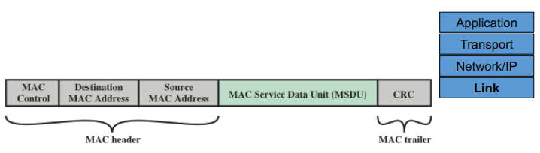
In the context of WLAN security, MIC (Message Integrity Code) is often used instead of MAC (Message Authentication Code) to avoid confusion with MAC addresses etc.

802.11 WLAN architecture: Station (STA), access point (AP), distribution system (DS), Basic Service Set (BSS), and Extended Service Set (ESS)
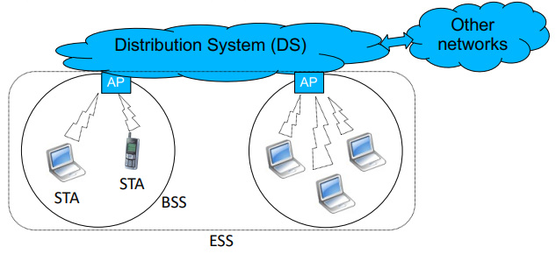
The Service Set Identifier (SSID) identifies an ESS (consisting of one or more BSSs). (The BSS is identified by the MAC address of the AP.)

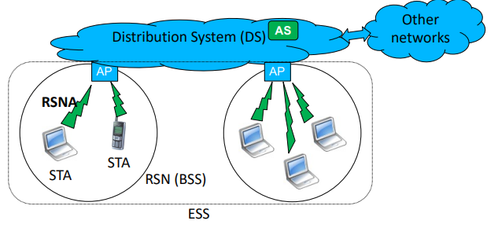
802.11i additionally introduces the Robust Security Network (RSN), the RSN Association (RSNA), and the Authentication Server (AS)
Only provides link security (end-to-end security must be provided at a higher layer)

WPA1, 2 & 3 overview
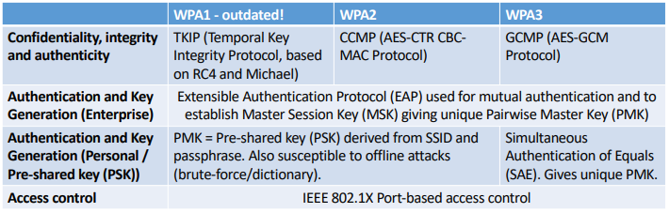
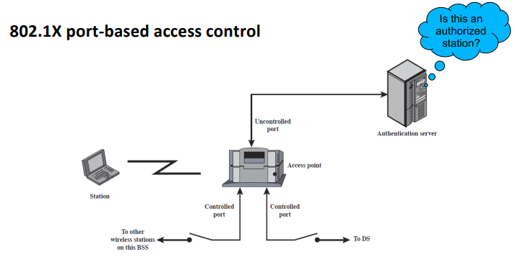
RSN phases of operation (Personal vs. Enterprise)
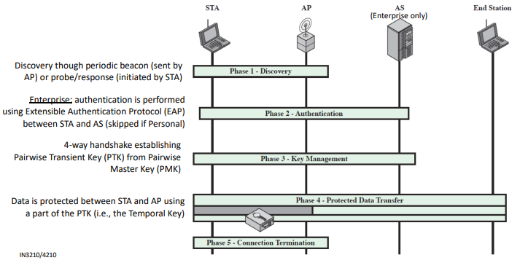
WPA2 pairwise key hierarchy and establishment
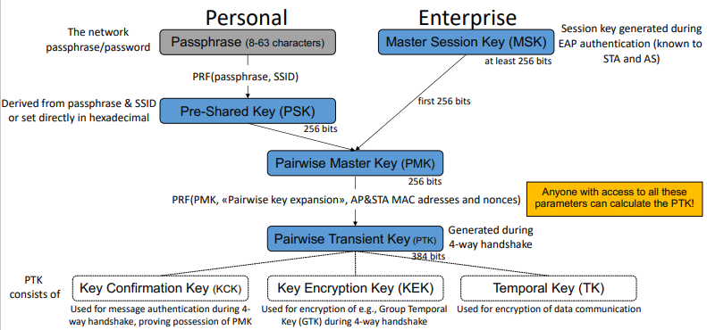

4-way handshake establishing Pairwise Transient Key (PTK)
(Phase 3 – Key management)
PTK = PRF(PMK, «Pairwise key expansion», AP&STA MAC adresses and nonces) *
Handshake messages are sent using EAPOL (EAP over LAN) Key messages
1. AP generates a random nonce and sends to STA
2. STA generates a random nonce and uses this together with the received nonce, the STA & AP MAC addresses and the PMK to calculate the PTK. Sends the nonce to AP who can then also calculate the PTK.
3. AP sends same nonce as in message 1, protected by a MIC confirming possession of the PTK 4. Message
4 serves as an acknowledgement to message 3 and that encrypted communication can start
Once the PTK is established, the AP can also send Group Temporal Key to the STA
*More specifically the PTK = PRF-384(PMK, “Pairwise key expansion”, Min(Amac,Smac) || Max(Amac,Smac) || Min(Anonce,Snonce) || Max(Anonce,Snonce))
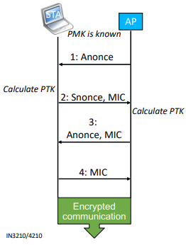

Offline dictionary / brute-force attacks on WPA2-Personal/PSK
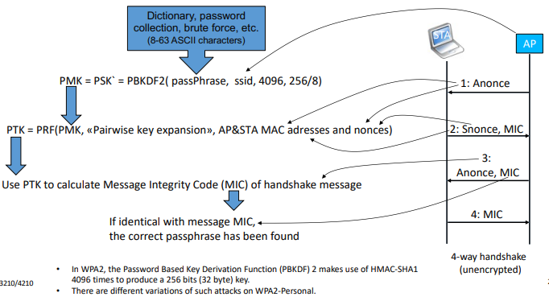
Given a weak network password, offline brute force or dictionary attacks are fully practical against WPA2-PSK/Personal
The number of attempts in an offline attack is only limited by compute resources and time
The key derivation function used is not that slow for modern standards (even iterating 4096 times) and can be parallelized on e.g., GPU(s)
The 802.11 standard (2024) states that “a key generated from a passphrase of less than about 20 characters is unlikely to deter attacks”
Apparently assumes that a passphrase of multiple words (or similar) is used
“Random passwords” (e.g., xFe>RLv6&s=@Q6q%&-q7CGdI9) of same length are much stronger (assuming it is not in a password list), but difficult to remember
Uncommon SSID may mitigate the use of rainbow tables (because PSK is generated from SSID and passphrase)

Disabling of identifier (SSID) broadcasting and MAC address filtering provides limited (if any) security
An implication of disabling SSID broadcasting at access points is that clients periodically send probes for the SSID to discover it
The client machine may become more exposed and the SSID can be discovered anyway MAC addresses are sent unencrypted and are easy to spoof
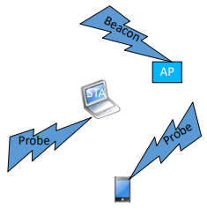

“Key Reinstallation Attacks: Forcing Nonce Reuse in WPA2” (M. Vanhoef & F. Piessens, CCS 2017)
Replay of handshake message results in key being reinitialized, including resetting nonce/IV - resulting in reuse of the keystream
CCMP: attacker can replay and decrypt packets
GCMP: Attacker can replay and decrypt packets, and forge packets in both directions Due to common implementation error (WPA2 Enterprise and Personal/PSK)
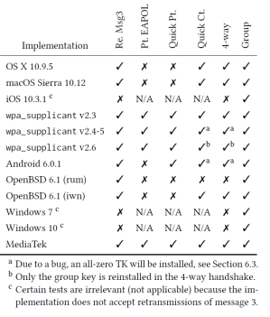

Wi-Fi Protected Setup (WPS): providing easy WPA/WPA2 key configuration for Alice, Bob…..and Eve
● 8 digit PIN, where last digit is checksum ● The validity of the first and second half is acknowledged independently
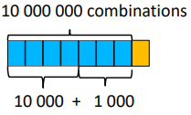

Depending on implementation: unrestricted number of PIN attempts
Wi-Fi Easy Connect (2018) provides a better alternative for both WPA2 and WPA3.

WPA3-Simultaneous Authentication of Equals (SAE) prevents offline dictionary/brute-force attacks (WPA-3 Personal)
Can only make one password guess per attack (i.e., per online authentication attempt) Cannot perform dictionary/brute-force attacks off-line
Gains no information about password through eavesdropping
Forward secrecy – compromise of the password will not disclose previous communication
Compromise of shared (session) secret won’t help attacker in later sessions
A variation of the password authenticated key-exchange Dragonfly
Successful attacks (password recovery) against WPA-3 Personal (https://wpa3.mathyvanhoef.com):
Downgrade attacks against Transition Mode (mitigation: Transition Disable)
Side-channel attacks (since mitigated in standard, but depending on implementation)

SAE-PK (Public Key) for WPA3–Personal added i 2020 avoid «evil twin attacks» given that Personal WLANs are often used in public places
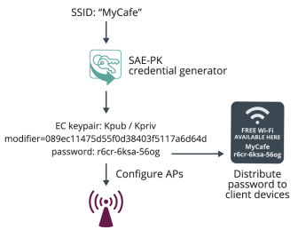

The password is a truncated hash of the SSID, modifier and public key (in human readable form)

Wi-Fi Enhanced Open - Opportunistic Wireless Encryption (OWE) for open networks Opportunistic Wireless Encryption (RFC8110) – as an alternative to sending in cleartext Based on the use of unauthenticated Diffie-Hellman
Does not protect against active attackers (e.g., fake AP)
Provides protection against passive attackers
Unique PMK for each connection, as opposed to WPA2-Personal when the same PSK is (openly) shared
Not part of the WPA3 specification – but likely to be supported by many WPA3 devices/products

Final remarks - wireless network security
WPA2 (i.e,. CCMP / AES) is a minimum for securing WLANs today
WPA3 provides significant security improvements
Higher layer security (e.g., VPN) may be used for additional security

