Executables and processes
An executable consists of dead bytes. Static analysis can be used to explore the contents of an executable, both to determine what a software or malware does, and to find vulnerabilities
A process is a running executable, started by a program or a user. When running, the instructions are executed. Analysis of a running process is called dynamic analysis

Binary files and executable files
A binary file format contains primarily binary data
Binary file formats include executable files (compiled programs), images, media and some types of compressed files
An executable file contains instructions that will be executed by the CPU if the file is run
Several types of executable file exist, and they are operating system, (OS) specific
We will focus on the Portable Executable (PE) file format

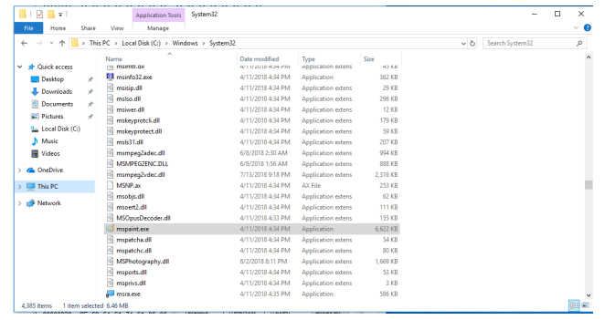
What does an executable look like?

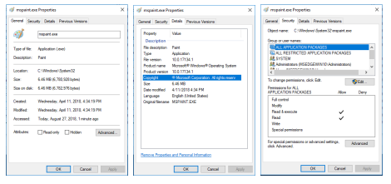
The security tab shows permissions for groups and users

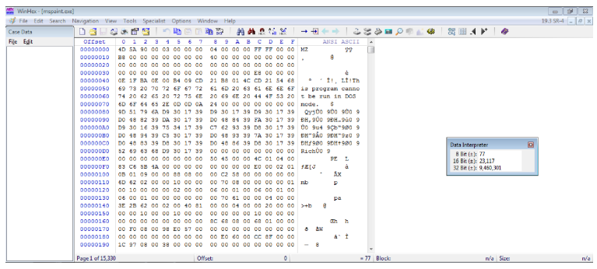
The binary file contains shown in WinHex. Not very readable

The PE file format

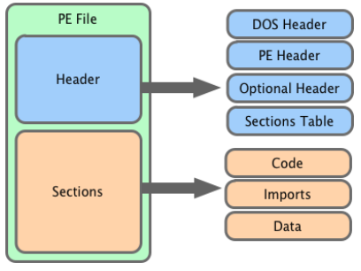

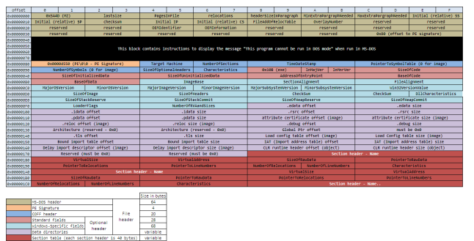

What does an executable look like in Peview?

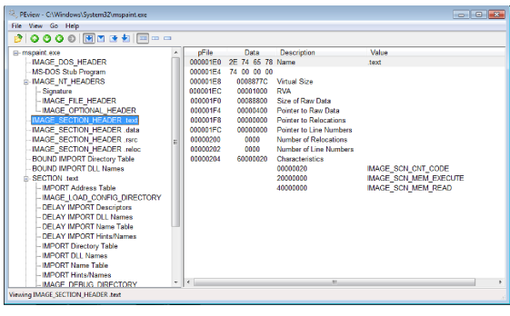
PEview
Extracts readable information from the PE file:
- Shows the sections present
- Lists included DLLs, exported and imported functions
- Look for suspicious section sizes (Virtual size and size of raw data should be relatively equal)

Interactive DisAssembler (IDA)
IDA extracts information form the PE file:
- Lists strings present in the file
- Lists included DLLs, exported and imported functions
- Finds the entry point of the executable (the exported function)
But IDA does much more
What does an executable look like in IDA
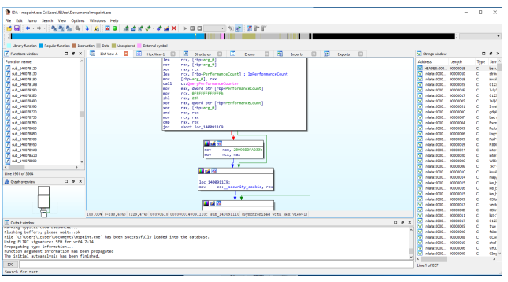
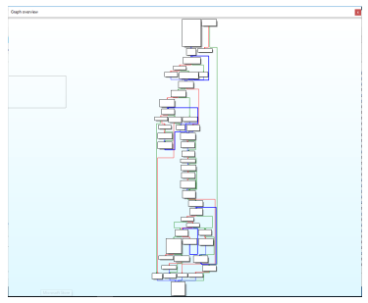

The control flow graph, shown in IDA

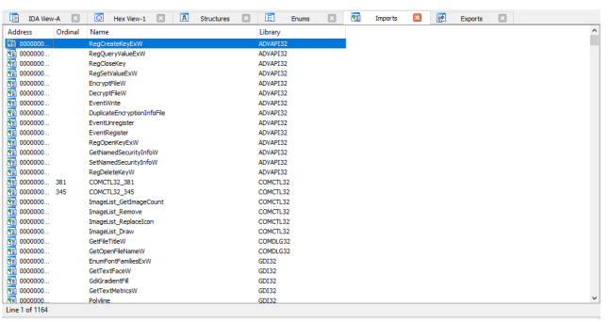
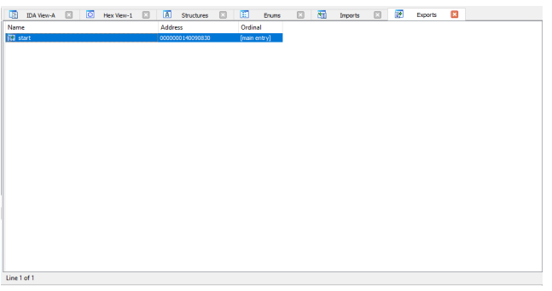

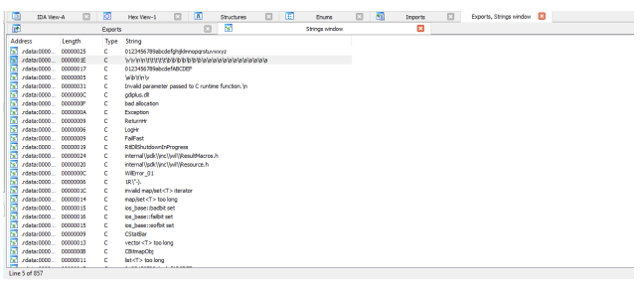
Basic dynamic analysis
How does the executable interact with the system? Process monitor
Which processes are running, and which DLLs are loaded? Process explorer
What happens in the registry? Regedit/Regshot

Process Monitor
Sysinternals suite: procmon.exe
Monitors activity in: Registry, File system, network and processed and threads
Which activity that is shown can be toggled by buttons or by setting filters manually
Need to use filters (Filters → Filter .. or ctrl + L)
Mastering filters is the key to mastering Process Monitor
Right click on an entry to add it to the filter, either as exclude or included
Start and stop capturing at the right times (ctrl + E)
Clear the log when suitable (ctrl + x)
Double click an event to see event properties (including process properties and call stack)

What can process monitor tell us?
- Registry. By examining registry operations, you can tell how a piece of malware installs itself in the registry
- File system: Exploring file system interaction can show all files that the malware creates or configuration files it uses
- Process activity: Investigating process activity can tell you whether the malware spawned additional processes
- Network: Identifying network connections can show you any ports on which the malware is listening

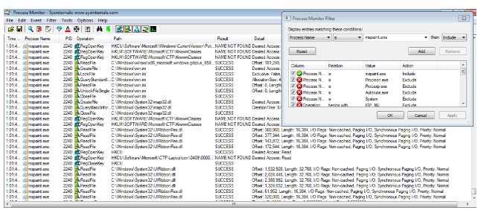
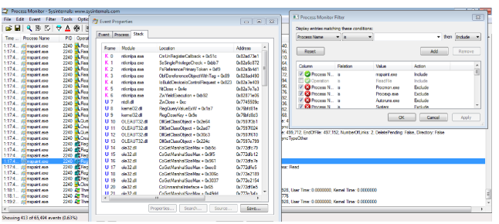
Process Explorer
Monitors running processes
Shows the process hierarchy
Shows more columns: Right click on the bar containing column titles and click Select Columns
Add the columns User name, Path, Integrity, and ASLR, for example
Shows which process is started by which user
One executable may have several processes
Open Lower pane and choose DLLs (or handles)
The DLLs loaded at startup may not be all

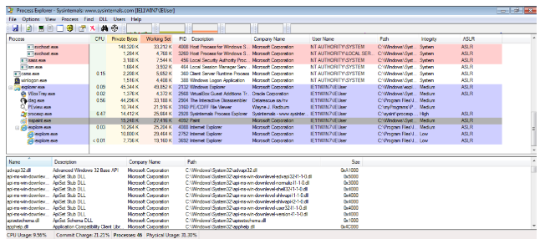

Process Explorer – Explore paint
Open Process Explorer
Open Paint
Have a look at the loaded DLLs
Click around in Paint. Press save, draw something, open help, …
Check the loaded DLLs again. You now should have more DLLs loaded

Process Explorer- Explore Internet Explorer and Edge
In Internet Explorer it was quite simple:
- Open Process Explorer
- Open Internet Explorer
- You get two processes, of different integrity
- Open more tabs
- You get one Low integrity process for each tab

Edge is more complicated
Open Edge
- Press Shift + Esc (or … → More Tools → Browser Task Manager)
- You get a list of the Edge processes, including a process for each tab
- The processes are also shown in Process Explorer, with integrity, but their roles are less obvious

How to use Process Monitor and process Explorer?
Run as administrator gives more information
These tools give an overview of what the executable is doing
Combine this information, and use it to guide you further investigations
Investigate files, registries, … that the executable interacts with
Malware may use temporary files to hide or obfuscate its actions

Registry Editor and Regshot
Regshot takes snapshots of the registry
Snapshots before and after a piece of malware is run shows how it installs itself in the registry
The registry may be used for persistence
Registry Editor (regedit) shows the contents of the registry
Press the windows key and write regedit to start the Registry Editor

The registry
Stores low-level settings for the Windows OS
Applications may store settings in the registry
The registry has an hierarchal structure
The registry contains keys and values
A key may contain subkeys and values
There is a set of specific root keys, including:
- HKEY_LOCAL_MACHINE contains local machine specific configuration data. Registered access
- HKEY_CURRENT_USER contains settings specific for the current user. Less restricted access
- HKEY_CURRENT_CONFIG contains information gathered at runtime. Generally not stored on disk
The registry is stored in multiple files in the system, called hives. And some are not stored on disk

Registry Editor
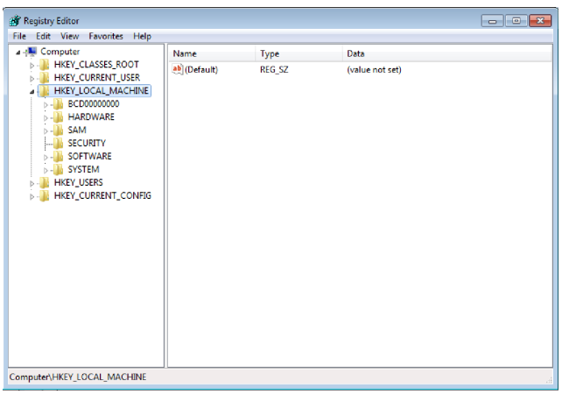
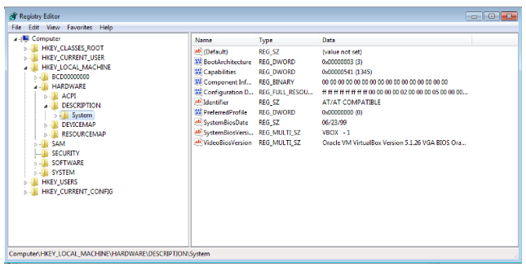
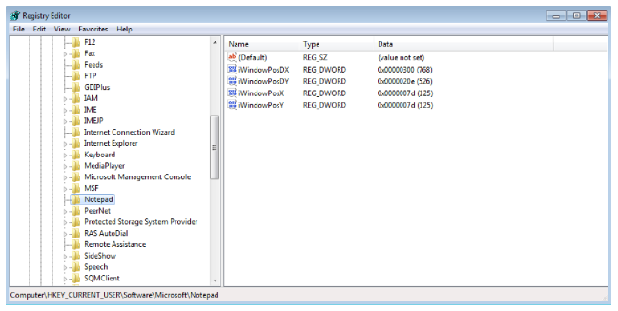

Processes
Levels of abstraction
- Hardware. The only physical level, consisting of electrical circuits able to perform logical operations
- Microcode. Also called firmware. Specific for the exact hardware for which it was designed
- Machine code consists of opcodes, hexadecimal numbers, which each corresponds to a specific instruction for the processor. Each opcode is normally implemented with several microcode instructions
- Low-level languages. Human readable version of the computer architecture’s instruction set. Assembly is most common. This is the level malware analysts operate at
- High-level languages. Written by computer programmers. Includes languages like C and C++. A compiler translated the programs into machine code
- Interpreted languages. Interpreted languages like C#, Perl, .NET, and java. These are interpreted into bytecode instead of machine code. Bytecode executes within an interpreter, which translates bytecode into executable machine code at runtime

Reference
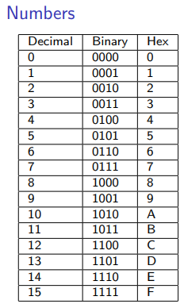
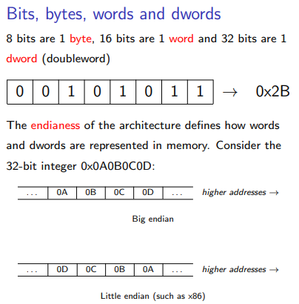

Processes in memory
The executable file and imported DLLs are loaded into memory. Each section is page aligned, so the executable in memory is larger than on disk
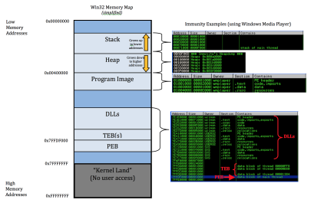
Stack and heap are created in the same virtual address space

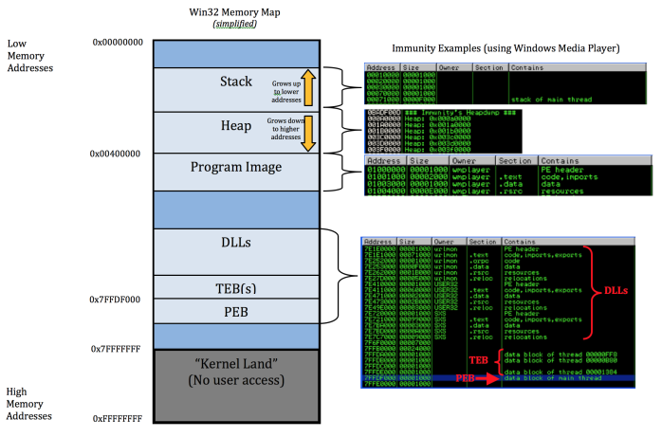

Data of several types. Static and global variables. Import and export functions initialized data
Code includes the instructions fetched by the CPU to execute the program’s tasks
The heap is used for dynamic memory during program execution
The stack is used for local variables and parameters for functions, and to help control program flow

Registers
General registers are used by the CPU during execution. EAX, EBX, ECX, EDX, EBP, ESP …
Segment registers are used to track sections of memory. CS, SS, DS, ES, FS, GS
Status flags are used to make decisions. EFLAGS (ZF – Zero flag, SF – Sign flag, …)
The instruction pointer is used to keep track of the next instruction to execute

EIP, the instruction pointer
EIP contains the address of the next instruction to be executed.
EIP moves to the next address unless the current instruction is a jump/call.
If you control EIP, you control what is executed by the CPU. Therefore attackers attempt to gain control of EIP.
They need to insert their own code (or find code already in the system that can do what they want) and let EIP point to that code.

Assembly crash course
Instructions consist of a mnemonic and zero or more operands.
A mnemonic is a word that identifies the instruction that is to be executed.
The operands are parameters to the instruction.
The opcodes are the hex numbers corresponding to the entire machine instruction.

Instruction: mov ecx, 0x12345678
Opcodes: B9 78 56 34 12
The x86 architecture uses the little-endian format, so values and addresses are reversed

mov dst, src - move src into dest.
push/pop - push a value onto the stack/pop a value off the stack
cmp dst, src - Compare the values of dst and src
jmp location - Jump to a location. Also several conditional jumps exist.
sub/add/inc/dec - subtraction, addition, increment by 1, decrement by 1
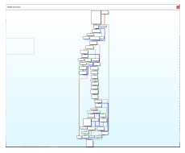
xor - xor eax, eax sets eax to zero
nop - no operation
int - interrupt, breakpoint

The stack
Before a function is called, its arguments are pushed onto the stack. A stack frame belongs to each function, and the function uses this section of the stack.
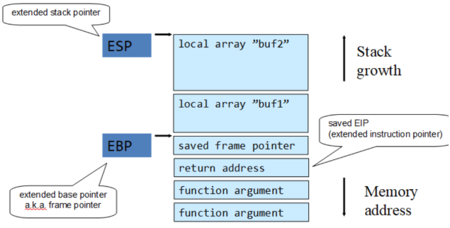
Example: C++ code vs assembly
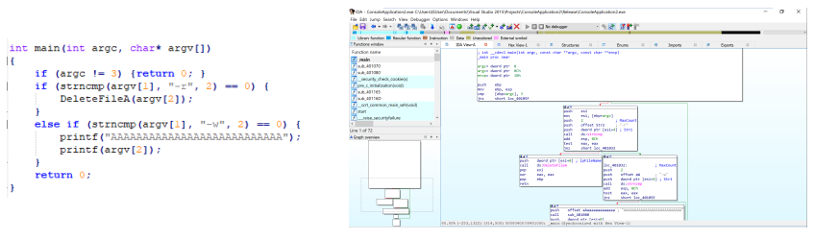

Example: Decompilation by pressing Tab
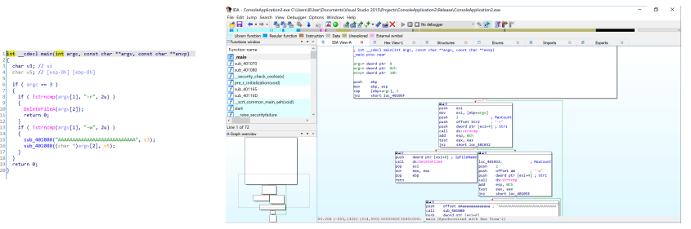
Example: C++ code vs decompiled code
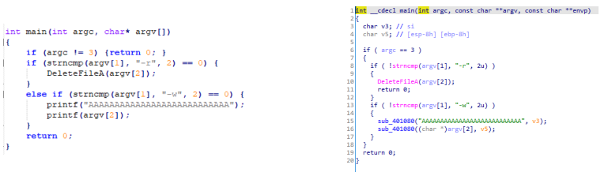
What to remember?
Stack
Registers
- EIP
- EBP
- ESP
Instructions
- push/pop
- jmp/call
- mov
- add/sub/inc/dec
- xor
- int
- nop

IDA - The Interactive DisAssembler
Configure options to view opcodes and auto comments.
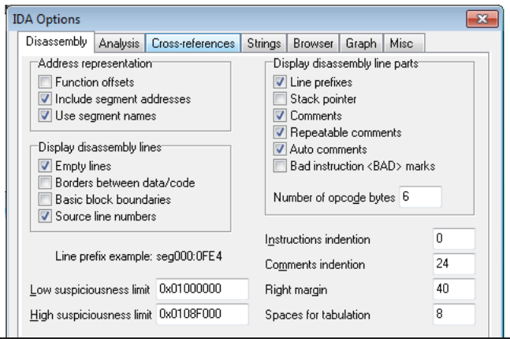

IDA - Cheat sheet
Space: Switch between graph mode and text mode.
Double click: Follow link.
X: View cross references
Esc: Go back (navigation)
Left/right arrow buttons: navigation
Windows menu: Reset desktop/Save desktop
g: Go to address or named location (sub xxx, loc xxx, printf,…)
Ctrl + E: Jump to entry point
Search: Next code, Text, Sequence of bytes

IDA - Cross references
Double click an import. Press X to find all cross references.
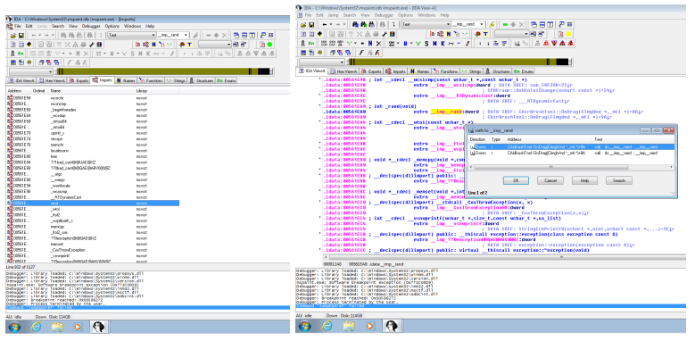

IDA - Break points
Set breakpoint using F2.
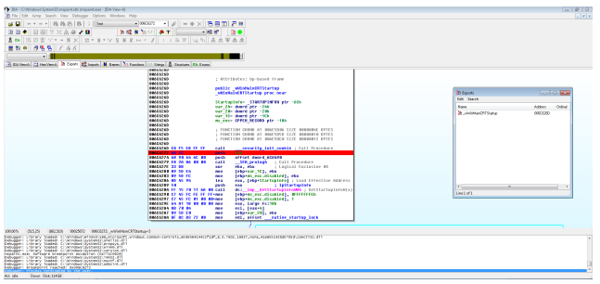
IDA - Debug step 1
When you start debugging, the window layout changes.
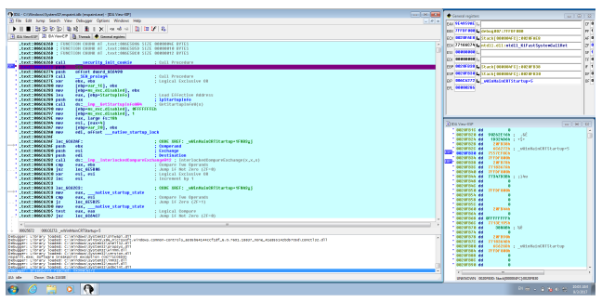

IDA - Debug step 2
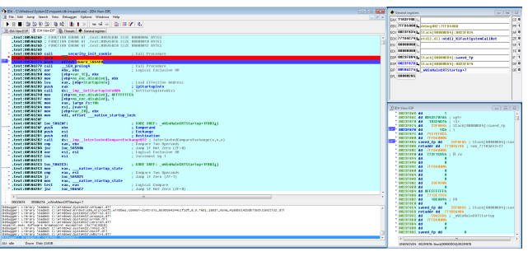
IDA - Debug step 3
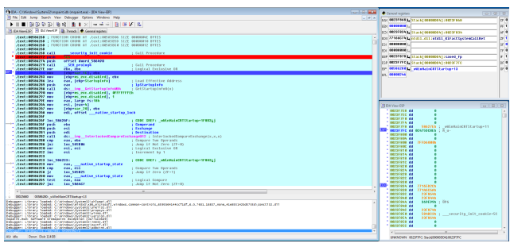

Assignment
Exercise Task 2
Part 1: Normal programs
A) Choose 5 different normal programs and use Process Monitor and Process Explorer
to get an overview of the events that occur during a normal startup procedure.

Run procmon.exe from the Sysinternals Suite.
Ctrl + L opens filters, Ctrl + E starts/stops capturing, and Ctrl + X clears the current log.
For every program you investigate, I would therefore use this exact workflow:
- Open Process Monitor as Administrator.
- Press Ctrl + E to stop capture if it is currently capturing.
- Press Ctrl + X to clear everything.
- Press Ctrl + L to open the filters.
- Create an include filter for the program/process you are investigating.
- Start capture with Ctrl + E.
- Launch your program.
- Wait until it has finished starting.
- Stop capture with Ctrl + E.
Running the tools as Administrator gives you more information.

Run procexp.exe from the Sysinternals Suite.
I'd configure it once before doing the five programs.
Right-click the column header and choose Select Columns, then add things such as:
- User name
- Path
- Integrity
- ASLR
Then enable the Lower Pane and choose DLLs.
Now:
- Start Process Explorer.
- Launch the program you're investigating.
- Find its process.
- Click the process.
- Look at the lower pane.
- Record which DLLs are loaded.
- Look at where the process appears in the process hierarchy.

Program 1: Paint
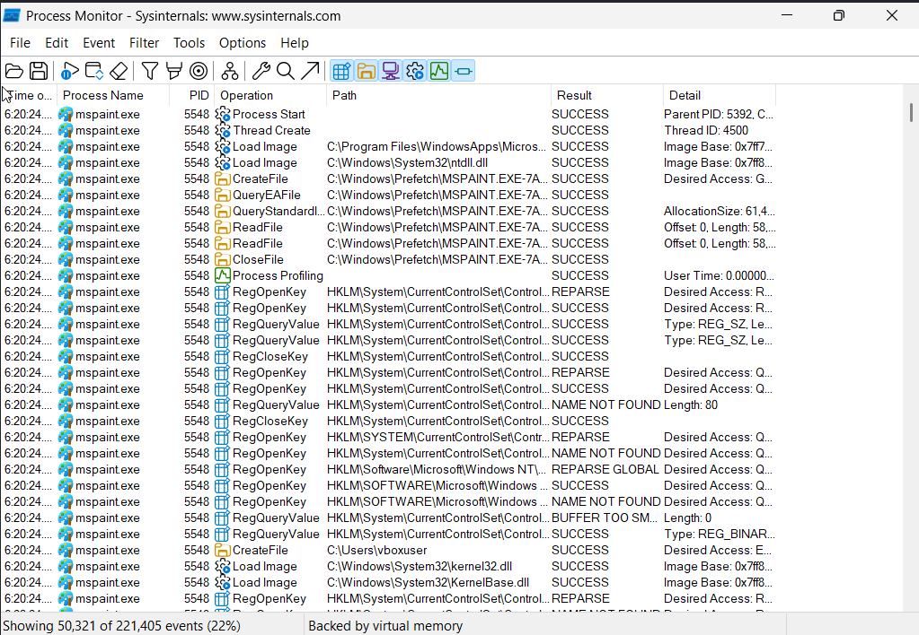
Paint produced file-system, registry, and process/thread activity during startup. Various Windows files and registry entries were accessed.

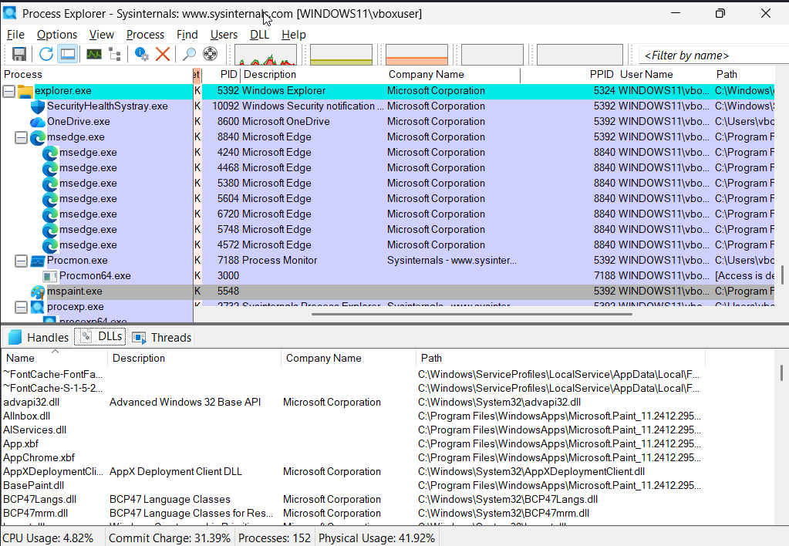
Do the same with four others.

Use Paint and Notepad to create two new files and save them to disk. Find the
corresponding events in Process Monitor. Do these actions trigger loading of
additional DLLs than those loaded at startup?

Paint DLLs — startup
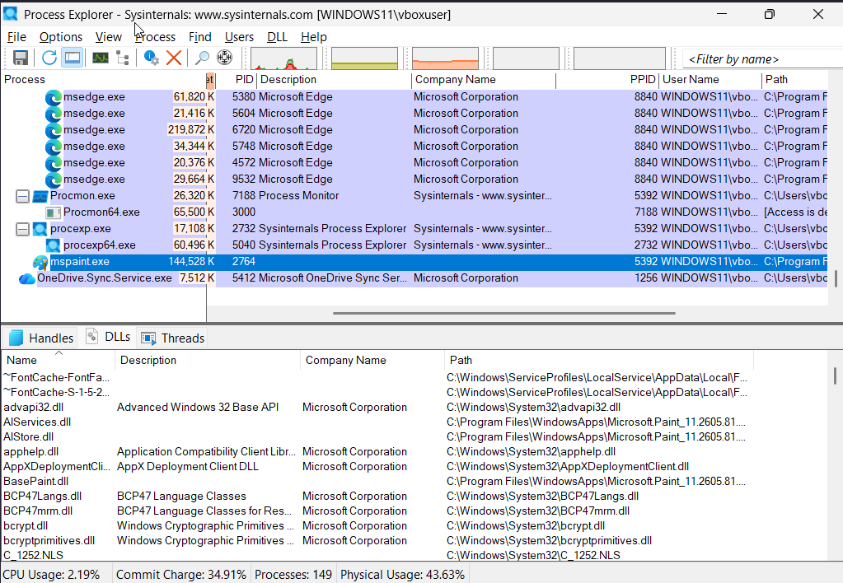

Paint DLLs after saving a file
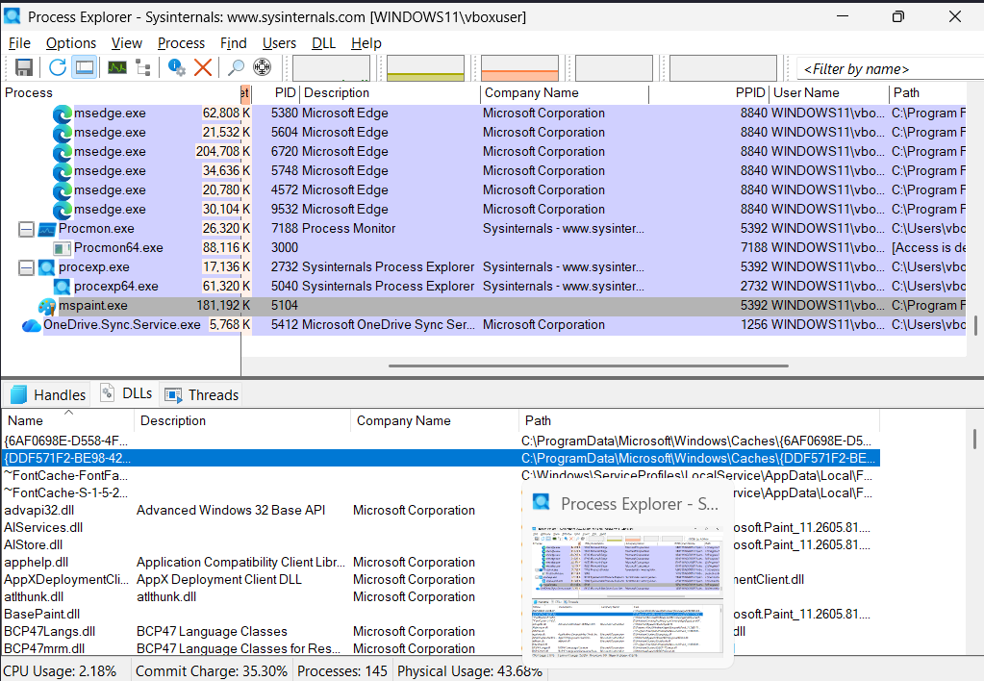

Activity involving the file you just saved in procmon.
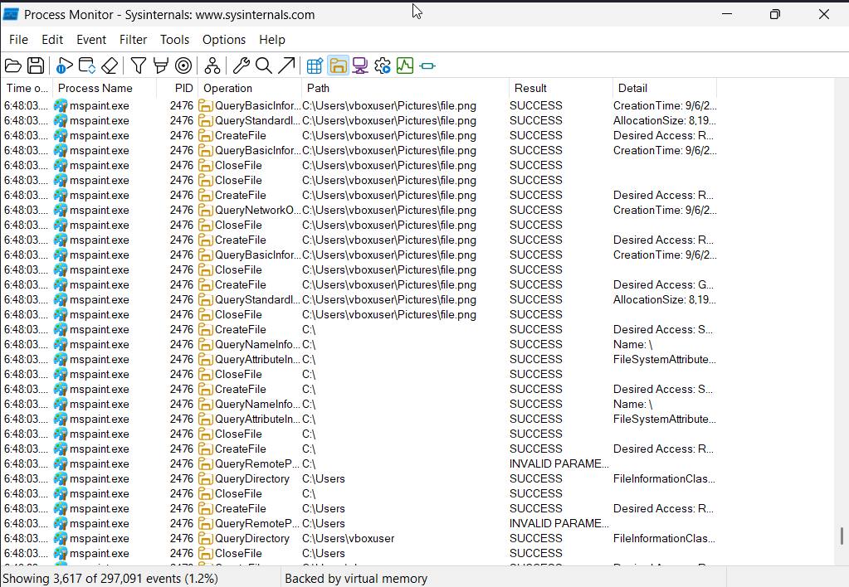
Do the same for other programs

