Executables and processes
An executable consists of dead bytes. Vulnerabilities can be detected through code analysis.
A process is a running executable, started by a program or a user. When running, its vulnerabilities can be exploited. Examination of a running process is called debugging.
- Programmers do debugging to make software work
- Attackers do debugging to find exploitable mistakes
- Security experts do debugging to determine the intention of or damage done by a piece of malware

What do we mean by security
Most definitions of security covers at least the following three aspects:
- Confidentiality is about preventing unauthorized disclosure of information (unauthorized reading)
- Integrity is about preventing unauthorized modification of information (unauthorized writing)
- Availability is the property of being accessible and usable upon demand by an authorized entity

An example
Eve gets Alice password by eavesdropping – confidentiality
Eve logs into Alice’s account and makes malicious changes to her webpage – integrity
Eve also changes Alice’s login script, such that Alice will be immediately logged out when trying to log in – availability and integrity

Malware
Simplistically, malware consists of two parts:
- An exploit of a vulnerability, giving control over the environment
- A payload, executing the actions wanted by the attacker

Vulnerabilities
A vulnerability is a weakness that can be caused by everything from simple software bugs to complex design flaws
We typically group vulnerabilities based on the underlying type of software flaw
- Memory corruption, input validation, race conditions, type confusion …

Known and unknown vulnerabilities
We can also distinguish between 0-day and N-day vulnerabilities:
- A o-day vulnerability is an undisclosed vulnerability – unknown to the vendor and the public
- An N-day is a vulnerability that is known, and for which a patch might already exist
Some of the more advanced cyberattacks of recent years have used 0-days vulnerabilities – stuxnet used several
The vulnerability used by Wannacry was an N-day that Microsoft already had patched but it still had a huge impact

Finding and disclosing vulnerabilities
The vast majority of security vulnerabilities are found and fixed internally, before the software is shipped
Naturally: when attackers find vulnerabilities, they very rarely disclose them
When security researchers find vulnerabilities, they usually choose to disclose them
Traditionally, we have two different models of disclosure:
- Full disclosure
- Responsible disclosure

Full disclosure
Full disclosure is the practice of publishing information on vulnerabilities as early as possible, with few or none restrictions of the information published
Some typical arguments for full disclosure
- The vulnerability might already have been discovered by malicious parties
- Customer will demand the vulnerability to be fixed by the vendor
- Administrators need to know the vulnerability details to make informed decisions about the risk it poses

Responsible disclosure
The practice of the first notifying the vendor, allowing them some time to fix the vulnerability before disclosing it to the public
A typical argument fir responsible disclosure is that the practice of full disclosure will leave users at the mercy of malicious actors until a patch is available

Vulnerability databases
Several public databases of vulnerabilities exist. The most well known is the Common Vulnerabilities and Exposures (CVE)
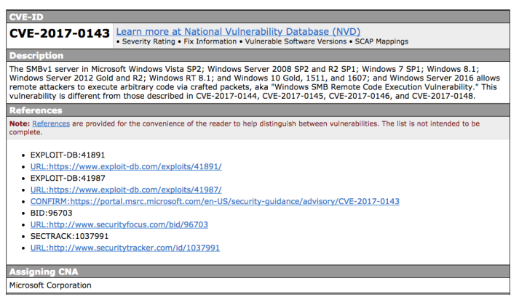

Exploit and malware
An exploit is the code or data that takes advantage of a vulnerability
Exploits can be classified by what type of connection they need to the system:
- A remote exploit works over the network and does not require prior access to the system
- A local exploit requires prior access to the machine and usually tries to increase the attackers privileges on the system

Another way of classifying exploits is by which abilities it gives the attacker:
- Arbitrary code execution: the ability to execute any command of the attackers choice
- Information disclosure: the ability to access information the vulnerable software did not intend to disclose
- Denial of service: the ability to make the vulnerable software unavailable to its legitimate users
Types of malware
Malware is software that has a malicious purpose:
- Computer virus, worm, Trojan horse, logic bomb, backdoor, botnet, ransomware, rootkit, keylogger
The malware taxonomy tries to capture different aspects of the malware:
- How the malware spreads/propagates
- The purpose of the malware
- How it is controlled
- And lots more
Example - Stuxnet and Wannacry are both worms, but where Wannacry is ransomware, Stuxnet is a logic bomb with rootkit functionality.

Classic types of malware
- Computer virus – self-replicating code attached to some other piece of code, a virus infects a program by inserting itself into the program code
- Worm – replicating but not infecting program: most reported virus attacks would be better described as worm attacks
- Trojan horse – program with hidden side effect, not intended by the user executing the program
- Logic bomb – program that is only executed when a specific trigger condition is met

Malware behaviour
Backdoors – malware that provides the attacker with remote access to the infected machine
- Reverse shell – a connection originating from the infected machine, providing the attacker with shell access to that machine
- RATs – remote administration tool, often used in targeted attacks with a high level of interaction between attacker and victim
- Botnets – large collection of Internet-connected compromised computers commanded and controlled by a botnet operator
Credential stealers – malware trying to steal credentials from the infected machine
- Hash dumpers – malware dumping password hashes, to be used directly or cracked offline
- Keyloggers – malware recording the keys struck on a keyboard
Rootkits – malware that enables continued privileged access to a computer; hides the existence of certain processes and files from normal methods of detection
Ransomware – software which restricts access to a computer, demanding a ransom to be paid

Who are the attackers?
There is a wide variety of attackers – all with different motivation, skills and resources
Script kiddies
- Use known and easily accessible techniques and tools
- have limited knowledge and skills
- Often easily traceable
Hacktivists
- Use hacking to promote and ideological or political agenda
- Anonymous and LulzSec are two well known groups
- Have been involved in website defacement, denial of service attacks and information disclosure
Organized crime
- Use of hacking for fraud, financial crimes, extortion
- Botnets, ransomware, fake antivirus
- Increasingly sophisticated and organized
APTs
- Advanced persistent threats
- Groups (often nation states) with the capability and intent to do highly targeted attacks
- Often highly sophisticated

Attribution
Attribution is about identifying the actors responsible for a cyber attack
- Attribution can have both a technical aspect and political aspect
- Actors sometimes try posing as other actors (false flag operations)

Stuxnet
- Malicious computer worm targeting SCADA systems
- Believed to target and damage Iran’s nuclear program
- A computer program doing physical damage
- Uncovered in 2010
- Used four zero-days

WannaCry
- Encrypting ransomware
- Worldwide cyberattack in May 2017
- Using the EternalBlue exploit for older windows systems, which was relayed by The Shadow Brokers a few months earlier
- Spread fast, but was stopped by a patch from windows and the discovery of a kill switch

Petya
Family of ransomware first discovered in 2016
Encrypting ransomware targeting Windows
Newer variants use the EternalBlue exploit

Spectre and Meltdown
Hardware vulnerabilities
The first of a series of vulnerabilities in processors
Modern processors execute operations speculatively/out of order while waiting for other operations to finish
- Better than being idle
- The internal cache is not cleared
- The contents of the cache reveals what has been executed speculatively
Hardware is shared
Between users e.g in clouds
Between processes with different privileges (kernel, userland)
