Transport Layer Security (TLS)
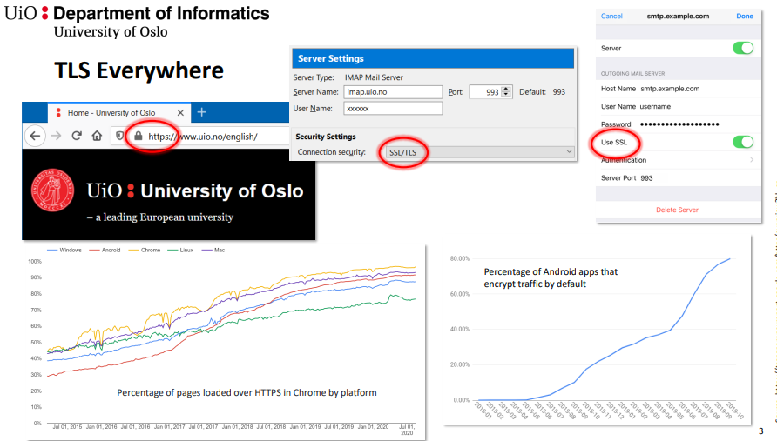
Transparent security protocol between TCP and application layer
Widespread usage, e.g.:
- − HTTP over TLS (HTTPS)
- − IMAP over TLS (IMAPS)
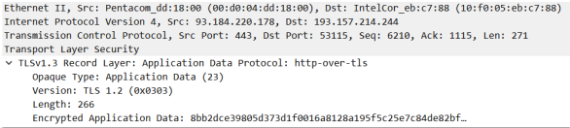
Security goals:
− Confidentiality
− Integrity
− Authenticity

TLS < 1.3
TLS: Protocols and Layers
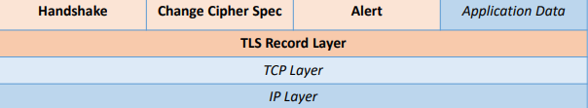

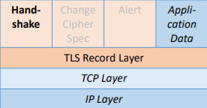
TLS Handshake
Negotiation of cryptographic algorithms + parameters
Authentication of communication partners (just server or mutual)
Exchange of symmetric session key

TLS Record Layer
„Core functionality“ of TLS
Accepts data from upper layer and performs (in that order):
- Fragmentation
- Compression
- Authentication (e.g., MAC) using session key
- (Symmetric) Encryption using session key

Key Exchange + Server Authentication
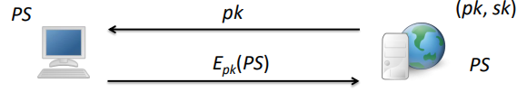
RSA Encryption (simplified)
- Server sends public key (inside a X.509 certificate)
- Client generates random number (premaster secret, PS)
- Client encrypts PS using the server public key and sends the result
- Server decrypts PS using its private key sk
- All further communication is encrypted with session key derived from PS
- (Implicit) authentication: only the owner of the private can participate in further communication

Key Exchange + Server Authentication
Attacks on RSA Encryption
- Attacker eavesdrops communication:
  - can not decrypt encrypted key
- Attacker replaces Epk(PS) with Epk(PS*) with PS* known to her
  - has negotiated a shared key with the server, but not with the client (i.e., can not communicate with the client)
- Attacker replaces server public key with the attacker's public key
  - Public keys are protected by certificate, client can detect the change
    - public key does not match the certificate
    - certificate is issued to wrong subject

- Diffie Hellman Key Exchange
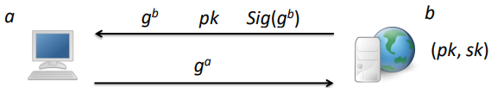
  - Client and server generate DH secret value a and b
  - Client and server calculate DH public value g a and g b and send it
  - Server sends public key (inside a X.509 certificate)
  - Server creates signature over g b (using its private key sk) and send it
  - Client verifies signature
  - Client and server calculate the DH shared secret (premaster secret, PS)
  - All further communication is encrypted with session key derived from PS

- Attacks on Diffie Hellman Key Exchange
  - Attacker eavesdrops communication
    - can not break DH key exchange
  - Attacker replaces g b
    - signature does not match
  - Attacker replaces pk with her own public key (and creates signature with her own private key)
    - public keys are protected by certificate, client can detect the change
  - Attacker replace g a with g e (e known to attacker)
    - has negotiated a shared key with the server, but not with the client (i.e., can not communicate with the client)

Forward Secrecy
● A key exchange protocol offers (perfect) forward secrecy 
the session key is not compromised even if the private server key is compromised
● Imagine the following situation:
− Attacker records the complete communication
− Attacker learns later (after the protocol has finished) the private key
● RSA:
− Attacker uses the private key to decrypt the premaster secret → calculates the session key → can decrypt the complete communication → no forward secrecy
● DH:
− Knowledge of private key is not helping with breaking DH key exchange→ forward secrecy
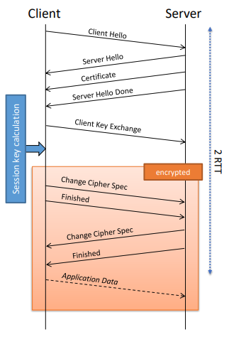
− Session key is “ephemeral”

TLS Handshake (here: using RSA)
● Client Hello:
− Supported algorithms
− 1. random number
● Server Hello:
− Selected algorithms
− 2. random number
− Session ID
● Client Key Exchange:
− Encrypted premaster secret
● Change Cipher Spec:
− Starts message protection
● Finished:
− Authenticates all previous messages (protects from downgrade attacks)

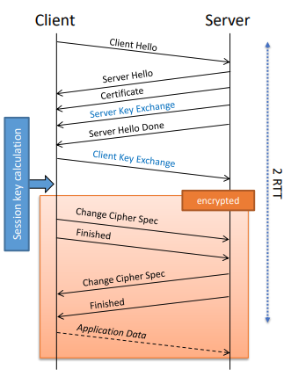
TLS Handshake (here: using DH)
● Client Hello:
− Supported algorithms
− 1. random number
● Server Hello:
− Selected algorithms
− 2. random number
− Session ID
● Client + Server Key Exchange:
− Diffie Hellman key exchange → “premaster” secret
− (Server Key Exchange signed)
● Change Cipher Spec:
− Starts message protection
● Finished:
− Authenticates all previous messages (protects from downgrade attacks)

TLS Handshake – Details (1)
● Algorithms
− Different types of algorithms bundled into “Cipher Suites”
− Format: TLS_key-exchange-algorithm_WITH_data-protection-algorithm
− Example: TLS_DHE_WITH_AES_128_CBC_SHA256
▪ DHE = Diffie Hellman key exchange (E = ephemeral)
▪ AES with CBC mode for encryption
▪ SHA256 as hash function for authentication and integrity protection
● Client offers list of cipher suites – server selects one
● Further examples for Cipher Suites:
− TLS_RSA_WITH_RC4_128_SHA
− TLS_ECDHE_RSA_WITH_AES_256_GCM_SHA384

● Random numbers in ClientHello and ServerHello
− Client and Server select independently random numbers
− Random numbers are included in session key calculation
● Certificate
− Most Cipher Suites required certificates for server authentication
− X.509 format
● Session ID
− For new session
▪ Client sends empty session ID field
▪ Server chooses session ID
− For resumed session
▪ Client sends known session ID

TLS Handshake – Session Key Calculation
● Key material calculation
− Uses “Key Expansion”
− Internally using a pseudo random function (based on hash function)
− Can produce arbitrary length key material
− Input: Premaster Secret, random number client, random number server
− Output: : Key block, is partitioned into required keys
● Required keys:
− Encryption (Client)
− Encryption (Server)
− Authentication / MAC (Client)
− Authentication / MAC (Server)
− Initialization Vectors

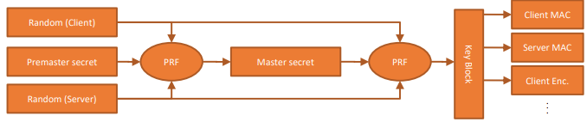
TLS in a Nutshell
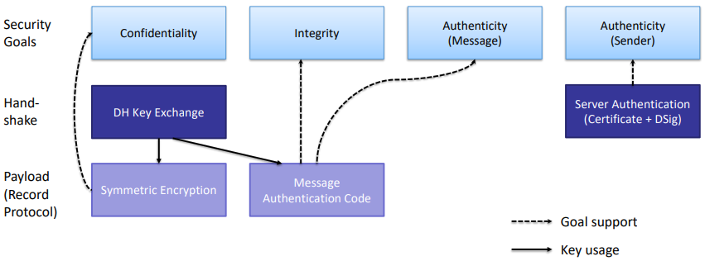
TLS 1.3
Major Changes in TLS 1.3
● Removal of old algorithms
− e.g., RC4, SHA-1
● Removal of insecure methods
− CBC, compression, “MAC then encrypt”
● Removal of non-forward-secrecy key exchange
− RSA, “DH static”
● Simpler and faster handshake:
− in most cases 1-RTT
− even 0-RTT possible
● Many cryptographic improvements
− e.g., EC, padding, DH groups
● Better privacy
− more protocol parameters (exchanged during handshake) are encrypted

TLS Handshake (1 RTT)
● Client assumes a key agreement protocol
● Sends key share for this protocol in his first message
● Client Hello:
− Supported algorithms (incl. guessed key agreement protocol)
− Client key share
● Server Hello:
− Chosen algorithms (incl. key agreement protocol)
− Server key share
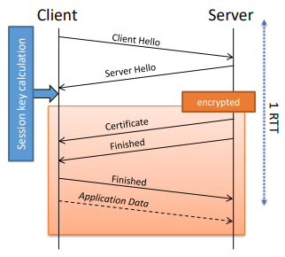

TLS Handshake – Details
● Supported algorithms (always DH key exchange!):
− Cipher suites:
▪ TLS_AEAD_HASH
o AEAD: The authenticated encryption algorithm for record protection
o HASH: The hash algorithm for key derivation
▪ TLS_AES_128_GCM_SHA256
▪ TLS_AES_256_GCM_SHA384
▪ TLS_CHACHA20_POLY1305_SHA256
− Diffie Hellman group:
▪ Elliptic curve (e.g., secp256r1, x25519)
▪ Finite field (e.g., 2048 bit, 3072 bit)
− Signature algorithm (e.g., ECDSA, RSA)

AES with Galois/Counter Mode (GCM)
● Combines encryption and authentication (“AE”, authenticated encryption)

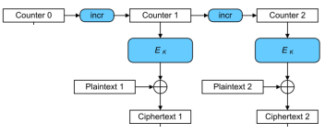

Authenticated Encryption
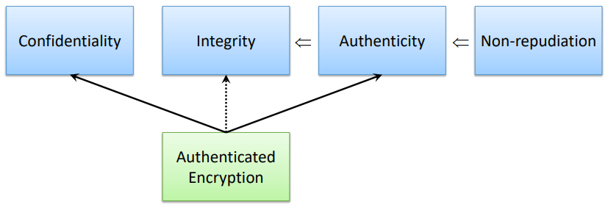
TLS Handshake (2 RTT)
● If client has guessed the wrong key agreement
→ additional RTT is required
● Hello Retry Request
− Chosen Key Agreement protocol

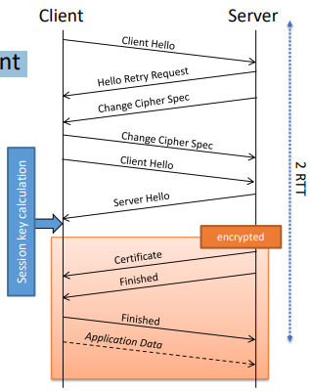

TLS Handshake (0 RTT)
● If client and server already have a shared key (from a previous session)
→ application data can be sent (encrypted) on the first flight
● Weaker security properties (e.g., no replay protection)
● Should not be used not for requests triggering an action (e.g., shopping, banking)
● Can be used e.g., for requesting a (static) Web page
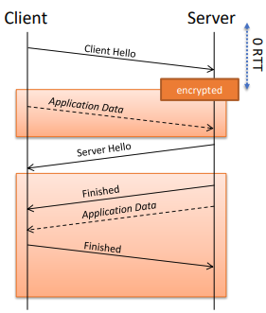

TLS and „Security Monitoring“ (1)
● In TLS all application data is encrypted
● Parameters visible to an external “monitor”:
− Layer 3 and 4 parameters (no very helpful)
− Server name from certificate
● TLS 1.3:
− Certificate is encrypted
− Increases privacy
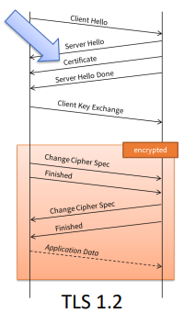
− Makes surveillance harder
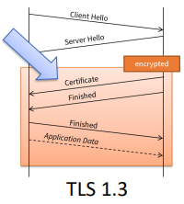

TLS and „Security Monitoring“ (2)
● Nowadays the insecure key exchange methods in TLS <1.3 are (mis-)used for network monitoring:
− All network traffic is copied to the monitor
− Monitor has a copy of the server’s private key
− Monitor can decrypt the RSA key exchange (or DH with static keys)
− Monitor can decrypt all traffic
● This is not possible any more with TLS 1.3
● ETSI created an alternative security protocol: ETS (formerly eTLS) still allowing interception

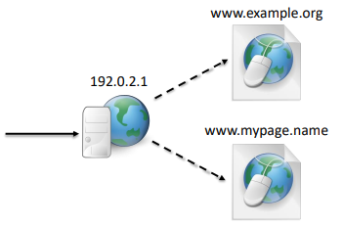
Further Details on TLS
Server Identification
● Common Web hosting:
− 1 Web server (1 IP address)
− multiple domain names/Web pages
− Web server demultiplexes requests
● How does the server know the target domain/pages?
● HTTP/1.1:
− Mandatory header field “host”

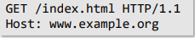

● Problem with HTTP over TLS hosting:
− Different domains/pages have different certificates (+ private keys)
− Web server must select certificate at the beginning of the TLS connection, i.e., before the HTTP request
● Solution:
− Host name is (additionally) sent inside the client hello message (SNI, server name identification)

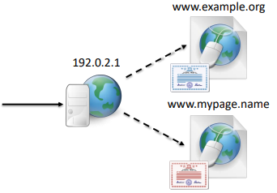
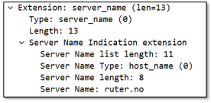

Implementation Aspects
● TLS implemented on application level
− For example, inside the browser
● Application (or even the user) decides about security level
− Advantages? Disadvantages?
● How to choose TLS protected connection:
− Browser: URL starts with “https”
− TLS protected service typically offered on different port:
▪ 80 (HTTP) 443 (HTTPS)
▪ 143 (IMAP) 993 (IMAPS)

Opportunistic TLS
● Some protocols allows switching to TLS protection inside given connection (“STARTTLS”)
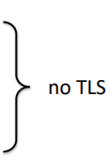
● Most common usage: SMTP
● Example (SMTP/STARTTLS):
S: 220 mail.example.org ESMTP service ready
C: EHLO client.example.org
S: 250 mail.example.org offers a warm hug of welcome
S: 250 STARTTLS
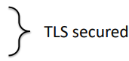
C: STARTTLS
S: 220 Go ahead [TLS handshake]
C: EHLO client.example.org
…

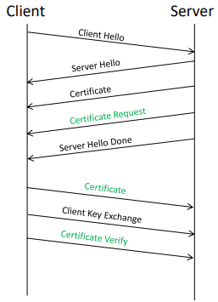
TLS: Client Authentication
● Client authentication (optional in TLS):
− Server
▪ “Certificate Request” requests client authentication
− Client:
▪ “Certificate”: client certificate
▪ “Certificate Verify”: signature over previous messages (proves ownership of private key)

Famous Attacks on TLS
● Downgrade Attacks
− POODLE (2014)
− FREAK (2015)
− Logjam (2015)
● Padding Oracle
− Lucky Thirteen (2013)
− ROBOT (2017)
● Misusing CBC
− BEAST (2011)
● Misusing Compression
− CRIME (2012)

TLS and the Web
Security for the Web
● Typical usage:
− Confidentiality: TLS
− Integrity: TLS
− Authentication (Server → Client): TLS / Certificate
− Authentication (Client → Server):
▪ Password (entered into HTML form) transported via HTTP POST
▪ Advantages / disadvantages compared to TLS client authentication?

TLS in the Browser
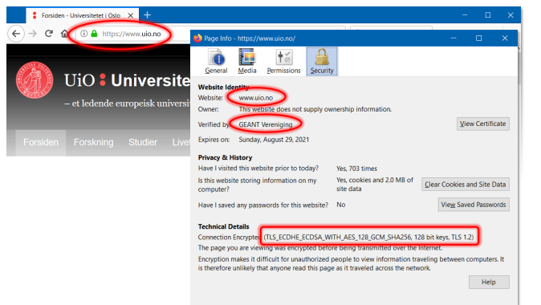
TLS in the Browser
● The browser is checking:
− Was the TLS handshake successful? (this proves that the server owns the private key)
− Are only “secure” crypto algorithms used?
− Hostname address bar = Hostname inside certificate?
− Exists signed chain from server certificate to trustworthy CA?
− Is certificate still valid?
− Was the certificate not revoked?

Summary
● TLS most widespread security protocol for layer 4
● Security for single application (in contrast to IPSec)
● User can directly influence security level
● Problems:
− certificate management
− usage of insecure algorithms → regular configuration verification
− weaknesses in protocol or implementation

