Perimeter Security and Network Segmentation
Background: Defence in depth may provide stronger security than
would be obtained by any of the security measures alone
True defence in depth requires that the security measures provide overlapping (i.e., redundant)
security and that the breach of one is independent from breaching the others
- E.g., antivirus scanning and firewall both in gateway and on host machines, potentially using products from different vendors?
- The use of the same libraries, hardware, etc. may result in common vulnerabilities
One way to look at it when designing a system is to assume that the other defensive layers (e.g.firewall) have been breached
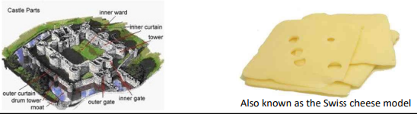
Bow-tie diagram illustration of perimeter security as one of several security measures
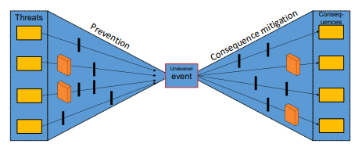

Firewalls
A firewall may be used to protect an internal network from an external network or to segment an internal network
- All traffic from inside to outside, and vice versa, should pass through
- The firewall policy defines what traffic can pass
- The firewall itself should be resistant to compromise
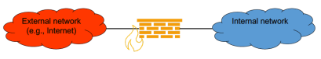

In addition to physical/virtual firewall appliances, firewall functionality is often also provided by routers, managed switches, and by host-based firewalls.

Some advantages of firewalls
- May mitigate the consequences of configuration errors, user mistakes etc.
- May provide protection against vulnerabilities being exploited before begin patched/fixed
- May provide protection against network enumeration (e.g., port scanning)
- May facilitate network monitoring and intrusion detection by reducing «noise» on the internal network and provide logs of firewall events/traffic

Some limitations of firewalls
- Provides limited protection against many threats (e.g., internal threats, malicious content, phishing,...) – but internal firewalls (e.g., «personal/software firewalls») may protect against e.g., malware spreading internally
- Do not protect against attacks circumventing or bypassing firewall filtering (e.g., through external WLAN, cellular network, SSH/VPN tunnel, memory stick…)
- Widely used protocols such as HTTPS (port 443) can be used to carry other traffic

Default firewall policy
- Allow biased / default permit: all packets except those meeting specified criteria are allowed to pass (that which is not expressly prohibited is permitted)
- Deny biased / default deny: only packets meeting specified criteria are allowed to pass (that which is not expressly permitted is prohibited)
The latter is generally the more secure approach, especially when only necessary traffic is allowed (i.e., principle of least privilege), but may be perceived as too strict unless the specified allowed traffic covers users´ needs.

Packet filtering firewalls filters packets based on information contained in the packet headers and the packet´s direction (i.e., incoming/outgoing firewall interface)
- Source and destination IP address
- Transport protocol
- Source and destination port number
- TCP flags (e.g., ACK, SYN)
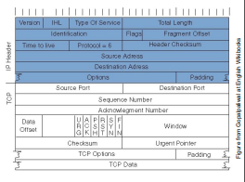

Packet-filtering rules example – allowing incoming/outgoing SMTP traffic
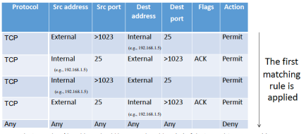

The internal src/dst address should be set to the address(es) of the internal SMTP server(s). (SMTP servers use port 25 for relaying email, but would typically also need to allow at least DNS)

A stateless packet filter makes its decision based on the current packet only. With stateful packet inspection (SPI), decisions are based on the current packet and state
- Maintains state about connections (e.g., TCP, UDP, ICMP)
- More powerful than stateless inspection
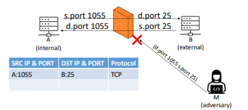

A stateful iptables example to allow incoming and outgoing SMTP on interface eth0 (IPv6 is handled separately using ip6tables )
- iptables –A OUTPUT –o eth0 –p tcp –dport smtp -j ACCEPT (accept outgoing SMTP connections (TCP dst port 25))
- iptables –A INPUT -i eth0 –m conntrack –ctstate ESTABLISHED -j ACCEPT (accept incoming traffic on established connections)
- iptables –A INPUT –i eth0 –p tcp –dport smtp –j ACCEPT (accept incoming SMTP connections (TCP dst port 25))
- iptables –A OUTPUT -o eth0 –m conntrack –-ctstate ESTABLISHED –j ACCEPT (accept outgoing traffic on established connections)
- iptables –A INPUT –i eth0 –j DROP (drop all other incoming traffic)
- iptables –A OUTPUT –o eth0 –j DROP (drop all other outgoing traffic)
Other states include RELATED, NEW and INVALID.
iptables is being replaced by nftables in Linux but is still in use many places. Distributions also provide different interfaces on top of nftables/iptables (e.g., ufw/gufw and firewalld).

Similar example using nftables to allow outgoing SMTP connections – with dual-stack support for IPv4 and IPv6
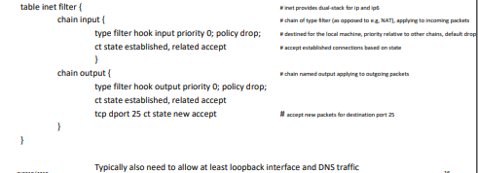

Application-level gateways (application proxy) can perform security inspection at the application layer
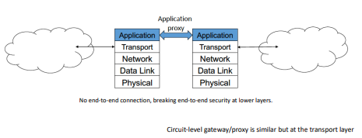

Next Generation Firewall (NGFW)
A term used to describe products combining a traditional packet filter firewall with additional functionality such as:
- Intrusion prevention and/or security monitoring
- Malware protection / antivirus (e.g., sandbox)
- Application level firewall
- Content filtering
- VPN
Unified Threat Mangement (UTM) is another term used in a similar way

Network Address Translation (NAT)
Network Address Translation (NAT) restricts incoming traffic, conceals details of the internal network, and prevents exposal of internal hosts´ IP-addresses
- Public address and port ⟷ private address and port
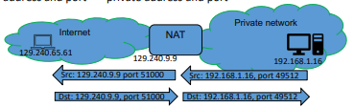

- Mapping must be created statically if to allow connections to be initiated from the outside, otherwise created dynamically
- Mapping must also include the remote address (e.g., 129.240.65.61, port 443) if other machines are not to be able to use the dynamic/static mapping to send IP-packets to the private network

Network segmentation
Segment network using, e.g.,
- Firewalls
- Virtual Local Area Networks (VLANs)
- Virtual Private Networks (VPNs)/encryption
- Software-/policy-defined approaches
May use Private VLAN (port isolation) to prevent hosts from communicating with other hosts within the same Private VLAN
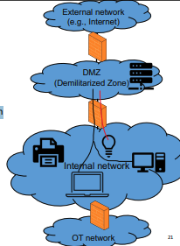

Cross domain transfer solutions support more stringent information flow control
Diode – provides one-way information flow only
- Typically implemented using optical fibre with only transmitter in one end and only receiver in the other
- E.g., enabling sensor data to be exported from a critical control system
Security filter – filtering of structured packets/data based on allowed data structure and values where only explicitly allowed packets/data are allowed to pass
Guard – may provide functionality similar to an application level gateway/proxy, but typically also makes use of security labels for release decisions (may also include security filter / content check)
- Security label: a set of metadata providing information on the security handling of a data object (e.g., a documents security classification). The security label, the data object to which it applies, and their association may be protected by a digital signature.
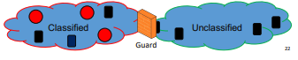

The Zero Trust Model
Main concepts:
- Ensure all resources are accessed securely regardless of location
- Adopt a least privilege strategy and strictly enforce access control
- Inspect and log all traffic
Zero trust: no trusted or untrusted interfaces, networks, users, network traffic, etc.

The zero trust network architecture
Segmentation gateway provides (micro-) segmentation
- Firewall, intrusion prevention system, content filtering, access control, crypto, activity monitoring
MCAP: Microcore and perimeter
NAV: Networks analytics and visibility
SIM: Security information management
DAN: Data Acquisition Network
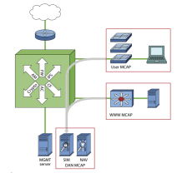

Saltzer and Schroeder (1975) identified eight design principles for security mechanisms
- Economy of mechanism (minimalism)
- Fail-safe defaults
- Complete mediation
- Open design (Kerckhoff 1883, Shannon 1948)
- Separation of privilege
- Least privilege
- Least common mechanism
- Psychological acceptability (Kerckhoff 1883)
Much has changed since 1975, but the principles are generally still valid. Least privilege and complete mediation are core principles in zero trust.
How do these principles apply to perimeter security and network segmentation?

