Domain Name System (DNS)
Directory services for name resolution
Requirements:
- support for “real” names (e.g. server01) and “logical” names (e.g. www.uio.no)
- support for different kinds of services (e.g. mail) and address formats (e.g. IPv4, IPv6)
- distributed data base
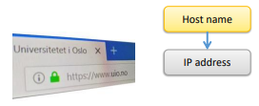
- local cache
DNS:
- RFC 1034
- RFC 1035

Name Space Definition
Domain Name Space
- tree structure
- nodes have a "label": 1
- 63 byte
- length of root node label = 0
- nodes with common parent must not have the same label
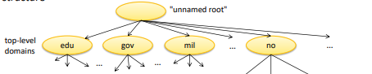

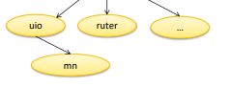

Country Code TLDs (ccTLDs )
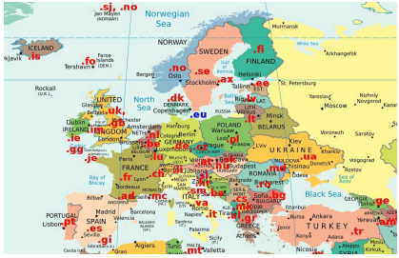

Generic TLDs (gTLDs)
„Classic“ gTLD:
- .com (commercial)
- .edu (educational)
- .org (non-commercial)
- .arpa (incl. the reserved domain for reverse lookup: in-addr.arpa)
„New“ gTLDs:
- since 2012: 1000+ of new gTLDs (e.g., 50 from Amazon, 50 from Google)
- Examples: .google, .fun, .berlin, .nyc, . ストア, 書籍

Name Space Definition
Zone concept
- A sub tree of the DNS tree can be defined as zone
- A zone is managed by a single organization
- A zone operates name server which store information on:
  - DNS names inside that zone (“authoritative information”)
  - Further zones “below” that zone (“glue records”)
- Example:
  - NO zone
  - Managed by Norid
  - Manages all names inside the zone (e.g. www.nic.no)
  - Contains information (“glue records”) on all zones below the NO node (i.e. all .no domains)

Root name servers
- Root zone name servers hold a list of names and IP addresses of the name servers for all top-level domains (TLDs).
- TLD resolution requires using a root server to obtain the responsible authoritative server.
- Currently (2020):
  - 13 root name servers
  - operated by 12 independent root server operators
  - 1326 instances

Name Resolution
Name Servers
- Per zone: two name servers, "primary" and "secondary"
- Names servers provide information per node of the related zone
  - "authoritative data" for "own" zone
  - "glue data" for querying name servers of delegated subzones
- Common data format (for storing and transmitting DNS data)
  - Resource Records (Rrs)

Zone file sample 1
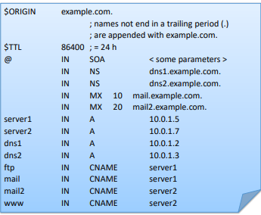

Zone file sample 2
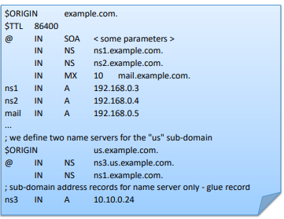

DNS Services and Protocol
Name resolution interactions
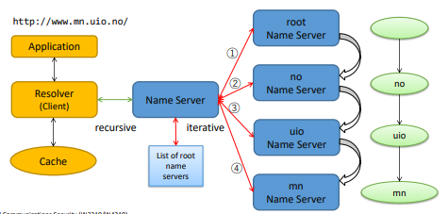

Resolution
- Client request: recursive resolution, i.e., let the name server scan other name servers and return a complete response
- Name server to name server request: iterative resolution, i.e., name server collects (partial) responses from other name servers

DNS Caching
- Forwarding every request to the authoritative server would produce a large amount of traffic
- Every DNS resolver stores DNS responses in a local cache
- Subsequent requests for same resource will be answered from the cache
- Entry is erased from the cache after expiration of TTL
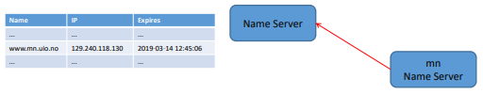

DNS protocol
- Query/Answer protocol
- port 53
- TCP or UDP (most common)
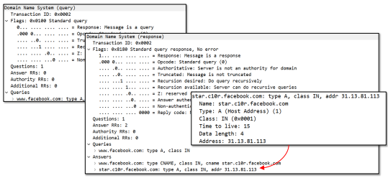
Other Resource Records
- TXT:
- Arbitrary text
- Typical usage:
  - SPAM interception (see chapter “email”)
  - Domain verification (e.g., certificate registration, some enterprise services)
- Example:
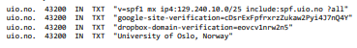

PTR:
- Reverse lookup: IP address to DNS name

Importance of DNS
- Nearly all IP communication starts with a DNS request
- Ideal for censoring/blocking access to certain hosts
- Most common application: blocking illegal movie offers

Security in DNS: Integrity and Authenticity
DNS Cache Poisoning (1. Version)

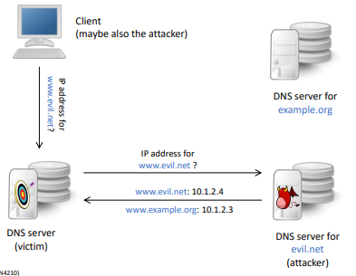
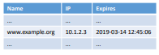

Attack result:
- Legitimate DNS server stores (wrong) IP address for example.org until the TTL has expired
- DNS request for example.org to this DNS server returns the wrong IP address
- Client accessed the attacker’s server
Countermeasure:
- DNS resolver accepts only responses for requested names + siblings (e.g., request example.org, response www.example.org)
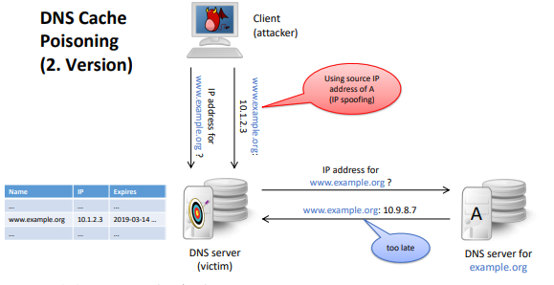

Countermeasure:
- Query ID
  - request and response must have same transaction ID

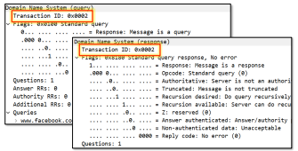

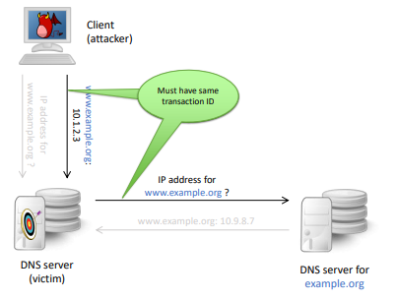
Countermeasure:
- Query ID
  - request and response must have same query ID
  - originally: ID is incremented for every request → easy to guess
  - nowadays (since 2000): ID is chosen randomly
- Still attacks possible:
  - “just” 216 possibilities
  - However: rather slow procedure for the attacker:
- Send request
- Guess query ID + send response
- if wrong ID: authoritative response is in the cache
  - wait until cache has expired (between seconds and days)
  - back to 1

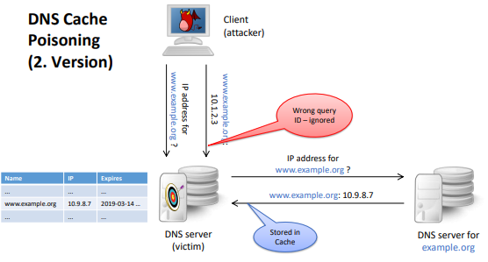

Dan Kaminsky attack (2008):
- Send request for non-existing hostname (e.g., pqz123.example.org)
- Guess query ID
- Send response for targeted hostname (e.g., www.example.org)
- If wrong ID: back to 1.
Effect:
- No storage in cache → high frequency of attacks
Countermeasure:
- Choose source UDP port randomly (before always port 53)
- Now: 232 possibilities for query ID + source port
- Attack harder, but still possible (e.g. distributed attack by botnet)

DNSSEC
- Domain Name System Security Extensions
- Goal: ensures authenticity and integrity of DNS records
- Basic idea: hierarchy of signed zones
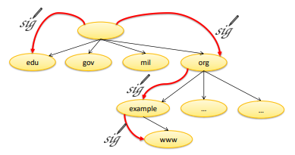

Defines new RR types:
- DNSKEY:
  - a public key
- DS:
  - reference to a key in a sub-zone
- RRSIG:
  - a digital signature
- NSEC, NSEC3:
  - reference to „next“ existing name

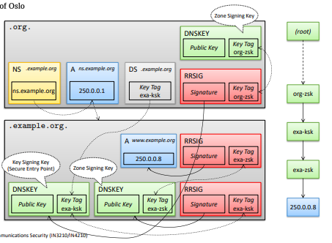

DNSSEC: NSEC
What about responses to non-existing names?
- Must also be secured!
- Signing „xyz does not exists“ during runtime too expensive
- Instead: signed chain of all existing name
- name1 → name2 → name4 → name5 → name1

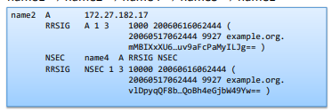

Example:
- Request: “name3”
- Response: “name2 → name4” (signed)
Problem:
- Adversary can gradually learn all host names (“zone walking”)

DNSSEC: NSEC3
- Calculating hash values of all existing names:
  - h(name1) = 5238
  - h(name2) = 1298
  - h(name4) = 3056
  - h(name5) = 2149
- Creating and signing an ordered list of hash values:
  - 1298 → 2149 → 3056 → 5238
- Request:
  - name3 (with h(name3) = 4578)
- Response: − 3056 → 5238 (signed; proves that 4578 (i.e. name3) does not exist, but does not reveal name2 or name4)

DNS Amplification Attack
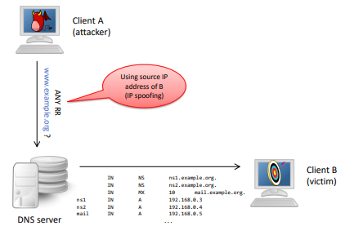

DNS Amplification Attack (DNSSEC)
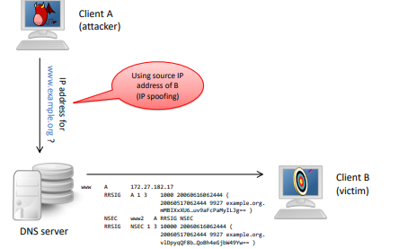

DNSSEC – Summary
Disadvantages:
- High complexity
- Large response messages
  - DNS amplification
  - TCP instead of UDP
- Still no browser support
- No confidentiality protection

Advantages:
- Stops DNS spoofing attacks
- Can be used as trust anchor for PKIs (DANE)

Security in DNS: Confidentiality
Privacy Concerns
- DNS messages are not protected from eavesdropping (even with DNSSEC!)
- DNS request are an easy way of tracking users (e.g., by the ISP or intelligence services)

DoH and DoT
Two protocols for adding confidentiality to DNS:
- DNS over HTTPS (DoH)
- DNS over TLS (DoT)
Creates a protected connection between DNS resolver and DNS server
DoH vs. DoT
- DoT uses service specific port (853)
  - might be filtered by firewall/attacker
- DoH uses standard HTTPS port (443)
  - usually, no filtering
  - easy integration into existing Web server deployment
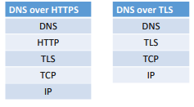

Problem: Not very widespread
Possible solution: using public (recursive) name server:
- 8.8.8.8 (Google)
- 1.1.1.1 (Cloudflare)
Remaining/new problems
- trust in DNS server required (even more data for Google?)
- no “local” DNS entries (e.g., company Intranet)
Also, a “problem”:
- No DNS blocking at the provider

Summary
DNS is the foundation of the Internet
Little built-in security in DNS
- Availability: distributed structure, primary/secondary nameserver, caching
Extensions:
- Integrity: DNSSEC → not widespread
- Authenticity: DNSSEC → not widespread
- Confidentiality: DOT/DOH → resolver still see requests
Future works:
- Oblivious DNS over HTTPS → ensures privacy of DNS requests

