Email Security
Message Transport System
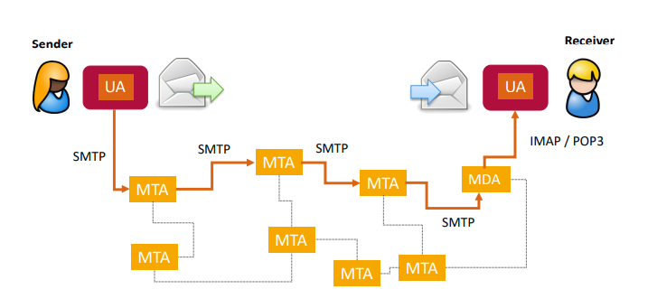
User Agent (UA)
- End user program for sending and receiving emails (e.g., Outlook, Thunderbird)
Message Transfer Agent (MTA)
- System for sending and receiving mail between systems
Mail Delivery Agent (MDA)
- System for delivering email to the end user (e.g., via IMAP or local delivery)
Email Structure (simplified)
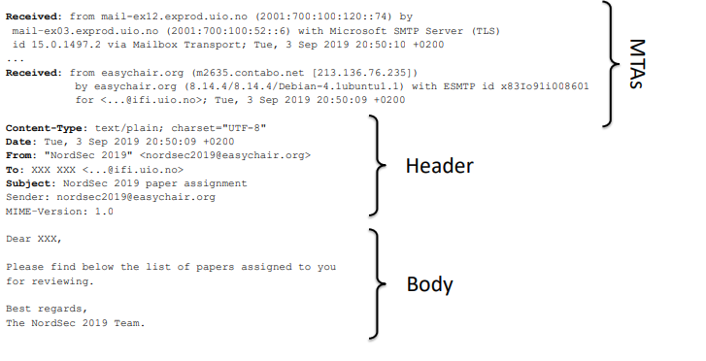

Full MTA Path
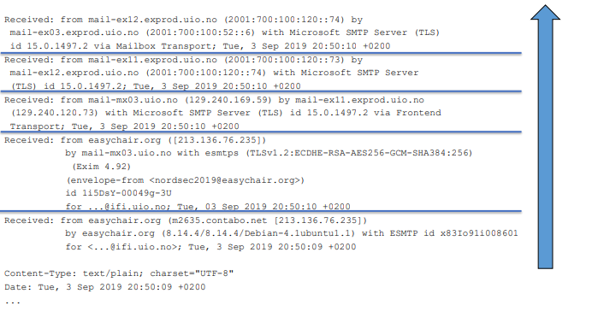
Email and DNS
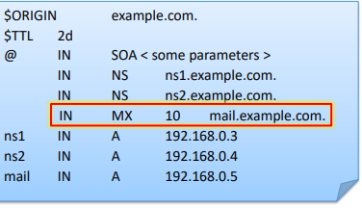
How does an MTA know the destination server?
Example:
- Mail address: john.doe@example.com
DNS contains a resource record for mail transfer: MX
Example:
- Domain: example.com
- DNS MX response:
  - mail.example.com

Email Protocols
Internet Message Access Protocol (IMAP)
- Protocol to access an email box (from multiple email clients)
- Standard ports:
  - IMAP: 143
  - IMAP over TLS: 993
- Has widely replaced the older POP3 protocol
Simple Mail Transfer Protocol (SMTP)
- Protocol for email transmission between UAs, MTAs and MDAs
- Standard ports: 25, 587 (for submission from clients)
- Secure transport typically not via SMTP over TLS, but opportunistic TLS

Example: SMTP
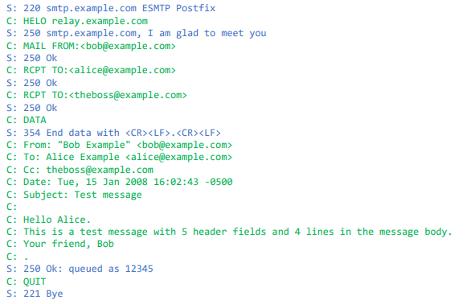

Extended SMTP (ESMTP)
Extends the original standard with several features, e.g., authentication, Unicode encoding, secure transport
Example (STARTTLS):
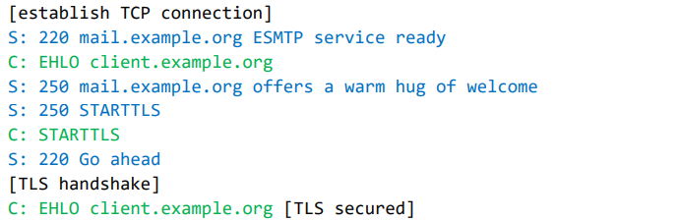
Multipurpose Internet Mail Extensions (MIME)
The original email standard only permitted 7-bit US ASCII text
Thus, no:
- special characters from non-English languages (e.g., ü, æ, ç, ω, ж)
- binary data (e.g., graphics, audio)
MIME allows definition of:
- content types (e.g., text, PNG, html)
- content encoding, e.g.,
  - base64: use Base64 encoding
  - quoted-printable: non-ASCII characters are replaced by hex value
  - 8bit: no encoding, direct transmission (only in newer implementation)
MIME additionally allows transport of multiple message parts

Example:
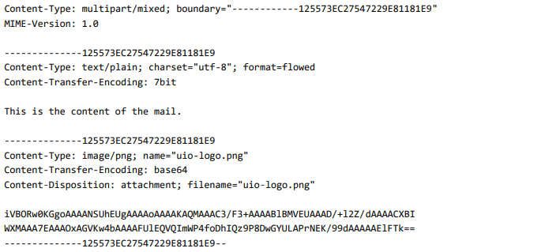
Security Issues and Countermeasures
Security Issues of Emails
- Phishing
  - Draw confidential information from victim (e.g., passwords)
- Privacy breach
  - Sender wants to track email recipients
- SPAM
  - Unwanted emails (e.g., advertisement)
- Eavesdropping
  - Disclosure of email content on servers or during transport between servers
- Spoofing
  - Faking sender identity
- Malware
  - Infiltrating malicious programs into recipient’s computer
- Fraud
  - Contact medium for deception (e.g., financial fraud)
Phishing
Phishing = „Password Fishing“
- Victim receives email with link to fake Web site and clicks link
- Victim enters confidential data (e.g., passwords) assuming he is on a trusted Web site
- Attacker misuses the entered data
The tricks …
- Sending mass emails is very easy and cheap
- Sender addresses in emails are not authenticated
- Creating Web sites and mails impersonating a trusted source is easy
- Hyperlinks to fake Web sites can be hidden in HTML mails

Phishing Emails – UiO
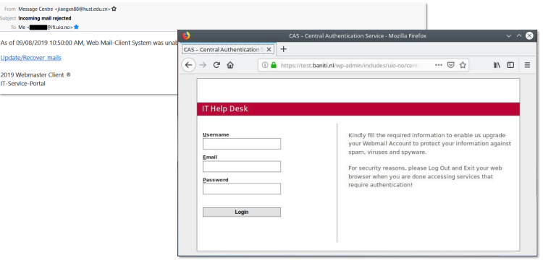

Phishing URLs (1)
Attacker uses his own domain name, e.g.: http://www.evil.net/login/
Other possibility:
- generic DNS name (e.g., host.1234.provider.net)
- IP address
Disadvantage:
- Easily detectable for the victim

Phishing URLs (2)
Attacker uses his own domain name, but disguises it with a clever sub domain, e.g.: http://www.online-bank.com.login.evil.net/
Advantage:
- Simple realization
- Harder detectable for the victim
Disadvantage:
- Most modern browsers highlight the domain and simplify detection of this URL spoofing

Phishing URLs (3)
The attacker registers a domain like the original domain, e.g.: http://www.online-bonk.com/login/
Advantage:
- Very hard to detect for the victim
Disadvantage:
- Higher effort (compared to the previous approaches)

Phishing URLs (4)
The attacker registers a domain looking like the original domain, e.g.: http://www.online-bаnk.com/login/
Advantage:
- Very hard to detect for the victim
Disadvantage:
- Higher effort (compared to the previous approaches)
- Not possible with modern browsers (see below)
Some browsers encode non-ASCII characters in “puny code”:

Phishing URLs (5)
The attacker uses the original domain: http://www.online-bank.com/login/
Advantage:
- Detection is impossible for the victim
Disadvantage:
- Requires DNS spoofing attack (see DNS chapter) → very high effort

Phishing – Countermeasures
Some mail programs check for suspicious content
- Example: Masking actual Web address
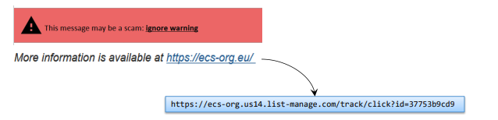
Observation of To and From addresses (but can be spoofed)
Careful observation of Web addresses (plus usage of TLS)
Most important countermeasure: use of common sense!

Email Tracking
The sender might want to know: has the recipient received/read the email?
Possibility 1: explicit request + receipt
- user must confirm mail receipt for finishing a business process
- hardly used any more
Possibility 2: implicit tracking (mainly for SPAM or phishing)
- does the email address exist?
- does the email bypass SPAM filters?
- is the recipient viewing the mail (or deleting it)?

Email Tracking: Images
- Many newsletters contain HTML content:

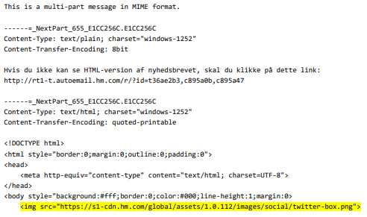

Mail program receives email in HTML format
HTML document contains image tags (located on Web server of the mail sender) − e.g.:
Mail program downloads the images for rendering the HTML mail
Web server owner (= mail sender) logs the request and can analyze the URL

Email Tracking: Countermeasures
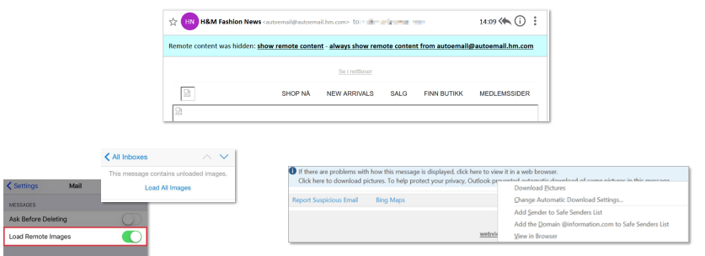
SPAM
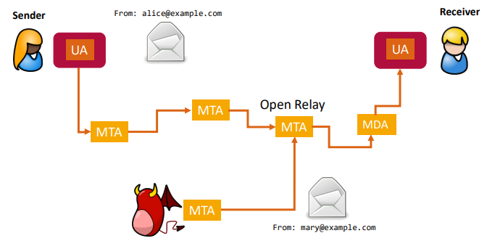
Message Transport System (original)
Message Transport System (nowadays)
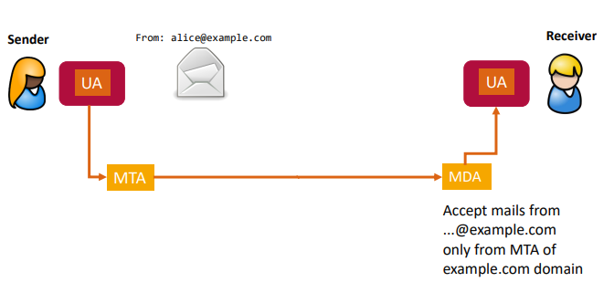
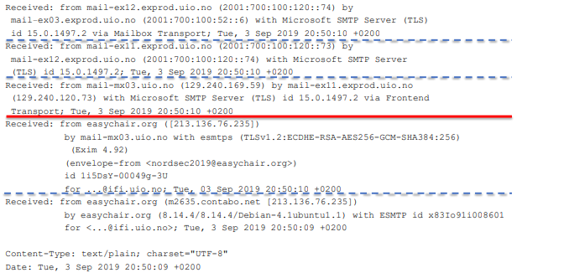
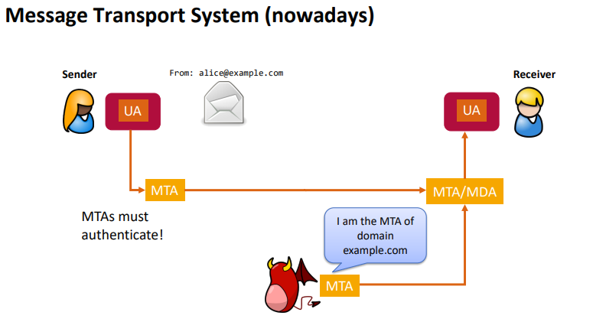
Sender Policy Framework (SPF)
Every domain defines a list of allowed sending MTAs
The list is published in the domain’s DNS
Receiving MTA checks if the sending MTA is on the SPF list
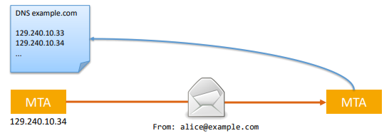

SPF Example: UiO
SPF record of uio.no (stored as TXT resource record in DNS):
v=spf1 mx ip4:129.240.10.0/25 ip6:2001:700:100:10::/64 ip6:2001:700:100:8210::/64 include:spf.uio.no ?all
Envelope of email sent from UiO address:
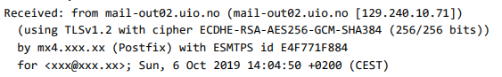

Receiving MTA has checked SPF (result also included in mail header):
Authentication-Results: mx4.xxx.xx;
spf=pass (mx4.xxx.xx: domain of xxx@uio.no designates 129.240.10.71
as permitted sender)

DomainKeys Identified Mail (DKIM)
Sending MTA digitally signs (parts of) outgoing emails
The corresponding public key is published in the domain’s DNS
Receiving MTA downloads the public key and verify the signature
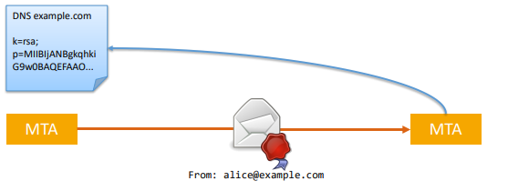

DKIM Example: Google Mail
DKIM record of Google Mail:
k=rsa; p=MIIBIjAN...YRJQqR" "tqEgSiJ+...DA/QAB
Envelope sent from Google Mail addresse:
DKIM-Signature: v=1; a=rsa-sha256; c=relaxed/relaxed;
d=gmail.com; s=20161025;
h=mime-version:from:date:message-id:subject:to; bh=OdI9XMdK6yLSftJKNtdmXt6Wt+JqJWNfaLu0qvcMd98=;
b=TbjoDJda8/UX3 ... Afy3Yqlg/==
Receiving MTA has checked DKIM signature (result also included in mail header):
Authentication-Results: mx4.xxx.xx;
dkim=pass header.d=gmail.com header.s=20161025 header.b=TbjoDJda;

Domain-based Message Authentication, Reporting and Conformance (DMARC)
Sending MTA specifies if it supports DKIM and/or SPF and what shall happen in case on of the checks fail
Additionally, DMARC forces the “alignment” of mail address domain and authenticated domain
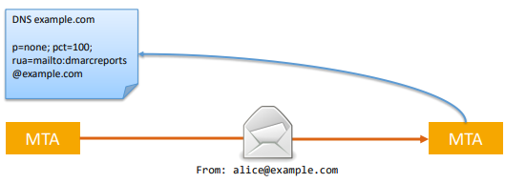

Still possible to sent SPAM:
- Register domain for SPAM purpose
- Sloppy configuration of mail servers
- Sending emails via botnets
Further SPAM detection mechanisms:
- Block- / allow-lists of email domains (e.g., dnswl.org)
- Inspection of email content (rule based or using machine learning):
  - typical ad keywords
  - suspicious formatting (e.g., white text on white background, using encoding to hide content)
  - suspicious attachments

Most SPAM detection systems calculate a “SPAM score” using a bonus/malus system (based on the mechanisms presented before)
If the total score exceeds a threshold  probably SPAM
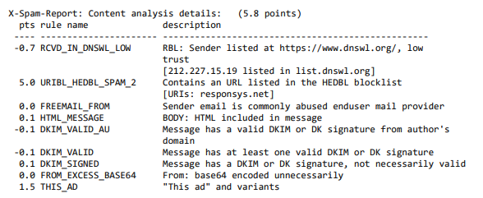

S/MIME
Method for encrypting and digital signing email content by the sender
Advantages:
- End-to-end integrity, authenticity and confidentiality
- Supported by most email clients
Disadvantages:
- “Official” certificate required
- Identification to the CA much more complicated then in the Web
- Key management: private key must be installed on all email devices
- Email header (e.g., From and To) are readable
Current state:
- Just used in some enterprises or universities (with own CA)

Pretty Good Privacy (PGP)
Method for encrypting and digital signing
Used for software integrity (signature) and email security
Trust model (no “official” CA certificate required):
- Direct trust (requires careful check of received certificate) → everyone can sign a trusted certificate and (re-)publish it
- Web of trust: if there exists a path of direct trust to a certificate you can also trust it (indirect trust)
Advantage:
- No identification to CA required

Disadvantages:
- Not (natively) supported by major email clients
- Complex key management (“Whom shall I trust?”)
- Many cryptographic and implementation flaws (e.g., EFAIL)
- Publication of certificate with huge number of signatures offers a possibility for DoS attack on PGP clients
Current state:
- For email security just in used in small communities

Malware
- Email is still the main infection source for malware
- Example: Locky
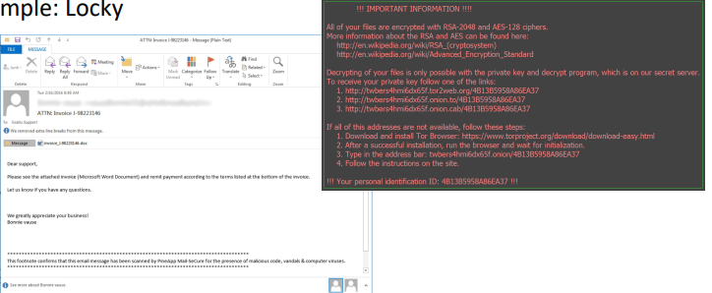
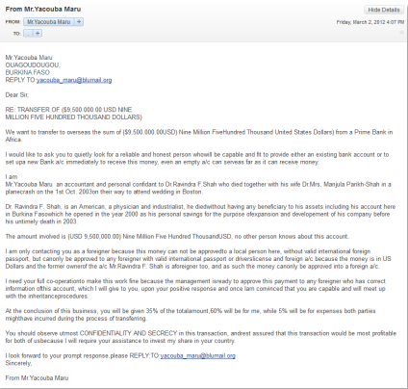
Fraud
Famous example

Summary
The email system has many security issues
Typical security mechanisms:
- Confidentiality, integrity:
  - MTA to MTA: TLS
  - End to end: (practically) nothing
- Authenticity:
  - MTA to MTA: DKIM, SPF
  - End to end: (practically) nothing
- Availability: SPAM detection (+ MTA authentication)
- Trustworthy content:
  - Backend: Virus detection (e.g., email sandboxing)
  - Client: URL inspection
  - User: common sense

