Symmetric encryption
Terminology
Cryptology
- Cryptography – Study of encryption principles/methods
- Cryptoanalysis – study of principles/methods of recovering key or deciphering cipher-text without knowing the key
- plain-text (P) - original message/data
- cipher-text (c) - coded message/data
- cipher - algorithm for transforming plain text to cipher text or vice versa
- key (K)– info used in cipher known only to sender/receiver
- encipher (encrypt) (E) – converting plain text to cipher text
- decipher (decrypt) (D) – recovering plain text from cipher text

Main cryptographic cipher types
Symmetric – one key i.e shared secret key (stream, block)
Asymmetric – two keys I.e public /private key

Model of symmetric cryptosystem (I.e the sender and receiver share a secret key)

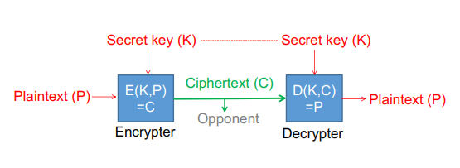
The secret key must be distributed over a secure channel while the encryption algorithm is assumed to be publicly known

The one time pad (the vernam cipher)
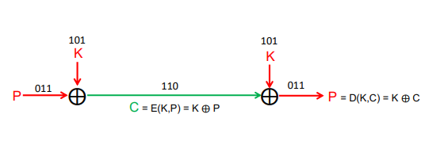
Advantage: Provides perfect secrecy (and is fast)
Disadvantage: Requires a random one-time key as long as the plain-text
(⨁ is the exclusive OR, operator) (e.g., 0⨁0=0, 0⨁1=1, 1⨁1=0)

Perfect secrecy: The cipher-text provides no information about the plain-text (except its maximum length), even if trying all possible keys.

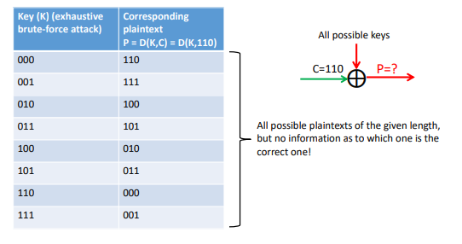
If the key is reused, the one time pad no longer provides perfect secrecy
- C1 and C2 encrypted using the same key:
- C1 ⨁ C2 = (K ⨁ P1) ⨁ (K ⨁ P2) = P1 ⨁ P2
E.g., given known plain-text P1:
C1 ⨁ C2 ⨁ P1 = P1 ⨁ P2 ⨁ P1 = P2

The one-time pad does not provide integrity/authenticity
If we know that the plain-text starts with a 0, how can we manipulate the cipher-text so that the decrypted plain-text starts with a 1?
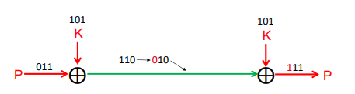

D(K, C ⨁ i) = P ⨁ i (i.e., changes to C are not detected and results in predictable changes to P)
The general lesson: a cipher only providing confidentiality does not provide integrity/authenticity

Notions of cryptographic security
Unconditional security – The system cannot be broken even with infinite computational resources. E.g the one time pad (confidentiality)
Computational security – It is impossible to break the system in practice due to the computational resources required by the best known algorithms for breaking the system. E.g symmetric ciphers such as AES or ChaCha20
Provable security – Breaking the system is equivalent to solving a difficult problem (e.g factoring of large numbers, discrete logarithm). E.g symmetric ciphers such as RSA (factoring)
Stream ciphers use pseudo-random number generators to generate a keystream that is XORed with the plain-text/cipher text

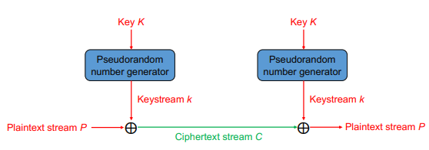
Stream ciphers can be realized using a block cipher in a stream mode or by dedicated stream ciphers (e.g ChaCha20)

RC4
RC4 is a variable key-size (1-256 bytes/2+48 bits), byte-oriented stream cipher making use of a permutation of all 8-bit values
Designed to be efficient to implement in software (as opposed to traditional stream ciphers intended to be implemented in HW)
Has been widely used, including:
SSL/TLS
- No longer recommended after attack demonstrated in 2013
- Enabled by biases in the start of the RC4 keystream
- The attack was not very practical but
WEP/WPA
- The attack on TLS with RC4 also applies to WPA/TKIP
- The vulnerabilities in WEP were not due to RC4 itself, but the way it was used
Should not be used in new systems
RC4 initialization
- Start with a key K of length ≤ 256:
for i = 0 to 255 do
S[i] = i
T[i] = K[i mod keylength] (S = 0, 1, 2, 3 ......, 255 e.g., K=2, 5 then T= 2, 5, 2, 5, 2 , 5,....)
S is now initialized with all numbers from 0-255. T is initialized with K (where K is
repeated if necessary to generate T of length 256).
- Use T to shuffle S:
j = 0
for i = 0 to 255 do
j = (j + S[i] + T[i]) mod 256
swap(S[i], S[j])
- S forms the internal state of the cipher

RC4 keystream generation – encryption/decryption
For each byte plain-text/cipher-text: shuffle S and generate keystream value that is XORed with plain-text/cipher-text byte:
i = j = 0
for each plaintext byte Pi do
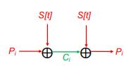
i = (i + 1) (mod 256)
j = (j + S[i]) (mod 256)
swap(S[i], S[j])
t = (S[i] + S[j]) (mod 256)
Ci = Pi ⨁ S[t] (Decryption: Pi = Ci ⨁ S[t] )

ChaCha20 stream cipher
ChaCha20 is a variation of Salsa20 that completed the final phase of Estream in 2008.
Designed to be fast when implemented in software
Faster than AES when AES is not supported in hardware
Successively calls a round function with increasing block counter:
- 20 rounds (I.e 80 quarter rounds) before the original input is added to the current state to produce a block of keystream
- Quarter round function: addition, XOR and roll/shift
- Alters between column and diagonal rounds where each quarter round takes one column or diagonal as input
ChaCha20-Poly1305 is an Authenticated Encryption with Associated Data (AEAD), e.g., supported in TLS 1.3 and QUIC

Small deviation or wrong assumptions can cause insecurity
Unless message authentication is used, stream ciphers do not provide integrity/authenticity:
- Remember the example with the OTP, stream ciphers are the same
- Lesson: only depend on a cryptographic mechanism for it intended purposes
A stream cipher is insecure if the same keystream is used twice
- Again, see the example with the OTP
- Reuse of the keystream may also happen for instance due to using the same key for encrypting traffic in both directions or because some type of counter wraps around
- Lesson: only use keys for their intended purpose and duration
The keystream must be completely unpredictable (without the key)

Random numbers
Many applications of random numbers in cryptography and security (e.g key generations key streams ..)
Critical that these values are statistically random (uniform distribution and independence) and that future values are unpredictable
- improper random number generation is a common source of security vulnerabilities
Often use a pseudo-random number generator (PRNG)
- Deterministic sequence of outputs, given a seed (e.g the secret key) as input
- Such pseudo-random numbers are not truly random but can pass many tests of randomness
- May be based on e.g symmetric/asymmetric ciphers or hash functions

Block ciphers
Symmetric block ciphers maps a fixed size input block to a fixed size output block
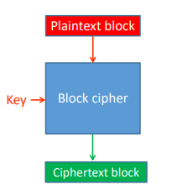
Block size: Number of bits taken as input/output at a time
- AES: 128 bits
Key size: Larger keys are more secure but may reduce speed
- AES: 128, 192, or 256 bits
Block ciphers can be used in different modes of operatioons

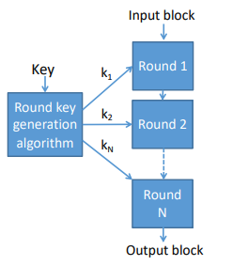
Block ciphers typically iterate a weaker round functions
The key is explanded into a sequence of round keys
AES-128: 10 rounds
AES-192: 12 rounds
AES-256: 14 rounds
Advanced Encryption Standard (AES) uses the Rjindael block cipher
Rijndael was developed by Belgium cryptographers Joan Daemen and Vincent
AES-128
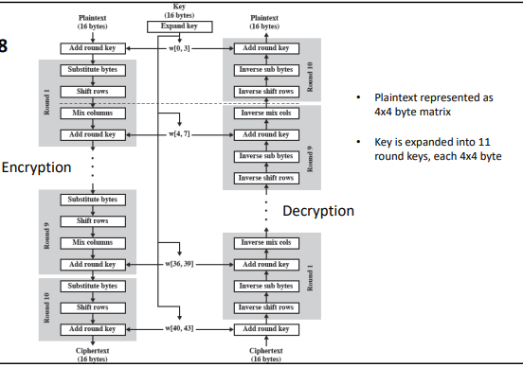

Rijndael/AES round function uses four invertible operations
Byte-by-Byte substitution based on table (S-box)
permutation performed by rotating row by row
Substitution altering each byte in a column based on all the bytes in the column
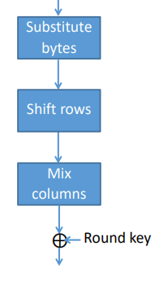
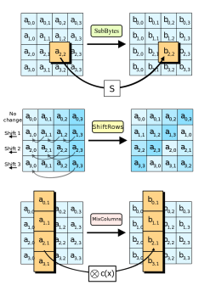

AES instruction Set and Intel’s AES-NI
- Extension to x86 instruction set providing hardware support for AES
- Provided by intel, AMD and others
- Used by many libraries and applications

Block cipher Modes of Operation specifies how to use symmetric block ciphers for practical applications
NIST SP 800-38A specifies five modes of operation:
- EXB
- CBC
- CFB
- OFB
- CTR
Sps 800-38 B – G specifies additional modes of operation, including authenticated encryption modes such as GCM and modes intended for storage encryption

Using Electronic Codebook (ECB), mode, each block is encrypted/decrypted independently
Identical plain-text blocks (encrypted with the same key) result in identical cipher-text blocks – may be insecure
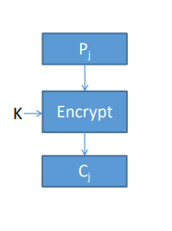
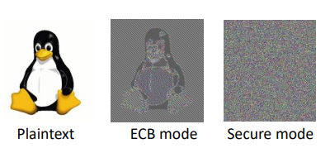

Cipher Block Chaining (CBC) mode
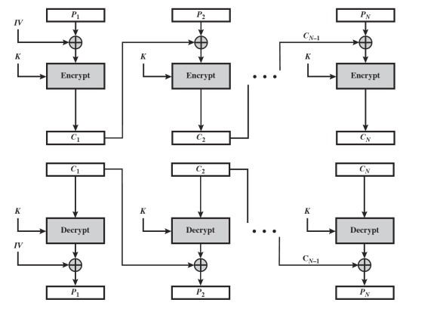

- The IV must be unpredictable (but does not need to be secret)
- Does not provide integrity/authenticity
- Correct decryption depends on correct receipt of the corresponding and previous cipher-text block
- Can not be parallelized well (decryption can to some extent)
- Needs to pad last block if the plain-text is not a multiple of the block size (can be avoided using cipher-text stealing)

Counter (CTR) mode (stream mode)

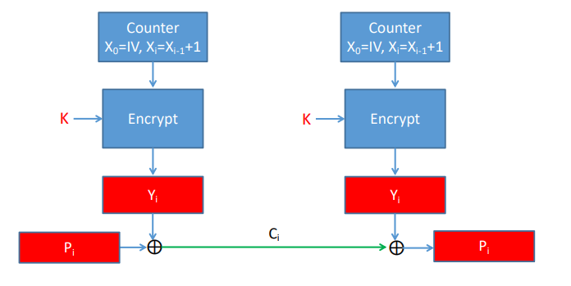
Hardware and software efficiency:
- Encryption/decryption can be done in parallel
- Preprocessing – The underlying encryption algorithm does not depend on plain-text or cipher-text input
Random access to cipher-text/plain-text blocks
Only required implementation of the encryption algorithm and not the decryption algorithm
Does not provide integrity protection

Galois/Counter Mode (GCM)
Uses a variation of CTR mode encryption for confidentiality and a keyed hash function (GMAC) to create the authentication tag
Mode of operation that combines encryption and authentication (I.e authenticated encryption with associated data)
To be used with 128-but block cipher – the “typical mode” used with AES (used in e.g TLS and Ipsec)

Output Feedback mode (OFB)
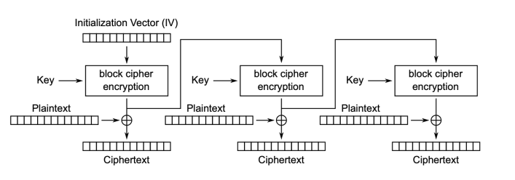
Decryption is the same as encryption, using the ciphertext (instead of the plaintext) as input

Attacks on (symmetric) cryptosystems
Brute-force attack
- On average half the number of possible keys must be tried
- Must be able to recognize valid plaintext
- Mitigated by sufficient key length
Cryptanalysis
- Weaknesses may result in much less resources/effort being required than for brute-force attack
Attacks on implementation
- E.g side channel attacks based on variations in power consumption, timing or emanation

Attacks o key management or the environment
- E.g curcumbventing encryption by exploiting vulnerabilities in the end.user operating system

Cryptanalytic attacks
- Ciphertext only – only know algorithm and ciphertext
- Known plaintext – knows/suspect plaintext and ciphertext
- Chosen plaintext – attacker select plaintext and obtain the corresponding ciphertext
- Chosen ciphertext – attacker select ciphertext and obtain the corresponding plaintext

Relative Illustration of Average Time Required for Exhaustive Key Search
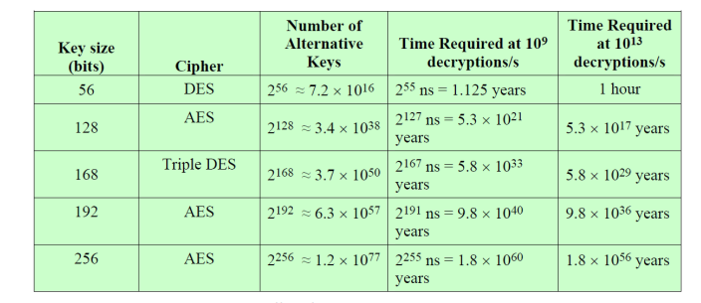
Using a meet in the middle attack the effort for 3DES can be reuced to 112 bits
Given successful quantum computers, the symmetric key size must be about doubled to achieve the same security (Grover’s algorithm)

