Key management and entity authentication: kerberos
Key management includes creation, storage, distribution, usage, and destruction of cryptographic keys
Creation:

- By key owner(s) or third party
- Randomness is critical for the security of the key
Protection during storage and use:
- Hardware security module (HSM), smart card, USB security token, trusted platform module (TPM), operating system

- Password derived keys may simplify key distribution/storage, but typically results in weaker keys
- Need for key backup/recovery?
Destruction
- Secure deletion of the key when it is no longer needed
- Can delete (or remove) key to make data/device unavailable/unusable

The challenge of key distribution
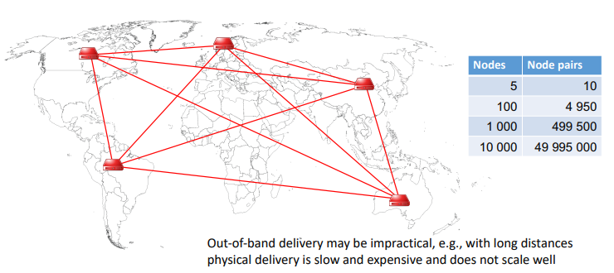
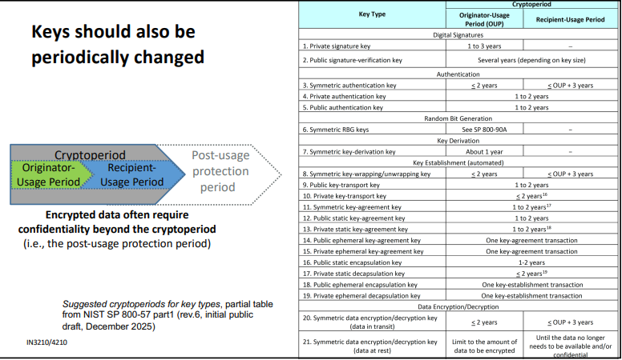

Key distribution can be achieved in several ways
Physical or out of band delivery by other means
A new key may be encrypted using an existing shared key
- Requires an existing shared key and the compromise of one key could compromise all following keys
A new key may be established using asymmetric cryptography, e.g encrypting the new key using the receiver’s public key or using authenticated Diffie Hellman key exchanger
- Must be able to verify the authenticity of the receivers public key (e.g using a PKI)
- Ephemeral Diffie Hellman provides Perfect Forward Secrecy
If both have a secure channel to a trusted third party, this third party could deliver a key to both
- A key Distribution Center (KDC) may constitute this trusted third party
Basic idea of a Key Distribution Center (KDC): Alice wants to communicate with Bob, but they don’t share a secret key, instead each share a secret key with a trusted KDC
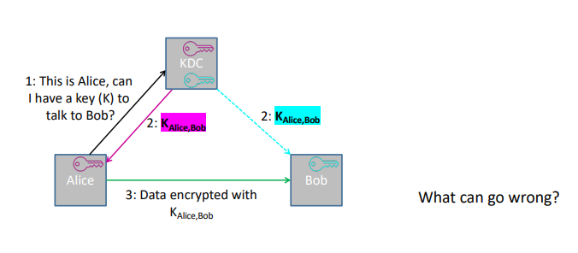
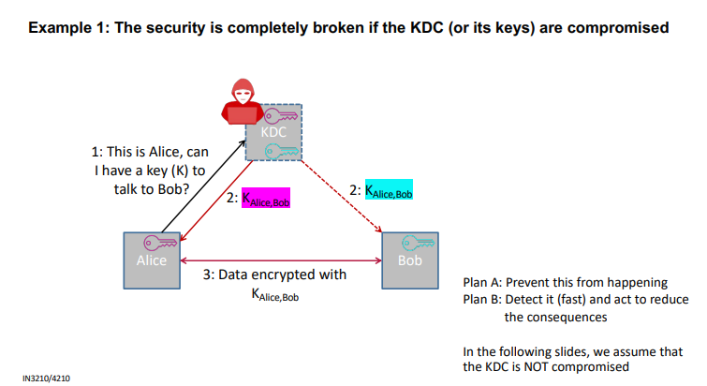

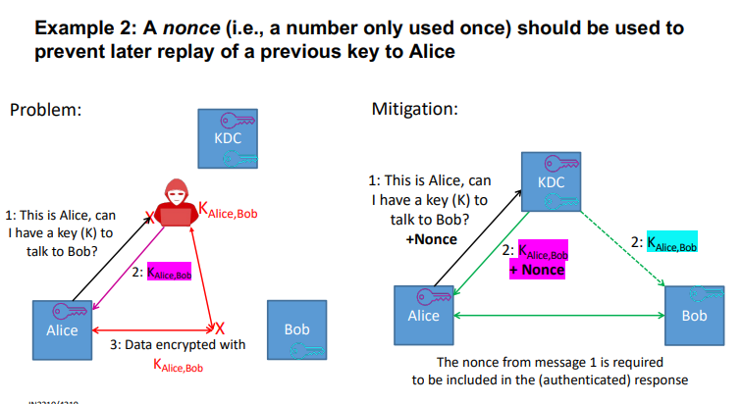
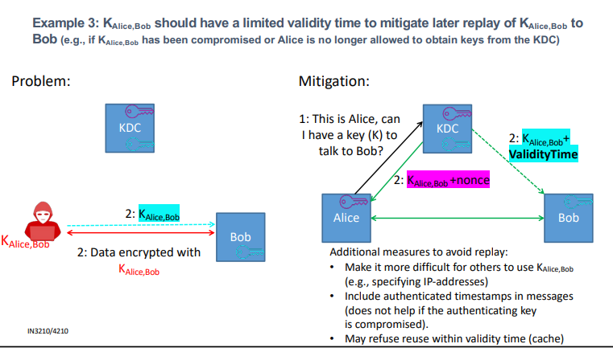

Kerberos protocol
Kerberos provides entity (e.g user or service) authentication and key distribution using KDC approach
Based on symmetric cryptography (public key extensions are available)
Supported by many products
- E.g default authentication protocol in Windows domains
Kerberos itself does not enforce authorization, but many provide a basis to do so (e.g privileged Attribute Certificate extension used in windows)

Kerberos is a third party authentication and key distribution scheme
Authentication Service/Server (AS)
- Users initially authenticate to AS
- AS issues Ticket Granting Ticket (TGT)
Ticket Granting Service/Server (TGS)
- Users use TGT to access TGS
- Users request TS for access to other services
- TGS issues (service granting) Ticket to be used to access requested service
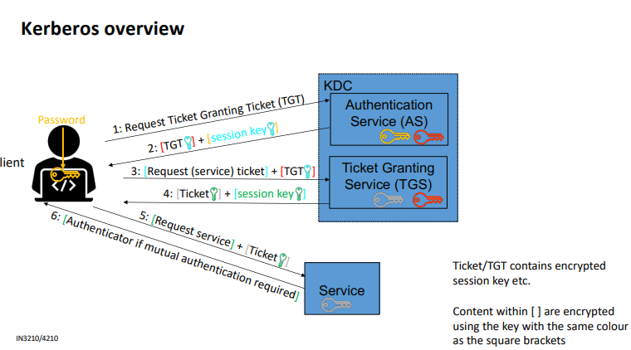
Often both services are provided by the same server

A Kerberos realm typically corresponds to one administrative domain and consists of the Kerberos KDC, clients and application services/servers
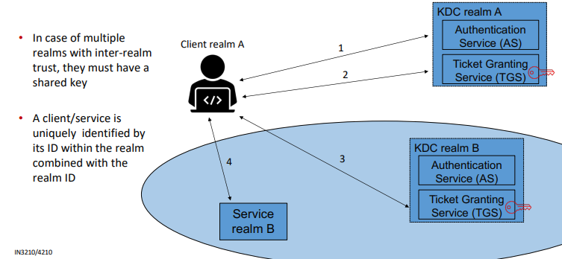
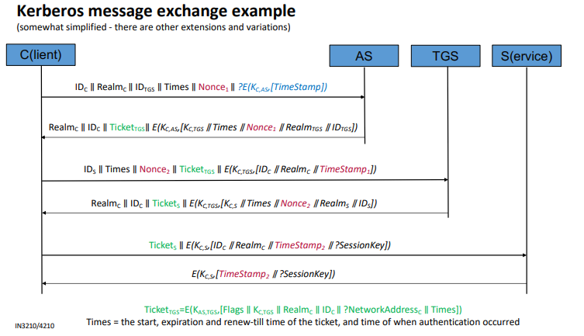

Delegation can be used to enable services to act on behalf of a principal (e.g user)
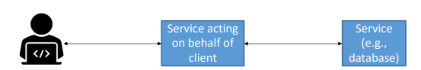
Proxy: The PROXIABLE flag tells the Ticket-granting server that it is OK to issue a new ticket (but not a TGT) with a different network address based on this TGT
- Set if requested by the client on initial authentication
- Can be used by client to allow a service to perform an operation on its behalf (I.e taking on the identity of the client)
- The use of the “proxy ticket” may be restricted to a particular purpose
Forwarded TGT: An instance of a proxy, but the FORWARDABLE flag tells the TGS that it is OK also to issue a new TGT with a different network address (enabling multi-hop delegation)
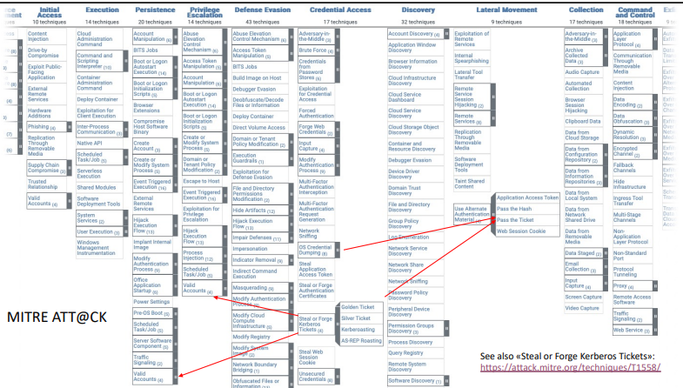
(Active Directory: Unconstrained, constrained and resource-based constrained delegation)

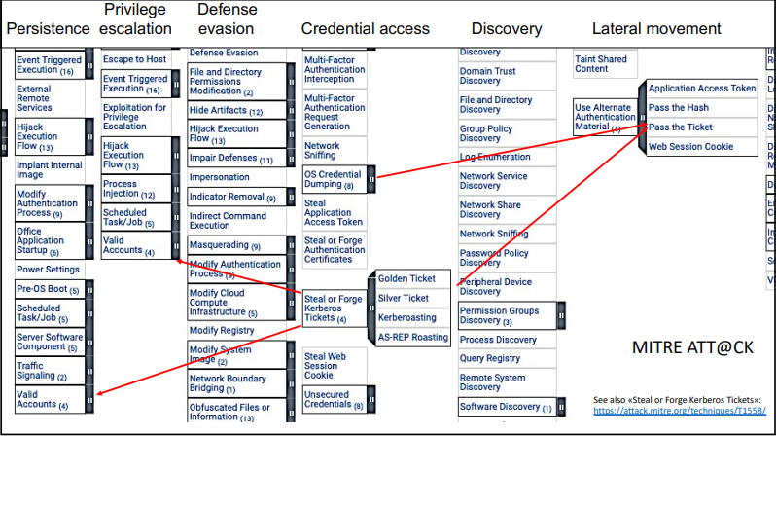
Some attacks on Kerberos
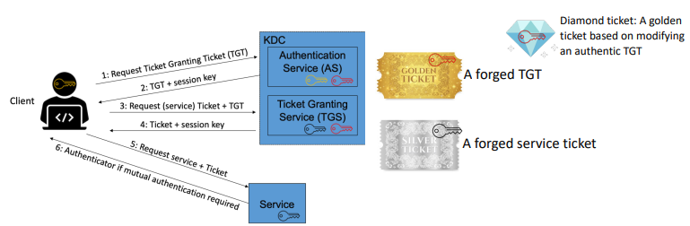
Need the correct key to forge tickets, e.g., Kerberoasting to obtain Service key or obtaining access to dump keys/hashes

Kerberoasting
Obtain service ticket for one or more services
- The TGS does not enforce service access control, so a user can obtain tickets for all services
Perform off-line dictionary/brute-force attack to recover password derived key (hash) of the account of the serviced
- Not practical if long random password is used (computer vs user accounts)
If successful, attacker may e.g create a silver ticket to access the service as someone else
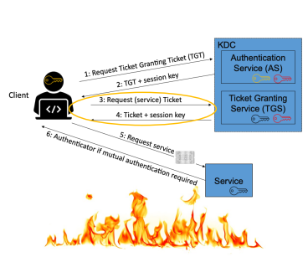

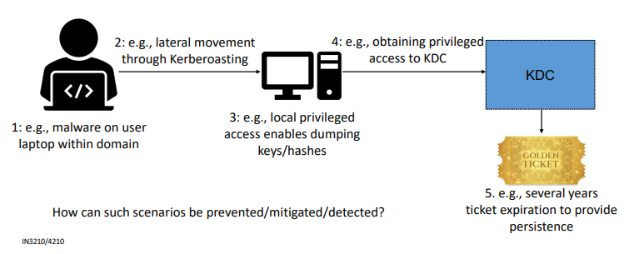
Kerberos attacks may enable lateral movement, persistence, and privilege escalation (simplified illustration)

