Technical information gathering
Technical information
Domain names of the target
Domain owners of the target
Domain registrant
Ip addresses associated with the target website
Ip ranges of the target
Ip range owners(s)
List of hosted website
Hosting companies

Domain names
A domain name is an identification string that defines a realm of administrative autonomy, authority or control within the internet
Example Aftenposten.no
Second level domain.topleveldomain

Domain names are formed by the rules and procedures of the domain Name System (DNS). Any name registered in the DNS is a domain name.
Top level domain can be (com, net, info, edu, org and country code) Second and third level domains can be any string. The full length of the domain cannot be longer than 255 characters.

Www.mn.uio.no
hostname.thirdlevel.secondlevel.TLD

A hostname is a domain name that has at least one associated IP addresses
The first domain was registered in 1985 (symbolics.com)
Domains are registered by the domain registrars that are accredited by the Internet Corporation for Assigned Names and Numbers (ICANN)
Each TLD is maintained and serviced technically by an administrative organization operating a registry (UNINETT Norid AS for .no)
All data has to be published and accessible with the whois protocol

Domain name registration data – whois (e.g who.is)
The whois database must contain the following information:
- Administrative contract
- Technical contact
- Billing contact
- Name servers

Nameservers are computers that provide subdomain information for that particular domain using the dns protocol

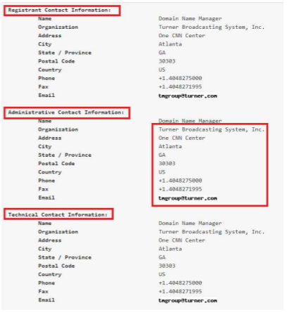

Unique name with country code (TLD)
Domain names belong to private individuals or companies
Everyone can register a domain (for trademarks there’s a priority)
A domain name is only the right to use a special string, it is not an ip and not a computer
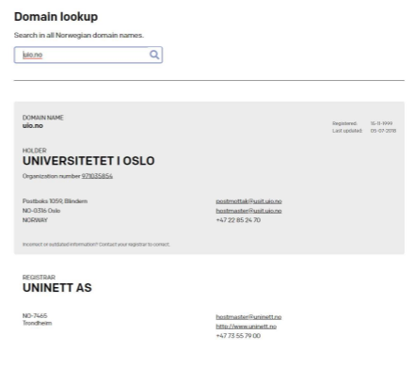

Domain name owner examples
Find the owner of the following domains:
- nrk.no
- dyreparken.no
- horsepro.no
Find a contact phone number for the following domains
- footish.se
- termesangiovanni.it
When is the expiration date of the following domains
- timeanddate.com
Domain name search
Example: find third level domains for uio.no!
Use the Google with the site: keyword
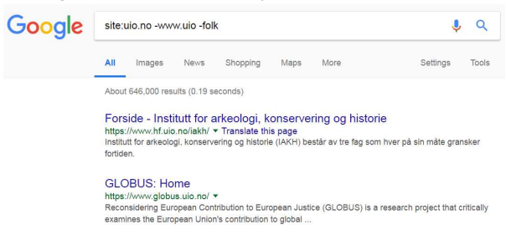
Example2: find third level domains for dn.no!
Domain name search – Netcraft
Finding domains with its owner
OS version detection
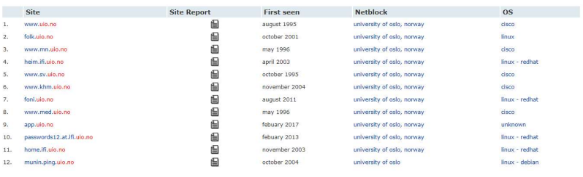

Domain name search – Pentest tools
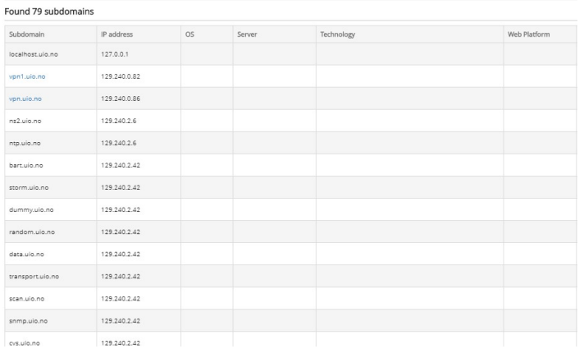
Domain name search - Dns dumpster
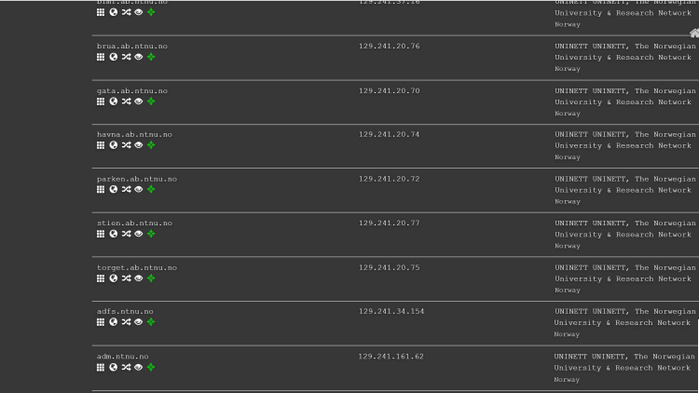
Domain name search – Certificate transparency logs
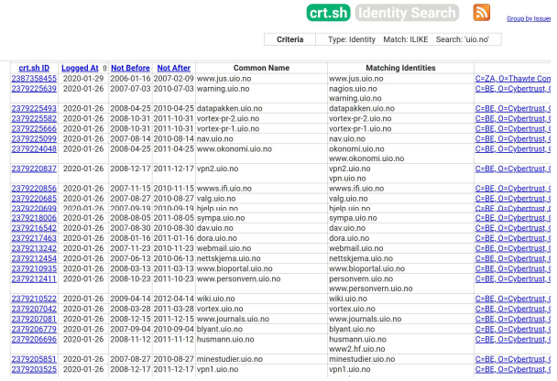

Ip addresses
IPv4: 32bit (2³² = 4 294 967 296 combinations)
IPv6: 128bit (2¹²⁸ = 3.4*10³⁸ combinations)

IP addresses are for the identification of computers during the communication (OSI 3rd layer)
In order to be easy to memorize it, 8 bit (byte) blocks are used for IPv4 e.g 129.240.171.52
For IPv6 addresses are represented as eight groups of four hexadecimal digits e.g 2001:0db8:0000:0042:0000:8a2e:0370:7334

IP ranges – classful networking
IP ranges contain more ip addresses e.g 129.240.171.56— 129.240.171.63 (8 addresses)
In 1981 the classfull networking was created. It consisted of the A, B and C class of network ranges
The idea was to divide the ip into network and subnet part
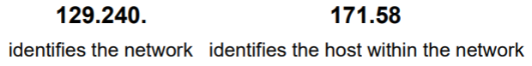
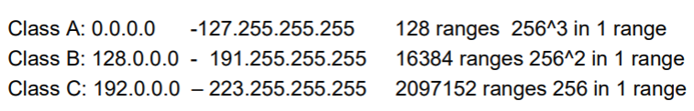
IP ranges: Classless interDomain Routing (CIDR)
CIDR was created in 1993
Network address length is arbitrary (not only 8, 16, 24 bits)
Examples
- 129.240.171.56 (10000001.11110000.10101011.00111000) – 129.240.171.63 (10000001.11110000.10101011.00111111)

The first 29 bits are fixed in the range, the last three can be anything within the network: CIDR: 129.240.171.56/29
130.18.0.0 (10000010.00010010.00000000.00000000) –
130.19.255.255 (10000010.00010011.11111111.11111111)
130.18.0.0/15

IP ranges CIDR – examples
What is the first and last address of the /23 network range that contains: 194.172.10.10?
What is the first and last address of the /18 network range that contains: 164.44.20.52?
How many addresses does a /25 network range have?

Domain to ip conversion (DNS service)
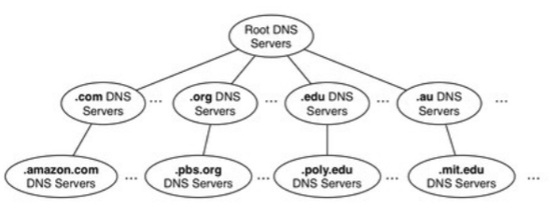
DNS servers are all around the world
Organized in tree structure (13 root servers)
The top level domains (.com, .net, .edu, .no, .de, etc) are directly under the root servers
DNS data are stored redundantly (master and slave server)

- Address mapping record (A)
- IP version 6 Address records (AAAA)
- Canonical Name records (CNAME)
- Host information records (HINFO)
- Mail exchanger record (MX)
- Name server records (NS)
- Reverse-lookup Pointer records (PTR)
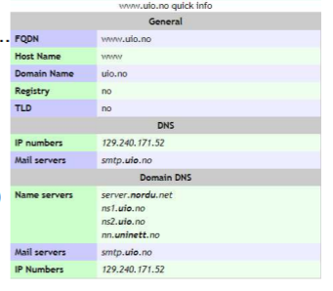
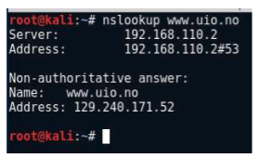

IP lookup with DNS – reverse ip lookup
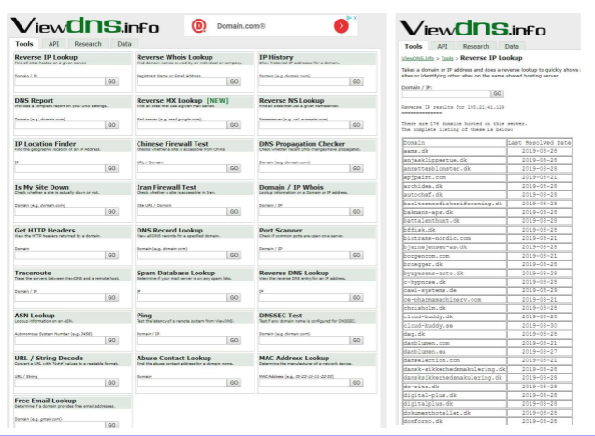

IP range owners
The whois protocol is also used to get the owner of a particular ip range
The records are stored in different databases according to the continents
The Norwegian entries are stored in the European database (RIPE NCC)
If we don’t know which database to use the general whois protocol helps us
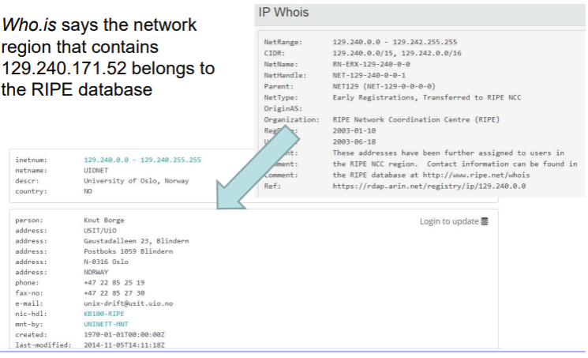
Network range examples
Who is the owner of the following ips and how big is the related network range?
- 5.44.65.150
- 195.88.55.16
- 188.44.50.103
- 198.62.101.225
- 172.65.90.18

Hosted websites – cloud services
In several cases a website is hosted. That means it is stored on a webserver
- That does not belong to the target organization
- Which can obtain several other websites
In those cases the webpage cannot be attacked or separate permission is needed form the owner of the server computer
Example: elektronikmesse.dk

Finding network ranges
Search for all domains including second and third level
Look for the corresponding ips
Check which database contains the ip owner (whois)
Check the ip ranges (ripe, arin, etc)
Check by AS number

ASN lookup
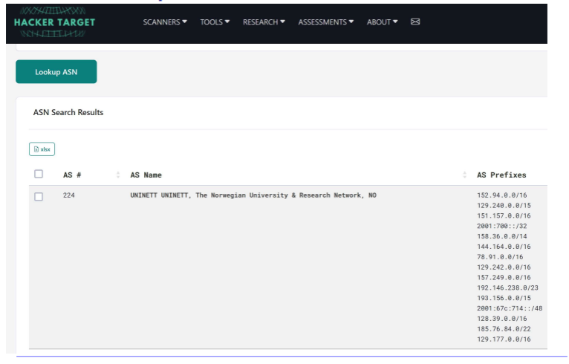
Finding network ranges examples
Practice: Find the network ranges of the owner of dn.no
Solution
Solution (demo)
- dn.no belongs to the DAGENS NÆRINGSLIV AS
- www.dn.no has the ip 87.238.54.132
- ripe ncc says it is a part of the network range: 87.238.54.128-143
- the owner of the range is the NHST media group
- dn.no has the following second level domains: s1,s2,s3,s4, arkiv, multimedia, investor, hotell, idn, ww5, sjakk, pad
- All the domains are associated with the same ip (87.238.54.132), except the pad.dn.no which is: 87.238.53.121, and the hosted websites (sjakk, )
- The pad.dn.no is in the range of 87.238.53.0-143

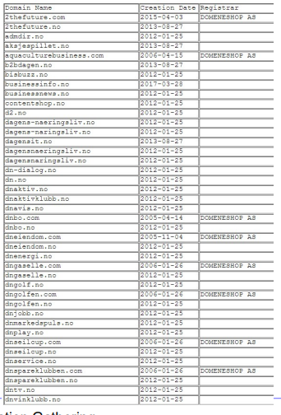
Finding network ranges –reverse whois
With the reverse whois service, we can search for domains by providing an
email or name.
For example more than 100 domains are associated with the email nhst.no
Finding the range: dnavis.no -> 87.238.54.132

Internal network ip address ranges
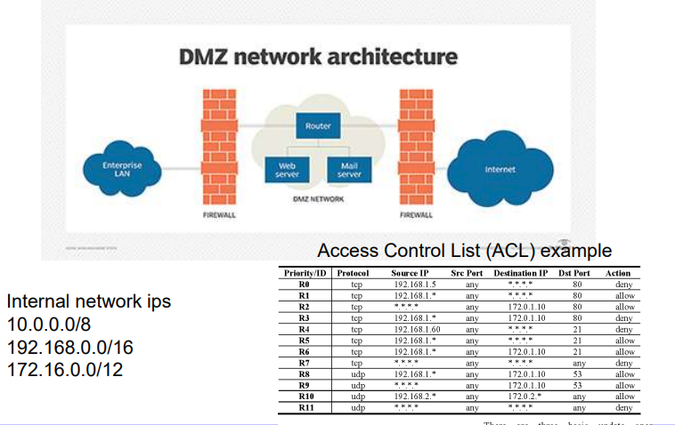
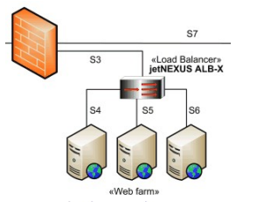
Domain to ip options
One domain to one ip
- A webserver with one website
Multiple domain to one ip
- A web server hosts multiple websites
One domain to multiple ip
- Load balancer, cloud service
Robtex
• Robtex is used for various kinds of research of IP numbers, Domain names, etc
Example: dn.no
It belongs to NHST Media Group AS
The network range is:
87.238.32.0/19
87.238.32.0-87.238.63.255
Who is Redpill Linpro?
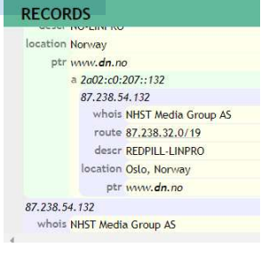

Robtex
DNS data is indicated
Subdomains, similar domains, domains with other TLD
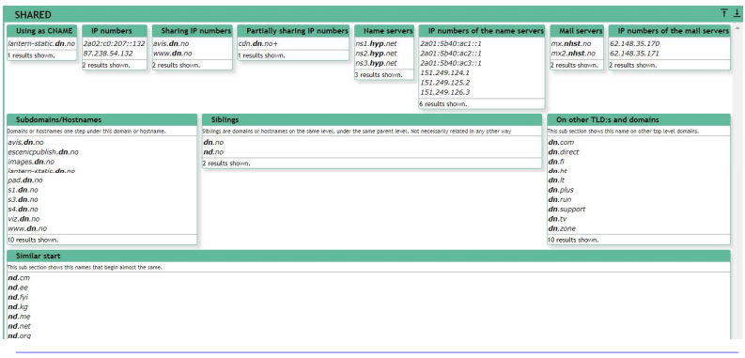

Robtex – graph view
It also presents a graph view of the target related ips and ranges
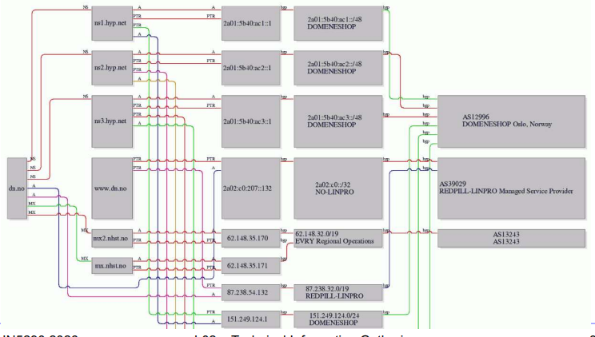
Shodan –IOT device finder
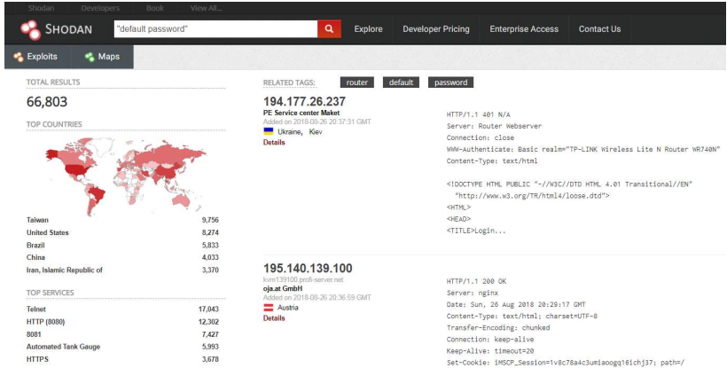
Types of computers in the network
- Server
- Network device (router, switch)
- Firewall (stateless, statefull), Ids, Ips
- Printers
- User desktops
- User laptops
- Mobil device

Network layout example 1.
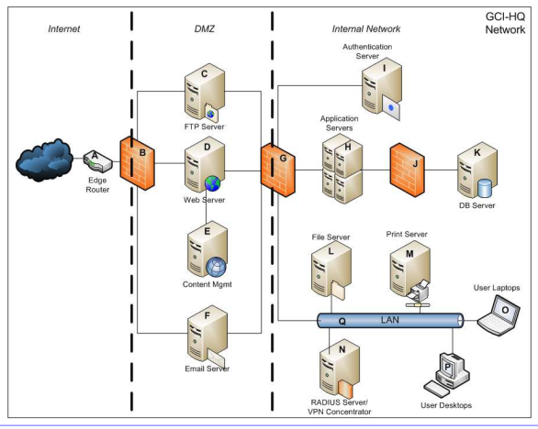

Network layout example 2.
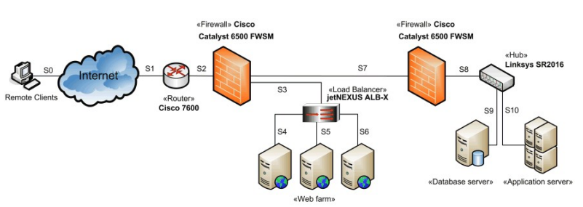
Network layout example 3.
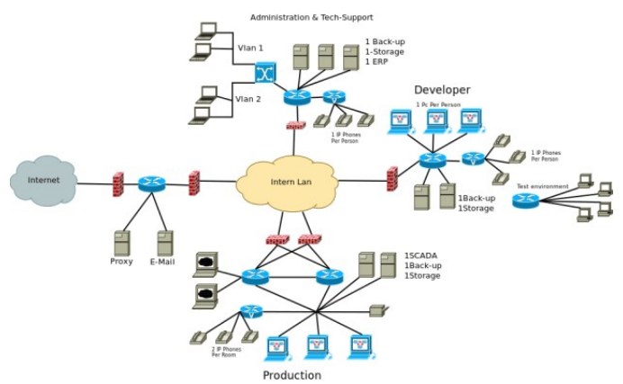

FOCA
Automatically identifies subdomains, servers, ips
- Websearch (google, bing)
- Fingerprinting
- DNS data
- IP Bing
- PTR search
- Shodan & Robtex
- Brute-forcing
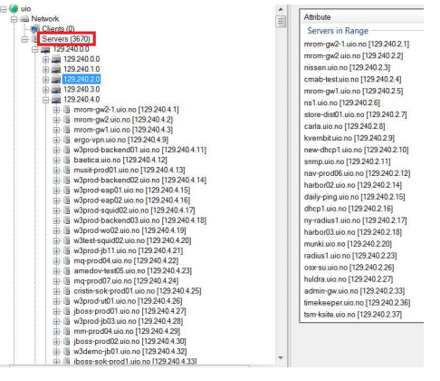

Maltego – Information gathering tool
