Get in touch with services
Where are we in the process of ethical hacking?
We have several general information about the target
We have the technical details (domains, ip ranges)
We mapped the target network and have an inventory (live hosts, responding services)
Whats next?
We try to compromise services
- Find a vulnerability
- Exploit the vulnerability

Reminder – network scanning positions
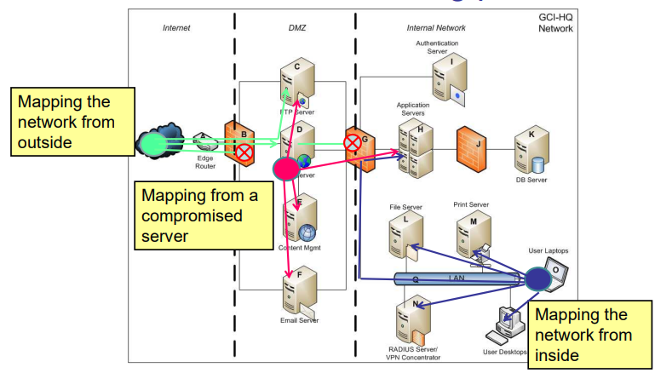

How to start compromising a service?
What kind of services do we have to face from outside?
Web, Ftp, ssh, dns, mail (SMTP, POP3, IMAP, Exchange), VPN and many others

Typical services inside:
Netbios, SMB, Printer, RDP, DB services, LDAP, etc.

What kind of errors (vulnerabilities) can we expect?
Configuration related errors
- Default credentials
- Easy to guess credentials (we had information gathering before)
- No or inappropriate protection against guessing (brute-force)
- Unnecessary function
- Privilege misconfiguartions
- Other configuration errors
Software vulnerability related error
- No input validation
- Memory handling errors

First use in the normal way
- Is there any information disclosure?
- Error messages etc
- Restriction
Force it to error and obtain information
- Provide invalid data
- Use it in an invalid way
Try factory defaults
Brute-forcing
Search for known exploits
Service specific exploitations
Unique ways

Factory defaults
Default credentials
– http://cirt.net
– http://phenoelit.org/dpl/dpl.html
– http://www.defaultpass

Brute-forcing
Trying out multiple combinations
How to generate the options?
- Random
- Trying out all combinations
- Using a list or dictionary

Brute-forcing tools
- THC hydra (ssh, ftp, http)
Hydra was created by a hacker group The Hacker’s choice. It is a universal brute-force tool that can be used for several protocols
- Ncrack
- Medusa

Service specific attacks
We cannot cover all services, but were going to focus on FTP
- SSH
- SMTP
- DNS
- Web

What is an exploit?
An exploit (from the English verb to exploit, meaning "to use something to one’s own advantage") is a piece of software, a chunk of data, or a sequence of commands that takes advantage of a bug or vulnerability to cause unintended or unanticipated behavior to occur on computer software, hardware, or something electronic (usually computerized). Such behavior frequently includes things like gaining control of a computer system, allowing privilege escalation, or a denial-of-service (DoS or related DDoS) attack

Attacking ftp service
The ftp server configuration file declares what is enabled
Example: vsftpd.conf file
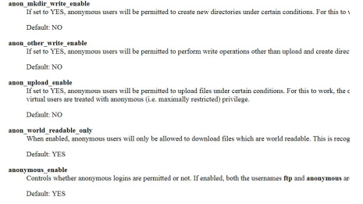

If anonymous is enabled, we can log in to see what we can do we can also brute-force the credentials or use exploits

Attacking ftp service: anonymous login
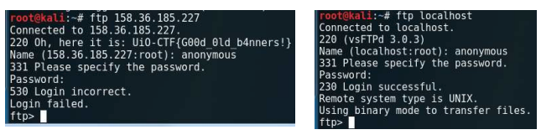
If anonymous login is enabled, anyone can log in (username: anonymous, password: arbitrary email)
anon_upload_enable, anon_other_write_enable settings are also important: e.g. if upload is enabled and the webroot is accessible attacking scripts can be uploaded

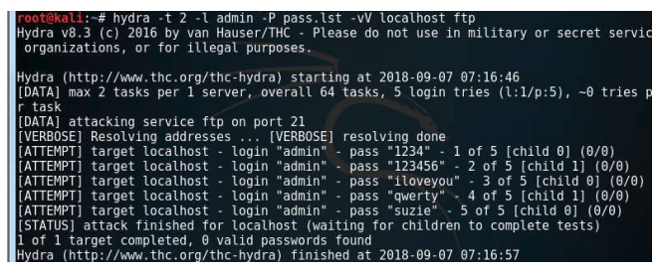
Attacking ftp service: brute-forcing with Hydra
-l for single user –L user list (the list has to be named after)
-p for single password –P password list (the list file has to be named after)
-t parallel tries (default 16)

Attacking ftp service: using exploits
The main exploit source is the exploit-db (http://exploit-db.com)
And of course the darkweb, if you have needless remaining crypto currencies ☺
(note that darkweb is not for Ethical Hackers!!!)
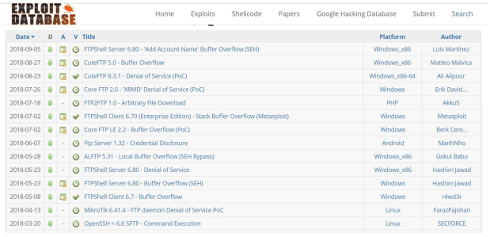

Example: FTPShell Client 6.7 - Buffer Overflow from May 2018
Theoretically it’s not necessary to understand what’s happening during the exploitation. The input has to
be generated with the provided python script and apply it against the vulnerable service.
Demo…
BUT! This exploit works only for that specific version with the same OS circumstances.
E.g. 0x00452eed has to contain a call esi instruction. Without understanding it you can’t customize it.
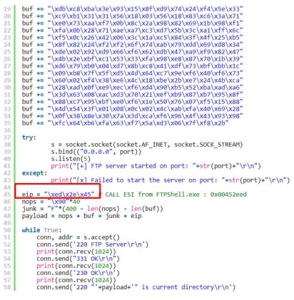

Attacking ssh service – brute force
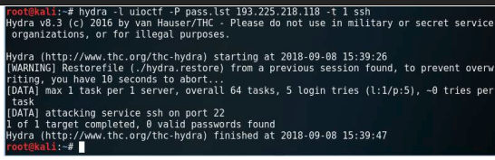
Without the valid password:

With the valid password:
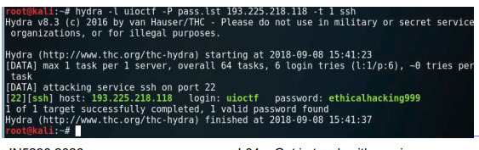
Attacking ssh service – using exploits
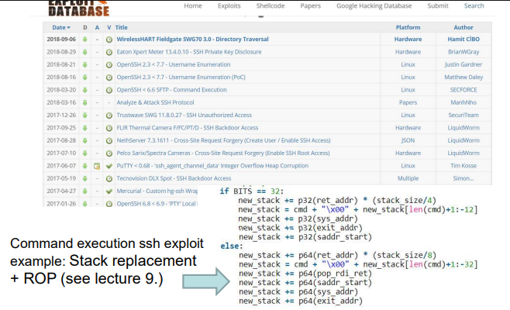

Attacking SMTP
SMTP (Simple Message Transfer Protocol) is a standard for email transmission in widespread today.
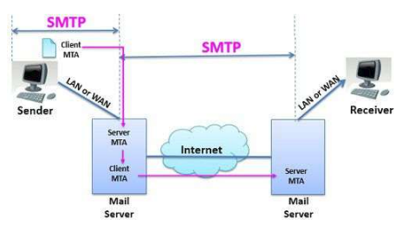

The client logs in to his/hers own server with credentials using SMTP.
The mail is forwarded to the receiver’s server with SMTP. The receiver
downloads the email (e.g. POP3, IMAP).

The main SMTP commands are:
HELO: Sent by a client to identify itself
EHLO: The same as HELO but with ESMTP (multimedia support)
MAIL FROM: Identifies the sender of the message
RCPT TO: Identifies the message recipients
DATA: Sent by a client to initiate the transfer of message content
Note there are no Subject, CC, BCC fields. All these data are
placed in the data section (these are not part of the smtp)
VRFY: Verifies that a mailbox is available for message delivery. If it’s allowed user enumeration is possible.

Attacking SMTP – open relay access
In case of open-relay settings, the user doesn’t need to provide credentials. Anyone can send a mail with arbitrary fields. DEMO..
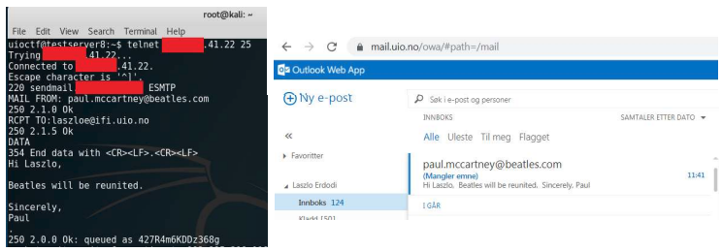
How to find open-relay SMTP?
If one of the client’s SMTP allows open-relay access then any email can be written unseeingly
Spamboxes will probably contain some open-relay SMTP server ☺
How can the users make sure that an email arrived from the right person?
Check the email header
There’s no 100% guarantee, use PGP (mail encryption)!
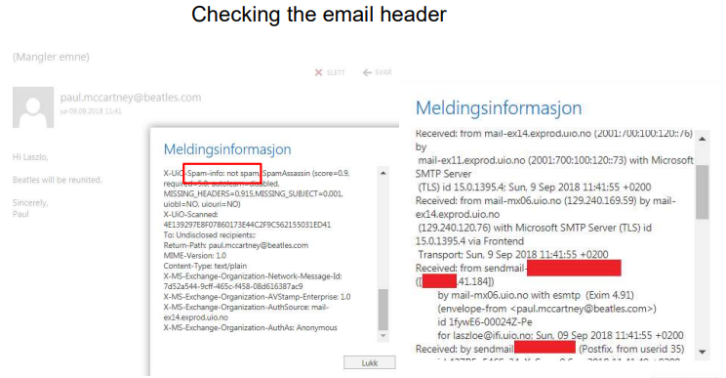
Email– brute force with THC-Hydra
hydra smtp.victimsemailserver.com smtp -l victimsaccountname -P ‘pass.lst’ -s portnumber -S -v –V
hydra –l username -P pass.txt my.pop3.mail pop3
hydra -L userlist.txt -p defaultpw imap://192.168.0.1/PLAIN

Supported protocols by THC-Hydra
Asterisk, AFP, Cisco AAA, Cisco auth, Cisco enable, CVS, Firebird,
FTP, HTTP-FORM-GET, HTTP-FORM-POST, HTTP-GET, HTTP#HEAD, HTTP-POST, HTTP-PROXY, HTTPS-FORM-GET, HTTPS#FORM-POST, HTTPS-GET, HTTPS-HEAD, HTTPS-POST, HTTP#Proxy, ICQ, IMAP, IRC, LDAP, MS-SQL, MYSQL, NCP, NNTP, Oracle
Listener, Oracle SID, Oracle, PC-Anywhere, PCNFS, POP3, POSTGRES, RDP, Rexec, Rlogin, Rsh, RTSP, SAP/R3, SIP, SMB, SMTP, SMTP Enum, SNMP v1+v2+v3, SOCKS5, SSH (v1 and v2),
SSHKEY, Subversion, Teamspeak (TS2), Telnet, VMware-Auth, VNC and XMPP.

DNS service
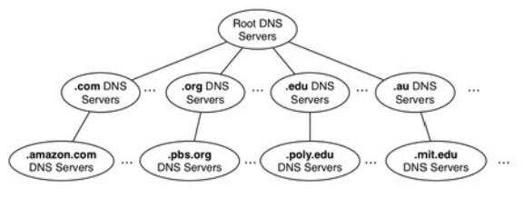
• DNS servers are all around the world
• Organized in tree structure (13 root servers)
• The top level domains (.com, .net, .edu, .no, .de, etc.) are directly under the root servers
• DNS data are stored redundantly (master and slave server)

Attacking DNS – zone transfer
Since DNS data is stored redundantly the slave DNS can ask the master DNS to send a copy of a part of its database (zone) to the slave.
Zone transfer operation should be limited for the slave ip address. If this is not the case, anyone can obtain the whole zone data (and network topological information too).
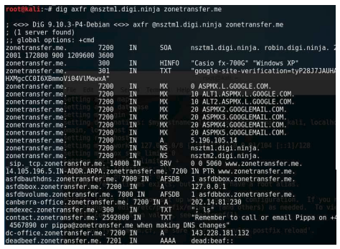

Attacking DNS – domain enumeration
• We can check if reverse lookup is enabled.
• Also brute-force the domain names in the DNS database
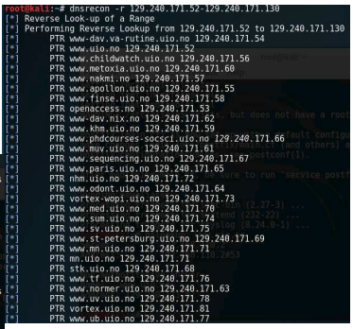
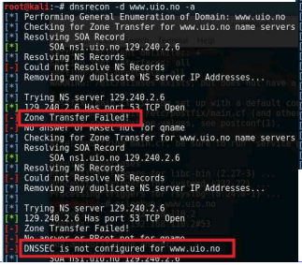

Attacking DNS – domain brute-forcing
See more: https://pentestlab.blog/tag/domain-brute-force/
https://github.com/rbsec/dnscan
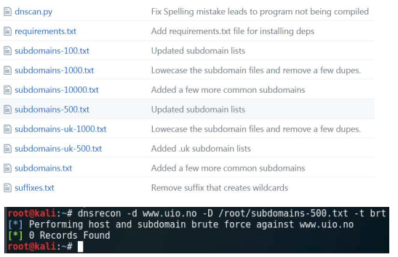
Nmap scripting engine, Medusa
• Default category: checks for factory defaults
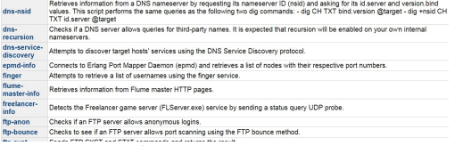
• Brute category: carry out brute-forcing with multiple protocols
• Vuln category: tries to identify vulnerabilities
• Auth category: authentication bypass, etc.
Medusa is a speedy, massively parallel, modular, login brute-forcer. It supports many protocols: AFP, CVS, FTP, HTTP, IMAP, rlogin, SSH, Subversion, and VNC, etc.

Ncrack
• Ncrack is a high-speed network authentication cracking tool. Ncrack was designed using a modular
approach, a command-line syntax similar to Nmap and a dynamic engine that can adapt its behavior
based on network feedback. It allows for rapid, yet reliable large-scale auditing of multiple hosts.
• Ncrack's features include full control of network operations, allowing for very sophisticated brute#forcing attacks, timing templates for ease of use, runtime interaction similar to Nmap's and many
more. Protocols supported include SSH, RDP, FTP, Telnet, HTTP(S), POP3(S), IMAP, SMB, VNC, SIP, Redis, PostgreSQL, MySQL, MSSQL, MongoDB, Cassandra, WinRM and OWA

Get in touch with services, what’s the order?
The order of the investigation is the following:
• Manual analysis (initial)
• Automatic analysis (several prewritten scripts) There are several tools to analyze the services
automatically. E.g. Nessus, OpenVAS, Qualys, etc..
• Manual analysis (to check for false positives)
