Network Security Monitoring and Detection
Why security monitoring and detection?
- Intrusions/incidents are likely to happen (even with proper security)
- The sooner a security incident (e.g., intrusion) is detected the better are the chances of limiting damage
- Collected information from a security incident can provide important knowledge for improving security and for establishing what has happened (both to handle an ongoing incident and afterwards to assess the consequences, e.g., data leakage)
- Security monitoring may potentially discourage malicious actions
- Provides visibility into what is happening in a network/system (before, during and after an incident)

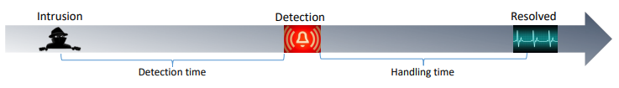
Network-based vs. host-based monitoring - Network sensor deployment
Often differentiate between network-based and host-based intrusion detection systems (IDS)
Network-based (NIDS) – monitoring one or more network segments
- IP packets (payload may be encrypted)
- Flow data
- TLS certificates (encrypted in TLS 1.3)
- DNS traffic (may be encrypted)
- Application layer data, e.g., HTTP or email (may be encrypted, may require application proxy/gateway)
- Logs from network devices (e.g., firewalls, wireless access points, DNS & email server)
Host-based (HIDS) – monitoring events at host(s)
- Logs from end-systems (e.g., clients and servers), including host agents such as antivirus
A single Intrusion Detection System (IDS) may include both network sensors and host agents. “Network sensors” may include sandbox technology to vet files etc. Thus, an intrusion detection system (IDS) may not necessarily be classified as purely hostor network-based. Events/logs may also be collected and analyzed in a Security Information and Event Management (SIEM) system, potentially including both network- and host-based sources.

Types of network sensor deployment
Inline – the traffic pass through the sensor
- E.g., for intrusion prevention purposes (or a router providing flow information, thereby acting as a sensor)
Passive - the sensor receives a copy of the traffic
- Spanning port (port mirroring)
- Network tap
Sensors may differ in what is returned, e.g., full content data, traffic metadata, alerts, etc. In host based IDSs, the term “agent” is typically used in place of “sensor”

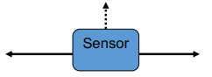
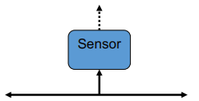

TLS inspection for network security monitoring
More and more traffic (malicious and non-malicious) is encrypted, either requiring the traffic to be decrypted or rendering payload-based detection approaches less effective
TLS inspection (i.e., decrypting TLS for inspection):
- Incoming connections can be decrypted with access to the internal server’s private key
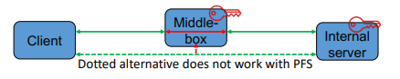

- Outgoing connections can be decrypted by inspection point acting as MitM and dynamically creating certificates for external server (requires that internal client trusts inspection point as Certificate Authority)
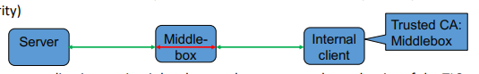
An alternative is to use an application or circuit level proxy that serves as the end-point of the TLS connection

TLS 1.3 complicates TLS inspection and network security monitoring (but is a significant improvement with regard to privacy and preventing censorship)
TLS 1.3 provides perfect forward secrecy (PFS) through default use of ephemeral Diffie-Hellman (i.e., static RSA and DH cipher suites are no longer supported)
- Thus, it is not possible to passively “eavesdrop” on the communication using the servers long term key
Middleboxes are unable to transparently disengage TLS inspection for a TLS 1.3 connection as the hash of the handshake messages is included in the key derivation
Most of the TLS 1.3 handshake, including the server certificate, is sent encrypted
- i.e., the information in the handshake is unavailable for security monitoring purposes unless the TLS connection is decrypted for inspection
- The Encrypted Server Name Indication (SNI) extension may also encrypt which website etc. a client connects to

Detection approaches - Signature-, anomaly, and flow-based and stateful protocol analysis
Classification of detection approaches (NIST SP 800-94)
Signature-Based
- Check against signatures of known attacks (e.g., string or binary pattern in IP-packet or log)
- “Blacklists” of IP-addresses, domain names, certificates etc. may be seen as a variation of this
Anomaly-Based
- Threshold detection (thresholds for frequency of events)
- Profile based (deviation from trained static or dynamic profile of normal behavior/activity)
Stateful Protocol Analysis (specification based)
- “Rules” for how given protocols should be used
Flow-based (Network Behavior Analysis)
- Makes use of information about flows (i.e., a set of packets passing an observation point with a set of common properties, e.g., src, dst, ports and protocol)

An IP flow is a set of IP packets passing an observation point in the network during a certain time interval
All packets in the flow have a set of common properties such as source and destination addresses and ports
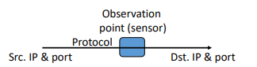

A flow record
- contains aggregated information about a flow, e.g., times of data transfer, number of packets and bytes, next layer protocol, flags etc.
- is exported (IPFIX/NetFlow) when the flow is finished, idle or reaches an allowed lifetime

Flow based monitoring and detection
Complements packet/payload intrusion detection
- Increased use of encryption (also by malware and attackers) challenges the use of packet-based detection
- Packet-based detection results in high resource consumption for high bandwidths
May be used to detect for instance:
- DoS attacks (e.g., detected by anomalies in traffic volume or SYN/ACKs)
- Scans (e.g., detected by high number of new flows with same source and different destination address/port)
- Worms (e.g., similar to scan detection, unusual connections including to honeypot)
- Other anomalies in communication patterns/volume (e.g., between unusual source-destination pairs) -
- Traffic to/from IP addresses “known” to be bad, e.g., to identify machines that have been compromised

Advantages and disadvantages of different detection approaches
Signature-based:
+ Effective at detecting known attacks (or known improper events)
- May be fooled by evasion techniques
- May require access to encrypted payload
Anomaly-based:
+ May detect previously unknown intrusions/attacks
- May create a high amount of false positives
- Profile (dynamic or static) may be tainted
Stateful protocol analysis:
+ Identifies unexpected use of protocols (but that’s it)
- Resource intensive
- Must be tailored to the specific protocol/application
Flow-based (network behavior analysis):
+ Can support high data rates and encrypted traffic is not a problem
- Not a replacement for other intrusion detection approaches

The challenge of false positives and negatives
There is a trade-off between false positives (FP) and false negatives (FN)
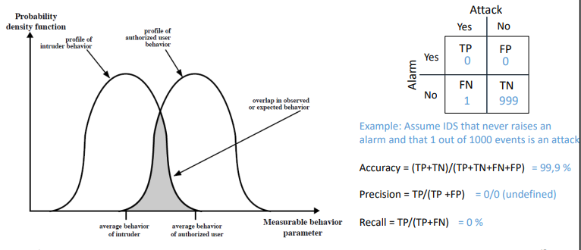
The base-rate fallacy is to assume value of Pr(a|d) without considering Pr(a) (i.e., the base-rate)
Example:
a: attack occurs (Pr(a)=0,01%) d: detects attack (Pr(d|a) = 99%, Pr(d|¬a) = 1%)
Given an alert in this example, the probability of it being an actual attack is only about 1%

The pyramid of pain and the Detection Maturity Level model
The pyramid of pain – detecting different types of indicators of an adversary cause different levels of pain to the adversary in terms of avoiding detection
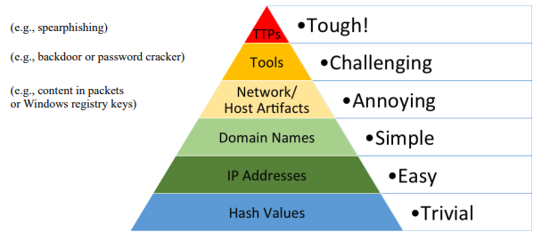
The Detection Maturity Level (DML) capability maturity model

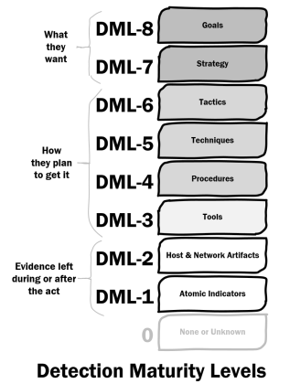

Intrusion prevention systems (IPS), honeypots-/nets, and data loss prevention
An Intrusion Prevention System (IPS) is basically an IDS that tries to stop detected intrusions
- End TCP session by sending TCP reset
- Block attacker (firewall or router)
- Block access to resource under attack
- Throttle bandwidth usage
- Sanitize (e.g., remove malicious e-mail attachment)
False positives may result in denial of service for authorized users

Honeypots/-nets may serve multiple purposes
Help detect intrusion attempts, as any connection to a honeypot can be viewed as unauthorized
Observe intrusion to gain information
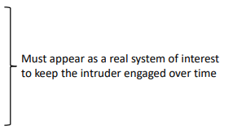
- about attacker
- about intrusion method
Divert attackers from critical systems

Data loss detection/prevention
E.g., using flow information to detect unusual and/or excessive outbound traffic, or data gathering internally
Detecting sensitive content, using e.g.,
- Document fingerprinting techniques
- Dirty-words (i.e., words indicating sensitive content)
- Regular expressions
- Machine learning
- Information retrieval

Machine learning
The use of machine learning for intrusion and data loss detection is increasing, especially for anomaly-based detection
Typical machine learning approach:
Train the model using training data
- Supervised (requires labelled dataset, e.g., log events labelled benign or malicious)
- Unsupervised (e.g., outlier detection)
Use the trained model to classify unknown data
The relevance and quality of the trained model is highly dependent on the training data. High quality training data may not be available

Example: Detection of transformed data leaks using machine learning and information retrieval
Controlled (user) environment:
- Know all imported documents and their sensitivity (input)
- Use this to infer sensitivity of new/modified document using machine learning - ML - (or information retrieval - IR) trained on the imported documents

- Provides improved performance for detecting transformed data leaks, that are more difficult to detect, compared to using a global classifier
While such solutions may be inefficient for detecting single data leaks, due to the number of false positives, aggregated results may be used to detect malicious/incompetent users and/or compromised systems
- The basic idea is to infer the likeliness that a user/system is leaking data from the aggregated discrepancies between the sensitivity claimed by the user, and that estimated by the data loss detection solution, for exported documents over time
- May be used to identify the entities who are most likely leaking data and better prioritize alerts


Machine learning based detection approaches may be subject to specific attacks
Causative/poisoning attacks: The attacker tries to influence the training set of the classifier in order to cause later misclassification
- especially a concern when continuous training is performed
Evasion attack: the attacker (potentially with knowledge of the training set and classifier) tries to shape the data to be classified in such a way as to escape detection


Model data leakage: The attacker may be able to infer data from the training set by probing the classifier – especially a concern if the training data is sensitive

