Cryptography, passwords and software security
Cryptographic methods
Cryptograpy is used to encode information. Why?
- To hide its contents – Confidentiality
- To ensure that it is not changed – Integrity
- To make it unusable/inaccessible for others – Availability

Symmetric methods
The same key is used for encryption and decryption. Applying the key twice returns the input.
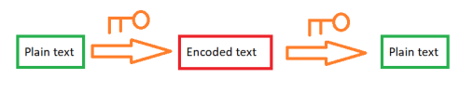

XOR
XOR of two bits is the Exclusive or operation, 0 if the bits are equal and 1 if the bits are different.
Example: 1101001 ⊕ 11001100
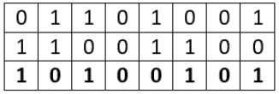

Asymmetric methods
One key is used for encryption and another one for decryption.
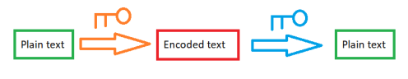

Public key and private key
Give your friends your public key, so they can encrypt their messages to you. Keep your private key private, so only you can decrypt the messages.

Old and modern cryptography
Earlier the difficulty was to know which method was used to encrypt the plaintext.
With computers, several methods could be applied quickly, making the old methods insufficient.
Modern cryptography is based on known standard methods, but rely on the keys being secret.

ROT-n
ROT-n (Rotation of the alphabet by n letters)
ABCDEFGHIJKLMNOPQRSTUVWXYZ RSTUVWXYZABCDEFGHIJKLMNOPQ
How about ROT-13?

Hashing
Encoding methods that by design should be infeasible to reverse.

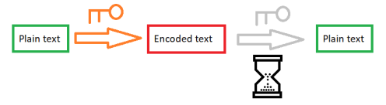

Small difference in input gives large difference in output.
Hashing is used by anti-virus programs to detect malware.
Malware samples are hashed, and the hashes are stored in a blacklist. New programs are hashed, and their hashes are compared with the blacklist.
A small change gives a new hash value. It is impossible to see from the hashes of two samples whether they are similar or completely different, only whether they are identical

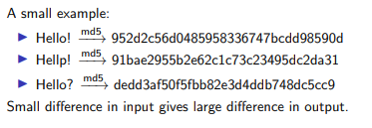

CyberChef
A tool for doing lots of text conversions, including hashing, encryption, decryption…
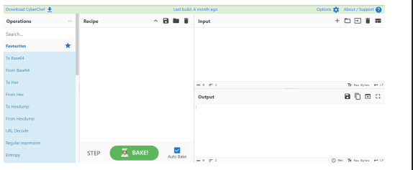
Malware uses crypto to hide
That it is malicious
Disguising the strings used for malicious activities
What it is doing
- Hiding configuration information, like a command-and-control domain
- Saving information to an encrypted file before stealing it.
- To store encrypted strings and decoding them just before they are needed
Strings and parts of the code can be encrypted (and packed) to obfuscate the contents of the program and make it look like legit software.
Communication with “home” may be encrypted to hide its contents.

Malware uses “homemade” crypto
Since standard algorithms are easily detected
Simple algorithms obfuscate sufficiently and are compact
“Homemade” implementations often contain bugs and weaknesses

How to break the “homemade” crypto?
Reverse the algorithm and reimplement it yourself. Then use it on the encrypted data.
Use the decryption algorithms in the malware sample directly.
- It is possible to call a specific function with your desired arguments.
- Or use breakpoints while running the malware.

How to find a decryption function
The function is typically called before a system call.
- Example: Before LoadLibraryA.
The output from the function is input to the system call.
- Example: The name of the library to be loaded.
A decryption function often has many cross references.
May be used only once, for example, to decrypt a blob that is written to a file.

Example: dropshot
A malware that decrypts strings containing the names of libraries and system calls.
Typical pattern for calling the decryption function.
Example of a “homemade” crypto.
How to decrypt all strings?
- Find all calls to the decryption function.
- Find the function argument (containing the encrypted string) for each call.
- Reimplement the decryption function.
- Call the decryption function with all arguments to find the system calls.

Cryptographic issues
Today, developers have access to strong, well-understood cryptographic algorithms and primitives.
Even so, cryptographic issues continue to be a very common class of software vulnerabilites.

Bruce Schneier’s essay Security Pitfalls in Cryptography gives a good overview of different types of attacks on cryptographic systems.
Schneier talks about attacks against:
- cryptographic designs
- implementations
- passwords
- hardware
- trust models
- users
- failure recovery
- cryptography
Cryptographic designs
A cryptographic system is only as strong as its individual components, and if they are put together correctly. If you reuse values, have bad random generators, etc. the crypto system will fail.

Implementations
If the cryptography is implemented wrong, it will break.
For example: Not destroying plaintext after encryption, save the plaintext to a temporary file, leave the plaintext in memory…

Passwords
People are bad at choosing passwords…
Will come back to this later this lecture.

Hardware
Relying on tamper resistent hardware.
A classic example are timing attacks and other side channels.

Trust models
Good cryptography does not help if the attacker is already in your system/network/house.
Many software systems place a lot of poor trust assumptions on the computer they run on.

Users
Users are notorious for breaking with best security policies.
- Giving away passwords
- Not reporting passkeys/smart cards missing
- Not checking signatures

Failure recovery
If a part of the system breaks you should not get the keys to the kingdom.
Often systems default to a more insecure mode.
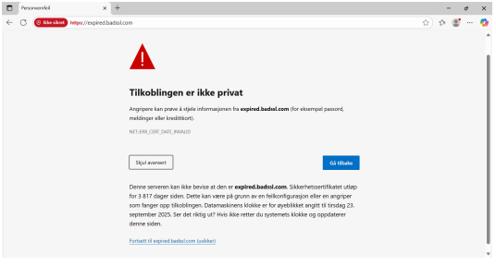
Heartbleed
Heartbleed (CVE-2014-0160) was an implementation bug in the popular OpenSSL library.
It allowed an attacker to read the memory of the systems using the vulnerable versions of OpenSSL, without leaving a trace.
In practice, this meant leaking secret keys for certificates, user names and passords, and emails and documents going through the vulnerable OpenSSL.

The TLS heartbeat extension is a keep-alive feature: one end of the connection sends a payload of arbitrary data to the other end, which then sends back an exact copy of the payload.
OpenSSL did not check if the payload data it received was of the length specified in the message header.
That meant the attacker could get OpenSSL to send more bytes from its memory, by lying about the payload length.

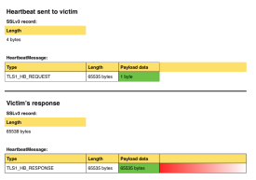

Apple’s “goto fail”
The “goto fail” (CVE-2014-1266) caused Apple devices to accept invalid certificates.
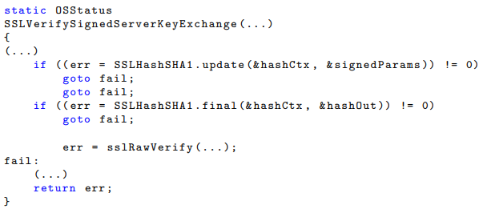
The problem is the duplicate goto fail: There is no curly braces after the if statement, and the second goto fail is always executed! The call to sslRawVerify is thus skipped, and the function returns with a 0 (no error).

Passwords
Passwords as authentication
Providing a user name and a password is still the most common form of logging on to computer systems.
This can be seen as a two step process:
1. Identification — who you are (user name)
2. Authentication — proving that you are who you claim to be (password)

Other ways of authenticating
Passwords belong to one of three categories of user authentication:
knowledge-based authentication
- something you know
- passwords, passphrases
ownership-based authentication
- something you have
- tokens (bank id OTP calculators, yubikeys)
inherence-based authentication
- something you are/do
- biometrics (fingerprints, iris scan, . . . )
Multi-factor authentication (MFA) requires the use of multiple authentication mechanisms, typically from two or more of the above categories. Two-factor authentication (2FA) is the most common type of MFA, combining two different mechanisms.
Attacking passwords
There are two major approaches for guessing passwords:
Exhaustive search
- Trying all possible combinations
- Often called brute force
Intelligent search
- The idea is to reduce the search space
- Guess based on personal information (names of friends, birthdays. . . )
- Try generally popular passwords
- Guess based on words in a dictonary (a dictionary attack)

Password strength
The strength of a truly random password is a function of the size of the set of symbols allowed in the password, and the length of the password.
Example
How many passwords are possible when the set of symbols are all alphanumerical characters (upper and lower case), and the password length is 6?
The size of the set is 62 (A-Za-z0-9), and the possible combinations are: 62⁶ = 56800235584

Storing passwords
Storing passwords in cleartext is obviously a bad idea.
Storing passwords encrypted might seem like a good idea, but:
- anyone with access to the keys and the encrypted passwords can impersonate any user
- the keys must be protected from attackers
Storing the hash value of the password is the preferred method for storing passwords:
- the hash function is one-way, we cannot deduce the password from the hash
- similar passwords have totally different hashes
- the authentication function first computes hash of received password, then compares against stored hash value
- but there still are issues…

Lookup and Rainbow table attacks
What if the attacker precomputes and stores the hash of probable passwords in a lookup table?
- Used to be infeasible due to the storage requirements.
A rainbow table is a precomputed table of passwords and their hashes, using clever methods for reducing the storage space required.
Using rainbow tables, the attacker can just lookup the stored password hash in the table and get back the password.

Salting the password
To defend against lookup/rainbow table attacks, we can salt the password.
- Prepend or append random data (salt) to the password before hashing it
- Store the salt together with the password hash
Now two instances of the same password will get different hashes, and the attacker will have to crack each and every password.

Example
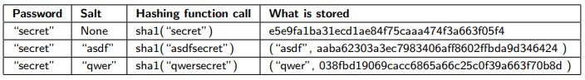
Bruteforcing password hashes
Modern day GPUs can compute billions of hashes per second.
Thus, slowing the attacker down becomes necessary.
This can be done by key stretching — making a weak key more secure against brute force attacks by increasing the time it takes to test each candidate key.
Some popular algorithms that uses key stretching are PBKDF2 and bcrypt.
Simplistically, they do several rounds of hashing, using the output of one round as the input for the next. The number of rounds are given as a parameter, and recommended number of rounds are several thousand.

Password policies
Choosing good random passwords is hard, and analyses of password dumps have shown that people often do choose poor passwords.
Password policies try to mitigate this by setting rules for:
password length and complexity
- requiring at length of 8 or more
- requiring both upper-case and lower-case letters, one or more numeric digits
- requiring special characters, such as #, !, %, ;, . . .
password duration
- changing every 180 days
password history
- remembering and denying the use of old passwords
password blacklisting
- passwords containing patterns as “qwerty”, “password” etc. . .
- passwords containing the user’s personal information

Helping the user choose strong passwords is a good thing, but:
remembering dozens of strong, random passwords doesn’t scale
users will be tempted to reuse their password on other systems
users will be tempted to write down the password on a piece of paper
the use of password managers can be problematic
- does the password leave the organization?
- what if the password manager is compromised?
- still have to make one safe password
- what if the password manager loses you passwords
users might create simple rules that technically follow the password policy, but make future passwords highly predictable given knowledge of the current one

Passphrases
Passphrases can be a good alternative to traditional passwords, provided the words really are chosen randomly.
