Linux security
Agenda
This lecture and the next will focus on operating system security. Today we will focus on Linux, but also introduce some generic concepts.
- Introduction to access control
- Unix security –– background
- Principals, subjects, objects
- Access rules
- Security patterns
- Hardening security

Access control
Access control enforces operational security policies.
A policy specifies who is allowed to do what.
The active entity requesting access to a resource is called principal.
The resource access is requested for is called object.
Access control gives the ability to permit or deny the use of a particular resource by a particular entity.

Terminology
Subject/Principal: active entity – user or process.
- Principal used when discussing policies, ie user identity
- Subject used for active entity, ie process
Object: passive entity – file or resource.
Access operations: vary from basic memory access (read, write) to method calls in an object-oriented system.
Security model is typically used to mean access control model
- i.e. a model/method for enforcing access control policies
Comparable systems may use different access operations or attach different meanings to operations which appear to be the same.

Discretionary/Mandatory Access Control
Access control based on policies that refer to user identities was historically (since the 1970s) called discretionary access control (DAC).
Referring to individual users in a policy works best within closed organisations.
Access control based on policies that refer to security labels (confidential, top secret, . . . ) was historically called mandatory access control (MAC).
Most systems today use elements from both DAC and MAC.

Access Control Matrix (ACM)
When all your users (subjects) are known individually, your policy can be expressed in an Access Control Matrix (ACM), with a row for each subject and a column for each object.
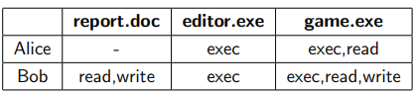

It is not very practical to directly implement ACMs; most operating system use Access Control Lists (ACLs).

Access Control Lists (ACLs)
Access Control Lists focuses on the object:
- access rights of principals are stored with the object
- ACLs are essentially the columns of the access control matrix.

Challenge: How to check access right of a specific subject?
Must iterate over every object in the system.

Groups
Entering a lot of names into several ACLs is tedious.
Declare the users to be members of a group, and put the group into the ACLs.
Access rights are often defined for groups:
- Linux: owner, group, others

Unix security – background
Unix preliminaries
Unix (like the Internet) was developed for friendly environments like research labs or universities.
Security mechanisms were quite weak and elementary; improved gradually.
Several flavours of Unix; vendor versions differ in the way some security controls are managed and enforced.
- Commands and filenames used in this lecture are indicative of typical use but may differ from actual systems.
Unix designed originally for small multi-user computers in a network environment; later scaled up to commercial servers and down to PCs.
Unix design philosophy
Security managed by skilled administrator, not by user.
- Command line tools and scripting.
- Archaic syntax retained; those who know it, love it (saves keystrokes!).
Focus on:
- protecting users from each other.
- protecting against attacks from the network.
Discretionary access control with a granularity of owner, group, other.
Vendor-specific solutions for managing large system and user-administered PCs.

Principals, subjects, objects
Principals
Principals: user identifiers (UIDs) and group identifiers (GIDs).
A UID (GID) is a 16-bit number; examples:
0: root
- 1: bin
- 2: daemon
- 8: mail
- 9: news
- 261: diego
UID values differ from system to system
Superuser (root) UID is always zero.

User accounts
Information about principals is stored in user accounts and home directories.
User accounts stored in the /etc/passwd file
- $ less / etc / passwd
User account format:
- username:passwordhash:UID:GID:name:homedir:shell
Example:
- ole:SQ.NmZIEsyT73:1012:23:Ole Duck:/home/ole:/bin/bash
Note: modern systems store passwords in /etc/shadow

User account details
User name: up to eight characters long
Password: stored “encrypted” (really a hash)
User ID (UID): user identifier for access control
Group ID (GID): user’s primary group
ID string: user’s full name
Home directory: location of the user’s home directory
Login shell: program started after successful log in

Superuser
The superuser is a special privileged principal with UID 0 and usually the user name root.
There are few restrictions on the superuser:
- All security checks are turned off for superuser.
- The superuser can become any other user.
- The superuser can change the system clock.
Superuser cannot write to a read-only file system but can remount it as writeable.
Superuser cannot decrypt passwords but can reset them.
The superuser is a major weakness of Unix; an attacker achieving superuser status effectively takes over the entire system

Groups
Users belong to one or more groups.
/etc/group contains all groups; file entry format:
- groupname:password:GID:list of users
Example:
- infosecwww:*:209:carol,albert
Every user belongs to a primary group; group ID (GID) of the primary group stored in /etc/passwd.
Collecting users in groups is a convenient basis for access control decisions.
- For example, put all users allowed to access email in a group called mail or put all operators in a group operator.

Subjects
The subjects in Unix are processes; a process has a process ID (PID).
New processes generated with exec or fork.
Processes have a real UID/GID and an effective UID/GID.
Real UID/GID: inherited from the parent; typically UID/GID of the user logged in.
Effective UID/GID: inherited from the parent process or from the file being executed.

Example
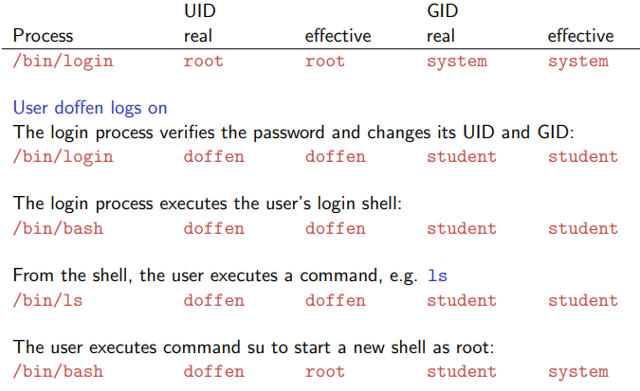
Passwords
Users are identified by user name and authenticated by password.
Originally, passwords were stored in /etc/passwd hashed with the algorithm crypt(3).
crypt(3) is really a one-way function: slightly modified DES algorithm repeated 25 times with all-zero block as start value and the password as key.
Salting: password encrypted together with a 12-bit random “salt” that is stored in the clear.

When the password field for a user is empty, the user does not need a password to log in.
To disable a user account, let the password field starts with an asterisk; applying the one-way function to a password can never result in an asterisk.
/etc/passwd is world-readable as many programs require data from user accounts; makes password-guessing attacks easy.
/etc/passwd (and /etc/group) should not be writable; an attacker who can edit /etc/passwd can become superuser (root) by changing its UID to 0.
Shadow password files: passwords are not stored in /etc/passwd but in a shadow file that can only be accessed by root.

/etc/shadow
Also used for password aging and automatic account locking; file entries have nine fields:
- username
- user password
- days since password was changed
- days left before user may change password
- days left before user is forced to change password
- days to “change password” warning
- days left before password is disabled
- days since the account has been disabled
- reserved

Example from modern Linux
/etc/passwd
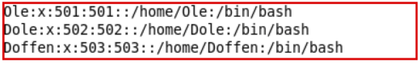
/etc/shadow
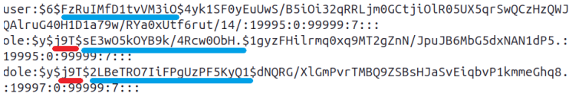
$6$ implies that sha-512 has been used to create the hashes. $y$ implies yescrypt.
The part marked in blue $ is the salt.
The part in red contains encoding parameters for yescrypt.

Objects
Files, directories, memory devices, I/O devices are uniformly treated as resources.
These resources are the objects of access control.
Resources organized in a tree-structured file system.
Each file entry in a directory is a pointer to a data structure called inode.

Inode
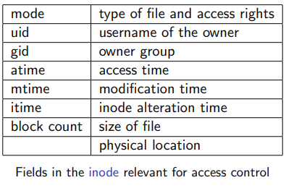

Information about objects
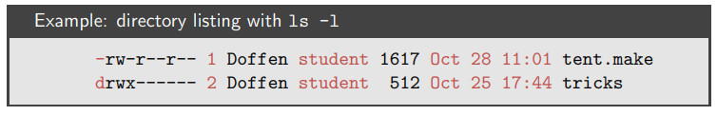
File type: first character
- ‘-’ file
- ‘d’ directory
- ‘b’ block device file
- ‘c’ character device file
- ‘s’ socket
- ‘l’ symbolic link
- ‘p’ FIFO
File permissions: next nine characters
Link counter: the number of links (i.e. directory entries) pointing to the file

Username of the owner: usually the user that has created the file.
Group: depending on the version of Unix, a newly created file belongs to its creator’s group or to its directory’s group.
File size, modification time, filename
Owner and root can change permissions (chmod); root can change file owner and group (chown).
Filename stored in the directory, not in inode.

File permissions
Permission bits are grouped in three triples that define read, write, and execute access for owner, group, and other.
A ‘-’ indicates that a right is not granted.
rw-r--r-- read and write access for the owner, read access for group and other.
rwx------ read, write, and execute access for the owner, no rights to group and other.
Three additional bits for:
- U: set UID to owner’s (SUID).
- G: set GID to owning group’s (SGID).
- S: sticky bit.

Octal representation
Three bit range is 0-7 =⇒ octal numbers are sufficient.
Examples:
- rw-r--r-- is equivalent to 644 Owner Read/Write; Group, Any: Read
- rwxrwxrwx is equivalent to 777 Owner, Group, Any: Read/Write/Exec
Conversion table for four character octal numbers:
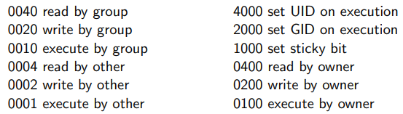

Default permissions
Unix utilities typically use default permissions 666 when creating a new file and permissions 777 when creating a new program.
Permissions can be further adjusted by the umask: a three-digit octal number specifying the rights that should be withheld.
Actual default permission is derived by masking the given default permissions with the umask: compute the logical AND of the bits in the default permission and of the inverse of the bits in the umask.

Example: default permission 666, umask 077
Invert 077: gives 700, then AND:
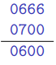

Owner of the file has read and write access, all other access is denied.
umask 777 denies every access, umask 000 does not add any further restrictions.

Sensible umask settings
- 022: all permissions for the owner, read and execute permission for group and other.
- 027: all permissions for the owner, read and execute for group and no permission for other.
- 037: all permissions for the owner, read permission for group, no permissions for other.
- 077: all permissions for the owner, no permissions for group and other.

Permissions for directories
Every user has a home directory; to put files and subdirectories into, the correct permissions for the directory are required.
Read permission: to find which files are in the directory, e.g. for executing ls.
Write permission: to add files to and remove files from the directory.
Execute permission: to make the directory the current directory (cd) and for opening files inside the directory.

To access your own files, you need execute permission in the directory.
Without read permission on the directory, you can still open a file in the directory if you know that it exists but you cannot use ls to see what is in the directory.
To stop other users from reading your files, you can either set the access permissions on the files or prevent access to the directory.
You need write and execute permission for the directory to delete a file; no permissions on the file itself are needed, it can even belong to another user.
Setting the sticky bit on a directory restricts file deletion; only the owner of a file (and the superuser) can remove the file in that directory.

Changing permissions
Access rights can be altered with chmod command:
- chmod 0754 filename
- chmod u+wrx,g+rx,g-w,o+r,o-wx filename
Ownership can be altered with the chown command:
- chown nOwner:nGroup filename

Permissions: Order of checking
Access control uses the effective UID/GID:
- If the subject’s UID owns the file, the permission bits for owner decide whether access is granted.
- If the subject’s UID does not own the file but its GID does, the permission bits for group decide whether access is granted.
- If the subject’s UID and GID do not own the file, the permission bits for other (also called world) decide whether access is granted.
Permission bits can give the owner less access than is given to the other users; the owner can always change the permissions.

Security patterns
We will discuss how some general security principles manifest themselves in Unix.
Controlled invocation: SUID programs.
Physical and logical representation of objects: deleting files.
Access to the layer below: protecting devices.
Searchpath
Importing data from outside: mounting filesystems.

Controlled invocation
Superuser privilege is required to execute certain operating system functions.
Example: only processes running as root can listen at the “trusted ports” 0 – 1023.
Solution adopted in Unix: SUID (set userID) programs and SGID (set groupID) programs.
SUID (SGID) programs run with the effective user ID or group ID of their owner or group, giving controlled access to files not normally accessible to other users.

Displaying SUID programs
When ls -l displays a SUID program, the execute permission of the owner is given as s instead of x: -rws--x-x 3 root bin 16384 Nov 16 1996 passwd
When ls -l displays a SGID program, the execute permission of the group is given as S instead of x: -rwx--S-x 3 root bin 16384 Nov 16 1996 passwd

SUID to root
When root is the owner of a SUID program, a user executing this program will get superuser status during execution.
Important SUID programs:
- /bin/passwd change password
- /bin/login login program
- /bin/at batch job submission
- /bin/su change UID program
As the user has the program owner’s privileges when running a SUID program, the program should only do what the owner intended

SUID dangers
By tricking a SUID program owned by root to do unintended things, an attacker can act as the root.
All user input (including command line arguments and environment variables) must be processed with extreme care.
Programs should have SUID status only if it is really necessary.
The integrity of SUID programs must be monitored.

Applying controlled invocation
Sensitive resources, like a web server, can be protected by combining ownership, permission bits, and SUID programs:
Create a new UID that owns the resource and all programs that need access to the resource.
Only the owner gets access permission to the resource.
Define all the programs that access the resource as SUID programs.

Deleting files
Unix has two ways of copying files.
cp creates an identical but independent copy owned by the user running cp.
ln creates a new filename with a pointer to the original file and increases link counter of the original file; the new file shares its contents with the original.
If the original is deleted (with rm or rmdir) it disappears from its parent directory but the contents of the file and its copy still exist.
- Users may think that they have deleted a file whereas it still exists in another directory, and they still own it.
- If a process has opened a file which then is deleted by its owner, the file remains in existence until that process closes the file.

Once a file has been deleted the disk blocks allocated to this file becomes available again.
Until these disk block are written to again, they still contain the file’s contents.
To avoid such residues, the file can be wiped by overwriting its contents with a pattern appropriate for the storage medium before deleting it.
But advanced file systems may move files around and leave copies.
Because of wear leveling, SSDs are notoriously hard to wipe.
Mounting filesystems
General issue: When importing objects from another security domain into your system, access control attributes of these objects must be redefined.
Unix filesystem is built by linking together filesystems held on different physical devices under a single root / with the mount command.
Remote filesystems (NFS) can be mounted from other network nodes.
Users could be allowed to mount a filesystem from their own USB disk (automount).
Mounted filesystems could have dangerous settings, e.g. SUID to root programs in an attacker’s directory.

mount command
mount [-r] [-o options] device directory
-r flag specifies read-only mount. Options:
nosuid: turns off the SUID and SGID bits on the mounted filesystem.
noexec: no binaries can be executed from the mounted filesystem.
nodev: no block or character special devices can be accessed from the filesystem.
Different versions of Unix implement different options for mount.

General issue: scoping of identifiers
NFS server trusts the client to enforce access control on the mounted filesystem.
UIDs and GIDs on two Unix systems (from different vendors) may be assigned differently.
The client may misinterpret the UID or GUID even if it tries to enforce access control.
Problem: UID and GID are local identifiers; only globally unique identifiers should be used across network.

Environment variables
Environment variables: kept by the shell, normally used to configure the behaviour of utility programs.
Inherited by default from a process’ parent.
A program executing another program can set the environment variables for the program called to arbitrary values.
Danger: the invoker of setuid/setgid programs is in control of the environment variables they are given.
Usually inherited, so this also applies transitively.
Not all environment variables are documented!
Inheriting things you do not want can become a security problem

Examples
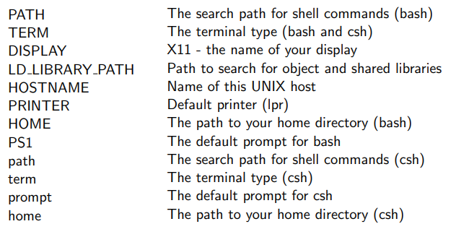

Searchpath
General principle: execution of programs taken from a ’wrong’ location.
Users can run a program by typing its name without specifying the full pathname that gives the location of the program within the filesystem.
The shell searches for the program following the searchpath specified by the PATH environment variable in the .profile file in the user’s home directory.

A typical searchpath: PATH=.:\$HOME/bin:/usr/ucb:/bin:/usr/bin:/usr/local: /usr/new:/usr/hosts
Directories in the searchpath are separated by ’:’; the first entry ’.’ is the current directory.
When a directory is found that contains a program with the name specified, the search stops and that program will be executed.

To insert a Trojan horse, give it the same name as an existing program and put it in a directory that is searched before the directory containing the original program.
As a defence, call programs by their full pathname, e.g. /bin/su instead of su.
Make sure that the current directory is not in the searchpath of programs executed by root
(ls -a lists all files in your home directory, more .profile shows your profile).

Hardening security
Disk encryption
Protecting the root account
LSM
- SELinux
- AppArmor
Memory corruption mitigations
Disk encryption
Most Linux distributions support several disk encryption methods:
- Stacked filesystem encryption –– a layer that stacks on top of an existing filesystem, files written get encrypted on-the-fly before the underlying filesystem writes them to disk. eCryptfs and EncFS are examples of stackable cryptographic filesystems.
- Block device encryption –– operates below the filesystem layer, and ensures that everything written to the block device is encrypted. dm-crypt is the standard block device encryption subsytem in the Linux kernel. Managed by the cryptsetup userspace utility.

Linux Security Modules
Linux Security Modules (LSM) provides a kernel framework to support security modules.
Focuses on supporting access control modules.
Several LSM modules that implement support for MAC exist:
- SELinux
- AppArmor
- Smack
- TOMOYO

Memory corruption mitigations
See Lectures 3 and 4 for background
No Execute/Data Execution Prevention (NX/DEP) used by most Linux distributions
Address Space Layout Randomization (ASLR) used by most Linux distributions
Stack Canaries used by most Linux distributions
However, embedded systems often lack any/all of these features!

