IN3210/IN4210 Autumn 25
Exercise 1 - Cryptography Part 1: Symmetric Encryption
In this part, you are asked to do tasks from the SEED Encryption Labs:
• Tasks: https://seedsecuritylabs.org/Labs_20.04/Files/Crypto_Encryption/Crypto_ Encryption.pdf
• Lab file: https://seedsecuritylabs.org/Labs_20.04/Crypto/Crypto_Encryption/
You can directly download the Lab file on your Ubuntu server using:
wget https://seedsecuritylabs.org/Labs_20.04/Files/Crypto_Encryption/Labsetup.zip
You are to perform the following tasks from the SEED Encryption Lab:
- 5 Task 3: Encryption Mode – ECB vs. CBC o See 4 Task 2 to see how to encrypt the image file using openssl
Run ssh ssh ubuntu@158.39.48.144 to start up the vnc server
Then ./run-vnc-rand.sh to start the browser display. Click on the link and begin
5 Task 3: Encryption Mode – ECB vs. CBC
The file pic original.bmp is included in the Labsetup.zip file, and it is a simple picture. We would like to encrypt this picture, so people without the encryption keys cannot know what is in the picture. Please encrypt the file using the ECB (Electronic Code Book) and CBC (Cipher Block Chaining) modes, and
then do the following:
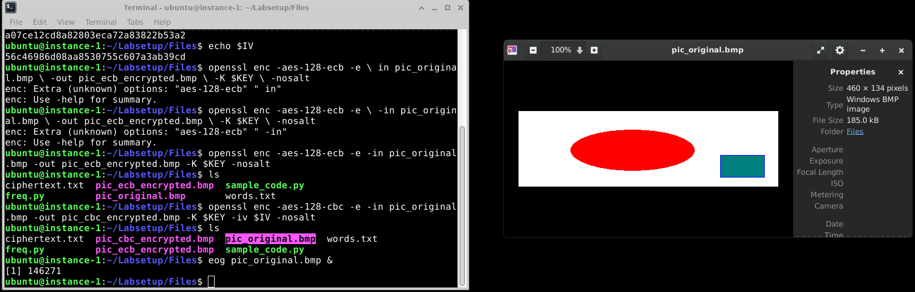
1. Let us treat the encrypted picture as a picture, and use a picture viewing software to display it. However, For the .bmp file, the first 54 bytes contain the header information about the picture, we have to set it correctly, so the encrypted file can be treated as a legitimate .bmp file. We will replace the header of the encrypted picture with that of the original picture. We can use the bless hex editor tool (already installed on our VM) to directly modify binary files. We can also use the following commands to get the header from p1.bmp, the data from p2.bmp (from offset 55 to the end of the file), and then combine the header and data together into a new file. SEED Labs – Secret-Key Encryption Lab 5
$ head -c 54 p1.bmp > header
$ tail -c +55 p2.bmp > body
$ cat header body > new.bmp
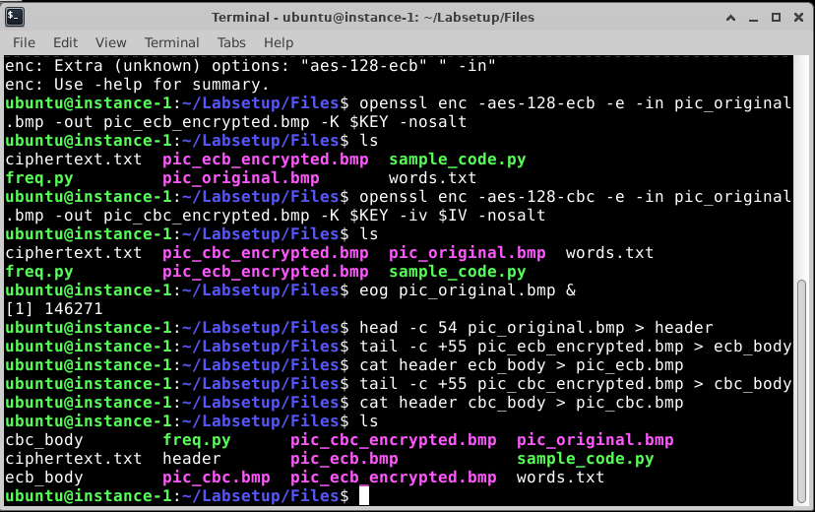
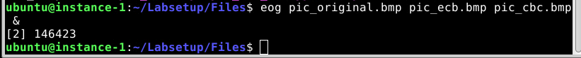
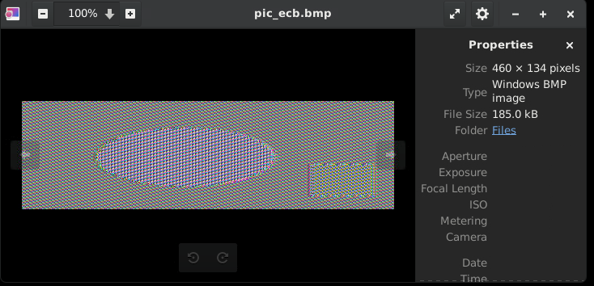
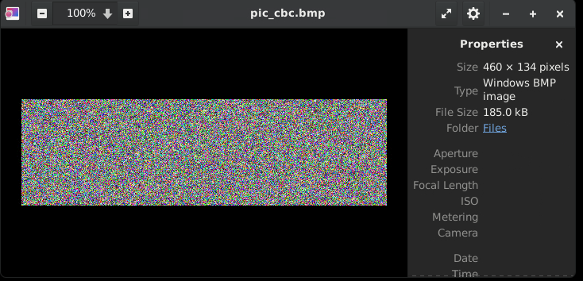
2. Display the encrypted picture using a picture viewing program (we have installed an image viewer program called eog on our VM). Can you derive any useful information about the original picture from the encrypted picture? Please explain your observations. Select a picture of your choice, repeat the experiment above, and report your observations.
You don't know what A and B originally were in ecb, but the pattern survives.
CBC prevents this because each block depends on the previous encrypted block

) 8 Task 6: Initial Vector (IV)
o Note on task 6.2: Common Mistake: Use the Same IV
You can skip the question about Cipher Feedback Mode (CFB).
o Note on task 6.3: The encryption oracle makes use of PKCS#5/PKCS#7 padding.
8.2 Task 6.2. Common Mistake: Use the Same IV
One may argue that if the plaintext does not repeat, using the same IV is safe. Let us look at the Output Feedback (OFB) mode. Assume that the attacker gets hold of a plaintext (P1) and a ciphertext (C1) , can he/she decrypt other encrypted messages if the IV is always the same? You are given the following information, please try to figure out the actual content of P2 based on C2, P1, and C1.
Plaintext (P1): This is a known message!
Ciphertext (C1): a469b1c502c1cab966965e50425438e1bb1b5f9037a4c159
Plaintext (P2): (unknown to you)
Ciphertext (C2): bf73bcd3509299d566c35b5d450337e1bb175f903fafc159
If we replace OFB in this experiment with CFB (Cipher Feedback), how much of P2 can be revealed? You only need to answer the question; there is no need to demonstrate that. The attack used in this experiment is called the known-plaintext attack, which is an attack model for cryptanalysis where the attacker has access to both the plaintext and its encrypted version (ciphertext). If this can lead to the revealing of further secret information, the encryption scheme is not considered as secure.
Sample Code. We provide a sample program called sample code.py, which can be found inside the Labsetup/Files folder. It shows you how to XOR strings (ascii strings and hex strings). The code is shown in the following:
#!/usr/bin/python3
# XOR two bytearrays
def xor(first, second):
return bytearray(xˆy for x,y in zip(first, second))
MSG = "A message"
HEX_1 = "aabbccddeeff1122334455"
HEX_2 = "1122334455778800aabbdd"
# Convert ascii/hex string to bytearray
D1 = bytes(MSG, ’utf-8’)
D2 = bytearray.fromhex(HEX_1)
D3 = bytearray.fromhex(HEX_2)
r1 = xor(D1, D2)
r2 = xor(D2, D3)
r3 = xor(D2, D2)
print(r1.hex())
print(r2.hex())
print(r3.hex())
