Marketing_Mix_-_Brands__1.R

Rohit

Sat Nov 21 22:51:18 2015

# Marketing Mix - Brands   
# Customer ratings for - perceptual adjectives and 4 brands.  
# Within marketing analytics - perceptual adjectives to be linked to perceptual maps.  
d <- read.csv("C:/Users/Rohit/Desktop/Marketing Mix - Brands/d.csv")  
head(d)

## cheap snappy effective luxurious artistic bold caring casual charming  
## 1 9 7 2 10 7 5 9 1 3  
## 2 4 2 2 8 5 4 9 7 2  
## 3 5 6 10 10 1 8 10 10 8  
## 4 8 10 5 5 10 2 9 2 1  
## 5 9 5 3 10 3 8 10 5 3  
## 6 10 10 4 9 9 3 5 1 10  
## contemporary creative daring elegant energetic exciting festive fresh  
## 1 2 10 5 4 10 10 2 10  
## 2 2 9 1 2 8 8 3 8  
## 3 10 9 4 1 8 8 3 8  
## 4 5 9 9 9 8 8 4 8  
## 5 3 9 6 6 8 8 5 8  
## 6 4 10 5 4 10 10 7 10  
## fun graceful hip brand.name  
## 1 10 9 10 1  
## 2 9 9 9 3  
## 3 8 9 8 3  
## 4 10 4 10 4  
## 5 9 7 9 4  
## 6 8 1 8 3

summary(d)

## cheap snappy effective luxurious   
## Min. : 1.000 Min. : 1.000 Min. : 1.000 Min. : 1.000   
## 1st Qu.: 4.000 1st Qu.: 4.000 1st Qu.: 4.000 1st Qu.: 3.000   
## Median : 8.000 Median : 8.000 Median : 6.000 Median : 6.000   
## Mean : 7.079 Mean : 7.074 Mean : 5.786 Mean : 5.642   
## 3rd Qu.:10.000 3rd Qu.:10.000 3rd Qu.: 8.000 3rd Qu.: 8.000   
## Max. :10.000 Max. :10.000 Max. :10.000 Max. :10.000   
## artistic bold caring casual   
## Min. : 1.000 Min. : 1.000 Min. : 1.000 Min. : 1.00   
## 1st Qu.: 3.000 1st Qu.: 3.000 1st Qu.: 3.000 1st Qu.: 3.00   
## Median : 6.000 Median : 5.000 Median : 6.000 Median : 6.00   
## Mean : 5.529 Mean : 5.486 Mean : 5.505 Mean : 5.54   
## 3rd Qu.: 8.000 3rd Qu.: 8.000 3rd Qu.: 8.000 3rd Qu.: 8.00   
## Max. :10.000 Max. :10.000 Max. :10.000 Max. :10.00   
## charming contemporary creative daring   
## Min. : 1.000 Min. : 1.0 Min. : 1.000 Min. : 1.000   
## 1st Qu.: 3.000 1st Qu.: 3.0 1st Qu.: 4.000 1st Qu.: 3.000   
## Median : 6.000 Median : 6.0 Median : 7.000 Median : 5.000   
## Mean : 5.637 Mean : 5.8 Mean : 6.085 Mean : 5.473   
## 3rd Qu.: 8.000 3rd Qu.: 8.0 3rd Qu.: 9.000 3rd Qu.: 8.000   
## Max. :10.000 Max. :10.0 Max. :10.000 Max. :10.000   
## elegant energetic exciting festive   
## Min. : 1.000 Min. : 1.000 Min. : 1.000 Min. : 1.000   
## 1st Qu.: 3.000 1st Qu.: 4.000 1st Qu.: 4.000 1st Qu.: 3.000   
## Median : 5.000 Median : 7.000 Median : 7.000 Median : 5.500   
## Mean : 5.502 Mean : 6.082 Mean : 6.072 Mean : 5.478   
## 3rd Qu.: 8.000 3rd Qu.: 9.000 3rd Qu.: 9.000 3rd Qu.: 8.000   
## Max. :10.000 Max. :10.000 Max. :10.000 Max. :10.000   
## fresh fun graceful hip   
## Min. : 1.000 Min. : 1.000 Min. : 1.000 Min. : 1.000   
## 1st Qu.: 4.000 1st Qu.: 3.000 1st Qu.: 3.000 1st Qu.: 3.000   
## Median : 7.000 Median : 6.000 Median : 5.000 Median : 6.000   
## Mean : 6.103 Mean : 5.961 Mean : 5.494 Mean : 6.005   
## 3rd Qu.: 9.000 3rd Qu.: 9.000 3rd Qu.: 8.000 3rd Qu.: 9.000   
## Max. :10.000 Max. :10.000 Max. :10.000 Max. :10.000   
## brand.name   
## Min. :1.000   
## 1st Qu.:2.000   
## Median :3.000   
## Mean :2.508   
## 3rd Qu.:4.000   
## Max. :4.000

# scaling the raw data - creating a scaled matrix  
dsc<-scale(d[,1:20])  
# creating a Data Frame of same name - "dsc" from scaled matrix   
dsc<-as.data.frame(dsc)  
summary(dsc)

## cheap snappy effective luxurious   
## Min. :-1.9334 Min. :-1.9356 Min. :-1.77078 Min. :-1.5973   
## 1st Qu.:-0.9793 1st Qu.:-0.9797 1st Qu.:-0.66072 1st Qu.:-0.9092   
## Median : 0.2929 Median : 0.2950 Median : 0.07933 Median : 0.1230   
## Mean : 0.0000 Mean : 0.0000 Mean : 0.00000 Mean : 0.0000   
## 3rd Qu.: 0.9290 3rd Qu.: 0.9323 3rd Qu.: 0.81937 3rd Qu.: 0.8112   
## Max. : 0.9290 Max. : 0.9323 Max. : 1.55941 Max. : 1.4993   
## artistic bold caring casual   
## Min. :-1.5710 Min. :-1.5652 Min. :-1.5577 Min. :-1.5768   
## 1st Qu.:-0.8772 1st Qu.:-0.8674 1st Qu.:-0.8662 1st Qu.:-0.8821   
## Median : 0.1634 Median :-0.1696 Median : 0.1711 Median : 0.1599   
## Mean : 0.0000 Mean : 0.0000 Mean : 0.0000 Mean : 0.0000   
## 3rd Qu.: 0.8571 3rd Qu.: 0.8771 3rd Qu.: 0.8626 3rd Qu.: 0.8545   
## Max. : 1.5509 Max. : 1.5749 Max. : 1.5541 Max. : 1.5492   
## charming contemporary creative daring   
## Min. :-1.5899 Min. :-1.76217 Min. :-1.7559 Min. :-1.5594   
## 1st Qu.:-0.9042 1st Qu.:-1.02798 1st Qu.:-0.7200 1st Qu.:-0.8622   
## Median : 0.1243 Median : 0.07331 Median : 0.3159 Median :-0.1649   
## Mean : 0.0000 Mean : 0.00000 Mean : 0.0000 Mean : 0.0000   
## 3rd Qu.: 0.8100 3rd Qu.: 0.80750 3rd Qu.: 1.0065 3rd Qu.: 0.8811   
## Max. : 1.4957 Max. : 1.54170 Max. : 1.3518 Max. : 1.5783   
## elegant energetic exciting festive   
## Min. :-1.5707 Min. :-1.7515 Min. :-1.7434 Min. :-1.556096   
## 1st Qu.:-0.8729 1st Qu.:-0.7176 1st Qu.:-0.7122 1st Qu.:-0.861158   
## Median :-0.1750 Median : 0.3162 Median : 0.3190 Median : 0.007514   
## Mean : 0.0000 Mean : 0.0000 Mean : 0.0000 Mean : 0.000000   
## 3rd Qu.: 0.8717 3rd Qu.: 1.0055 3rd Qu.: 1.0064 3rd Qu.: 0.876186   
## Max. : 1.5695 Max. : 1.3501 Max. : 1.3502 Max. : 1.571123   
## fresh fun graceful hip   
## Min. :-1.7679 Min. :-1.66693 Min. :-1.564 Min. :-1.691154   
## 1st Qu.:-0.7286 1st Qu.:-0.99490 1st Qu.:-0.868 1st Qu.:-1.015407   
## Median : 0.3107 Median : 0.01315 Median :-0.172 Median :-0.001785   
## Mean : 0.0000 Mean : 0.00000 Mean : 0.000 Mean : 0.000000   
## 3rd Qu.: 1.0035 3rd Qu.: 1.02120 3rd Qu.: 0.872 3rd Qu.: 1.011836   
## Max. : 1.3499 Max. : 1.35722 Max. : 1.568 Max. : 1.349710

# as seen in summary - "mean" for all - dimensions - is now "0.00"   
  
# Now we create a merged data frame "dsc1" - adding the "brand.name" variable to the   
# scaled data frame created earlier   
dsc1<-cbind(dsc,d$brand.name)  
# change the - "d$brand.name" to just "brand.name"  
names(dsc1) [21] <- "brand.name"  
  
library(corrplot)  
  
# varied permutations of the bi variable correlation plot....  
# too many variables thus creating seperate Correlation Plots   
c1<-cor(dsc1[, 1:5])  
c2<-cor(dsc1[, 6:10])  
c3<-cor(dsc1[, 10:15])  
c4<-cor(dsc1[, 16:20])  
  
layout(matrix(c(1, 1, 2, 3), 2, 2, byrow = TRUE))  
corrplot.mixed(c1,lower="number", upper="circle")  
corrplot.mixed(c2,lower="number", upper="circle")  
corrplot.mixed(c3,lower="number", upper="circle")

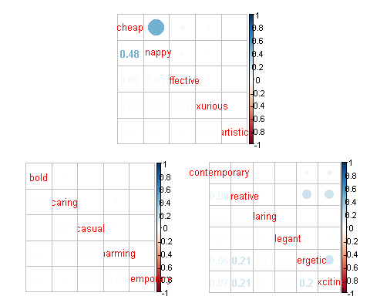

corrplot.mixed(c4,lower="number", upper="circle")  
  
corrplot(c3,type="upper", method="number",order="AOE")  
# "AOE" for the angular order of the eigenvectors  
corrplot(c4,type="upper", method="shade",order="hclust")

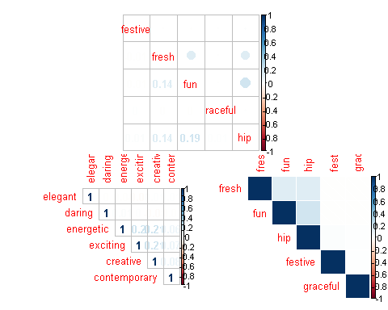

# "hclust" for the hierarchical clustering order.  
corrplot(c3,type="upper", method="shade",order="FPC")  
# "FPC" for the first principal component order.  
corrplot(c4,type="upper", method="ellipse",order="FPC")  
# "FPC" for the first principal component order.  
# method="ellipse"   
corrplot(c4,type="upper", method="color",order="hclust")

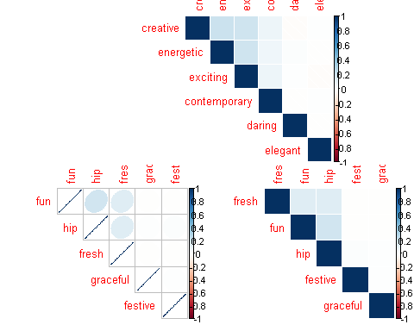

# "FPC" for the first principal component order.  
# method="color"   
corrplot(c3,type="upper", method="shade",order="hclust")  
# "FPC" for the first principal component order.  
# method="shade" - not very different from "color"  
  
###  
# Whats the average or the "mean" rating for each brand   
# for all given - 20 - perceptual adjectives ?   
###  
  
avg.ratings <- aggregate(.~ brand.name , data=dsc1 , mean)  
View(avg.ratings)  
library(gplots)

##   
## Attaching package: 'gplots'  
##   
## The following object is masked from 'package:stats':  
##   
## lowess

library("RColorBrewer", lib.loc="~/R/win-library/3.1")  
heatmap.2(as.matrix(c3),col=brewer.pal(9, "GnBu"),  
 xlab=" Perceptual Adjectives ", ylab= "Coded Brand Names",trace="none", key=T, dend="none",main="\n\n\n Heat Map \n\n Perceptual Adj. Avg Ratings")

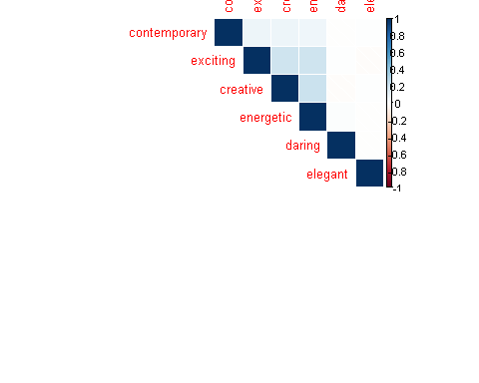 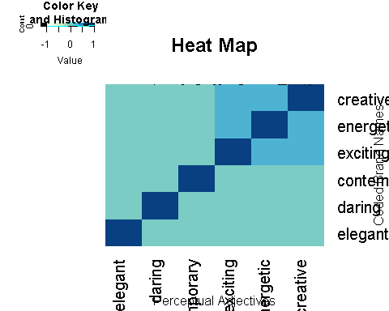

heatmap.2(as.matrix(c4),col=brewer.pal(7,"Greens"),  
 xlab=" Perceptual Adjectives ", ylab= "Coded Brand Names",trace="none", key=T, dend="none",main="\n\n\n Heat Map \n\n Perceptual Adj. Avg Ratings")

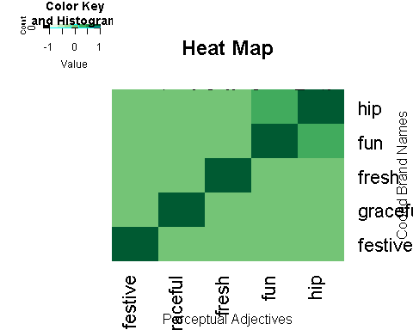

#   
heatmap.2(as.matrix(c4),col=brewer.pal(9,"BrBG"),  
 xlab=" Perceptual Adjectives ", ylab= "Coded Brand Names",trace="none", key=T, dend="none",main="\n\n\n Heat Map \n\n Perceptual Adj. Avg Ratings")

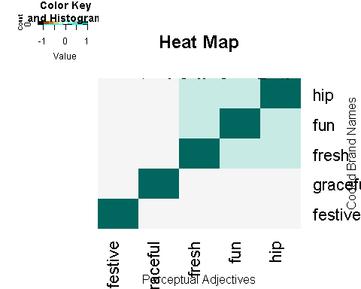

#   
heatmap.2(as.matrix(avg.ratings),col=brewer.pal(9,"BrBG"),  
 xlab=" Perceptual Adjectives ", ylab= "Coded Brand Names",trace="none", key=T, dend="none",main="\n\n\n Heat Map \n\n Perceptual Adj. Avg Ratings")

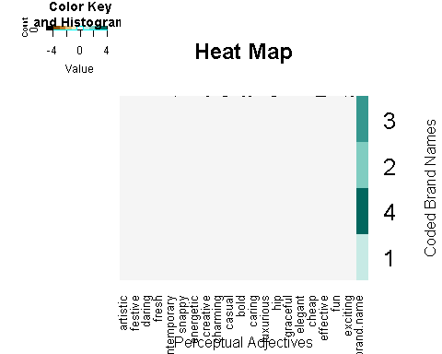

#  
# As the average ratings are mostly in the "0.000" range we need to   
# multiply with "1000" across to get a decent data viz with the HeatMap .   
getwd()

## [1] "C:/Users/Rohit/Desktop/Marketing Mix - Brands"

write.table(avg.ratings,"C:/Users/Rohit/Desktop/Marketing Mix - Brands/avg.csv",sep=",")  
# Excel calc - external to R - now import avg1.csv   
avg1 <- read.csv("C:/Users/Rohit/Desktop/Marketing Mix - Brands/avg1.csv")  
View(avg1)  
#  
heatmap.2(as.matrix(avg1),col=brewer.pal(9,"BrBG"),  
 xlab=" Perceptual Adjectives ", ylab= "Coded Brand Names",trace="none", key=T, dend="none",main="\n\n\n Heat Map \n\n Perceptual Adj. Avg Ratings")

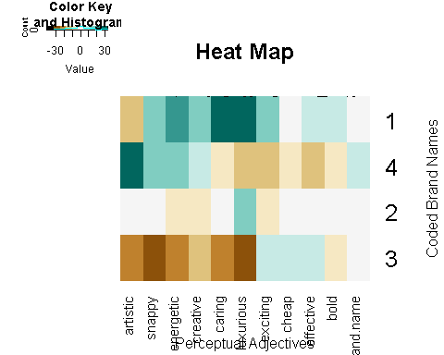

#  
heatmap.2(as.matrix(avg1),col=brewer.pal(9, "GnBu"),  
 xlab=" Perceptual Adjectives ", ylab= "Coded Brand Names",trace="none", key=T, dend="none",main="\n\n\n Heat Map \n\n Perceptual Adj. Avg Ratings")



