# Long-term monitoring of weather near Portal, Arizona (1980 – 2013).

# Authors

S.K. Morgan Ernest

Department of Biology, UMC 5305, Utah State University, Logan, UT 84322

(Department of Wildlife Ecology and Conservation, 110 Newins-Ziegler Hall, PO Box 110430, Gainesville, FL 32611)

Glenda Yenni

Department of Biology, UMC 5305, Utah State University, Logan, UT 84322

(Department of Wildlife Ecology and Conservation, 110 Newins-Ziegler Hall, PO Box 110430, Gainesville, FL 32611)

Ginger Allington

Department of Biology, St. Louis University, 3507 Laclede Ave. St. Louis, MO 63103

(School of Natural Resources and Environment, University of Michigan, 440 Church St., Ann Arbor, MI 48109)

Erica Christensen

Department of Biology, UMC 5305, Utah State University, Logan, UT 84322

(Department of Wildlife Ecology and Conservation, 110 Newins-Ziegler Hall, PO Box 110430, Gainesville, FL 32611)

Keith Geluso

Department of Biology, 167 Castetter Hall, MSC03 2020, 1 University of New Mexico, Albuquerque, NM 87131

(Biology, The University of Nebraska at Kearney, 905 West 25th Street, Kearney, NE 68849)

Jake Goheen

Department of Biology, 167 Castetter Hall, MSC03 2020, 1 University of New Mexico, Albuquerque, NM 87131

(Departments of Zoology & Physiology and Botany, University of Wyoming, 1000 E. University Ave, Laramie, WY 82071)

Michelle Schutzenhofer

Department of Biology, St. Louis University, 3507 Laclede Ave. St. Louis, MO 63103

(McKendree University, 701 College Road, Lebanon, Illinois 62254)

Sarah Supp

Department of Biology, UMC 5305, Utah State University, Logan, UT 84322

(University of Wisconsin-Madison, Department of Geography, 550 North Park Street, Madison, WI 53706)

Kate Thibault

Department of Biology, 167 Castetter Hall, MSC03 2020, 1 University of New Mexico, Albuquerque, NM 87131

(NEON, 1685 38th Street Suite 100, Boulder, CO 80301)

James H. Brown

Department of Biology, 167 Castetter Hall, MSC03 2020, 1 University of New Mexico, Albuquerque, NM 87131

Thomas J. Valone

Department of Biology, St. Louis University, 3507 Laclede Ave. St. Louis, MO 63103

# INTRODUCTION

Water is arguably the most limiting resource in arid environments. Long-term data on precipitation collected at the long-term site has been used to better understand the relationship between this important and highly variable resource and the biota. Temperature is also a potentially important factor in desert dynamics. Our data update includes temperature data not provided in the previous data publication. This metadata file describes the data collection and structure for the weather data. The location of the weather station can be found on the map of the site (*Portal_metadata_overview.html*; Fig 1).

# METADATA CLASS I. DATA SET DESCRIPTORS

A. Data set identity:

**Title:** Long-term monitoring of weather in the Chihuahuan Desert near Portal, AZ (1980 – 2013).

B. Data set identification codes: Portal_ weather_19801989.csv

Portal_ weather_19892013.csv

C. Data set description

Principal Investigators:

S.K. Morgan Ernest, Department of Biology, Utah State University, Logan UT 84322

**Abstract:** The data set covers a 34 year period (1980-2013) of weather monitoring near Portal, Arizona. From 1980-1989, daily minimum and maximum air temperature values were recorded at the site. Manually collected precipitation data is also available. Unlike the temperature data, the precipitation data for these years is not daily and should only be used after summarizing over months or years. In 1989, the site switched to an automated weather station which recorded hourly rainfall amounts and air temperatures. In 2002, this weather station was updated and continues to collect hourly precipitation and air temperature. This data will be updated.

**D.** Key words: precipitation, Chihuahuan Desert, LTREB data, meteorology

# CLASS II. RESEARCH ORIGIN DESCRIPTORS

A. Overall project description

**Identity:** Long-term monitoring of weather near Portal, AZ (1980 – 2013).

**Originators:** Drs. James H. Brown, Diane W Davidson, James Reichman

Period of Study: 1980 - 2013

**Objectives:** To monitor availability of a limiting resource (i.e. water) and its effects on the dynamics of a desert ecosystem.

**Source(s) of funding:** SeePortal_overview_metadata.html

B. Specific subproject description

**1. Site description:** The 24 experimental plots cover an area not more than 20 ha in size. Due to the small spatial-scale of the plot and the spatial scale of the typical precipitation event, there is only one weather station for the site. This station has been located in the same general vicinity of the 20 ha site since 1980 (See *Portal_overview_metadata.html*, Fig 1 for location).

**Data Collection Period, Frequency:** Before 1989, precipitation was collected in a standard “manual” rain gauge and approximately weekly a volunteer residing in the vicinity would visit the site and collect data on rainfall amounts. The Day column in the pre-1989 data therefore does not reflect actual daily rainfall, but provides a record of data collection only. **It is necessary to use only summarized monthly rainfall for this data.** The temperature data was recorded by a circular hygrothermograph and daily minimum and maximum temperatures were transcribed onto datasheets (see Figure 1). In 1989, an automated weather station was installed at the site (Campbell Scientific) capable of recording precipitation amounts and air temperature on an hourly basis. The automated and manual collection protocols were run concurrently for approximately 2 months until the old weather station was hit by lightning. No information currently exists on the make or model of the rain gauge for the first automated weather station. After a serious malfunction in February 2002, a new automated weather station (Campbell Scientific) was installed in December 2002. The rain gauge associated with the current weather station is a Texas Electronics 8 inch gauge (TE525WS-L). The datalogger records hourly precipitation and air temperature. Note that this is finer scale weather information than was recorded previously at the site. The inclusion of the temperature data also constitutes more weather information than was made available in the previous data publication (Ernest et al 2009). The weather data are divided into two files (1980-1989 and 1989-2013) to reflect the different frequencies of data collection. In 2011, gaps exist in the 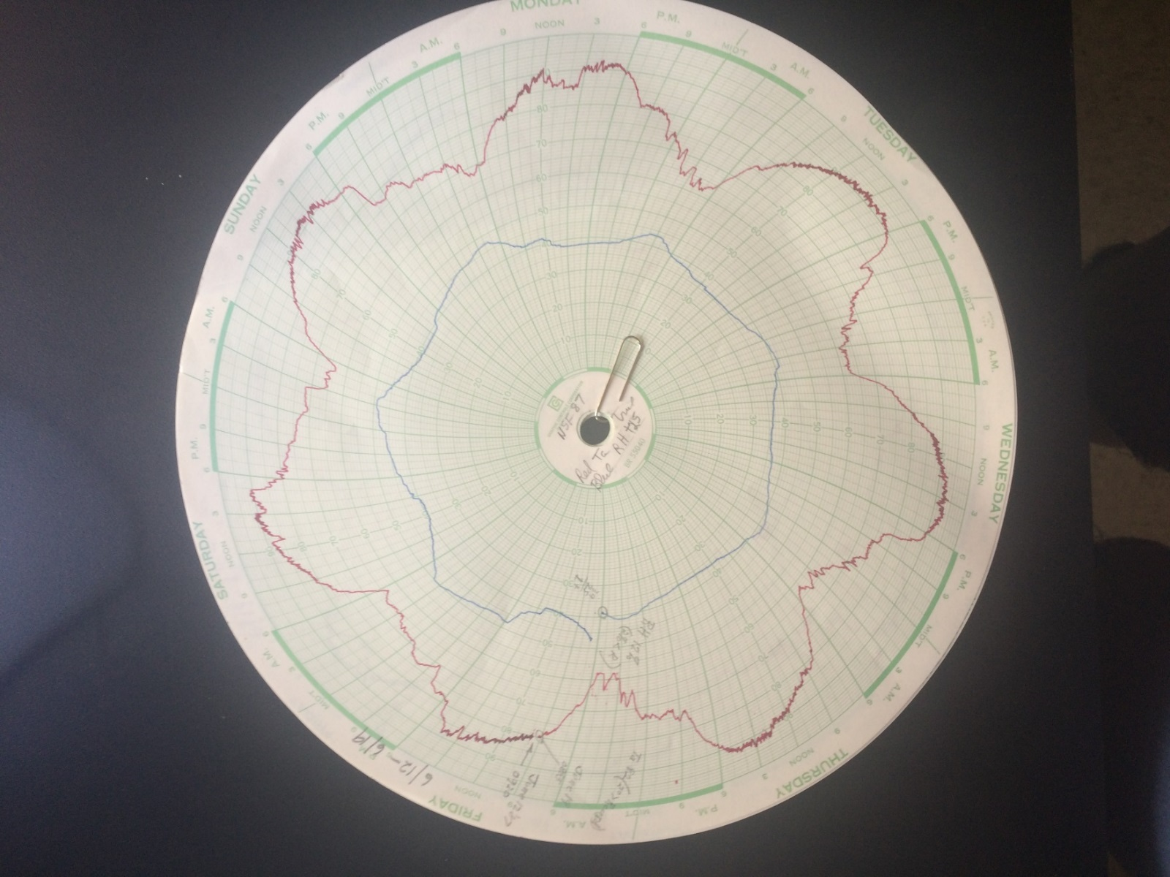weather data.

Figure 1: Circular graph paper from the 1980 hygrothermograph, recording temperature and humidity. Daily minimum and maximum temperatures were transcribed from these charts. Quality of the % humidity data was suspect and they were not used.

3. Research Methods

**Field:** *1980-1989:* Very little documentation exists regarding collection of weather data prior to 1989. Though we know from the charts that a circular hygrothermograph was used to collect temperature data, we do not know the instrumentation used. Humidity was also recorded, but we know from notes on the charts that it was considered unreliable. Our only record of the collection of precipitation data is the date on which a non-zero amount was recorded. We have included precipitation in the daily data table to retain this collection record. Of course, this does not reflect actual daily rainfall. **The daily precipitation data should absolutely not be used, but should be summed over longer time periods to correct for the irregular collection.**

*1989-2013:*  Data are downloaded monthly in conjunction with the monthly rodent census. While we do not appear to have documentation on the accuracy of the rain gauge associated with the first automated weather station, we do know that it was a tipping bucket rain gauge and the data suggest that each tip was equal to 0.254 mm. This is equivalent to the tipping bucket rain gauge associated with the current weather station which began operation in 2002.

# CLASS III. DATA SET STATUS AND ACCESSIBILITY

A. Status

Latest Update: December 2013

Latest Archive date: December 2013

**Metadata status**: The metadata are complete and up to date.

**Data verification:** A manual rain gauge is maintained on site and recorded monthly when the datalogger is downloaded. The manual rain gauge data is compared to monthly precipitation totals from the datalogger to provide independent verification of rainfall amounts.

B. Accessibility

**Storage location and medium:** (Ecological Society of America data archives [Ecological Archives], URL published in each issue of its journals). Original data files reside with S.K. Morgan Ernest on two separate machines.

**Contact person:** S.K. Morgan Ernest, Department of Wildlife Ecology and Conservation, 110 Newins-Ziegler Hall, PO Box 110430, Gainesville, FL 32611. email:skmorgane@ufl.edu

**Copyright restrictions**: None.

**Proprietary restrictions:** None. However, we do request that authors of publications using the precipitation database notify S.K. Morgan Ernest (contact information above) of publication of their study. This helps us by allowing us to make accurate reports to the National Science Foundation and document that the scientific community finds the data from this study to be useful.

**Costs:** None.

# CLASS IV. DATA STRUCTURAL DESCRIPTORS

### 1980-1989 WEATHER DATA

**A. Data Set File:**

**Identity:** Portal_weather_19801989.csv

**Size:** 3493 rows (including header), 73 kilobytes.

**Format and storage mode:** ASCII text, comma delimited. No compression scheme used.

**Header information:** The first row of the file contains the variable names below.

**Alphanumeric attributes:** Mixed

**B. Variable information**

**Table 1.** Column information for Portal_weather_19801989.csv.

|  |  |  |  |
| --- | --- | --- | --- |
| *Variable name* | *Variable definition* | *Storage type* | *Variable codes, definitions, and notes* |
| Year | Year data collected | Integer | 1980-1989 |
| Month | Month data collected | Integer | 1-12 |
| Day | Day data collected | Integer | 1-31 |
| MaxTemp | Maximum daily temperature | Double | Measurement unit: C  -99 = missing data |
| MinTemp | Minimum daily temperature | Double | Measurement unit: C  -99 = missing data |
| Precipitation | Precipitation amount in rain gauge on day collected | Double | Measurement unit: millimeters  NOT a daily measurement!  -99 = missing data |

### 1989-2013 WEATHER DATA

A. Data Set File:

**Identity:** Portal_weather_19892013.csv

**Size:** 201562 rows (including header row), 4625 kilobytes.

**Format and storage mode:** ASCII text, comma delimited. No compression scheme used.

**Header information:** The first row of the file contains the variable names below.

Alphanumeric attributes: Mixed.

B. Variable information

**Table 2**. Column information for Portal_weather_19892013.csv

|  |  |  |  |
| --- | --- | --- | --- |
| *Variable name* | *Variable definition* | *Storage type* | *Variable codes, definitions, and notes* |
| Year | Year data collected | Integer | 1989-2013 |
| Month | Month data collected | Integer | 1-12 |
| Day | day data collected | Integer | 1-31 |
| Hour | Hour data collected | Integer | 1-24 |
| TempAir | Air Temperature | Double | Measurement unit: Celsius |
| Precipitation | Precipitation amount | Double | Measurement unit: millimeters |

# CLASS V. SUPPLEMENTAL DESCRIPTORS

A. Publications using the data set: See *Portal_overview_metadata.html*

# LITERATURE CITED

Ernest, S. K. Morgan, Thomas J. Valone, and James H. Brown. 2009. Long-term monitoring and experimental manipulation of a Chihuahuan Desert ecosystem near Portal, Arizona, USA. Ecology 90:1708.