IoT w przemyśle – IioT (Industrial Internet of Things) jest określane mianem czwartej rewolucji przemysłowej. Jednym z kluczowych elementów jest Big data analytics (BDA) polegające na zbieraniu i analizie ogromnej ilości danych zbieranych często z różnych lokacji. Jednym z rozwiązań tego problemu jest CCM - (concentric computing model) będący paradygmatem tworzenia i deploymentu systemów zajmujących się BDA.
CCM jest zdefiniowany jako wielowarstwowy model w którym każda warstwa jest projektowana z uwzględnieniem ziarnistości urządzeń i systemów, oraz często dużych dystansów pomiędzy źródłami danych a jednostkami pracującymi na tych danych. CCM nie jest sztywnym paradygmatem i projekt może być dopasowany do danego problemu BDA, w zależności od zadanej przepustowości sieci, wymagań prywatności i bezpieczeństwa, pingu, poboru energii w przypadku urządzeń na baterie. Poniżej znajduje się przykładowy model:
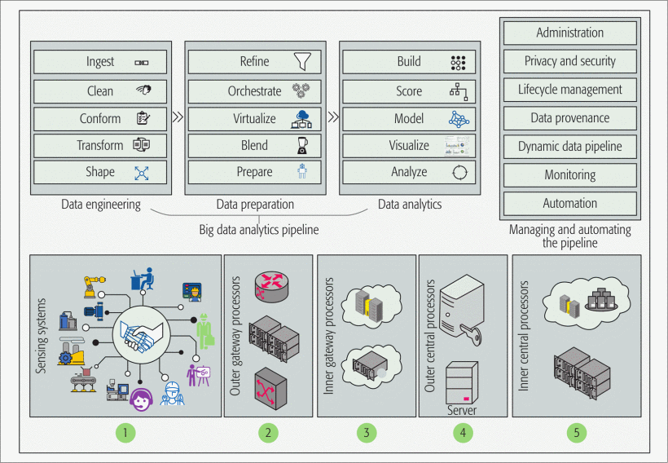

Warstwy:
- Sensoryczna – IWSNs (intelligent wireless sensor networks), maszyny, sensory
- Zewnętrzne gatewaye – smart routery i switche, serwery aplikacyjne
- Wewnętrzne gatewaye – micro chmury, cloudlety (małoskalowe, mobilne, chmurowe centra danych)
- Zewnętrzne centralne procesory – serwery wirtualne, VPN, kontrolery chmury
- Wewnętrzne centralne procesory – serwery WAN, chmurowe centra danych

Warstwa sensoryczna
W zależności od zadanego problemu i stopnia jego skomplikowania może składać się z prostych sensorów (np. termometrów) lub z high-endowych systemów (IWSNs). Zintegrowane sensory w maszynach produkcyjnych oraz wyposażenie robotników (smartphony czy smart-okulary) także będą integralną częścią przyszłych systemów produkcyjnych. Umożliwienie data processingu już w tej warstwie może znacznie obniżyć pingi i ruch wewnątrz sieci, ale spowoduje znaczny wzrost poboru prądu co może stanowić problem w systemach zasilanych bateriami.

Zewnętrzne gatewaye
Istnienie tej warstwy umożliwia efektywne wykorzystanie energii i zmniejszenie pingu, oraz wprowadzenie redukcji i filtracji danych co obniży obciążenie sieci.

Wewnętrzne gatewaye
Istnienie tej warstwy umożliwia kontrolę przepływu danych w sposób bezpieczny, odporny na ataki i zachowujący prywatność użytkowników sieci.

Zewnętrzne centralne procesory
Wielkoskalowa infrastruktura obliczeniowa pozwala na zarządzanie działaniem aplikacji, kontrolę i routing danych oraz ich dalszą filtrację i redukcję.

Wewnętrzne centralne procesory
Znajdują się najdalej od urządzeń sensorycznych. Projektowane są jako systemy rozproszone zdolne do równoległej pracy – klastry, chmury, multi-chmury. Umożliwiają deployment aplikacji BDA wymagających ogromnych mocy obliczeniowych, oraz wielkich sieci komunikacyjnych i magazynów danych.

Smart cities:
Urbanization can be seen all around the world, but especially in developing countries, where resources are often scarce and efficient management is necessary to meet the needs of growing urban population.
Key smart sectors include health care, transport, energy, water and waste management. Figure below shows some of the possible pillars for the smart city and the applications related to it.

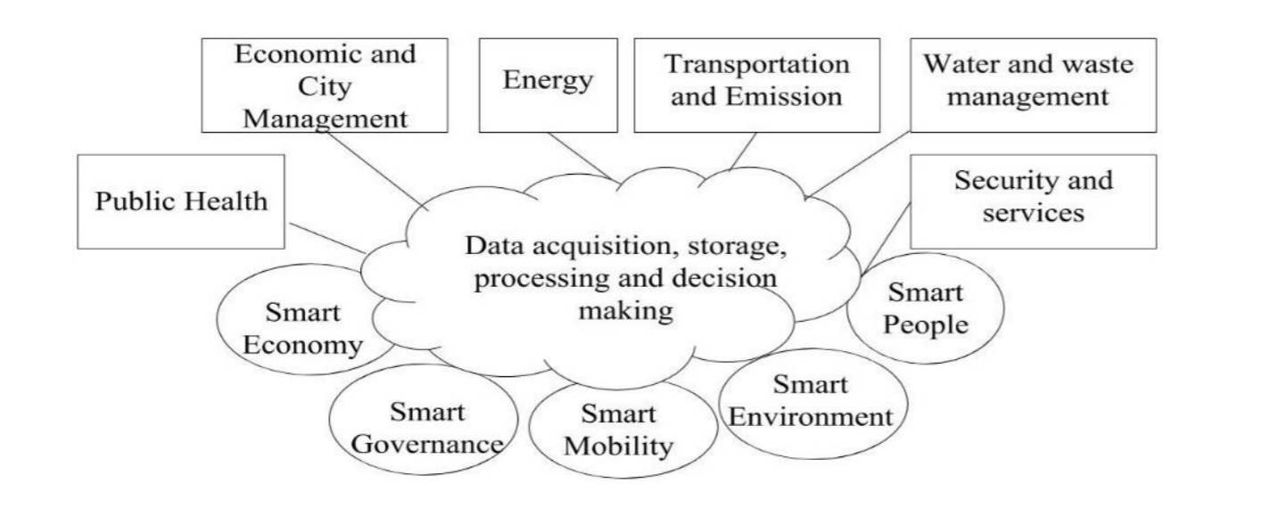
In some countries, like India, the main incentive for the use of IoT in creating smart cities is its ability to provide very efficient water managment, without which the cities could not grow.
Machine learning methods are considered to be vastly superior in tackling this kind of problems as the amount of data generated is too big for humans to analyze.
The smart water management can be divided mainly into three parts (1) forecasting demand, (2) water quality monitoring and (3) anomaly detection.

- Water demand forecasting
The optimization of water management system can be done cost effectively by using prediction. For a better planning and also to meet up with the demand for a resource it’s always essential to plan for the future.
Almost all kinds of different approaches were already used to make forecasts, although time series analysis is the most widely used. The Autoregressive Integrated Moving Average (ARIMA) model comprises of differentiation and integration process. When the seasonality property of time series is reflected then the model is extended to SARIMA. The time series data with auto correlation makes use of the Autoregressive Fractionally Integrated Moving Average (ARFIMA). Error percentage Correction(EPC) algorithm which uses weighted hourly usage and error feedback to forecast the demand hourly, Genetic Programming (GP) with Extended Kalman filter (EKM) where GT selects the best model and EKF predict states or Bayesian Network for forecasting and a new accuracy measurement called Discrete Mean Absolute Forecasting Error (DMAE). Out of all methods the following conclusions are infered:
Input parameters: There are fair number of papers in which the model just makes use of the water demand as a single input and is still able to make a fairly accurate forecast. Other models make use of the measured weather information like the temperature, humidity, rainfall etc as the input along with water demand.
Time step: The time step denotes the time difference in which the consumption on water have been recorded. Time step for a model is decided by the purpose for which the model is being used. The model can be for hourly basis, daily or monthly. The smallest time step found is one hour, which is a large gap as it can’t describe all the variations in the demand.
Demand patterns: Most of the models use different patterns for different days of week: one for weekdays, one for Saturday’s and another for Sunday’s. Also sometimes national holidays are taken into consideration.
Model recalibration: Almost all the models are formulated on some historical data and so the model needs to be recalibrated with new datasets when implementing in real life situations.
- Water quality
It is essential to monitor the quality of a life sustaining resource like water. The machine learning techniques like Artificial Neural Network (ANN) and fuzzy systems are widely used for this purpose. The main sensing parameters that are measured to analyse the water quality are level of turbidity, chlorine, ORP, Nitrates, pH, conductivity and temperature.
- Anomaly Detection
The anomalies are those data which don’t follow the usual pattern of the data, such data are also called outlier. Due to high dimensionality of data, statistical techniques ofthen don’t work, nearest neighbours are computationally complex. Clustering is also used, where large clusters are normal data and small are outliers.

General purpose gateways
One of the most complex problems in IoT is data aggregation – the issue of all the devices using different methods of comunication, comunicating different types of data. This is why most of systems use specifically desinged gateways, which limit flexibility. Architecture described below enables the use of general purpose gateways which can be used with different sensors and devices.
To maintain the normal requirements for IoT gateways and in order to be able to use multiple communication protocols, adapting them to user requirements a gateway was created, based on common requirements and capable of using every sensor and communication protocol, both wired and wireless, that is available. The system relies on a group of devices connected over a network that is controlled by an application using a given communication protocol. Figure presents a high level system architecture and, as shown, the system is composed by hardware, software and the implemented communication features.
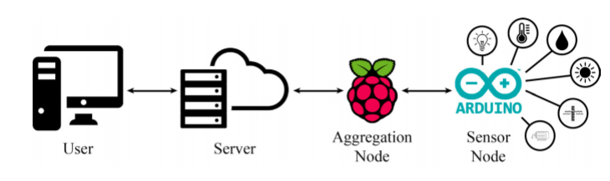

- Hardware
The hardware components adopted consist in a Raspberry Pi 314, a low-cost credit card sized computer with enough processing power and memory, that support programmable I/O ports and the use of standard peripherals, as an aggregation node or gateway; an Arduino Uno15, an open-source electronics single board based on a simple input/output capable of interfacing different peripherals, sensor and wireless communication devices, as a node sensor that collects information from temperature, humidity, luminosity and water level. Also a set of relays are used to control numerous actuators such as lights and motors.
The aggregation nodes are not responsible for reading sensors, they just provide a gateway between the user and the Sensor Network and also perform some data analyses. The sensor node, the lowest level of a Sensor Network, is responsible for gather information from sensors, perform user actions and use communication mechanisms to send data to the aggregation node.
- Software
WebPlatform
The web platform consists on a display for the information gathered from the sensor network. The user can choose which sensors to display, as well as the current values and past data retrieved, turn on and off all the actuators and switch between functionality modes. The web platform also provides the user a bridge to the sensor network using the MQTT protocol, with the Eclipse Paho JavaScript Client 16. It is hosted on a private server, containing a private MySQL database for storage and was built using HTML, PHP, Javascript, CSS and AJAX for both control and communication.
Python Scripts
Present in the aggregation node, this scripts are responsible for receiving the data from the sensor node and send them to the server using the MQTT protocol. They are also responsible for receiving commands sent from the user through the web platform and pass them to the sensor node. These scripts use the Eclipse Paho Python Client 16. They represent as well the MQTT broker, in which the web platform and the client scripts will connect, using the Mosquitto MQTT broker 17.
- Communication protocols
As mentioned before, communication is one of the main elements of IoT. In the system there are two key communication points, between the server and the aggregation node and from the this last to the sensor node. In the first, the need was to have an open-source, low bandwidth consumption and good performance application layer Internet protocol that can also connect a JavaScript Client to a Python Client, so the communications are done using MQTT, a protocol design for IoT projects. In the second, there is a range of options with both wired or wireless capabilities. Low-cost, low-power, high range, multi-node communication protocol with low hardware complexity is needed. The protocols that adapt to the specification range from both environments, like I2C, RS485, ZigBee or LoRaWAN but to ensure a bigger reliability and an easy connection the communications are done using Serial Communication in the form of an USB cable.
Message Queuing Telemetry Transport
MQTT is a messaging protocol that aims at connecting embedded devices and networks with applications and middleware. Built on top of the TCP protocol, uses a publish/subscribe pattern, with a routing mechanism (one-to-one, one-to-many, many-to-many), to provide flexibility and simplicity transition making MQTT an optimal connection protocol for the IoT and M2M being suitable for small, cheap, low power and low memory devices with low bandwidth networks. Compared to HTTP, MQTT is designed to have a lower protocol overhead. MQTT consist of three components: subscriber, publisher and broker. A device registers as a subscriber for specific topics of interest in order to get the information publish to that topic. The publisher acts as a generator of data for some topic, transmitting that information to the subscriber through the broker.
Materiały z których będziemy korzystać przy kontynuowaniu prac nad dokumentacją:
https://en.wikisource.org/wiki/Approaches_on_Internet_of_Things_Solutions
https://techbeacon.com/4-stages-iot-architecture
https://www.sciencedirect.com/science/article/pii/S1877050916316428
https://www.sciencedirect.com/science/article/pii/S187770581630008X
https://www.sciencedirect.com/science/article/pii/S1877050917310128
https://www.sciencedirect.com/science/article/pii/S016412121730105X

