# Movie Groovy

Movie Groovy is a movie repository for storing movies and their description. This gives the user access to a database of movies that they are interested in.

## Installation

Upload the "MovieApp_CSC660.sln" file into visual studio and the "app-repository-movies.bacpac" into Microsoft SQL.

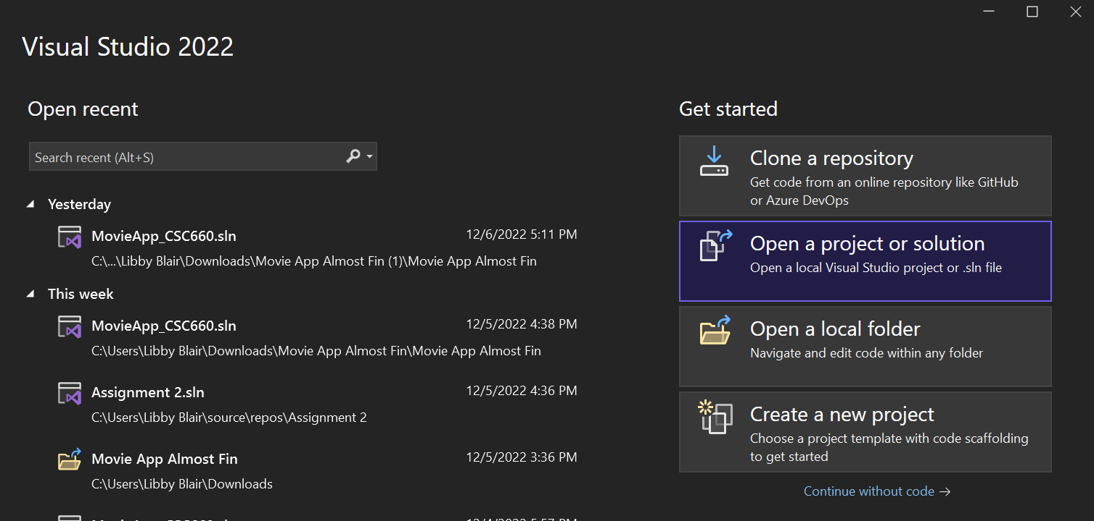

## Usage

You can either create movies or search movies that have already been created in the movie repository by running the app in Visual Studio.

