Demo Report



Officer Package Demo

Libby Heeren

Contents

# Average Total Interactions by Month

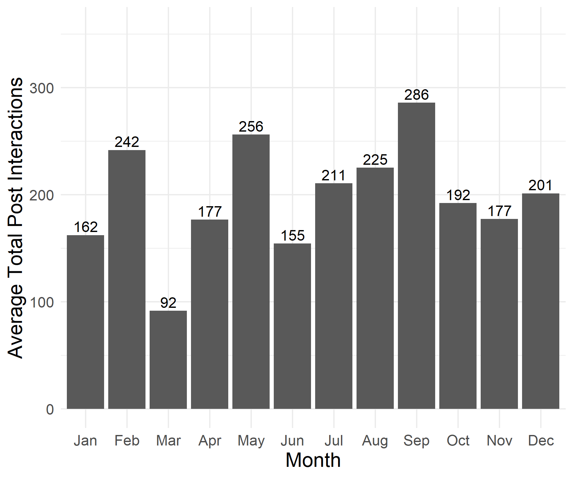

## Average Total Interactions Table

| Month | Average |
| --- | --- |
| Jan | 162 |
| Feb | 242 |
| Mar | 92 |
| Apr | 177 |
| May | 256 |
| Jun | 155 |
| Jul | 211 |
| Aug | 225 |
| Sep | 286 |
| Oct | 192 |
| Nov | 177 |
| Dec | 201 |

## Description

This section shows the average Total Interactions on posts by month and includes both paid (paid facebook to promote the post) and unpaid posts. In the plot above, we see that February, May, and September show the highest average levels of Total.Interactions per post.

## Strengths

Data strengths go here, delete sections as needed.

## Limitations

Data limitations go here.

## Assumptions

Data assumptions go here.

# Average Total Interactions by Weekday

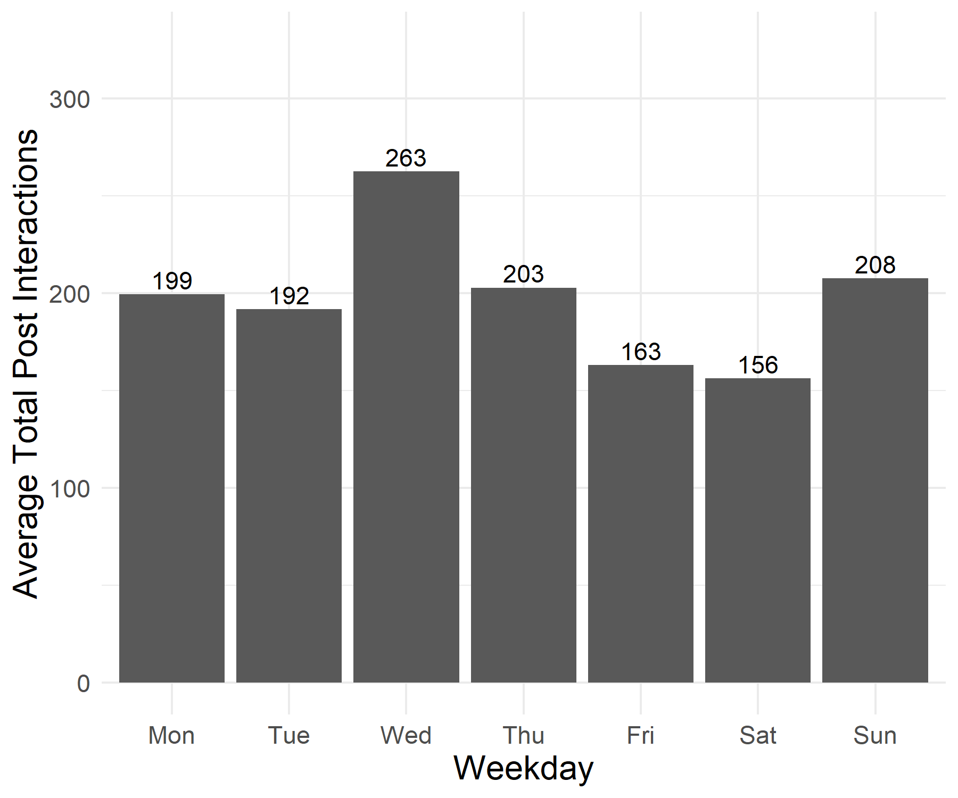

## Average Total Interactions Table

| Weekday | Average |
| --- | --- |
| Mon | 199 |
| Tue | 192 |
| Wed | 263 |
| Thu | 203 |
| Fri | 163 |
| Sat | 156 |
| Sun | 208 |

## Description

This section shows the average Total Interactions on posts by Weekday and includes both paid (paid facebook to promote the post) and unpaid posts. In the plot above, we can see that Wednesdays and Sundays have the highest levels of interactions per post.

## Strengths

Data strengths go here, delete sections as needed.

## Limitations

Data limitations go here.

## Assumptions

Data assumptions go here.

# Average Total Interactions of Paid vs Unpaid Posts

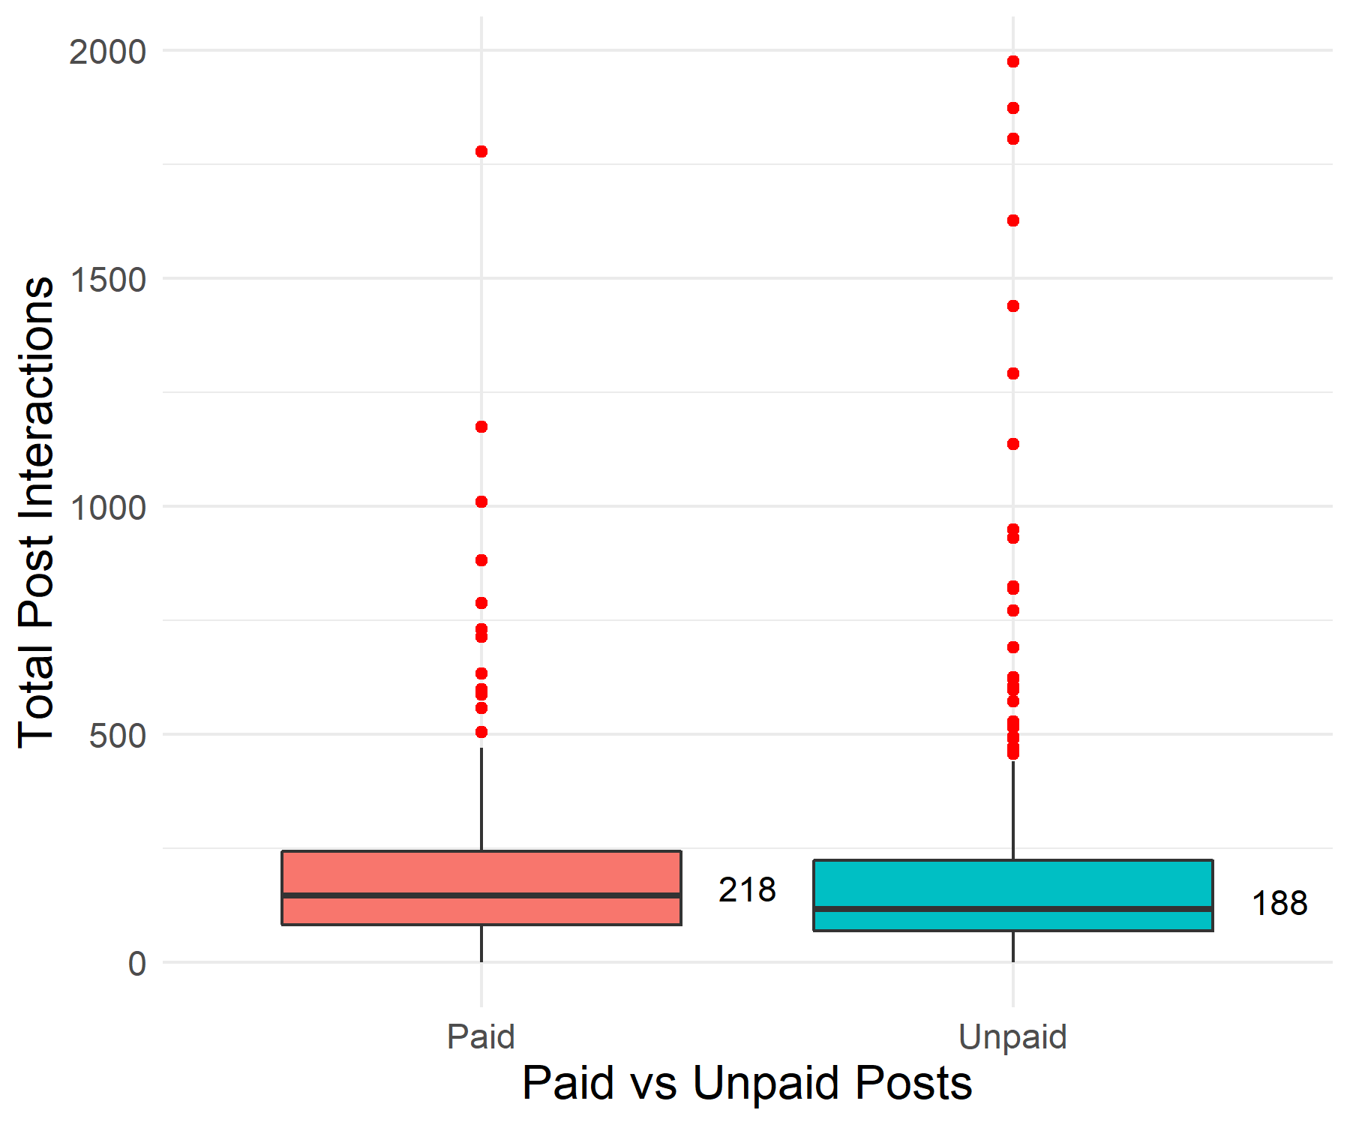

## Average Total Interactions Table

| Paid_or_Unpaid | Average |
| --- | --- |
| Paid | 218 |
| Unpaid | 188 |

## Description

This section shows the mean (labeled on the chart) and distribution Total Interactions on paid versus unpaid posts. In the plot above, we can see the average number of Total.Interactions for Paid posts (via Facebook Ads) is slightly higher than that of Unpaid posts, though the majority of both types of posts have about the same number of Total.Interactions, and both groups have some high outliers skewing their distributions to the right.

## Strengths

Data strengths go here, delete sections as needed.

## Limitations

Data limitations go here.

## Assumptions

Data assumptions go here.