Officer Package Demo

Libby Heeren

2/26/2022

This demo would’nt be possible without the guidance and mentorship of my former director, Walt DeGrange. He taught me all I know about the officeverse. Thanks, Walt!

The below code chunk is a formatting chunk, the yInfl sets the y axis to be 1.25 times larger than the max y value, allowing headroom for data callouts on chart bars. I’ve set the colors using the tropical palette from my coolers.co collection: <https://coolors.co/palette/e08e94-e5ce6e-dadc89-bfe8d6-5ac1be-66a5c4-7973b3-d6d6d6>

For the colorBlindFriendly setting, if set to TRUE, ggplots will use the viridis palette, which doesn’t rely on red/green contrast.

This is the chunk where the template Word and PowerPoint files are read in. For my uses in this demo, I will use the standard templates that the officer package author David Gohel uses in his github (<https://github.com/davidgohel/officer>), but with some modifications of my own to the styles by choosing a different theme and adding a title and TOC (table of contents) page.

# Report will be the Word document, Presentation will be the PowerPoint deck  
  
# These objects will contain the blank template file which we will add to by creating objects called ReportNew and PresentationNew.   
  
  
Report <- read_docx("template.docx")  
  
  
Presentation <- read_pptx("template.pptx")

Let’s import some data. The Facebook data set has 490 rows and 19 columns. We will remove all rows with missing data. It can be found here: <https://www.kaggle.com/roxannac/facebook-data>

# read in facebook data set  
facebook = read.csv("dataset_Facebook.csv", header=TRUE)  
  
# remove all rows with missing values  
fbook = facebook[complete.cases(facebook),]  
  
# remove all output variables except Total.Interactions   
# and Lifetime.Post.Total.Reach  
removedVars <- c(9:18)  
fbook2 <- fbook[, -removedVars]  
  
# define "month" (numeric month is column 4 in the facebook data set)  
fbook2$Month <- month.abb[fbook2$Post.Month]  
  
# reorder month to be an ordered factor so months aren't in alphabetical order  
fbook2$Month <-factor(fbook2$Month,   
 levels = c("Jan", "Feb", "Mar", "Apr", "May", "Jun",  
 "Jul", "Aug", "Sep", "Oct", "Nov", "Dec"))  
  
# define "weekday" (numeric weekday is column 5 in the facebook data set)  
weekday=c()  
weekday[fbook2[,5]==2]="Mon"; weekday[fbook2[,5]==3]="Tue"  
weekday[fbook2[,5]==4]="Wed"; weekday[fbook2[,5]==5]="Thu"  
weekday[fbook2[,5]==6]="Fri"; weekday[fbook2[,5]==7]="Sat";   
weekday[fbook2[,5]==1]="Sun"  
  
# add weekday variable to dataset  
fbook2$Weekday <- weekday  
  
# reorder weekday to be an ordered factor so days aren't in alphabetical order  
fbook2$Weekday <-factor(fbook2$Weekday,   
 levels = c("Mon", "Tue", "Wed", "Thu", "Fri", "Sat",  
 "Sun"))  
  
# create a factor variable for paid vs unpaid posts (column 7)  
paid=c()  
paid[fbook2[,7]==1]="Paid"; paid[fbook2[,7]==0]="Unpaid"  
  
fbook2$Paid_or_Unpaid <- paid

Now that we have our data in place and ready to report on, we can begin adding pages to our document. Let’s start by exploring Total.Interaction by month.

## # A tibble: 12 x 2  
## Month Average   
## <fct> <formttbl>  
## 1 Jan 162   
## 2 Feb 242   
## 3 Mar 92   
## 4 Apr 177   
## 5 May 256   
## 6 Jun 155   
## 7 Jul 211   
## 8 Aug 225   
## 9 Sep 286   
## 10 Oct 192   
## 11 Nov 177   
## 12 Dec 201

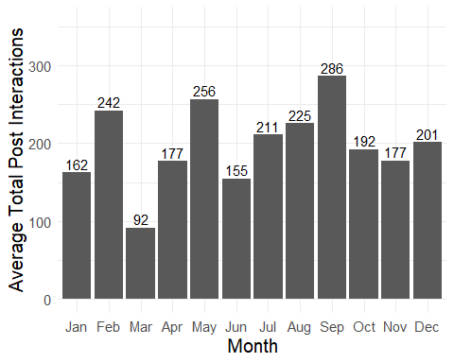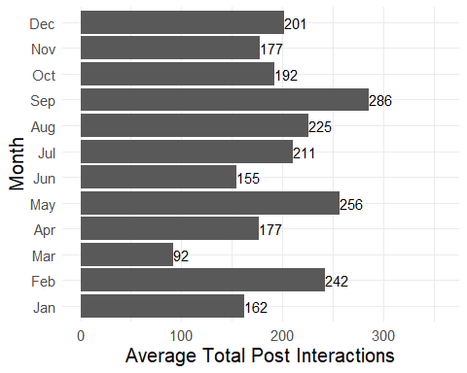

Now, let’s add a section exploring the average Total Interactions on posts by Weekday. All we have to do is copy the chunk above, change a few parameters, change the text descriptions as needed, and we’re done. We will change the Month variable to Weekday, and change any titles containing “by Month” to “by Week,” as well as the description of our findings.

Just for fun, let’s see the difference in average Total Interactions for paid and unpaid facebook posts, just so that we have another section to view in our demo. We will change anything that used the Weekday variable to use the Paid_or_Unpaid variable.