TELECOM CUSTOMER CHURN ANALYSIS REPORT
Prepared by: Pamella Nyahuma, Shingirai Machaka, Lillian Mkandla & Libert Kanojerera
1.0 Executive Summary
This report presents the findings of a comprehensive analytics project conducted to understand and predict customer churn within the business segment of a major Bulgarian telecommunications operator. Using customer level data from 8,453 business accounts, we developed and evaluated predictive models to determine which customers are most likely to leave the company and to identify the factors that may be driving this behavior. The dataset includes revenue attributes, subscriber activity measures, and customer segmentation variables.
Our analysis revealed that although several models achieve high overall accuracy, averaging around 92 to 93 percent, none of them perform well at identifying actual churners. This is due largely to the severe imbalance in the data; only 6.5% of customers have churned, which causes traditional models to default toward predicting that customers will stay. From a business perspective, the inability to correctly identify churners limits the usefulness of these models for proactive retention and account-management strategies.
However, the modeling work provides valuable insights into the structure and limitations of the existing data, highlights key variables that influence customer behavior, and lays the groundwork for a more advanced churn-prediction system. The findings point toward several practical actions the business can take, including improving data richness especially behavioral and service-quality indicators integrating class-imbalance techniques, and adjusting classification thresholds. Implementing these changes will enable the organization to better anticipate account losses, protect recurring revenue, and focus retention resources on the customers who matter most.
2.0. Introduction
Customer churn remains one of the most critical strategic challenges in the telecommunications industry, particularly within the B2B segment where each account represents significant recurring revenue and often holds influence over wider business networks. Competition in the market continues to intensify, and organizations that lack early-warning systems for customer loss run the risk of reduced profitability, churn contagion across related business units, and increased acquisition costs associated with replacing lost clients.
This project was designed to explore whether churn can be reliably predicted from the company’s existing customer dataset. The central question is whether the company can use this data to identify which accounts are at the highest risk of leaving, thereby enabling the business to deploy targeted retention strategies, adjust service delivery practices, or intervene through account-management teams before the customer disengages. Predictive churn analytics is not only about forecasting attrition; it is a tool for prioritizing resources, protecting revenue, and strengthening customer relationships.
Business question:
Can we build a predictive model that flags business customers at high risk of churn, so that the operator can proactively intervene with retention actions (e.g., discounts, tailored offers, or account management outreach)?
The key objectives of this project are to:
- Prepare and clean a real telecom dataset of business customers.
- Apply different predictive modelling methods to forecast churn.
- Compare models and discuss their usefulness in a decision-making context.
- Provide recommendations on how the telecom operator can use and improve such models.

3.0. Data Description and Preparation
The dataset used in this project consists of 8,453 customer records containing a mixture of revenue figures, subscriber counts, segmentation labels, and basic identifying information. Before modeling could begin, it was necessary to assess the quality of the data, address missing information, correct category inconsistencies, and remove fields that do not contribute predictive value. The raw dataset contains the following variables:

Variable Name | Description
pid | customer ID (business customer)
crm_pid_value_segment | customer value segment (Bronze
Silver | Gold
Platinum | etc.)
effective_segment | business segment (SOHO
VSE | SME
SE | LE
Other)
billing_zip | location ZIP code
ka_name | key account manager initials
active_subscribers | number of active SIMs/subscriptions
not_active_subscribers | number of inactive subscribers
suspended_subscribers | subscribers suspended in last 6 months
total_su_bs | total subscribers
avg_mobile_revenue | average mobile revenue per customer
avg_fix_revenue | average fixed-line/Internet revenue
total_revenue | total revenue
arpu | average revenue per user
churn | churn status (Yes/No)

3.1 Data Quality and Missing Values
A missing value assessment revealed substantial gaps in two variables: Suspended Subscribers (95.8 percent missing) and Not Active Subscribers (49.1 percent missing). These fields are potentially meaningful because they reflect subscriber inactivity or service suspension, which may signal disengagement. Rather than discarding them, we treated missing values as zeros due to the operational interpretation that “no recorded activity” often means “no inactive or suspended subscribers.” This approach preserves potential signals while maintaining dataset completeness.
- suspended_subscribers: 95.8% missing
- not_active_subscribers: 49.1% missing
- billing_zip: 0.02% missing
- arpu: 0.01% missing
All other fields: 0% missing
3.2 Variable Reduction
Several variables were removed because they functioned as identifiers rather than behavioural indicators, such as PID, billing ZIP code, and account-manager initials. Similarly, certain revenue fields that were highly correlated with others, for example ARPU, total revenue, and total subscriber counts were excluded to prevent redundancy and statistical distortion. The following were also excluded:
- pid – pure ID, no predictive meaning.
- billing_zip – too granular, risk of overfitting, not central to churn logic here.
- ka_name – high-cardinality identifier of account managers.
- total_subs, total_revenue, arpu – highly correlated with other revenue or subscriber variables (risk of multicollinearity and redundancy).
3.3 Category Cleaning
We also corrected category inconsistencies in the value-segment variable, merging rarely occurring categories and fixing spelling errors to ensure consistency across the dataset. Outliers were detected for several numeric fields, but these were retained because they likely represent legitimate high-value enterprise accounts rather than data errors.
3.4 Handling Missing Values
We replaced:
- not_active_subscribers NA → 0
- suspended_subscribers NA → 0
These treats missing values as “no inactive/suspended subscribers recorded”, which is consistent with how such fields are often interpreted operationally in business datasets.
3.4 Dummy Encoding for Some Models
For the logistic regression, kNN, and classification tree models, we converted categorical variables into dummy variables:
- crm_pid_value_segment → multiple binary dummy columns (Bronze, Gold, Iron, Silver, etc.)
- effective_segment → dummies (SOHO, VSE, SME, SE, Other)
- We used fastDummies::dummy_cols() with:
- remove_first_dummy = TRUE – to avoid perfect multicollinearity.
- remove_selected_columns = TRUE – drop the original categorical fields.
After all cleaning and encoding, the final modeling dataset (for the GLM/kNN/tree part) had 18 columns: numerical predictors, dummy variables, and the binary churn indicator.
4.0 Target Variable and Class Imbalance
We converted churn into numeric for some models:
- churn = 1 → customer churned
- churn = 0 → customer retained
Overall churn rate:
- Churn = 0: 7,904 customers (93.5%)
- Churn = 1: 549 customers (6.5%)
This strong class imbalance is the central difficulty in this modeling task: the models naturally tend to predict “No churn” almost all the time
4.0. Methodology
To evaluate the company’s ability to predict churn, we tested several widely used classification techniques. The dataset was randomly divided into a 60 percent training set and a 40 percent testing set, ensuring the churn proportion remained consistent across both subsets. The split was done using the following code;
set.seed(12345)
training_size <- 0.6
training <- sample(1:nrow(telecom), training_size*nrow(telecom))
And this resulted in;
- 60% of the data for training ~ 5,071 observations.
- 40% for testing ~ 3,382 observations.
logistic regression, k-nearest neighbors, classification trees, and bagged decision trees where applied. Each model was optimized through hyperparameter tuning to ensure fairness in comparison. Model performance was assessed through confusion matrices, accuracy scores, sensitivity, and specificity. Because the business objective is to detect churners as early as possible, sensitivity is the most important metric.
Logistic Regression  Model: glm(churn ~ ., family = binomial(link = "logit"))  Used all numeric and dummy-encoded features. | K-Nearest Neighbors  Used knn() from the class package.  Loop over k= 1 to 20  Best K Chosen based on minimal error rate
Classification Trees  Used tree() with different mindev values  loop searched over mindev values in the range 0.0005 to 0.05.  Best mindev chosen based on lowest test set error | Random Forest  Converted churn into a factor.  Fitted a Random Forest model with:  - ntree = 100 trees  - mtry = p for bagging

4.1 Evaluation Metrics
All models were evaluated using the test dataset, with performance assessed through both overall accuracy and detailed confusion-matrix outcomes. Accuracy provided a high-level view of how many predictions were correct, but the confusion matrix offered deeper insight by showing how often the models correctly identified non-churners (true negatives) and churners (true positives), as well as how often they misclassified customers as churners or non-churners (false positives and false negatives). Given the severe class imbalance in the dataset, accuracy alone can be misleading. For this reason, greater emphasis was placed on two metrics:
Sensitivity (Recall for churners): Measures the model’s ability to correctly identify customers who actually churn. Formula: TP / (TP + FN)
Specificity (Recall for non-churners): Indicates how effectively the model recognizes customers who remain with the company. Formula: TN / (TN + FP)
These metrics are especially important from a business perspective because failing to detect a churner (low sensitivity) carries far greater financial impact than incorrectly flagging a customer who is unlikely to leave.

5.0 Results
The logistic regression model achieved roughly 92.9 percent accuracy but predicted all customers as non-churners at the standard 0.5 threshold. The model identified only one weak predictor, average mobile revenue. The model also showed average fixed revenue as a negative predictor though it is statistically insignificant. The classification tree behaved similarly, and both models failed to meaningfully detect churn. The kNN model identified two churners and reached an accuracy of around 93 percent, while the bagged-tree model produced an accuracy of roughly 91.9 percent and also detected only two churners.
Model | Accuracy | Sensitivity (recall of churners) | Specificity | True positives | Notes
Logistic regression | 92.9% | 0% | 100% | 0 | Predicts all as non-churn
KNN (k=7) | 93.0% | 0.8% | 99.9% | 2 | Best performing model
Classification tree | 92.9% | 0% | 100% | 0 | No churners detected
Random forest | 91.9% | 0.8% | 98.8% | 2 | Slight improvement

These results show that while the models are technically sound, their ability to detect churn is severely restricted by the class imbalance. They predict retention correctly because almost all customers in the dataset remain with the company; however, they offer little predictive value for identifying the small minority that churn.
kNN (k=7) is the only model with any predictive value for churners. Random Forest is second best sensitivity, but lower specificity. Logistic Regression for worst at being useless for finding churners. However, even kNN's 0.8% sensitivity means only 1 in 125 churners are caught.

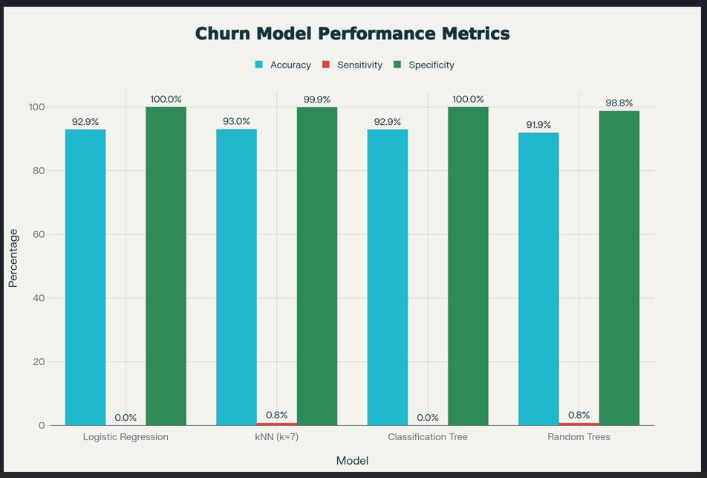
6.0 Discussion and Business Implications
Although none of the models accurately detected churners at a scale suitable for operational use, the analysis provides critical business insight. The current dataset does not contain sufficiently strong behavioural or service-quality indicators to distinguish churners from non-churners. Churn in business telecommunications environments is often influenced by contract renewal cycles, pricing structures, network quality, customer complaints, and competitive pressures, factors not captured in the existing dataset. The analysis demonstrates that the company cannot rely on accuracy alone as a success metric for churn prediction. Sensitivity is significantly more important for retention programs, since missing a churner is more costly than incorrectly flagging a customer who intends to stay.
6.1 Key Take Aways
- We now understand that data quality and class balance are major constraints.
- Some features like avg_mobile_revenue and segment dummies appear in the logistic regression and tree splits and can be further explored as potential risk indicators.
- The modeling pipeline (cleaning, dummy encoding, hyperparameter tuning, ensemble) if implemented correctly, can serve as a foundation for more advanced churn modeling.

6.2 Analysis Limitations
- Severe class imbalance (93.5% vs. 6.5%)
Models default to predicting “No churn” because that minimizes error.
- Limited feature richness
No usage, complaint, tenure, or contract information is present, which are often crucial for churn prediction.
- Single train-test split
We used one 60/40 split; repeated cross-validation would be more robust.
- Default probability threshold (0.5)
We did not yet operationally tune a lower threshold (e.g., 0.3) inside these R models; doing so could trade specificity for better sensitivity.
- No explicit imbalance techniques used
We did not apply SMOTE, under-sampling, or class weights in this R workflow.

7.0 Recommendations and Future Directions
1 Fix class imbalance
- Action: Rebalance the churn vs non-churn data and adjust the decision rule.
- How: Apply oversampling (e.g., SMOTE) or under sampling, use cost-sensitive training that penalizes missed churners more, and lower the churn probability threshold (for example from 0.5 to around 0.3) so more at-risk customers are flagged.
2 Use stronger models
- Action: Upgrade the modeling approach while keeping the current pipeline.
- How: Test Random Forests (with tuned depth and class weights), gradient boosting models such as XGBoost or LightGBM with imbalance-aware settings, and regularized logistic regression (LASSO/Ridge) with class weights to capture more complex churn patterns.
3 Improve data and features
- Action: Enrich the dataset with behavior and lifecycle features that better explain churn.
- How: Add variables such as tenure, contract/renewal dates, payment behavior, service quality metrics, customer-care interactions, and product mix so models can distinguish truly at-risk customers from stable ones.
8.0 Conclusion
This project evaluated several predictive modeling techniques logistic regression, k-nearest neighbors, classification trees, and bagged random forests on a real telecommunications churn dataset. The underlying data was rigorously cleaned, transformed, and feature-engineered, and hyperparameters were systematically optimized for the kNN and tree-based models.
Across models, overall accuracy was consistently high (approximately 92–93%), but performance in identifying churners remained weak because of severe class imbalance and a limited set of predictive features. This underscores an important consideration in applied analytics: high accuracy alone does not guarantee a model’s usefulness when the minority class is both rare and strategically critical. There is a likelihood of missing the most important churn drivers in the dataset in which case focus should be put on getting better features rather than trying different algorithms.
The work conducted provides a solid technical foundation in terms of data preparation, modeling workflow, and evaluation methodology, upon which more advanced, imbalance-aware approaches can be developed. By incorporating richer behavioral and lifecycle data, applying resampling and cost-sensitive techniques, and refining classification thresholds within more sophisticated models, the telecom operator can progress toward an effective churn early-warning system that enables targeted retention initiatives and enhances customer lifetime value.

Appendices
  - K-NN CONFUSION MATRIX
 | telecom.test.results
telecom.knn | 0 | 1
0 | 3142 | 237
1 | 1 | 2

  - RANDOM FORESTS CONFUSION MATRIX
 | Actual
Predicted | No | Yes
No | 3105 | 237
Yes | 38 | 2

  - CLASSIFICATION MODEL CONFUSION MATRIX
 | telecom.test.results
telecom.tree.classifications | 0 | 1
0 | 3143 | 239

  - Logistic regression RESULTS
Call:
glm(formula = churn ~ ., family = binomial(link = "logit"), data = telecom[training,
])

Coefficients:
Estimate Std. Error z value Pr(>|z|)
(Intercept) -2.902e+01 1.680e+03 -0.017 0.98622
active_subscribers 2.609e-03 9.950e-03 0.262 0.79314
not_active_subscribers 6.648e-03 7.659e-03 0.868 0.38543
suspended_subscribers 4.060e-02 1.024e-01 0.397 0.69166
avg_mobile_revenue 3.223e-03 1.118e-03 2.882 0.00395 **
avg_fix_revenue -2.436e-03 7.296e-03 -0.334 0.73844
crm_pid_value_segment_Bronze 1.324e+01 8.400e+02 0.016 0.98743
crm_pid_value_segment_Gold 1.296e+01 8.400e+02 0.015 0.98769
crm_pid_value_segment_Iron 1.330e+01 8.400e+02 0.016 0.98736
crm_pid_value_segment_Lead 2.207e-01 9.034e+02 0.000 0.99981
crm_pid_value_segment_Other 1.318e+01 8.400e+02 0.016 0.98748
crm_pid_value_segment_Platinum 1.260e+01 8.400e+02 0.015 0.98804
crm_pid_value_segment_Silver 1.326e+01 8.400e+02 0.016 0.98740
effective_segment_Other 1.294e+01 1.455e+03 0.009 0.99290
effective_segment_SE 1.197e+01 1.455e+03 0.008 0.99344
effective_segment_SME 1.206e+01 1.455e+03 0.008 0.99339
effective_segment_SOHO 1.253e+01 1.455e+03 0.009 0.99313
effective_segment_VSE 1.283e+01 1.455e+03 0.009 0.99296
---
Signif. codes: 0 ‘***’ 0.001 ‘**’ 0.01 ‘*’ 0.05 ‘.’ 0.1 ‘ ’ 1

(Dispersion parameter for binomial family taken to be 1)

Null deviance: 2333.4 on 5070 degrees of freedom
Residual deviance: 2299.4 on 5053 degrees of freedom
AIC: 2335.4

Number of Fisher Scoring iterations: 14

