Main Log Page
This is the default view when the database opens.
All records are sorted using a time stamp which is updated when a fault has progress added to it.
The idea is to make it easy to browse over what has been attended to in the last few days. Recent activity always bubbles to the top. (Useful for shift workers).

When a device is rolled in for repair, we look up it’s barcode or serial number (these are independently searchable).
If a device is not found, we add it to the database.
Non-barcoded items are given an auto-generated number, prefixed with “TS“. This number is written to both “Barcode” and “Serial Number” fields. However, it can be over-written in the “Serial Number” field, if a serial number exists.
The device is then labelled with this number for future identification.

After a barcode or serial number is searched, the entire fault history of a single device can be browsed.
Details of each fault can then be accessed using the magnifying glass button.

In a similar fashion, a history of system or facility faults can be found by selecting them by name from the “Sub Group” pull-down.
The database was originally designed for devices, so presently, systems are not well catered for. They rely too much on free text and therefore require a lot of administration to maintain description conformity.
My latest thoughts are to create a separate “System” table and deal with systems in the same manner as devices.

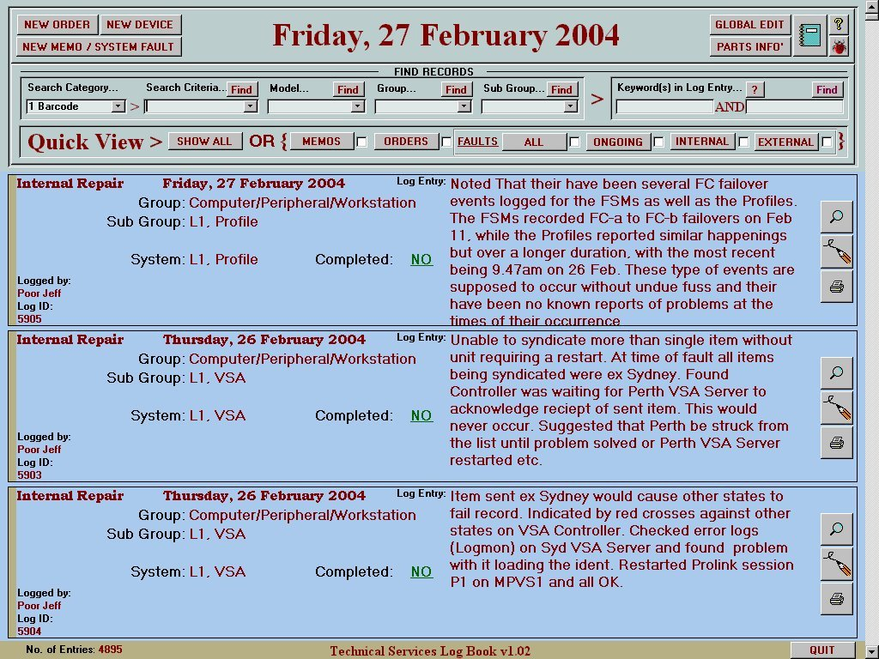

Searching
The number of records on the main page can be reduced using a variety of pull-down filters. The look-up on the “Search Criteria” pull-down can be changed according to “Search Category” selection.
Devices are uniquely identified by Barcode AND Serial Number, whereas Systems or Facilities are identified by Name and/or Location.
The “Group” field is used to categorise a facility according to it’s broad function.
The “Sub Group” field is a sub-set of “Group” and is used to uniquely identify a System or Facility.

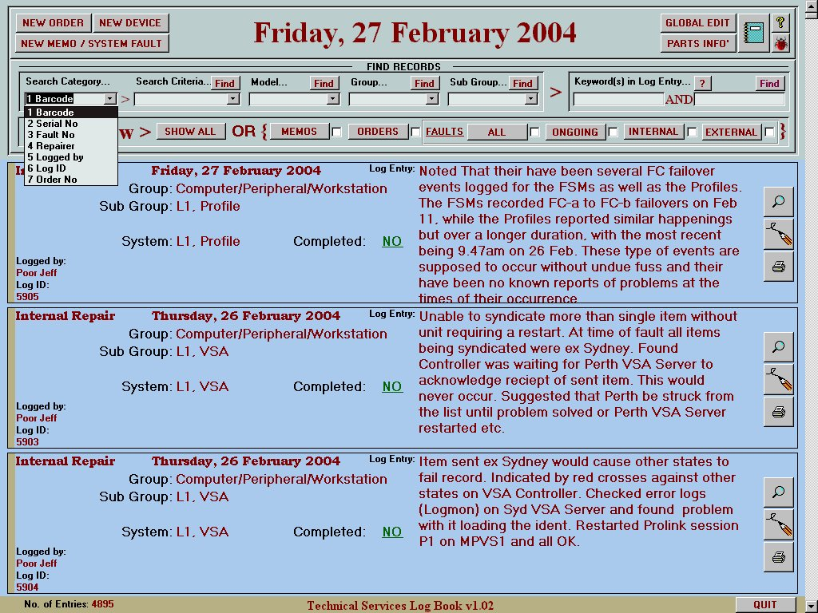

List of devices, where search is by Barcode…

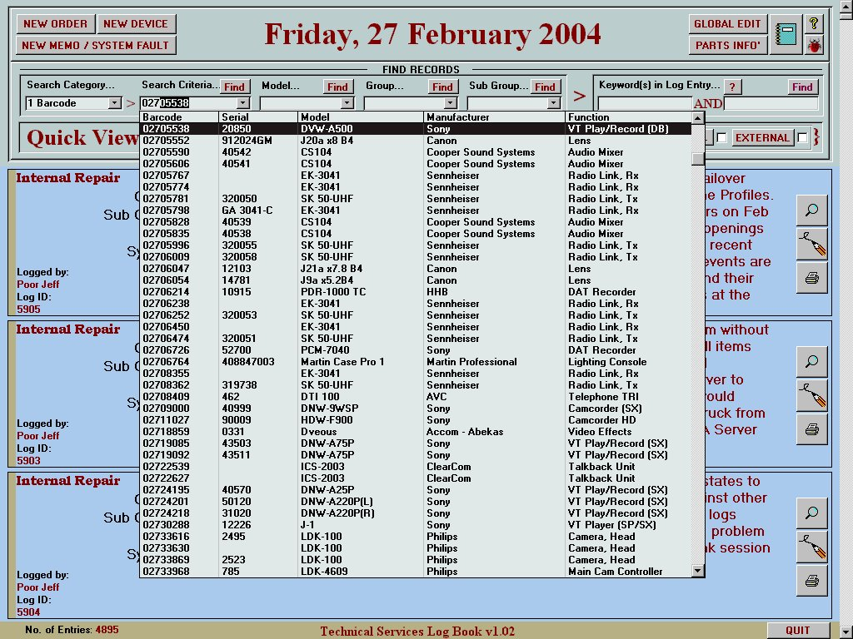

List of devices, where search is by Serial Number…

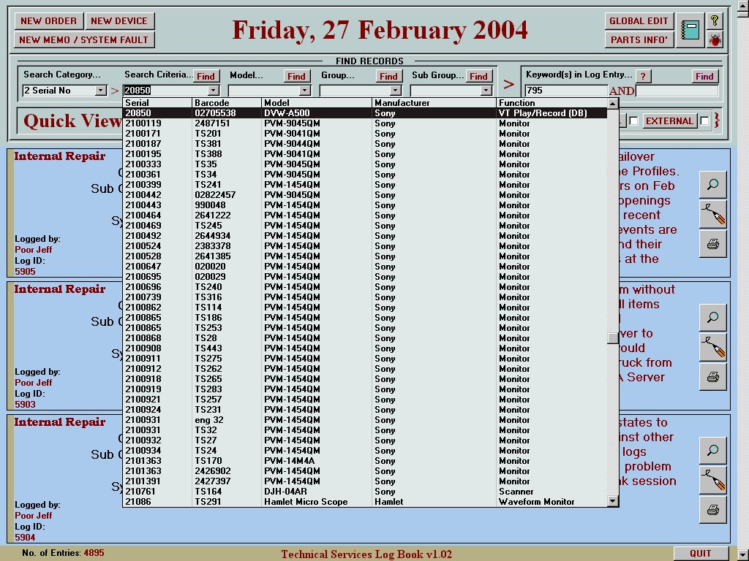

After a barcode search, entire history of a device can be browsed.
(Being an old machine, only two faults were entered)

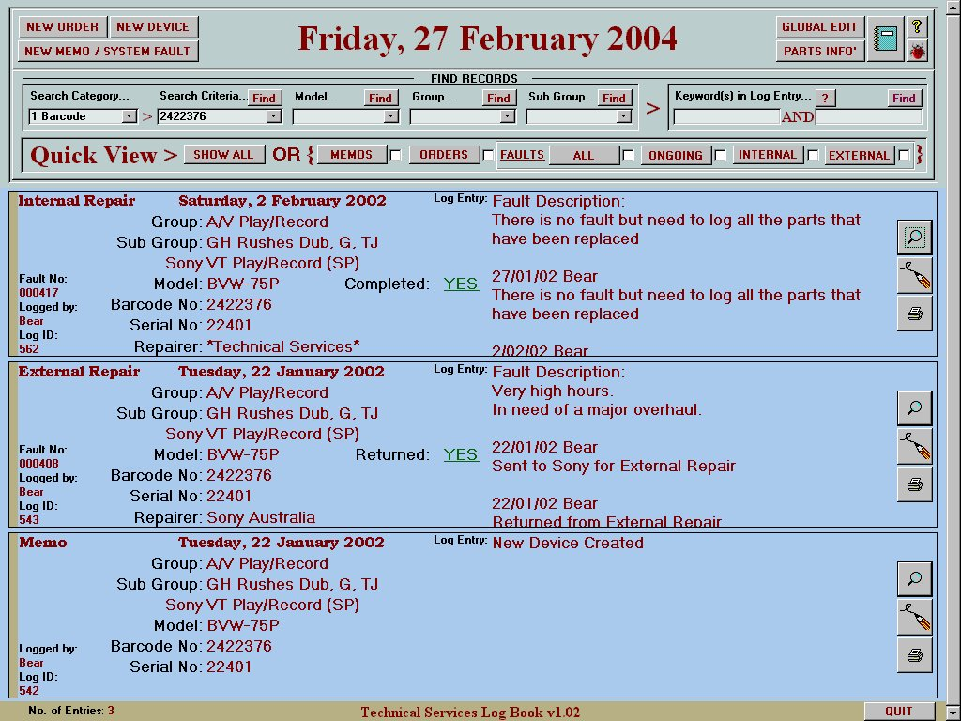

Pull-down list for search by Model…
This won’t identify a device directly, but it reduces the browse list down to a level that may help find a device that is not right in front of you. ie. When the barcode or serial number is not known.

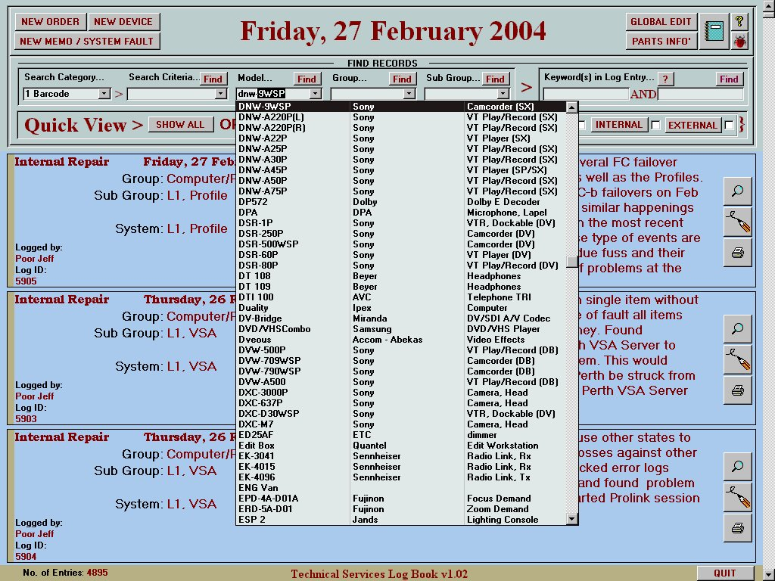
This is the detailed view of a fault for a device.
The record selector allows navigation to detail of faults before and after this one.
The Parts Replaced History together with drum and tape hours is useful for gauging when it’s time for a major overhaul.
The “Sub Group” field usually identifies the location of the device. (Useful when you have a hundred or so VTR’s spread across the building(s))

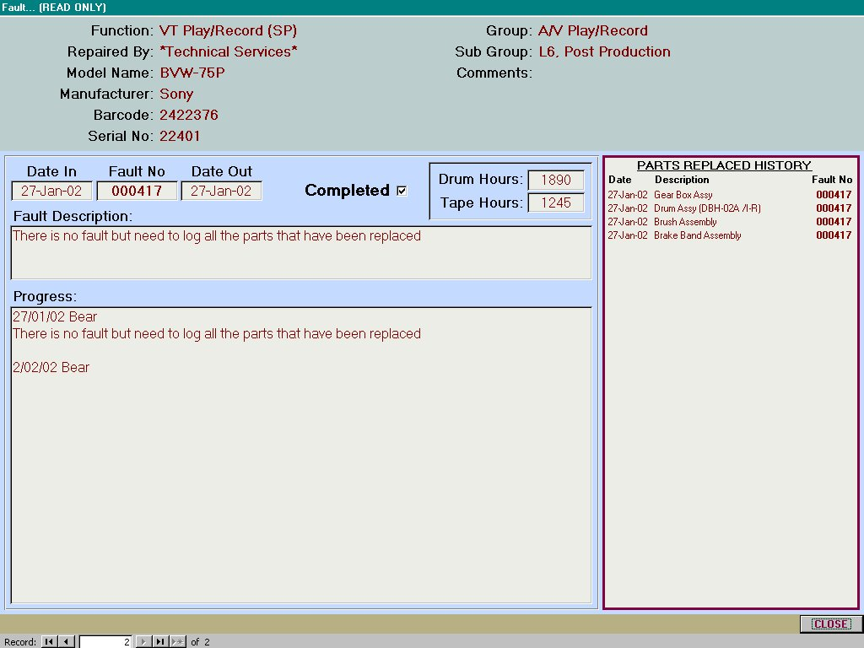
This is the form for creation of a new fault.
Each “Device” has a “Model” associated with it that has a “Default Repairer”.
If “External” repair is checked, the default repairer is automatically selected from a repairer list. Other repairers can be selected if desired. This feature is useful when you have no clue who normally repairs a particular model.
Wherever possible, free text entry has been avoided. In the case of external repairs, the log entry message is automated.
If something were to be typed in the log entry field, the auto-message is appended to it.
The idea is that the correctly spelled repairer always appears somewhere in the log entry.

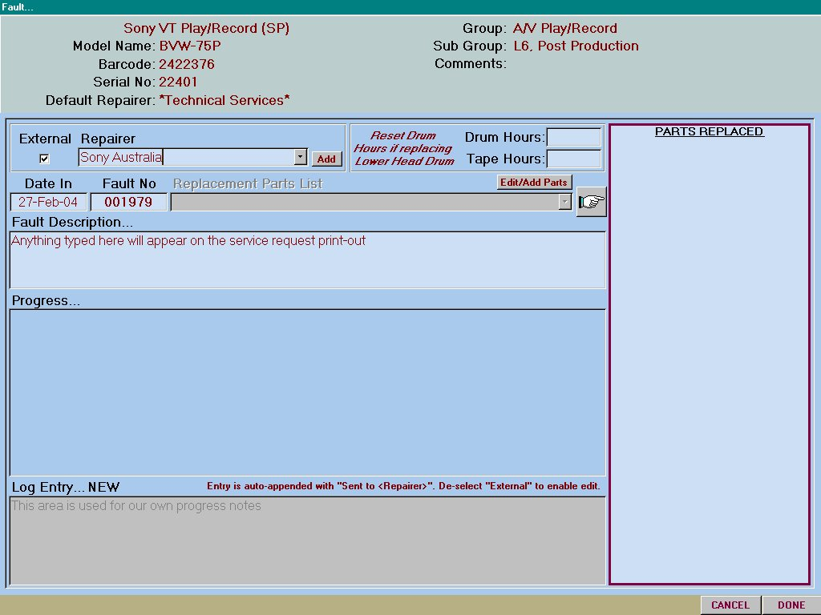
Print options available to an “External Repair” include a “Service Request”.
This gathers information about the “Model”, “Repairer” and “Sender” and prints out one copy for the dispatching store and another for our maintenance records.

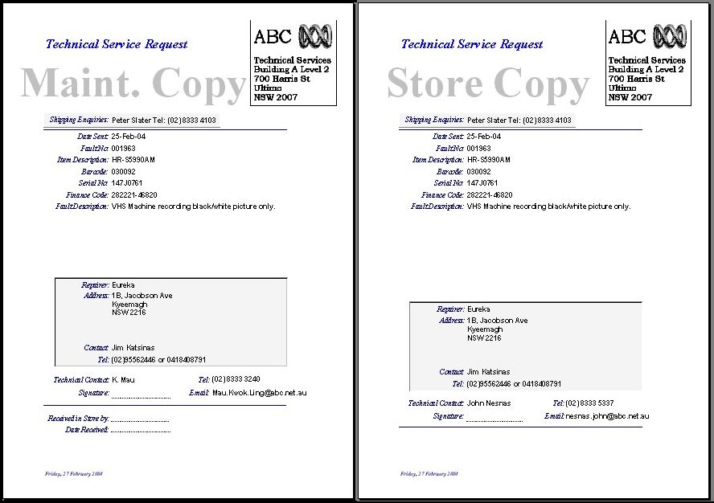

If “External” is not checked, the repairer becomes *Technical Services* and the fault is treated as an “Internal Repair”.

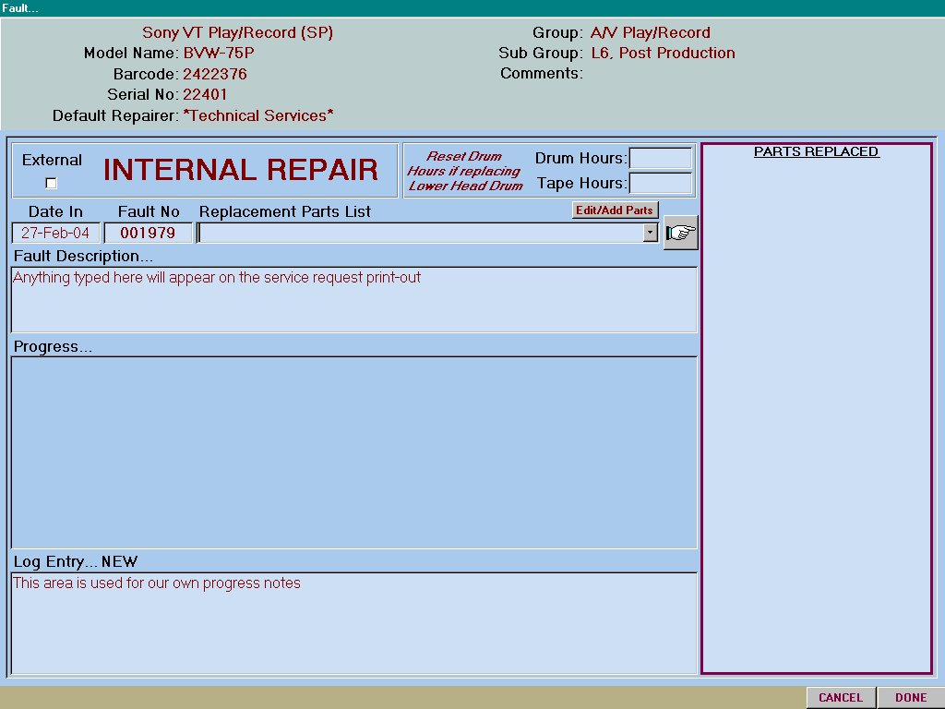
The fault form has a pull-down list of parts relevant to the model being repaired.
Parts that are common across a number of models share the same “Model Range” and therefore appear in the list of more than one model.
The stock level of a part is decremented as it is added to the parts replaced list. You are warned if stock levels fall below a specified minimum for that part.
More important than this, however, is storing the fact that a major part has been replaced.
It is an important aspect of device history and appears in the detailed view of any fault for a particular device.

