**Programming Keyboard**

**1**

Four decades ago, a computer keyboard looked like this:

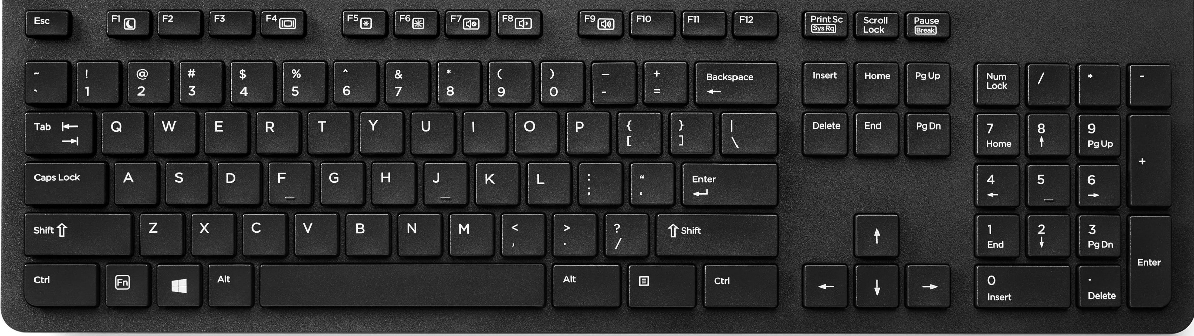

And four decades later, at present day, a computer keyboard still looks like this; it haven’t changed much.

So for we young people, the keyboard was just like this when we started to learn how to use it at the very beginning; and we get used to what it is like now.

We are so used to it and maybe you ignored some problems. for example, did you notice that many of the characters on the keyboard shared the same key with the other character?

@ shares the same key with the number 2, * shares the same key with number 8, ? shares the same key with / ,etc; When you press this kind of keys , the character below was input by default, if you want to input the characters at the above, you must press the “shift” key and the character key at the same time.

Well, some people may just use those characters occasionally, so it seems not so unconvenient for them; but for programmers, they use every character of those a lot for every day. They may press the “shift” key thousands of times per day. This costs a lot of work.

If your programming language is PHP, I’m sure the “$” character could almost have killed you after a long day programming.

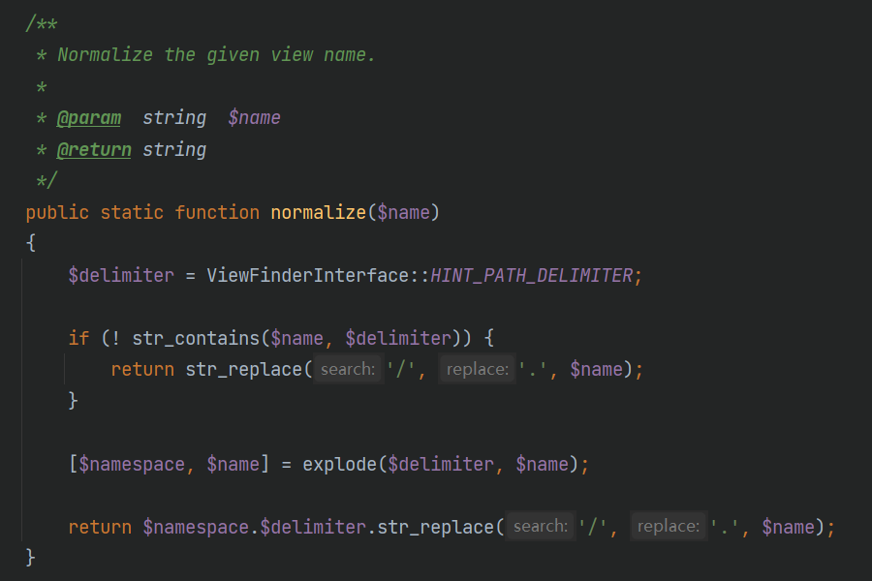

**2**

And there’s another problem. If your mother lauguange is not English, you will have to change your input mode frequently when you use the computer keyboard, especially when you are a programmer. And at the mean time, the input mode shift key is “shift” by default in Windows. Actually the word “shift” means nothing to you if your mother languange is not English, it’s just a shift key. When you want to input the above characters you’ll have to press “shift” key, and sometimes you may change the input mode by mistake when you don’t want to change it at all, this will cause you much annoyance.

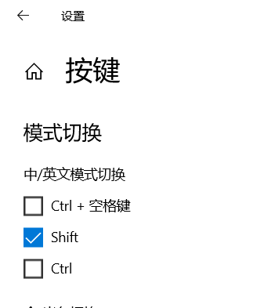

So why don’t we set those characters which need us press the “shift” key at the same time when we input them on a seperated key, just like the picture below:

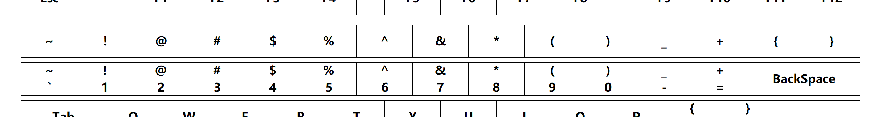

If we don’t have to press the shift key, we won’t have the input mode shift problem; and this can save a lot of work for programmers

**3**

Furthermore, in order to increase our input efficiency, IDE and many other softwares provide us many shortcut keys; the most famouse ones are Ctrl+c and Ctrl+v; we use those shortcut keys so frequently, so why don’t we use just one key to fulfill these operations? There’s no difficulty with tech to make this happen.

Well, actually 2 keys shortcut is ok with most of the people; the annoying shortcut is 3 keys shortcut or even 4 keys shortcut; for example: ctrl+alt+del or alt+shift+esc.

For some of the regular combinations, we can arrange them just on one key, and this will make many of our shortcuts much more easier; it’s just like the picture below:

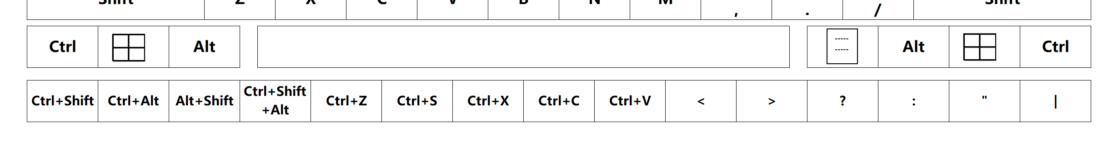

How do you like this idea?

I think programmer need this very much.

Regular people need this, too; who doesn’t need Ctrl+c and Ctrl+v after all?

**4**

the complete design is just as below:

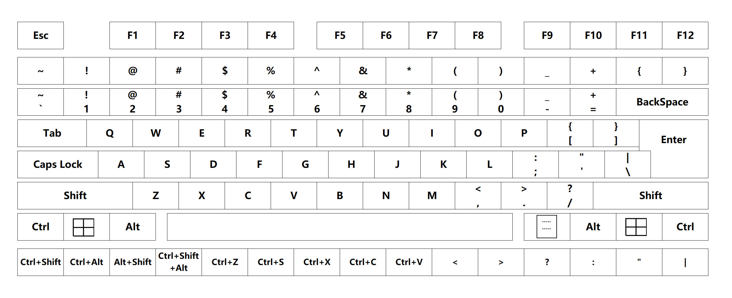

And the rendering is as this:

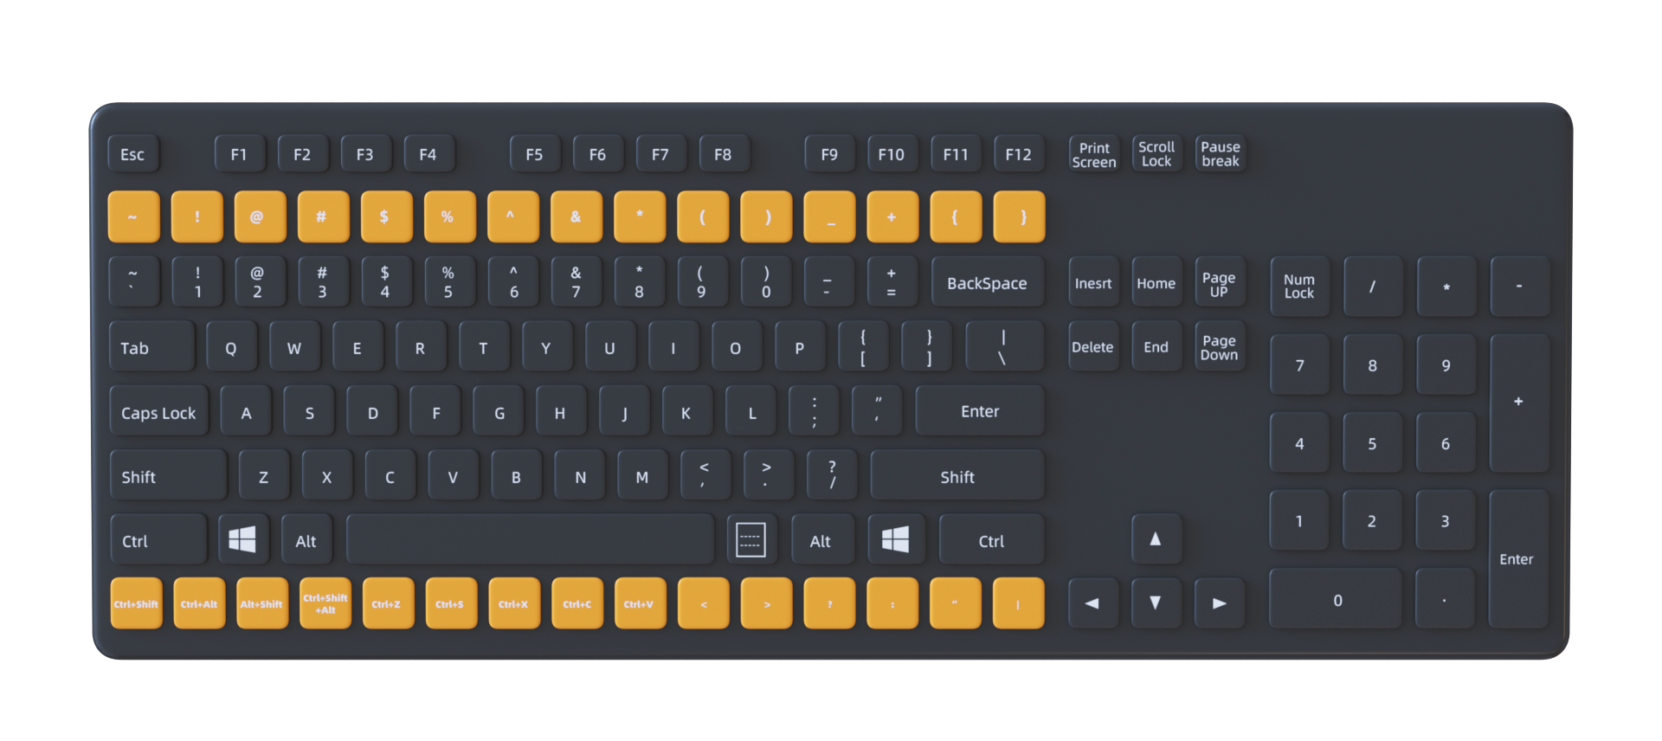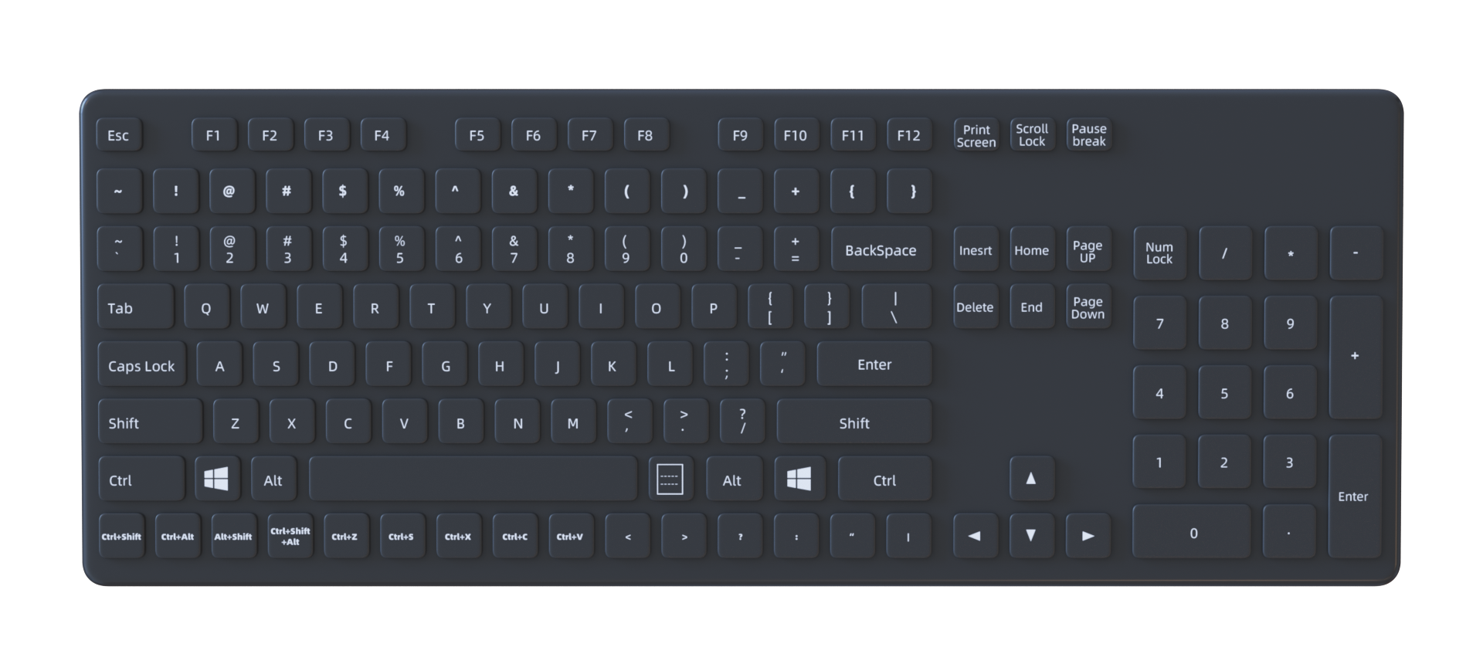

If you don’t agree with me, no problem, as you can see, this design doesn’t change the normal old layout of the keyboard, you can just use it by your old habits.