PDFSCRIBE
Contents
1. PdfScribe Introduction 2
2. License 2
3. Pre-Requisites 2
4. Building Pdfscribe Application Exe With Installer Msi: 3
4.1 Steps To Build Pdfscribe Application With Installer: 3
4.1.1 Description 3
4.1.2 Precondition 3
4.1.3 Steps To Peform 3
a. Important Files OR Folder Details: 4
5.Configuration And Installation: 7
a. Install Default Instance of Printer 7
b. Install Multiple Instances Of Printer other than default instance 8
Important Notes: 10

PdfScribe Introduction
- PdfScribe is a PDF virtual printer.

- This is updated code of opensource PdfScribe (https://github.com/stchan/PdfScribe) in which you can install multiple instance of Printer by just changing Config.xml and Install_Instance.bat file located in OutTest directory.. Check Configuration Installation Point for more details. This code is made for install 10 Instances of virtual printer.

- Also all pdf files will we saved in predefined directory with predefined name for each instance and with incremental number.

- This code will Give you options to predefine each printer instance’s Pagesize, Color Format, Output Directory, and OutputFileName.

- Prebuilt Installer and dependent files are located in OutTest Directory.

- When You Build from source using Visual Studio PdfScribeInstall.msi installer will be created. After build copy PdfScribeInstall.msi in OutTest Directory And follow Configuration Installation Point to configure and install default and multiple instance of virtual printer.

License
- Redmon is distributed under the GPL v3. Ghostscript is AGPL (more restrictive than GPLv3), so PdfScribe is bound by that license.

Pre-Requisites
- For building application executable from source code and creating installer from application executable and resources, following software components needs to be installed on the development PC.
- Visual Studio 2015.
- Wix 3.11.
- Votive 2015.

- PdfScribe links to, and distributes the following third party components:
- Microsoft Postscript Printer Driver (V3)
- Ghostscript (64-bit)
- Redmon 1.9 (64-bit)

Building Pdfscribe Application Exe With Installer Msi:

4.1 Steps To Build Pdfscribe Application With Installer:

4.1.1 Description
- Developer can build the PdfScribe application from the latest source code provided. This Section 4.1 provides instructions for developer to build the application exe and installer from source code using Microsoft Visual Studio 2015.

4.1.2 Precondition
  - For building PdfScribe application exe with Installer we required following items,
- PdfScribeInstall.zip, which contains PdfScribe application project with latest source code.
- WinRAR zip tool for extracting PdfScribe.zip file.
- Microsoft Visual Studio 2015(or higher version)
- .Net framework 4.0 installed on developer PC.
- 64-bit Windows Vista or later

4.1.3 Steps To Peform
- First you must have PdfScribeInstall.zip file provided by Radix software development team.
- Extract the files from the zip using unzip tools like WinRAR.

- Open the extracted “PdfScribeInstall” folder.
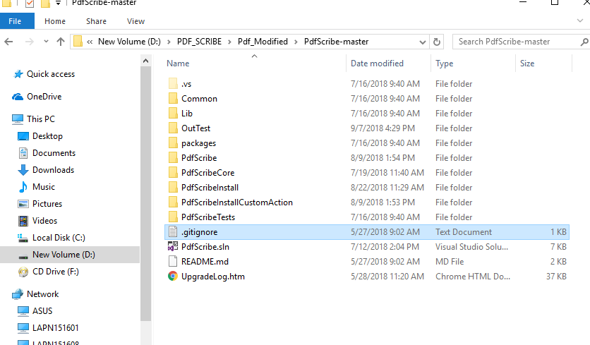

Important Files OR Folder Details:
- PdfScribe:
This directory Contains below Important Files or Folder
  - Program.cs File: In this file we have put all Logic to Predefine Incremental filename, and also pagesize and color options.
  - bin Directory: This directory contains PdfScribe.exe generated by Source code build.
- PdfScribeCore:
This directory is Core directory for PdfScribe which have configuration for Port and HardwareId and other items.

- PdfScribeInstall:
This Directory contains code for making MSI Installer for PdfScribe.
  - Product.wxs File: This is Wix Installer setup file with Multiple Instance Declaration.
  - Bin Directory: This directory contains PdfScribeInstall.msi file generated by source code build.

- PdfScribeInstallCustomAction:
This directory contains code for setting all Custom Actions for wix installer.
- OutTest:
This directory contains below files.
NOTE: All Below Files Must And Should Be Present in This Directory to Install Default and All Instances of PdfScribe.
  - Config.xml: This file Is Used for Setup Printer Properties like OutputFilename, OutputFIlePath, Color, PageSize.
  - Install_Instance.bat: This file is Used for setup Which Instance You want to install and Where you want to install printer instance.
  - PdfScribeInstall.msi: This is prebuilt PdfScribe Installer.
  - PdfScribe.sln: This is Visual studio Solution File.

- Open PdfScribe.sln solution with Microsoft Visual Studio 2015 or later.

- Right click on PdfScribe solution and select Build Solution property or press F7 to build PdfScribe solution project as given below

- As shown below Output window, PdfScribe solution project will be built successfully and the Output window displays compiler generated file path, where the executable is created.

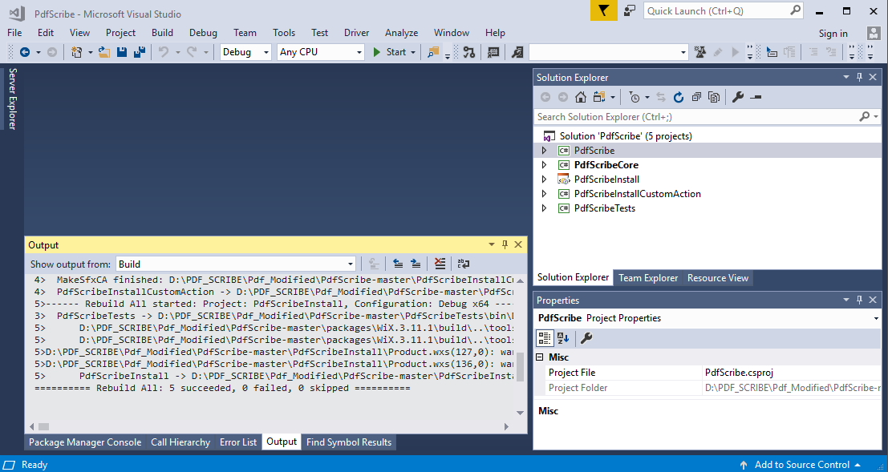

- Now Copy PdfScribeInstall.msi from PdfScribeInstall directory’s bin folder and Paste it in OutTest Folder.

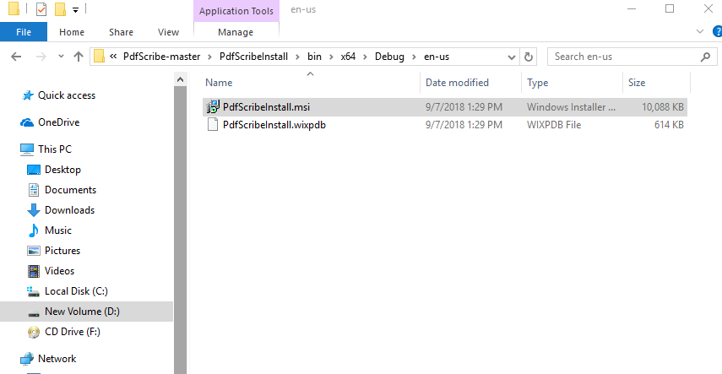

- Now configure Printer Properties using below configuration and installation point.

5.Configuration And Installation:

Install Default Instance of Printer
- Open Config.xml file.
  - Change PrinterName, PortName, HardwareId, outputFilePath,outputFileName,paperSize,color parameters Values as needed.
  - Here PrinterName,PortName,HardwareId must be different for all instances of printer.
    - i.e. For Default instance(First Instance) below values are okay.
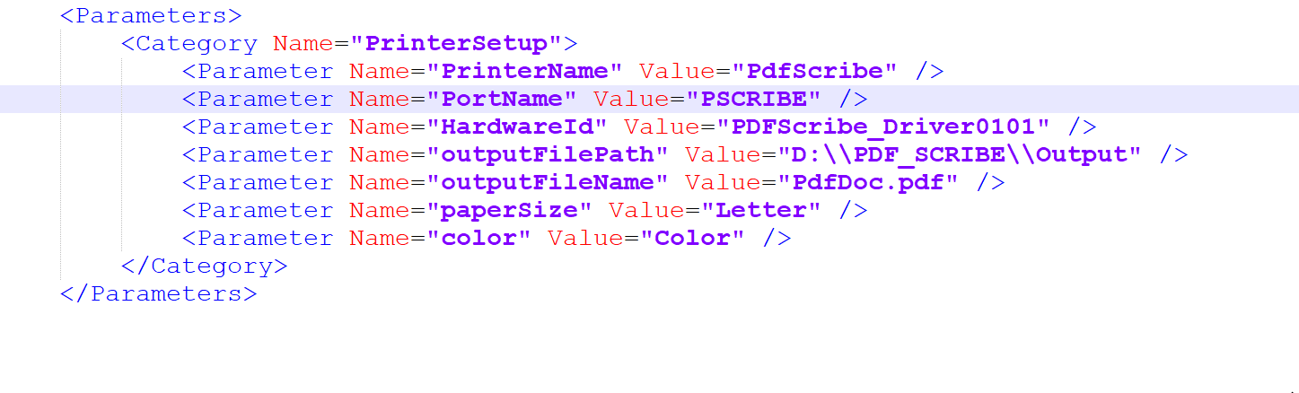
- Save Config.xml File
- Run PdfScribeInstall.msi directly by double clicking to install default instance of printer.
- This will install Scribe.

Install Multiple Instances Of Printer other than default instance
- Open Config.xml file.

  - Change PrinterName, PortName, HardwareId, outputFilePath,outputFileName,paperSize,color parameters Values as needed.
  - Here PrinterName,PortName,HardwareId must be different for all instances of printer.
    - i.e. For Second instance below values are okay.
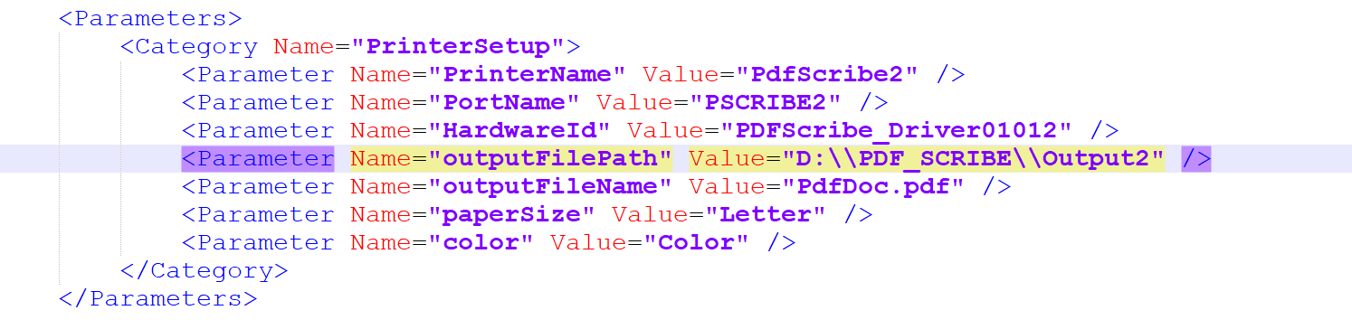
- Save Config.xml File
- Open Install_Instance.bat file in any Text Editor(i.e. Notepad++)
  - Check TRANSFORMS=":instanceX" Parameter, And change X according to Instance number.(X >=2 And X<=10)
  - e.x. --> Suppose you want to install second instance then change X to 2.(i.e. TRANSFORMS=":instance2")
  - check INSTALLFOLDER="" parameter, And put installation path in string where you want to install, which predefine the installation path.
  - e.x. --> Suppose you want to install second Instance on "C:\Program Files\PdfScribe2" path, then put it like (INSTALLFOLDER="C:\Program Files\PdfScribe2")
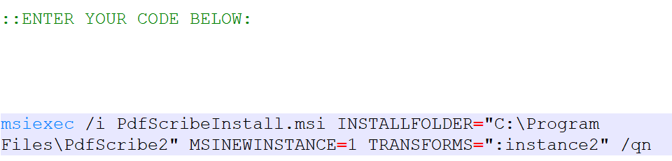
- Save the file And run the Install_Instance.bat file.(See Important Notes Below)
- e.x. --> Suppose you want to install third instance then change X to 3.(i.e. "TRANSFORMS=":instance3") and change INSTALLFOLDER parameter to installation path.(i.e. INSTALLFOLDER="C:\Program Files\PdfScribe3")
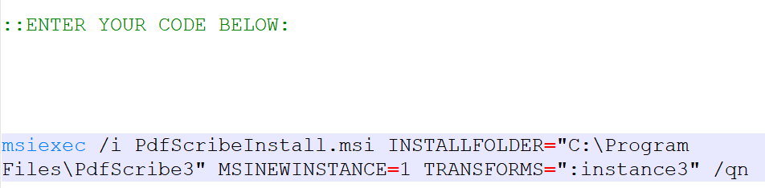
- Save the file and run the Install_Instance.bat file.

Important Notes:
- You must have to Install New Instance of printer to different Directory.
- Suppose for default instance installation directory is "C:\ProgramFiles\PdfScribe\"
- For new instance you have to set new directory other than default instance directory for proper working of priner.
- i.e You can set C:\ProgramFiles\PdfScribe\YourDesired_Name or C:\ProgramFiles\YourDesired_Name
- But not same directory "C:\ProgramFiles\PdfScribe\".

