MP #1: Peer Feedback #1 (Pre-Feedback Work to Date)

Libo Zhang (lz200)

The structure of my work to date format will follow the recommended project milestones.

Note: Only the code written for **testing** my algorithm will be displayed to help peer review/feedback.

**Week 1:**

1. Load/read the images

1. Plot (“imshow”) the images

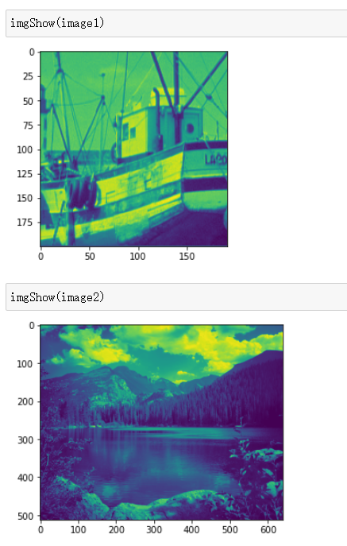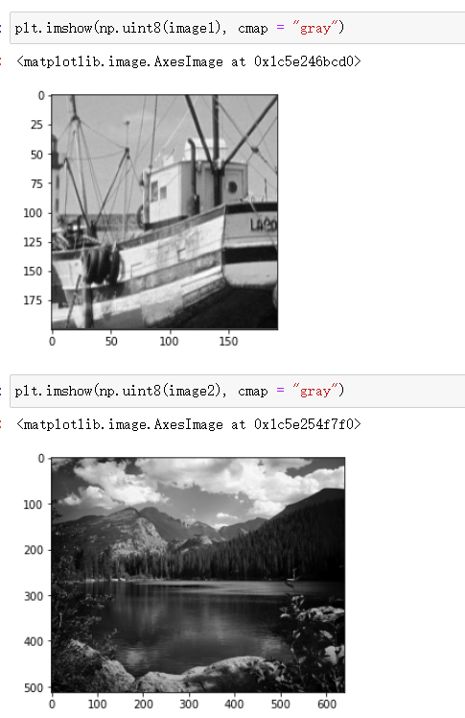

1. Select a desired K * K block from an image

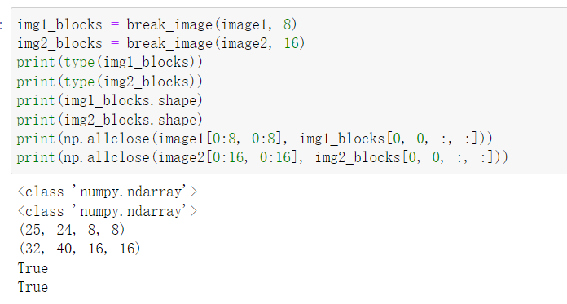

1. Sample pixels from a block (to simulate a compressed sensed or corrupted image)

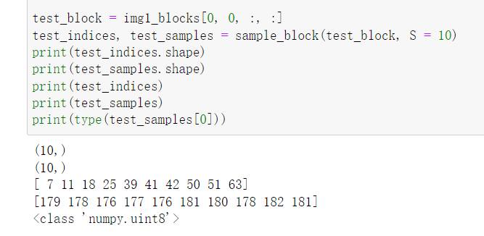

**Week 2:**

1. Implement LASSO regression to estimate DCT coefficients for a single block

First, I need to calculate the 2D Discrete Cosine Transformation (DCT) matrix T and its rasterized version.



