MP #2: Peer Feedback #1 (Pre-Feedback Work to Date)

Libo Zhang (lz200)

The structure of my work to date format will follow the recommended project milestones.

Note: Only the code written for testing my algorithm will be displayed to help peer review/feedback.

**Week 1:**

1. Load/Read the data

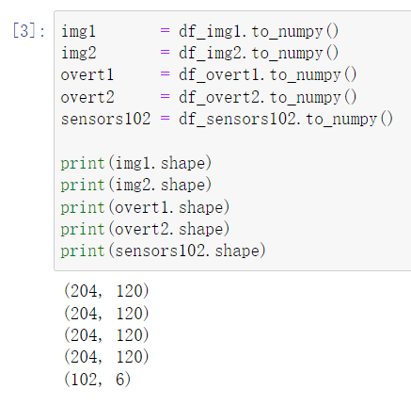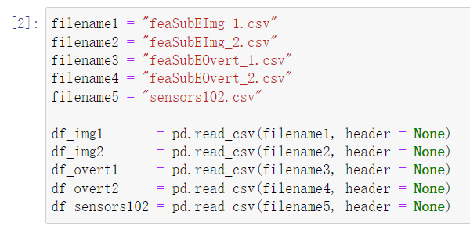

Block [2] proves that I can successfully Load the data, and Block [3] proves that I can successfully Read the data.

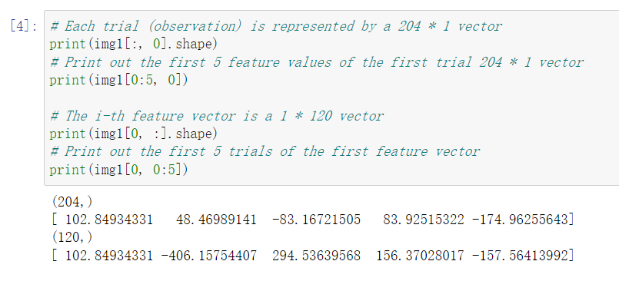

Block [4] further proves that I understand what the data represents.

1. Plot (image) channel weights on the brain surface

(You can create your own vectors of 204 positive numbers to test)

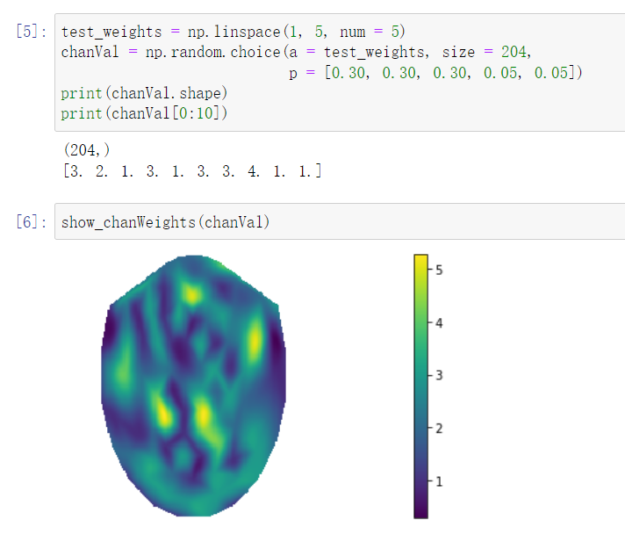

Blocks [5] and [6] demonstrate that I have successfully tested the auxiliary plotting function for plotting channel weights on the brain surface.