MP #2: Peer Feedback #2 (Pre-Feedback Work to Date)

Libo Zhang (lz200)

The structure of my work to date format will follow the recommended project milestones.

Note: Only the code written for testing my algorithm will be displayed to help peer review/feedback.

In Peer Feedback #1, I only completed Week 1 milestones. Therefore, in this session, to fully demonstrate that I have completed milestones for Week 2, 3, and 4, I decide to export the ROC plots for imaginary dataset and overt dataset first, as shown below (left blank space saved for Post-Feedback Annotation).

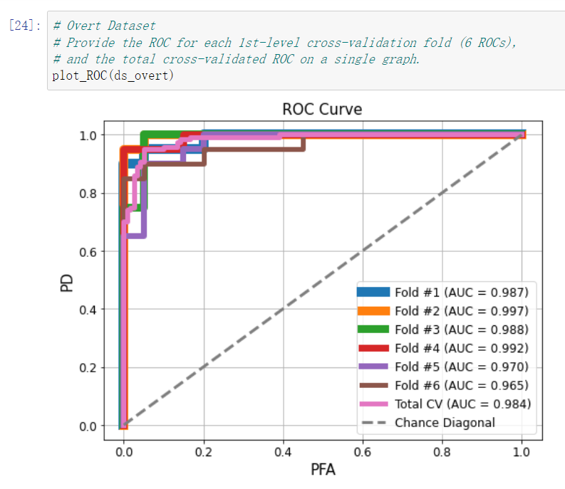

Then, let us visualize the $204×1$ vector weights on the brain surface (Imaginary and Overt).

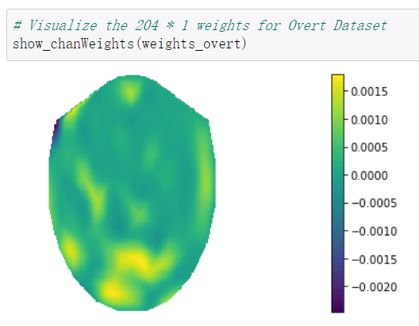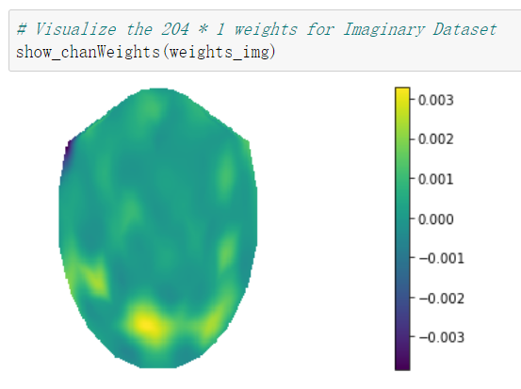

To demonstrate that I can successfully implement the $2^{nd}$ level cross-validation to optimize the regularization parameter $λ$ for each $1^{st}$ level fold, intermediate results during Two-Level Cross Validation are shown below.

