A computational-experimental framework for mapping plant coexistence
Libo Jiang, Meixia Ye, Miaomiao Zhang, Mengmeng Sang, Lina Wang, Chaozhong Shi, Feifei Xi, Wenhao Bo, and Rongling Wu

Guideline for the use of computer code
All the data and R-based computer code are given at
- GitHub https://github.com/LiboJiang/PcQTL,
- Beijing Forestry University http://ccb.bjfu.edu.cn/program.html

In what follows, we provide a guideline on how to use the R-based computer package designed to detect quantitative trait loci (QTLs) for phenotypic traits based on the dynamic property of plant coexistence. This guideline provides a manual for the interested readers to analyze their data for QTL detection by this package. The manual is organized as follows:

Section 1: Loading function
Section 2: Data format
Section 3: Examples
Section 4: Results
Section 4: Function lists

1. Loading function
This package relies on the mvtnorm, deSolve and ggplot2 package.
Loading functions and packages:
>library(mvtnorm)
> library(deSolve)
>library(ggplot2)
>source("An.load.R")
>source("An.ODE.R")
>source("an.covar.R")
>source("An.curve.R")
>source("An.est.R")
>source("An.plot.R")

2. Data format
This package works on four files include genotype, phenotype, pair information between individuals, and annotation. The appropriate formation of these four files is described below:

Genotype file
ID | SNP1 | SNP2 | SNP3 | SNP4 | SNP5 | SNP6 | SNP7 | ...
1 | 1 | 1 | 1 | 0 | 0 | 0 | 0 | ...
2 | 0 | 1 | 1 | 0 | 1 | 1 | 0 | ...
3 | 0 | 0 | 1 | NA | 0 | NA | 0 | ...
4 | NA | 1 | 1 | 1 | 1 | 0 | 1 | ...
5 | 1 | 0 | 0 | 1 | 1 | 1 | 0 | ...
...
Two genotypes (QQ=1, qq=0) and missing data (coded as NA) are valid marker values.

Phenotype file
ID | Point1 | Point2 | Point3 | Point4 | Point5 | Point6 | Point7 | ...
1 | 5.125 | 7.289 | 8.308 | 9.232 | 9.383 | 10.23 | 11.21 | ...
2 | 6.184 | 7.397 | 8.520 | 11.32 | 45.44 | 66.37 | 72.21 | ...
3 | 7.151 | 7.249 | 7.413 | 8.361 | 22.20 | 45.36 | 94.49 | ...
4 | 6.144 | 7.371 | 7.552 | 8.418 | 10.44 | 64.56 | 146.1 | ...
5 | 6.150 | 7.254 | 8.284 | 8.265 | 8.367 | 9.262 | 9.292 | ...
...
The phenotype file contains numerical values.

Pair information between individuals
ID1 | ID2
1 | 2
3 | 4
5 | 6
7 | 8
15 | 16
... | ...
Pair information contains ID for all individuals.

Annotation file
SNP | Chr | Position | Annotation | ...
SNP1 | 1 | 698 | upstream_gene_variant;gene:AT1G01010.1 | ...
SNP2 | 1 | 2748 | upstream_gene_variant;gene:AT1G01010.1 | ...
SNP3 | 1 | 5975 | 3_prime_UTR_variant;gene:AT1G01020.1 | ...
SNP4 | 1 | 6063 | synonymous_variant;gene:AT1G01030.1 | ...
SNP5 | 1 | 6768 | upstream_gene_variant;gene:AT1G01046.1 | ...
...
Annotation file contains chromosome, position and gene annotation for each SNP.

2. Example
# Loading data from five files.
dat <- an.load(phenotype="Height-pairs.txt",genotype="final-snp-example.txt",
pheno.info="Pairs.txt",genotype.info="snp-info-example.txt")

# Calculate the initial parameters
H0par <- an.com.H0(dat, tri=2:9)

# Draw the fitting curve
An.plot.mean(dat,par0=H0par,tri=2:9)

# Perform QTL scanning based on the hypothesis test
res <- An.est1(dat,interval=c(1,10),tri=2:9)

Details
The critical values obtained from the chisq or permutation. If using chisq, the LR values are evaluated by chi-square distribution, the 5% and 1% significant level after calibration as the critical values, this option is best for large samples.

3. Results
The outputs include data object and result objects of genome scanning.

Data object
The data object includes the following:
1) Phenotype table: pheno1, pheno2;
2) Pair information: pheno.i
3) Genotype table and annotation information: snp.i and snp;
4) Time point, sample size and maker number: sample.time, n and nm.
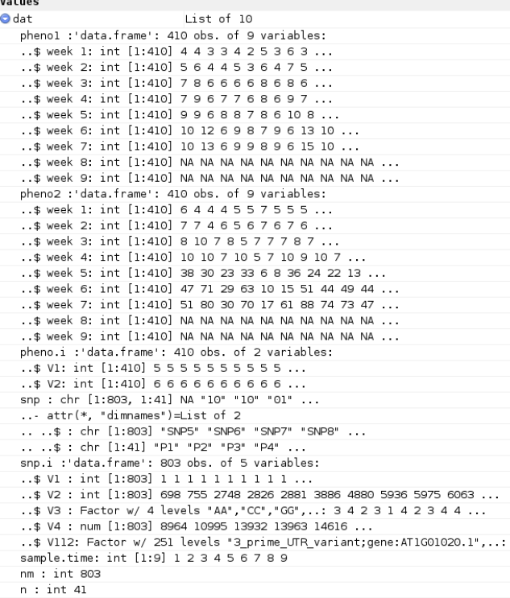

Parameter initialization
The initial parameters of ODE and covariance include the following:
1) ODE parameter;
2) SAD parameter;
3) The figure for individual and mean of all fit curve, which are saved to working directory (Figure-1.pdf).
> H0par
[1] 8137.3820316 2.0271900 0.1303405 2.0186660 0.1219697 0.1567875 5.1546631 7.7932936 16.8954647 -4.6205316 -0.2276995 1.7412619 15.3576099 13.8041344 -1.2998718 -0.6859819
> H0par[2:6] # SAD parameter
[1] 2.0271900 0.1303405 2.0186660 0.1219697 0.1567875
> H0par[7:10] #ODE parameter
[1] 5.1546631 7.7932936 16.8954647 -4.6205316 -0.2276995 1.7412619 15.3576099 13.8041344 -1.2998718 -0.6859819

QTL mapping
The result of QTL mapping includes the following:

> rres[1:10,1:47]
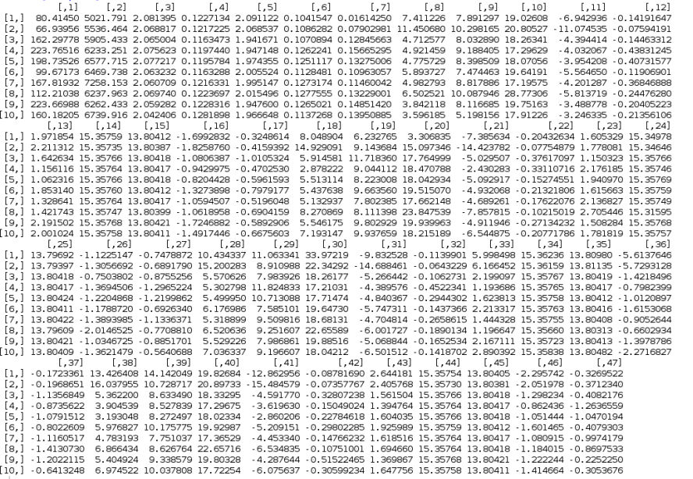
The first column indicates LR value, the second column is maximum likelihood for the alternative hypothesis, column 3 to column 7 is SAD parameters and the remaining columns are ODE parameters for four genotype combinations. Select significant QTLs according to the chisq or permutation test.

4. Function lists
No | Description
1 | an.load(phenotype, genotype, pheno.info, genotype.info)
1 | Load the data from four files and return a data object.  Arguments: phenotype is a txt file of phenotypic traits, genotype is txt file of marker, phenol.info is a txt file of pair information between individuals and genotype.info is a txt file of annotation information of marker. The format of file is described in the details section 1.
2 | an.com.H0(dat, tri)
2 | Calculate initial parameter of ODE and SAD.  Arguments: dat is a data object returned by an.load. The format of dat is described in the details section 3. tri is a numeric vector indicating which time points get involved in the QTL mapping.
3 | An.est1 (dat, interval, tri)
3 | Perform the hypothesis test based on the data object and initial parameter.  Arguments: dat is a data object returned by an.load. The format of dat is described in the details section 3. interval contains two number indicating scan interval. tri is a numeric vector indicating which time points get involved in the QTL mapping.

