**3AutotetraMap**

1. **Introduction**

At present, the **3AutotetraMap** package is used to linkage analysis in the full-sib of autotetraploid based on the two-point and three-point model. This guide gives some brief instructions on how to perform the tasks of linkage analysis by this package. The outline of this guide is as follows:

1. **Data format**

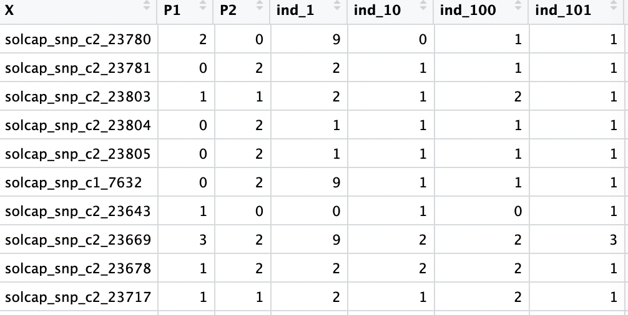

Five genotypes (aaaa=0, Aaaa=1,AAaa=2, AAAa=3, AAAA=4) and missing data (coded as 9 ) are valid marker values.

1. **Computer simulation**

#Two-point model

#load functions

source("auto_sim.R")

source("auto_est.R")

source("auto-debug.R")

#Simulation for a=0.05,b=0.1,r=0.05

#1111=0, 1112=1, 1122=2, 1222=3, 2222=4

#set the marker type

pmap <- matrix(c(2,1,2,1,

1,2,1,2,

1,2,1,2,

1,2,1,2),nrow=4,byrow=T)

#set the linkage phase

index <- matrix(c(1,2,3,4,

3,2,1,4,

1,2,3,4,

3,2,1,4),nrow=4,byrow=T)

# data simulation

two_z <- Frz1_two_sim1(ff1=f1,n=500,m=50,pmap=pmap,index=index)

#f1 indicates the f frequency, n indicates the sample size, m indicates the number of markers.

# estimate recombination fraction and DR

ret_two <-two_rfz_phase_g2(M1=two_z$zm1[,i],M2=two_z$zm2[,i],

pmap=pmap,index=index1)

#Three-point model

#load functions

source("auto_three_util.R")

source("auto_three_mai.R")

source("phase-debug.R")

#set the linkage phase

index <- matrix(c(1,2,3,4,

1,3,2,4,

1,2,3,4,

4,3,2,1,

1,2,3,4,

1,4,2,3),nrow=6,byrow=T)

#set the marker type

pmap <- matrix(c(1,1,2,2,

1,1,2,2,

1,1,2,2,

1,1,2,2,

1,1,2,2,

1,1,2,2),nrow=6,byrow=T)

#data simulation by three-point model

dat <- Frz1_three_sim1(ff1=ff1,n=500,m=10,pmap=pmap,index=index)

#ff1 indicates the g frequency

# estimate recombination fraction, cocand DR

ret_three<- three_rfz_phase(M1=dat$zm1[,i],M2=dat$zm2[,i],M3=dat$zm3[,i],

pmap=pmap,index=index)

1. **Work example**

#chr5 and chr9

#read genotype file

g5 <- read.csv("../data/geno5.csv")

g51 <- as.matrix(g5[,-1])

g9 <- read.csv("../data/geno9.csv")

g91 <- as.matrix(g9[,-1])

#two-point analysis for the chromosome 5 and 9

ex_chr5 <- work_test(geno=g51)

ex_chr9 <- work_test(geno=g91)

#three-point analysis for the chromosome 5 and 9

three_chr5 <- three_scan1(geno=g51)

three_chr9 <- three_scan1(geno=g91)