Table 3: QTL position and effect in swithgrass data. (Phenotype: green weight)

|  |  |  |  |  |  |  |  |  |  |
| --- | --- | --- | --- | --- | --- | --- | --- | --- | --- |
| Group | Marker  interval | Position | Effect parameter | | | | | | Linkage phase |
| *μ1* | *μ2* | *μ3* | *α* | *β* | *γ* |
| 4 | sww389_247-  nfsg025_121 | 131.2 | 209.6 | 166.9 | 142.1 | 0.18 | 0.12 | 0.76 | SSS1 |

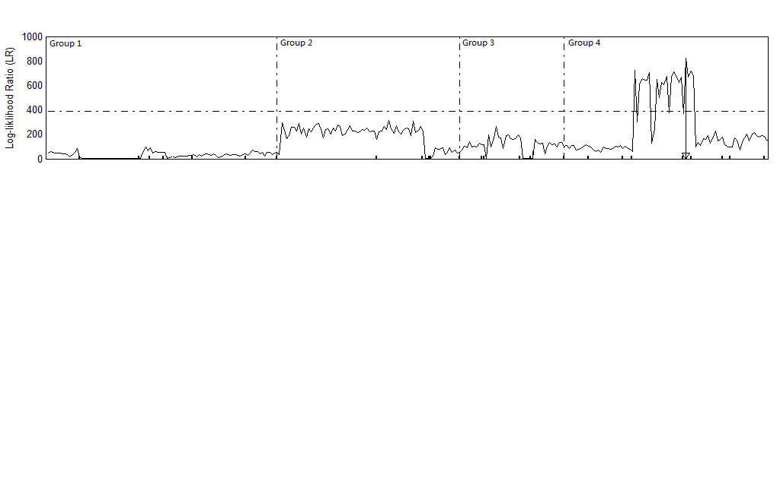

*α* : Maker A double reduction rate

*β* : Maker B double reduction rate

*γ* : QTL double reduction rate