Module l10n_it_ddt_improved

Abstract:
To introduce automatic package composition for a TD (Transport Document).

Detailed Description:
Starting from a stock.picking entity (delivery order) in Odoo a TD can be generated. A TD can refer to more than a stock.picking entity.
When you are ready to package the shipping, from TD choose “Put in Pack” operation. Starting this operation, all the related stock.picking will be processed; for each one it will be performed an evaluation of existing stock.move.line evaluating if each move line can be stored in current package.

Currently, evaluation is based on product weight so each move line, in quantity 1, is evaluated if allowable to be added to current package.

Each product/line is added to current package, summarizing quantities where needed, until the package operation reaches the limit of that packaging container (weight, volume).

When a package reaches the limiting value the package is closed, a new package selection is operated on remaining move_lines and a new package filling cycle starts.

When you employ more than a package to ship the delivery order/s contained in TD, it will be created a new package containing all the previously created packages. Package will be linked to TD.

Requirements:
To define packages (dimensions, weight, volume)
To define product dimensions
To define product weight
To define product volume

Printout:
You can print for a packaged shippable TD the packing list.

Configuration
Before to start using “Packing List” be sure to activate option “Delivery Packages” in Odoo Inventory Settings.

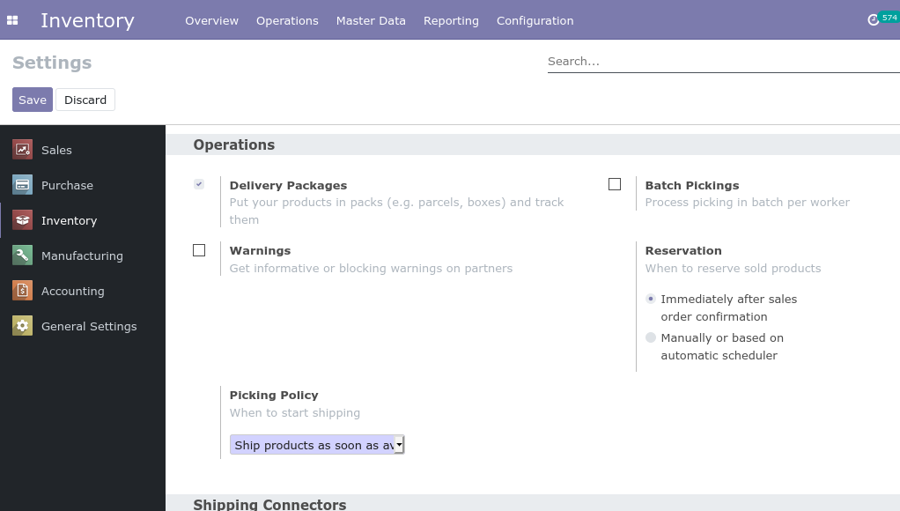
Package Configuration:

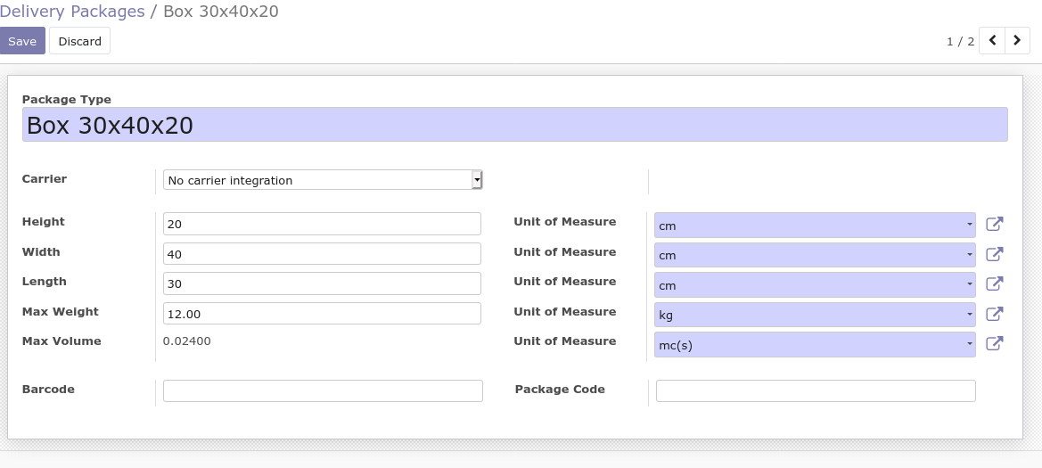
Configure each package specifying UoM for each dimension, weight allowable, volume (computed by dimensions).

Products Configuration:

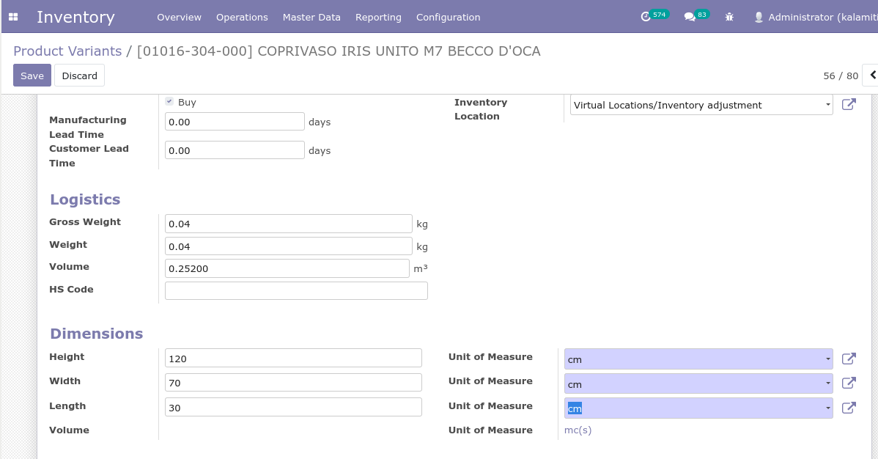
Configure each product specifying UoM for each dimension; volume will be computed by dimensions or manual setting.

