Module extend_calendar

Abstract:
To introduce time intervals management.

Detailed Description:
This module offers a practical support to manage time intervals or predefined days of week.

Introduces concepts of time interval and days; it allows to assign time intervals to a day of week so you will be able to define a delivery time, a “opening and closing” hours, etc .

Requirements:
To define time intervals (dimensions, weight, volume)
To define days of week

Printout:
You can introduce these entities in yours to be able to printout them:

<td colspan="3"><h6>Delivery required</h6>
<t t-foreach="o.partner_shipping_id.preferred_delivery_ids" t-as="delivery">
<div>
<span t-field="delivery.name"/>: <span/>
<t t-foreach="delivery.interval_ids" t-as="interval">
<span t-field="interval.starting"/> - <span t-field="interval.ending"/>
<t t-if="len(delivery.interval_ids)>1">
<span/>, <span/>
</t>
</t>
</div>
</t>
</td>

Sample of xml code in report to printout data
Configuration
Once module is installed you can find in Odoo, Settings, Configuration, Time Management section in which you can configure Time Intervals and Days of the week.

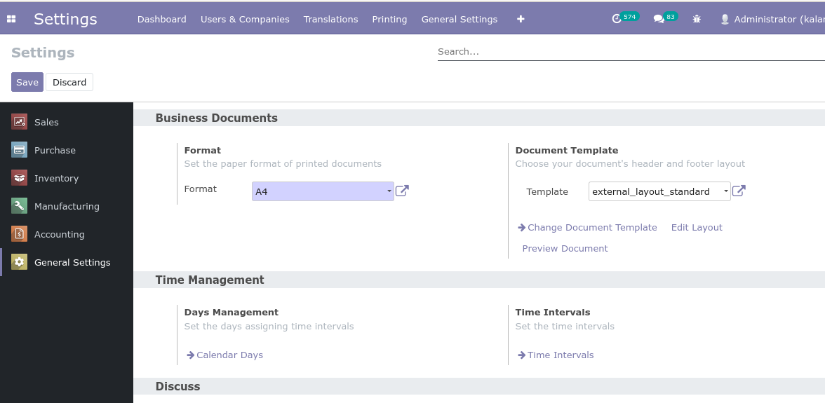
Time Intervals:

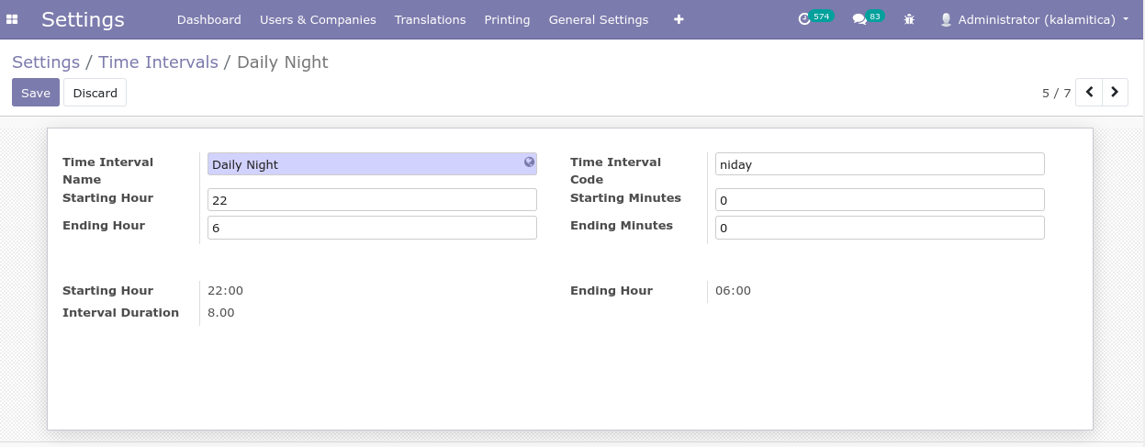
Configure each time interval you need to use defining hours and minutes and check using interval duration that it works as you need.

Standard Time Intervals provided are as follows:

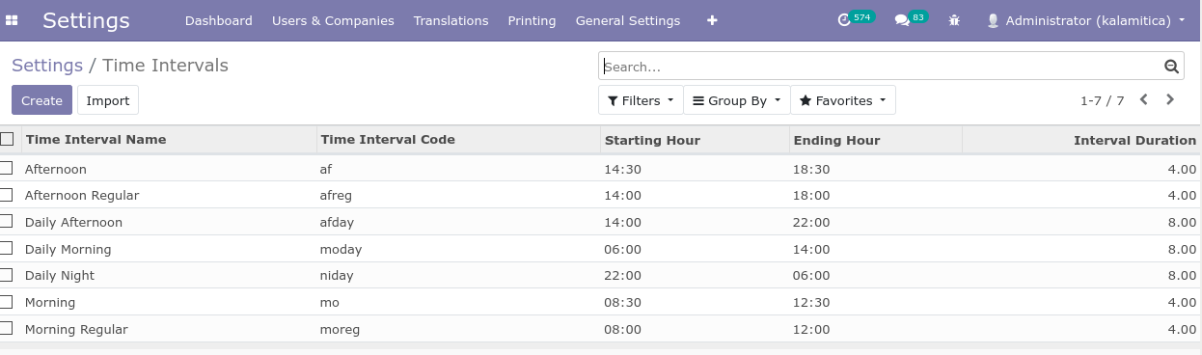

Days Management:

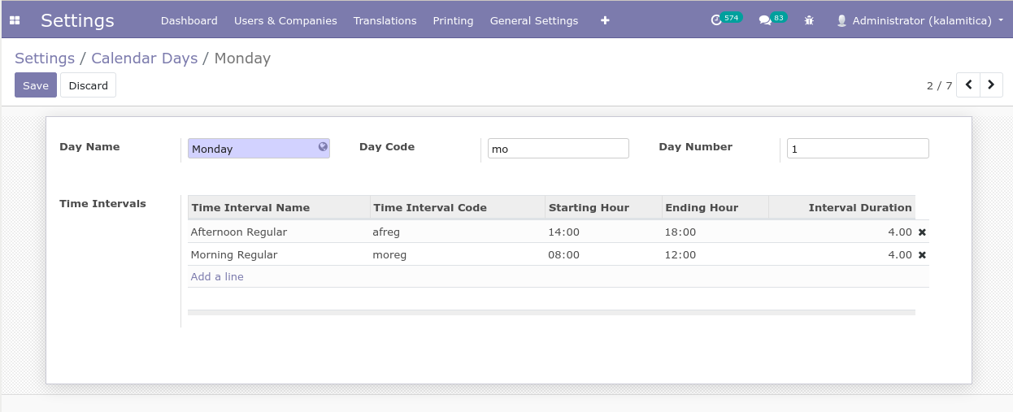
Configure each Calendar Day specifying time intervals it has to cover.
Day Code and Day Number are provided for future usages.

Standard Calendar Days provided are as follows:

Day index is set as returned by “weekday()” method.

