Tina Morrell

CWB130 – Final Project

5/09/2021

# Online Student Survival Guide

The Bootstrap – Agency template was chosen for the project:

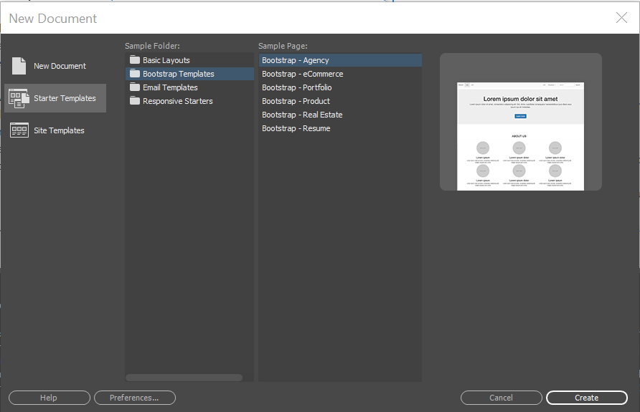

Prepared the Bootstrap – Agency starter template to use as the .dwt template:

1) Removed unneeded components.

2) Modified the text for the top navigation, header, and footer.

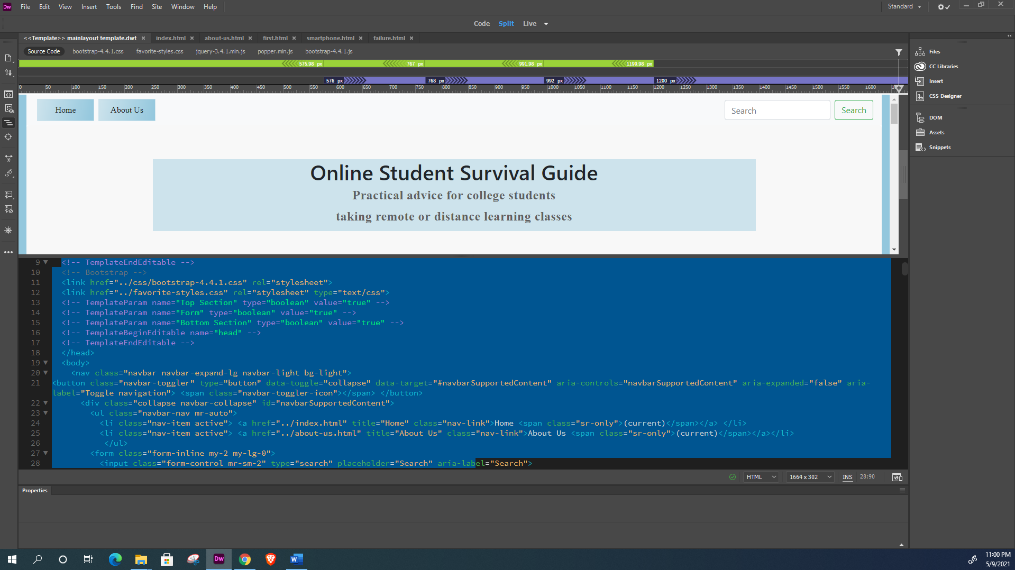

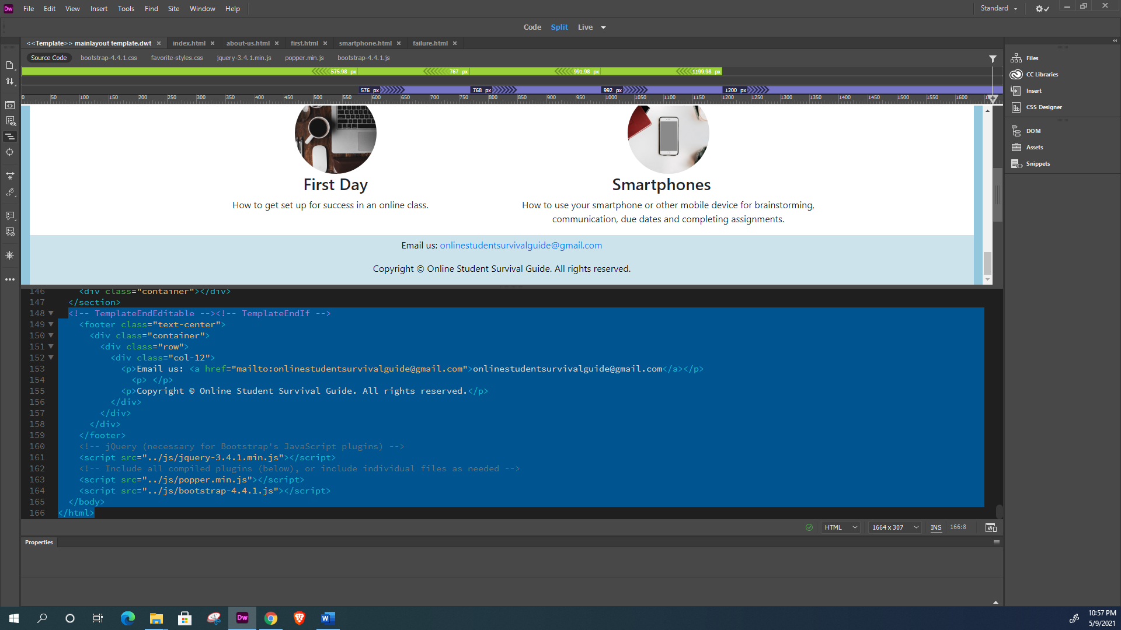

Changing the navigation buttons to being a blue with gradient, turning to a light gray when the user hovers:

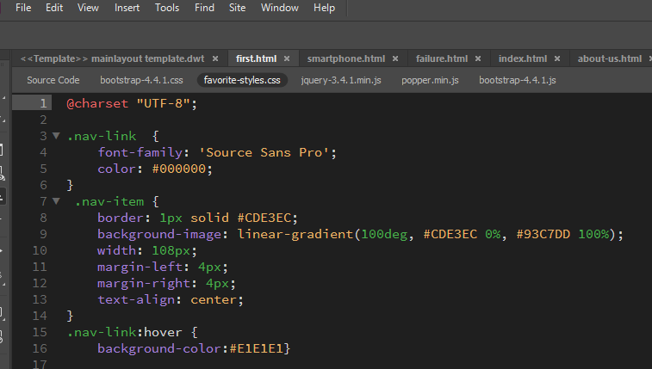

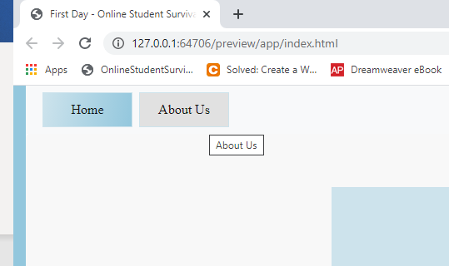

Validation of HTML code prior to creating the template:

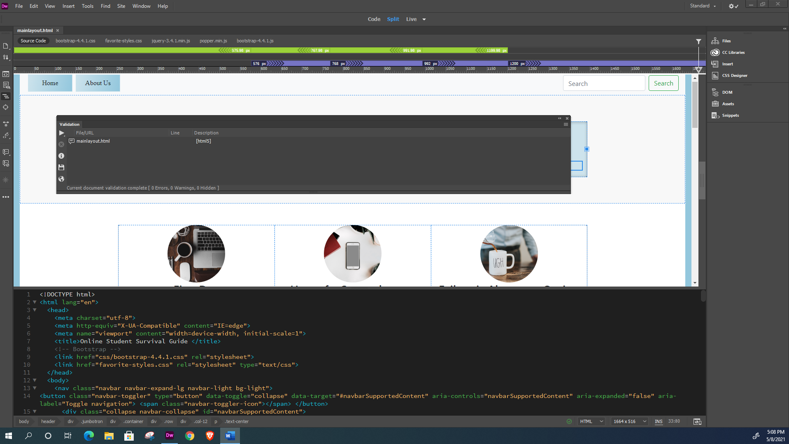

Creating the optional editable regions:

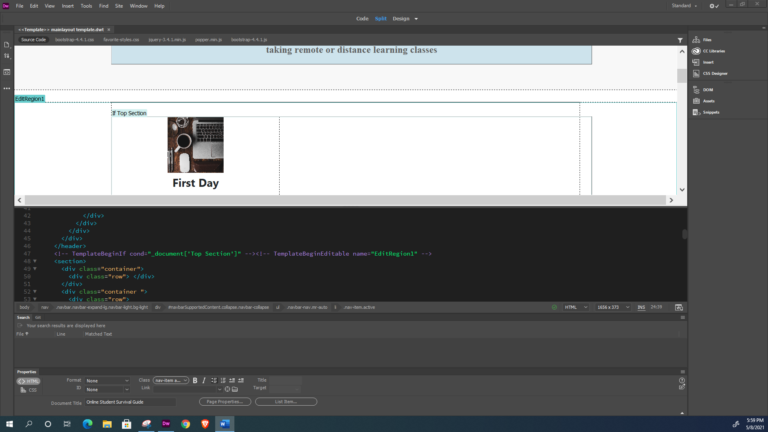.

Locked regions include the top navigation, the header, and the footer:

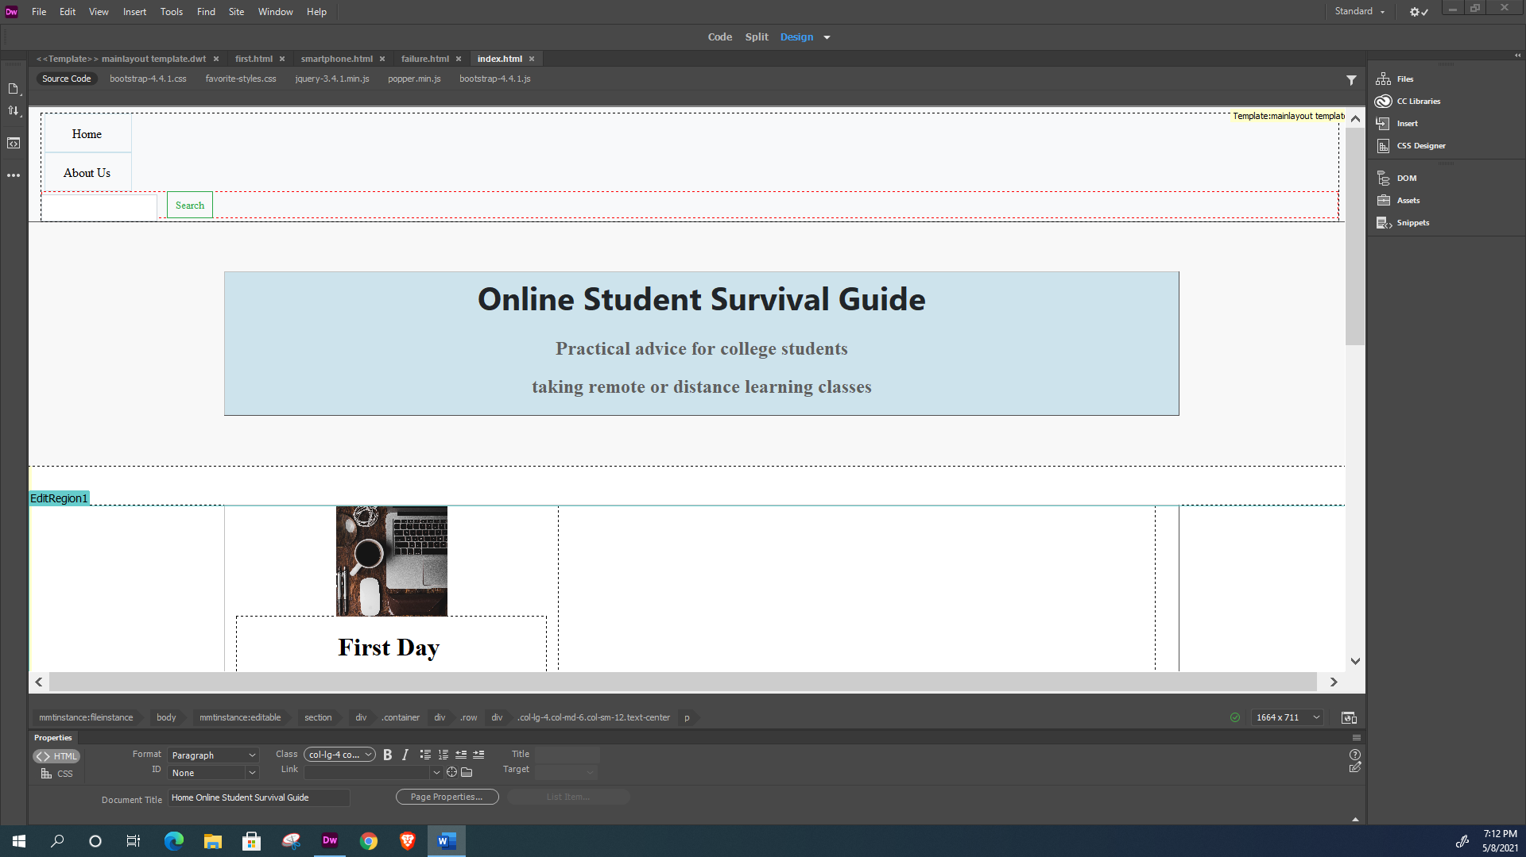

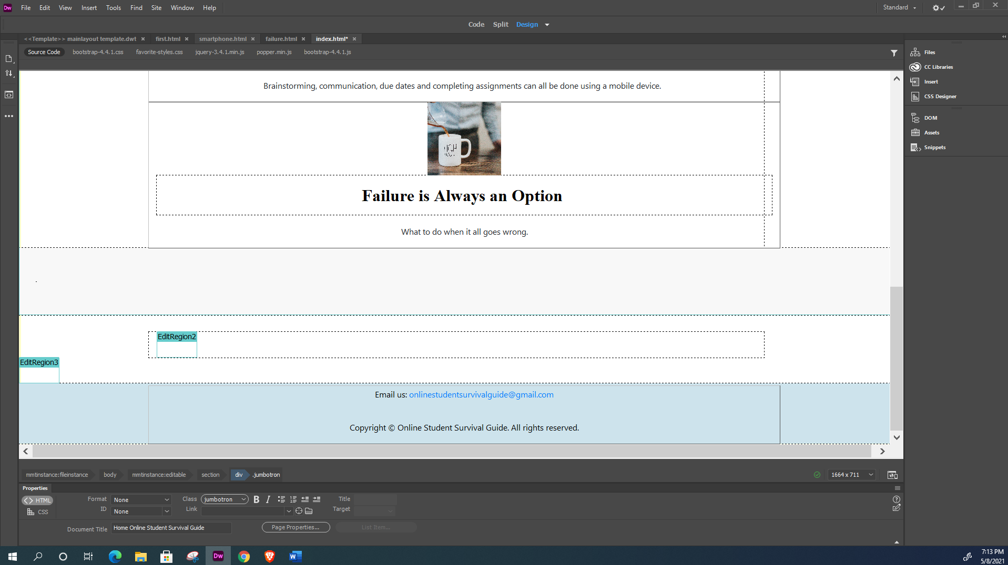

Created the child pages from the mainlayout template: index.html, about-us.html, first.html, smartphone.html, and failure.html

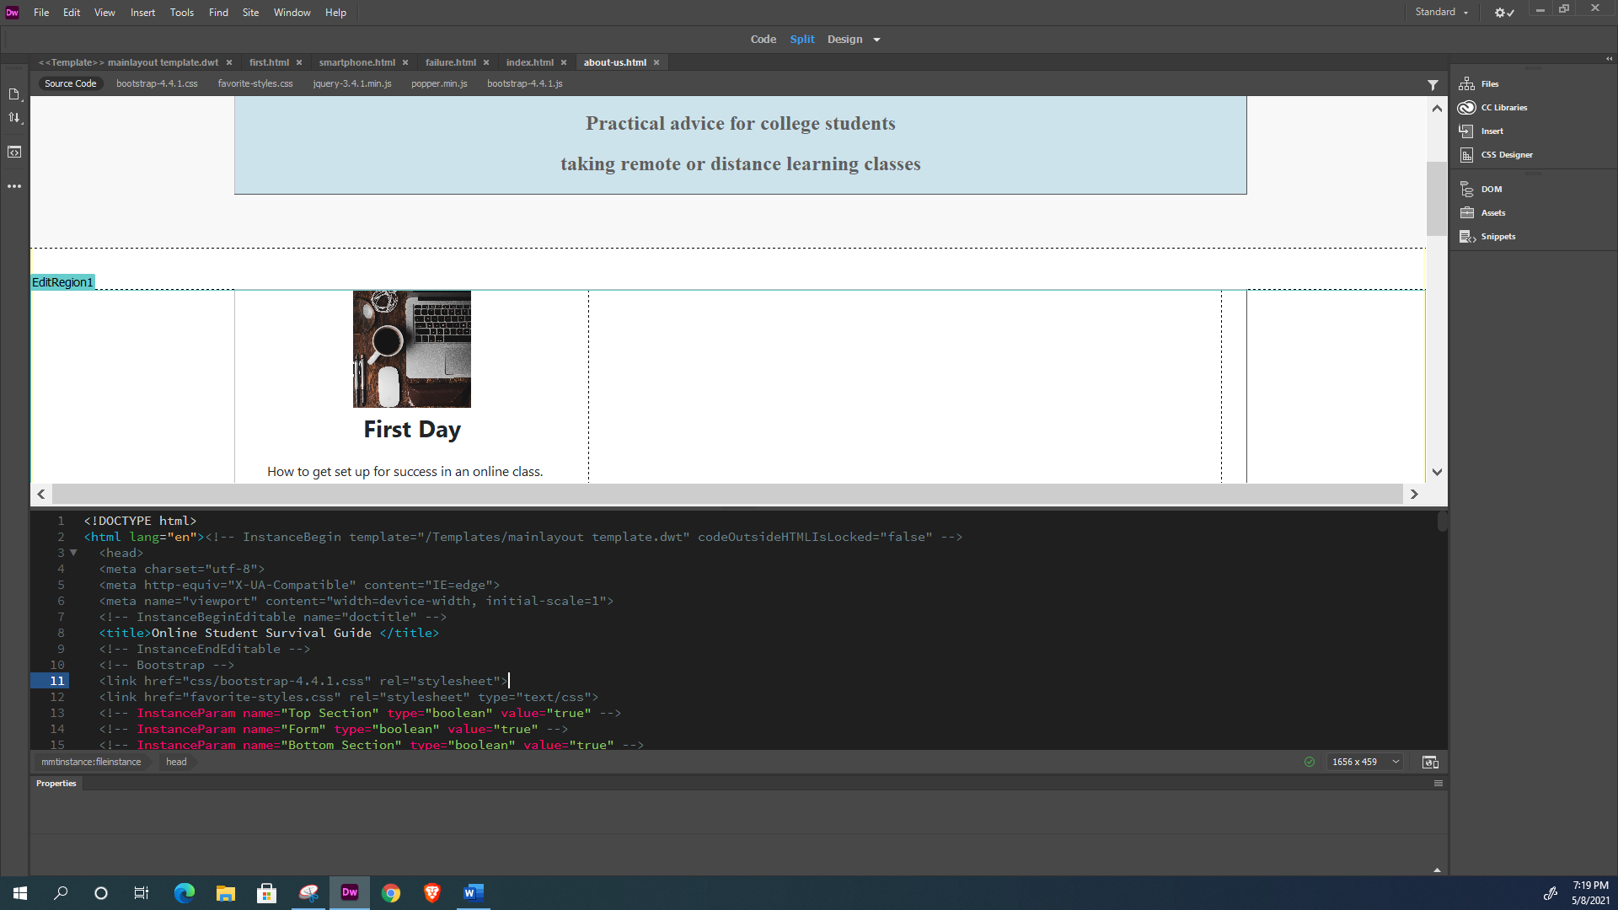

Setting up the links for the three main pages: First Day, Uses of a Smartphone, and Failure is Always an Option:

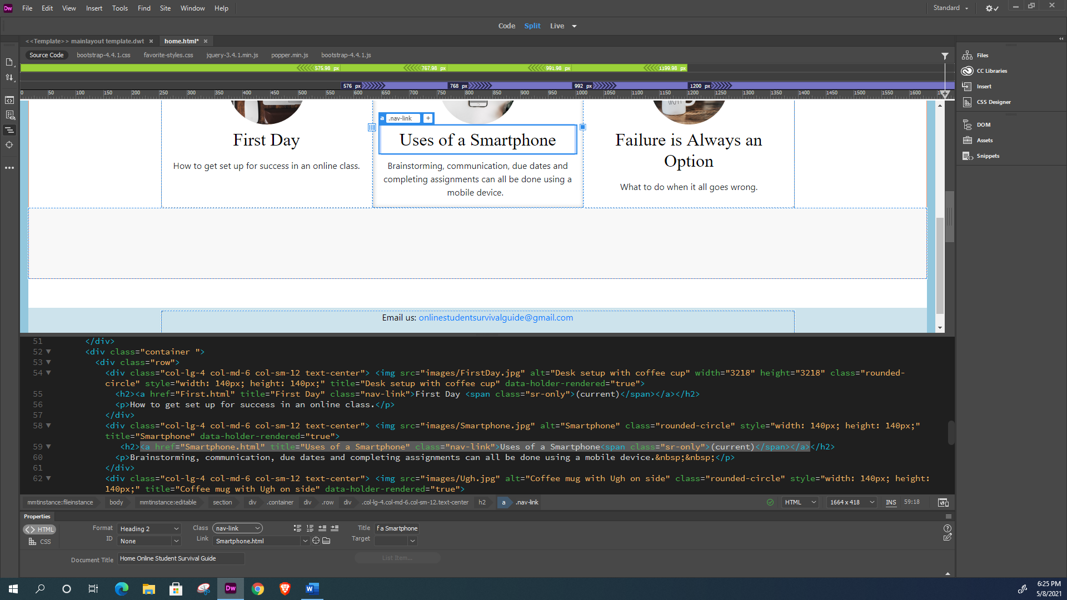

First Day content:

1) Added a table from sos_first.html, (a document created in notepad for the CWB110 class). Copied the text and pasted into the div container:

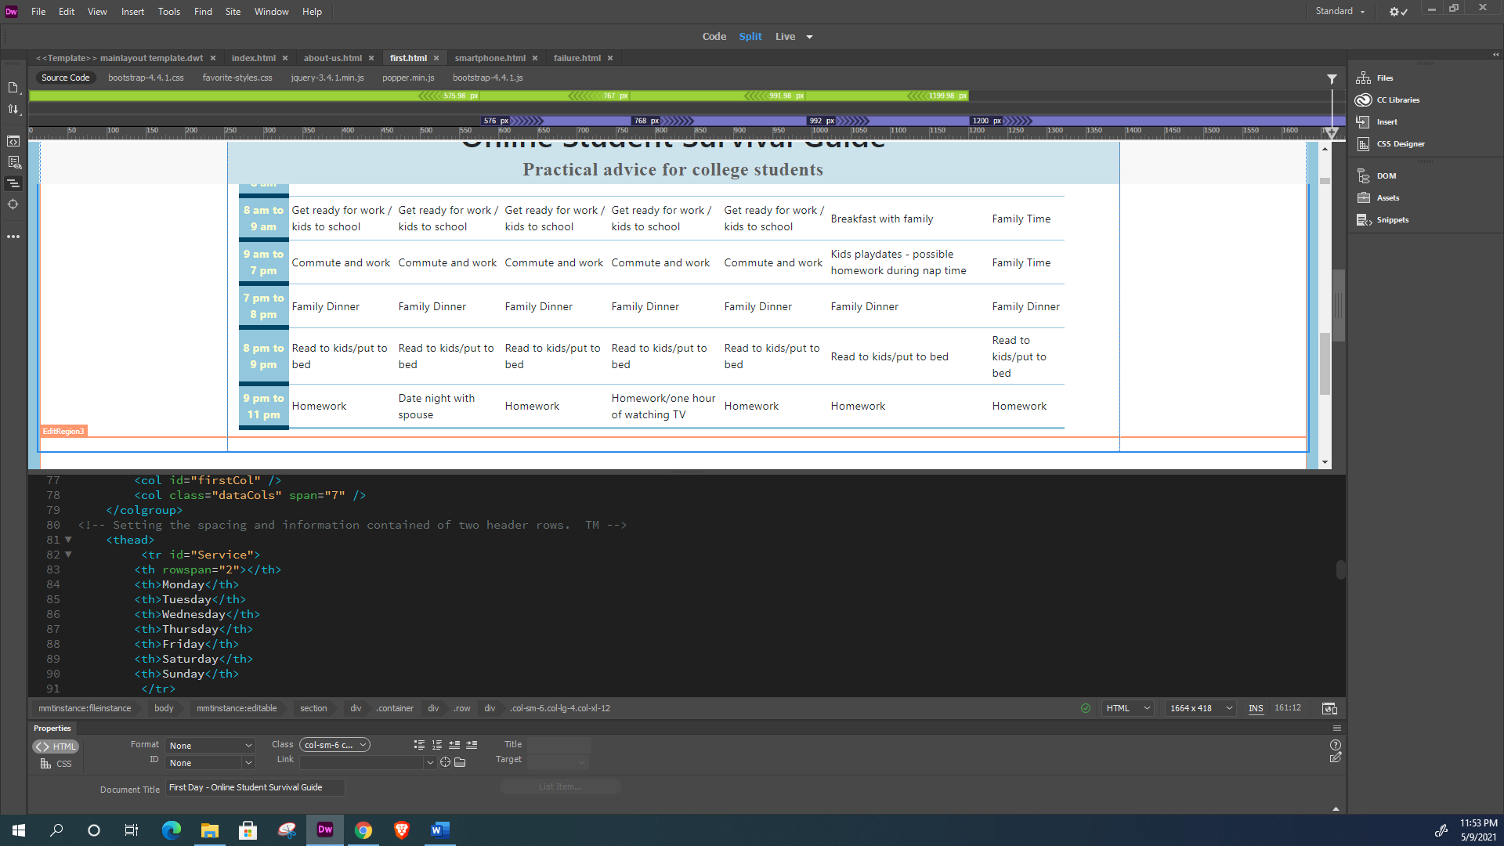

First Day – Added a caption element to the table:

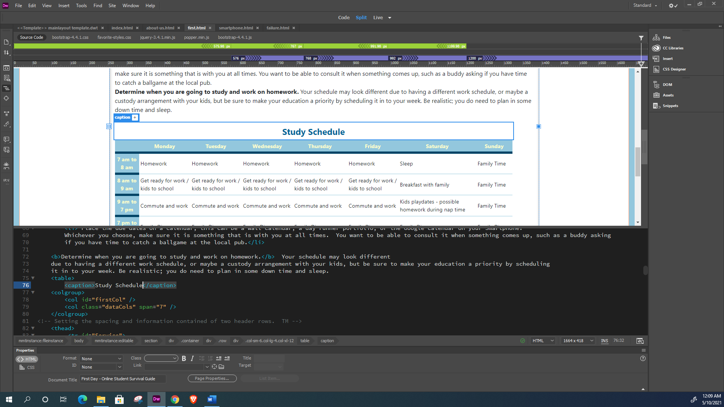

Created the metadata for each page, and alt text and titles for each image:

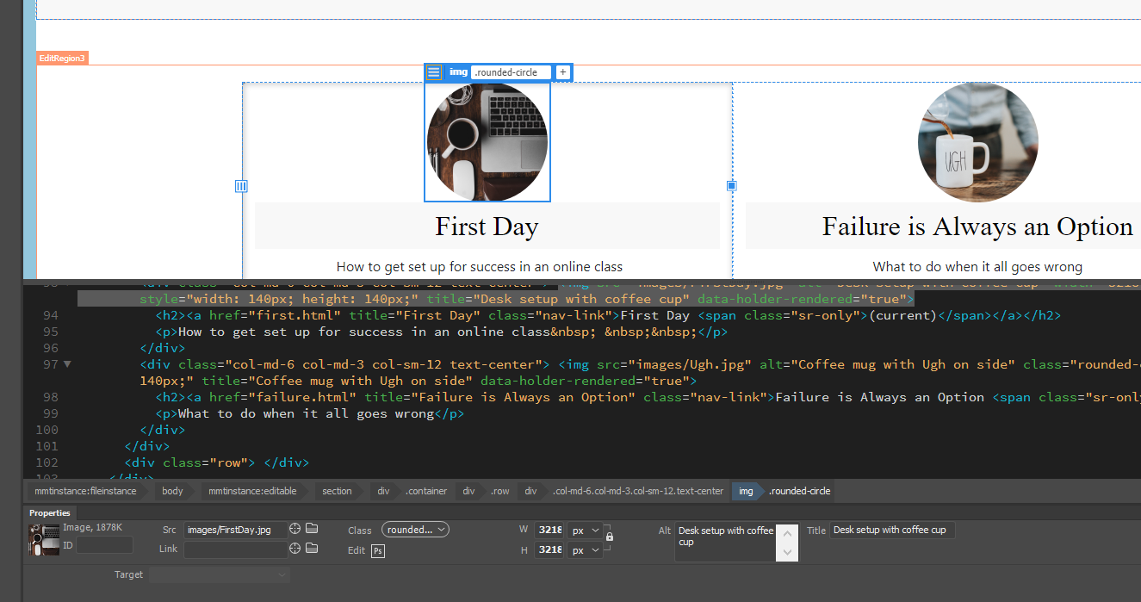

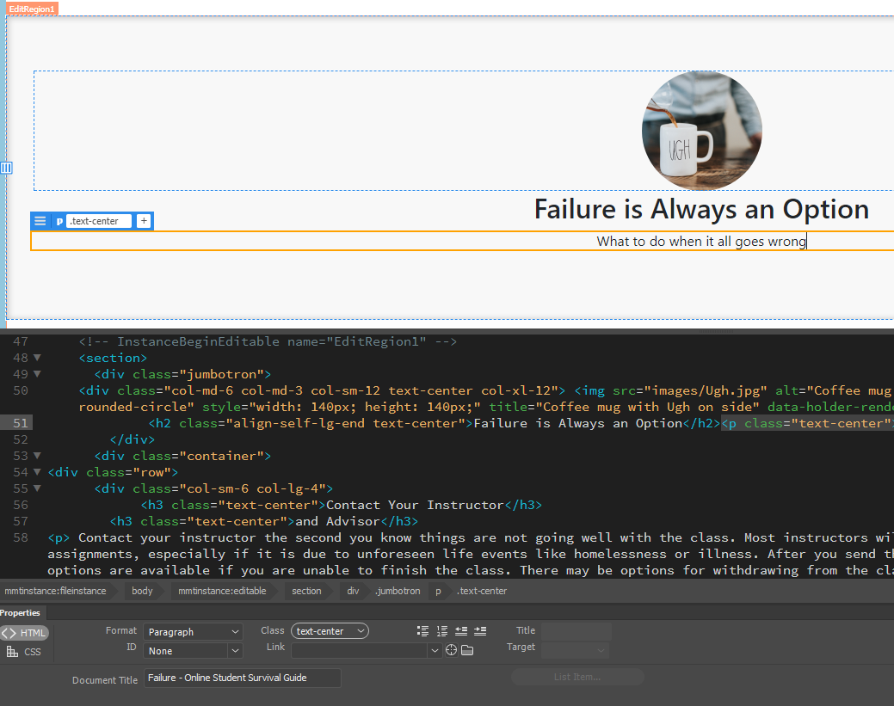

Spell-checked each html document:

