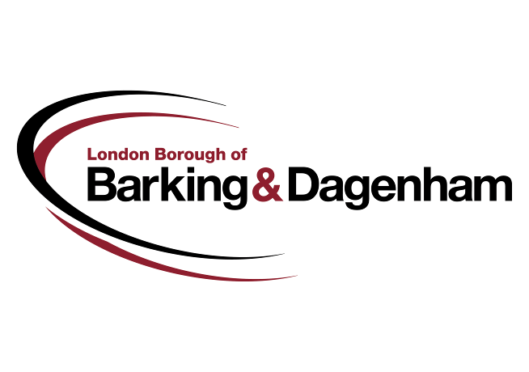

Mr D Rowe 26 September 2017

**Freedom of Information request 4732233**

We wish to advise you that the LBBD has decided not to disclose the information you requested on 01 September 2017 regarding  annual CIPFA library stats.

The information requested is being withheld as it falls under the exemption in section 22 (Future Publication) of the Freedom of Information Act. In applying this exemption, we have had to balance the public interest in disclosing the information.

Section 22 provides an exemption for information that is intended to be published in the future. Information is exempt if, at the time when the public authority receives a request for it:

* the public authority holds the requested information;
* the public authority intends the information to be published at some future date, whether that date is determined or not; and

In all the circumstances, it is reasonable to withhold the information until its planned publication.

**Factors for disclosure:**

* The public interest in the accountability, openness and transparency of government, and the promotion of public understanding;
* The public has a right to know the information; and
* To show compliance with the FOIA by disclosing information held by the Council

**Factors for withholding:**

* The information is being drafted and it is intended for publication at an appropriate date;

**Reasons why public interest favours withholding information:**

The answer is yes the borough of Barking and Dagenham does send in to CIPFA our statistical return for libraries.

It will be published in due course by CIPFA and at this point we will be more than happy to provide you with the return sent to them, but until this date we are not able to share that data as it must be validated by CIPFA.

The data needs to be validated by CIPFA and will be available to share in January 2018.

**Internal Review Procedure**

If you are dissatisfied with the handling of your request then you have a right under Section 50 of the Act to request an internal review. All such requests must be sent to us within 8 weeks and must clearly state your reference number and your reason for your request for an internal review.

We will respond to your request for an internal review within 20 working days of receipt. Your request for an internal review should be sent by email to [foi@lbbd.gov.uk](mailto:foi@lbbd.gov.uk) quoting your FOI reference number.

**Information Commissioners Office**

Should you remain dissatisfied with the final outcome of the internal review then you may apply directly to the Information Commissioner (the “ICO”) for an independent review. The ICO is the Government’s Independent Body responsible for overseeing the Freedom of Information Act 2000, the Data Protection Act 1998 and The Environmental Information Regulations 2004. Please note the ICO will only review cases that have exhausted the council’s internal review procedure. All correspondence to the ICO must quote the council’s reference number and your reasons for your appeal. The ICO’s contact details are as follows;

The Information Commissioners Office,

Wycliffe House,

Water Lane, Wilmslow,

Cheshire,

SK9 5AF.

More information can be found at the ICO’s website at http://www.ico.org.uk If you have any further enquiries about this matter, please do not hesitate to contact us by emailing [foi@lbbd.gov.uk](mailto:foi@lbbd.gov.uk)

I trust you find the above to be satisfactory but should you have any queries please do not hesitate to contact us.

Yours sincerely

FOI Team