Compiling with ASIO Support

1) Download the ASIO SDK from Steinberg’s website:

https://www.steinberg.net/en/company/developers.html

2) Unzip the package and copy the content into the lib-src folder:

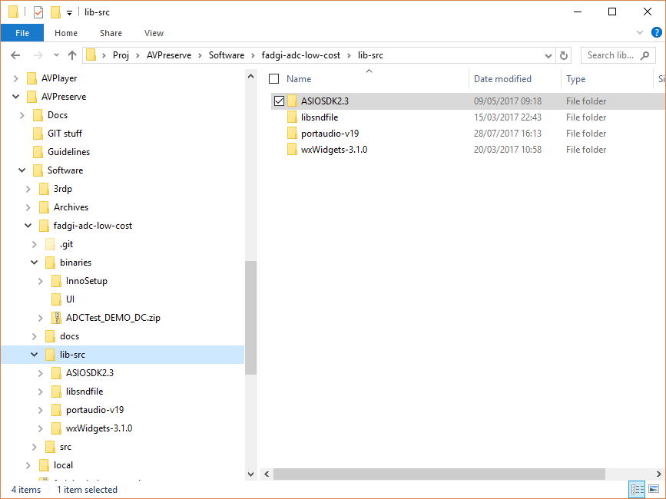

3) Open the Visual Studio solution located in \src\msvc\AVPTester\AVPTester.sln

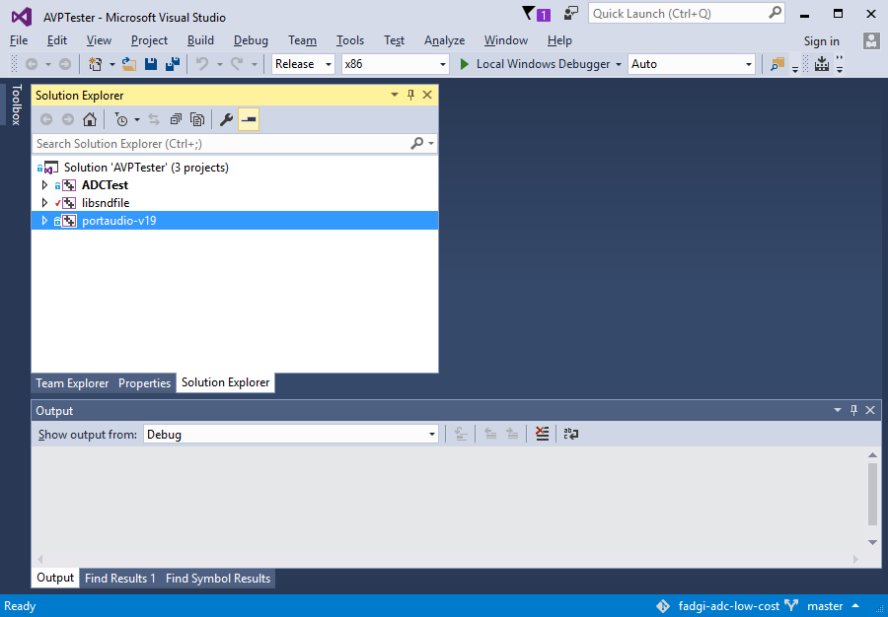

4) In order to add ASIO support, perform the following actions:

- Select the portaudio-19 project

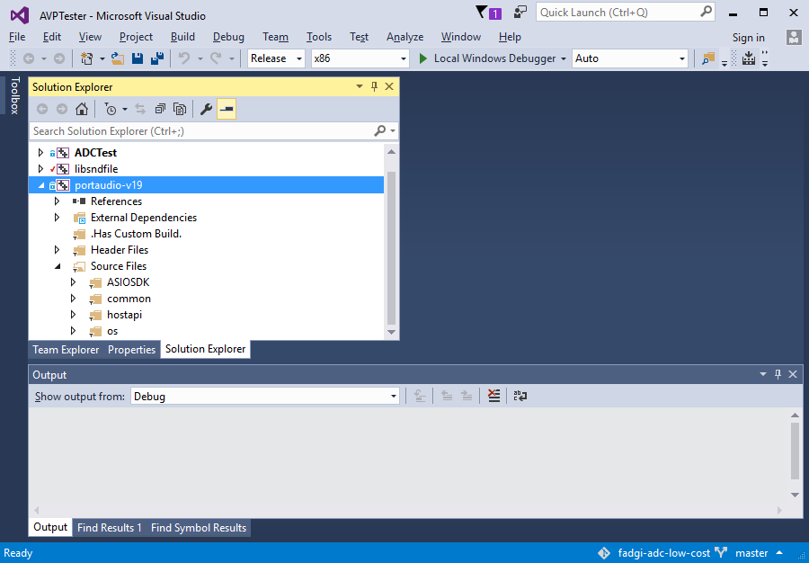

- Right click on the ASIOSDK folder and select Add→ Existing Item

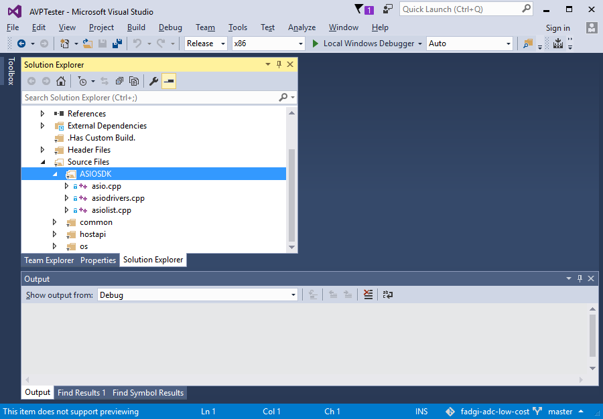

Add the following files:

lib-src\ASIOSDK2.3\host\pc\asiolist.cpp
lib-src\ASIOSDK2.3\host\asiodrivers.cpp
lib-src\ASIOSDK2.3\common\asio.cpp

- Right click on the “hostapi\asio” folder and select Add→ Existing Item

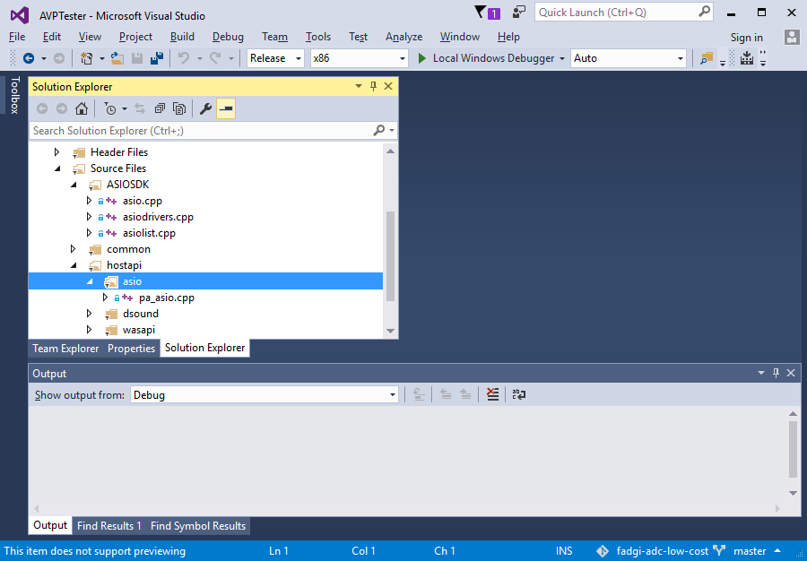

Add the following file: lib-src\portaudio-v19\src\hostapi\asio\pa_asio.cpp

- Right click on the portaudio-19 project header and select “Properties”

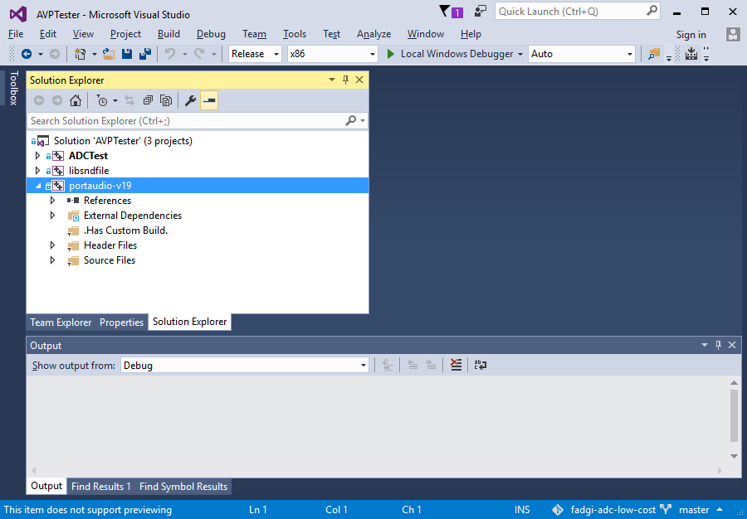

In the properties page, select the page “C/C++ → Preprocessor”

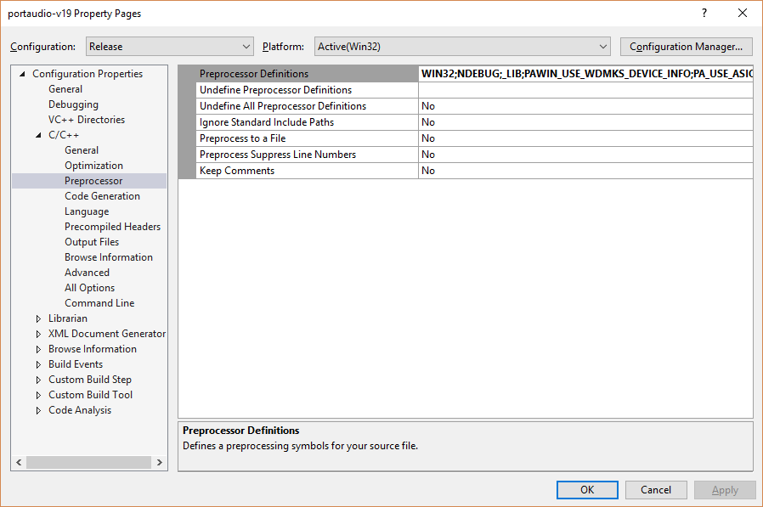

Edit the Preprocessor definitions and change the definition PA_USE_ASIO=0 to PA_USE_ASIO=1

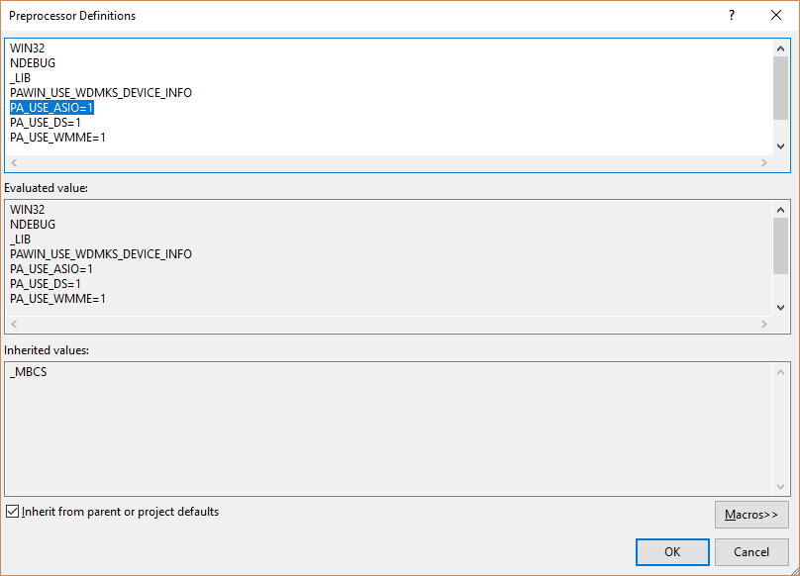

Save everything and compile.

