Bagger User Guide

Version 2.8
Supporting BagIt specification 0.97

U.S. Library of Congress
The Repository Development Center

Contacts
Kate Zwaard (kzwa@loc.gov)
Justin Littman (jlit@loc.gov)
Salim Malik (smalik@loc.gov)

Table of Contents

Introduction 4
About 4
Bagger and BIL 4
Getting started 4
Windows 4
Linux/Ubuntu 4
Exceptions 5
Display layout 6
Views 6
Bag action buttons 7
Bag content display 8
Bag property display 9
Bag-Info input forms 9
Making Bags 9
Creating a New Bag 9
Opening an Existing Bag on Disk 17
Creating a bag-in-place 19
Saving Bags 25
Saving a bag to disk 25
Save Bag 26
Save Bag As 29
Browse location button 30
Holey Bag 32
Serialize Type 32
Generate Tag Manifest 34
Generate Payload Manifest 34
Verify Bag after Save 35
Saving as a holey bag 37
Payload and Tag Files 40
Adding/deleting payload files 40
Adding/deleting tag files 44
View Tag Files 49
Checking Bag Status 50
Checking that a bag is complete 50
Incomplete bag 52
Checking that a bag is valid 54
Invalid bag 56
Project Profile 58
Satisfies project profile 60
Unsatisfied Project Profile 63
Bag-Info 66
Editing 66
Bag-Info 68
Add Field 69
Add Field - Standard 72
Add Field - New 74
Remove Field 76
Project profiles 77
Appendix 77
Appendix 78
BagIt Overview 78
BagIt package layout 78

Introduction

About

The Bagger application was created for the U.S. Library of Congress as a tool to produce a package of data files according to the BagIt specification (see the ‘BagIt Overview’ section for more details). It can create a structured directory of verified files and folders, or it can create a serialized compressed archive file of the directory, such as a zip file.

Bagger and BIL

The Bagger application is a graphical user interface conforming to the BagIt specification. For this document, 'bag' refers to Bagger's representation of a bag. This bag is in computer memory which may have been loaded into the Bagger application from content on a disk. 'Bag on disk' refers to an instance of a bag that exists on a disk-drive as opposed to merely in computer memory.

Bagger differs from a command line tool by providing graphical dialogs and buttons for file and data manipulation features as well as a visual view of the bag contents, bag state and options. In addition Bagger provides a project profile capability. The user can create customized bag-info.txt data with project specific properties that the user defines, including: required fields, required field values and default field values. These project profile values can be saved and loaded as desired or shared with other users.

When the bagger application is first started the bagger folder gets created in the user's home folder and contains some default profiles. Profile files should be named <profile name>-profile.json and stored in the bagger's home directory: <user-home-dir>/bagger.
On Windows, it is C:\"Documents and Settings"\<user>\bagger and in a Unix-like operating system, it is ~/bagger. Also when the bagger application is started it creates a few default profiles in the above bagger folder, which could also be used as a guide to create custom profiles.

Getting started

The Bagger application is intended for users that have multiple versions of the Java VM that may conflict with the Bagger application, or may have security constraints that prevent them from downloading and installing software on their systems.

To use the Bagger application in Windows, copy and unzip the file bagger.zip that is downloaded from github by selecting the link:

https://github.com/LibraryOfCongress/bagger/releases/latest

Windows
After unpacking the zip file, find the bagger directory. This directory will be named bagger-<VERSION> where VERSION is the version you downloaded (for example bagger-2.8.1). To start the Bagger application, double-click on the bagger.bat file in the bagger/bin folder.
The Bagger application starts with a splash banner page.

Linux/Ubuntu
After unpacking the zip file, find the directory bagger-2.1.3. To start the Bagger application, execute the bagger file in the bagger/bin folder (i.e. ./bin/bagger).
The Bagger application starts with a splash banner page.

Exceptions
There are two common causes for the bagger application to fail, which are:

- Using the incorrect version of the Java Run Time Environment or if no System Path is set for Java. The fix is to use the correct Java Runtime Environment (i.e. 1.8+ in Windows and OpenJDK 8 in Linux/Ubuntu)
- The bagger folder in the user's home folder contains Profile files with older JSON format. The fix is to delete the old Profile files in the bagger folder and rerun the bagger application, which will create the new default Profile files with the latest JSON format.

To further investigate the above exceptions/errors while running bagger, please refer to the included README.txt file.


Bagger startup splash page

Display layout

Views
The Bagger application consists of 4 main section views:
- Bag action buttons along the top of the display
- Bag content display on the left-hand side of the display
- Bag property display on the upper right-hand side of the display
- Bag-Info input forms on the lower right-hand side of the display

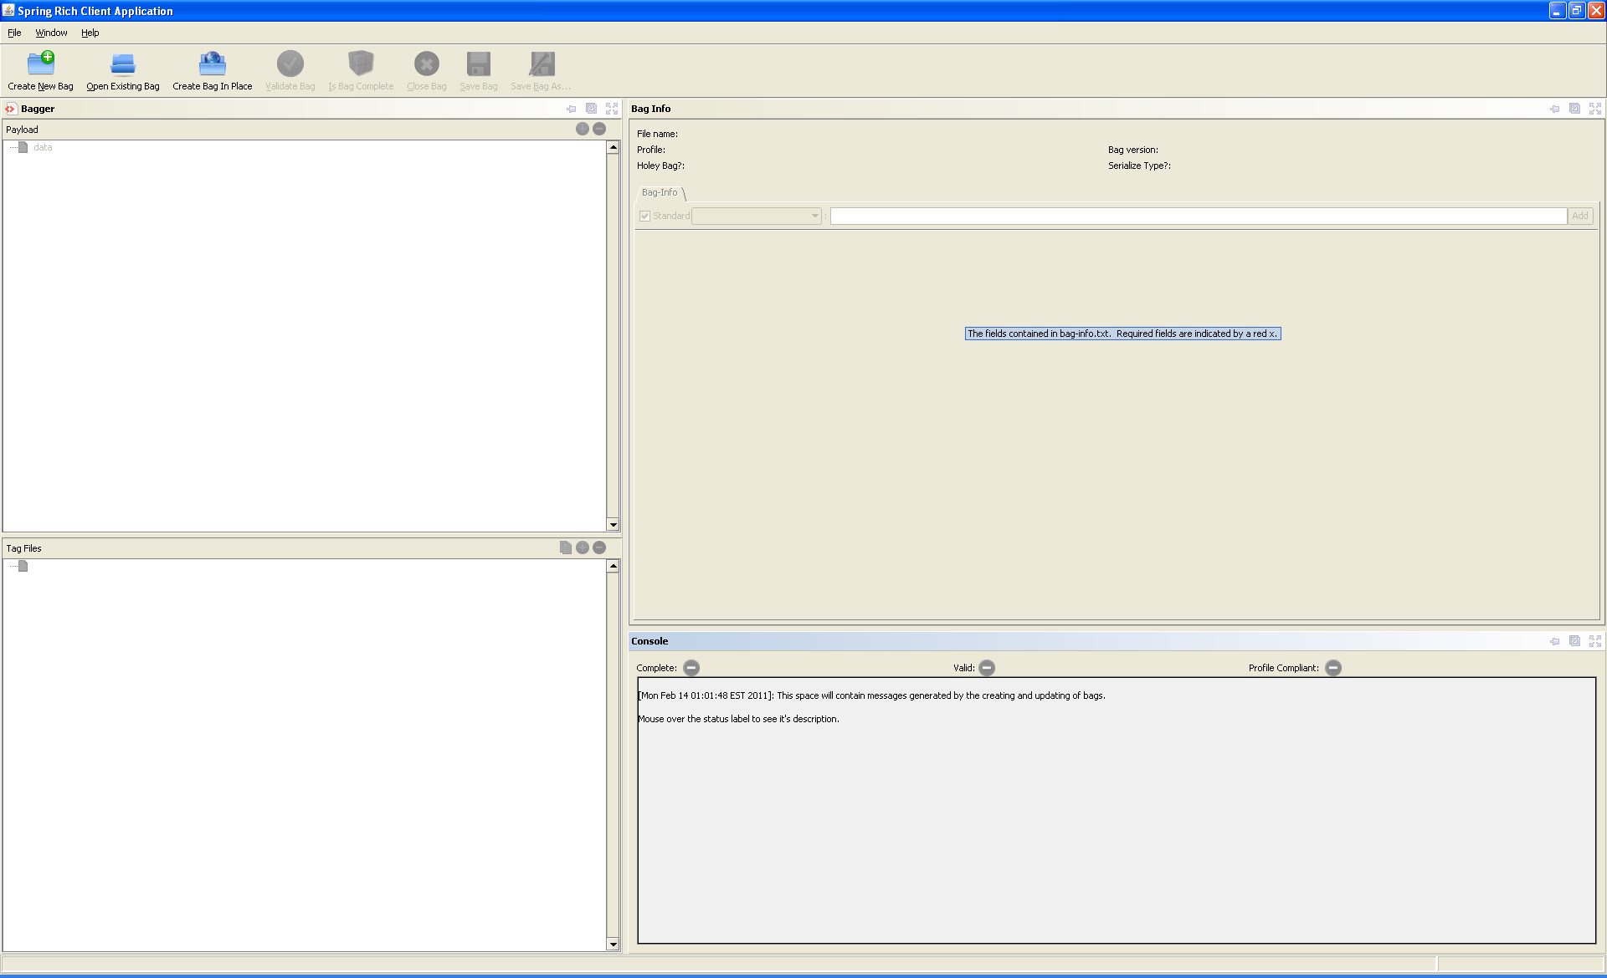
Bagger default display

Bag action buttons
The top row action buttons allow the user to create bags and determine a bag’s state.
Upon startup the Bagger application buttons and properties are disabled except for the three top buttons that open a new or existing bag: 1) ‘Create New Bag’, 2) ‘Open Existing Bag’, and 3) ‘Create Bag-in-place’. Once a bag is initiated with one of those buttons then the other buttons become enabled as needed according to the following rules.

- ‘Create New Bag’ – always enabled
  - Enables Add Data button
  - Enables Clear Bag button
- ‘Open Existing Bag’ – always enabled
  - Enables Add Data button
  - Enables Save Bag button
  - Enables Save Bag As button
  - Enables Check is Complete button
  - Enables Check is Valid button
  - Enables Clear Bag button
- ‘Create Bag-in-place’ – always enabled
  - Enables Add Data button
  - Enables Save Bag button
  - Enables Save Bag As button
  - Enables Check is Complete button
  - Enables Check is Valid button
  - Enables Clear Bag button
- ‘Save Bag’ – default disabled
  - Enabled after Open Existing Bag selected
  - Enabled after Create Bag-in-place selected
  - Enabled after Save Bag As selected
  - Enables Check is Complete button
  - Enables Check is Valid button
- ‘Save Bag As’ – default disabled
  - Enabled after Open Existing Bag selected
  - Enabled after Create Bag-in-place selected
  - Enabled after Add Data selected
  - Enables Check is Complete button
  - Enables Check is Valid button
  - Enables Save Bag button
- ‘Is Bag Complete’ – default disabled
  - Enabled after Open Existing Bag selected
  - Enabled after Create Bag-in-place selected
  - Enabled after Save Bag selected
  - Enabled after Save Bag As selected
- ‘Validate Bag’ – default disabled
  - Enabled after Open Existing Bag selected
  - Enabled after Create Bag-in-place selected
  - Enabled after Save Bag selected
  - Enabled after Save Bag As selected
- ‘Close Bag’ – default disabled
  - Disables Save Bag button
  - Disables Save Bag As button
  - Disables Check is Complete button
  - Disables Check is Valid button
  - Disables Add Data button

These buttons are used to create new bags or view existing bags. They also allow the user to add content to a bag and save the bag. Once a bag exists it can be validated. The results of bag creation and validation are displayed in the console display at the lower-left. Adjacent to the buttons is a selectable checkbox tree that displays a hierarchical representation of the payload files and directories and tag files currently added to the bag. Selecting and deselecting a file will add it to or remove it from the bag. Selecting and deselecting a directory will add to or remove from the bag the selected directory and all its child contents.

Bag content display

The application displays the following information for the bag:

- The payload contents (i.e., the list of files in the bag data directory)
- The tag contents (i.e., the list of files in the base directory)
- The BagInfo contents
- The Project profile
- If the bag exists on disk:
  - The path/filename
  - The format (unserialized, serialization format)
  - The version
- If the bag is complete
- If the bag is valid
- If the bag has a Project profile and satisfies that profile
- Any completion, validation, additional verify warning or errors

Console Display

As the user manipulates the bag contents the results of these actions are displayed in a console on the lower right-hand side of the Bagger Application. This console displays the following information:
- ‘Complete:’ - ‘Label does not have Green Check Mark’ by default
From the BagIt specification: “A bag is considered complete if every file in every payload manifest and tag manifest is present, and if every payload file appears in at least one payload manifest. A payload file does not need to appear in every payload manifest as long as it appears in one payload manifest (i.e., it must belong to the "union" of payload manifests). In a complete bag containing one or more tag manifests, any tag file may appear in zero or more of those manifests, but every tag file appearing in any tag manifest must be present in the bag.”
- ‘Valid:’ - ‘Label does not have Green Check Mark’ by default
From the BagIt specification: “A bag is considered valid if it is complete and if each CHECKSUM in every payload manifest and tag manifest can be verified against the contents of its corresponding FILENAME.
Note that tag files (including tag manifest files) can be added to or removed from a bag without impacting the completeness or validity of the bag as long as the tag files do not appear in a tag manifest.“
- ‘Profile:’ - ‘Label does not have Green Check Mark’ by default
This status is disabled by default. It becomes enabled when a ‘Profile’ other than <no profile> has been selected. If the bag has a Bag-Info project profile and satisfies that profile when the required fields and values specified for the selected project appear in the bag-info.txt tag file of the bag. The BagIt specification allows a bag to be created even though all fields are not valid.
- Console display
This console shows any status check, warning or error messages. The default value is a definition of bag status.

Bag property display
If the bag exists on disk then the following information is enabled and displayed on the upper-right view of the Bagger application:

- ‘File name’
The name and path of the bag base location on disk.
- ‘Project profile’
The current project profile selected for this bag.
Here is shown the list of bag project profiles the user can choose to associate a bag with and also add validation restrictions to the bag input forms based upon the chosen project. Default project options are [<no profile>, eDeposit, ndiipp, ndnp, other_project]. The default option is <no profile>. Each project profile associates a project to user and contact information as well as other fields that are to be included in the bag-info.txt metadata file. These fields uniquely identify a bag as belonging to a specific project and are necessary project input.
- ‘Bag version’
BagIt version for this bag
- ‘Holey bag’
Whether the bag is holey, i.e. the payload is included. This option is unselected by default. Selecting the holey bag option when saving a bag will indicate that the data files for this bag will not be included in the bag package. The payload data is to be retrieved from an address which will be provided in the URL field. See the ‘BagIt Overview’ for more details.
- ‘Serialize type’
Format of the bag on disk, either un-serialized or serialized based upon the format specified when the bag was created.
This option is selected to none by default. Selecting an option other than none tells the Bagger Application to create a serialized archive file from the bag contents with the same name as the bag directory in the format of zip. The success of this operation is indicated by the ‘Has a bag been created?’ indicator in the Console tab. See the ‘BagIt Overview’ for more details about bag serialization.

Bag-Info input forms
This form consists of the following tab form:
- ‘Bag-Info’
This lists the fields and field values to be included in bag-info.txt tag file. If a field has no value then it is not included when bag-info.txt is created. Some fields are automatically generated upon bag creation and are displayed when the bag is loaded from disk. It includes the action buttons:
  - ‘Add’

See the sections ‘Bag-Info Editing’ and ‘Project profile’ for more details about this feature.

Making Bags

Creating a New Bag
Advantages of creating a new bag -

Any arbitrary files or directories can be added to a new bag. The bag can be saved in any location either as an un-serialized directory or using any of the serialization formats provided.

Disadvantages of creating a new bag -

If the bag is saved in a new location and/or in a serialized format, all of the files will be copied, which is potentially expensive in terms of time and disk space.
To create a new bag from scratch the user first selects the ‘Create New Bag’ button from the Bag action buttons at the top of the Bagger application. This clears any pre-existing bag and creates an empty bag with blank values for the input forms and resets previously selected buttons and options to their default values. The user does not yet need to enter a bag name. This name and location will be defined when the user saves the bag.
Basic flow:
1. User selects to create a new bag.
2. User selects a bag version.
3. Application clears any displayed information from previous bag and creates a new bag.

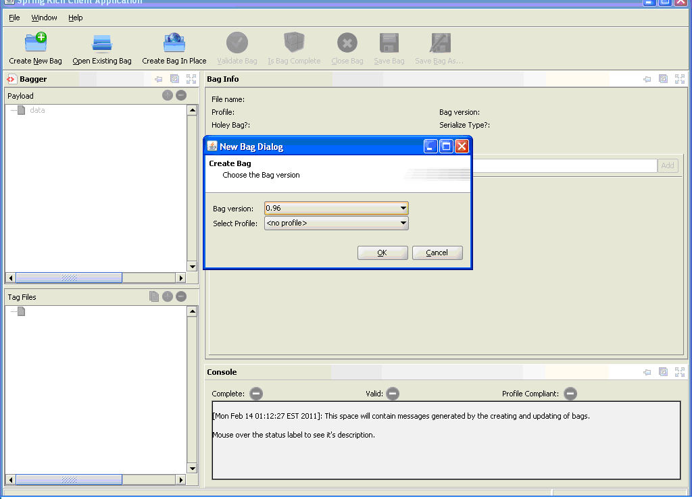
New Bag Dialog
A New Bag Dialog window appears that gives the user the option to select which version of BagIt this bag will comply with. The default bag version will be the latest BagIt specification implemented in BIL. Selecting the New Bag button will create an empty bag with default settings.

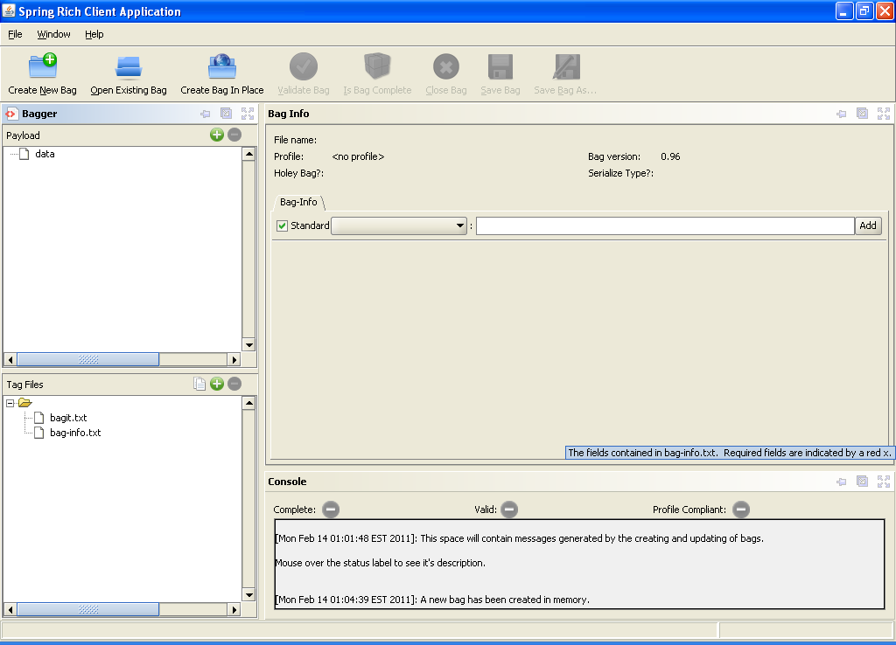
New empty bag

Notice that the new bag has several additional buttons now enabled:
- ‘Add File’ (i.e. the plus sign in the Payload form)
- ‘Remove File’ (i.e. the minus sign when the payload file is selected in the Payload form)
- View Tag Files (i.e. the file button in the Tag Files form)
- ‘Add Tag File’ (i.e. the plus sign in the Tag Files form)
- ‘Remove Tag’ (i.e. the minus sign when the tag file is selected in the Tag Files form)
- ‘Add’ (i.e. in the Bag-Info tab in the Bag-Info Form)

We will address the function of each of these buttons later in the guide.
For now, select the ‘Add Files’ button (i.e. the plus sign in the Payload Form) to select the first directory of files to include in the bag data payload.

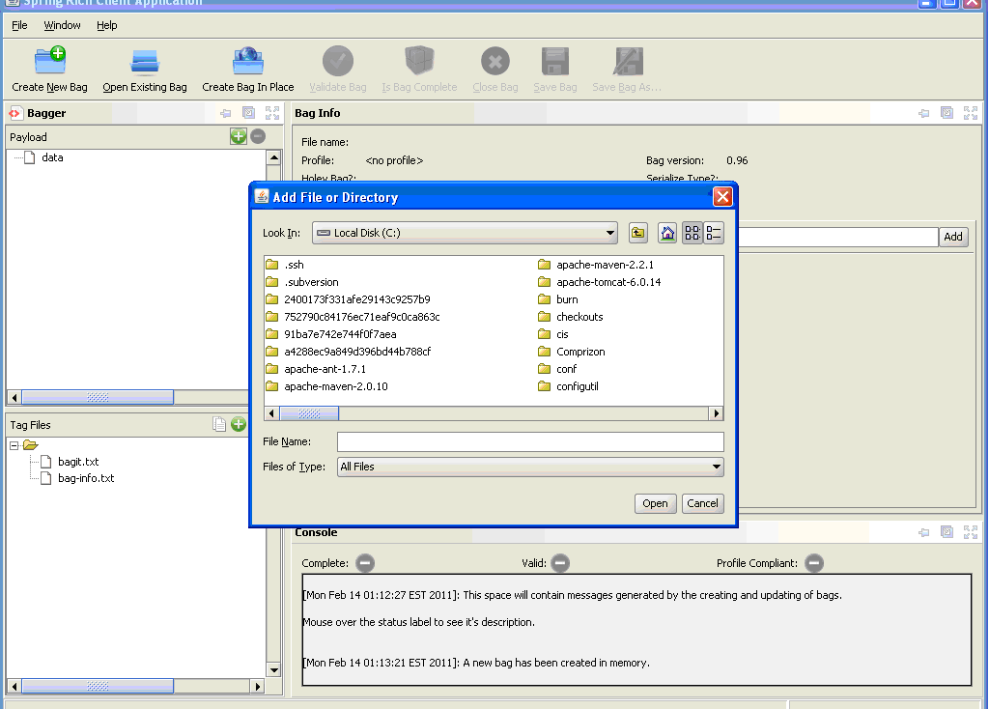
Add File or Directory

An Add File or Directory chooser dialog is displayed that allows the user to select multiple files and/or directories to be included in the bag. Go to the directory containing the files that need to be included in the bag. Then select the Open button to include them.

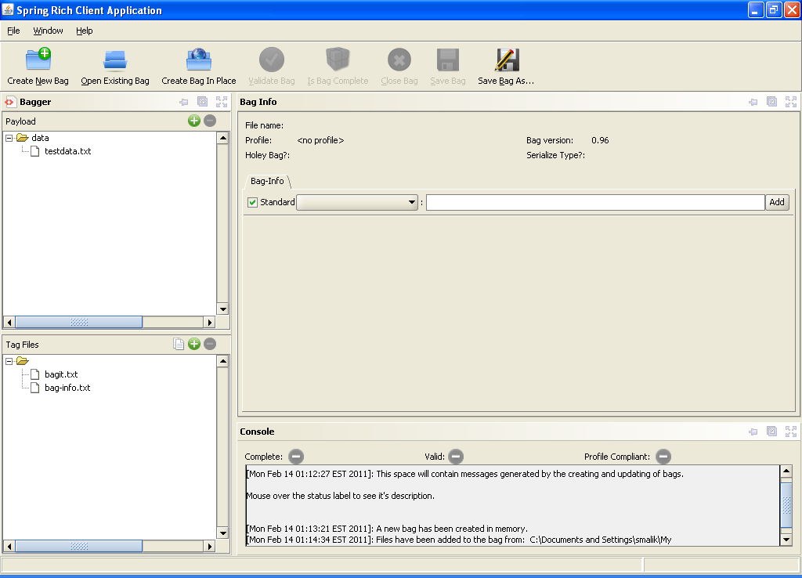
Added Data

The Payload frame now displays the hierarchical tree of files as they will be created within the bag data payload directory. Notice that now the ‘Save Bag As’ and ‘Remove Selected Files’ (i.e. the minus sign when payload file is selected) buttons are enabled. Now that the bag has had data content added it can be saved. Select the ‘Save Bag As’ button.
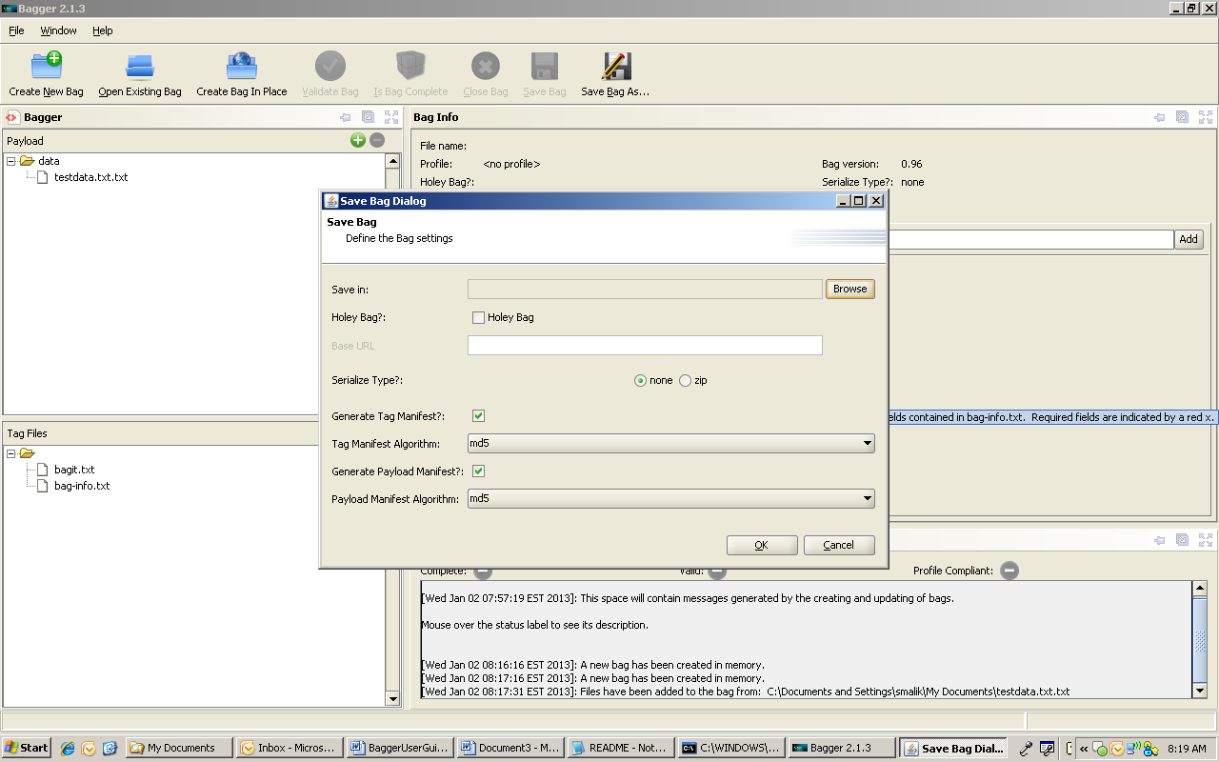
Save Bag Dialog

The ‘Save Bag Dialog’ is displayed. This presents the user with all the options available for saving a bag. Next select the Browse button. This will be the name and location of the bag that will be saved to the disk drive to be selected.

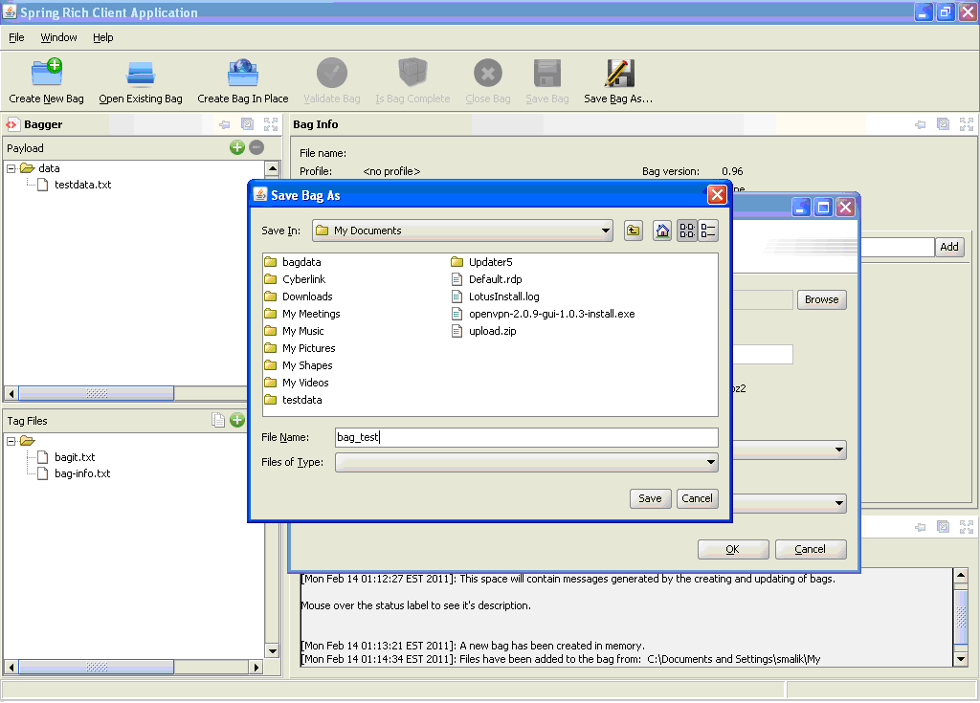
Save Bag As dialog

An Add File or Directory chooser dialog is displayed that allows the user to select the location the bag is to be saved within. Enter the name of the bag in the File Name field and then select the Save button. It has now been selected where it is needed to save the bag and what it is to be called. We will look at the other features of the ‘Save Bag Dialog’ later in this guide. For now, select the ‘Save’ button. Once the bag has successfully been saved a Bag saved popup confirmation dialog is shown.

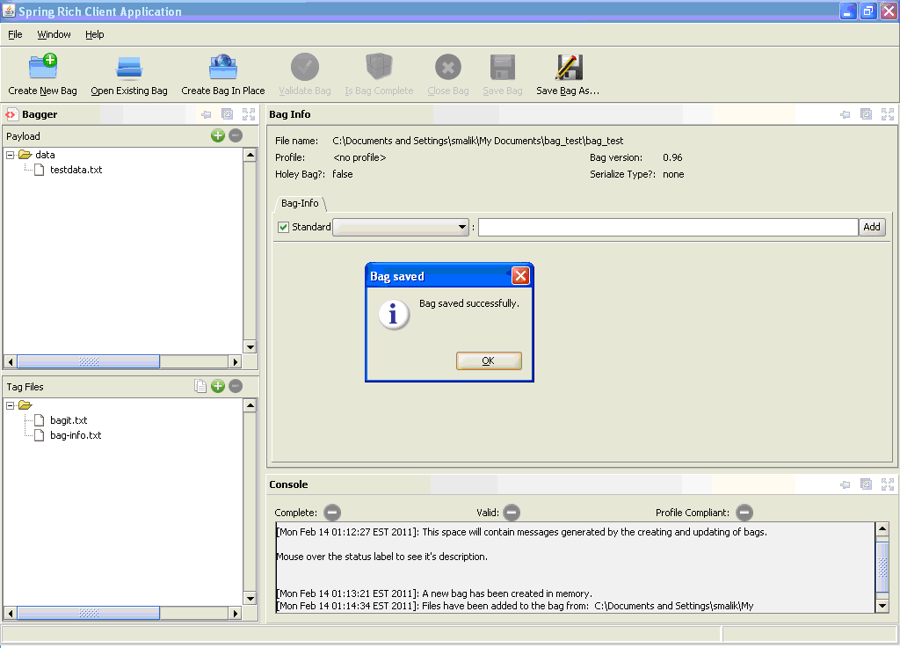
Bag saved dialog

Select Ok from the popup dialog to see the newly saved bag.

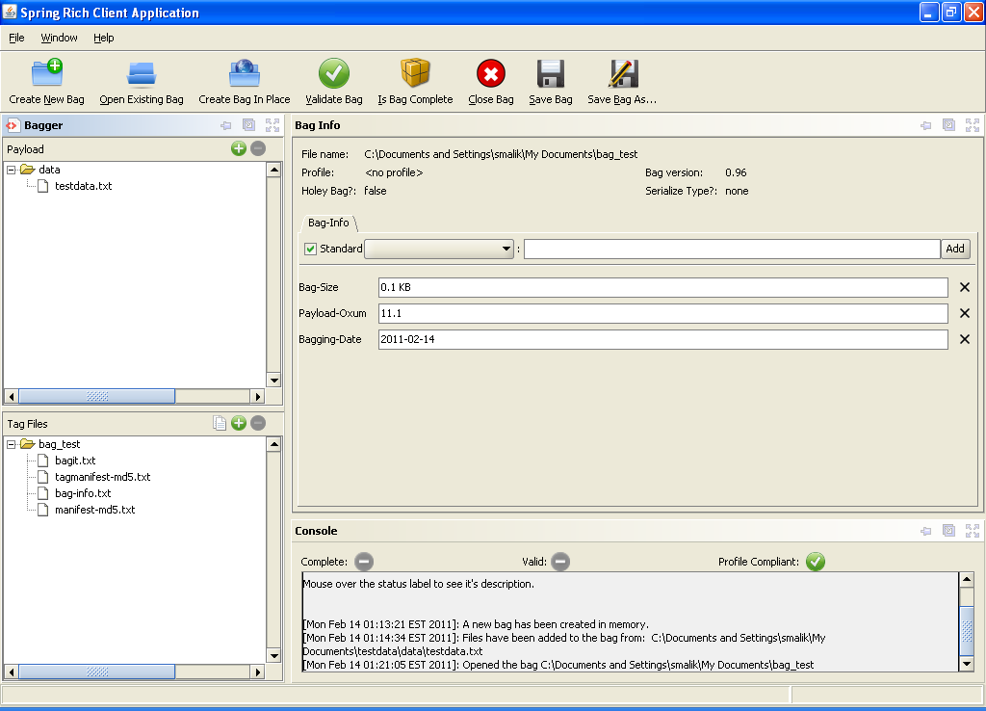
Saved Bag

Notice that the ‘Check Is Complete’, ‘Check Is Valid’ and ‘Save Bag’ buttons are now enabled. These features will be discussed later in the guide.

Opening an Existing Bag on Disk
The Bagger Application can also load an existing bag folder or serialized bag file. This could be done to check whether the folder contains a valid bag or to add more data or more information to an existing bag.

Start by selecting the ‘Open Existing Bag’ button from the Bag action buttons at the top of the application. This displays a directory and file chooser dialog window. Select the desired bag from the file chooser dialog and then select the Open button. This will load the directory or file and create a bag if one exists.

Note: There is no need to close the current bag that is being worked on. It will start a new bag in its place, but if the current bag has not already been saved then it will be replaced with the new bag.
Basic flow:
1. User selects to open an existing bag.
2. User selects a bag on disk. (User provides file/directory using a File/Directory picker. User should have option to limit display of files by serialization format.)
3. Application creates the bag.
4. Application clears any displayed information from the previous bag and displays information from new bag.

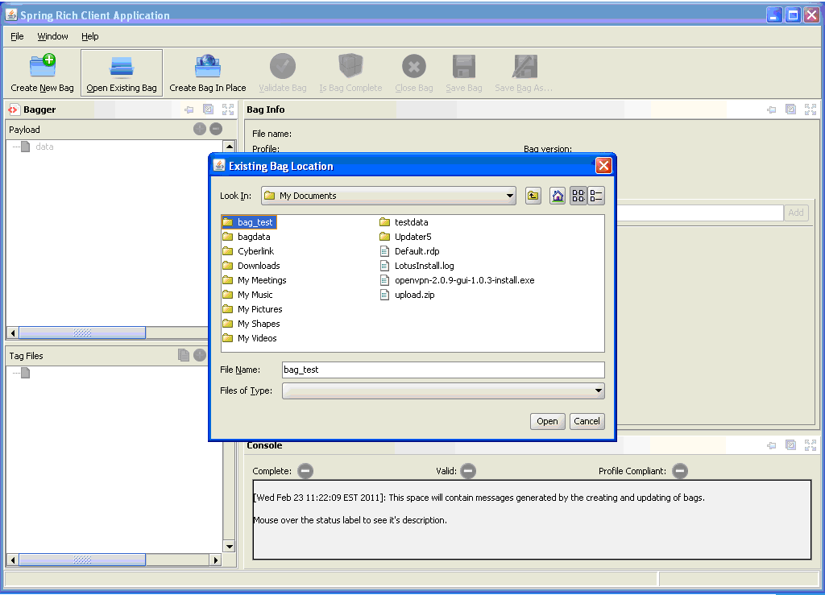
Open Existing Bag

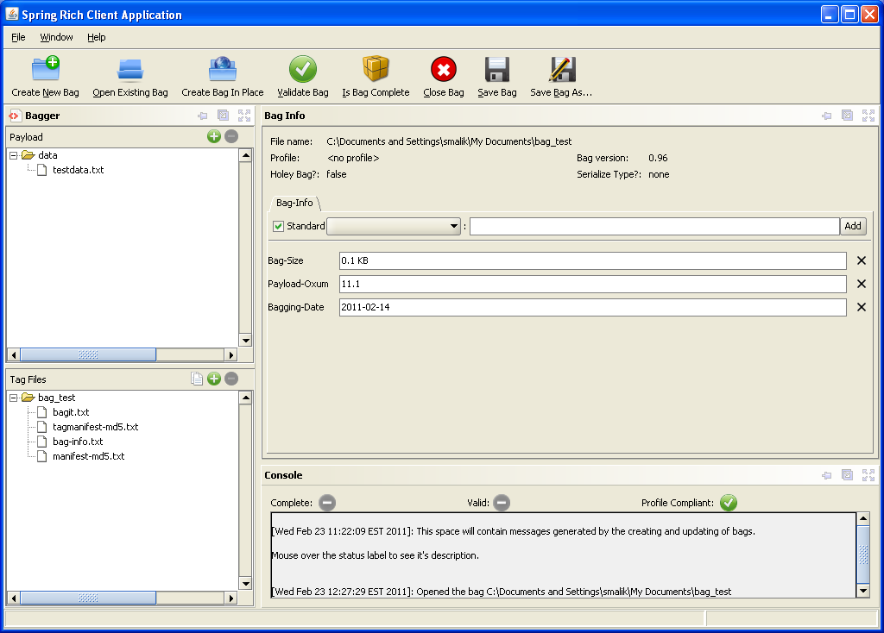
Existing bag loaded

The existing bag has been loaded and its data contents are now displayed in the data hierarchy file tree. Notice that all the buttons are now enabled. The status of this bag may be checked, add additional data, or edit the Bag-Info forms and update it.

Creating a Bag In Place
Advantages of creating a bag in place -

The files or directories will be moved into the bag structure rather than copied, which is efficient in terms of time and disk space.

Disadvantages of creating a bag in place -

Only the files or directories at a particular location will be added to the new bag. The bag will be saved at that location and must be un-serialized.

To create a new bag-in-place the user first selects the “Create Bag In Place” button from the Bag action buttons at the top of the Bagger application.

Notes: The directory that is bagged in place may be:
Basic flow:
1. User selects to create a bag in place.
2. User selects a directory on disk. (User provides file/directory using a File/Directory picker. User should have option to limit display of files by serialization format.)
3. User selects a version and whether to retain the base directory.
4. Application creates the bag, including moving the directory/files as necessary to create the bag structure, completing the bag, and writes to disk.
5. Application clears any displayed information from the previous bag and displays information from new bag.
- A set of files/directories in the basic structure of bag a bag (i.e., it has a data directory with content), but is not complete.
- A directory containing a set of files/directories.
A New Bag in Place Dialog window appears that gives the user the option to select which version of BagIt this bag will comply with. The default bag version will be the latest BagIt specification implemented in the Bagit Library (BIL).
Also the “.keep Files in Empty Folder(s):” check box will place .keep files in empty folders which would be bagged during the “Create Bag In Place” process.

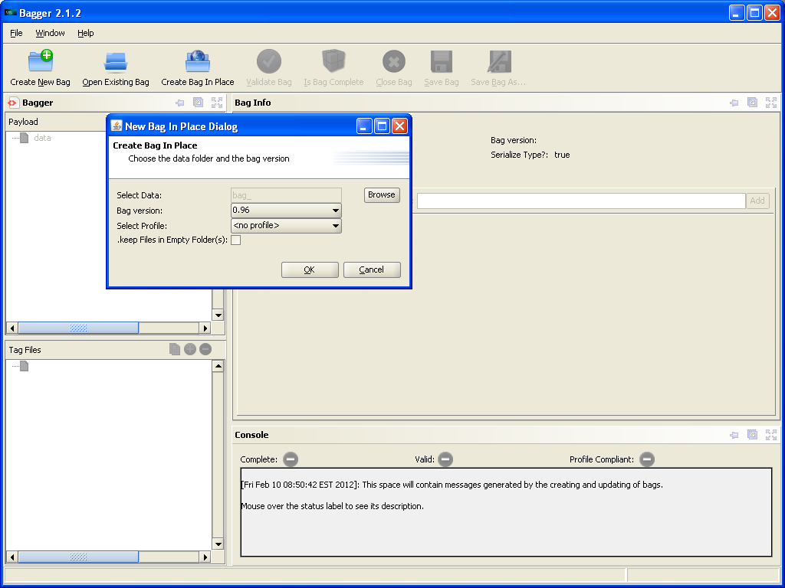
New Bag-in-place Dialog

In addition the user chooses the data directory to be bagged by selecting the Browse button.

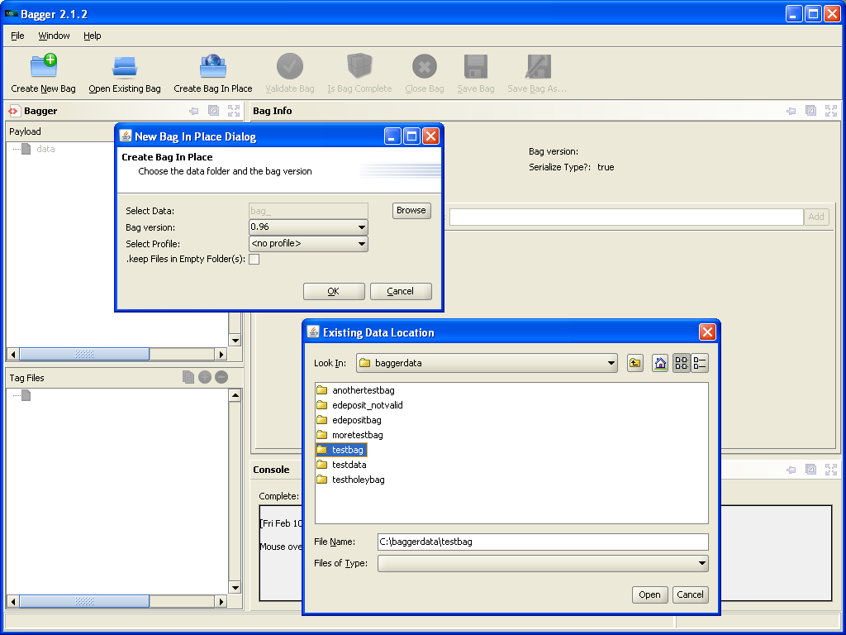
New Bag-in-place Browse

Choose the existing data location that needs to be bagged and then select the Open button.

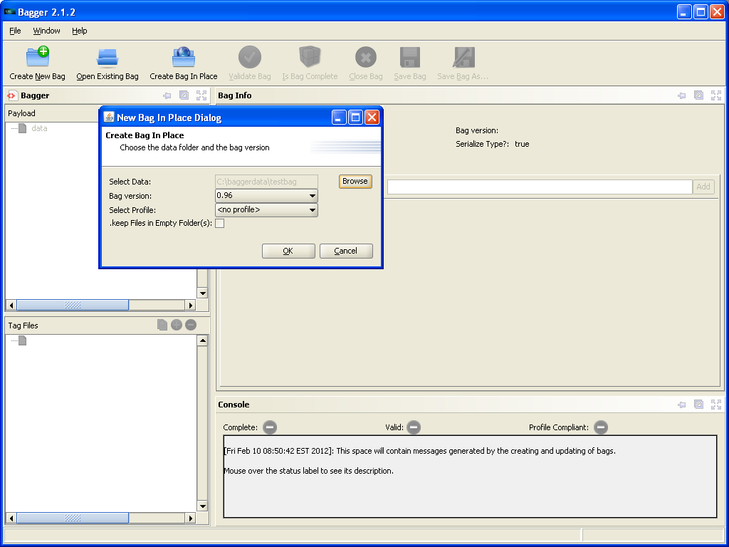
Choose existing data

Selecting the “Bag In Place” button will clear any pre-existing bag and save a bag with a data payload from the chosen directory. A Bag saved dialog confirms that the bag was successfully saved to disk.

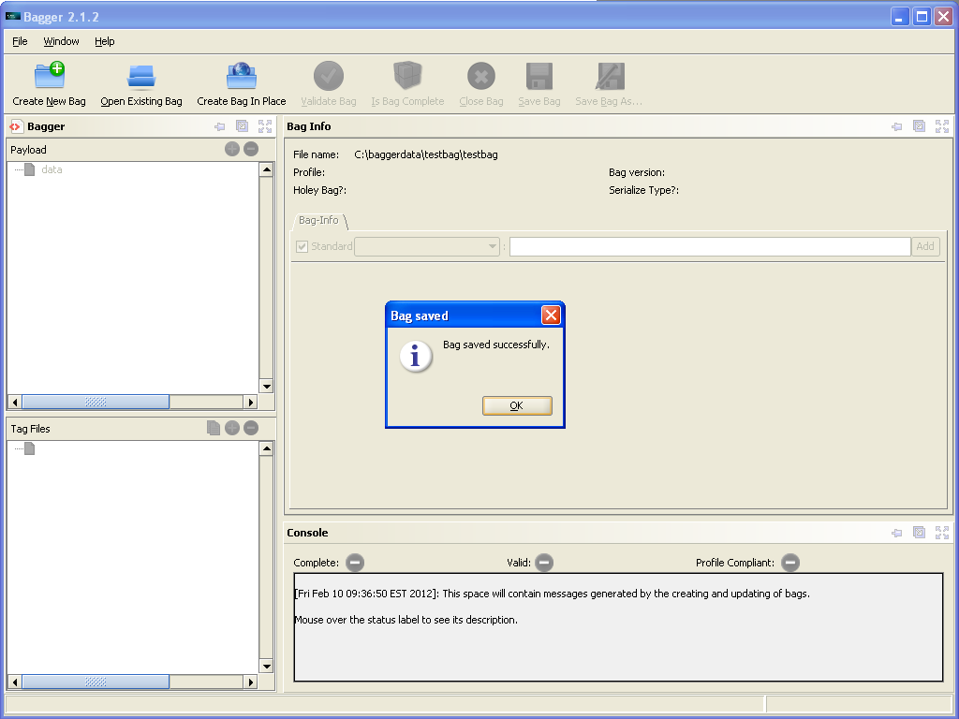
Bag In Place

Select the Ok button to view the newly created bag. The input forms and previously selected buttons and options are reset to their default values. The bag name and location were derived from the selected data directory name.

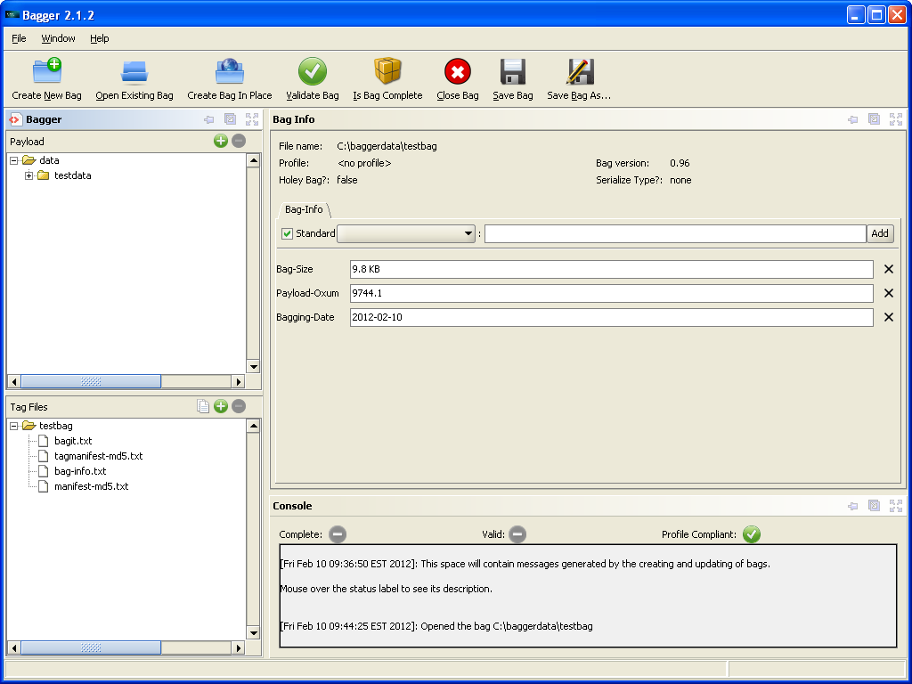
New Bag-in-place

Saving Bags

Saving a bag to disk
There are two Bag action buttons for saving bags:
- ‘Save Bag’ – is available if the selected destination already exists. It will overwrite the bag on disk with the current bag of the same name using the existing settings.
- ‘Save Bag As’ – is available to any current bag open in Bagger. It provides the user with several options such as making a bag holey and serializing the bag.

Basic flow:
1. User selects to save bag.
2. User provides save options. Save options include:
* File/directory (User provides file/directory using a File/Directory picker).
* Format (unserialized, zip)
* Whether to generate/regenerate a tag manifest and if so, the algorithm.
* Whether to generate/regenerate a payload manifest and if so, the algorithm.
* Whether to verify a bag after writing.
3. If the selected destination for the bag already exists, user confirms that files will be overwritten.
4. Application completes the bag.
5. Application writes the bag and replaces the current bag with the bag returned by saving. (The bag returned by saving references the new bag on disk.)
6. Application verifies the bag, if selected by user.
7. Application updates the displayed information for the saved bag.

Save Bag
To overwrite an existing bag, select the ‘Save Bag’ button.

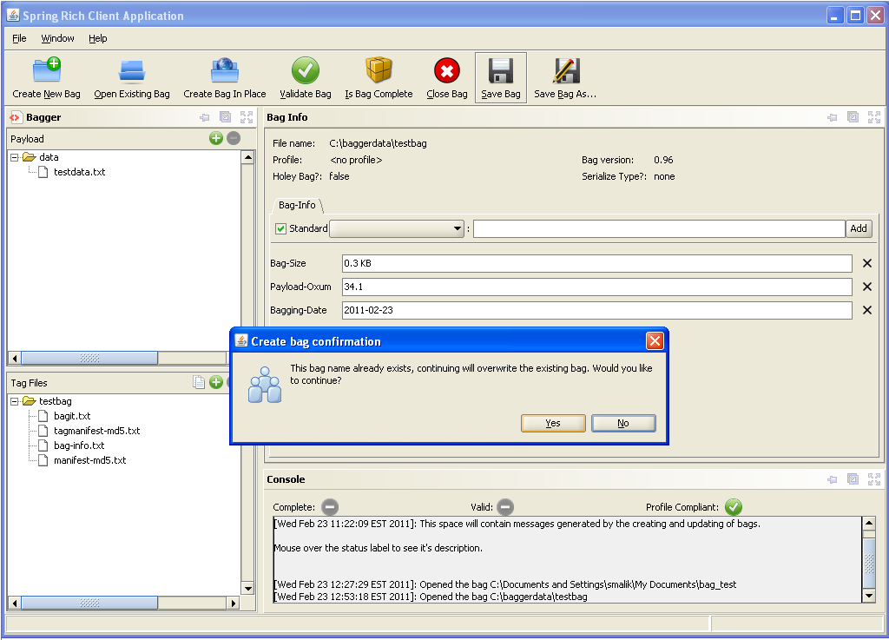
Create bag confirmation

Selecting “Yes” from the Create bag confirmation dialog will save the bag to disk at the preexisting location. Once the bag has successfully been saved a Bag saved popup confirmation dialog is shown. Select Ok to continue to the newly saved bag.

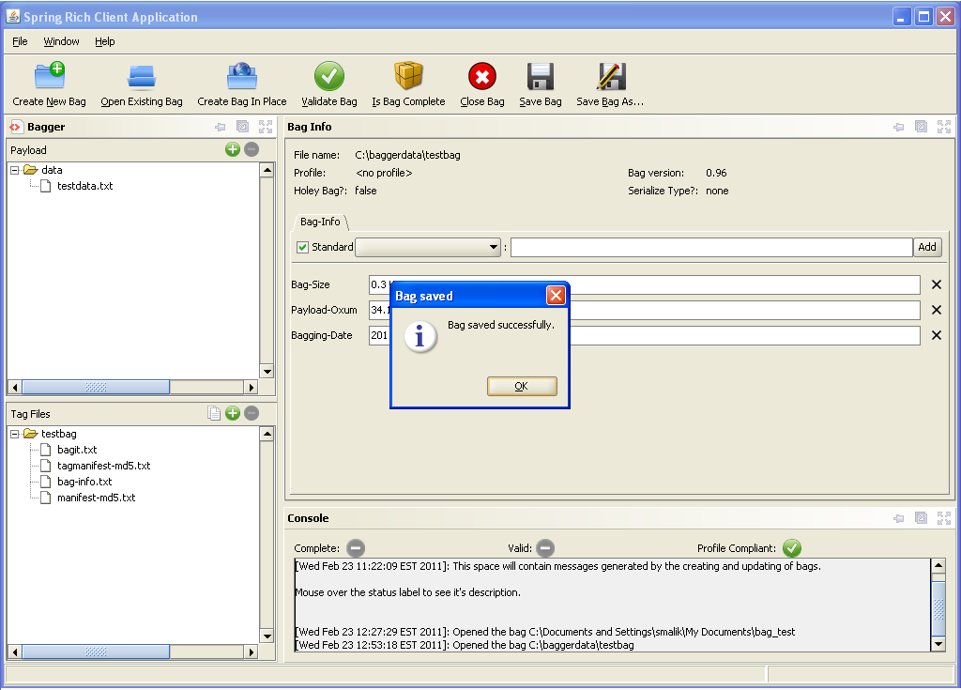
Bag saved dialog
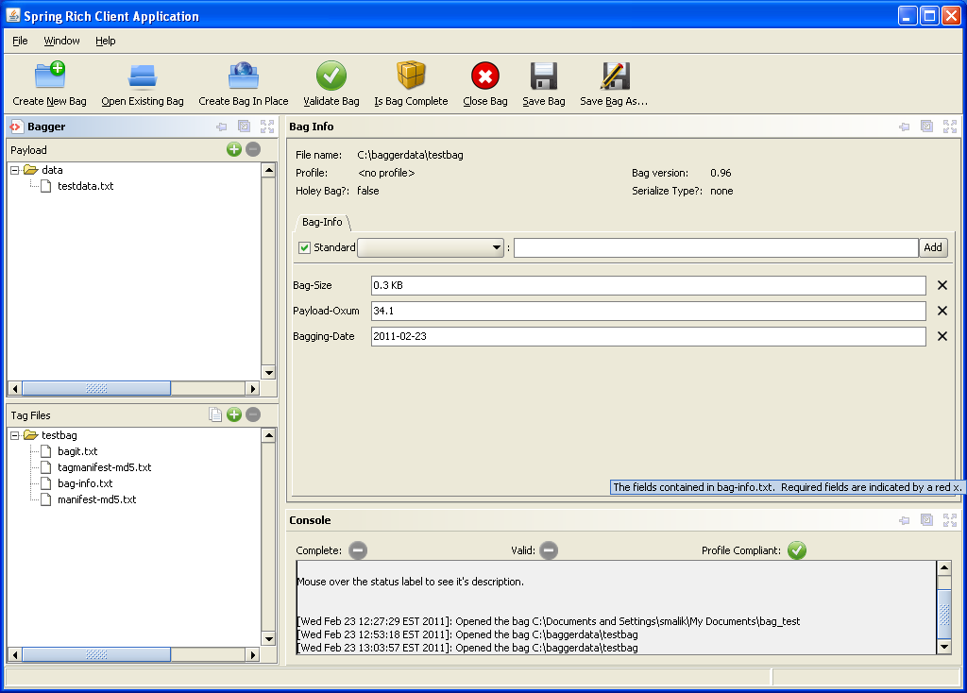
Saved Bag
Save Bag As
Selecting the ‘Save Bag As’ button will open the Save Bag Dialog which shows the different options that can be applied to saving a bag.

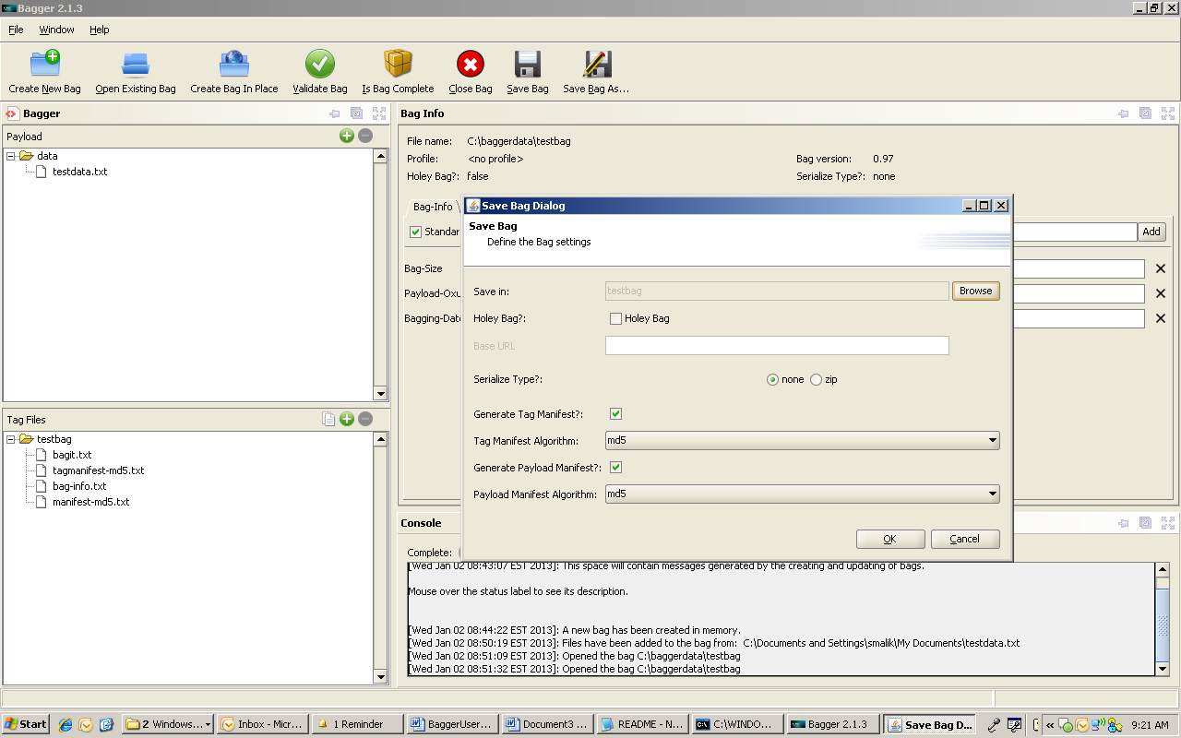
Save Bag Dialog

The Save Bag Dialog shows the following options:
- Browse location button:
- Holey Bag:
  - Base URL
- Serialize Type?
  - none
  - zip
- Generate Tag Manifest?
  - Tag Manifest Algorithm
- Generate Payload Manifest?
  - Payload Manifest Algorithm
- Verify Bag after Save?

Browse location button
This is the only save input that is required on this dialog. The browse button will open a file selection chooser to set the bag file name and location.

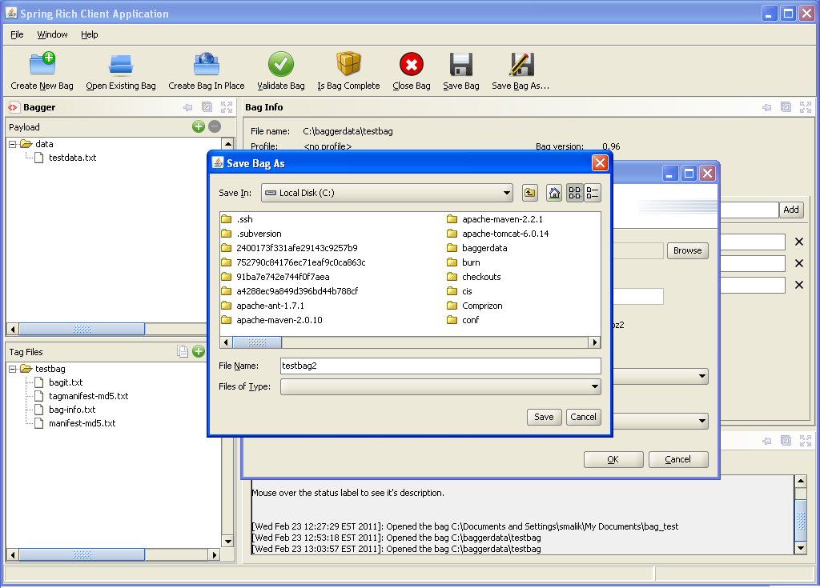
Save Bag As dialog

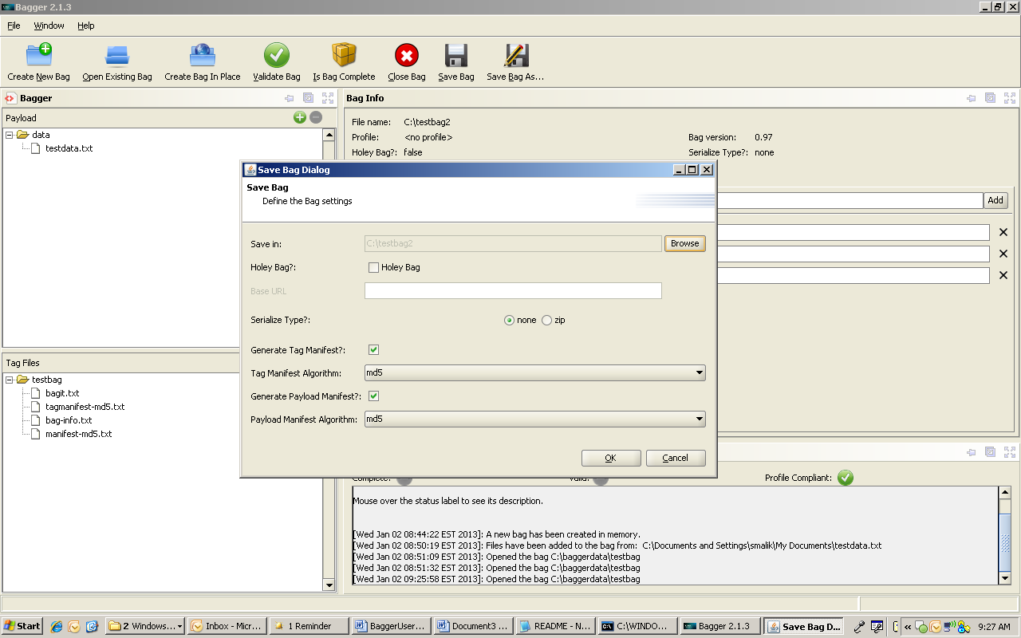
Save Bag Dialog location and name selected

Holey Bag
See the section ‘Saving as a holey bag’ for information on creating holey bags.
Serialize Type
In some scenarios, it may be convenient to serialize the bag's base directory (i.e., the file system hierarchy representing the bag) into a single-file archive format such as ZIP (which might involve a compression step). The resulting serialization may later be de-serialized (which might involve an uncompressing step) to recreate the file system hierarchy.

When serializing a bag, care must be taken to ensure that the format's restrictions on file naming, such as allowable characters, length, or character encoding, will support the requirements of the systems on which it will be used. See the ‘BagIt Overview’ section for rules on bag serialization.

The user may decide it is necessary to create a serialized version of the bag’s base directory by changing the ‘Serialized Type?’ option from none to one of the serialization formats provided. If a preexisting location exists, but in a different format then it will not be overwritten. A new bag of the chosen format will be created in the same location. In the example shown, the serialization format is changed to the zip compression format.

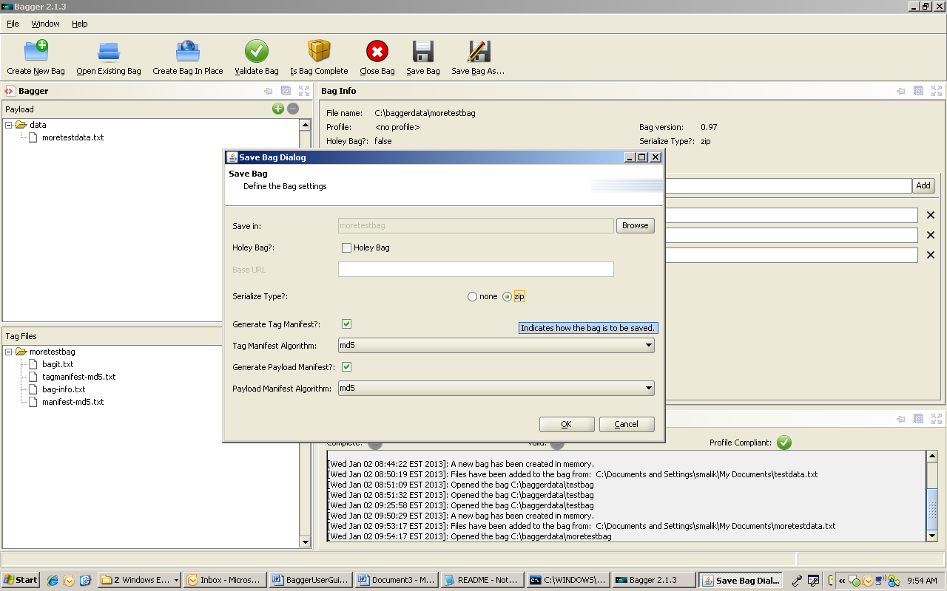
Save Bag Dialog with Serialize Type zip

Select the Save button to create the serialized zip format of the bag. Once the bag has been successfully saved a Bag saved popup confirmation dialog is shown. Select Ok to continue to the saved zip bag.

Note: The payload file tree displays the file contents in the serialized format in which they are stored in the compressed bag on disk.

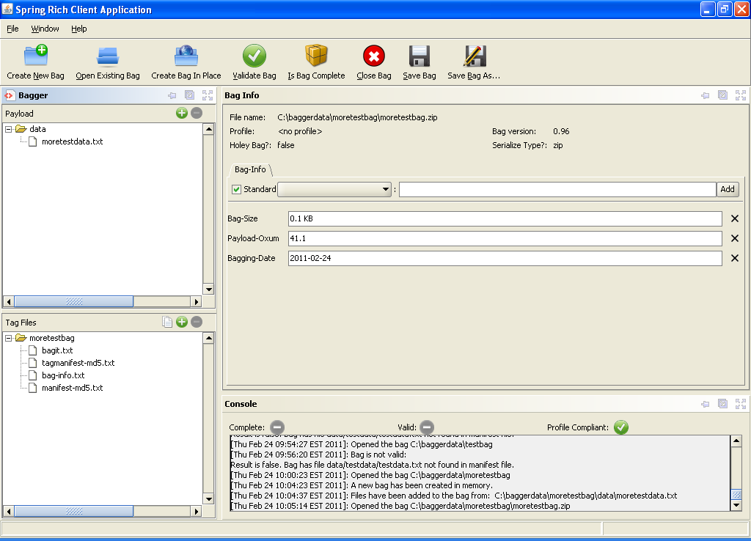
Saved zip bag

Generate Tag Manifest
A tag manifest is a tag file listing tag files and corresponding checksums generated using a particular cryptographic checksum algorithm. A tag manifest file has a name of the form "tagmanifest-algorithm.txt", where algorithm is a string specifying a checksum algorithm. For example, a tag manifest file using SHA1 would have the name tagmanifest-sha1.txt

Bagger provides the following ‘Tag Manifest Algorithms’ to choose from:
md5, sha1, sha256, sha512

Note: A bag may only contain a single tag manifest for a particular checksum algorithm.

Generate Payload Manifest
A payload manifest is a tag file listing payload files and corresponding checksums generated using a particular cryptographic checksum algorithm. A payload manifest file has a name of the form manifest-algorithm.txt, where algorithm is a string specifying a checksum algorithm, such as
manifest-md5.txt or manifest-sha1.txt

Bagger provides the following ‘Payload Manifest Algorithms’ to choose from:
md5, sha1, sha256, sha512

Note: A bag may only contain a single payload manifest for a particular checksum algorithm.

Refer to the ‘BagIt Overview’ section for details about checksum algorithms and how they are used in BIL.

Verify Bag after Save
Verify bag after successful save by clicking on the Validate Bag button.

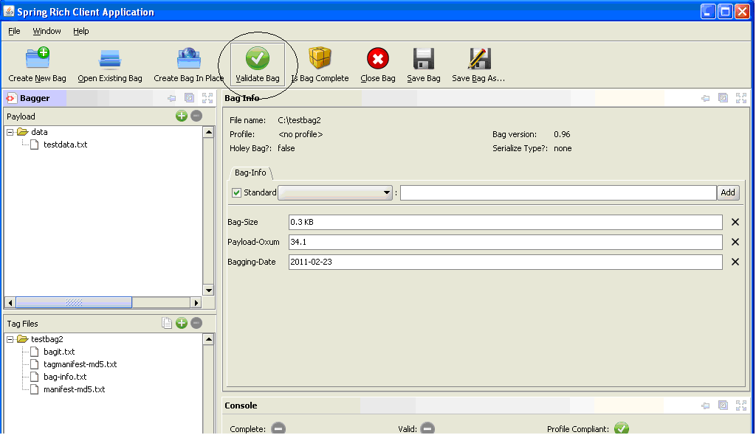
Verify bag after save

Upon a successful save, click on the ‘Validate Bag’ button. If the bag is valid a Validation dialog will be shown indicating a successful check. The ‘Complete’ and ‘Valid’ green check marks should be displayed. If the bag is not valid an error message dialog will be shown indicating the validation problem and the status indicators will show ‘no’.

See the section ‘Checking that a bag is valid’ in the ‘Checking Bag Status’ chapter for information on verifying bags.

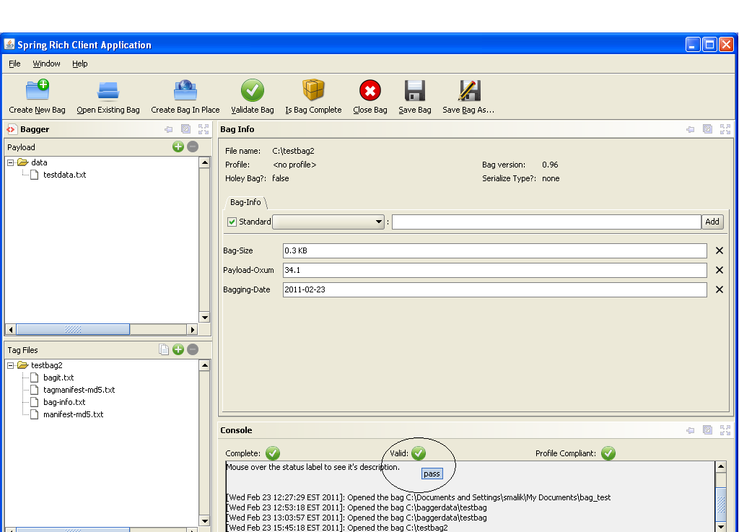
Verified bag after save

Saving as a holey bag

The Bagger Application allows the user to create a holey bag. According to the BagIt specification, a holey bag is a bag that does not itself contain its data payload files. Instead it contains a reference file called fetch.txt that is a list of all the files to be included in the bag and the URL location from which the files can be retrieved at a later time. A holey bag cannot be complete until these files are actually fetched and reincorporated to create a whole bag with all its payload files. The Save Bag Dialog provides a checkbox to indicate that a bag should be made holey. To learn the details about what holey bags are and how they are used, refer to the ‘BagIt Overview’ section.

From the BagIt specification: “For reasons of efficiency, a bag may be sent with a list of files to be fetched and added to the payload before it can meaningfully be checked for completeness. An optional top-level file named ‘fetch.txt’, if present, contains such a list.
The ‘fetch.txt’ file allows a bag to be transmitted with ‘holes’ in it, which can be practical for several reasons. For example, it obviates the need for the sender to stage a large serialized copy of the content while the bag is transferred to the receiver. Also, this method allows a sender to construct a bag from components that are either a subset of logically related components (e.g., the localized logical object could be much larger than what is intended for export) or assembled from logically distributed sources (e.g., the object components for export are not stored locally under one file system tree).

Selecting the ‘Save Bag As’ button will open the Save Bag Dialog which shows the different options that can be applied to saving a bag, including selecting the ‘Holey Bag’ checkbox.
Basic flow:
1. User selects to save as a holey bag.
2. User provides save options. Save options include:
* File/directory (User provides file/directory using a File/Directory picker).
* Base URL.
* Format (unserialized, zip.)
* Whether to generate/regenerate a tag manifest and if so, the algorithm.
* Whether to generate/regenerate a payload manifest and if so, the algorithm.
3. If the selected destination for the bag already exists, user confirms that files will be overwritten.
4. Application completes the bag.
5. Application makes the bag holey. (Making the bag copy holey will return a new bag that is holey.)
6. Application writes the holey bag.
7. Application updates the displayed information for the original bag.

Selecting the ‘Holey Bag’ checkbox option enables the ‘Base URL’ field. This is required in order to identify the server address location of the files to be fetched. Enter a URL address into the ‘Base URL’ field and select the ‘Save’ button.

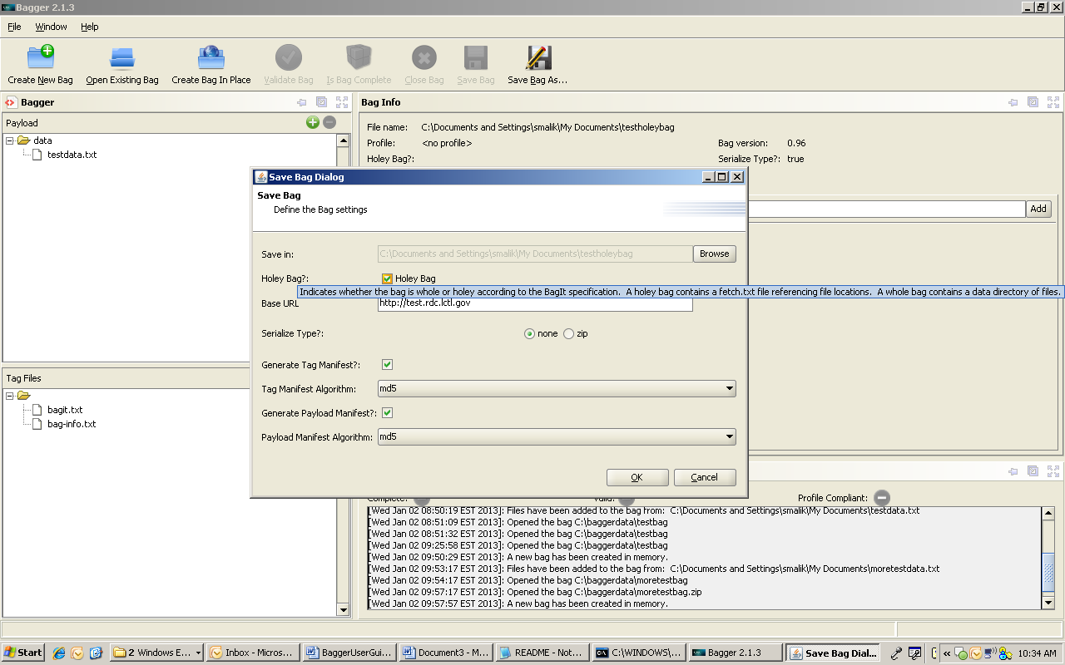
Save Bag Dialog – holey bag

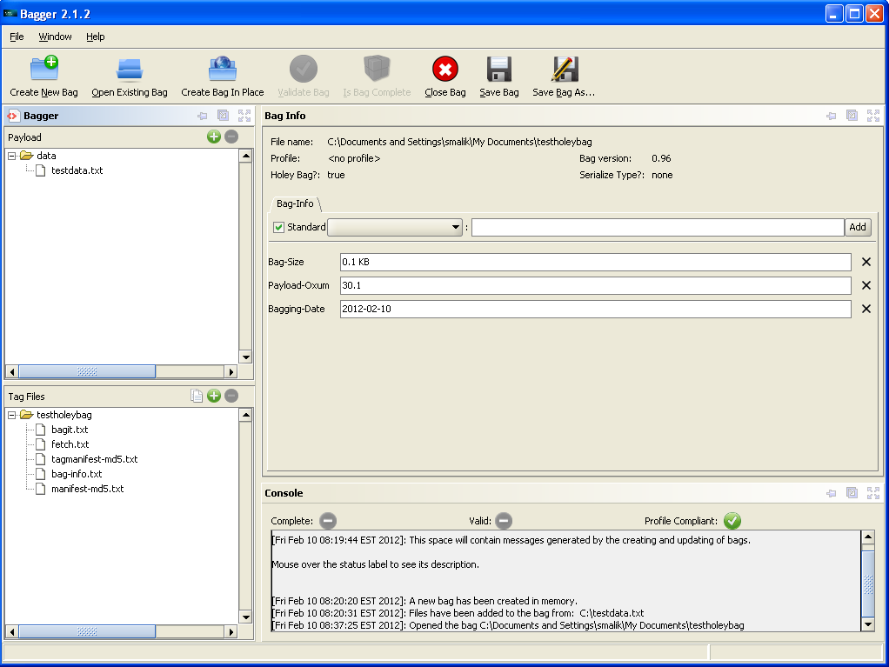
Holey Bag saved

This results in a new holey bag.

Note: For the holey bag the “Validate Bag” and “Is Bag Complete” buttons are disabled on the top toolbar. The bag will not be valid and complete until the files are fetched and the bag is made whole.

Payload and Tag Files

Adding/deleting payload files
Once there is a new bag or an open bag, adding files to the bag data payload or removing them from the bag data payload is easy and straight forward with the Bagger application. This can be accomplished by either selecting the Add Data or Remove Data buttons, or by utilizing the system’s drag-and-drop capability. The following state changes activate these buttons:

- Add Data – default disabled
  - Enabled after Create New Bag selected
  - Enabled after Open Existing Bag selected
  - Enabled after Create Bag-in-place selected
  - Enables Save Bag As button
- Remove Data – default disabled
  - Enabled after Create New Bag selected
  - Enabled after Open Existing Bag selected
  - Enabled after Create Bag-in-place selected

Add basic flow:
1. User provides files/directories to add to bag's payload. (User provides files/directories using a File/Directory picker or drag-and-drop.)
2. Application adds new files/directories to bag's payload.
3. Application adds new files/directories to display of bag's payload.
Delete basic flow:
1. User selects files/directories from the display of bag's payload and request that they be deleted. (User selects files/directories from payload display and select Delete or drags-and-drops outside application.)
2. Application deletes files/directories from bag's payload.
3. Application removes files/directories from display of bag's payload.

Select the Add Data button to choose the first directory of files to include in the bag.
A file and directory chooser dialog is displayed that allows the user to select multiple files and/or directories to be included in the bag. Go to the directory containing the files that would be included in the bag, and then select the Open button to include them.

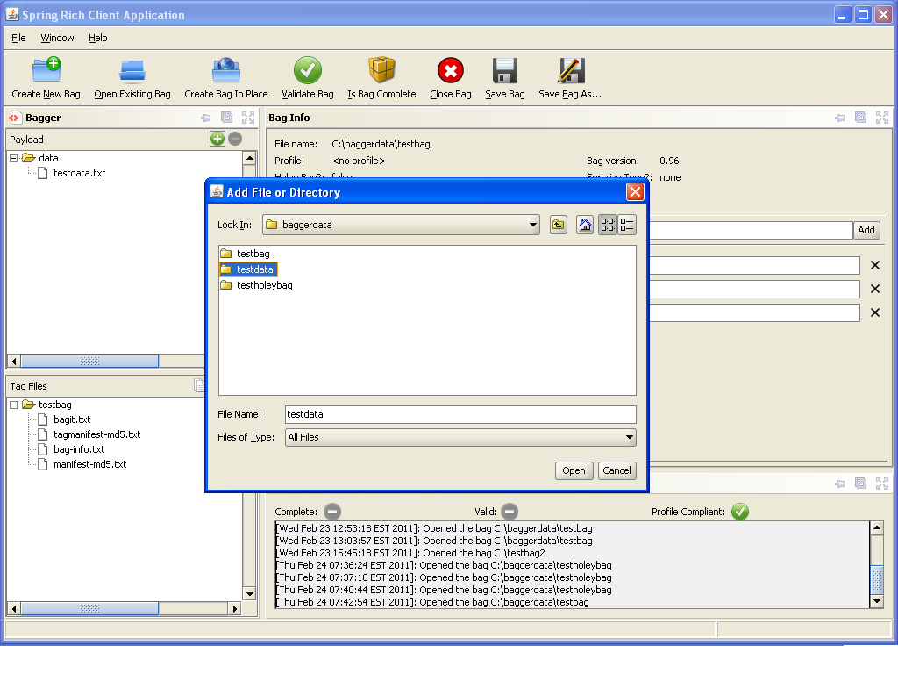
Add payload data browser

The window next to the ‘Add Data’ button now displays the hierarchical tree of files as they will be created within the bag data directory. Also, notice that if this is a new bag, the ‘Save Bag As’ button is now enabled. Now that the bag has had data content added it can be saved.

To remove payload data, first select the file or directory to be removed. Then click on the red ‘Minus’ button.

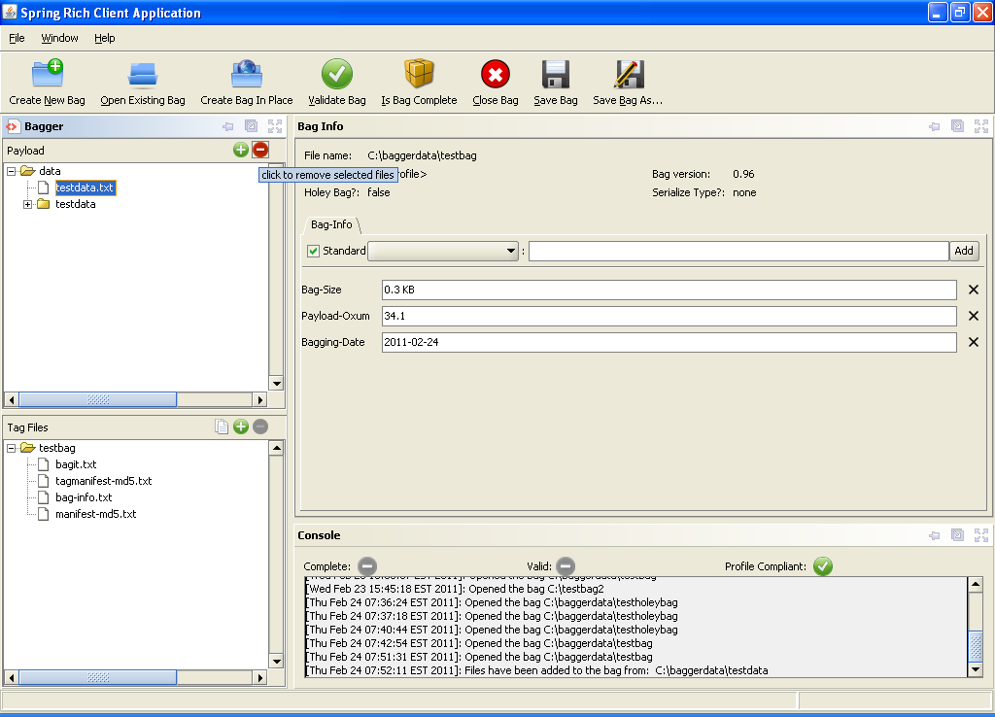
Remove payload data

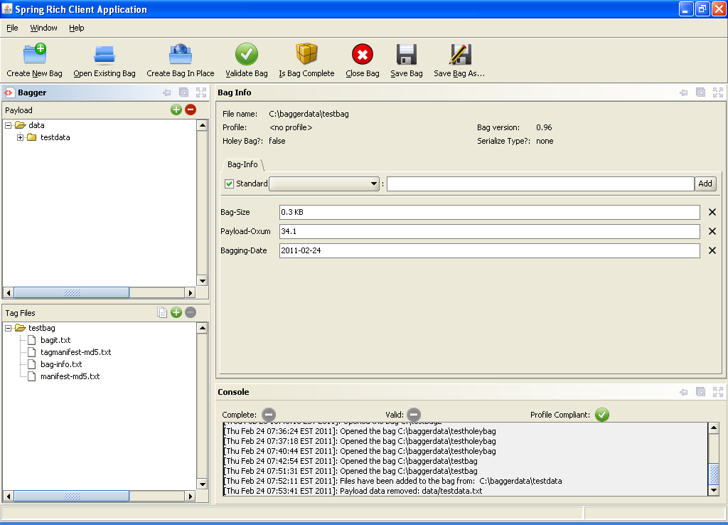
Payload data removed

Likewise, pick the file or directory to be removed and drag it off of the Bagger application screen. This will also remove the payload data from the bag.

Adding/deleting tag files
Once there is a new bag or an open bag, tag files can be easily added or removed. This can be accomplished by either selecting the Add Tag or Remove Tag buttons, or by utilizing the system’s drag-and-drop capability. The following state changes activate these buttons:

- Add Tag – default disabled
  - Enabled after Create New Bag selected
  - Enabled after Open Existing Bag selected
  - Enabled after Create Bag-in-place selected
- Remove Tag – default disabled
  - Enabled after Create New Bag selected
  - Enabled after Open Existing Bag selected
  - Enabled after Create Bag-in-place selected

Add basic flow:
1. User provides file(s) to add as tags. (User provides files using a File/Directory picker or drag-and-drop.)
2. Application adds new file(s) to bag as tags.
3. Application adds new file(s) to display of bag's tags.
Note: Any tag file may be deleted.
Delete basic flow:
1. User selects file(s) from the display of bag's tags and request that they be deleted. (User selects files/directories from payload display and select Delete or drags-and-drops outside application.)
2. Application deletes file(s) from bag's tags.
3. Application removes file(s) from display of bag's tag.

Select the Add Tag button to choose the tag files to include in the bag.
A ‘Tag File Chooser’ dialog is displayed. Go to the directory containing the file that needs to be included in the bag, and then select the Open button to include them.

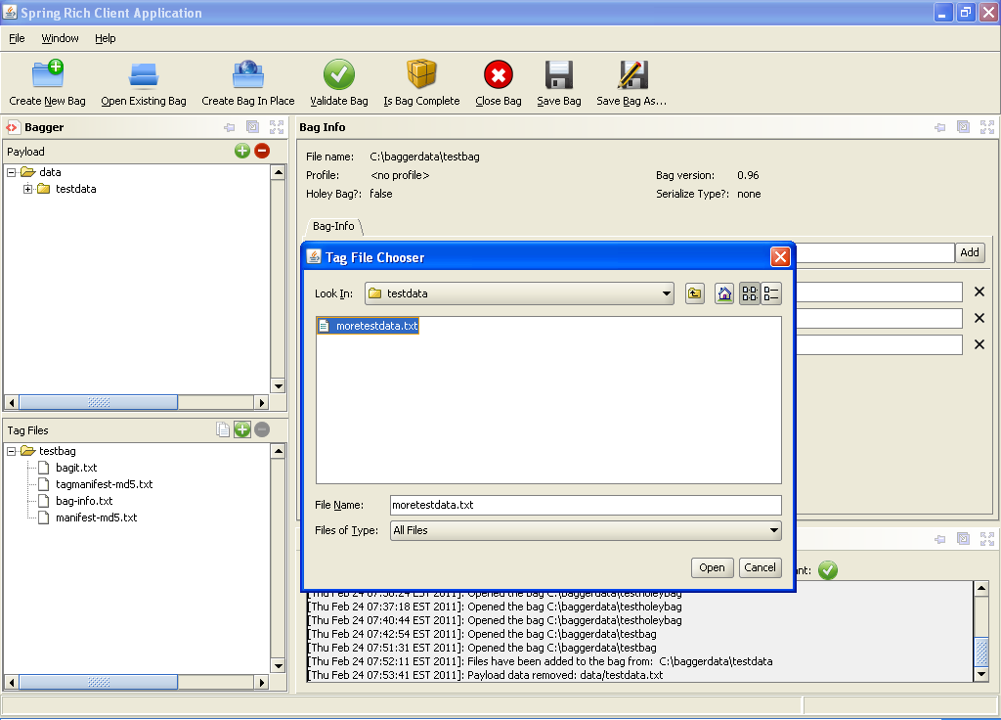
Add tag file browser

The window next to the ‘Add Tag’ button now displays the hierarchical tree of tag files as they will be created within the bag base directory.

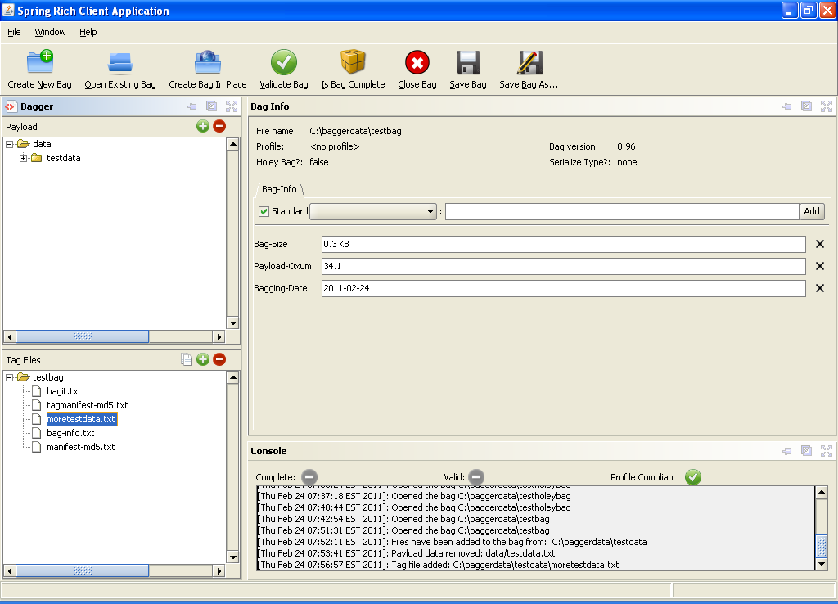
Tag file added

To remove payload data, first select the file or directory to be removed. Then click on the red ‘Minus’ button.

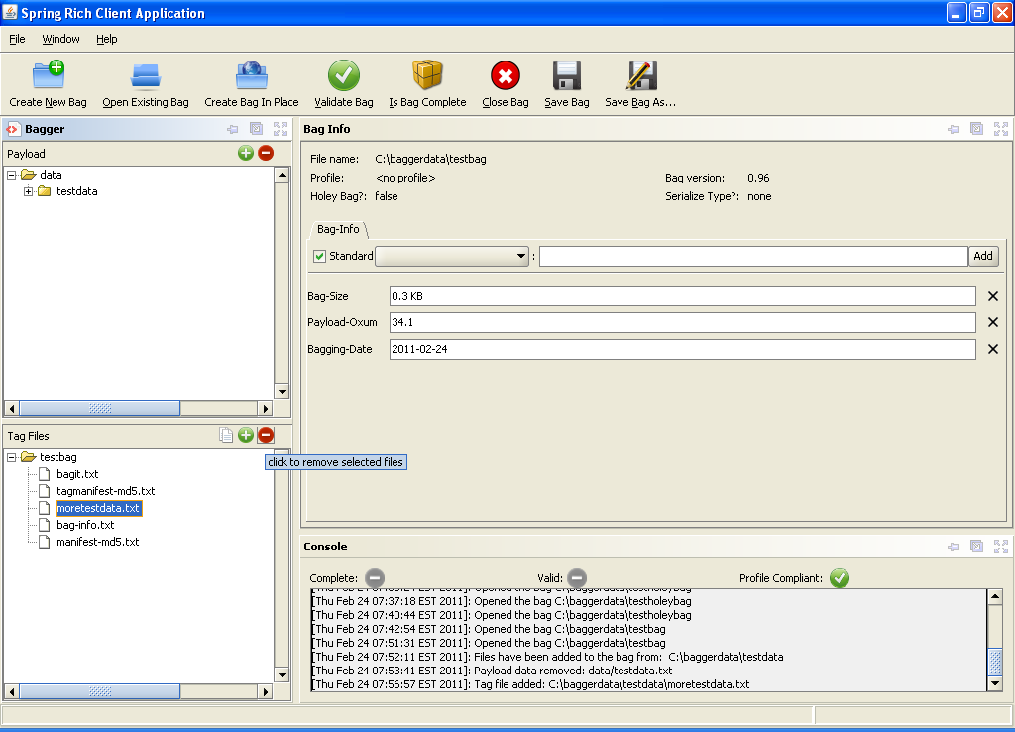
Remove tag file

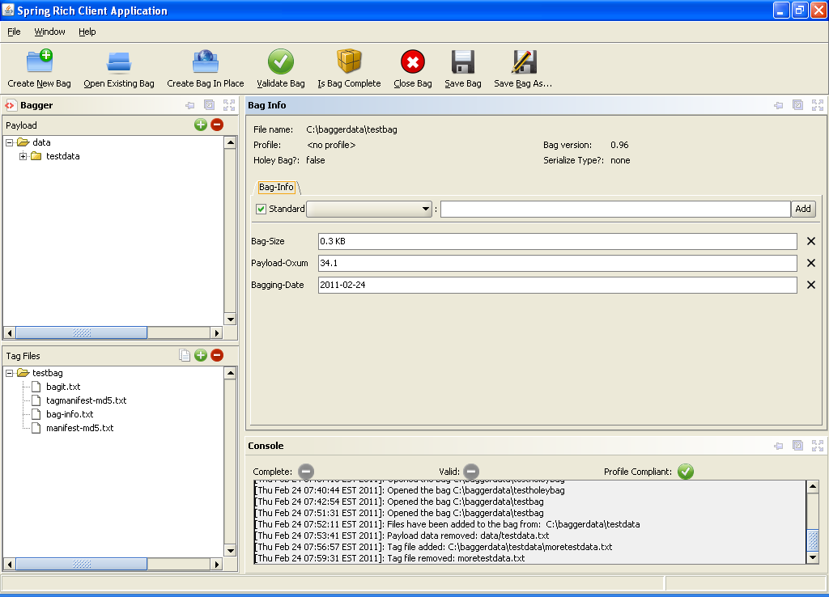
Tag file removed

Likewise, the tag file to be removed can also be picked and dragged off of the Bagger application screen. This will also remove the tag file from the bag.

View Tag Files
Once there is a new bag or an open bag, the tag files contents can be viewed. This can be accomplished by selecting the View Tags button. The following state changes activate this button:
- View Tags – default disabled
  - Enabled after Create New Bag selected
  - Enabled after Open Existing Bag selected
  - Enabled after Create Bag-in-place selected

Upon selecting the View Tags button (i.e. beside the red ‘Plus’ button), a tabbed frame opens showing the currently added tag file contents displayed as read-only. The default tag files consist of:
* ‘manifest.txt’
* ‘tag-manifest.txt’
* ‘bag-info.txt’
* ‘bagit.txt’
* ‘fetch.txt’ (for holey bags only)

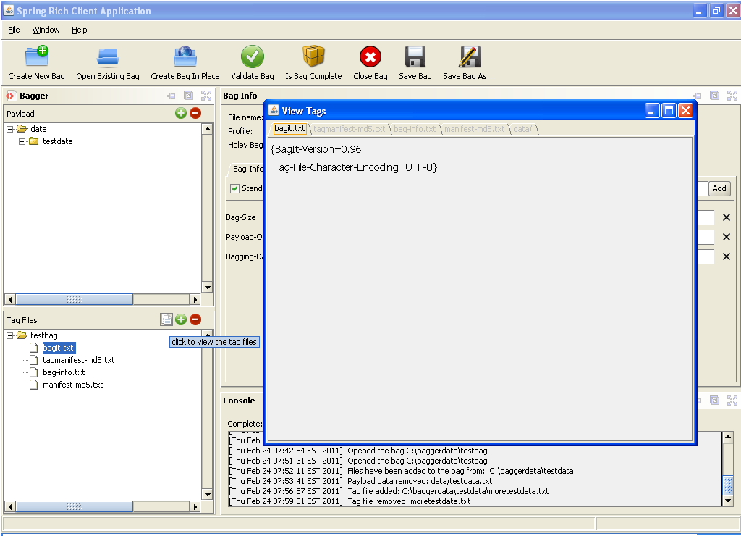
View Tag files

In addition there is a tab containing the non-tag listing of the data directory payload contents. For more information regarding tag files, refer to the BagIt specification.

Checking Bag Status

Checking that a bag is complete
From the BagIt specification: “A bag is considered complete if every file in every payload manifest and tag manifest is present, and if every payload file appears in at least one payload manifest. A payload file does not need to appear in every payload manifest as long as it appears in one payload manifest (i.e., it must belong to the "union" of payload manifests). In a complete bag containing one or more tag manifests, any tag file may appear in zero or more of those manifests, but every tag file appearing in any tag manifest must be present in the bag.”

Note: A user may want to check that a bag is complete instead of verifying a bag because it is less time-consuming.
Basic flow:
1. User selects to check that a bag is complete.
2. Application checks that a bag is complete.
3. If a Project profile has been selected, application checks that it has been satisfied.
4. Application updates the displayed information with the result, including warning about any unsatisfied fields from Project profile.

In order to check for a bag’s completeness, the bag must first be saved. Once the bag is saved to disk, the ‘Is Bag Complete’ button will be enabled. Select the ‘Is Bag Complete’ button.

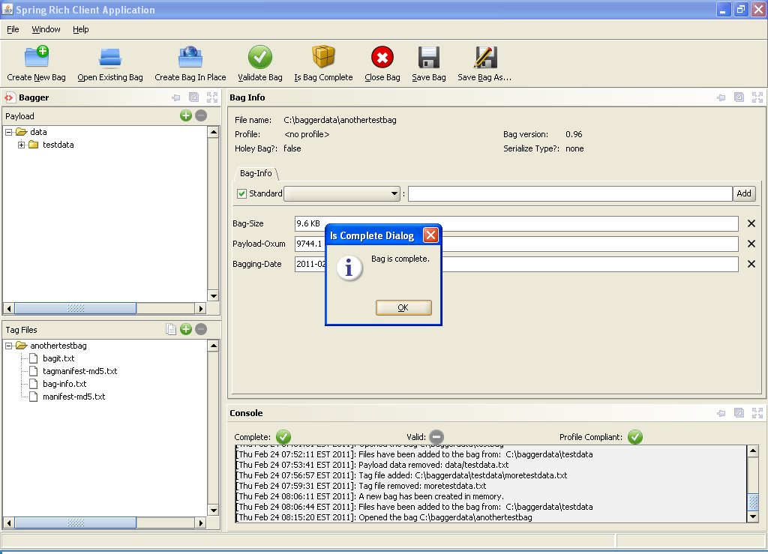
Check is complete

When a bag is complete, the ‘Is Complete Dialog’ pops up with the message: ‘Bag is complete.’

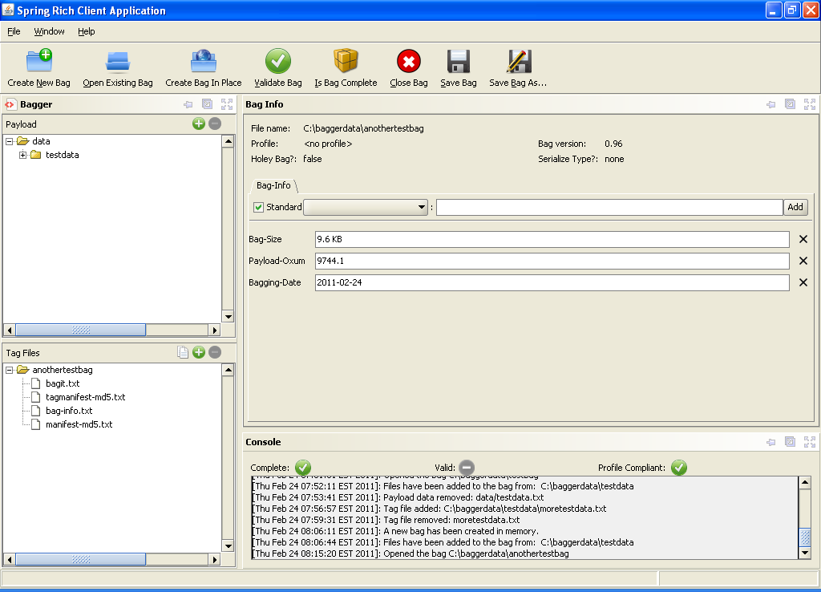
Bag is complete

Selecting Ok on the popup dialog displays the bag and the green ‘Complete’ check sign will be displayed.

Incomplete bag
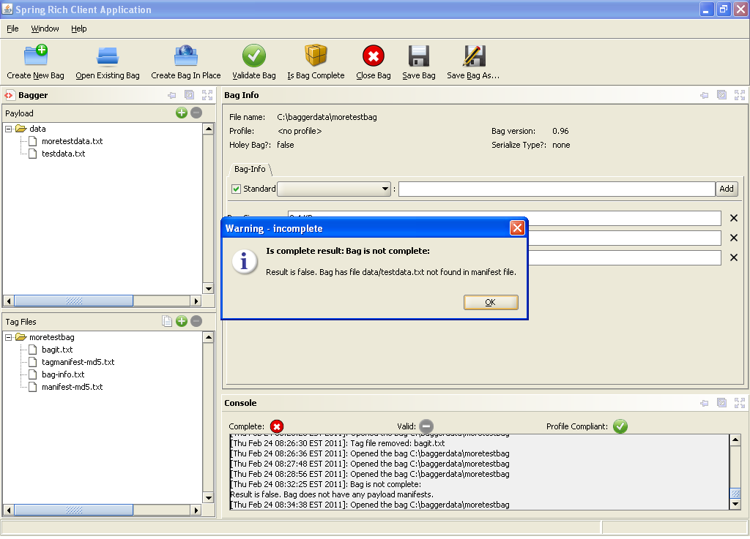
Warning incomplete

If a bag is not complete, a ‘Warning – incomplete’ popup dialog will appear and display the problem causing the bag to be incomplete. In this example, there is a file in the data payload called ‘testdata.txt’ which is not found in the ‘manifest-md5.txt’ tag file.
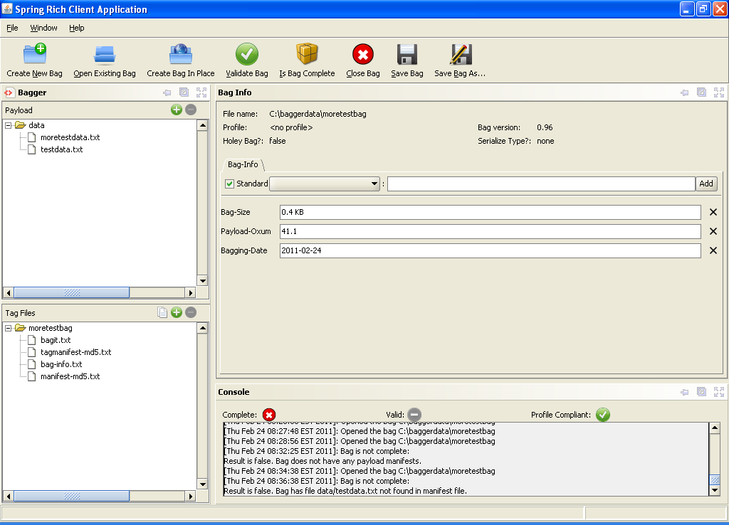
Bag is incomplete

Selecting Ok on the popup dialog displays the bag and there is a red ‘X’ mark beside the ‘Complete’ sign.

Checking that a bag is valid
The spec does not require a bag-info.txt at all, let alone the contact information.
A bag is considered valid if it is complete and if each CHECKSUM in every payload manifest and tag manifest can be verified against the contents of its corresponding FILENAME.
Note that tag files (including tag manifest files) can be added to or removed from a bag without impacting the completeness or validity of the bag as long as the tag files do not appear in a tag manifest.

In order to check for a bag’s validity, the bag must first be saved. Once the bag is saved to disk, the ‘Validate Bag’ button will be enabled. Select the ‘Validate Bag’ button.
Basic flow:
1. User selects to check that a bag is valid.
2. Application checks that a bag is valid.
3. If a Project profile has been selected, application checks that it has been satisfied.
4. Application updates the displayed information with the result, including warning about any unsatisfied fields from Project profile.

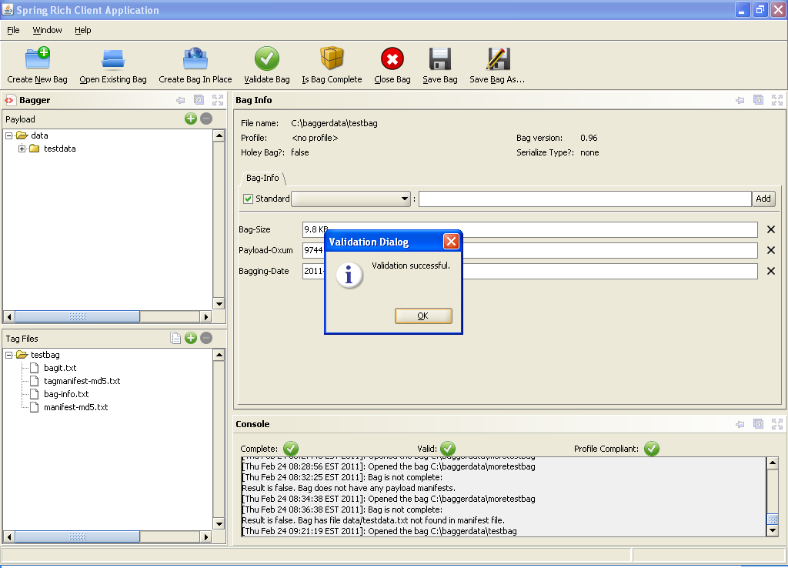
Check is valid

When a bag is valid, the ‘Validation Dialog’ pops up with the message: ‘Validation successful.’

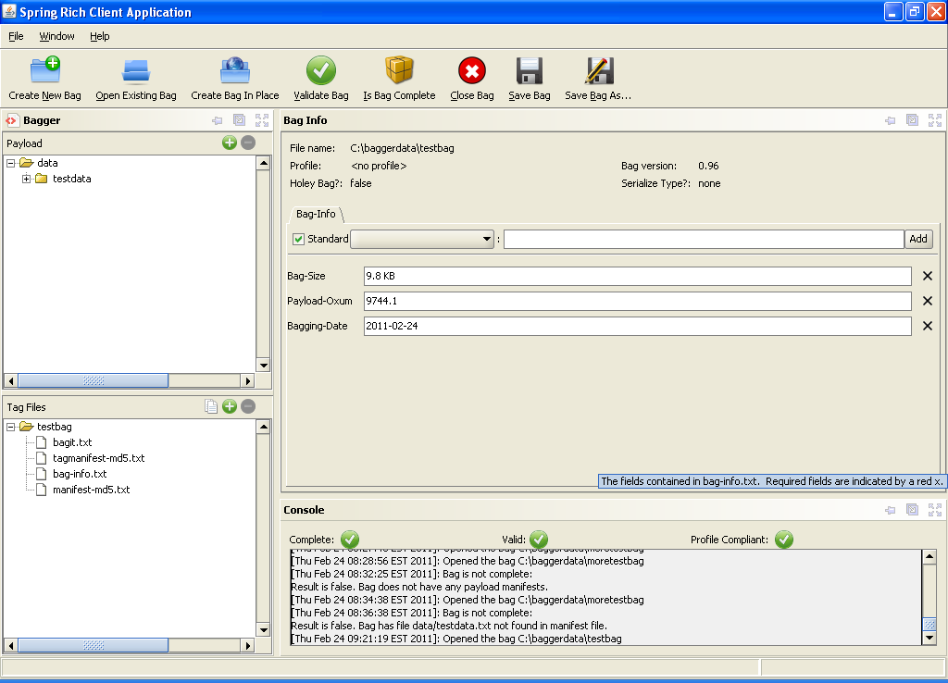
Bag is valid

Selecting Ok on the popup dialog displays the bag and both the ‘Complete’ and ‘Valid’ labels are checked ‘Green’.

Invalid bag
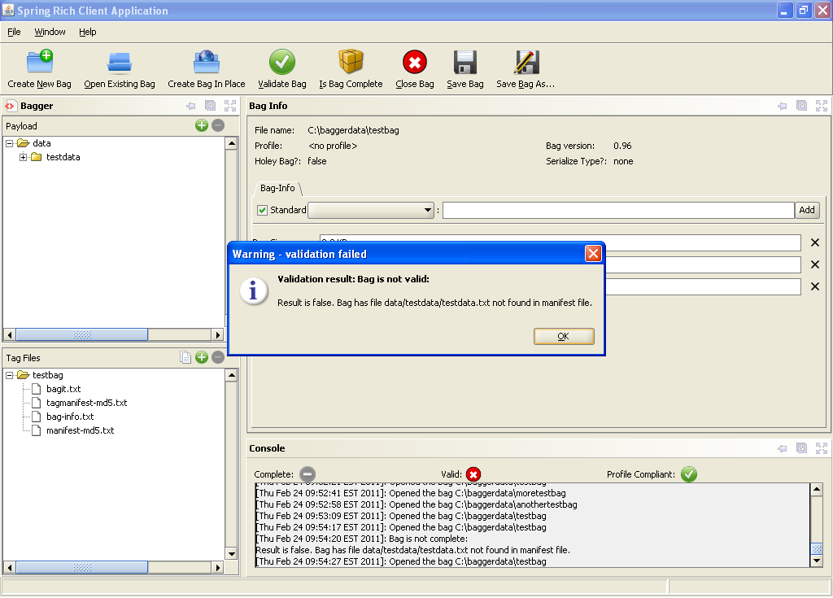
Warning invalid

If a bag is not valid, a ‘Warning – validation failure’ popup dialog will appear and display the problem causing the bag to be invalid. In this case there is a mismatch between the fixity values in the manifest and tag manifest files. See the BagIt specification for more information about fixity checksums and bag verification.
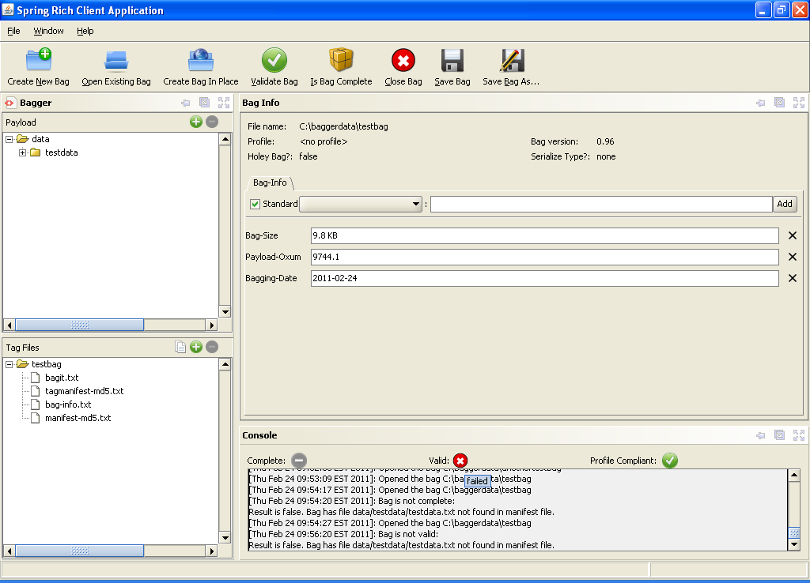
Bag is invalid

Selecting Ok on the popup dialog displays the bag and the ‘Valid’ label will now display red ‘X’ mark.

Project Profile

Bag metadata is stored in a 'bag-info.txt' file, as defined in the BagIt specification. When using Bagger to manage bags for a project or collection, it can be helpful to have a template of bag-info.txt fields and values that are filled out similarly for each bag in that project or collection. Profiles let users define a collection of bag metadata fields and default field values to be used with each bag in a consistent way. Users can select a project profile when creating a bag, and that profile will determine the initial fields and values in the bag-info.txt file, and the profile used is identified by the LC-Project field.

User can create custom project profiles using a simple JSON-based format. Profile files should be named <profile name>-profile.json and stored in the bagger's home directory: <user-home-dir>/bagger. On Windows, it is C:\"Documents and Settings"\<user>\bagger. On Unix-like operating system, it is ~/bagger. Also when the bagger application is started it creates a few default profiles in the above bagger folders, which can be used as a guide to create custom profiles.

To support the use of profiles for bag-info.txt editing in the Bagger and in the various Transfer webapps, the following describes a JSON serialization of a profile:

{
"<field name>" : {
"fieldRequired" : <true/false, where false is default if not present>,
"requiredValue" : "<some value>",
"defaultValue" : "<some value>",
"valueList" : ["<some value>",<list of other values...>]
},
<repeat for other fields...>
}

The meanings of some field properties are explained here:

* "fieldRequired": true/false, where false is default if not present
* "requiredValue": some value if fieldRequired is true
* "defaultValue": default value
* "valueList": some value or a list of values and is stored in a drop down list of field values in the Bag-Info tab form in Bagger

The Project Profile format is subject to change in the future releases.

Here is a sample profile (please ignore the comments (//) when creating a JSON profile, it is only for explaining the fields):

{
//Source-organization is required and may have any value
"Source-organization" : {
"fieldRequired" : true
},

//Organization-address is not required and may have any value
"Organization-address" : {},

//Contact-name is not required and default is Justin Littman
"Contact-name" : {
"defaultValue" : "Justin Littman"
},
//Content-type is not required, but if a value is provided it must be selected from list
"Content-type" : {
"valueList" :["audio","textual","web capture"]
},

//Content-process is required, has a default value of born digital, and must be selected from list //of field values in the Bag-Info tab form in Bagger
"Content-process" : {
"fieldRequired" : true,
"defaultValue" : "born digital",
"valueList" : ["born digital","conversion","web capture"]
}
}

The file should be named <profile name>-profile.json. For example, ndnp-profile.json.
Satisfies project profile

If a Project profile other than ‘<no profile>’ has been selected, then the bag is not considered valid until all profile rules have been met for that project. These rules are determined by adding fields to the Project profile that contain requirement constraints. Each project contains a unique profile. Additions to a project profile must be saved and reloaded each time the Bagger application is restarted. See the section Project profiles for more information.

As an example, selecting the Project profile ‘eDeposit’ will automatically include the Bag-Info fields required for that project. This Project profile, by default, requires two Bag-Info fields:
- ’Profile Name’: is required to be present and also is required to have a value equal to the project name, e.g. ‘eDeposit’. This field cannot be modified or removed
- ’Publisher’: is required to be present. This field can be modified but not removed.

Once a Project profile has been selected, any validation check performed by Bagger will also check whether the bag satisfies the Project profile rules. Any required fields will be denoted by an ‘R‘ adjacent to the field name.

Enter a value for all ‘Bag-Info’ fields and select the ‘Save Bag As’ button.

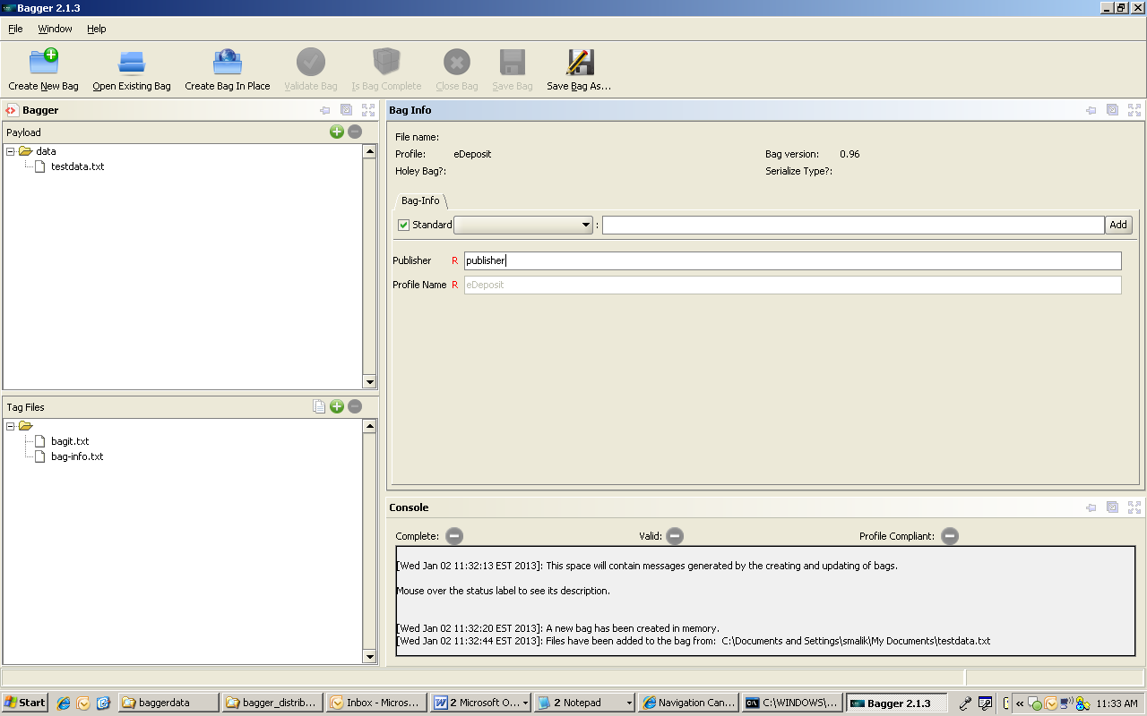
Project profile ‘eDeposit’ with Publisher

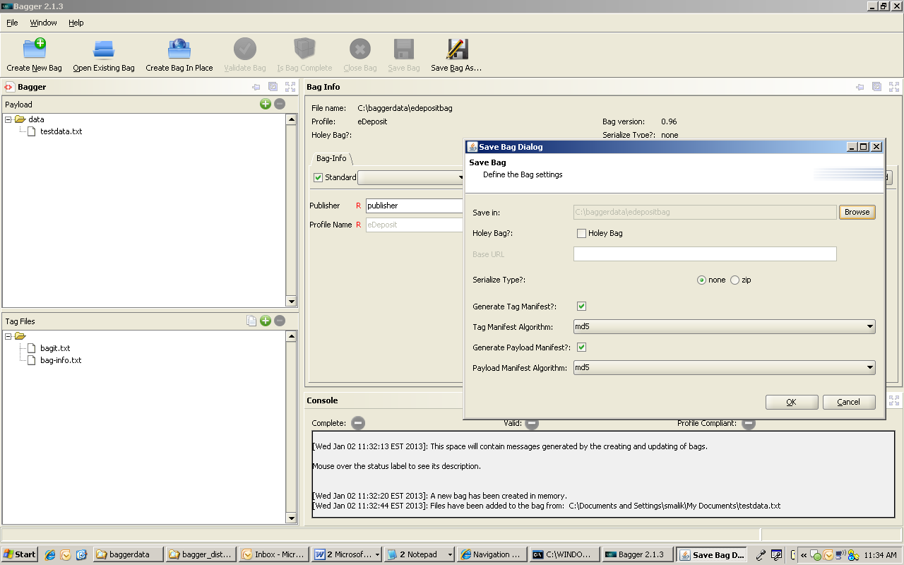
Save Bag As Project profile ‘eDeposit’

Select the desired bag file name and then select the ‘OK’ button to save the new bag.

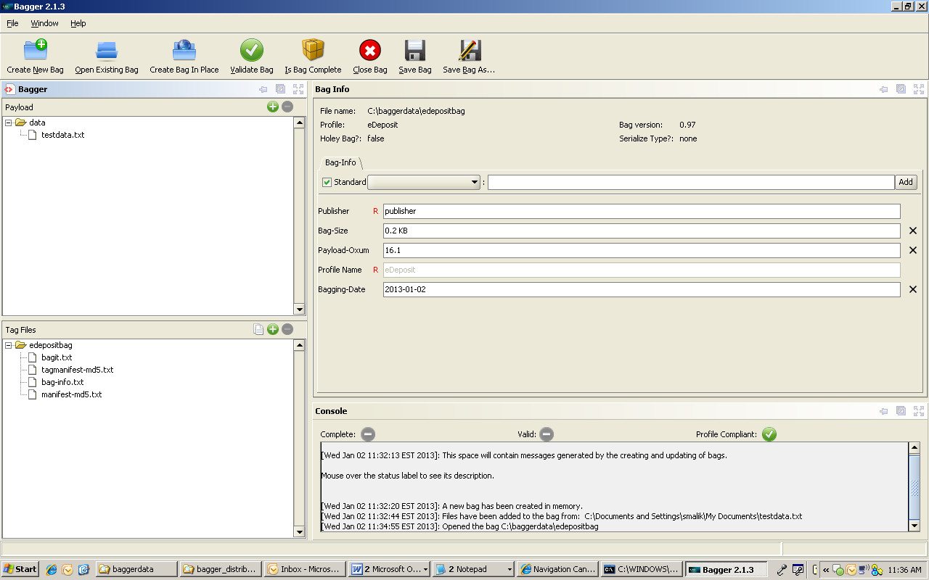
Satisfies project profile

Once Ok has been selected to confirm all of the popup dialog windows, then click on ‘Validate Bag’ button and the status console will now display all labels as checked ‘Green’ for all three status checks. Since a Project profile is selected, the ‘Profile Compliant’ label is checked ‘Green’.

Unsatisfied Project Profile
If there are missing required Bag-Info fields, the ‘Is Bag Complete’ or ‘Validate Bag’ test will include a warning about any unsatisfied fields from the Project profile. An invalid bag can still be saved; however, it will not be considered a valid bag for the selected project.

To demonstrate, do not enter a value in the ‘eDeposit’ required field ‘Publisher’. Then select the ‘Save Bag As’ button.

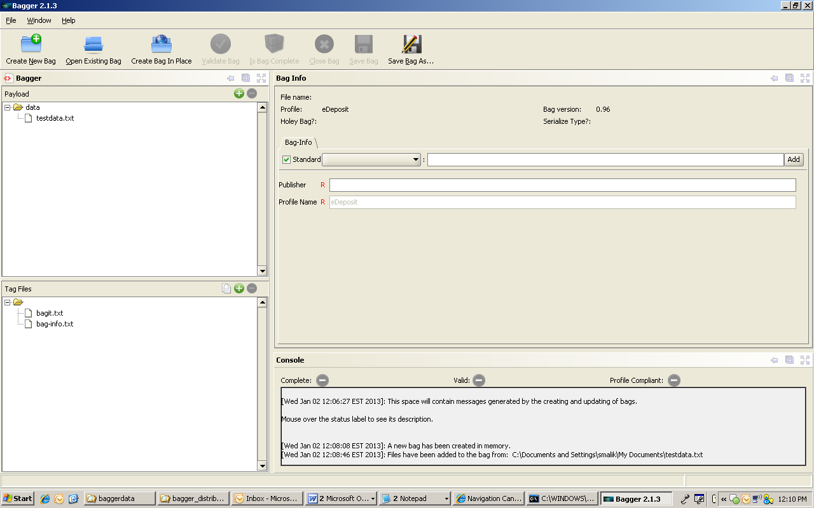
Project profile ‘eDeposit’ with no Publisher

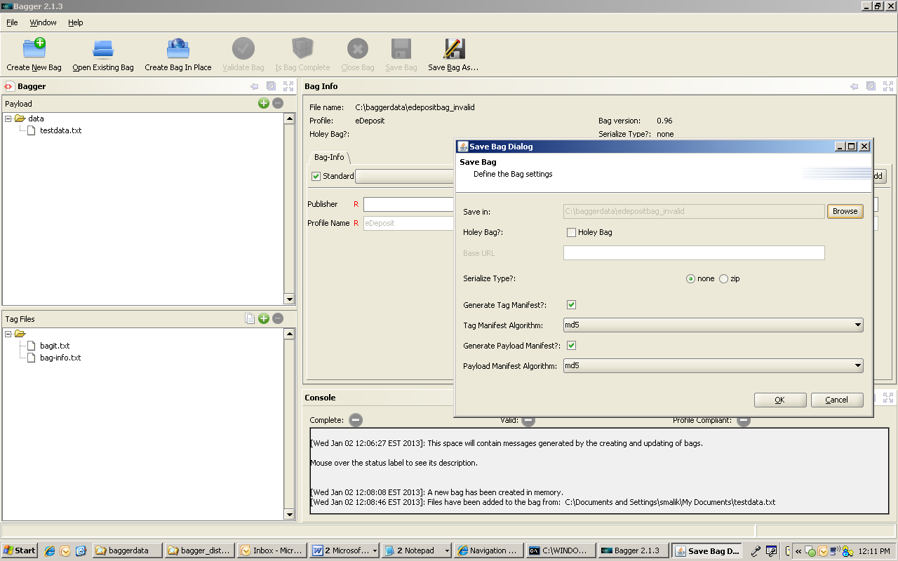
Save Bag as project profile

Select the desired bag file name and then select the ‘OK’ button.

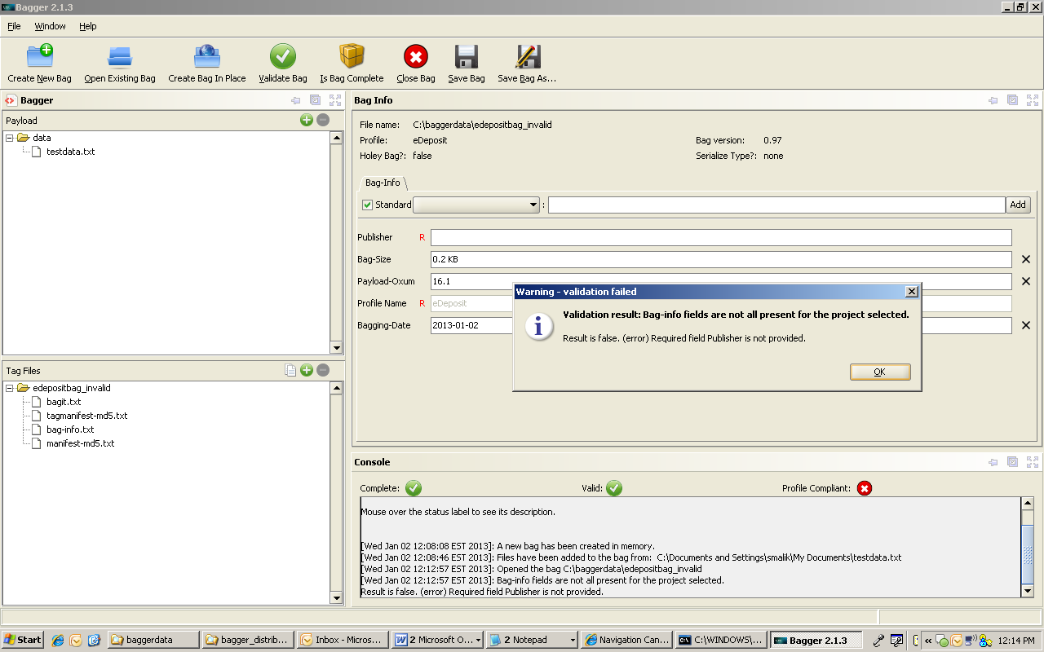
Project profile validation failed

After the bag is saved, the ‘Profile Compliant:’ label has a ‘Red’ warning check mark due to the required ‘Publisher’ field with no value.
Also after the ‘Validate Bag’ button is selected, a ‘Warning – validation failed’ dialog appears indicating that the, “Required field Publisher is not provided.” Selecting the Ok button will update the bag status console.

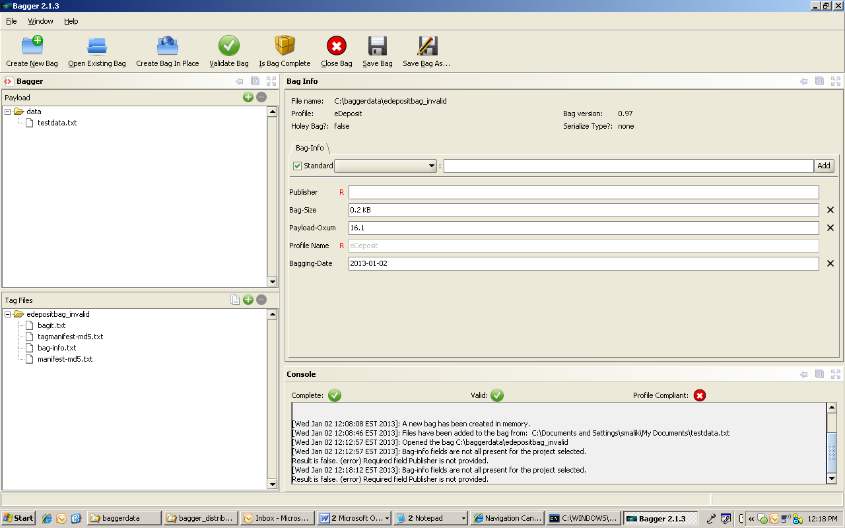
Does not satisfy project profile

Since a Project profile is selected, and there is a missing required field value, the ‘Profile Compliant:’ label has a ‘Red’ check mark.

Bag-Info

Editing
The contents of the ‘bag-info.txt’ tag file can be manipulated in Bagger using input forms that allows adding, removing, and editing the fields that are to be included when the ‘bag-info.txt’ file is written to disk. These values can be stored to the local disk and reloaded for future use in other bags. They can also be associated with a specific bag project that requires the presence of specific values in the ‘bag-info.txt’ file to identify the bag with a project and project rules. This will be discussed further in the section ’Project profiles’.

Here are some excerpts from the BagIt specification regarding BagInfo elements:
* For an existing BagInfo, all fields are displayed.
* When displaying a field, the user is provided with the name of the field and the value of the field. Except as noted elsewhere, the user can edit the value.
* Some fields may have larger values (and hence require large edit boxes).
* Users may add additional fields. The User may select from the list of standard fields or provide his own field name.
* Users may delete fields, except as noted elsewhere.
* An empty field should not be added to BagInfo.
* Changes to BagInfo are written to disk when the bag is saved.
* Payload-Oxum cannot be edited, but can be deleted.
* Bagging-Date is provided by default, but can be edited and deleted.
“The ‘bag-info.txt’ file is a tag file that contains metadata elements describing the bag and the payload. The metadata elements contained in the ‘bag-info.txt’ file are intended primarily for human readability. All metadata elements are optional.

Reserved metadata element names are case-insensitive and defined as follows.
External-Description
A brief explanation of the contents and provenance.
Bagging-Date
Date (YYYY-MM-DD) that the content was prepared for delivery.
External-Identifier
A sender-supplied identifier for the bag.
Bag-Size
Size or approximate size of the bag being transferred, followed by an abbreviation such as MB (megabytes), GB, or TB; for example, 42600 MB, 42.6 GB, or .043 TB. Compared to Payload-Oxum (described next), Bag-Size is intended for human consumption.
Payload-Oxum
The ‘octetstream sum’ of the payload, namely, a two-part number of the form ‘OctetCount.StreamCount’, where OctetCount is the total number of octets (8-bit bytes) across all payload file content and StreamCount is the total number of payload files. Compared to Bag-Size (described above), Payload-Oxum is intended for machine consumption.
Bag-Group-Identifier
A sender-supplied identifier for the set, if any, of bags to which it logically belongs. This identifier must be unique across the sender's content, and if recognizable as belonging to a globally unique scheme, the receiver should make an effort to honor reference to it.
Bag-Count
Two numbers separated by "of", in particular, "N of T", where T is the total number of bags in a group of bags and N is the ordinal number within the group; if T is not known, specify it as "?" (question mark). Examples: 1 of 2, 4 of 4, 3 of ?, 89 of 145.
Internal-Sender-Identifier
An alternate sender-specific identifier for the content and/or bag.
Internal-Sender-Description
A sender-local prose description of the contents of the bag.
In addition to these metadata elements, other arbitrary metadata elements may also be present.“

To help manage the contents of the ‘bag-info.txt’ file, Bagger provides a tabbed frame called ‘Bag-Info’.

Bag-Info
By default a newly created bag which has no project profile selected will contain no fields in the ‘Bag-Info’ tab. When an existing bag is loaded, the ‘Bag-Info’ tab will be populated with all the fields contained in that bag’s ‘bag-info.txt’ tag file.

Note: Fields with no value will not be saved to ‘bag-info.txt’ or loaded into Bagger.

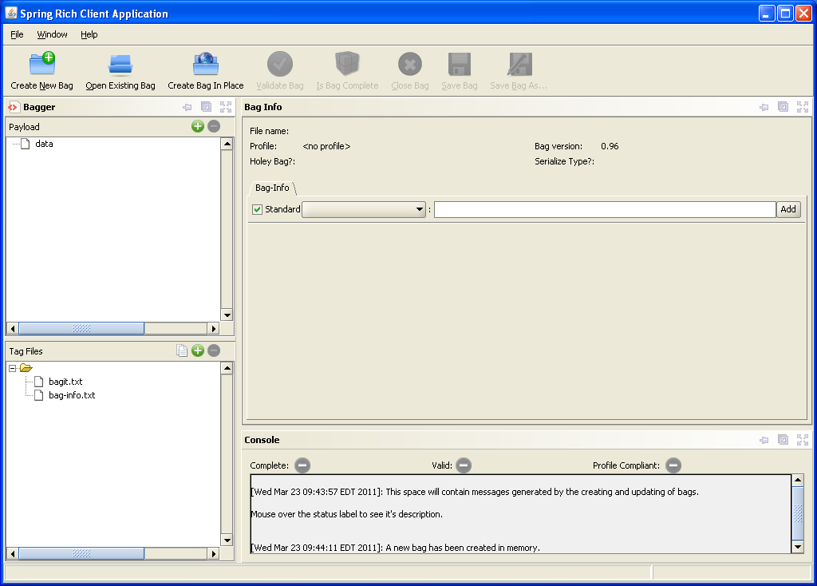
No Project Profile Selected
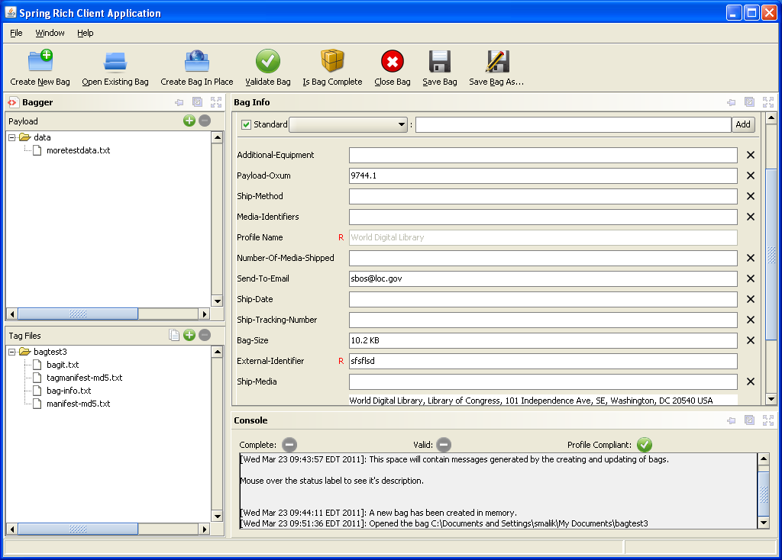
Bag-Info existing fields

At the top of this form is the ‘Add’ button (i.e. disabled until a bag is opened) and allows the user to add additional fields.

Add Field
Selecting the ‘Add’ field button allows the user to add the field based on the field selected from the list of standard fields or providing a newly created field name based on the user’s choice (i.e. Standard checkbox needs to unchecked to allow user defined field).

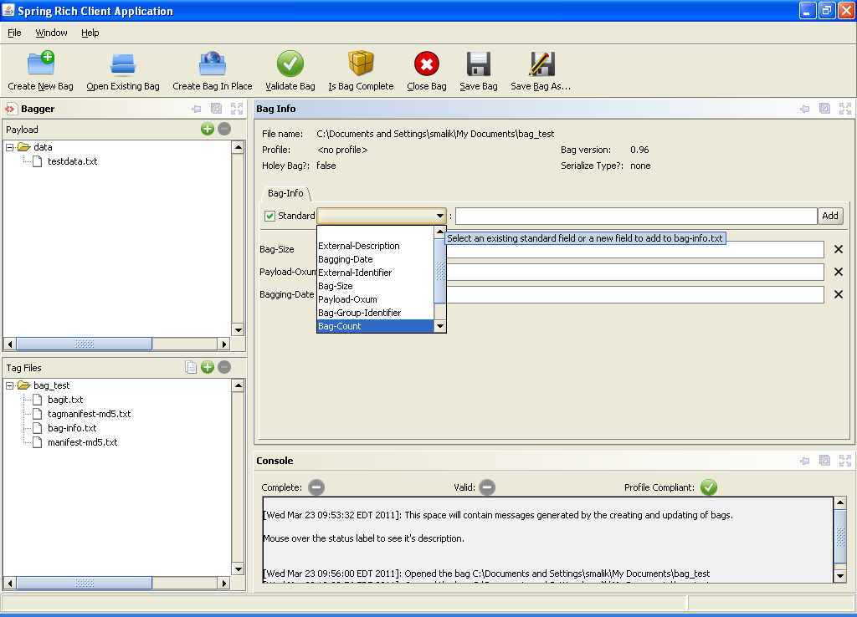
Adding Field From List

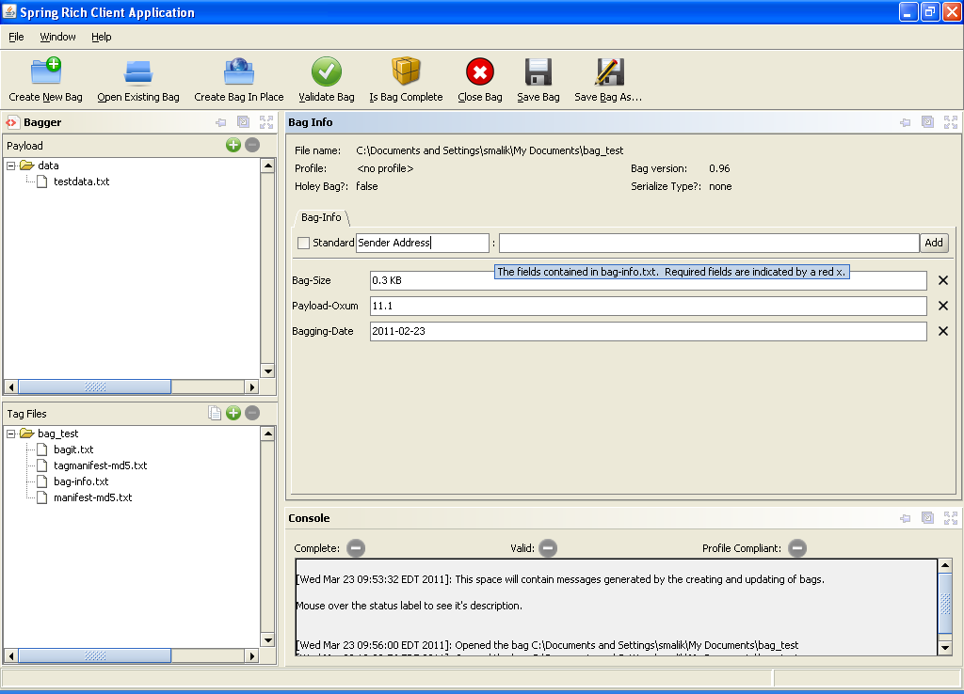
Adding User Defined Field

The ‘Field Type’ specified whether the field has larger values (and hence require large edit boxes) by selecting ‘Extended Text’. Otherwise use the default value of ‘Brief Text’. The other options on the field pertain to project profile rules. See the section Project profiles to learn how to use these options.

Add Field - Standard

Add Field From Standard List

To add a standard field select the ‘Standard’ dropdown list, and then choose from one of the standard options shown in the dropdown list. A standard field will automatically set the appropriate ‘Field Type’. Select the Add button to add the field to the ‘Bag-Info’ view.

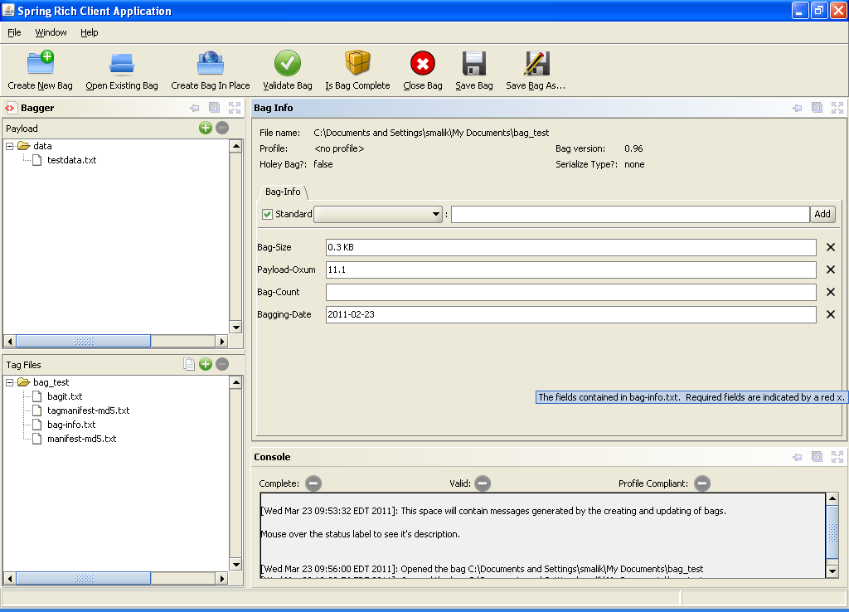
Added Standard Field

The field is displayed with the name and value. If the value cannot be edited the value input box will be disabled. For non-required fields, the user may delete the field by selecting the button at the end of the field row. Required fields will also display an R after the field name.

Add Field - New

Add New Field

To add a new field, uncheck the Standard checkbox to allow user defined fields. Enter the new field name in the text box beside the Standard checkbox. Then select the Add button to add the field to the ‘Bag-Info’ view.

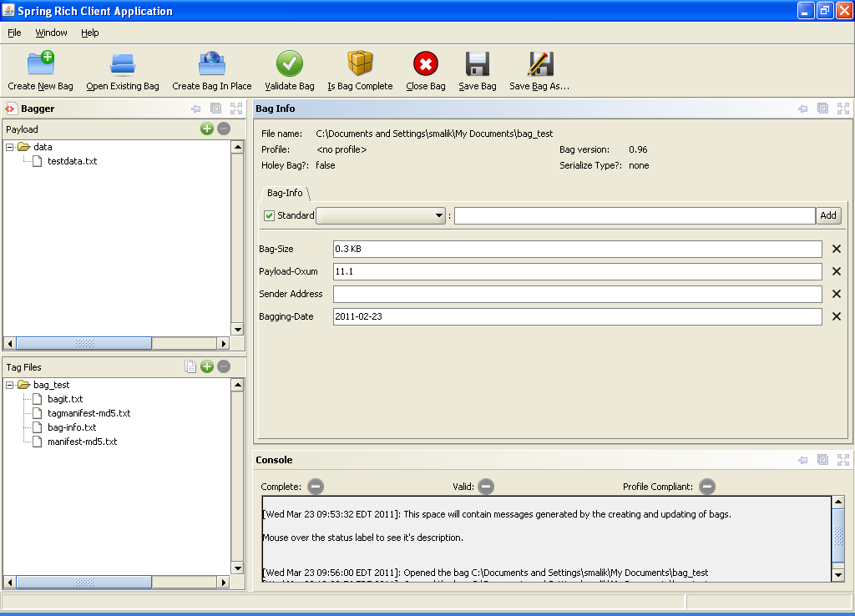
New field added

Remove Field

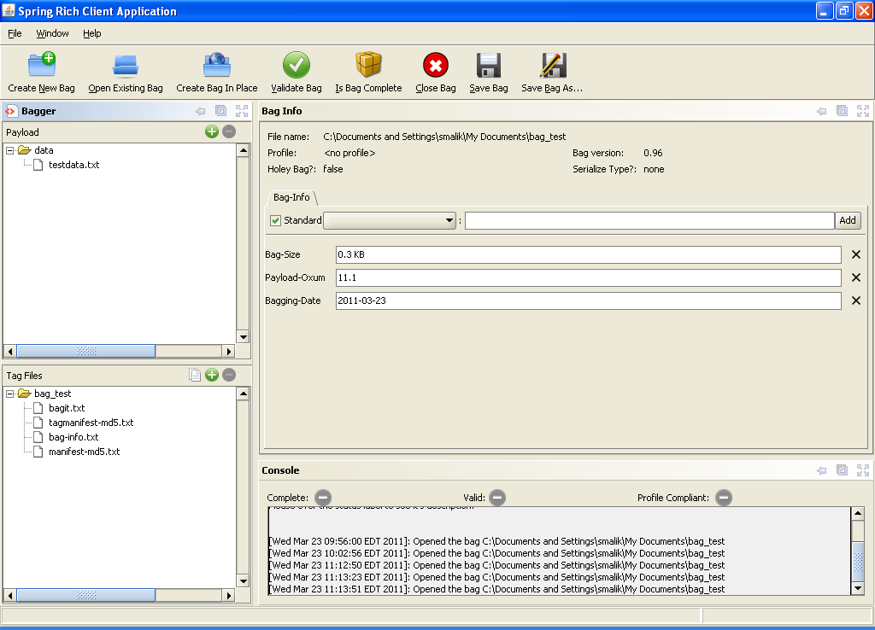
Removed Field

To remove a field, select the button adjacent to the field that needs to be removed. The field row name Sender Address in the previous screen shot is now deleted from the ‘Bag-Info’ panel and will not be saved to the ‘bag-info.txt’ tag file.

Project profiles

The project profile concept is a way to associate a collection of fields and field values with a bag via a standard project or a project of the user’s creation. These values are stored in the ‘bag-info.txt’ tag file and are identified as a project profile by the Project field. The default Project profile of a newly created bag is <no profile>.

- Users may select a Project profile. A profile specifies the value of the Project field and one or more:
  - Required fields
  - Required field with required values
  - Default field values
- Required fields should be displayed for the user to provide a value. The user should not be able to remove required fields.
- Required fields with required values should be displayed for the user. The user should not be able to remove required fields or change their values.
- Fields with default values should be displayed for the user. The user should be able to remove fields with default values and change their values.
- By default a bag has no Project profile. When loading an existing bag, if the BagInfo contains a recognized Project field, a Project profile is automatically selected.
- Satisfying a project profile is not required to save a bag.
- Users may add new Project profiles or modify existing profiles.
- Project is a required field with required values.

Appendix

BagIt Overview

Bagger and BagIt

The Bagger application creates bags that conform to the BagIt specification. However, in addition the Bagger application includes project specific context in the bag. For example, the eDeposit project out of the U.S. Copyright Office requires the Publisher field in the bagit-info.txt file.

For details of the BagIt specification reference the specification document online:

https://confluence.ucop.edu/display/Curation/BagIt

BagIt package layout
A "bag" consists of a base directory containing a set of top-level files comprising the "tag" and a sub-directory named "data/" that holds the payload. The base directory may have any name and the "data/" directory may contain an arbitrary file hierarchy.
<bag_dir>/
| manifest-<algorithm>.txt
| bagit.txt
| [optional additional tag files]
\--- data/
| [optional file hierarchy]
The "tag" consists of one or more files named "manifest-algorithm.txt", a file named "bagit.txt", and zero or more additional files. In top-level text files with ".txt" extension, each line should be terminated by a newline (LF) or carriage return plus newline (CRLF); in practice cautious programmers will also accept a carriage return by itself (CR) as a line terminator. In all such tag files, text is assumed to be Unicode encoded as UTF-8.
Required Elements

BagIt requires a bag directory that contains:
- manifest txt
  - requires a list containing a checksum for a file, followed by the name of the file as represented in the data directory
- bagit.txt
  - requires a tag “BagIt-Version” followed by a number
  - requires a tag “Tag-File-Character-Encoding” followed by the value “UTF-8” (currently the only supported format)
- data directory
  - requires a file hierarchy listed in manifest.txt

- bagit-info (optional, required for certain projects)
- fetch.txt (optional, required for Holey bags)
- tagmanifest.txt (optional)

