**[](https://crowd.loc.gov)Transcription Quick Tips**

**Rule #1:**

**Type what you see!**

**Misspellings**

Don’t edit! Keep the author’s original spelling, even if incorrect

**Insertions**

For text inserted or added later, type it in the order you would read it aloud. If it’s part of a sentence, bring it down into the line.

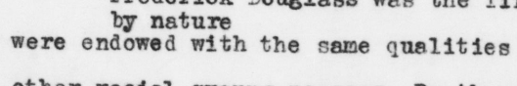 *were endowed by nature with the same qualities*

**Deletions**

If you can read crossed out or otherwise deleted text, transcribe the deleted words inside a pair of brackets.

*It was [difficult] hard to believe*

**Line breaks**

Hit “enter” at the end of a line of text to preserve line breaks, except when words are broken across them. Write “presented” rather than “pre-sented.”

*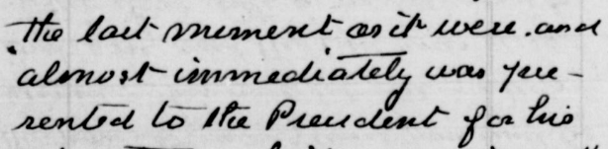the last moment as it were and*

*almost immediately was presented*

*to the President for his*

**Emphasis**

Even when you see bold, italic, underlined or superscript text, transcribe it without any styling.

**

*to individual glory*

**Marginalia (writing in the space around the main text)**

Use a square brackets and asterisks [* *] around marginalia text and order it within the transcription where it makes the most sense.