Installing Stand Alone SQL Database Admin Tools

This document uses PhpMyAdmin as an example of setting up an SQL Database administration tool outside of LibreEHR. In versions before 4.2 phpMyAdmin was embedded inside LibreEHR, this was considered a security risk as well as hard to maintain. As there are many tools available for administration and reporting from MySQL database we modified LibreEHR to allow the user to install and configure a customer preference.

First, Install the tool of choice. Shown below are the steps for installing phpMyAdmin on an Ubuntu or other debian based Linux installation.
You will need to know the root password for your MySQL installation and the super-user password of the account you use to install from
From the command (or from the graphical Ubuntu Software Center) install the phpmyadmin package
# sudo apt-get install phpmyadmin
You will see a series of screens, it is safe to take the defaults, use the tab key to move in the text boxes and the space bar to select [OK] or to change a value.

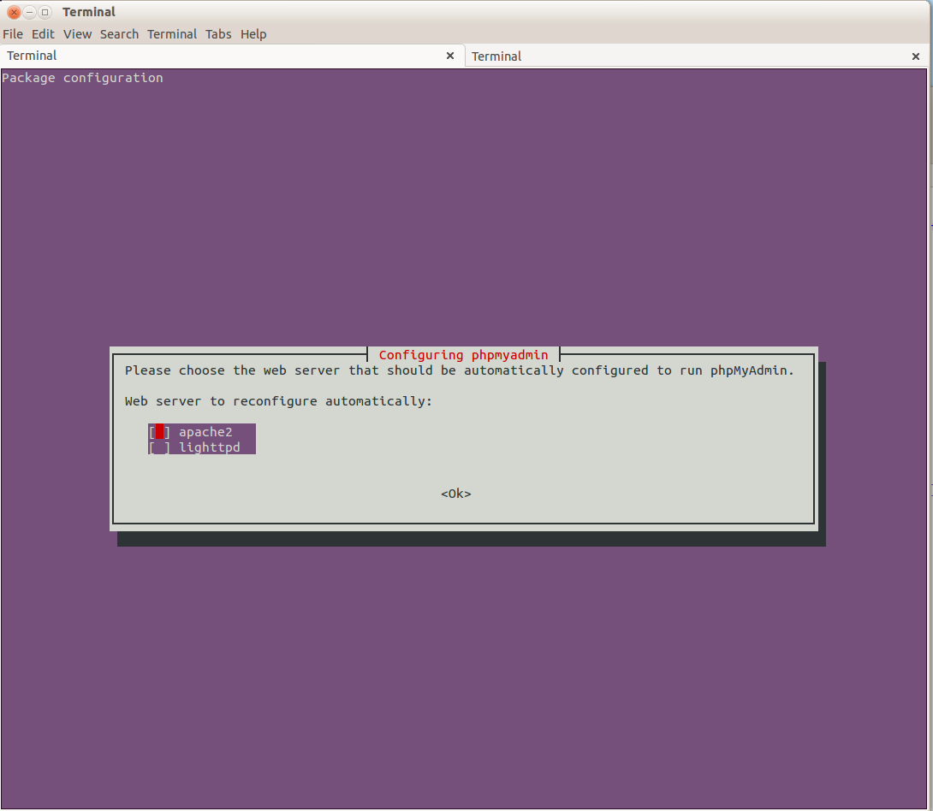

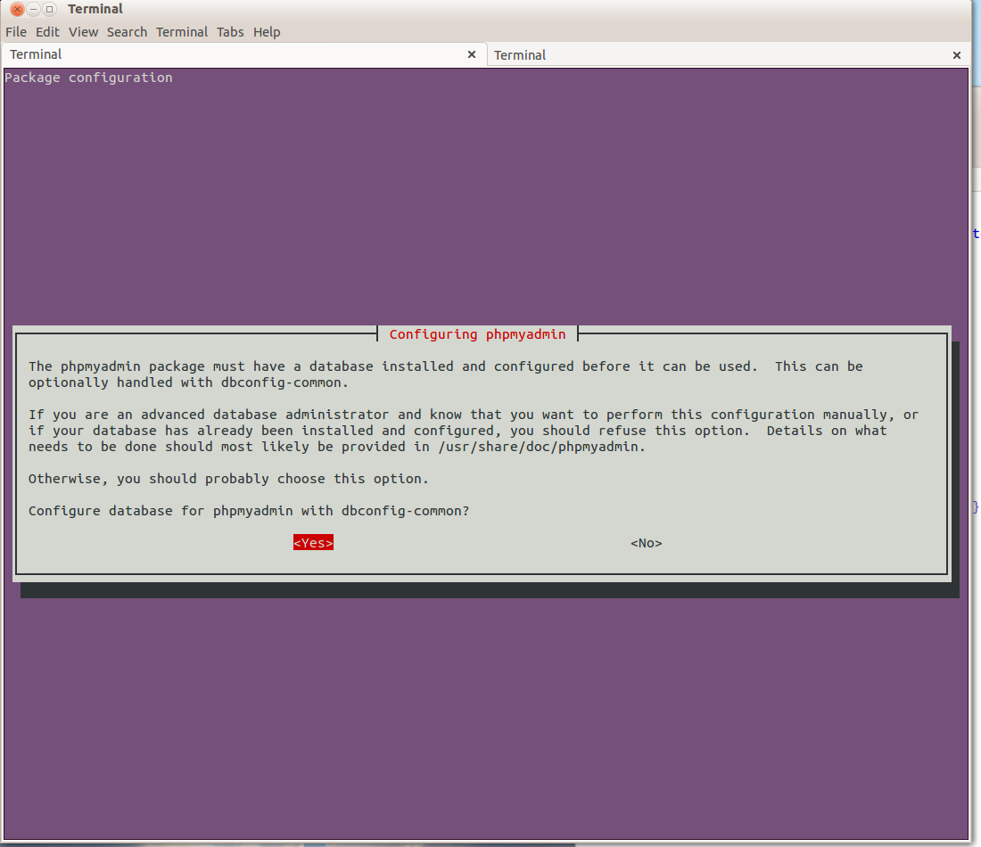
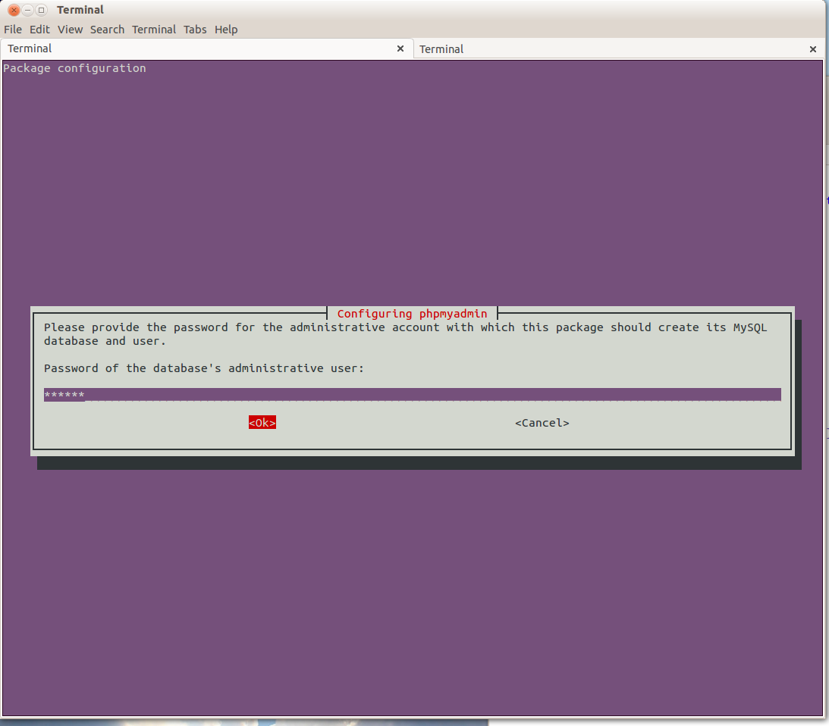

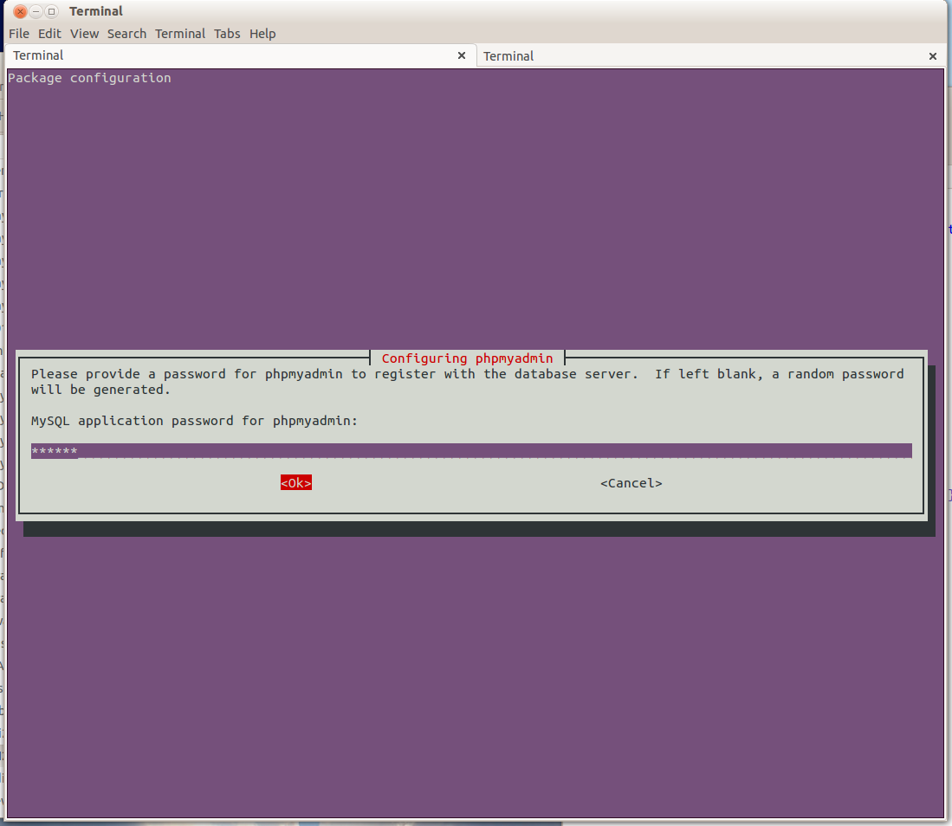
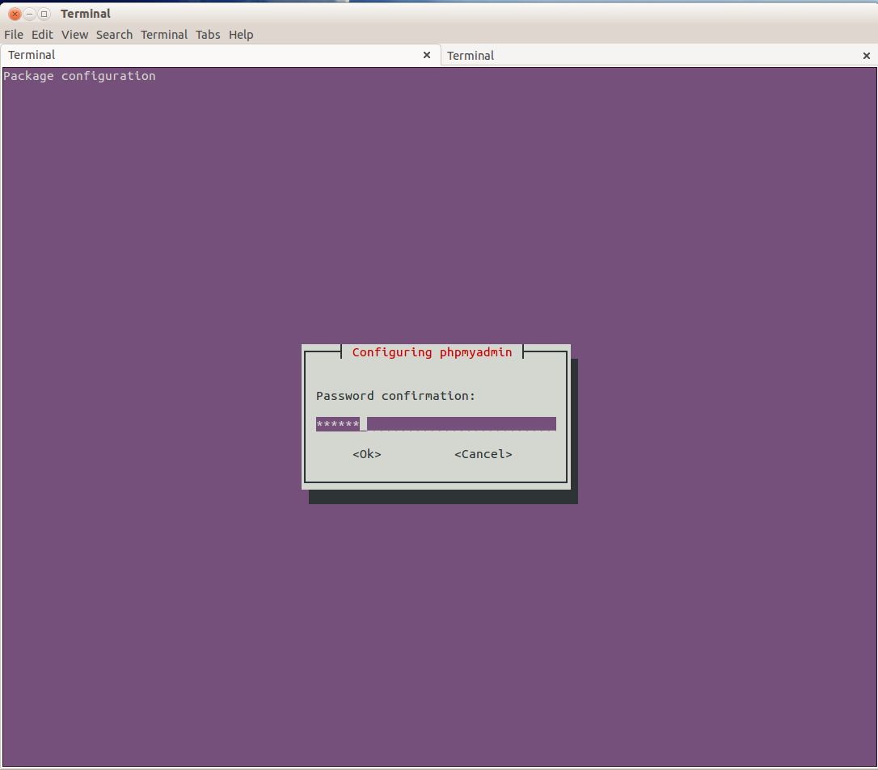

When installation is complete test your access. The usual local access URL for this will be http://localhost/phpmyadmin if you are accessing it from a designated LibreEHR server then test using that servers IP address or DNS name.
You may need to enable the installed config file in apache.
# cd /etc/apache2/sites-enabled
# sudo ln -s /etc/phpmyadmin/apache.conf 001-phpmyadmin.conf
# sudo service apache2 restart

If you are using Chrome browser you may need to enable XFRAME access by creating the following configuration file as follows:
# /etc/phpmyadmin/conf.d/allow-framing.inc.php
Containing
# $cfg['AllowThirdPartyFraming'] = true;

Now login to you LibreEHR instance and go to the Administration->Globals:Miscellaneous TAB and change the URL Path to SQL Admin Tool to the URL you tested above.

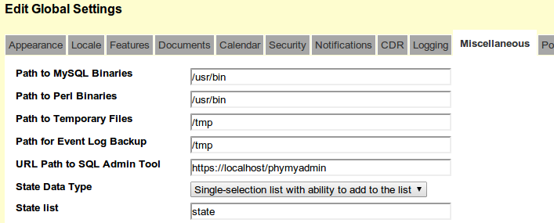

Now when you select Adminstration->Other->Database phpMyAdmin will open in a new tab or browser window. Login with either your root MySql user and password or better, with the LibreEHR user and password you created for this installation.

