
Calc Guide 25.2

Chapter 15
Calc as a Database

Copyright
This document is Copyright © 2025 by the LibreOffice Documentation Team. Contributors are listed below. You may distribute it and/or modify it under the terms of either the GNU General Public License (https://www.gnu.org/licenses/gpl.html), version 3 or later, or the Creative Commons Attribution License (https://creativecommons.org/licenses/by/4.0/), version 4.0 or later.
All trademarks within this guide belong to their legitimate owners.

Contributors
To this edition
Edward Olson | Olivier Hallot | Lisa Samy
To previous editions
‍Skip Masonsmith | Barbara Duprey | Jean Hollis Weber
Andrew Pitonyak | Kees Kriek | Zachary Parliman
Simon Brydon | Leo Moons | Felipe Viggiano
Steve Fanning | Rafael Lima‍ | Olivier Hallot
B. Antonio Fernández

Feedback
Please direct any comments or suggestions about this document to the Documentation Team’s forum at https://community.documentfoundation.org/c/documentation/loguides/ (registration is required) or send an email to: loguides@community.documentfoundation.org.
- Note
Everything you send to a forum, including your email address and any other personal information that is written in the message, is publicly archived and cannot be deleted. Emails sent to the forum are moderated.

Publication date and software version
Published June 2025. Based on LibreOffice 25.2 Community.
Other versions of LibreOffice may differ in appearance and functionality.

Using LibreOffice on macOS
Some keystrokes and menu items are different on macOS from those used in Windows and Linux. The table below gives some common substitutions for the instructions in this document. For a detailed list, see the application Help and Appendix A (Keyboard Shortcuts) to this guide.
Windows or Linux | macOS equivalent | Effect
Tools > Options on Menu bar | LibreOffice > Preferences on Menu bar | Access to setup options
Right-click | Ctrl+click and/or right-click depending on computer setup | Opens a context menu
Ctrl or Control | ⌘ and/or Cmd or Command, depending on keyboard | Used with other keys
Alt | ⌥ and/or Alt or Option depending on keyboard | Used with other keys

Introduction
In many everyday scenarios, Calc spreadsheets can be used to aggregate sets of data and to perform analyses on them. As the data in a spreadsheet is laid out in a table view, plainly visible and easily edited or extended, some users may not need the comprehensive relational database facilities provided by the Base component of LibreOffice. For such users, Calc has sufficient functionality to act as a simple yet capable database-like platform. This chapter presents an overview of these capabilities.
For those users who initially choose to manage their data in a Calc spreadsheet and subsequently decide that they need to use a more comprehensive database system, migrating Calc data to Base is straightforward. In the other direction, for Base users who wish to take advantage of some of Calc’s features to analyse or visualize their data, Base can be used for creating linked data ranges in Calc files, for pivot table analysis, or as the basis for charts. See the Base Guide for more information.
Earlier versions of this chapter contained several examples with LibreOffice Basic macros. These are now available on The Document Foundation’s wiki at https://wiki.documentfoundation.org/Macros/Calc. Much of the macro information on those pages is drawn or adapted from Andrew Pitonyak’s book, OpenOffice.org Macros Explained (OOME) and LibreOffice’s API reference at https://api.libreoffice.org/docs/idl/ref/index.html.

A database primer
In a typical database, related data is organized into tables, which are arranged in a grid-like series of rows and columns similar to a spreadsheet. Each row of a table represents a data record, while each column represents a field within each record. Each cell in a field contains an individual data item or attribute, such as a name, while each record consists of related attributes that correspond to a single entity, like a person. A database table tends to have a fixed number of fields, but can have an indefinite number of records.
While a table may have hundreds or thousands of rows, individual records can be easily found, retrieved, and updated using information requests, called queries, that search for records that meet a specified set of criteria. It is this ease of access that makes a database table more useful than simply filing away information in an unordered spreadsheet.
To illustrate this concept of a database table, consider the example of a class grading sheet (Figure 1). In this sheet, each row represents individual students taking the class, while each column contains their names and grades. With this table, you can quickly look up individual students’ grades simply by searching for their names, and you can determine which students are passing the class by filtering out records with failing average scores.
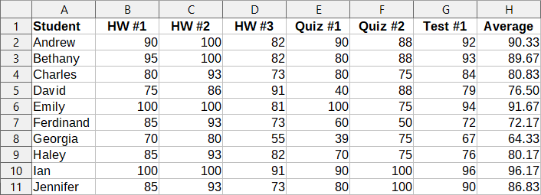
Figure 1: Grading sheet example
Many modern database management systems are based on the relational database model, in which the data and relationships are represented by a series of inter-related tables. The Base component of LibreOffice is a fully featured relational database management system. Calc does not support the relational database model.

Calc as a database-like program
A Calc sheet is similar to a flat, non-relational database table, and it is possible for a database table to be contained in a Calc sheet. The data can be deeply analyzed using a wide range of tools and functions. It can be sorted, filtered, pivoted, and presented visually in 2-D/3-D charts and graphics. Calc is not a replacement for a fully featured database application but it can be useful for managing data in many small-scale personal or professional contexts.

Associating a range with a name
In order to set up a database table in a Calc sheet, you first need to set up an area for it to occupy. This is necessary since some of Calc’s database-like features depend on accessing or modifying a table’s location. Such an area is represented by a range, which is a contiguous group of one or more cells. To make the range for a table easy to access, you can assign a meaningful name to it. Doing this has four particular benefits:
- Giving a range a name makes it easier to identify, especially if you are working with multiple ranges in a document.
- A named range can be referenced by its name rather than just by its address. For example, if you have a range named Scores, you can simply reference it in a cell with a formula like =SUM(Scores).
- References by name to a named range are automatically updated every time the range’s address is changed. This avoids the need to change individual references every time a range’s location is modified.
- All named ranges can be quickly viewed and accessed through the Navigator, which is opened by selecting View > Navigator on the Menu bar, pressing the F5 key, or clicking the Navigator icon on the Sidebar tab panel.
Two types of named range exist in Calc: database ranges, which store settings for database-like operations, and standard named ranges, which do not.

Named ranges
Technically a named range is a named formula expression and its content is always set as a string. A commonly used type of expression is an absolute cell range like “$Sheet1.$A$1:$E$15”. However, other expression types are possible. For example, the expression “$Sheet1.$A$1:$A$4~$Sheet1.$B$1:$B$4” encompasses two separate cell ranges (the tilde character is a reference concatenation operator). Alternatively a formula expression such as “PI()*B1*B1” might be defined to calculate the area of a circle, given the radius. In the remainder of this section we will be concerned only with named ranges defined as a single matrix-like cell range.
A quick way of creating a new named range is to select the relevant cells in your sheet and then simply start typing a name in the Name Box, located at the left of the Formula bar. Notice the “Define Name for Range” tooltip that appears as you type and press the Enter key when you have finished typing.
Named ranges are also created using the Define Name dialog (Figure 2), which is opened either by selecting Sheet > Named Ranges and Expressions > Define on the Menu bar or by clicking the Add button on the Manage Names dialog (Figure 3).
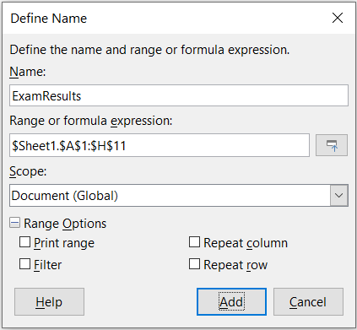
Figure 2: Define Name dialog
To create a named range, select a range of cells from a sheet, then open the Define Name dialog. Next, give the range a meaningful name, and click on Add to add it to the current document’s list of named ranges. You can then access and modify these ranges using the Manage Names dialog (Figure 3), which is opened by selecting Sheet > Named Ranges and Expressions > Manage on the Menu bar, or pressing Ctrl+F3, or selecting Manage Names in the Name Box located at the left of the Formula bar.
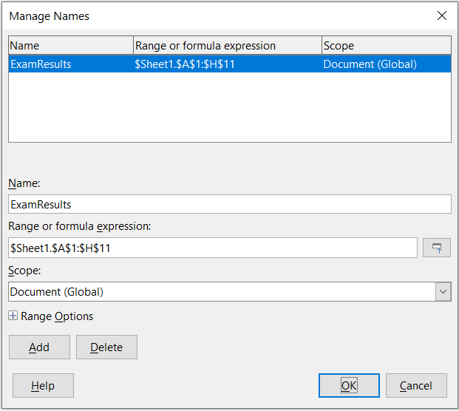
Figure 3: Manage Names dialog
To reduce the typing required when referencing a named range, a Paste Names dialog (Figure 4) can be accessed by selecting Insert > Named Range or Expression or Sheet > Named Ranges and Expressions > Insert on the Menu bar. Select the entry for the relevant named range and click the Paste button to insert the selected named range at the current cursor position.
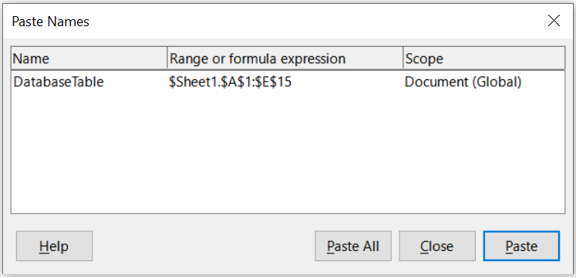
Figure 4: Paste Names dialog
For more detail about how to create and manage ranges, see Chapter 8, Printing, Exporting, Emailing, and Signing, and Chapter 9, Using Formulas and Functions.

Creating named ranges using row or column headers
With the Create Names tool, which is accessed by selecting Sheet > Named Ranges and Expressions > Create on the Menu bar (Figure 5), you can create multiple named ranges simultaneously from the headers of a table. These headers can be drawn from the table’s borders – top and bottom rows, and left and right columns – and each row or column that corresponds to a header is used to create the named ranges themselves. For example, if you choose to create ranges from headers contained in the top row of a table, each range will be generated from the individual columns that correspond to each header label.
- Note
Header cells are not included in the named ranges generated using the Create Names tool. This is because the labels in each of these cells are used to name the ranges.
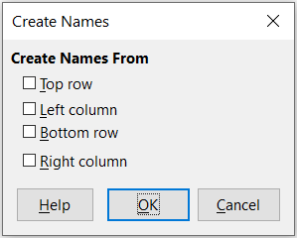
Figure 5: Create Names dialog
To use the Create Names tool:
- In a sheet, select the table from which to create the named ranges. Be sure to include the header rows or columns as part of your selection.
- Open the Create Names dialog by selecting Sheet > Named Ranges and Expressions > Create on the Menu bar.
- Calc automatically identifies which rows or columns contain headers, and will mark the checkboxes – Top row, Left column, Bottom row, Right column – that apply. However, if you wish to change this selection, you can manually select or deselect any of the boxes at this point.
- Click OK to close the dialog and create the new named ranges.
- Tip
Avoid giving multiple rows or columns the same label, as the ranges generated from them will likewise share the same name, and can end up being overwritten by Calc.

Database ranges
Although it can be used like a regular named range, a database range is intended to be used like a database table, with each row representing a record and each cell a field within a record. Specifically, a database range differs from a named range in the following ways:
- A database range cannot be a formula expression, only a single rectangular cell range. This range can be formatted as a table, with the first row reserved for headings and the last row for subtotals. Cell formatting can also be preserved for each field in the table.
- Database ranges cannot be referenced relative to a base address within a sheet, which is possible with a named range.
- Database ranges store sorting, filtering, subtotaling, and data import settings in data structures called descriptors, which can be retrieved and accessed using macros. All descriptors of a database range are updated when a database operation is carried out on the cell range of the database range.
- Unlike a named range, a database range can be connected to an external data source, from where you can fetch data into the spreadsheet document.
Database ranges can be created, modified, and deleted using the Define Database Range dialog (Figure 6).
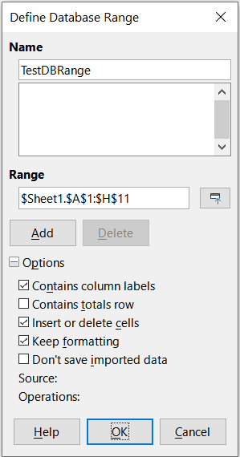
Figure 6: Define Database Range dialog
To create a database range:
- If you want Calc to automatically determine the full extent of your database table, then select a single cell within its cell area. If you want to explicitly define the extent of the database table, then select all relevant cells.
- Open the Define Database Range dialog by selecting Data > Define Range on the Menu bar.
- Type a name for the range in the Name field. Only use letters, numbers, and underscores; spaces, hyphens, and other characters are not allowed.
- Click on the expand symbol (usually a plus or a triangle) next to the Options label to expand this section and view and select the following options:
- Contains column labels – Denotes whether the top row is reserved for field headings.
- Contains totals row – Denotes whether the bottom row is reserved for totals.
- Insert or delete cells – If active, this option will insert new rows and columns into the database range when new records are added to its source. Only relevant if an external database source is linked to the range. To manually update the database range, use Data > Refresh Range on the Menu bar.
- Keep formatting – Applies the existing cell formats of the first data row to the whole database range.
- Don’t save imported data – If selected, this option only saves a reference to the source database; the contents of the range’s cells are not preserved.
- Source – Displays information about the current database source, if one exists. For example, “Bibliography/biblio”.
- Operations – Denotes what operations (if any) have been applied to the database range. For example, “Sort”, “Filter”, or “Subtotals”.
- Click Add to add a range to the database range list under the Name field.
- Click OK to close the dialog and save the database range.
To modify an existing database range:
- Open the Define Database Range dialog by selecting Data > Define Range on the Menu bar.
- Select a range from the range list under the Name field or type its name into the Name field. The Add button will change to Modify at this point.
- Make any modifications in the Range field and the Options section.
- Click Modify to update the database range.
- Click OK to close the dialog and save the modified database range.
To delete an existing database range:
- Open the Define Database Range dialog by selecting Data > Define Range on the Menu bar.
- Select the range to be deleted from the list in the upper section of the dialog.
- Click Delete and then click the Yes button on the confirmation dialog that appears.
- Click OK to close the Define Database Range dialog.
To select an existing database range from the current document, open the Select Database Range dialog by choosing Data > Select Range on the Menu bar (Figure 7). Next, select a range in the Ranges list and click OK. Another way to select an existing database range is using the Navigator deck on the Sidebar. Calc will automatically highlight the range’s position in the sheet in which it is located.
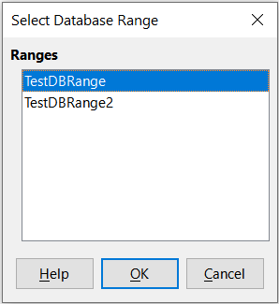
Figure 7: Select Database Range dialog

Using the Data Provider Tool to Load Data in Spreadsheets
The Data Provider tool enables users to import data from various sources and manipulate it within LibreOffice Calc. During the import process, the tool allows for data transformations to be applied before loading it into the spreadsheet. These transformations include operations on columns and rows, as well as numerical, date, and text modifications, along with content replacement and sorting.
The Data Provider tool operates on predefined database ranges. Before you can retrieve data, you need to establish a range (Data > Define Range; please refer to the section on Database ranges above). When creating a database range, be sure to size it appropriately for the volume of data you anticipate loading.
Before finalizing the import, a preview window offers a glimpse of the resulting data set, ensuring you can review the changes before they are applied.
The input data must be available in one of the following formats:
- CSV (Comma Separated Value)
- HTML
- XML (Extensible Markup Language)
- LibreOffice Base files
The Data Provider dialog window can be opened in three ways:
- From the menu bar, choose Data > Data Provider
- From the Data tab on the tabbed interface, choose Data Provider
- From toolbars, choose Data Provider

Data Provider Input Parameters
The following parameters must be set using the Data Provider dialog (Figure 8):
Database Range
Select the database range to receive data from the provider using the dropdown list. You must have database ranges defined previously.
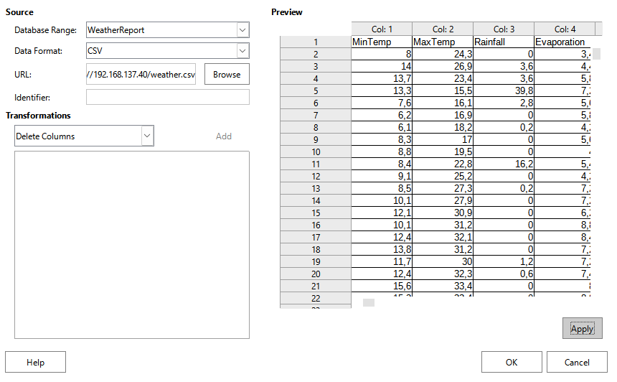
Figure 8: Data provider dialog
‍Data Format
Choose the format of the imported data from the dropdown list
‍URL
Enter the data provider’s URL. For local files, provide the file path and name. For web services, enter the URL.
‍Identifier
Specify the target ID for HTML data or the XPath for XML data.
Transformations
Select one of the transformations in the dropdown list and then click on the Add button. The transformation is placed in the box just below. Many transformations require further parameters and you must supply them. If a transformation is not needed, remove it by clicking on the Delete button. Table 1 below list all available transformations.
- Note
You cannot reorder the transformation list. You must plan in advance the correct sequence of transformations.

Available Data Transformations
The set of transformation is extensive, and many transformations have secondary operations.
Table 1: Available data provider transformations
Transformation | Description
Delete Column | Removes columns based on specified indexes (separated by semicolons).
Delete Rows | Removes rows containing the specified lookup value in the given column index.
Swap Rows | Swaps the positions of two rows.
Split Columns | Splits a column into two based on a specified separator character or string.
Merge Columns | Combines multiple columns, inserting a separator between values.
‍‍‍‍‍Text Transformations | Modifies text in selected columns:  To Lower: Converts text to lowercase.  To Upper: Converts text to uppercase.  Capitalize: Capitalizes the first letter of each word.  Trim: Removes excess spaces, leaving only single spaces between words.
‍‍Sort Columns | Sorts rows in ascending or descending order based on a column index.
‍‍‍‍‍Aggregate Functions | Adds aggregate results at the bottom of a column:  Sum: Total of column values.  Average: Mean of column values.  Max / Min: Highest or lowest value in the column.
Numeric Functions | Performs numeric calculations on selected columns:  Sign: Returns +1 for positive, -1 for negative, and 0 for zero values  Round, Round Up / Round Down: Rounds numbers to a specified precision.  Absolute Value: Converts negative numbers to positive.  Log (base e or 10): Computes the logarithm.  Cube / Square / Square Root: Computes respective mathematical values.  Exponent: Returns ex.  Is Even / Is Odd: Identifies even or odd numbers (returns 0 for decimals).
‍Replace Null | Replaces missing or null values with specified text.
‍‍‍‍‍‍‍‍‍Date and Time Transformations | Extracts or modifies date/time values based on locale settings:  Year / Month / Day: Extracts date components.  Start / End of Year, Month, Quarter: Returns respective boundary dates.  Hour / Minute / Second: Extracts time components.
‍‍‍Find / Replace | Finds and replaces values in the specified column index.
- Tip
Right-click column headers in the preview table to format data before finalizing.
Once all parameters and transformations are set and previewed, click OK to load the data.

Refreshing data provided.
If the data provided comes from a web service or the input data has changed, you can refresh the data using the Refresh Data Provider Tool.

Fetching data from data sources
To fetch data from a data source to create a new database range, carry out the following steps:
- Open the Data Sources Explorer by selecting View > Data Sources on the Menu bar or pressing Ctrl+Shift+F4.
- In the left pane of the Data Sources Explorer, click the expand symbol at the left of the data source name of interest. This action opens the tree to display the tables or queries associated with the data source.
- Click on the required table or query to display its constituent data in the right pane of the Data Sources Explorer.
- Click on the blank rectangular area in the top left corner of the right pane of the Data Sources Explorer to select all the data in the displayed table or query.
- Drag and drop the data to the cell that is to be in the top left corner of the data in your spreadsheet. Search for “drag and drop – data source view” in the Help system for more information about dragging and dropping data from the Data Sources Explorer.
- Calc automatically creates a new database range with default parameters, encompassing the cell range of the imported data and with a default name of the form Import1, Import2, etc.
- If required, access the Define Database Range dialog (Figure 6) to update settings of the new database range.
Select Data > Refresh Range on the Menu bar to refresh the contents of a database range once the data in the associated data source is updated. The data in the sheet is updated to match the data in the external database. Registering and linking to external database sources are explained in more detail in Chapter 12, Linking Data.

Referencing in a Calc Database Table
LibreOffice can make formulas in Calc database tables easier to read and maintain, by referencing a cell rectangle or the entire database range without using direct references like $B$1:$D$23. To use database tables references you need to know:
- The name of the database range;
- Its field names, usually given by the first row of the database range;
- Specific reference keywords;
For example: myData[[#Totals];[Sales]]
This concept is similar to “structured references" for a "table" in Microsoft Excel. An Excel "table" is loaded as a database-range in Calc.
- Note
When saving as an .xlsx file in Excel, “structured references” are retained. However, in Calc, the ODF standard does not yet have the means to save “structured references”. When saving as an .ods file, a “structured reference” is converted into a direct reference using the values present at the time of saving.

Setting up a table
Spreadsheet “tables” are defined by database ranges (Data > Define Range). See Database ranges above. In addition to the name of the database, the following is mandatory for using “structured references”:
- Tables must be vertically oriented.
- Tables must have column labels, if interoperability with Excel is required.
- The column label names must follow the named range rules. See Named ranges above.
The table below contains values used in examples later on in this document.
 | A | B | C | D
1 | Name | Region | Sales | Seniority
2 | Smith | West | 21 | 5
3 | Jones | East | 23 | 11
4 | Johnson | East | 9 | 7
5 | Taylor | West | 34 | 11
6 | Brown | East | 23 | 15
7 | Walker | East | 12 | 4
8 | Edwards | East | 15 | 12
9 | Thomas | West | 17 | 10
10 | Wilson | West | 31 | 3
11 | Totals | 2 | 185 | 8.67
The cell range A1:D11 was defined as database range "myData". The options Contains column labels and Contains totals row were checked when defining the database range (Figure 6).

Reserved reference keywords
[#Headers]
The keyword [#Headers] references the row of field names (column labels). It is the first row of the database range.
Example: The expression myData[#Headers] references the cells A1:D1.
If the database range has no labels, a #REF! error is generated.
[#Data]
The keyword [#Data] references the data records of the database range, excluding the columns header row and the totals row.
Example: The expression myData[#Data] references the cell rectangle A2:D10.
The short form myData[] can be used as well.
[#Totals]
The keyword [#Totals] references the row of totals. It is the last row of the database range.
Example: The expression myData[#Totals] references the cells A11:D11.
If the database range has no totals, a #REF! error is generated.
[#All]
The keyword [#All] references the entire database range including column headers and totals.
Example: The expression myData[#All] references the cells A1:D11.
[#This Row]
This keyword describes an implicit intersection. See Implicit intersection of array formulas in Chapter 89 – Using Formulas and Functions for more information and examples.
Example: If the expression myData[#This Row] is used in a formula in cell F2, it references A2:D2. If the same expression is used in a formula in cell F5, it references A5:D5.
- Note
The intersection is only possible with rows of the database range. A similar This Column does not exist. If a database row does not exist in the row where the formula is placed, a #VALUE! error is generated.
- Tip
When switching from Excel to Calc, Excel does not allow the keyword [#This Row] for the entire table range. If applied to non-data record rows, such as header or totals rows, an error is produced.
In the user interface, Excel uses the short form myData[@]. This implicit intersection operator @ is not currently available in Calc.

Referencing data in tables
A “structured reference” to cells in a database range has the form name of database range […] where the part inside the square brackets can be one of the keywords described in the previous section, a field name in square brackets, or a combination of the two.
In case a single keyword or a single field name is used, single brackets are used instead of double brackets. For example: myData[#Headers] instead of myData[[#Headers]] or myData[Region] instead of myData[[Region]].

Field name in square brackets
To address the array of all values in the records that belong to the same field, use the form [field name]. The referenced cell range does not include label and totals. For example, the expression myData[[Region]] or its simplified form myData[Region] references the cells B2:B10. If the database range has no label row, generic labels like Column1, Column2 can be used.
- Note
In Excel, if the formula cell belongs to the table, then the name of the table may be omitted. For example, the formula =SUM(myData[Sales]) in cell C11 could be written as =SUM([Sales]). Omission of the table name is not yet possible in Calc.

Combinations
To reference a combination of the labels row and data records, use the format [#Headers];[#Data] or [#Headers],[#Data], where the separator is the same separator as for function parameters. So whether to use a semicolon or a comma depends on the setting defined in Tools > Options > Calc > Formula.
To reference a combination of data records and totals row, use [#Data];[#Totals]. For example, myData[[#Data];[#Totals]] references the cells A2:D11.
A combination like [#Headers];[#Totals] is not possible as that would result in two disjoint cell rectangles.
To address several adjacent columns, use the range operator “:”. For example, the formula myData[[Name]:[Sales]] addresses the cells A2:C10.
The use of non-adjacent columns is not possible since it would reference two separate cell rectangles.
The reference via field name and the use of a reference keyword can be combined, first the keyword, then function separator and last the field name in brackets. For example, myData[[#Totals];[Sales]] references the cell C11.

Using structured references
The use of structured references is only allowed if the database range has a vertical orientation. Using a structured reference on a horizontally oriented database range will produce invalid results without producing an error message.
A direct use such as =myData[#Headers] is possible. The generated array Names Region Sales Seniority spills over 4 columns.
- Note
Instead of using the formula =myData. which will copy the entire database range in LibreOffice and then produce an error when opened in Excel, use the formula =myData[#All].
The output array or value of a structured reference can be used as input to other functions. For example, the cells in row 11 have these formulas:
B11 =COUNTA(UNIQUE(myData[Region]))
C11 =SUM(myData[Sales])
D11 =AVERAGE(myData[Seniority])
If a formula uses a structured reference and it references an array of more than one cell, then the formula has to be handled as array formula that has enclosing curly brackets in the input line like {=myData[#Headers]}.

Sorting
Sorting is the process of rearranging data in a range or a sheet according to a specified sort order.
The simplest way to sort a database table based on the contents of a single column is to use the Sort Ascending and Sort Descending tools, as follows:
- Select any cell in the column.
- To sort in ascending order, select Data > Sort Ascending on the Menu bar or click the Sort Ascending icon on the Standard toolbar. If you have enabled AutoFilters (see next section), you can also select Sort Ascending on the relevant column’s AutoFilter combo box.
- To sort in descending order, select Data > Sort Descending on the Menu bar or click the Sort Descending icon on the Standard toolbar. If you have enabled AutoFilters, you can also select Sort Descending on the relevant column’s AutoFilter combo box.
When using the Sort Ascending and Sort Descending tools, Calc automatically identifies the full cell range occupied by your table and sorts the entire area based only on the values in the indicated column. However, it also recognizes the first row as a header row and excludes it from the sort.
The AutoFilter combo box described in the “Filtering” section also provides Sort Ascending and Sort Descending options, in addition to a Sort by Color menu which allows sorting by cell background or font colors.
For more complex sorting, use the Sort dialog (Figure 9), which is accessed by selecting Data > Sort on the Menu bar or by clicking the Sort icon on the Standard toolbar. If you select just one cell within the database table before accessing the Sort dialog, then the entire table will be shown as selected when the dialog is displayed.
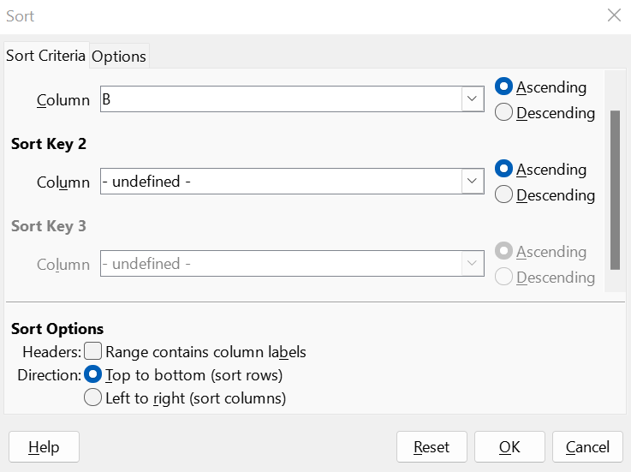
Figure 9: Sort dialog
On the Sort Criteria tab of the dialog, you can specify three levels of sorting. The data is sorted first by the values in the column selected in the Sort Key 1 drop-down, second by the values in the column selected in the Sort Key 2 drop-down, and third by the values in the column selected in the Sort Key 3 drop-down. Checking the Headers option will exclude the first row (for column sorting) or column (for row sorting) from sorting with the rest of the data.
The Options tab of the Sort dialog provides additional sorting options. For more information about how to use this dialog and its options, see Chapter 2, Entering and Editing Data, and the Help system.

Filtering
A filter is a tool that hides or displays records within a sheet based on a set of filtering criteria. Similar to sorting, filters are useful for narrowing down long lists of data in order to find particular data items. In Calc, three types of filter exist:
- AutoFilters
- Standard filters
- Advanced filters
If you want to remove any filtering applied to your database table, simply select Data > More Filters > Reset Filter on the Menu bar.
Filters are also described in Chapter 2, Entering and Editing Data.

AutoFilter
AutoFilters are the most straightforward of the three filter types. They work by providing access to a combo box through a down-arrow button located at the top of one or more data columns. To add AutoFilters to all columns of a database table, click on a cell anywhere within the table area and then select Data > AutoFilter on the Menu bar, click the AutoFilter icon on the Standard toolbar, or press Ctrl+Shift+L. It is possible to add AutoFilters to individual columns by selecting those columns before choosing Data > AutoFilter, clicking the AutoFilter icon, or pressing Ctrl+Shift+L, but this is not normally necessary for a database table. To access the AutoFilter combo box for a column, click on the down-arrow button in the header cell of that column.
To remove AutoFilters from all columns of a database table, click on a cell anywhere within the table area and select Data > AutoFilter on the Menu bar, select Data > More Filters > Hide AutoFilter on the Menu bar, click the AutoFilter icon on the Standard toolbar, or press Ctrl+Shift+L. The down-arrow buttons at the tops of columns will disappear.
- Tip
Selecting Data > AutoFilter, clicking the AutoFilter icon, and pressing Ctrl+Shift+L toggle AutoFilters on/off.
Each AutoFilter combo box (Figure 10) provides the following options:
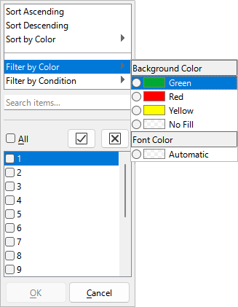
Figure 10: Autofilter combo box
- A basic sort can be applied using the Sort Ascending and Sort Descending options.
- Use the Sort by Color menu to sort entries by background or font color, based on any such color that appears in the column of interest.
- Use the Filter by Color menu to filter entries by background or font color for any such color that appears in the column of interest.
- The Filter by Conditions menu provides Empty, Not Empty, Top 10, and Bottom 10 filter options. In addition, the menu contains a menu item to access the Standard Filter dialog (Figure 11).
- Check the All box to display or hide all values in the current column.
- Show only the current item and Hide only the current item shortcut buttons are provided, located adjacent to the All box. In the context of these buttons, the term “current” refers to the item highlighted in the set of check boxes below the buttons (for example the “1” in Figure 10).
- If any filter has been applied to a column, use the Clear Filter option to remove all filters defined for that column.
- The AutoFilter combo box includes check boxes for each unique value in the current column. If a checkbox is not ticked, rows of the database table that contain that value in this column are not displayed. Change the filtering status of a particular value by marking or removing the mark from the relevant checkbox.
For more information on how to use the AutoFilter combo box and its options, see Chapter 2, Entering and Editing Data.

Standard filters
Standard filters are more complex than AutoFilters, and allow for up to eight filter conditions. Powerful filters can be set up using regular expressions. Also, unlike AutoFilters, standard filters use a dialog (Figure 11), which is accessed by selecting Data > More Filters > Standard Filter on the Menu bar or the Standard Filter option on an AutoFilter combo box.
For more information on how to use this dialog and its options, see Chapter 2, Entering and Editing Data.
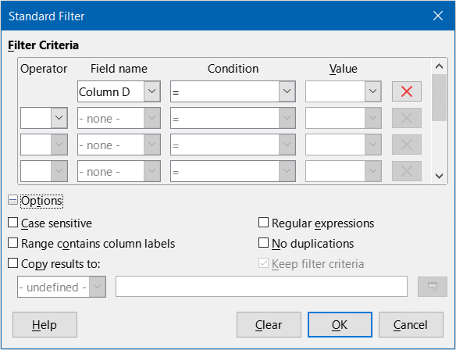
Figure 11: Standard Filter dialog

Advanced filters
The criteria for an advanced filter are stored in a sheet rather than entered into a dialog. As a result, you must first set up a cell range that contains the criteria before you use the Advanced Filter dialog (Figure 12).
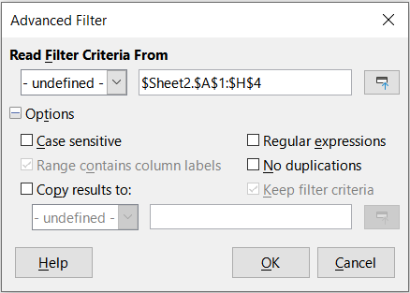
Figure 12: Advanced Filter dialog
To set up a criteria range:
- Copy the column headings of the range to be filtered to an empty space in a sheet. It does not need to be the same sheet as the one with the source range.
- Enter filter criteria underneath the column headings in the criteria range. Each individual criterion in the same row is connected with AND, while the criteria groups from each row are connected with OR. Empty cells are ignored. Up to eight criteria rows may be defined for a filter.
- Tip
Although it is possible for the criteria area to contain only the headings for columns with defined filter criteria, for simplicity you may choose to copy all of your database table’s headings to the criteria area.
After creating a criteria range, set up an advanced filter as follows:
- Select the cell range that you wish to filter. For a database table you can simply click a cell within the table area and Calc will automatically select the whole table as it opens the dialog at step 2).
- Go to Data > More Filters > Advanced Filter on the Menu bar to open the Advanced Filter dialog (Figure 12).
- In the Read Filter Criteria From field, enter the address for the criteria range, either by selecting a named range from the drop-down box, typing in a reference, or selecting cells from a sheet. Remember to use the Shrink / Expand button if you need to temporarily minimize the dialog while selecting cells.
- Click OK to apply the filter and close the dialog.
- Note
For an individual named range, it is possible to tick a Filter checkbox on the Define Name and Manage Names dialogs (Figures 2 and 3 respectively). Only named ranges marked for filtering in this way can be selected in the drop-down box in the Read Filter Criteria From area of the Advanced Filter dialog. Database ranges cannot be selected in the drop-down box.
Advanced filter options are the same as standard filter options, and are described in further detail in Chapter 2, Entering and Editing Data.
Figure 13 demonstrates an example criteria range for the grading sheet example in Figure 1.

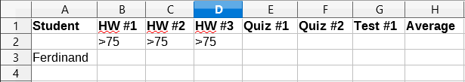
Figure 13: Advanced filter criteria range (in Sheet 2)
In this range, there are two criteria groups: the first displays the records of students who scored above a 75% in every homework, and the second displays records of any student named “Ferdinand”. Figure 14 displays the result of this filter operation using these criteria.

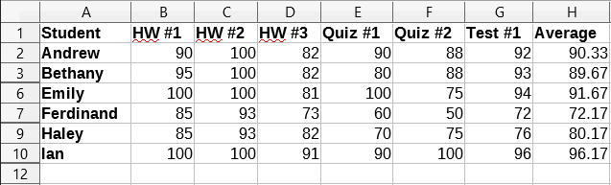
Figure 14: Grading sheet example filtered using an advanced filter

Useful database-like functions

Database category functions
The twelve functions in the Database category are intended to help you analyze a simple database that occupies a rectangular spreadsheet area comprising columns and rows, with the data organized as one row for each record. The header cell of each column displays the name of the column and that name usually reflects the contents of each cell in that column.
The functions in the Database category take three arguments as follows:
- Database. The cell range of the database.
- DatabaseField. The column containing the data to be used in the function’s calculations.
- SearchCriteria. The cell range of a separate area of the spreadsheet containing search criteria.
These arguments are described more fully below.
All functions have the same simple concept of operation. The first logical step is to use the specified SearchCriteria to identify the subset of records in the Database that are to be used during subsequent calculations. The second step is to extract the data values and perform the calculations associated with the specific function (average, sum, product, and so on). The values processed are those in the DatabaseField column of the selected records.

Database function arguments
The following argument definitions apply for all functions in the Database category:
Database argument
Database specifies the range of cells occupied by the database table. The first row of the range contains the field names, and subsequent rows are records with corresponding field values.
One way of defining the range of cells is to enter the cell reference for the upper left-hand cell, followed by a colon (:), and then the lower right-hand cell reference. An example might be A1:E10.
The Database argument may also be specified by passing the name of a named range or database range. Using a meaningful name to define the cell range can enhance formula readability and document maintenance. If the name does not match the name of a defined range, Calc reports a #NAME? error.
Other errors that might be reported as a result of an invalid Database argument are #VALUE! and Err:504 (error in parameter list).
DatabaseField argument
DatabaseField specifies the column which the function will use for its calculations after the search criteria have been applied and the data rows have been selected. It is not related to the search criteria.
Specify the DatabaseField argument in any of the following ways:
- By entering a reference to a header cell within the Database area. Alternatively, if the cell has been given a meaningful name as a named range or database range, enter that name. If the name does not match the name of a defined range, Calc reports a #NAME? error. If the name is valid but does not correspond to one cell only, Calc reports Err:504 (error in parameter list).
- By entering a number to specify the column within the Database area, starting with 1. For example, if a Database occupied the cell range D6:H123, then enter 3 to indicate the header cell at F6. Calc expects an integer value that lies between 1 and the number of columns defined within Database and ignores any digits after a decimal point. If the value is less than 1, Calc reports Err:504 (error in parameter list). If the value is greater than the number of columns in Database, Calc reports a #VALUE! error.
- By entering the literal column header name from the first row of the Database range, placing quotation marks around the header name; for example, “Distance to School”. If the string does not match one of the Database area’s column headings, Calc reports Err:504 (error in parameter list). You can also provide a reference to an arbitrary cell (not within the Database and SearchCriteria areas) that contains the required string.
The DatabaseField argument is optional for the DCOUNT and DCOUNTA functions but it is required for the other ten Database functions.
SearchCriteria argument
SearchCriteria specifies the range of cells containing search criteria. Like Database, its first row is also field names, and subsequent rows are conditions for related fields. The Database and SearchCriteria areas need not be adjacent, or even on the same sheet.
One way of defining the range of cells is to enter the cell reference for the upper left-hand cell, followed by a colon (:), and then the lower right-hand cell reference; for example, A13:B14. The cell range may also be specified by passing the name of a defined named range or database range. If the name does not match the name of a defined range, Calc reports a #NAME? error.
Err:504 (error in parameter list) may also be reported as a result of an invalid SearchCriteria argument.
The contents of the SearchCriteria area are described in more detail in the next section.

Defining search criteria
The number of columns occupied by the SearchCriteria area need not be the same as the width of the Database area. All headings that appear in the first row of SearchCriteria must be identical to headings in the first row of Database. However, not all headings in Database need appear in the first row of SearchCriteria, while a heading in Database can appear multiple times in the first row of SearchCriteria.
Search criteria are entered into the cells of the second and subsequent rows of the SearchCriteria area, below the row containing headings. Blank cells within the SearchCriteria area are ignored.
Create criteria in the cells of the SearchCriteria area using the comparison operators <, <=, =, <>, >=, and >. = is assumed if a cell is not empty but does not start with a comparison operator.
If you write several criteria in one row, they are connected by AND. If you write several criteria in different rows, they are connected by OR.
Criteria can be created using wildcards, providing that wildcards have been enabled via the Enable wildcards in formulas option on the Tools > Options > LibreOffice Calc > Calculate dialog. When interoperability with Microsoft Excel is important for your spreadsheet, this option should be enabled.
Even more powerful criteria can be created using regular expressions, providing that regular expressions have been enabled via the Enable regular expressions in formulas option on the Tools > Options > LibreOffice Calc > Calculate dialog.
- Tip
When using functions where a search criterion string can be a regular expression, the first attempt is to convert the criterion string to numbers. For example, ".0" will convert to 0.0 and so on. If successful, the match will not be a regular expression match but a numeric match. However, switching to a locale where the decimal separator is not the dot makes the regular expression conversion work. To force the evaluation of the regular expression instead of a numeric expression, use some expression that can not be misread as numeric, such as ".[0]" or ".\0" or "(?i).0".
Another setting that affects how the search criteria are handled is the Search criteria = and <> must apply to whole cells option on the Tools > Options > LibreOffice Calc > Calculate dialog. This option controls whether the search criteria you set for the Database functions must match the whole cell exactly. When interoperability with Microsoft Excel is important for your spreadsheet, this option should be enabled.

Example of Database function use
Figure 15 provides a simple example demonstrating how to use one of the functions in the Database category. The formula in the selected cell E15 can be seen in the Formula bar and comprises a call to the DCOUNT function. The arguments of this function call are as follows:
- Database argument. The database table used for this example extends over the cell range A1:E10.
- DatabaseField argument. As the DCOUNT function counts the records that match the criteria without further calculation, it is not necessary to provide a value for this argument, although the relevant argument separators (commas in this case) must be provided.
- SearchCriteria argument. The search criteria area used in this example extends over the cell range A12:E13. The condition in cell D13 (“>600”) will cause DCOUNT to count all records which have a value greater than 600 meters in the Distance (meters) column. In many cases it may be convenient to replicate the column headings of the database table within the search criteria area as shown in Figure 15. However, this is not essential and the formula =DCOUNT(A1:E10,,D12:D13) would give exactly the same value of 5.
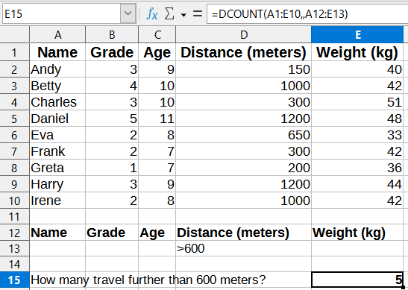
Figure 15 - Example usage of a Database function
Many more examples can be found by searching for “database functions” in the Help system, or by visiting the relevant page for each function within the Calc Functions Wiki at https://wiki.documentfoundation.org/Documentation/Calc_Functions.

List of Database functions
- Note
Calc will treat dates and logical values (such as TRUE or FALSE) as numeric when calculating with these functions.
DAVERAGE
For all rows (database records) that match the specified search criteria, DAVERAGE calculates the average of the numeric values in the cells (fields) of the specified column. Non-numeric values in those cells are ignored.
Returns a #DIV/0! error if no records match the specified search criteria, or if there are no numeric values in the cells of the specified column for the matching records.
Syntax: DAVERAGE(Database; DatabaseField; SearchCriteria)
DCOUNT
For all rows (database records) that match the specified search criteria, DCOUNT counts the number of cells (fields) of the specified column that contain numeric values. However, if no column is specified, DCOUNT returns the count of all records that match the specified search criteria irrespective of their contents.
Syntax: DCOUNT(Database; [DatabaseField]; SearchCriteria)
DCOUNTA
For all rows (database records) that match the specified search criteria, DCOUNTA counts the number of cells (fields) of the specified column that are not blank. Blank cells of the specified column are not counted. However, if no column is specified, DCOUNTA returns the count of all records that match the specified search criteria irrespective of their contents.
Syntax: DCOUNTA(Database; [DatabaseField]; SearchCriteria)
DGET
For the single row (database record) that matches the specified search criteria, DGET returns the contents of the cell (field) of the specified column.
Calc reports Err:502 (invalid argument) if multiple matches are found, or a #VALUE! error (wrong data type) if no matches are found. A #VALUE! error is also reported if a single match is found but the relevant cell is empty.
Syntax: DGET(Database; DatabaseField; SearchCriteria)
DMAX
For all rows (database records) that match the specified search criteria, DMAX calculates the maximum value across the cells (fields) of the specified column that contain numeric values. Blank cells or cells containing non-numeric characters are not included.
Returns 0 if no matches are found, or if there are no non-zero numeric values in the cells of the specified column for the matching records.
Syntax: DMAX(Database; DatabaseField; SearchCriteria)
DMIN
For all rows (database records) that match the specified search criteria, DMIN calculates the minimum value across the cells (fields) of the specified column that contain numeric values. Blank cells or cells containing non-numeric characters are not included.
Returns 0 if no matches are found, or if there are no non-zero numeric values in the cells of the specified column for the matching records.
Syntax: DMIN(Database; DatabaseField; SearchCriteria)
DPRODUCT
For all rows (database records) that match the specified search criteria, DPRODUCT calculates the product of all numeric values in the cells (fields) of the specified column. Blank cells or cells containing non-numeric characters are not included.
Returns 0 if no matches are found, or if there are no numeric values in the cells of the specified column for the matching records.
Syntax: DPRODUCT(Database; DatabaseField; SearchCriteria)
DSTDEV
For all rows (database records) that match the specified search criteria, DSTDEV calculates the sample standard deviation based on the numeric values in the cells (fields) of the specified column. Non-numeric values are ignored.
Returns a #NUM! error if exactly one record matches the specified search criteria, or if there is only one numeric value in the cells of the specified column for the matching records.
Returns 0 if no matches are found, or if there are no numeric values in the cells of the specified column for the matching records.
Syntax: DSTDEV(Database; DatabaseField; SearchCriteria)
DSTDEVP
For all rows (database records) that match the specified search criteria, DSTDEVP calculates the population standard deviation based on the numeric values in the cells (fields) of the specified column. Non-numeric values are ignored.
Returns a #NUM! error if no records match the specified search criteria, or if there are no numeric values in the cells of the specified column for the matching records.
Syntax: DSTDEVP(Database; DatabaseField; SearchCriteria)
DSUM
For all rows (database records) that match the specified search criteria, DSUM calculates the sum of all numeric values in the cells (fields) of the specified column. Blank cells or cells containing non-numeric characters are not included.
Returns 0 if no matches are found, or if there are no numeric values in the cells of the specified column for the matching records.
Syntax: DSUM(Database; DatabaseField; SearchCriteria)
DVAR
For all rows (database records) that match the specified search criteria, DVAR calculates the sample variance based on the numeric values in the cells (fields) of the specified column. Non-numeric values are ignored.
Returns a #NUM! error if exactly one record matches the specified search criteria, or if there is only one numeric value in the cells of the specified column for the matching records.
Returns 0 if no matches are found, or if there are no numeric values in the cells of the specified column for the matching records.
Syntax: DVAR(Database; DatabaseField; SearchCriteria)
DVARP
For all rows (database records) that match the specified search criteria, DVARP calculates the population variation based on the numeric values in the cells (fields) of the specified column. Non-numeric values are ignored.
Returns a #NUM! error if no records match the specified search criteria, or if there are no numeric values in the cells of the specified column for the matching records.
Syntax: DVARP(Database; DatabaseField; SearchCriteria)

Other database-like functions
Calc includes over 500 functions to help you analyze and reference data. Some of these functions are intended for use with tabular data (such as HLOOKUP and VLOOKUP), while others can be used in any context. This section provides a list of some of the functions that may be useful if you intend to utilize tables in Calc for your database. Many will be familiar as typical spreadsheet functions used in other contexts, while some may be less frequently used but are particularly helpful with database tables.
Further reference material for all Calc’s functions can be found in the Help system and in the Calc Functions area of the The Document Foundation’s wiki, at https://wiki.documentfoundation.org/Documentation/Calc_Functions.
Table 2: Some useful database-like functions
Function | Category | Description
AGGREGATE | Mathematical | Returns an overall result calculated by applying a selected aggregation function to the specified data. Nineteen selectable aggregation functions are available, including average, count, large, maximum, median, minimum, mode, percentile, product, quartile, small, standard deviation, sum, and variance.
AVERAGE | Statistical | Returns the arithmetic mean of the specified data, ignoring empty cells and cells that contain text.
AVERAGEA | Statistical | Returns the arithmetic mean of the specified data, ignoring empty cells but assigning the value 0 to any cell that contains text.
AVERAGEIF | Statistical | Returns the arithmetic mean of all cells in a range that satisfy a given criterion.
AVERAGEIFS | Statistical | Returns the arithmetic mean of all cells in a range that satisfy multiple criteria in multiple ranges.
CHOOSE | Spreadsheet | Returns one value from the specified data, selected according to the index passed as an argument.
COUNT | Statistical | Returns a count of the numeric values in the specified data, ignoring empty cells and cells that contain text.
COUNTA | Statistical | Returns a count of the numeric and text values in the specified data, ignoring empty cells.
COUNTBLANK | Statistical | Returns the number of empty cells in the specified data.
COUNTIF | Statistical | Returns the number of cells in a range that satisfy a given criterion.
COUNTIFS | Statistical | Returns the number of cells that satisfy multiple criteria in multiple ranges.
HLOOKUP | Spreadsheet | Searches for a specified value in the first row of a table (often a column heading) and returns a value retrieved from the same column but a different row. HLOOKUP stands for horizontal lookup.
INDEX | Spreadsheet | Returns the contents of one cell in a table. The position of that cell is specified by row and column offsets. Can also be used in an array formula context to retrieve data from multiple cells.
INDIRECT | Spreadsheet | Returns a valid reference constructed from a supplied string representation of the reference. This function is powerful because it enables a user to create dynamic references.
LOOKUP | Spreadsheet | Searches for a specified value in a single row or column and returns a value from the same position in a second row or column. It is not necessary for the search and result areas to be adjacent.
MATCH | Spreadsheet | Returns the relative position of a search item in a single row or column range.
MAX | Statistical | Returns the maximum value in the specified data, ignoring empty cells and cells that contain text.
MAXA | Statistical | Returns the maximum value in the specified data, ignoring empty cells but assigning the value 0 to any cell that contains text.
MAXIFS | Statistical | Returns the maximum value of all cells in a range that satisfy multiple criteria in multiple ranges.
MEDIAN | Statistical | Returns the median value of the specified data. The median of a finite list of numbers is the "middle" number, when those numbers are listed in order from smallest to greatest.
MIN | Statistical | Returns the minimum value in the specified data, ignoring empty cells and cells that contain text.
MINA | Statistical | Returns the minimum value in the specified data, ignoring empty cells but assigning the value 0 to any cell that contains text.
MINIFS | Statistical | Returns the minimum value of all cells in a range that satisfy multiple criteria in multiple ranges.
MODE  MODE.SNGL | Statistical | Returns the mode value of the specified data. The mode is the most common value in a list of values. If there are several values with the same frequency, the smallest value is returned.
MODE.MULT | Statistical | Returns a vertical array of the mode values of the specified data. The mode is the most common value in a list of values. The function returns more than one value when there are multiple modes sharing the same frequency of occurrence.
OFFSET | Spreadsheet | Returns a modified reference to a single cell or a range of cells, offset by a certain number of rows and columns from a given reference point.
PRODUCT | Mathematical | Returns the product of the numeric values in the specified data, ignoring empty cells and cells that contain text.
STDEV  STDEV.S | Statistical | Returns the sample standard deviation of the specified data, ignoring empty cells and cells that contain text.
STDEVA | Statistical | Returns the sample standard deviation of the specified data, ignoring empty cells but assigning the value 0 to any cell that contains text.
STDEVP  STDEV.P | Statistical | Returns the population standard deviation of the specified data, ignoring empty cells and cells that contain text.
STDEVPA | Statistical | Returns the population standard deviation of the specified data, ignoring empty cells but assigning the value 0 to any cell that contains text.
SUBTOTAL | Mathematical | Returns an overall result calculated by applying a selected total function to the specified data. Eleven selectable total functions are available, including average, count, maximum, minimum, product, standard deviation, sum, and variance. Use this function with AutoFilter to take only the filtered records into account.
SUM | Mathematical | Returns the sum of the specified data, ignoring empty cells and cells that contain text.
SUMIF | Mathematical | Returns the sum of all cells in a range that satisfy a given criterion.
SUMIFS | Mathematical | Returns the sum of all cells in a range that satisfy multiple criteria in multiple ranges.
VAR  VAR.S | Statistical | Returns the sample variation of the specified data, ignoring empty cells and cells that contain text.
VARA | Statistical | Returns the sample variation of the specified data, ignoring empty cells but assigning the value 0 to any cell that contains text.
VARP  VAR.P | Statistical | Returns the population variation of the specified data, ignoring empty cells and cells that contain text.
VARPA | Statistical | Returns the population variation of the specified data, ignoring empty cells but assigning the value 0 to any cell that contains text.
VLOOKUP | Spreadsheet | Searches for a specified value in the first column of a table (often a row heading) and returns a value retrieved from the same row but a different column. VLOOKUP stands for vertical lookup.

