
Calc Guide 26.2

Chapter 6
Creating Charts and Graphs
Presenting information visually

Copyright
This document is Copyright © 2026 by the LibreOffice Documentation Team. Contributors are listed below. You may distribute it and/or modify it under the terms of either the GNU General Public License (https://www.gnu.org/licenses/gpl.html), version 3 or later, or the Creative Commons Attribution License (https://creativecommons.org/licenses/by/4.0/), version 4.0 or later.
All trademarks within this guide belong to their legitimate owners.

Contributors
To this edition
Olivier Hallot
To previous editions
Skip Masonsmith, Christian Chenal, Pierre-Yves Samyn, Jean Hollis Weber, Laurent Balland-Poirier, Shelagh Manton, Barbara Duprey, Philippe Clément, Peter Schofield, John A Smith, Kees Kriek, Steve Fanning, Cathy Crumbley, Felipe Viggiano, Leo Moons, Olivier Hallot, B. Antonio Fernández, Dione Maddern, Edward Olson

Feedback
Please direct any comments or suggestions about this document to the Documentation Team’s forum at https://community.documentfoundation.org/c/documentation/loguides/ (registration is required) or email: loguides@community.documentfoundation.org.
- Note
Everything you send to a forum, including your email address and any other personal information that is written in the message, is publicly archived and cannot be deleted. Emails sent to the forum are moderated.

Publication date and software version
Published February 2026. Based on LibreOffice 26.2.
Other versions of LibreOffice may differ in appearance and functionality.

Using LibreOffice on macOS
Some keystrokes and menu items are different on macOS from those used in Windows and Linux. The table below gives some common substitutions for the instructions in this document. For a detailed list, see the application Help and Appendix A (Keyboard Shortcuts) to this guide.
Windows or Linux | macOS equivalent | Effect
Tools > Options on Menu bar | LibreOffice > Preferences on Menu bar | Access to setup options
Right-click | Ctrl+click and/or right-click depending on computer setup | Opens a context menu
Ctrl or Control | ⌘ and/or Cmd or Command, depending on keyboard | Used with other keys
Alt | ⌥ and/or Alt or Option depending on keyboard | Used with other keys

Introduction
Calc offers a variety of ways to present data in the form of customizable charts and graphs.
For readers interested in effective ways to present information graphically, two excellent introductions to the topic are William S. Cleveland’s The Elements of Graphing Data, 2nd edition, Hobart Press (1994) and Edward R. Tufte’s The Visual Display of Quantitative Information, 2nd edition, Graphics Press (2001).

Chart Wizard
Calc’s Chart Wizard may be used to create an initial chart from spreadsheet data. The Chart Wizard includes options for changing the type of chart, adjusting data ranges, and editing chart elements. Each change is immediately seen in the underlying chart.
The data shown in Figure 1 is used in the following sections to demonstrate Chart Wizard functionality.
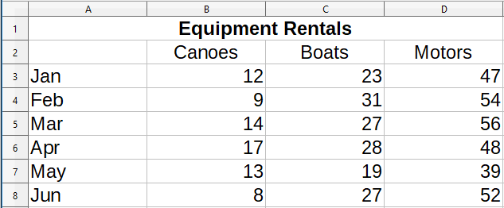
Figure 1: Example data for creating a chart
To create a chart using the provided data:
- Select the cells containing all the data—including names, categories, and labels—to be included in the chart. The selection can be a single block, individual cells, or groups of cells (columns or rows). In this example, it may be best to select the cell range A2:D8, which will intentionally omit the overall title “Equipment Rentals” from the chart.
- Tip
When the data is in one place, the Chart Wizard can guess the range and create an initial chart even if all the data is not selected. Before opening the Chart Wizard, just place the cursor or select a cell anywhere in the area of the data.
- To place a chart on the spreadsheet as an object (Figure 2) and open the Chart Wizard dialog (Figure 3), do one of the following.
- Go to Insert > Chart on the Menu bar.
- Click the Insert Chart icon on the Standard toolbar.
- Choose the chart type and make any other selections desired. The options are explained below.
- Click Finish to save the selections and close the Chart Wizard.
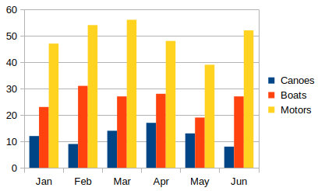
Figure 2: Example chart automatically created using the Chart Wizard

Selecting chart type
Ten basic chart types are available in Calc. The options for customization vary by the type of chart selected. For more information about the different chart types, see Chapter 7 Gallery of Chart Types.
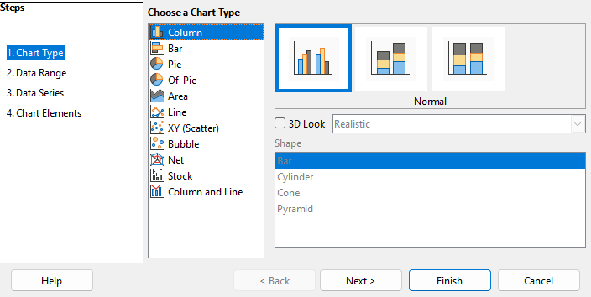
Figure 3: Chart Wizard dialog – selecting chart type
The initial chart created using the Chart Wizard is a 2D column chart. A small preview of the selected variant is highlighted with a surrounding border, as shown in Figure 3. The name of the variant (Normal in Figure 3) is shown below the preview.
To change chart types and options:
- Select the type of chart from the list under Choose a Chart Type.
- If needed, select a chart variant in the preview box by clicking on it. The options available depend on the type of chart selected. The chart changes instantly to reflect the selection.
To use a 3D chart, select the checkbox 3D Look and select the type of 3D view (Realistic or Simple). This option is available only for column, bar, pie, or area charts.
- Click Next to make changes to data range, data series, and chart elements, explained in greater detail below.
- When satisfied with the chart, click Finish to close the Chart Wizard.
- Note
To recreate many of the charts shown in the following sections, select the Column chart type, Normal variant, with the 3D Look option unchecked.

Selecting data range
The data range contains all the cells with data (including labels and categories) that should be included in the chart. In the Data Range step of the Chart Wizard (Figure 4), manually correct any mistakes in data selection for the chart.
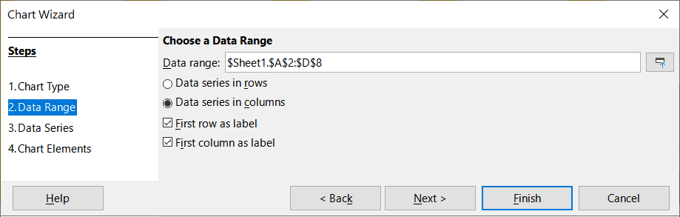
Figure 4: Chart Wizard dialog – selecting data range
To use the Data Range page:
- If necessary, change the rows and columns used as data for the chart by editing the cell references in the Data range text box. Edit the cell references in one of these two ways:
- Directly modify the text in the Data range text box.
- Click the Select data range button to the right of the Data range box. Then use the pointer to select the data range(s) on the spreadsheet.
- Specify whether the data series are arranged in rows or in columns. In the example data, shown in Figure 1, the data series are in columns.
- Select whether to use the first row, or first column, or both, as labels.
- Click Next to move to making changes to the data series (Figure 5).
- When satisfied with the chart, click Finish to close the Chart Wizard.
- Note
If the syntax for a data range is not correct, Calc highlights the Data range text box to indicate the error and disables the Back, Next, and Finish buttons.

Selecting non-adjacent data
To create a complete data range from multiple cells that are not next to each other, use a delimiter between individual ranges. For example, the English (USA) locale uses a comma as a delimiter and “$Sheet1.A1:A5,$Sheet1.D1:D5” is a valid data range. A semicolon is another commonly used delimiter.
The appropriate delimiter depends on the option selected in the Locale setting menu on the Formats section at Tools > Options > Languages and Locales > General. See or change the default delimiter for a locale at Tools > Options > LibreOffice Calc > Formula. In the Separators section, Array column shows the default delimiter.
- Note
The options under Tools > Options may not be available when the chart is in edit mode. If desired, click outside the chart to leave edit mode and see the options. Click the chart twice to enter edit mode again.
To select non-adjacent data, do one of the following while in step 1) above:
- Manually enter the data ranges in the text box with delimiter(s) between them.
- Select the data with the mouse pointer by first clicking the Select data range button to the right of the Data range box. Place the pointer at the end of the first data range in the text box (otherwise the first range is selected and then deleted) and enter the delimiter. Then drag the pointer in the spreadsheet to select the next data range.
- Note
When the data is in the same document as the chart, changes to the data are instantly reflected in the chart.

Linking to external data
Calc offers several options for linking data to external sources. This enables data (and the chart using the data) to automatically update when the external data changes. The following types of files can be linked: HTML, Calc, Base, CSV, Excel, and registered data sources. For further information, refer to Chapter 12, Linking Data.

Selecting data series
The Data Series page of the Chart Wizard (Figure 5) enables fine-tuning of the data. Each data series contains a set of data that have something in common, such as the types of rental equipment listed in Figure 1. Use the Data Series page to change the source range of each data series and to organize how the data is presented in the chart. This includes removing unnecessary data and specifying how data is plotted along the axes.

Organizing data series
- Tip
The Chart Wizard makes initial assumptions about how the data should be displayed, but the assumptions could be incorrect. If a chart does not look as expected, the first thing to check is if all data series are defined correctly.
Also, check the settings on the Data Range page that define whether the data are in rows or columns and whether the first row or first column should be considered labels.
The names of each data series appear in the Data series list box (the middle box in Figure 5). To organize the data series, select an entry in the Data series list and do one or more of the following:
- To change the name of the data series, select Name in the Data ranges list on the right. Edit the cell references in the Range for Name text box below.
- To change the cell references for data series categories, edit the cell references in the Categories text box below the Data ranges box.
- Click Add to add another data series below the selected entry. The data ranges for the new data series will then need to be defined.
- Click Remove to remove the selected entry from the Data series list.
- Click the Up or Down button to move the selected entry up or down in the Data series list. This does not change the order in the data source table, but changes the arrangement in the chart.
- Note
Different data series must be in separate columns or rows. Otherwise, Calc will assume that they are the same data series.

Setting data series ranges
To understand how Calc treats data in charts, it is important to understand the distinction between values and categories. Values are numeric data that vary continuously. By contrast, categories have no mathematical relationship with each other. For example, the categories for the chart data referred to in Figure 5 and the chart shown in Figure 2 are months of the year.
Most Calc charts require both value and category data, with values plotted along the Y axis and categories plotted along the X axis. The exceptions are XY (scatter) charts and bubble charts, which use value data along both axes.
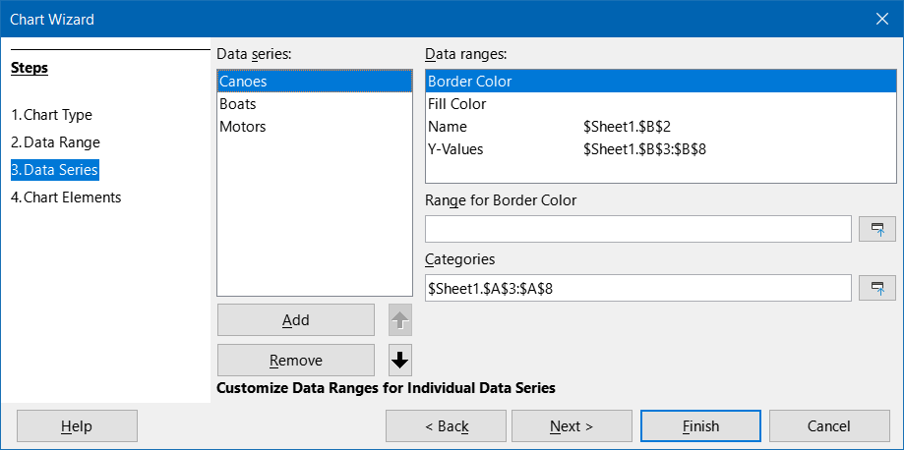
Figure 5: Chart Wizard dialog - selecting data series
Data ranges that may be defined for a specific chart type appear in the Data ranges box on the right side of the Data Series page, shown in Figure 5. Not all data ranges may need to be filled in.
The data ranges may include:
Border Color and Fill Color
Border and fill colors for each data point in the data series can be specified here using numeric values for the RGBA color system. If not specified here, Calc will use default colors. Conditional formatting can also be used. This enables data point colors to vary, depending on whether they meet certain conditions or values. For further information, refer to “Assigning colors” on page 26.
Name
When Data series in columns and First row as label are selected on the Data Range page, Calc assumes that the column labels of the selected data are the data series names. Thus, Calc assumes that the data series names of the data in Figure 1 are “Canoes”, “Boats”, and “Motors”. Similarly, when Data series in rows and First column as label are selected, Calc assumes that the row labels of the selected data are the data series names.
The only way to change a data series name is by selecting Name in the Data ranges box in the upper right of the Data Series page (Figure 5). To change it enter a different cell range in the Range for Name box that appears below the Data ranges box. (Note that the data series name is often contained in a single cell, rather than a range of cells.)
Y-Values
These are numeric values that are often plotted along the vertical axis. However, this is not always the case. For example, while Y-values are plotted on the vertical axis in column charts, they are plotted along the horizontal axis in bar charts.
Categories
The range for category data is defined in a separate Categories box below the Data ranges box. Note the difference between categories and data series names. For the data in Figure 1, the categories are the row labels while the data series names are the column labels.
- Note
XY (scatter) and bubble charts differ from other chart types because they use value data for the X axis rather than category data. For the XY (scatter) and bubble chart types, the Data Series page of the Chart Wizard includes a Data labels box instead of the Categories box displayed for other chart types. To create a set of data labels (one for each data point), enter the required text strings into a range of spreadsheet cells and then enter details of that cell range into the Data labels box. The labels can then be displayed on the chart by selecting the Show category option on the Data Labels dialog (see Figures 36 and 37).
Depending on the type of chart, other data ranges may need to be defined in addition to those shown in Figure 5.

Selecting chart elements
On the Chart Elements page of the Chart Wizard dialog (Figure 6), add or change the title, subtitle, axes names, and grids. Use titles that draw the attention of viewers to the purpose of the chart and describe what they should focus on.
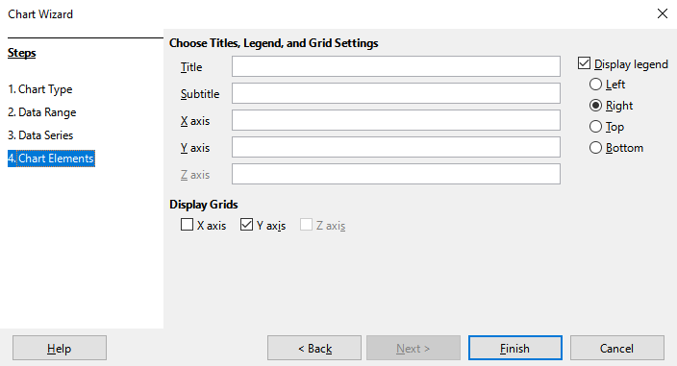
Figure 6: Chart Wizard dialog – selecting and changing chart elements
The chart elements for 2D and 3D charts are illustrated in Figure 7.
- The chart wall contains the graphic displaying the data.
- The chart area is the background of the entire chart.
- The chart title and subtitle, chart legend, axes labels, and axes names are in the chart area.
- The chart floor is only available for 3D charts.
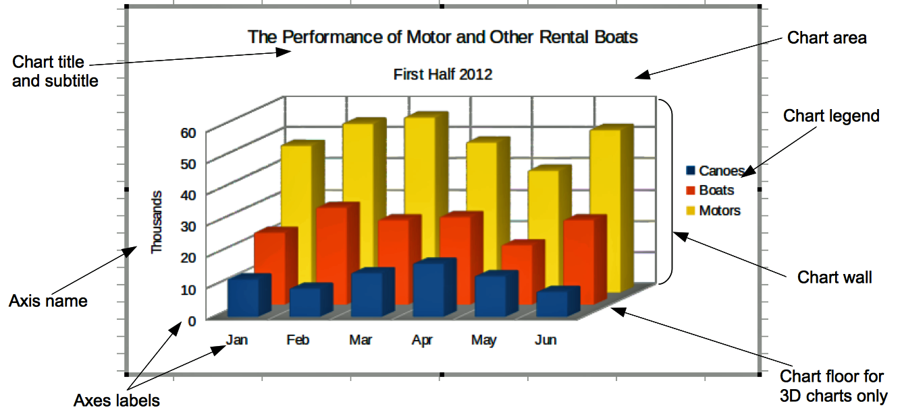
Figure 7: Chart elements
To add elements to a chart, do one or more of the following on the Chart Elements page (Figure 6):
- Enter a title and subtitle (if desired) in the Title and Subtitle text boxes.
- Enter names to be used in the X axis and Y axis text boxes. The Z axis text box is only active if creating a 3D chart.
- Select the Display legend checkbox (turned on by default) and choose where to display the legend – Left, Right, Top, or Bottom. The names in the legend are the data series names. Specify the names in the Range for Name field on the Data Series page.
- Under Display Grids, select the Y axis or X axis check boxes to display horizontal or vertical grid lines respectively. For some charts, the axis grids are displayed by default. Grids are not available for pie charts. The Z axis checkbox is only active when creating a 3D chart. For further information about grids, refer to Grids on page 43.
- Note
While clicking Finish closes the Chart Wizard, the chart remains in edit mode, indicated by gray borders, and can still be modified. Click outside the chart in any cell to exit the edit mode.

Using the Sidebar to change chart settings
The Properties deck of the Sidebar (Figure 8) may be used to set the basic appearance of charts. To open the Sidebar, first click outside the chart to deselect it, then go to View > Sidebar on the Menu bar or press Ctrl+F5. By default, the Sidebar opens on the right side of the screen.
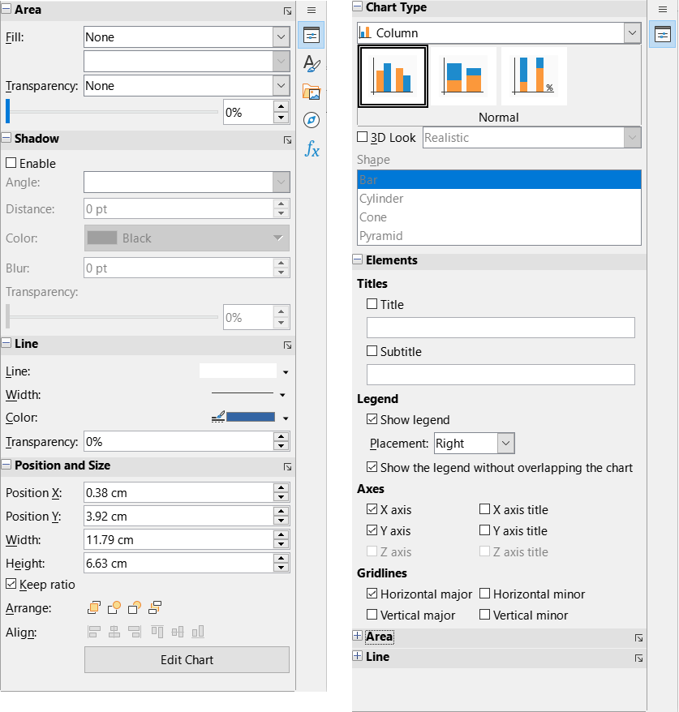
Figure 8: Sidebar Properties deck with chart selected (left) and in edit mode (right)
The contents of the Sidebar depend on whether the chart is selected or is in edit mode. The Sidebar on the left in Figure 8 shows the Properties deck when a chart is selected (by clicking on it once). When a chart is in edit mode (by clicking on it twice), the Properties deck on the right in Figure 8 appears.
- Tip
If the Properties deck of the Sidebar does not appear using the steps above, click the Properties icon on the upper right of the Sidebar to launch it.
The options available on the Properties deck of the Sidebar are also available elsewhere. They may be found in the Menu bar, the Formatting toolbar, or context menus (made available by right-clicking a chart element).
- Note
The Sidebar can be quite useful. However, because the options are easy to see and are available elsewhere, further references to it are not included in this chapter.

Modifying charts
Calc provides many options for formatting and fine-tuning the appearance of charts. This includes tools for editing the chart type, chart elements, data ranges, fonts, colors, and many other options.
Modify charts in one of two ways, depending on what needs to be changed.
Edit object properties
Click on a chart once to edit its object properties. These include size, position on the page, alignment, outer borders, copying, exporting, and more. See the sections starting with “Resizing, moving, and positioning charts.” on page 58 for more information.
Use edit mode
Use edit mode to change data selection and chart type as well as elements such as axes, titles, backgrounds, grids, data series, data labels, trend lines, and more.

Overview of using edit mode
Here are some general ways to modify charts in edit mode. These are discussed in greater detail in the following sections.
- To add an element not already in the chart, use the Insert menu on the Menu bar. Insert titles, legends, axis labels, grids, data labels, trend lines, mean value lines, error bars, and special characters.
- To move or change the size of titles, axis names, chart walls, and legends, click on them once. The pointer changes to a move icon (appearance depends on the system). Drag the element to the new location. To change the size, drag the selection handles.
- Modify elements in a few basic ways. The following methods may open the appropriate dialog or menu. Not all of these methods will work for every element:
- Double-click the element (see an exception below).
- Select the element from the Insert menu (Figure 9) or from the Format menu (Figure 10) on the Menu bar.
- Click the element once, then click on the Format Selection icon on the Formatting toolbar (Figure 11).
- Select the element from the Select Chart Element drop-down list, then click the Format Selection icon next to it on the Formatting toolbar.
- Right-click the element to open the context menu.
- Double-click titles and axis names to change their spelling. To modify the spelling of other text, such as categories, data labels, and legend entries, change the text in the data on the spreadsheet.
- Click once on a data point (such as a column or bar) to select and edit the associated data series.
- With a data series selected, double-click a single data point to edit its properties (for example, a single column in a column chart).

Entering edit mode
To edit or format charts, double-click on the chart to place it in edit mode. The chart is now surrounded by a gray border. In edit mode, the Menu bar changes and the Formatting toolbar contains a number of formatting options and icons, as discussed in the following sections.
- Note
The next several sections (until “Resizing, moving, and positioning charts.” on page 58) require a chart to be in edit mode.

Insert menu
In edit mode, the Insert menu on the Menu bar displays the options shown in Figure 9.
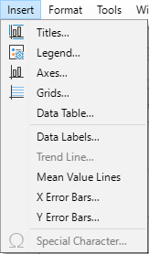
Figure 9: Insert menu when chart is in edit mode
Titles
Provides text boxes for entering chart title and subtitle as well as titles for X-, Y-, and Z- axes, including secondary axes. For more information, see “Titles, subtitles, and axis names” on page 17.
Legend
Specifies if a legend should be included and if so, where. For more information, see “Legends” on page 18.
Axes
Provides options for showing or not showing axis labels. The Chart Wizard shows the labels by default. For more information, see “Axes” on page 29.
Grids
Provides options for showing or not showing major and minor grids for X, Y, and Z axes. To format grids, see “Grids” on page 43.
Data Table
Inserts a Chart Data Table and configure its appearance. Chart data tables allow to visualize the data represented by the chart. A table containing the data is placed at the bottom of the chart. See “Chart Data Tables” on page 40.
Data Labels
Provides options for text attributes, whether to show categories, and the position and rotation of the labels. These labels appear on each data point. For more information, see “Data labels” on page 36.
Trend Line
Specifies the type of regression line to be used, options for extrapolation, where the axes should intersect, the name of the trend line, and whether and how the equation should be displayed. The option is grayed out until a data series is selected. For more information, see “Trend and mean value lines” on page 48.
Mean Value Lines
Displays mean value lines for selected or all data series. For more information, see “Mean value lines” on page 52.
X Error Bars and Y Error Bars
Specifies the error category to be used, parameters, and display options for positive and negative indicators. For more information, see “Error bars” on page 53.
Special characters
Enables the input of special characters in text strings (for example, title and subtitle). The option is disabled if not relevant for the selected chart element. See Chapter 2, Entering and Editing Data, for more information about inserting special characters.

Format menu
In edit mode, these settings appear on the Format menu (Figure 10) of the Menu bar.
Title
Formats the title and subtitle for the chart as well as axis names. The text must first be entered on the Chart Elements page of the Chart Wizard or by going to Insert > Titles.
Legend
Formats the appearance and position of the legend. The legend must first be turned on by using the Chart Elements page of the Chart Wizard or by going to Insert > Legend.
Axis
Formats properties such as where the axes cross each other, the scale of units, and formatting of the axis labels.
Grid
Formats the grid lines. Use the Chart Elements page of the Chart Wizard to turn on grids or go to Insert > Grids to turn grids on or off.
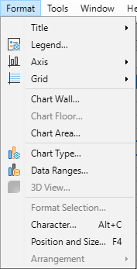
Figure 10: Format menu when chart is in edit mode
Chart Wall, Chart Floor, or Chart Area
Formats borders, area, and transparency of these elements. Note that the chart floor is available only for 3D charts. See “Formatting chart backgrounds” on page 20 for more information.
Chart Type
Changes the type of chart and whether it is a 2D or 3D chart. The various chart types are explained in Chapter 7 “Gallery of Chart Types”.
Data Ranges
Sets ranges for all data in the chart and for individual data series, as explained in “Selecting data range” on page 5, and “Selecting data series” on page 6.
3D View
Formats 3D charts and is only available for 3D charts. Note that only column, bar, pie, and area charts can be displayed as 3D charts. See “3D charts” on page 44 for information.
Format Selection
Opens a dialog with settings for whatever element is selected. Options may include area fill, borders, positioning, transparency, fonts, labels, scale, and other attributes.
Character
Specify the formatting and the font that you want to apply. The changes are applied to the current selection, to the entire word that contains the cursor, or to the new text that you type.
Position and Size
Enables precise specification of the position and size of a selected element. The position is defined in relationship to the chart. See “Position and Size dialog” on page 59 for more information.
Arrangement
Provides two options: Bring Forward and Send Backward. Only one option may be active for some items. Use these options to arrange overlapping data series.

Formatting toolbar
In edit mode, the Formatting bar appears as in Figure 11. Click one of the icons to open a dialog or turn an option on or off. The Insert and Format menus on the Menu bar, described above, contain the same options, with one exception.
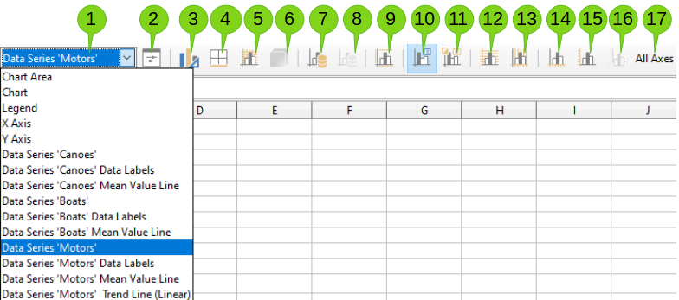
Figure 11: Formatting toolbar when chart is in edit mode
- Select Chart Element  - Format Selection  - Chart Type  - Chart Area  - Chart Wall  - 3D View | - Data Ranges  - Data Table  - Titles  - Legend On/Off  - Legend  - Horizontal Grids | - Vertical Grids  - X Axis  - Y Axis  - Z Axis  - All Axes
The option Select Chart Element drop-down list does not appear elsewhere. Use it to easily select individual chart elements. It can be especially helpful when the chart is crowded, or it is otherwise difficult to select elements using the pointer. Note that options such as Data Labels or Trend Line do not appear on this list unless they have already been inserted using the Insert menu.

Selecting and moving chart elements

Selecting chart elements
After double-clicking on the chart to enter edit mode, select chart elements using one of the following methods:
- Click once on the element in the chart (to select individual data points, click twice—but not too quickly—after clicking once on the data series).
- Select the element from the Select Chart Element drop-down list that appears on the left of the Formatting toolbar, as shown in Figure 11.
When selected, the chart element will be highlighted with square selection handles.
- Tip
Hovering the cursor over an element will display the element name, making it easier to select the correct element. The name of the selected element also appears in the Status Bar, and it is displayed in the Select Chart Element area of the Formatting toolbar.

Moving chart elements
It is possible to move individual elements of a chart, such as the title or axis names, independent of other chart elements as follows:
- Select the element as described above.
- Keep pressing the mouse button. The pointer changes to the move icon (appearance depends on computer setup).
- Drag the pointer to move the element.
- Release the mouse button when the element is in the desired location.
Alternatively, use the Position and Size dialog for some elements, as described on page 59.
Individual points or data series cannot be moved, except pie charts. Individual wedges of a pie can be moved, or the entire pie can be exploded.
To move axis labels, see “Positioning axis, labels, and interval marks” on page 32. To move data labels, see “Adding and formatting data labels for a data series” on page 36.
- Tip
For some chart elements (such as title, subtitle, axis name, and legend), press the arrow keys to move the object in small steps.
- Note
When a 3D chart element is selected, round selection handles may appear. These handles control the 3D angle of the element. Elements cannot be resized or repositioned while they are showing. Clicking again obtains the square selection handles that allow resizing and repositioning of the 3D chart graphic.

Changing chart type
To change the type of chart (bar, column, pie, line, and so on):
- Select the chart by double-clicking on it to enter edit mode. The chart should now be surrounded by a gray border.
- Open the Chart Type dialog using one of these methods:
- Go to Format > Chart Type on the Menu bar.
- Click the Chart Type icon on the Formatting toolbar.
- Right-click on the chart and select Chart Type in the context menu.
The dialog is the same as the first page of the Chart Wizard dialog shown in Figure 3.
- Select the chart type and variant desired.
- Click OK to close the dialog. If desired, click outside the chart to leave edit mode.
For further information about the types of charts, please refer to the Chapter 7 “Gallery of Chart types”.

Titles, subtitles, and axis names

Creating or changing text
To create or change the text of a chart title, subtitle, or axis name:
- Select the chart by double-clicking on it to enter edit mode. The chart should now be surrounded by a gray border.
- Use one of these methods to open the Titles dialog (Figure 12):
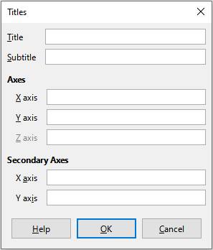
Figure 12: Titles insertion dialog
- Go to Insert > Titles on the Menu bar.
- Click on the Titles icon on the Formatting toolbar.
- Right-click in the chart area and select Insert Titles in the context menu.
- Enter or edit the text in the appropriate text box.
- Click OK to close the dialog. If desired, click outside the chart to leave edit mode.
- Tip
The text of a title (but not formatting) can be modified directly. With the chart in edit mode, double-click on the text to directly change it. Use Shift+Enter at the end of the line to create an additional line that splits the text.

Formatting text
Use a more extensive Titles dialog to format the appearance of a chart title, subtitle, or axis name. To access this dialog:
- Select the chart by double-clicking on it to enter edit mode. The chart should now be surrounded by a gray border.
- Do one of the following to open the Titles dialog for formatting (Figure 13):
- Click Format > Title and select the desired type of title or the All Titles option.
- Click on the element in the chart, right-click, and select Format Title (or appropriate element) from the context menu.
- Click on the element in the chart or select it in the Select Chart Element drop-down list on the Formatting toolbar. Then select Format > Format Selection on the Menu bar or click on the Format Selection icon on the Formatting toolbar.
- Format titles or names as needed. The options are self-explanatory or easily researched.
- Click OK to close the dialog. If desired, click outside the chart to leave edit mode.
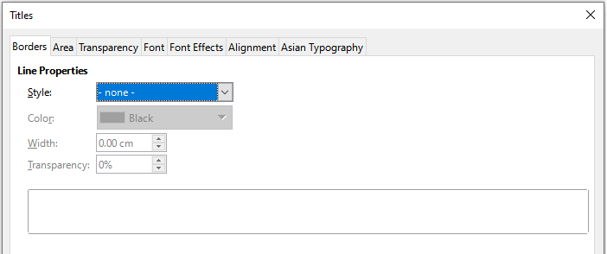
Figure 13: Titles formatting dialog (after selecting All Titles option)
Text inside chart's titles, text boxes and shapes (and parts thereof) can be formatted with the Character dialog (available with the Character button in the Formatting toolbar, with the right-click context menu, or with the top-bar menu: Format > Character). This allows, for example, to use subscripts and superscripts in formulas annotating the chart.

Legends
When a legend is displayed, it shows data series names along with their graphical representations, such as bars, lines, or points. It will also show trend and mean lines when those are turned on, as shown in Figure 14.
Figure 14: Example of a chart legend at the bottom of a chart

Positioning, inserting, or deleting legends

Inserting or deleting only
To only insert or delete a legend:
- Enter edit mode by double-clicking the chart. The chart should now be surrounded by a gray border.
- Do one of the following:
- Click on the Legend On/Off icon on the Formatting toolbar. The default position for inserting a legend is on the right side of the chart.
- Right-click in the chart area and select Insert Legend or Delete Legend in the context menu.
- If desired, click outside the chart to leave edit mode.
- Note
The names in the legend are the data series names. They are taken from the Name data range, discussed in “Selecting data series” on page 6. Change a legend name by changing the text in the spreadsheet.

Positioning, inserting, and deleting
To position a legend using the Legend dialog (Figure 15) as well as insert or delete it:
- Enter edit mode by double-clicking the chart. The chart should now be surrounded by a gray border.
- Go to Insert > Legend on the Menu bar to open the basic Legend dialog.
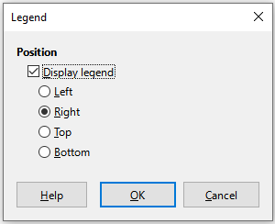
Figure 15: Legend insertion dialog
- Select or deselect the Display legend checkbox to either display or not display the legend.
- Select the desired location for the legend – Left, Right, Top, or Bottom.
- Click OK to close the dialog.
- If desired, click outside the chart to leave edit mode.
- Tip
For finer positioning of the Legend, use one of the methods described in “Moving chart elements” on page 16.

Formatting legends
For advanced editing of a legend’s appearance, a more extensive Legend dialog (Figure 16) has several options for formatting borders, fill, fonts, transparency, and position.
- Enter edit mode by double-clicking the chart. The chart should now be surrounded by a gray border.
- Do one of the following to open the Legend dialog (Figure 16):
- Click on the Legend icon on the Formatting toolbar.
- Select Format > Legend on the Menu bar.
- Right-click on the legend and select Format Legend in the context menu.
- Click on Legend in the Select Chart Element drop-down list on the Formatting toolbar or click the legend in the chart to select it. Then click on the Format Selection icon on the Formatting toolbar or select Format > Format Selection.
- Make any desired changes. The options are self-explanatory or easily researched.
- Click OK to close the dialog. If desired, click outside the chart to leave edit mode.
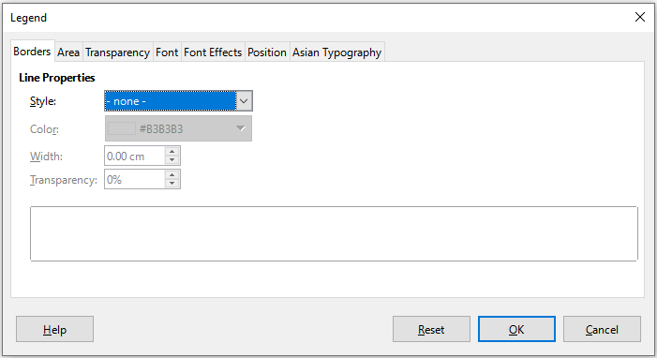
Figure 16: Legend formatting dialog

Formatting chart backgrounds
The background of a chart is divided into chart area, chart wall, and chart floor, as shown in Figure 7. To set border, area, and transparency options for these areas:
- Select the chart by double-clicking on it to enter edit mode. The chart should now be surrounded by a gray border.
- Do one of the following to open the appropriate dialog (such as Figure 17):
- Go to Format on the Menu bar and select Chart Wall, Chart Floor, or Chart Area.
- Right-click the chart wall, chart floor, or chart area in the chart and select Format Wall, Format Floor, or Format Chart Area in the context menu. (For help with selecting these areas, see “Selecting chart elements” on page 8.)
- On the Formatting toolbar, click on the Chart Area icon or the Chart Wall icon (there is no icon for chart floor).
- Click on Chart Area, Chart Wall, Chart Floor, or Chart in the Select Chart Element drop-down list on the Formatting toolbar. Then click the adjacent Format Selection icon or select Format > Format Selection.
- Double-click on the chart area, chart wall, or chart floor.
- Select the desired settings from the Borders, Area, and Transparency tabs.
- Click OK to save the changes and close the dialog. If desired, click outside the chart to leave edit mode.
In the steps above, references to the chart floor are only applicable for 3D charts.
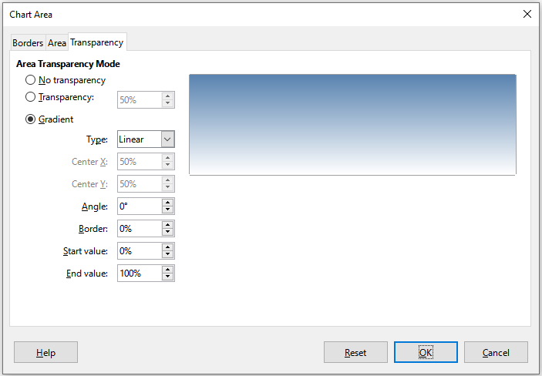
Figure 17: Chart Area dialog – Transparency tab

Data range and series
Calc provides several ways to define and present data for charts. The following sections discuss topics such as defining and changing data ranges, aligning data to a secondary Y axis, and formatting the appearance of the data series.

Changing data ranges
When data ranges change in the spreadsheet, modify the chart settings to reflect those changes. Use one of the following methods.
- Note
The chart automatically reflects changes in the spreadsheet data. Thus, changing a number from 5 to 50 in the data will instantly show the new number in the chart.

Replacing data by dragging
It is easy to manually replace one set of data with another set of data. Do this in the following way:
- Use the mouse to select all the new data.
- Drag the data over the chart, then release the mouse. This opens the Change Source Data Range dialog shown in Figure 18.
- Specify whether or not the first column or row contains labels, then click OK.
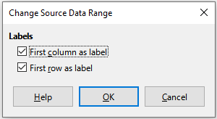
Figure 18: Change Source Data Range dialog

Modifying the data range and data series
To change the data range or data series, do the following:
- Select the chart by double-clicking on it to enter edit mode. The chart should now be surrounded by a gray border.
- Open the Data Ranges dialog using one of these methods:
- Go to Format > Data Ranges on the Menu bar.
- Click on the Data Ranges icon on the Formatting toolbar.
- Right-click on the chart and select Data Ranges from the context menu.
- Edit the data range on the Data Range tab, which is similar to the Choose a Data Range area shown in Figure 4.
- Edit data series on the Data Series tab, which is similar to the Customize Data Ranges for Individual Data Series area shown in Figure 5.
- Click OK to save changes and close the dialog. If desired, click outside the chart to leave edit mode.
- Tip
It may be faster to initially organize the chart using only part of the data. Once the chart is properly formatted, all of the data can be selected.
For further information, see “Selecting data range” on page 5, and “Selecting data series” on page 6.

Opening the Data Series dialog
The Data Series dialog offers several options for presenting data in the chart. Note that only one data series can be selected at a time.
To open the Data Series dialog (Figure 19):
- Select the chart by double-clicking on it to enter edit mode. The chart should now be surrounded by a gray border.
- Do one of the following to select the data series:
- Click on the data series in the chart.
- Click the data series name in the Select Chart Element drop-down list on the Formatting toolbar.
- Do one of the following to open the Data Series dialog:
- Go to Format > Format Selection on the Menu bar.
- Click on the Format Selection icon on the Formatting toolbar.
- Right-click on the data series and select Format Data Series.
- Click on the tab of the appropriate page to make the changes needed. The options for each page are explained below.
- Click OK to save changes and close the dialog. If desired, click outside the chart to leave edit mode.
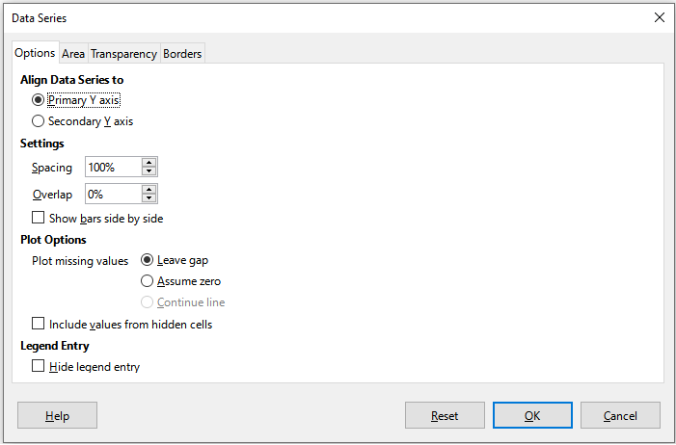
Figure 19: Data Series dialog – Options tab
- Note
The tabs that appear on the Data Series dialog depend on the type of chart selected. Similarly, the controls that appear on each tab may differ depending on the type of chart.

Alignment, spacing, and plot options

Aligning data to secondary Y axis
A secondary axis may be helpful when data differs in units or scale. As shown in the Figure 20 example, one of the data series (kayaks) has considerably larger numbers than the others. To plot all three data series on the same chart, and keep the plotted lines close to each other, the kayak data series is aligned to a secondary Y axis, which has a wider scale. The color of the secondary Y axis and the axis titles help to show this relationship.
- Note
A data series can be associated with a secondary Y axis only after the Chart Wizard has finished creating the chart.
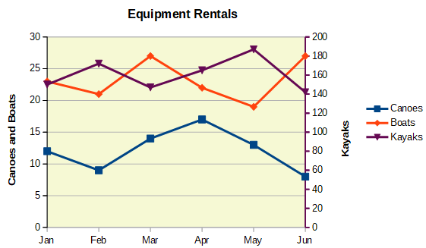
Figure 20: Data series aligned to a secondary Y axis
To align a data series to a secondary Y axis:
- Select the data series and open the Data Series dialog as described in the previous section.
- On the Options tab, under Align Data Series to, select Secondary Y axis.
- Click OK to close the dialog. If desired, click outside the chart to leave edit mode.
Aligning data series to a secondary Y axis is not possible for pie and net charts.
Data can only be aligned to a secondary Y axis, not a secondary X axis. However, it is possible to create secondary X and Y axes that duplicate the primary axes on the opposite sides of a chart. This is described in “Add or remove axis labels” on page 29. It is also possible to show different units or scales on the secondary axis (with or without aligning data to it), as described under “Defining scales” on page 31.

Spacing and plot options
The Options tab of the Data Series dialog (Figure 19) contains additional settings that depend on the type of chart. These include:
Spacing
Sets the spacing interval of columns or bars between category settings, such as time. Values above 100% increase the spacing while values below 100% decrease the spacing. Maximum spacing is 600%.
Overlap
Sets overlap of columns or bars within the same category setting, such as a specific time. The higher the percentage, the greater the overlap (maximum of 100%). Negative percentages increase the separation (minimum of -100%).
Show bars side by side
When checked, shows no gap in columns or bars in the interval between categories. When this option is not checked, data aligned to a secondary Y axis may hide other data. Enable the option to prevent this.
Connection lines
For stacked and percent column (vertical bar) charts, mark this checkbox to connect the column layers that belong together with lines.
Plot missing values
Specifies handling of missing values, with options depending on the type of chart.
Include values from hidden cells
Enables data from hidden cells to be included or not included.
Hide legend entry
Enables the name of the selected data series to be included or removed from the legend.
For pie or donut charts, in addition to the Include values from hidden cells option, two more are available (not shown in Figure 19):
Orientation
Specifies the order of the pie sections (data points) – clockwise or counterclockwise. The default direction is counterclockwise.
Starting Angle
Specifies the starting angle of the first pie section (data point), in the range 0 to 359 degrees. Drag the small dot around the circle or enter a number for the degrees. Use 0 degrees to start the first section at the 3 o’clock position and 90 degrees to start the first section at 12 o’clock.

Area, transparency, and borders
For chart types other than line and scatter, the Data Series dialog (Figure 21) contains tabs for formatting the fill and borders of graphical representations such as columns and bars. The Area tab offers options for selecting color by clicking directly on a color in a palette, adding a custom palette, specifying the RGB or Hex color codes, or by selecting a custom color using the Pick button. Other pages contain options for gradient, bitmap, pattern, hatch, transparency, and borders.
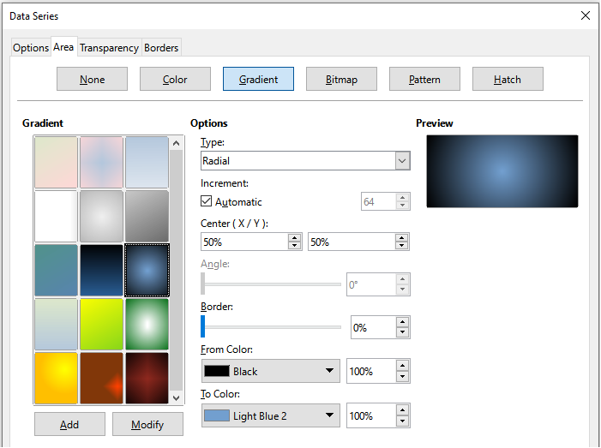
Figure 21: Data Series dialog – Area tab, Gradient page
- Tip
When working with gradients, it may be helpful to create a custom gradient. To do so, select the desired options on the Gradient page, click Add, provide a name for the gradient, and click OK.

Lines, areas, and data point icons
For some chart types (such as line charts and xy (scatter) charts), the Data Series dialog contains only an Options tab and a Line tab (Figure 22).
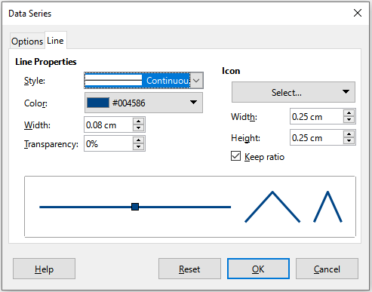
Figure 22: Data Series dialog for line and scatter charts – Line tab
Specify style, color, width, and transparency of the line in the Line Properties section on the left side of the Line tab. In the Icon section, select an option for the symbol from the drop-down list: No Symbol, Automatic, From file, Gallery, or Symbols.
- From file opens a browser for selecting the file that contains the desired symbol.
- Gallery opens a list of available graphics that can be selected.
- Symbols opens a list showing available symbols that can be selected.
A preview of the selection is shown in the preview box at the bottom of the dialog. Enter the desired width and height of the symbol. Select Keep ratio if the ratio of width to height of the symbol should be maintained.

Assigning colors
Colors for the display of data series can be specified in four ways: changing the default color scheme, applying a color theme from the Sidebar, using the Data Series dialog, or using data ranges to set colors for border and fill.

Changing default color scheme
To modify the default color scheme for data series, go to Tools > Options > Charts > Default Colors to specify colors for each data series. Changes made here affect the default colors for any future chart.

Applying a color palette
LibreOffice Calc offers a selection of color palettes to apply themed colors to your data series. First, select the data series you want to customize. Then, open menu Format - Format Selection - Color Palette tab, or, open the Colors section in the Sidebar’s Properties panel. Click the Colors dropdown menu to view and choose from the available color palette.
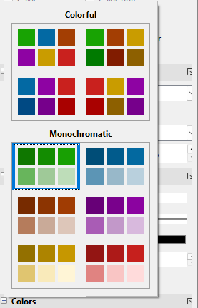
Figure 23: Color panel in Properties deck
Hover your mouse over a color in the Sidebar’s palette to see a live preview of how it will look in the active chart.
Colors are assigned to data series in order, from left to right and top to bottom. Currently, you cannot create a new theme or modify the colors in existing themes.

Using Data Series dialog
As discussed in the previous section, the Data Series dialog has options for assigning colors for lines, areas, and borders. Available options depend on the type of chart.

Using data ranges to assign colors
Use the COLOR function in the Function Wizard (described in Chapter 9, Using Formulas and Functions) to specify colors with numbers based on combined RGB values. Then assign the numbers to data ranges for border and fill colors in the Data Series page of the Chart Wizard (see “Selecting data series”) or in the Data Series tab of the Data Ranges dialog (see “Changing data ranges” on page 21).
For example, using the COLOR function in the Function Wizard, enter 255 for R (red), 0 for G (green), and 255 for B (blue). The COLOR function calculates a combined RGB value of 16711935. Then, when defining data ranges, enter the RGB value(s) in the cell range for border or fill color. Optionally, include a value for the alpha channel (A) in the COLOR function. The value of A can range from 0 (fully transparent) to 255 (fully opaque).
- Note
Data ranges for border color and fill can only be specified for column, bar, pie, bubble, and column and line charts.
Conditional formatting may also be used to define criteria for when specific colors will be used. Conditional formatting is described in Chapter 3, Formatting Data.
Figure 24 shows an example of using conditional formatting to specify colors. The COLOR function in the Formula Wizard was used to create the conditional formula =IF(B2>100,COLOR(240,240,0,20),COLOR(150,0,150,20))
Using this formula, when the value in column B is over 100, the first RGB setting is used to color that data point in the chart. When the value in column B is 100 or less, the default color (150, 0, 150) is used. This formula is in all cells of column C. The numbers appearing in column C are the RGB values calculated using the conditional formula (with cell references changed accordingly).
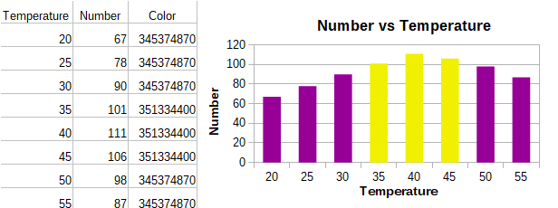
Figure 24: Using the COLOR function and a conditional formula to specify colors
The chart on the right in Figure 24 shows how the colors change to reflect the conditional formatting.

Formatting data points
Modify the appearance of an individual data point such as a column or bar using the Data Point dialog. For most chart types, the dialog contains the same Area, Transparency, and Borders tabs as the Data Series dialog shown in Figure 21. For line, scatter, net, and stock charts, the dialog contains the same options as the Line tab of the Data Series dialog shown in Figure 22.
To format data points:
- Enter edit mode by double-clicking the chart. The chart should now be surrounded by a gray border.
- Click two times (but not too quickly) on the data point to be formatted. The data point will show square selection handles.
- To open the Data Point dialog, do one of the following:
- Go to Format > Format Selection.
- Right-click on the data point and select Format Data Point in the context menu.
- Click the Format Selection icon on the Formatting toolbar.
- Apply formatting options as desired.
- Click OK to close the dialog. If desired, click outside the chart to leave edit mode.
- Tip
As shown in Figure 25, hover the pointer over a data point to show the number of the data point, the number of the series, and the X and Y values of the data point.
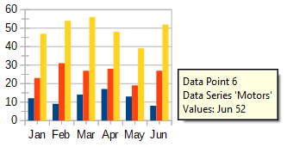
Figure 25: Tooltip showing information about a data point

Axes

Add or remove axis labels
Use the Axes dialog shown in Figure 26 to add or remove axis labels, such as numbers or categories. (To change the name of an axis, see “Titles, subtitles, and axis names” on page 17).
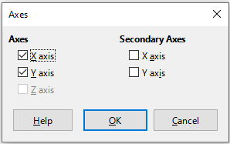
Figure 26: Axes insertion dialog
To use the Axes dialog:
- Enter edit mode by double-clicking the chart. The chart should now be surrounded by a gray border.
- Open the Axes dialog by doing one of the following:
- Go to Insert > Axes on the Menu bar.
- Right-click on the chart and select Insert/Delete Axes in the context menu.
- Select or deselect the checkboxes for axis labels. The Z-axis checkbox is only active when editing a 3D chart.
- Click OK to close the dialog. If desired, click outside the chart to leave edit mode.
Selecting a secondary X axis or a secondary Y axis in this dialog creates duplicate labels on the opposite side of the chart, as shown in Figure 27. To specify different units or intervals for the secondary axis, use the Scale tab of the more extensive Axis dialog described in the following section.
It is also possible to align one or more data series to the secondary Y axis. Do this using the Data Series dialog, described in “Aligning data to secondary Y axis” on page 23.
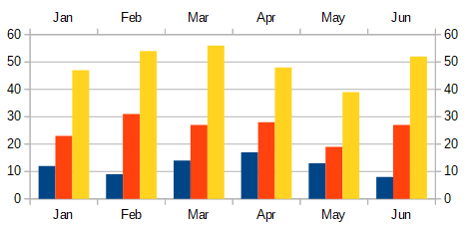
Figure 27: Both secondary axes enabled

Edit and format axes
In addition to the simple dialog above, a more extensive Axis dialog contains options for grid intervals, positioning the axis, formatting the axis line and axis labels, and defining the scale, among other settings. Use a dialog for a specific axis, or use a dialog that applies to all axes. The options in the dialog depend on which axis was selected, type of chart, and whether the chart is 2D or 3D.
To open the more extensive Axis dialog:
- Enter edit mode by double-clicking the chart. The chart should now be surrounded by a gray border.
- Open a specific axis dialog (Figure 28) by doing one of the following (some options do not allow choosing all axes):
- Go to Format > Axis on the Menu bar and select the desired axis (X Axis, Y Axis, Z Axis, Secondary X Axis, Secondary Y Axis, or All Axes).
- Right-click on the desired axis in the chart to open the context menu. Then select Format Axis.
- Click the axis on the chart or select the axis in the Select Chart Element drop-down list on the Formatting toolbar and click the adjacent Format Selection icon or select Format > Format Selection on the Menu bar.
- Click on the icon for X Axis, Y Axis, or Z Axis on the Formatting toolbar. Or click on the All Axes option to the right of the other icons.
- Click the tab of the appropriate page to make the changes needed. The options for each page are explained below.
- Click OK to save changes and close the dialog. If desired, click outside the chart to leave edit mode.
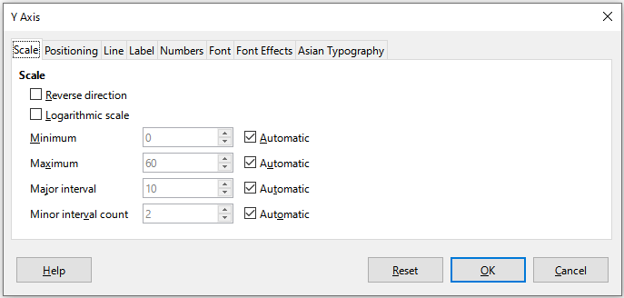
Figure 28: Y Axis formatting dialog – Scale tab

Defining scales
Use the Scale tab to modify the automatically generated scale for a primary axis. In addition, use the Scale tabs for secondary axes to specify scales that are different from the scales for primary axes. This can be quite useful for showing Celsius and Fahrenheit scales on the same chart, for example, or for when data are aligned to a secondary Y axis (see “Aligning data to secondary Y axis” on page 23).
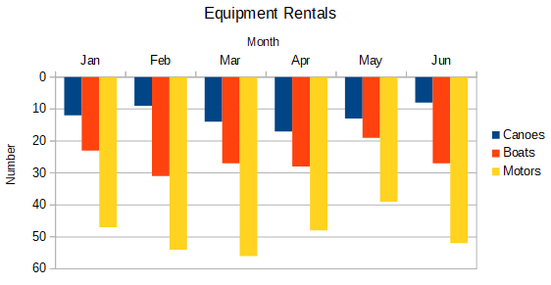
Figure 29: Result when direction is reversed on the Y axis
The contents of the Scale tab (Figure 28) vary with chart type but may contain the following options:
Reverse direction
Defines the order of lower and higher values along the axis. When not selected, the X axis shows the lower values on the left and the Y axis shows the lower values at the bottom. When selected, the orientation of the data display is reversed, as shown in the Y axis in Figure 29.
Logarithmic scale
Specifies that the axis is to be subdivided logarithmically. Logarithmic scaling makes the grid lines of the axis equidistant from each other, but the values between the lines are not equal. Use this option when working with values that differ sharply from each other.
Minimum/Maximum
Sets the first/last value for the axis. Automatic must be deselected to set this option manually.
Major interval
Defines the intervals between major divisions of the axis. These intervals will be used for interval marks (specified on the Positioning tab of the Axis dialog) and grid lines. Automatic must be deselected to set this option manually.
Minor interval count
Defines the number of intervals (not the values between intervals) that subdivide the major intervals. The same as for major intervals, the interval count defined here will be used for interval marks (specified on the Positioning tab of the Axis dialog) and grid lines. Automatic must be deselected to set this option manually.
For some types of charts, additional options may be available:
Type
Specifies whether the labels are text, date, or should be detected automatically.
Resolution
For dates, specifies that the interval steps should be days, months, or years.
- Tip
If the X axis is not displaying time as expected, manually entering the minimum and maximum times on the Scale tab may solve the problem.

Positioning axis, labels, and interval marks
The Positioning tab (Figure 30) controls the position of axis labels and interval marks.
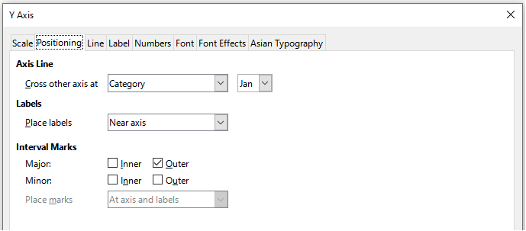
Figure 30: Axis formatting dialog – Positioning tab
Axis Line
Sets where the axis crosses the other axis, as shown in Figure 31. The options on the drop-down list are Start, End, or Category. If Category is selected, a further drop-down menu is displayed enabling selection of the value required.
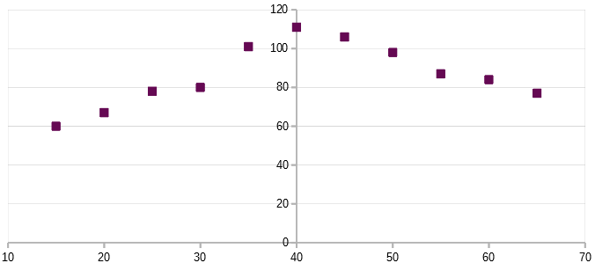
Figure 31: Y axis set to cross X axis at specified value
Labels
Sets where axis labels are placed, using the Place labels drop-down list. The Outside end and Outside start options are useful for positioning labels on axes with negative numbers, as shown in Figure 32.
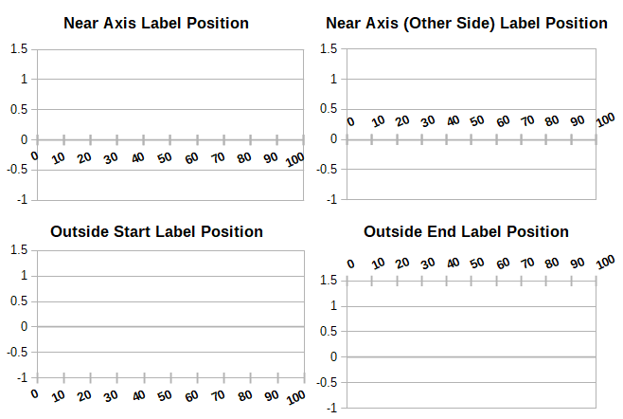
Figure 32: Axis label positions
Interval Marks
- Major/Minor – specifies whether interval marks are displayed for major/minor intervals. These intervals are defined on the Scale tab, described above.
- Inner/Outer – specifies whether interval marks are placed on the inner or outer side of the axis. The interval marks in Figure 32 are on both sides.
- Place marks – specifies where to place the marks: At labels, At axis, or At axis and labels. (The top two charts in Figure 32 show the labels along the axes. The marks are thus both at axis and labels. The marks in the bottom two charts are located at the labels.)

Line tab
The Line tab has options for formatting the axis line style, color, width, and transparency. It has the same contents as the Line tab of the Data Series dialog shown in Figure 22 but excluding the Icon section.

Label tab
On the Label tab (Figure 33), choose whether to show or hide the labels and specify how to handle them when they do not fit neatly in the chart. The options are described below.
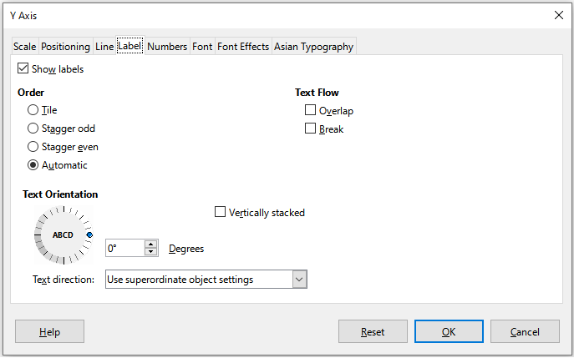
Figure 33: Axis formatting dialog – Label tab
Show labels
Sets whether to show or hide the axis labels.
Order
Defines the horizontal or vertical alignment of the labels on the X or Y axis. These options are available only for 2D charts.
- Tile – arranges labels on the axis side by side.
- Stagger odd – staggers labels on the axis, with even numbers lower than odd numbers (even numbers to the left on vertical axis).
- Stagger even – staggers labels, with odd numbers lower than even numbers (odd numbers to the left on vertical axis).
- Automatic – automatically arranges labels on the axis.
- Note
Problems may arise in displaying labels if the chart is too small. Avoid this by either enlarging the chart or decreasing the font size.
Text flow
Determines how text flows in axis labels.
- Overlap – allows axis labels to overlap.
- Break – allows text breaks, enabling text to wrap into new lines in the available space.
Text Orientation
Defines the direction and orientation of label text.
- Vertically stacked – Stacks characters vertically so that text is read from top to bottom.
- ABCD wheel – Defines text orientation by clicking and dragging the indicator on the wheel. Orientation of the characters “ABCD” on the wheel corresponds to the new setting.
- Degrees – Shows the orientation angle of the text as determined by the ABCD wheel or by manually entering the degrees in the spin box.
- Text direction – Specifies the direction for any text that uses complex text layout (CTL). CTL is only available if Tools > Options > Languages and Locales > General > Default Languages for Documents > Complex text layout is enabled.

Numbers
Use the Numbers tab (Figure 34) to set the attributes for any numbers used on the axis. When Source format is selected (as it is by default), numbers are formatted exactly as they are formatted on the spreadsheet. Deselect this option to change number formatting. For information about formatting numbers, see Chapter 3, Formatting Data, as well as the online Help.
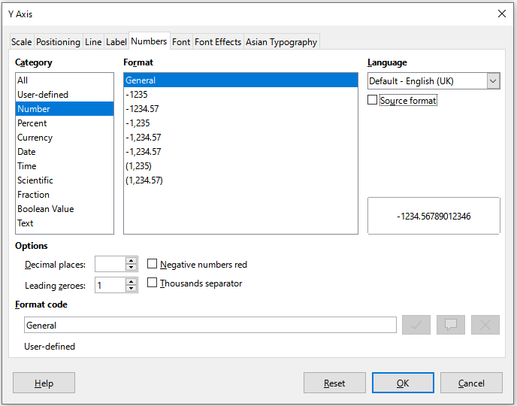
Figure 34: Axis formatting dialog – Numbers tab

Font and Font effects
Use the Font and Font Effects tabs to set the font and font effects for the axis labels. These tabs are the same as the tabs for specifying fonts and font effects in cells. See Chapter 3, Formatting Data, for more information.

Asian Typography
Sets the Asian typographic options for axis labels. This tab is the same as that for specifying Asian typographic options for cells. See Chapter 3, Formatting Data, for more information.

Hierarchical axis labels
Multiple levels of categories can be displayed in a hierarchical manner along the axis of a chart. Hierarchical axes labels are created automatically if the first column or row defined as data is text (as opposed to the first column or row defined as labels). An example of hierarchical labels is shown in Figure 35. In this case, Calc automatically defines the data range for categories as the first two columns in the spreadsheet. This is reflected in the chart, which shows the hierarchical relationship between quarters and months.
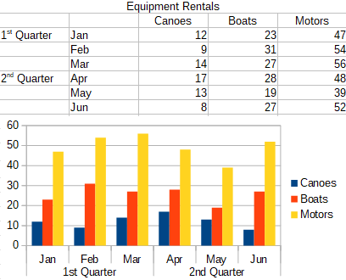
Figure 35: Example of hierarchical axes labels

Data labels
Data labels display information next to data points on the chart. They can be quite useful for highlighting specific data when presenting detailed information, but can make the chart look cluttered if overused.

Adding and formatting data labels for a data series
To add or format data labels for a data series:
- Select the chart by double-clicking on it to enter edit mode. The chart should now be surrounded by a gray border.
- Do one of the following to select a specific data series:
- Click once somewhere in the data series.
- In the Select Chart Element drop-down list of the Formatting toolbar, select the data series name.
- Note
If no data series is selected, then all data series on the chart will be labeled.
- To open the Data Labels dialog (Figure 37), do one of the following:
- Go to Insert > Data Labels on the Menu bar. If a data series has been selected, then Calc displays data labels for that data series using default settings, and displays the Data Labels dialog for the selected data series. In this case, the data labels will remain displayed even when pressing Cancel on the dialog. If no data series was selected, Calc displays the Data Labels for all Data Series dialog (Figure 36). The controls on this dialog are similar to those on the Data Labels tab of the Data Labels dialog, which are described below.
- Right-click on the selected data series in the chart and select Insert Data Labels in the context menu. Calc displays data labels with default settings. Then right-click again and select Format Data Labels in the context menu.
- Select the intended data labels on the chart or in the Select Chart Element drop-down, and then select Format > Format Selection on the Menu bar or press the Format Selection icon on the Formatting toolbar.
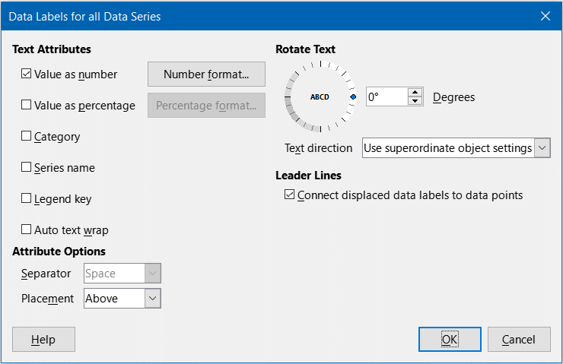
Figure 36: Data Labels for all Data Series dialog
- Select the options as desired. The options are explained below.
- Click OK to close the dialog. If desired, click outside the chart to leave edit mode.
- Tip
Select a data series by clicking once on a column, bar, or other graphic representation of the data series. Select a single data point by pausing, then clicking again.
Most of the tabs in the Data Labels dialog are used in other dialogs and can be readily understood or easily researched. The exception is the Data Labels tab (Figure 37), which contains the following options:
Value as number
Displays the numeric value of a data point. When selected, this option activates the Number format button.
Number format
Opens the Format Number dialog, which is the same as the Numbers tab of the Format Cells dialog discussed in Chapter 3, Formatting Data. Deselect Source format to activate options on the Format Number dialog.
Value as percentage
Displays the percentage value of the data points in each data series. When selected, this option activates the Percentage format button. Note that the percentage referred to is a data point’s Y value as a percent of total Y values for a specific X category or value. Thus, in Figure 38, the February canoe value 9 is 10% of the total February value of 94 (the sum of 9, 31, and 54).
Percentage format
Opens the Number Format for Percentage Value dialog, which is the same as the Numbers tab of the Format Cells dialog discussed in Chapter 3, Formatting Data. Deselect Source format to activate options on the Number Format for Percentage Value dialog.
Category
Displays the category next to each data point. This option is activated for all data labels in Figure 38. Thus, all data labels show the month. The text for data labels comes from the category data series and cannot be changed in the chart. It can only be changed in the spreadsheet data.
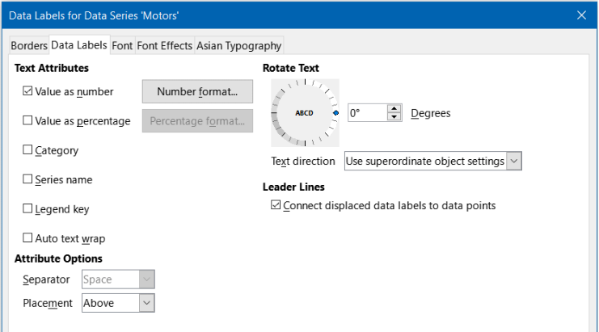
Figure 37: Data Labels tab of the Data Labels dialog
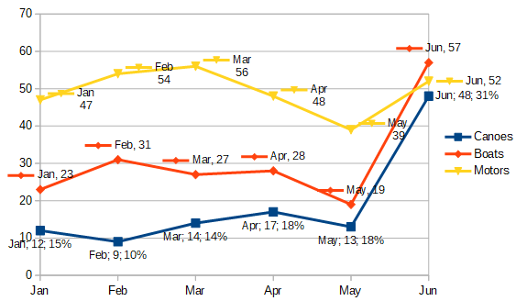
Figure 38: Examples of data label options
Series name
Displays the data series name next to each data point.
Legend key
Displays the legend icon for the data series next to each data point. Figure 38 shows the legend keys for motors and boats, but not for canoes.
Auto text wrap
Wraps data label text if needed.
Separator
Selects what will be used to separate multiple text strings when at least two options above are selected. In Figure 38, the separator is Semicolon for the canoes data labels, New line for the motors data labels, and Comma for the boats data labels (except for the June label, which was modified for better fit). Further options are Space and Period.
Placement
Specifies the placement of data labels relative to the data point representation. In Figure 38, the placement of data labels is Below for canoes, Above for boats, and Right for motors. Other available options depend on chart type but may include Left, Center, Outside, Inside, and Near Origin.
Rotate Text
Sets the text orientation of data labels by using the dial or entering the rotation angle in degrees.
Text Direction
Specifies the text direction for a paragraph that uses complex text layout (CTL).
Leader Lines
When data labels are enabled, Calc automatically determines where to place each label on the chart. However, data labels may be dragged to a more convenient position. By default, a “leader line” is drawn that connects such a displaced data label to its associated data point. Leader lines for the selected data series may be hidden by unchecking the Connect displaced data labels to data points checkbox.

Data labels for individual data points
Sometimes it is appropriate to apply data labels to one or a few data points rather than all data points. This reduces clutter and highlights the most important data.

Adding a single data label
Insert a data label for a single data point in the following way:
- Select the chart by double-clicking on it to enter edit mode. The chart should now be surrounded by a gray border.
- Click the data point once, pause, then click again to select it. (Clicking too quickly opens the Data Series dialog.)
- Right-click on the selected data point and select Insert Single Data Label in the context menu. The data label will have the default settings.
- If desired, click outside the chart to leave edit mode.

Formatting the label for a single data point
To format an existing label for a single data point, follow the directions above but instead of step 3), do the following to open the Label for Data Series dialog (similar to Figure 37): right-click on the data point and select Format Single Data Label from the context menu.
The options in the Label for Data Series dialog are the same as for the Data Labels dialog described above.
The Label for Data Series dialog may also be accessed by clicking on the data label, pausing, and then clicking on it again. Then, in the context menu, right-click and select Format Single Data Label.

Removing data labels
Remove labels from a single data point, a single data series, or all data points using one of the methods below.
Before doing any of the following, first select the chart by double-clicking on it to enter edit mode. The chart should now be surrounded by a gray border. When finished, if desired, click outside the chart to leave edit mode.

Removing all data labels from a single data series
Method One
Right-click somewhere in the data series and select Delete Data Labels in the context menu.
Method Two
- Do one of the following to open the Data Labels dialog (Figure 37):
- Click somewhere in the data series to select it. Go to Insert > Data Labels on the Menu bar.
- In the Select Chart Element drop-down list of the Formatting toolbar, select the data labels entry for the required series name or select one of the labels for the data series. Then click the adjacent Format Selection icon or select Format > Format Selection on the Menu bar.
- Right-click in the data series or on the labels of the data series and select Format Data Labels in the context menu.
- On the Data Labels tab, deselect all of the options and click OK.

Removing a data label from a single data point
- Click once on the data point, pause, then click again to select it.
- Right-click to open the context menu and select Delete Single Data Label.

Removing all data labels
- Make sure that no data label or data series is selected.
- Go to Insert > Data Labels on the Menu bar.
- On the Data Labels for all Data Series dialog, deselect all of the options for the data labels to be removed, then click OK.

Chart Data Tables
When designing a chart, it may be useful to display the source data with the chart. This can be achieved easily by adding a chart data table. Chart data tables display the underlying data represented by a chart, in a tabular form positioned automatically below the chart. For certain chart types, the data table replaces the x-axis labels.
Chart data tables can be formatted freely, and a simple example is shown in Figure 39.
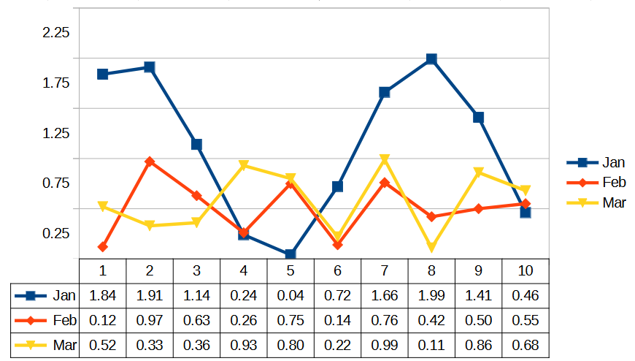
Figure 39: Chart data table displayed below chart
Data tables can be shown for most chart types, apart from Net and Pie charts.
- Note
The nature and volume of data shown on a chart, and the type of chart, may not be suitable for displaying a usable chart data table. In such cases, the chart data table can simply be removed.

Inserting a chart data table
To display a chart data table:
- Select the chart by double-clicking on it to enter edit mode. The chart should now be surrounded by a gray border.
- Go to Insert > Data Table on the Menu bar to open the Data Table dialog (Figure 40).
- Select the Show data table option.
- Click OK to close the dialog. If desired, click outside the chart to leave edit mode.
- Tip
The content of the chart data table inherits the formatting of the chart’s source data.

Removing a chart data table
To remove a chart data table:
- Select the chart by double-clicking on it to enter edit mode. The chart should now be surrounded by a gray border.
- Go to Insert > Data Table on the Menu bar to open the Data Table dialog (Figure 40).
- Deselect the Show data table option.
- Click OK to close the dialog. If desired, click outside the chart to leave edit mode.
Alternatively, with the chart in edit mode, right-click on the chart data table and select Delete Data Table in the context menu.

Modifying the properties of a chart data table
The Data Table dialog shown in Figure 40 is accessed using Insert > Data Table on the Menu bar. In addition to providing a display on/off control for the chart data table (Show data table), it also provides options to control the basic formatting properties of the chart data table:
- Show horizontal border: show or hide internal row borders.
- Show vertical border: show or hide internal column borders.
- Show outline: show or hide borders around the table.
- Show keys: show or hide the color keys associated with each data series. These are similar to the color keys used in the chart legend.
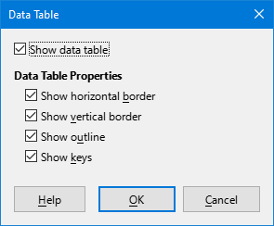
Figure 40: Data Table dialog
Each of the following interactions leads to the display of the larger Data Table dialog shown in Figure 41. In all cases, first select the chart by double-clicking on it to enter edit mode.
- Double-click the chart data table.
- Right-click on the chart data table and select Format Selection in the context menu.
- Select the chart data table and go to Format > Format Selection on the Menu bar.
- Select the Data Table option in the Select Chart Element drop-down list on the Formatting toolbar and then click the adjacent Format Selection icon.
This version of the dialog has five tabs – Data Table, Line, Area, Font, and Font Effects. Through these tabs it is possible to change the line, fill and font properties of the data table. For example, the line properties define how the borders (lines) will be shown – it is possible to change the line style (for example, continuous line, dashes, or dots), the color of the line, transparency, and line thickness. The fill properties define the color of the cell background. The font properties define the font and size to be used for the text in the data tables.
- The Data Table tab provides the same four options that appear in the Data Table Properties area of the Data Table dialog shown in Figure 40.
- The Line tab provides similar options to those on the Line tab of the Data Series dialog shown in Figure 22 but excluding the Icon section.
- The Area tab provides similar options to those on the Area tab of the Data Series dialog described in the “Area, transparency, and borders” section.
- The Font and Font Effects tabs provide similar options to those on the corresponding tabs of the Cell Style dialog, described in the “Cell style attributes” section of Chapter 4, Using Styles and Templates.
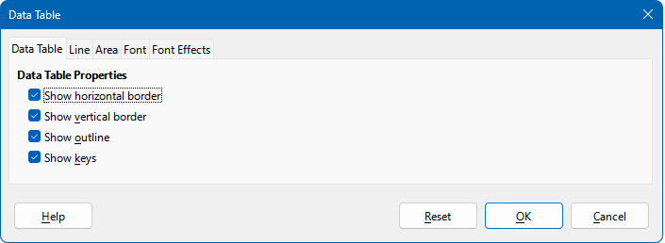
Figure 41: Data Table dialog with multiple tabs

Grids
Grid lines or grids divide the intervals along axes to help estimate data point values. Major and minor grid lines are shown in Figure 42. The darker lines with numbers are major grid lines while the lighter lines between them are minor grid lines. Note that the Y-axis major grid line is activated by default.
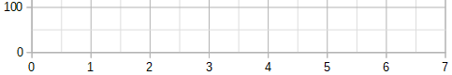
Figure 42: Major and minor grid lines for the X and Y axes
Grids are available for all chart types with the exception of pie charts.

Adding/removing grid lines
- First select the chart by double-clicking on it to enter edit mode. The chart should now be surrounded by a gray border.
- Do one of the following:
- Go to Insert > Grids on the Menu bar to open the Grids dialog (Figure 43). Select/deselect the checkboxes as needed. The Z axis checkbox is only active for a 3D chart. Click OK to close the dialog.
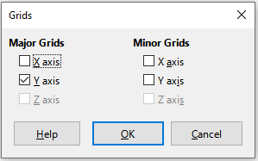
Figure 43: Basic Grids dialog
- Click the Horizontal Grids icon or the Vertical Grids icon, both located on the Formatting toolbar. Clicking once turns on the major grid lines. Clicking twice turns on the minor grid lines as well. Clicking again turns off the grids.
- If desired, click outside the chart to leave edit mode.
- Note
In the Formatting toolbar, the Horizontal Grids icon and the Vertical Grids icon set grid lines for the Y axis and X axis, respectively. This can be misleading because both the Y axis and the X axis can be horizontal or vertical, depending on the type of chart. Thus, for a bar chart, click the Horizontal Grids icon to control the vertical grids.

Formatting grids
In addition to the Grids dialog shown in Figure 43, there is another dialog for formatting grids. To open the grid formatting dialog:
- Select the chart by double-clicking on it to enter edit mode. The chart should now be surrounded by a gray border.
- Go to Format > Grid on the Menu bar and select the appropriate type of grid to open the Grid formatting dialog (Figure 44).
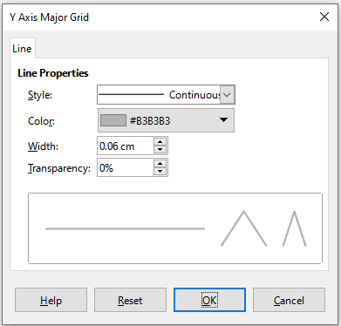
Figure 44: Grid formatting dialog
- Set formatting options for line style, color, width, and transparency.
- Click OK to close the dialog. If desired, click outside the chart to leave edit mode.
- Note
Use the Scale tab of the Axis dialog to specify the intervals between grid lines. This is described in “Defining scales” on page 31.

3D charts

Setting 3D look
Column, bar, pie, and area charts can be displayed as 3D charts. The setting to make a chart 3D is on the first page of the Chart Wizard. If the chart has already been created, do the following to give it a 3D look:
- Select the chart by double-clicking on it to enter edit mode. The chart should now be surrounded by a gray border.
- Do one of the following:
- Go to Format > Chart Type.
- Click on the Chart Type icon on the Formatting toolbar.
- Right-click in the chart and select the Chart Type option in the context menu.
- Select 3D Look in the Chart Type dialog.
- Select the basic rendering scheme as Simple or Realistic from the adjacent drop-down.
- For column and bar charts, select the shape as Bar, Cylinder, Cone, or Pyramid.
- Click OK to close the dialog. If desired, click outside the chart to leave edit mode.

Formatting 3D view
To make changes to a 3D chart, use the 3D View dialog (Figure 45).
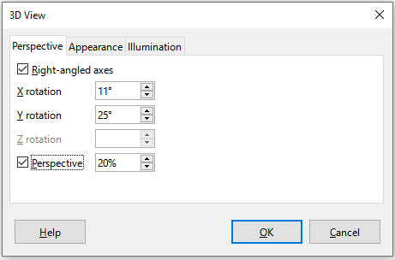
Figure 45: 3D View dialog – Perspective tab
Use the 3D View dialog to change the 3D settings, including perspective, appearance, and illumination. Note that the chart must already be set to show a 3D look, as described above. To open the 3D View dialog:
- Select the chart by double-clicking on it to enter edit mode. The chart should now be surrounded by a gray border.
- Do one of the following:
- Right-click on the chart and select 3D View in the context menu.
- Go to Format > 3D View.
- Click on the 3D View icon on the Formatting toolbar.
- Make any changes required.
- Click OK to close the dialog. If desired, click outside the chart to leave edit mode.
This dialog has three tabs, which are explained below.

Rotation and perspective
Some hints for using the Perspective tab (Figure 45) to rotate a 3D chart or change its perspective view:
- Set all angles to 0 degrees for a front view of the chart. Pie charts and donut charts are shown as circles.
- With Right-angled axes enabled, the chart can be rotated only in the X and Y direction; that is, parallel to the chart borders.
- An X value of 90 degrees, with Y and Z set to 0 degrees, provides a view from the top of the chart. With X set to –90 degrees, the view is from the bottom of the chart.
- Rotation is applied in the following order: X axis first, then Y axis, and Z axis last.
- When shading is enabled (see below) and the chart is rotated, the lights are rotated as if they are fixed to the chart.
- The rotation axes always relate to the page, not to the axes of the chart. This is different from some other chart programs.
- Select the Perspective option to view the chart in central perspective as through a camera lens (as opposed to using a parallel projection). Set the focal length with the spin box or type a number in the box. With a 100% setting, a far edge in the chart looks approximately half as big as a near edge.

Rotating 3D charts interactively
In addition to using the Perspective tab of the 3D View dialog, rotate 3D charts interactively in the following way:
- Select the chart by double-clicking on it to enter edit mode. The chart should now be surrounded by a gray border.
- Click once on the chart wall to select it, causing round selection handles to appear. The pointer changes to a rotation icon.
- Press and hold the left mouse button while dragging in the desired direction. A dashed outline of the chart is visible to help see how the result will look.
- Release the mouse button when satisfied.
- Click outside the chart to exit edit mode.

Appearance
Use the Appearance tab of the 3D View dialog (Figure 46) to modify some aspects of the appearance of the data in a 3D chart.
First select a rendering scheme from the Scheme drop-down list – Realistic (default) or Simple. The scheme selected sets the options and light sources. Depending on the scheme selected, not all options may be available. To create a custom scheme, select or deselect a combination of Shading, Object borders, and Rounded edges.
Some hints:
- Select Shading to use the Gouraud method for rendering the surface. Otherwise, a flat method is used. The flat method sets a single color and brightness for each polygon. The edges are visible but soft gradients and spotlights are not possible. The Gouraud method applies gradients for a smoother, more realistic look. See the Draw Guide for more information on the use of shading.
- Select Object borders to draw lines along the edges.
- Select Rounded edges to smooth the edges of box shapes.
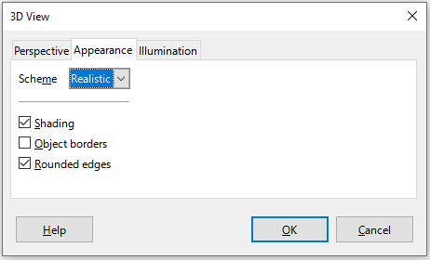
Figure 46: 3D View dialog – Appearance tab

Illumination
Use the Illumination tab (Figure 47) of the 3D View dialog to control light sources for the 3D view.
Here are the options with some hints:
- Click any of the eight buttons to switch a directed light source on or off.
- The first light source projects a specular light with highlights.
- By default, the second light source is switched on. It is the first of seven normal, uniform light sources. To activate the others sources, click twice on their respective button.
- For the selected light source, select a color from the first drop-down list below the eight light source buttons. Alternatively press the adjacent button to select a color using the Pick a Color dialog. Note that the brightness values of all lights are added together, so use dark colors when enabling multiple lights.
- The small preview in the dialog shows the effect of repositioning the light source.
- Each selected light source appears as a small colored sphere in the specified color. The sphere is larger when the light source is actively selected.
- Each light source always points at the middle of the object initially. Move the vertical slider to adjust the lighting angle. The horizontal slider rotates the light around the object. In addition, click the light source and drag it to the desired location.
- Click the button in the bottom right corner of the preview to switch the internal illumination model between a sphere and a cuboid.
- Use the Ambient light drop-down list to define the ambient light, which shines with a uniform intensity from all directions. Alternatively press the adjacent button to select a color using the Pick a Color dialog.
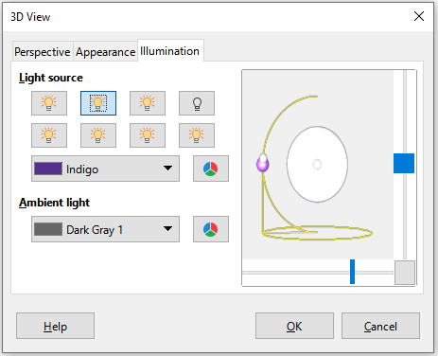
Figure 47: 3D View dialog – Illumination tab
See the Draw Guide for more information on setting the illumination.

Trend and mean value lines
Trend lines help show the relationships among scattered data points of a data series. Calc has a good selection of regression types for creating trend lines: linear, logarithmic, exponential, power, polynomial, and moving average. Choose the type that comes closest to passing through all of the points in a data series.
Trend lines can be added to all 2D chart types except for pie, net, bubble, and stock charts. When inserted in the chart, representations of the trend lines are automatically shown in the chart legend.
- Note
For chart types that use categories for the X axis, such as column, bar, or line charts, the numbers 1, 2, 3… are used as values for calculating trend lines. By contrast, XY (scatter) chart types show data rather than categories along the X axis. Thus, only XY (scatter) chart types can show meaningful regression equations.

Adding and modifying trend lines
Trend lines can only be added to one data series at a time. To add a trend line to a data series:
- Double-click on the chart to enter edit mode. The chart should now be surrounded by a gray border.
- Select the data series by doing one of the following:
- Click once on a data series representation such as a bar, column, line, or point.
- Select the data series from the Select Chart Element drop-down list on the Formatting toolbar.
- Do one of the following to open the Trend Lines dialog (Figure 48):
- Go to Insert > Trend Line on the Menu bar.
- Right-click on the data series and select Insert Trend Line in the context menu.
- Select the type of regression and choose the desired options. These are explained below.
- Click OK to close the dialog and place the trend line in the chart. If desired, click outside the chart to leave edit mode.
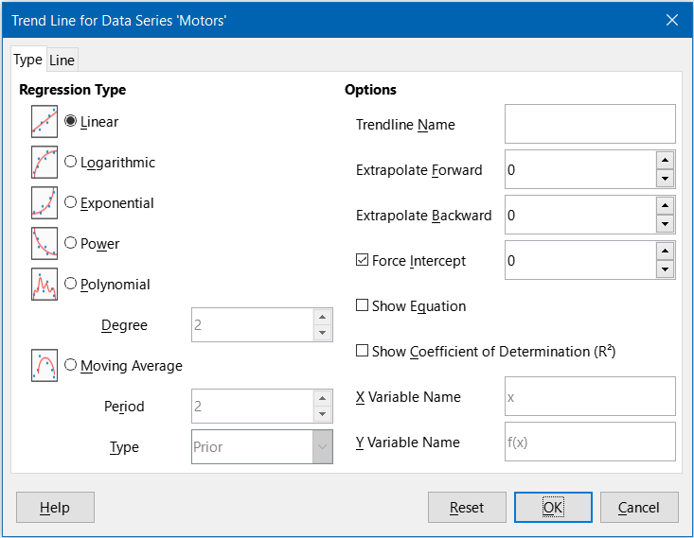
Figure 48: Trend Line dialog – Type tab

Regression types
By default, x is used for the abscissa variable and f(x) for the ordinate variable. Change the names under X Variable Name and Y Variable Name on the Trend Line dialog.
Linear
Regression through equation y = a ∙ x+b. Intercept b can be forced.
Logarithmic
Regression through equation y = a ∙ ln(x) + b. Only positive x values are used.
Exponential
Regression through equation y = b ∙ exp(a ∙ x).This equation is equivalent to y = b ∙ mx, with m = exp(a). Intercept b can be forced. Only positive y values are considered, except if all y values are negative. In that case, the equation used is y = -b∙exp(a ∙ x).
Power
Regression through equation y = b ∙ xa. Only positive x values are considered. Only positive y values are considered, except if all y values are negative. In that case, the equation used is y = -b ∙ xa.
Polynomial
Regression through equation y = Σi (ai ∙ xi). Intercept a0 can be forced. Degree of polynomial must be given (at least 2).
Moving Average
Simple moving average for n previous y-values, with n being the period. No equation is available for this trend line. The type of moving average regression curve is selected as Prior, Central, or Averaged Abscissa.
- Tip
It is possible to add multiple trend lines to a single data series. This could be useful when comparing different regression types for the data.
Search for the term “Trend Lines” in the index of the Help system for more information about these regression types.

Trend line options
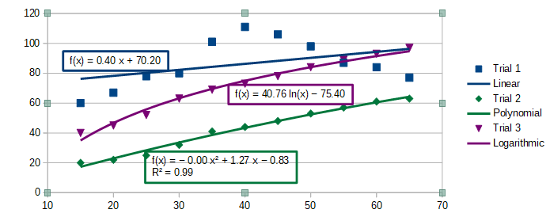
Figure 49: Trend lines showing various equations
Trendline Name
Specifies the name to be used for labeling the equation in the legend; see Figure 49.
Extrapolate Forward/Backward
Specifies the number of units the trend line should be extended forward or back. This only works for charts that have numeric values along the X axis rather than categories.
Force Intercept
Forces the line to cross the Y axis at the specified value.
Show Equation
Displays the equation in the chart, as shown in Figure 49.
Show Coefficient of Determination (R2)
Displays the coefficient of determination in the chart. Shown with the polynomial equation in Figure 49.
X and Y Variable Names
Enables changing the names of X or Y variables for displaying the equation in the chart. The Show Equation option must be checked for these options to be active.
Select a trend line to display information about it in the Status bar, as shown in Figure 50. The Status bar is normally located at the bottom of the spreadsheet.
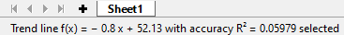
Figure 50: Equation information displayed in the Status bar

Formatting trend lines
When originally inserted, a trend line has the same color as the corresponding data series. To change the style, color, width, or transparency of a trend line, use the Line tab of the Trend Line dialog (Figure 51). The options are easily understood or researched.
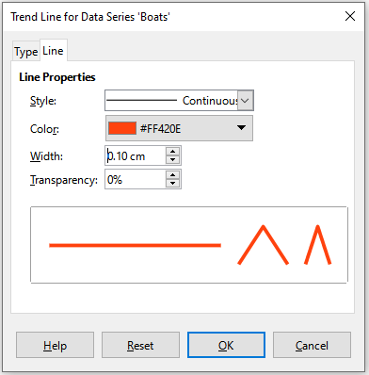
Figure 51: Trend Line dialog – Line tab

Formatting trend line equations
Display the equation in the chart by selecting Show Equation on the Type tab of the Trend Line dialog (Figure 48). Options for the trend line equation include formatting the border around the equation, area fill, transparency, font, and alignment. The number style can also be specified—this may be quite useful, especially for specifying the number of decimal places.
To format trend line equations:
- Select the chart by double-clicking on it to enter edit mode. The chart should now be surrounded by a gray border.
- Do one of the following to open the Equation dialog:
- Select the equation on the Select Chart Element drop-down list and then click the Format Selection icon on the Formatting toolbar or select Format > Format Selection on the Menu bar.
- Click once on the equation to select it then click the Format Selection icon on the Formatting toolbar or select Format > Format Selection on the Menu bar.
- Right-click on the equation and select Format Trend Line Equation in the context menu.
- Select the desired options on the dialog. The options are self-explanatory or easily researched. The Numbers tab has the same options as the Numbers tab of the Axis dialog, Figure 34.
- Click OK to close the dialog.
- If desired, click outside the chart to leave edit mode.

Deleting trend lines
- Select the chart by double-clicking on it to enter edit mode. The chart should now be surrounded by a gray border.
- Do one of the following:
- Select the trend line and press the Delete key.
- Right-click on the trend line and select Delete Trend Line in the context menu.
- If desired, click outside the chart to leave edit mode.

Mean value lines
Mean value lines are a special type of trend line. To create one, Calc calculates the average of a data series and places a colored line at that value in the chart, as shown in Figure 52. They can only be created for 2D charts and cannot be created for pie, bubble, net, or stock charts.
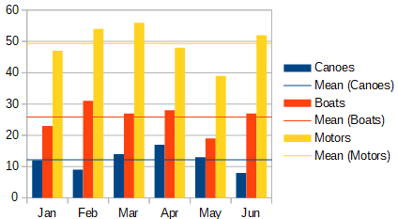
Figure 52: Mean value lines

Inserting mean value lines
For all data series (if no data series is selected, mean value lines are inserted for all data series):
- Select the chart by double-clicking on it to enter edit mode. The chart should now be surrounded by a gray border.
- Go to Insert > Mean Value Lines on the Menu bar.
- If desired, click outside the chart to leave edit mode.
For a single data series:
- Select the chart by double-clicking on it to enter edit mode. The chart should now be surrounded by a gray border.
- Select a data series by doing one of the following:
- Click once somewhere in the data series.
- Select the data series from the Select Chart Element drop-down list on the Formatting toolbar.
- Add the mean value line by doing one of the following:
- Go to Insert > Mean Value Lines on the Menu bar.
- Right-click on the data series and select Insert Mean Value Line in the context menu.
- If desired, click outside the chart to leave edit mode.

Modifying mean value lines
When inserted, a mean value line has the same color as the corresponding data series. To modify the style, color, width, and transparency of a mean value line:
- Double-click on the chart to enter edit mode. The chart should now be surrounded by a gray border.
- Do one of the following to open the Mean Value Line dialog (the dialog has the same options as the Line tab of the Trend Line dialog in Figure 51):
- Right-click on the mean value line and select Format Mean Value Line in the context menu.
- Left-click on the mean value line or select the appropriate mean value line from the Select Chart Element drop-down list on the Formatting toolbar, then click the Format Selection icon in the Formatting toolbar, or select Format > Format Selection.
- Make the desired changes.
- Click OK to close the dialog. If desired, click outside the chart to leave edit mode.

Deleting mean value lines
- Select the chart by double-clicking on it to enter edit mode. The chart should now be surrounded by a gray border.
- Do one of the following:
- Left-click on the mean value line or select the appropriate mean value line from the Select Chart Element drop-down list on the Formatting toolbar and then press the Delete key.
- Right-click on the data series and select Delete Mean Value Line in the context menu.
- If desired, click outside the chart to leave edit mode.

Error bars
Error bars, shown in Figure 53, can be useful for presenting data that has a known possibility of error, such as social surveys using a particular sampling method, or for showing the measuring accuracy of the tool used. In Figure 53 variance is shown for canoes, standard deviation for boats, and standard error for motors. Error bars can be created for 2D charts only and cannot be created for pie, bubble, net, or stock charts.
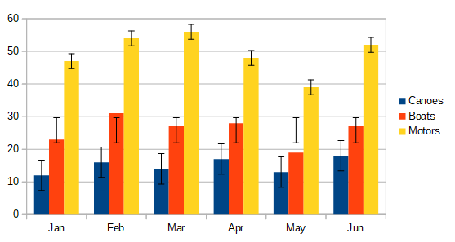
Figure 53: Chart with error bars

Inserting error bars
If no data series is selected, X or Y error bars are inserted for all data series. To add error bars for all data series:
- Select the chart by double-clicking on it to enter edit mode. The chart should now be surrounded by a gray border.
- Go to Insert > X Error Bars or Insert > Y Error Bars on the Menu bar to open the Error Bars dialog (Figure 54). The Line tab is not present when inserting error bars for all data series; in this circumstance, an extra None option appears in the Error Category area.
- Select the desired options. See below for more information about the options.
- Click OK to close the dialog and add the error bars to the chart. If desired, click outside the chart to leave edit mode.
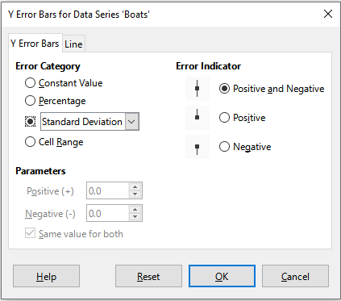
Figure 54: Error Bars dialog – Error Bars tab
To insert error bars for a single data series:
- Select the chart by double-clicking on it to enter edit mode. The chart should now be surrounded by a gray border.
- Do one of the following to select the data series:
- Click once on a bar, column, line, or other graphical representation in the data series.
- Select the data series from the Select Chart Element drop-down list on the Formatting Toolbar.
- Do one of the following to open the Error Bars dialog (Figure 54):
- Go to Insert > X Error Bars or Insert > Y Error Bars on the Menu bar.
- Right-click on the data series and select Insert X Error Bars or Insert Y Error Bars in the context menu.
- Select the desired options. See below for more information about these options.
- Click OK to close the dialog and add the error bars to the chart. If desired, click outside the chart to leave edit mode.

Error Bars dialog options
Under Error Category, only one of the following options can be selected at a time.
None – does not show any error bars. This option is only available when no data series is selected.
Constant Value – shows the error as constant positive and/or negative value(s). Specify these values in the Parameters section.
Percentage – shows the error as a percentage of the data points. Specify this percentage in the Parameters section.
The drop-down list has four measures of the error value:
- Standard Error
- Standard Deviation
- Variance
- Error Margin – uses the value for the error margin that is specified in the Parameters section.
Cell Range – uses error values defined in a range of cells. Specify the range in the Parameters section.
Under Parameters, specify positive and negative values or ranges for the error bars. Constant Value, Percentage, Error Margin, or Cell Range must be checked for these options to be active.
Under Error Indicator, select whether the error graphic shows both positive and negative errors, only positive errors, or only negative errors.
The Line tab may be used to adjust the line style, color, width, and transparency for the error bars.

Modifying error bars
Error bars can only be changed one data series at a time, using the Error Bars dialog (Figure 54). Do one of the following to open the Error Bars dialog:
- Select the chart by double-clicking on it to enter edit mode. The chart should now be surrounded by a gray border.
- Do one of the following to open the Error Bars dialog:
- Click once on the data series to select it, then go to Insert > X Error Bars or Insert > Y Error Bars on the Menu bar.
- Select the error bars for the specific data series from the Select Chart Element drop-down list on the Formatting toolbar. Then go to Format > Format Selection or click the Format Selection icon on the Formatting toolbar.
- Right-click on the data series and select Format X Error Bars or Format Y Error Bars in the context menu.
- Select the desired options on the Error Bars and Line tabs of the Error Bars dialog.
- Click OK to close the dialog and update the error bars for the selected series. If desired, click outside the chart to leave edit mode.

Deleting error bars
To delete X or Y error bars for all data series:
- Select the chart by double-clicking on it to enter edit mode. The chart should now be surrounded by a gray border.
- With no data series selected, go to Insert > X Error Bars or Insert > Y Error Bars on the Menu bar to open the Error Bars dialog (Figure 54).
- Select None.
- Click OK to close the dialog and delete the error bars.
- If desired, click outside the chart to leave edit mode.
To delete error bars for a single data series, follow the same steps as above but instead of steps 2) to 4), right-click on the data series and select Delete X Error Bars or Delete Y Error Bars in the context menu.

Adding drawing objects to charts
Use the Drawing toolbar to add shapes such as lines, rectangles, circles, text objects, or more complex shapes such as symbols or block arrows. Use additional shapes to add explanatory notes, highlight points of interest on a chart, or even hide certain data or text.
Open the Drawing toolbar by going to View > Toolbars > Drawing. Note that it can be moved around the workspace as needed. For more information on using the Drawing toolbar and drawing shapes, see Chapter 5, Using Images and Graphics, as well as the Draw Guide.
The Drawing toolbar (Figure 55) appears when the chart is in edit mode (by clicking on it twice).
- Tip
To place arrows, text, or other drawing objects in a chart, be sure that the chart is in edit mode. Otherwise, an object will not be connected to the chart and will not be moved with it.
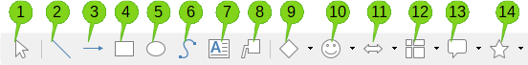
Figure 55: Drawing toolbar when chart is placed in edit mode
- Select  - Insert Line  - Line Ends with Arrow  - Insert Rectangle  - Insert Ellipse | - Freeform Line  - Insert Text Box  - Callouts  - Basic Shapes  - Symbol Shapes | - Block Arrows  - Flowchart  - Callouts  - Stars and Banners
Most of these options are self-evident or can be readily researched, especially by referring to the Draw Guide. Clicking on the icon for an option changes the pointer’s appearance, depending on the option. Click and drag the pointer to create the desired drawing object in the chart. Information that may be helpful for charts follows.
Insert Line
Draws a straight line where dragged.
- Note
When drawing a line in the spreadsheet (outside any chart), holding Shift while dragging will constrain angles of the line to multiples of 45 degrees. This facility is not applicable when inserting a line on a chart.
Write on the line by double-clicking the line and typing or pasting text. If the text is too low, press Enter to raise it above the line.
Insert Text Box
Draws a text box with horizontal text direction. To place the text at an angle, click once on the text box to select it, right-click, and select Position and Size from the context menu. Specify the angle on the Rotation tab.
Callouts
Draws a line that ends in a graphic in which text can be placed. Use a callout to describe or draw attention to a specific point or area. Double-click the callout to write text in it. In Figure 55, Callouts option 8 creates a default callout while option 13 opens a tool palette of callout styles.
Clicking the down arrows next to the last six options on the right of the Drawing toolbar (Figure 55) opens tool palettes similar to those shown in Figures 56 to 61.
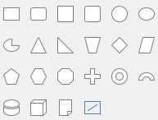
Figure 56: Basic Shapes
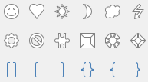
Figure 57: Symbol Shapes
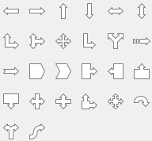
Figure 58: Block Arrows
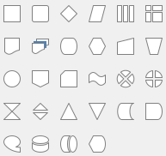
Figure 59: Flowcharts
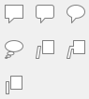
Figure 60: Callouts
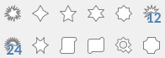
Figure 61: Stars and Banners

Resizing, moving, and positioning charts.
To resize or move a chart, click it once to put it in selection mode. Resize or move a chart in two ways: interactively, or by using the Position and Size dialog. Combining both methods may be useful. Position a chart interactively for quick and easy changes, then use the Position and Size dialog for precise sizing and positioning.

Changing interactively

Resizing
To resize a chart interactively:
- Click once on the chart to select it. Square selection handles appear around the border of the chart.
- Click and drag one of the selection handles. The pointer indicates the direction to increase or decrease the chart size. Clicking and dragging a corner handle preserves the horizontal to vertical size ratio.
- When finished, click outside the chart to leave selection mode.

Moving
Move a chart interactively using one of two methods:
For small moves
- Click once on the chart to select it. Square selection handles appear around the border of the chart.
- Press an arrow key to move the chart a few pixels at a time, or press Alt + an arrow key to move the chart one pixel at a time.
- When finished, click outside the chart to leave selection mode.
For larger moves
- Click once on the chart to select it. Square selection handles appear around the border of the chart.
- Hover the pointer anywhere over the chart until it changes to a move pointer (shape depends on computer setup).
- Click and drag the chart to its new location.
- Release the mouse button when the chart is in the required position.
- When finished, click outside the chart to leave selection mode.

Position and Size dialog
The Position and Size dialog contains options for defining the position of the chart on the page, specifying its size, rotating it, and slanting it.
- Note
In addition to charts, the Position and Size dialog can also be used to modify and position other graphic elements, such as those available on the Drawing toolbar.
To resize or move a chart using the Position and Size dialog:
- Right-click on the chart and select Position and Size in the context menu to open the Position and Size dialog (Figure 62).
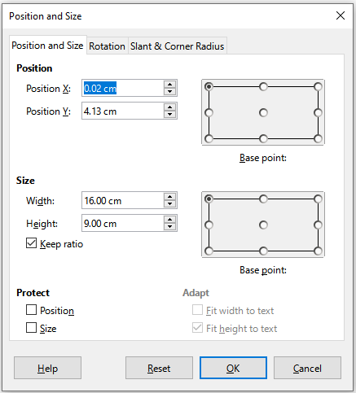
Figure 62: Position and Size dialog — Position and Size tab
- Select the desired options on the Position and Size, Rotation, and Slant & Corner Radius tabs on this dialog. See below for further information about the options on these tabs.
- Click OK to close the dialog and save changes.
- When finished, click outside the chart to leave selection mode.
When positioning or resizing, click one of the points in the Base point graphic corresponding to the location to use for anchoring either the position of the chart or its size.
Note that either the position or the size can be protected from unwanted changes by clicking the appropriate box in the Protect section. Either or both option(s) selected will remain active after the dialog is closed. By contrast, Calc resets the base point to the default position after the dialog is closed.

Position and Size
The options available on the Position and Size tab (Figure 62) are as follows:
Position
Determines the location of the chart on the page. The position of a chart is coordinated relative to a fixed point (the base point). By default, this base point is located at the upper left of a chart. To make positioning of a chart simpler, the base point can be temporarily changed.
- Position X – specifies the horizontal location of the chart relative to the base point.
- Position Y – specifies the vertical location of the chart relative to the base point.
- Base point – specifies a temporary base point for the chart.
Size
Specifies the amount by which to resize the selected chart with respect to the selected base point.
- Width – sets a width for the selected object.
- Height – sets a height for the selected object.
- Keep ratio – maintains proportions between width and height when resizing the chart.
- Base point – determines the directions in which the chart size will be increased or decreased.
Protect
Prevents unintended changes to the position or the size of the chart.
- Position – prevents unintentionally moving the chart.
- Size – prevents unintentionally resizing the chart.
Adapt
These options are always unavailable for charts.

Rotation
The options for the Rotation tab (Figure 63) are as follows:
Pivot Point
The chart can be rotated around a pivot point. The default pivot point is at the top left of the chart. Note that if there is not enough room to rotate the chart, it could be rotated off of the page.
- Position X – specifies the horizontal distance from the left edge of the page to the pivot point.
- Position Y – specifies the vertical distance from the top edge of the page to the pivot point.
- Default settings – sets the location of the pivot point in a visual approach. The pivot point can be temporarily changed. However, when the dialog is opened again, the pivot point will return to its default location and the X and Y positions will reflect the default location.
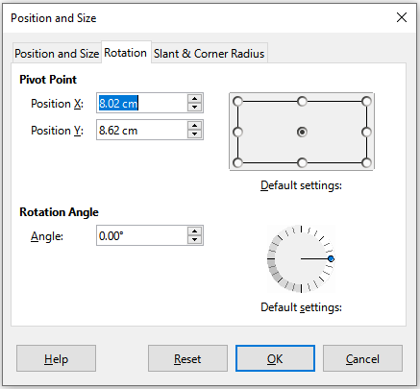
Figure 63: Position and size dialog – Rotation tab
Rotation Angle
Specifies the number of degrees that the chart is rotated.
- Angle – shows the number of degrees of rotation (in the range 0 to 359 degrees). The number can be entered directly, or it can be set using the indicator labeled Default settings.
- Default settings – graphically shows the rotation angle. The angle can be set by clicking and dragging the indicator. The number of degrees rotated is shown in the Angle box.

Slant & Corner Radius
The options for the Slant & Corner Radius tab (Figure 64) are as follows:
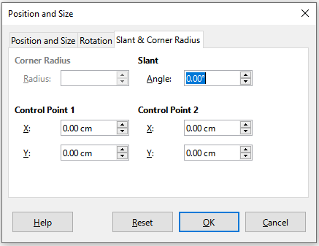
Figure 64: Position and Size dialog – Slant and Corner Radius tab
Corner Radius
This option is not available for charts.
Slant
Slants the chart along an axis. Specify the angle of the axis (in the range -89° to +89°).
Control Points
These options are not available for charts.

Selecting multiple charts
Select multiple charts by clicking once on the first chart then pressing Shift while clicking on additional charts. An invisible selection rectangle covers all of the selected charts and selection handles appear at the corners and midway between corners. The multiple charts are now treated as a single object and actions such as the following can be conducted.
- Cut and paste or drag them to new locations.
- Use the Position and Size dialog described in the previous section.
- Use the Drawing Object Properties toolbar to align all the charts, format the outer borders, or anchor the charts to the same cell or page.

Changing overall appearance of charts
When a chart is selected (by clicking on it once) it can be formatted as an object. The Drawing Object Properties toolbar (Figure 65) usually appears below the Standard toolbar (but the location depends on setup) and shows tools available for all objects, including charts.
Most of the options are self-evident or can be easily researched. Please refer to Chapter 5, Using Images and Graphics, and the Draw Guide for further information. Following are a few tips for using these tools with charts.
Anchor
Connects a chart to either remain in the same position on a page or to move with a cell (when rows and columns are inserted or deleted). When To cell (resize with cell) is chosen, the chart or object increases or decreases in size when the cell is made larger or smaller.
Align Objects
Click the icon to open options for aligning multiple charts horizontally (left, centered, right) or vertically (top, center, bottom). This option is only active when two or more charts (or other objects) are selected.
Figure 65: Drawing Object Properties toolbar that appears when chart is selected
- Anchor  - Align Objects  - Bring to Front  - Forward One  - Back One  - Send to Back | - To Foreground  - To Background  - Line Style  - Line Width  - Line Color  - Area Style/Filling | - Fill Color  - Arrow Style  - Rotate  - Points  - Group
Bring to Front/Forward One/Back One/Send to Back
Stacks charts or other objects in front of or behind other objects.
To Foreground/To Background
Places charts or stacks of objects in either the foreground or the background. In Calc, objects in the background are behind the cell grid and may be difficult to select. Use the Select tool (arrow icon) on the Drawing toolbar (Figure 55) to select them.
Line Style/Line Width/Line Color
Formats the outer borders of charts.
Area Style/Filling and Fill Color
Colors objects such as arrows, shapes, and callouts. For charts, use the fill options available in edit mode.
Arrow Style
Specifies the appearance of line arrows and lines. Does not apply to the block arrows shown in Figures 55 and 56.
Rotate
Rotates the chart around a base point. When selected, places round rotation handles at each corner. Move these to rotate the chart. Move the small circle in the center of the chart to change the base point. Move the handles midway between the corners to slant the chart or other object.
Points
Changes the shape of curved objects. Move the points to shape curves created with the Curve tool on the Drawing toolbar.
Group
Groups or ungroups two or more objects. When grouped, the objects can be moved together and global changes can be applied to them. From left to right, the four icons are Group, Enter Group, Exit Group, and Ungroup.

Copying, exporting, and deleting charts

Copying charts in the same spreadsheet document
When a chart is copied, it retains a connection to the source data it is built on as long as it is in the same document. This means that changes made to the source data will be reflected in the chart.
Copying and pasting the chart is easy. Just click the chart once to select it, then either press Ctrl+C, or right-click on the chart and select Copy in the context menu, or click the Copy icon on the Standard toolbar, or select Edit > Copy on the Menu bar. To paste the chart in the desired location, press Ctrl+V, or right-click and select Paste in the context menu, or click the Paste icon in the Standard toolbar, or select Edit > Paste on the Menu bar.

Copying to another LibreOffice document
When a chart is copied and pasted into another LibreOffice document, any connection to the data it is based on is lost. The data is kept with the chart and is now called a data table rather than a data range. Figure 66 shows an example of this internal data table.
- Note
A copied chart links to or retains its data only when pasted into a LibreOffice document. To retain data or links outside LibreOffice, use embedding or linking, as explained in Chapter 12, Linking Data.

Keeping original data
If the goal is to use the original data for the chart, follow the same procedure as above to copy and paste the chart to another document. Nothing more needs to be done.

Modifying original data
If the original data for the chart needs to be modified, do the following:
- Select the copied chart by double-clicking on it to enter edit mode. The chart should now be surrounded by a gray border.
- Right-click on the chart and select Data Table to open the Data Table dialog shown in Figure 66.
- Modify the data as desired. In addition to changing numbers in the data, use options to insert, move, or delete columns and rows.
- Click Close to close the dialog.
- If desired, click outside the chart to leave edit mode.
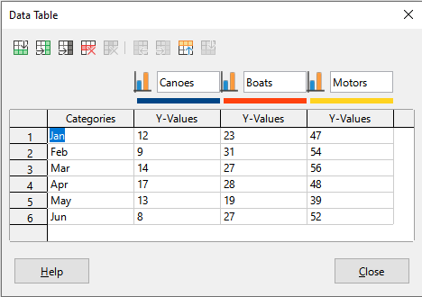
Figure 66: Data Table dialog when a chart is copied into another document

Dragging replacement data
If the chart is still in Calc and replacement data is in the same spreadsheet, select and drag the new data onto the chart. This is described in “Replacing data by dragging” on page 21.
- Note
Calc does not provide a direct way to save chart settings for creating another chart in LibreOffice. Here are three options for using the same chart settings: 1) copy and paste the chart into another file; 2) save the file containing the chart as a new file; and 3) save the chart in a template. Depending on the method used, create a new chart by modifying either the data range or the data table.

Exporting chart images
Charts can be exported in a variety of image formats for use in other documents. File types include BMP, EMF, EPS, GIF, JPEG, PDF, PNG, SVG, SVM, TIFF, and WMF.
To export a chart in an image format:
- Right-click on the selected chart and select Export as Image in the context menu to open the Save as Image dialog.
- In the dialog, type a name for the graphic file, select the location for saving the file, and select the desired graphic format.
- Click Save and an image of the chart will be exported to the location specified.

Deleting charts
To delete a chart, click it once to select it. Square selection handles appear on the borders of the chart. Then press Delete.

