
Calc Guide 26.2

Chapter 16
Setting up and Customizing

Copyright
This document is Copyright © 2026 by the LibreOffice Documentation Team. Contributors are listed below. You may distribute it and/or modify it under the terms of either the GNU General Public License (https://www.gnu.org/licenses/gpl.html), version 3 or later, or the Creative Commons Attribution License (https://creativecommons.org/licenses/by/4.0/), version 4.0 or later.
All trademarks within this guide belong to their legitimate owners.

Contributors
To this edition
Olivier Hallot
To previous editions
Barbara Duprey, Jean Hollis Weber, Simon Brydon, Mark Morin, Kees Kriek, Steve Fanning, Leo Moons, Felipe Viggiano, Skip Masonsmith, Olivier Hallot, B. Antonio Fernández, Dione Maddern

Feedback
Please direct any comments or suggestions about this document to the Documentation Team’s forum at https://community.documentfoundation.org/c/documentation/loguides/ (registration is required) or send an email to: loguides@community.documentfoundation.org.
- Note
Everything you send to a forum, including your email address and any other personal information that is written in the message, is publicly archived and cannot be deleted. Emails sent to the forum are moderated.

Publication date and software version
Published February 2026. Based on LibreOffice 26.2.
Other versions of LibreOffice may differ in appearance and functionality.

Using LibreOffice on macOS
Some keystrokes and menu items are different on macOS from those used in Windows and Linux. The table below gives some common substitutions for the instructions in this document. For a detailed list, see the application Help and Appendix A, Keyboard Shortcuts.
Windows or Linux | macOS equivalent | Effect
Tools > Options on Menu bar | LibreOffice > Preferences on Menu bar | Access to setup options
Right-click | Ctrl+click and/or right-click depending on computer setup | Opens a context menu
Ctrl or Control | ⌘ and/or Cmd or Command, depending on keyboard | Used with other keys
Alt | ⌥ and/or Alt or Option depending on keyboard | Used with other keys

Introduction
This chapter presents some, but not all, of the setup options found under Tools > Options on the Menu bar (LibreOffice > Preferences on macOS). Information about options not covered in this chapter are covered in the Help and in the Getting Started Guide.
This chapter does explain how to customize menus, toolbars, and keyboard shortcuts. Application extensions available from the LibreOffice website and other providers can simplify the customization process.
Utilizing the Type to search function under Tools > Options on the Menu bar is useful for finding a particular option to customize. When typing in this field, Calc automatically hides the options in the tree that do not match the entered keywords.

LibreOffice options
The settings described in this section apply to all components of LibreOffice and are of particular interest to users of Calc. To access the options:
- Choose Tools > Options to open the Options dialog. The dynamic list on the left-hand side only displays options applicable to open applications. The illustrations in this chapter show the list as it appears when Calc is open.
- Click the expansion symbol (+ or triangle) next to LibreOffice to reveal the list of subsections.
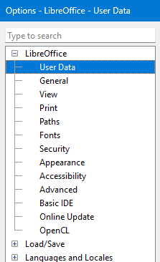
Figure 1: LibreOffice options
- Note
The Reset button, located in the lower right of the full Options dialog, has the same effect on all pages of the dialog. It resets the options to the values that were in place when you opened the dialog.

User data
User data entries are used by templates and wizards in LibreOffice. For example, Calc uses the first and last name entries to populate the Created and Modified fields in the document properties, in the footer of a printed spreadsheet, or as the username associated with comments.
ODF Cryptography
Set the preferred public key for OpenPGP encryption and digital signature. These preferred keys will be pre-selected in key selection dialog every time you sign or encrypt a document, so you don't have to select it yourself when signing with one specific key frequently.
Signing key
Select your OpenPGP key from the drop-down list for signing ODF documents.
OpenPGP encryption key
Select your OpenPGP key from the drop-down list for encrypting ODF documents.
When encrypting documents, always encrypt to self
Mark this checkbox to also encrypt the file with your public key, so you can open the document with your private key.
- Warning
Keep this option selected!
Otherwise, you will not be able to decrypt documents you've encrypted for other people.

General
Set preferences for Help, Open/Save, File Associations, and more. You can also disable the tip of the day popups here.

View
View settings affect how the document window looks and behaves. Users can change the size and style of toolbar and sidebar icons, among other settings.

Print
The print options may be set to suit your default printer and your most common printing method. You can change these settings at any time, either through this dialog or during the printing process using the Print dialog. Calc-specific print options are described in Print options, below. See Chapter 8, Printing, Exporting, Emailing, and Signing, for more about these options.

Paths
The path options can be used to change the location of files associated with, or used by, LibreOffice. Some items have two or more paths listed: one to a shared folder (which might be on a network) and one to a user-specific folder (normally on the user’s personal computer). You could, for example, change the default path to a shared server instead of your PC.

Security
The security options can be adjusted to change the behavior of the application when a potential security issue is present, such as hidden information or macros. The controls for the security options shown in 2 are described in detail below.
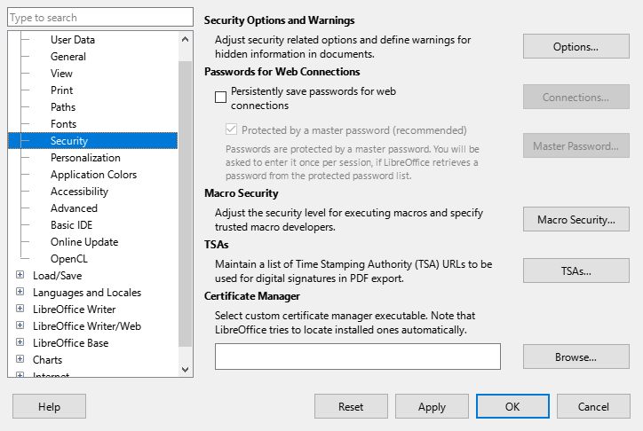
Figure 2: Choosing security options for opening and saving documents
Security Options and Warnings
If you record changes, save multiple versions, or include hidden information or notes in your documents, and you do not want some of the recipients to see that information, you can set warnings to remind you to remove this information, or you can have LibreOffice remove some information automatically. Note that, unless removed, much of this information is retained in a file, whether the file is in LibreOffice’s default OpenDocument Format (ODF), or has been saved to other formats, including PDF.
Click the Options button to open a separate dialog with specific choices (see Figure 3).
Passwords for Web Connections
You can enter a master password to enable easy access to websites that require a user name and password. If you select the Persistently save passwords for web connections option, the Set Master Password dialog opens. LibreOffice will securely store all passwords that you use to access files from web servers. You can retrieve the passwords from the list after you enter the master password.
Macro Security
Click the Macro Security button to open the Macro Security dialog, where you can adjust the security level for executing macros and specify trusted sources.
Certificate Path
Users can digitally sign documents using LibreOffice. A digital signature requires a personal signing certificate. Most operating systems can generate a self-signed certificate. However, a personal certificate issued by an outside agency (after verifying an individual’s identity) has a higher degree of trust associated with it than a self-signed certificate. LibreOffice does not provide a secure method of storing these certificates, but it can access certificates that have been saved using other programs. Click the Certificate button, and select the preferred certificate store to use.
- Note
The Certificate Path option appears only on Linux and macOS systems. On Windows, LibreOffice uses the default Windows location for storing and retrieving certificates.
TSAs –Time Stamping Authorities
Allows you to select a Time Stamping Authority (TSA) URL for PDF documents created by LibreOffice. Adding a trusted timestamp to an electronic signature on a PDF provides a digital seal of data integrity and a trusted date and time of when the file was signed. Recipients of PDF documents with a trusted timestamp can verify when the document was digitally or electronically signed, as well as verify that the document was not altered after the date the timestamp vouches for.
GPG Certificate Manager
Select your preferred GPG certificate manager. LibreOffice tries to locate installed certificate managers automatically. Press the Browse button to locate the certificate manager executable in your system.

Security Options and Warnings
While most of the options available on the Security Options and Warnings dialog (Figure 3) are straightforward, those listed below benefit from additional explanation.
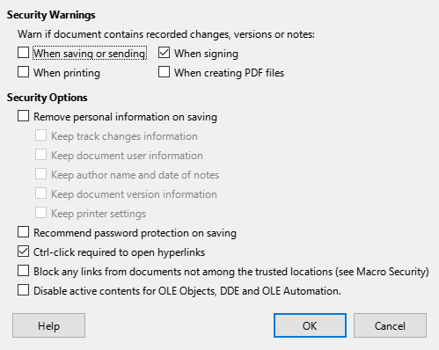
Figure 3: Security Options and Warnings dialog
Security warnings
Warnings take the form of a suitable icon and text displayed in an infobar located above the grid of cells.
Remove personal information on saving
Select this option to always remove user data from the file properties when saving the file. Control the granularity of the user data removed using the four check boxes located below this option. To manually remove personal information from specific documents, deselect this option and then use the Reset Properties button under File > Properties > General on the Menu bar.
Ctrl-click required to open hyperlinks
The default behavior in most components of LibreOffice is to Ctrl+click on a hyperlink to open the linked document, but you can choose to open hyperlinks using a single click.

Appearance
On the LibreOffice – Appearance page (Figure 4), you can specify colors independent of the desktop environment theme. This setting applies to all LibreOffice modules.
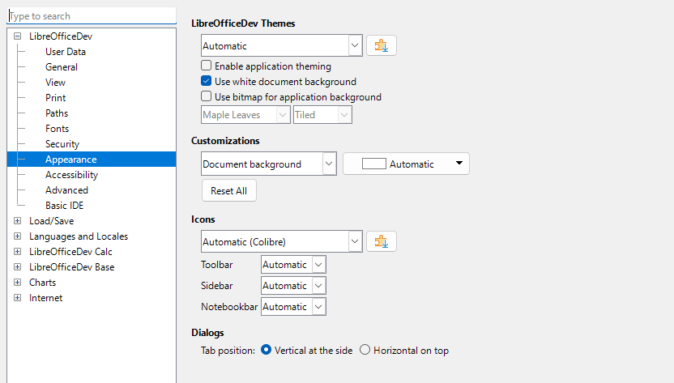
Figure 4: Application appearance page
LibreOffice Themes
Select the theme scheme you want from the dropdown list. More themes are available as extensions when you press the Add more themes button. The Automatic scheme refers to the default colors of the operating system.
- Enable application theming: mark this checkbox to enable an extension theme.
- Use white document background: overrides the theme document background color and set it to white for better readability.
- Use bitmap for application background: select a bitmap from the dropdown list to set as application background.
Customization
You can define colors to all the user interface elements listed in the Items drop-down list. The Application background element can also display one of the images available in the Images drop-down list, either Stretched or Tiled.
- Note
When removing a theme from the list, LibreOffice resets to the Automatic scheme.
Icons
Select an icon set from the available list. Add more icon sets using the Extensions button. Adjust the icon size for the various user interface elements listed.
Dialogs
Choose the position of the dialog tabs.

Advanced options
Three items of interest on this page, besides the Java Options, are found under Optional Features:
Enable experimental features (may be unstable)
Selecting this option enables features that are not yet complete or contain known bugs. The list of these features varies from version to version.
Enable macro recording (may be limited)
This option enables macro recording, with some limitations. For more about macro recording, see the Getting Started Guide, and Chapter 14, Macros, in this book.
Open Expert Configuration
The expert configuration dialog contains advanced settings for LibreOffice. Avoid changing any of these configurations without good knowledge fo the consequences, which may not be visible immediately and can turn the user profile unusable and subject to a factory reset or to a call to the Help desk.

Options for loading and saving documents
You can set the Load/Save options to suit the way you work. This chapter describes only a few of the options, those most relevant to working with Calc. See the Getting Started Guide for a description of the other options.
If the Options dialog is not already open, click Tools > Options on the Menu bar. Click the expansion symbol (+ or triangle) to the left of Load/Save on to display the list of load/save options pages.

General
Many of the choices on the Load/Save – General page (Figure 5) are familiar to users of other office suites. Those of most interest to Calc users are in the Default File Format and ODF Settings section.
Default File Format and ODF Settings
ODF format version: LibreOffice by default saves documents in OpenDocument Format (ODF) version 1.4 Extended. You will rarely need to change this for compatibility when exchanging files with other people.
Document type: If you routinely share documents with users of Microsoft Excel, you might want to change the Always save as option to one of the Excel formats, including XLSX. However, you can choose an Excel format when you save any individual file.
We recommend that you always save a working copy in ODS format and only create an Excel version if necessary for sharing. Also, note that recent versions of Microsoft Excel can open ODS files, so this may no longer be needed.
- Note
The Save AutoRecovery information every and Always create backup copy options are enabled by default. Optionally you can save the document instead. By default, backup copies accumulate in the folder specified in Tools > Options > LibreOffice > Paths. This can be changed by selecting the Place backup in same folder as document option.
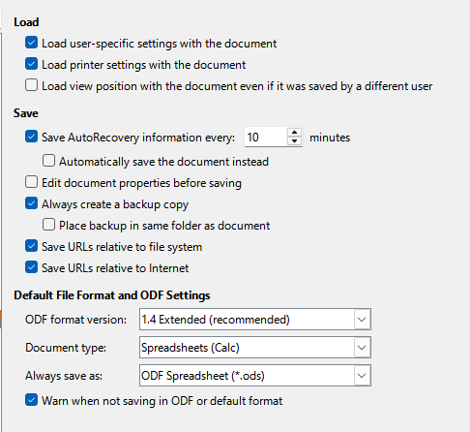
Figure 5: Choosing Load and Save general options

VBA Properties
On the Load/Save – VBA Properties page (Figure 6), you can choose whether to keep any VBA (Visual Basic for Applications) macros in Microsoft Office documents that are opened in LibreOffice.
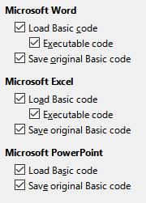
Figure 6: Choosing Load/Save VBA Properties
If you choose Load Basic code, you can edit the macros in LibreOffice. The changed code is saved in an ODF document but is not retained if you save into a Microsoft Office format.
If you choose Save original Basic code, the macros will not work in LibreOffice but are retained unchanged if you save the file into Microsoft Office format.
If you are importing a Microsoft Word or Excel file containing VBA code, you can select the option Executable code. Code is preserved but rendered inactive by default (if you inspect it with the LibreOffice Basic IDE you will see that it is all commented), but when Executable code is selected, the code is ready to be executed.
Save original Basic code takes precedence over Load Basic code. If both options are selected, and you edit the disabled code in LibreOffice, the original Microsoft Basic code will be saved when saving in a Microsoft Office format.
To remove any possible macro viruses from the Microsoft Office document, deselect Save original Basic code. The document will be saved without the Microsoft Basic code.

Microsoft Office
On the Load/Save – Microsoft Office page (Figure 7), you can choose what to do when importing or exporting Microsoft Office OLE objects (linked or embedded objects or documents such as spreadsheets or equations): convert them into or from the corresponding LibreOffice OLE object or load and save them in their original format.
Select the [L] options to convert Microsoft OLE objects into the corresponding LibreOffice OLE objects when a Microsoft document is loaded into LibreOffice.
Select the [S] options to convert LibreOffice OLE objects into the corresponding Microsoft OLE objects when a document is saved in a Microsoft format.
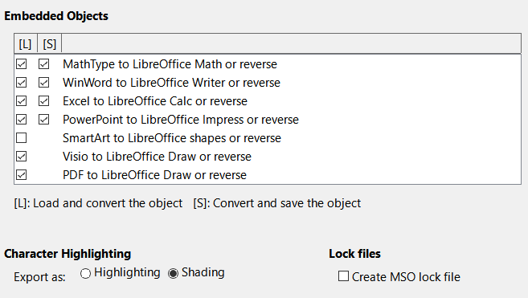
Figure 7: Choosing Load/Save Microsoft Office options
The Character Highlighting options enable you to select between the two text highlighting (character background) attributes that Microsoft Office provides, Highlighting or Shading. Shading is the initial default.
The Create MSO lock file option improves interoperability with Microsoft Office for shared spreadsheets. When enabled, Calc writes two lock files when opening a Microsoft Office format file, one LibreOffice lock file and one Microsoft Office lock file. This enables users of both suites to be made aware that the file is in use. The option is initially disabled by default.

HTML Compatibility
Choices made on the Load/Save – HTML Compatibility page (Figure 8) affect how LibreOffice imports or exports HTML pages. See the Getting Started Guide, and the HTML documents importing/exporting Help page, for more information.
The main items of interest for Calc users are in the Export section.
LibreOffice Basic
Select this option to include LibreOffice Basic macros (scripts) when exporting to HTML format. If you do not activate this option before you create the LibreOffice Basic macro; the script will not be inserted. LibreOffice Basic macros must be located in the header of the HTML document. Once you have created the macro in the LibreOffice Basic IDE, it appears in the source text of the HTML document in the header.
If you want the macro to run automatically when the HTML document is opened, choose Tools > Customize > Events. See Chapter 14, Macros, for more information.
Display warning
When the LibreOffice Basic option (see above) is not selected, the Display warning option becomes available. If the Display warning option is selected, then when exporting to HTML a warning is shown that LibreOffice Basic macros will be lost.
Print layout
Select this option to export the print layout of the current document as well. The HTML filter supports CSS2 (Cascading Style Sheets Level 2) for printing documents. These capabilities are only effective if print layout export is activated.
Copy local images to Internet
Select this option to automatically upload the embedded pictures to an Internet server when uploading using FTP.
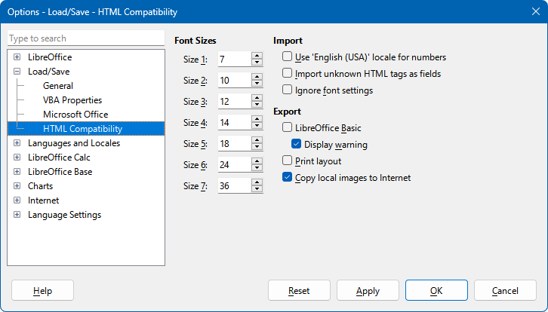
Figure 8: Choosing HTML compatibility options

Calc specific options
Calc must be open in order for the LibreOffice Calc options to be displayed in the Options dialog. Click the expansion symbol (+ or triangle) by LibreOffice Calc. A list of subsections drops down (Figure 9).

General
The choices on the LibreOffice Calc – General page (Figure 10) affect the units used for rulers and other measurements, the default tab stop positions, the updating of links and fields, and various input settings.

Metrics section
Choose the unit of measurement used in spreadsheets and the default tab stops distance.
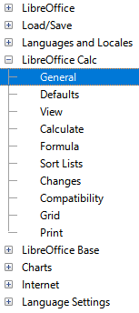
Figure 9: Calc options

Update links when opening section
Choose whether to update links when opening a document: Always, On request, or Never. Spreadsheets that include many or large charts or graphics may load slowly if this option is set to Always.
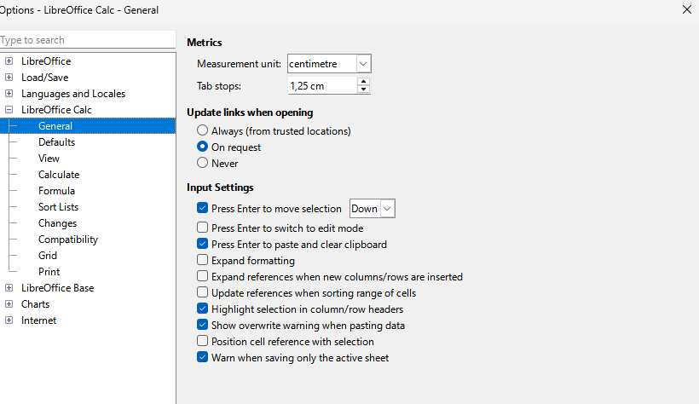
Figure 10: Selecting general options for Calc

Input Settings section
Press Enter to move selection
Specifies that pressing Enter moves the cursor to another cell. You can also choose the direction the cursor moves: Up, Down, Left, or Right. If this option is not selected, pressing Enter places the data into the cell but does not move the cursor.
Press Enter to switch to edit mode
Specifies that pressing Enter puts the selected cell into edit mode. To end edit mode and move the cursor in the desired direction, press Enter again.
Press Enter to paste and clear clipboard
When the content of a cell is copied to the clipboard, you can paste the information in another cell by pressing the Enter key. After pasting occurs, the clipboard is cleared. Here you can enable/disable this feature.
Expand formatting
Specifies whether to automatically apply the formatting attributes of the selected cell to empty adjacent cells. If, for example, a selected cell has the bold attribute, this attribute also applies to empty adjacent cells. However, cells that already have a special format are not modified by this function. To see the affected range, press Ctrl+* (multiplication sign on the number pad). The format will also apply to all new values inserted within this range. This feature works only while you are inserting data in adjacent cells with the previous formatting style; if you insert some data in a non-adjacent cell, Expand formatting will no longer work. In order to get it to work again, you will need to format a cell again (it could be the same one if you like) and insert data into its adjacent cells.
Expand references when new columns/rows are inserted
Specifies whether to expand references when inserting columns or rows adjacent to the reference range. This is only possible if the reference range, where the column or row is inserted, originally spanned at least two cells in the desired direction.
Example: If the range A1:B1 is referenced in a formula and you insert a new column after column B, the reference is expanded to A1:C1. If the range A1:B1 is referenced and a new row is inserted under row 1, the reference is not expanded, since there is only a single cell in the vertical direction.
If you insert rows or columns in the middle of a reference area, the reference is always expanded.
Update references when sorting range of cells
When selected, references to cells are updated when a range of cells is sorted. If not selected, the references are unchanged.
Highlight selection in column/row headers
Specifies whether to highlight column and row headers in the selected columns or rows.
Show overwrite warning when pasting data
Pasting contents of the clipboard into a cell will replace the contents of that cell with what is in the clipboard. Select this option to be alerted to a possible loss of data when pasting.
Position cell reference with selection
With this option set, expanding a selection (with Ctrl+Shift+Down/Up) jumps to the end of the range in the column that was added as last to the initial selection. When the option is not set, expanding a selection (with Ctrl+Shift+Down/Up) jumps to the end of the range in the column where selecting the cell range was started. The same applies when extending a selection on rows, with Ctrl+Shift+Left/Right.
Warn when saving only the active sheet
When saving a spreadsheet in CSV file format, only the active sheet will be saved. To prevent any loss of content from other sheets, Calc displays a warning (Figure 11).
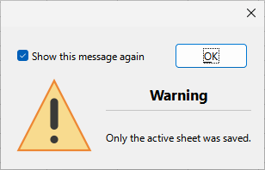
Figure 11: Saving active sheet warning

Defaults
On the LibreOffice Calc – Defaults page you can enter the number of sheets to be opened by default when you start a new spreadsheet, and either accept the default sheet prefix or type a new one. After a spreadsheet is created, you can add new sheets and change the label of any tab; see Chapter 1, Introduction, for more information.
Calc default sizes of spreadsheet are up to 10,000 sheets and each sheet can have a maximum of 1,048,576 rows and 16,384 columns. To allow Calc to read files with up to 16 million rows and 16,384 columns, check the Enable very large spreadsheets box.
- Note
As expected, handling very large spreadsheets can slow down your system.

View
The options on the LibreOffice Calc – View page (Figure 13) affect the way the document window looks and behaves when viewed onscreen.

Display section
Select various options for the display.
Formulas
Display the content of a cell either as a formula or as the result of that formula.
Zero values
Display a zero in a cell when the cell has a value of zero, or display as a blank cell.
- Note
A blank cell is not the same as an empty cell. In the case of zero display value setting, a cell can display as blank when its value is zero but is not empty.
Comment indicator
Select this option to show a small symbol in the top right corner of a cell that contains a comment.
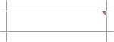
Figure 12: Comment indicator
To always display a comment, right-click on the cell and select Show comment in the context menu.
Comment authorship
If this box is checked, the author of the comment and the date and time at which the comment was made will appear in the comment window, when you mouse over a comment.
The comment author name appears as it appears in the First Name and Last Name fields in the User Data dialog. If those fields are blank, the author name appears as "Unknown Author". Updating the user data only affects comments made after the update.
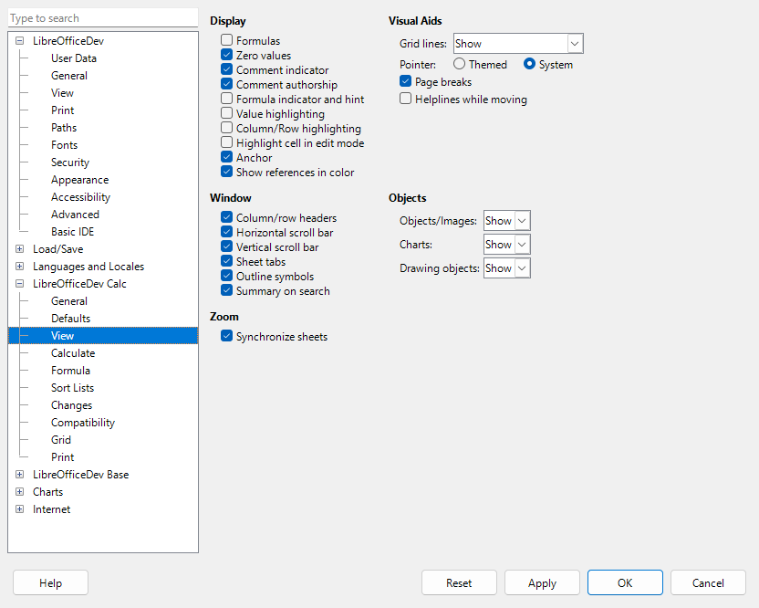
Figure 13: Selecting view options for Calc
Formula indicator and hint
Select this option to place a blue triangle in the bottom-left corner of each cell that contains a formula. When hovering the pointer over the blue triangle, the formula is shown in a tool tip.
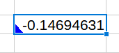
Figure 14: Formula indicator
Value highlighting
Select this option to highlight all values, or results of formulas, in the sheet. Text is highlighted in black; numbers, dates and logical values in blue, since they are all handled as numbers by Calc; formulas are displayed in green. When this option is active, any colors assigned in the document are not displayed.
Column/Row highlighting
Select this option to highlight the entire row and column of the active cell using a transparent color.
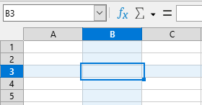
Figure 15: Columns and row highlighting
Highlight cell in edit mode
Highlight the background of the cell in its edit mode.
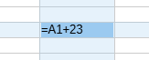
Figure 16: Highlight cell in edit mode
Anchor
If an inserted object, such as a picture, is anchored to a cell, an image of an anchor will appear in the cell to which the object is anchored.
Show references in color
Select this option to provide a visual aid to assist the editing of a formula. Each reference is highlighted in color in the formula. The referenced cell range is enclosed by a colored border as soon as the cell containing the reference is selected for editing.
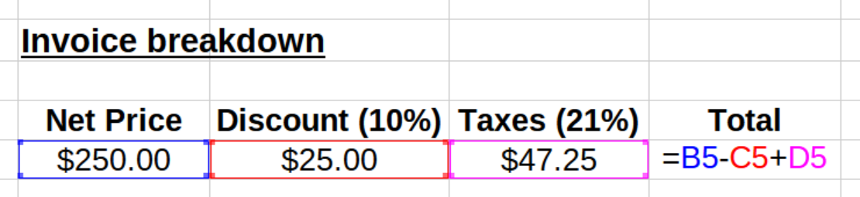
Figure 17: Formula references – visual aids

Window section
The following elements of the spreadsheet window can be made visible or invisible: column and row headers, horizontal and vertical scroll bars, sheet tabs, and, if an outline has been defined, outline symbols.
If the Sheet tabs option is not selected, you can only switch between the sheets by using the Navigator.
The Summary on search option controls the display of the Search Results dialog, which is described in detail in Chapter 2, Entering and Editing Data.

Visual Aids section
Grid lines
Grid lines are the borders around the cells of a spreadsheet when viewed onscreen. The options are: Show, Show on colored cells, or Hide. If grid lines are hidden, tables will be displayed on a solid background with no grid around cells. The color choice overrides the selection made in Tools > Options > LibreOffice > Appearance > Customization > Spreadsheets > Grid lines.
- Note
To print grid lines, choose Format > Page Style > Sheet > Print > Grid.
Pointer
When the mouse pointer hovers over the grid of cells on a Calc spreadsheet, the default pointer (“System”) is normally shown, typically as an arrow pointer. However, an alternative pointer (“Themed”) is available to allow you to switch to using the pointer shape defined in the icon theme (typically a “fat” cross, Figure 18).
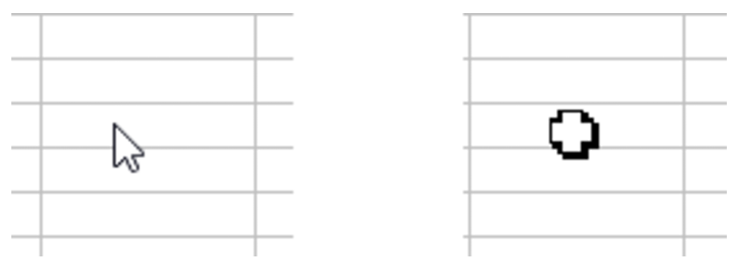
Figure 18: Typical System (left) and Themed (right) cursors
Page breaks
Specifies whether to display the page breaks within a defined print area.
Helplines while moving
Specifies whether to view helplines when moving drawings, frames, graphics, and other objects. These lines help you align objects.
In Figure 19, the graph with the dark background represents the image in its original location. The lighter area represents the position of the image as it is being moved. Helplines are the horizontal and vertical dotted lines at the corners of the lighter object.
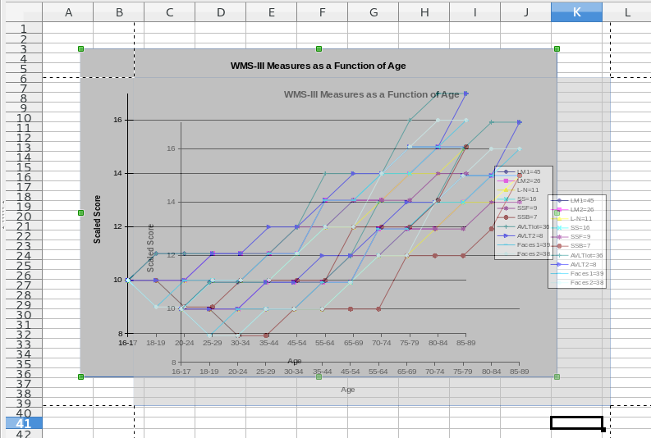
Figure 19: Helplines visible when moving a graphic

Objects section
Choose whether to show or hide graphics, charts, and drawing objects.

Zoom section
Select the Synchronize sheets option to apply any selected zoom (magnification) factor to all sheets in the spreadsheet. If this option is not selected, separate zoom factors can be applied to individual sheets.

Calculate
Use the LibreOffice Calc – Calculate page (Figure 20) to define the calculation settings for spreadsheets.

Formulas Wildcards section
Enable wildcards in formulas
Specifies that wildcards are enabled when searching and also for character string comparisons. Select this option for spreadsheets that need to be interoperable with Microsoft Excel.
Enable regular expressions in formulas
Specifies that regular expressions instead of simple wildcards are enabled when searching and also for character string comparisons. Do not enable regular expressions in formulas for spreadsheets that need to be interoperable with Microsoft Excel.
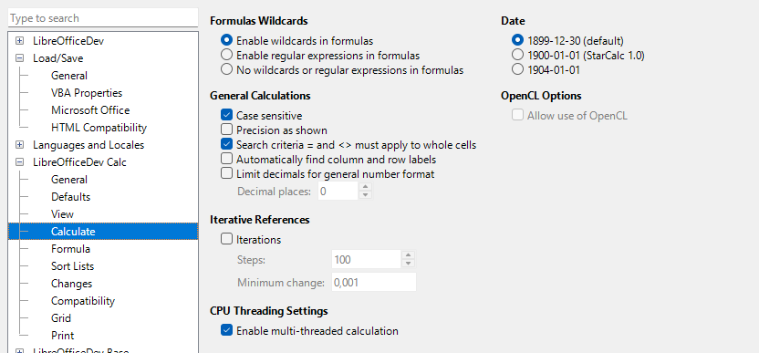
Figure 20: Calc calculation options
No wildcards or regular expressions in formulas
Specifies that only literal strings are used when searching and also for character string comparisons. Do not disable wildcards in formulas for spreadsheets that need to be interoperable with Microsoft Excel.
The options listed above are mutually exclusive. For more information about them, see Chapter 9, Using Formulas and Functions.

Date section
Select the start date for the internal conversion from days to numbers.
1899-12-30 (default) – Sets December 30, 1899 as day zero.
1900-01-01 (StarCalc 1.0) – Sets January 1, 1900 as day zero. Use this setting for StarCalc 1.0 spreadsheets containing date entries.
1904-01-01 – Sets January 1, 1904 as day zero. Use this setting for spreadsheets that are imported from foreign formats.

General Calculations section
Specify a variety of options relevant to spreadsheet calculation.
Case-sensitive
Specifies whether to distinguish between upper and lower case in texts when comparing cell contents. For example: type Test in cell A1; and test in B1. Then type the formula =A1=B1 in cell C1. If the Case sensitive option is checked, FALSE will appear in the cell; if the analysis was case-insensitive, TRUE will appear in the cell. This option is not applied to the EXACT text function, which is always case-sensitive.
Precision as shown
Specifies whether to make calculations using the rounded values displayed in the sheet. Charts are shown with the displayed values. If the Precision as shown option is not marked, the displayed numbers are rounded, but they are calculated internally using the non-rounded number.
Search criteria = and <> must apply to whole cells
The default search method in Calc is to search for any instance of the target regardless of the position of the target within a word. For example, when searching for day, Calc will match Friday, Sunday, and days. Select this option to search an exact occurrence of the target. Wildcard symbols can be used to expand the search to match the default condition.
Automatically find column and row labels
Calc will name the range of data, under a column heading or to the right of a row heading, using the text in those headings.
Example: Cell E5 contains the text Europe. Below, in cell E6, is the value 100 and in cell E7 the value 200. If the Automatically find column and row labels option is selected, you can write the following formula in cell A1: =SUM(Europe).
Limit decimals for general number format
Limits the number of decimals to be displayed for numbers with the general number format. This overrides the setting applied in the General option of the Format section inside the Number Category in Format > Cells > Numbers. This setting refers to how numbers are displayed. When decimal places are limited, calculations are not affected because of rounding.

Iterative References section
Iterative references are formulas that are continuously repeated until the problem is solved. In this section you can choose the number of approximation steps carried out during iterative calculations and the degree of precision of the answer.
Iterations
Select this option to enable iterations. If this option is not selected, an iterative reference causes an error message.
Steps
Sets the maximum number of iteration steps.
Minimum change
Specifies the difference between two consecutive iteration step results. If the result of the iteration is lower than the minimum change value, then the iteration will stop.

CPU Threading Settings section
Enable multithreaded calculation
Controls the use of multi-threading / parallelism, which can be used to speed up LibreOffice Calc calculations on computers with multiple processing cores. See Chapter 9, Using Formulas and Functions for more information.
- Caution
When calculations involve a range that includes an empty cell, take note of the setting for Zero values in the LibreOffice Calc > View options. If this option is not selected, a value of zero will display as an empty cell. Empty cells and the value zero are treated differently by many functions. For example, COUNT will not include an empty cell as an item to be counted. The average of eight cells, one of which contains the value zero, is not the same as the average of eight cells, one of which is empty (an empty cell is not included in determining the average).

Formula
Use the LibreOffice Calc – Formula page (Figure 21) to specify the following formula options.

Formula Options
Formula syntax
Syntax is the format in which formulas are written. Choose the syntax most appropriate for your work. If you regularly open or save to Microsoft Excel formats, you may wish to use one of the Excel syntaxes.
To illustrate the differences between syntaxes, assume a spreadsheet contains two sheets.
The cell C4 can be referenced in three ways:
Calc A1 =$Sheet2.C4 – the default syntax for Calc.
Excel A1 =Sheet2!C4 – the default of Microsoft Excel.
Excel R1C1 =Sheet2!R[3]C[2] – the relative row and column addressing used in Excel.
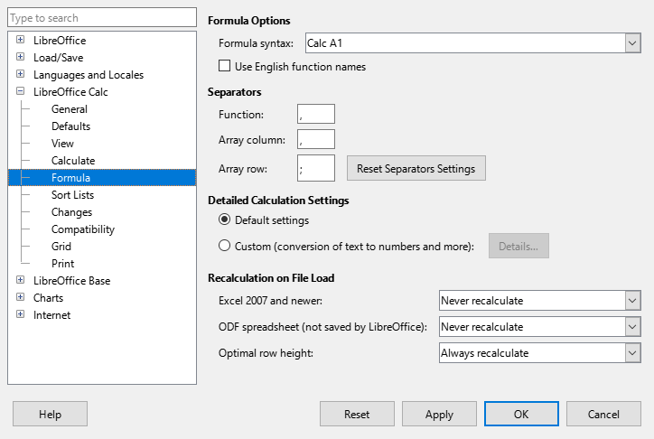
Figure 21: Formula options
Use English function names
The default names for functions in Calc are those for the user's locale. For English users, the localized names are the same as the English names. When the language set by locale is not English, you may wish to express functions in English; if so, select this option to change formula input and display, Function Wizard, and formula tips.

Separators
Separators are used in functions to distinguish points in the range used in the function: the symbols used between elements. Enter the separator character to be used for functions, row arrays, and column arrays. For example, a comma can be used as a separator in functions and instead of writing =SUM(A1;B1;C1) the function would be expressed as =SUM(A1,B1,C1).

Detailed Calculation Settings
Most users will not need to change the default setting. For custom settings, select Custom and click Details to choose reference syntax and whether to treat empty strings as zero.

Recalculation on File Load
Recalculating formulas can take significant time while loading very large files.
Excel 2007 and newer.
Loading a large spreadsheet file can take a long time. If you do not need to update your large spreadsheet data immediately, you can postpone the recalculation to a better time. Calc allows you to defer recalculation of Excel 2007 (and more recent) spreadsheets to speed up loading time.
ODF spreadsheet (not saved by LibreOffice)
Recent versions of Calc cache spreadsheet formula results in its ODF file. This feature helps Calc to recalculate a large ODF spreadsheet saved by Calc faster. For ODF spreadsheets saved by other programs, where such cached formula results may not exist, recalculation can be deferred to speed up file loading as with Excel 2007 files.
For each of these two options, the following choices are possible: Never recalculate (no formulas will be recalculated on loading the file), Always recalculate (all formulas will be recalculated on file load), and Prompt user (prompt user for action).
ODF spreadsheets saved in Calc will honor Never recalculate and Always recalculate options.
Optional Row height
For large spreadsheets documents, optimal row height calculation depends on the cell contents formatting and also on the result of the conditional formatted formulas. This setting helps to shorten load times by controlling the optimal row height calculation.

Sort lists
View, define, delete, and edit sort lists on the LibreOffice Calc – Sort Lists page. Sort lists are utilized for various purposes beyond just sorting, such as populating a series of cells during data entry. These lists are organized in a specific sequence, but not necessarily in alphabetical or numerical order; for instance, the days of the week. Besides the provided lists, you have the option to create and modify your own lists, as detailed in Chapter 2, Entering and Editing Data.
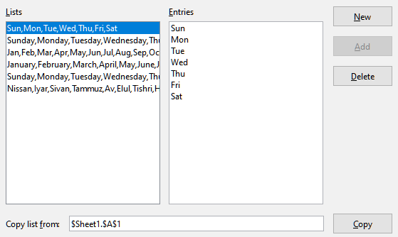
Figure 22: Defining sort lists in Calc

Changes
On the LibreOffice Calc – Changes page, you can assign specific colors for insertions, deletions, and other changes, or you can let Calc assign colors based on the author of the change. In the latter case, one color will apply to all changes made by that author. The selections made here are applied when change recording is enabled by Edit > Track Changes > Record on the Menu bar.
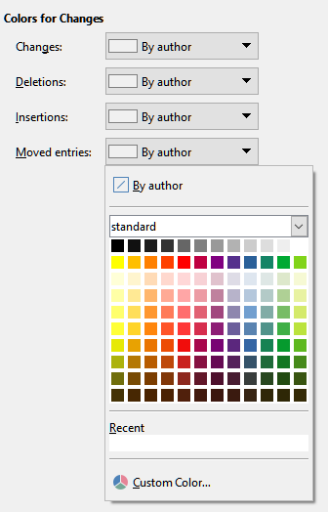
Figure 23: Calc options for highlighting changes

Compatibility
Key Bindings
The LibreOffice Calc – Compatibility page provides a quick way to switch between LibreOffice’s default key bindings and OpenOffice.org’s legacy default key bindings for Calc. Most of the defaults are identical, but there are some differences.
The actions associated with the two key binding choices are shown in the table below.
Key Binding | Default | OpenOffice.org legacy
Backspace | Opens Delete Contents dialog | Immediately deletes contents
Delete | Immediately deletes contents | Opens Delete Contents dialog
Control+D  (Command+D on macOS) | Fills cell content down within selection | Opens the Selection List dialog
Alt+DownArrow  (Option+DownArrow on macOS) | Select header of range;  no action in empty cell | Increases row height
Hyperlinks
Calc can insert multiple hyperlinks in a cell as text fields, but multiple hyperlinks in a cell cannot be saved to Excel file formats. This option prevents inserting multiple hyperlinks in a cell when Excel files are edited, in order to be interoperable with Excel.

Grid options
The LibreOffice Calc – Grid page defines the grid settings for spreadsheets. Using a grid helps determine the exact position of any charts or other objects you may add to a spreadsheet. You can also set this grid in line with the snap grid.
If you have activated the snap grid but wish to move or create individual objects without snap positions, press the Ctrl key to deactivate the snap grid for as long as needed.
Grid section
Snap to grid activates the snap function.
Visible grid displays grid points on the screen. These points are not printed.
Resolution and Subdivision sections
Here you can set the unit of distance for the spacing between horizontal and vertical grid points and subdivisions (intermediate points) of the grid.
Synchronize axes changes the current grid settings symmetrically.
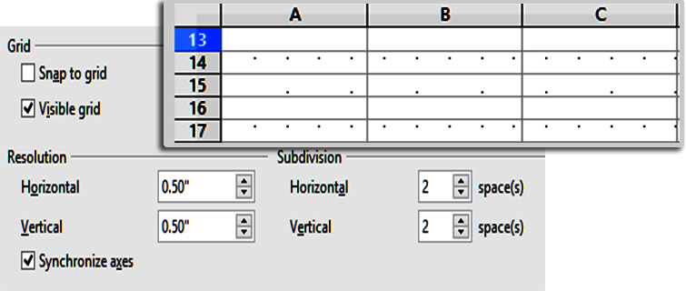
Figure 24: Calc grid options

Print options
Use the LibreOffice Calc – Print page to choose defaults for printing spreadsheets. You can override these for individual print jobs.
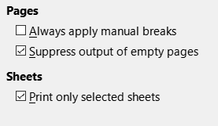
Figure 25: Calc Print options

Default colors for charts
Use Tools > Options > Charts > Default Colors to change the default colors used for charts or to add new data series to the list provided.
To add new colors to the choices, see Adding custom colors, below.
To change the default color for a data series, select it in the left-hand column and then click on the required color in the color table.
To add another data series, click Add, then select the new series and click on the required color.
Click Default to restore the color settings that were defined when the program was installed.
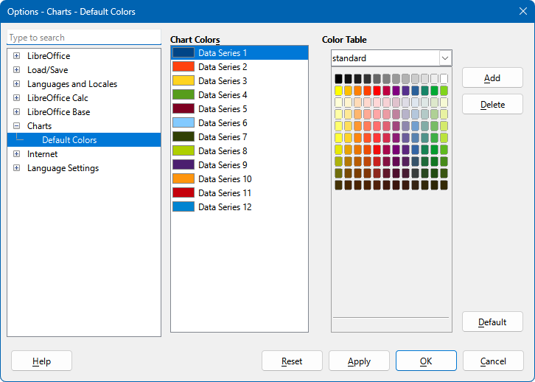
Figure 26: Defining chart colors

Customizing the user interface
You can customize menus, toolbars, keyboard shortcuts, and the tabbed interface; add new menus and toolbars; and assign macros to events.
- Tip
Changes to menus and toolbars can be saved in a template. First, save them in a document; then, save that document as a template, as described in Chapter 4, Using Styles and Templates.

Menu content
You can add and rearrange menus on the Menu bar or context (right-click) menus; add, rearrange, and remove commands on menus; and make other changes.
To customize menus, choose Tools > Customize on the Menu bar. On the Customize dialog, go to the Menus tab (Figure 27) or the Context Menus tab. The following examples focus on the Menus tab but the Context Menus tab is similar in appearance and behavior.
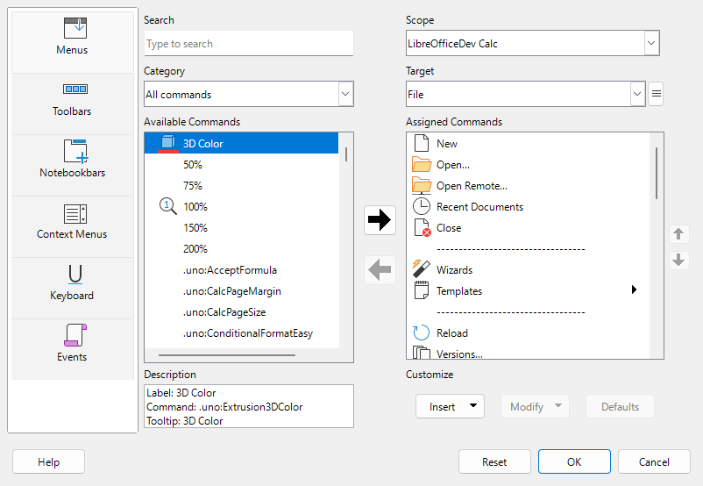
Figure 27: The Menus tab of the Customize dialog

Modifying an existing menu
To modify an existing menu:
- In the Scope drop-down list in the upper right of the Customize dialog, choose whether to save this changed menu for Calc or for a selected document.
- In the Target drop-down list, select the menu that you want to customize. The list includes all the sub-menus as well as the main menus. The commands on the selected menu are shown in the Assigned Commands list below.
- To add a command to the selected menu, click on a command in the Available Commands list and then click the right arrow. You can narrow the search by using the Search box on the top left or selecting the Category in the drop-down list. Use the up and down arrows on the far right-hand side to move the command into the place where you want it in the Assigned Commands list.
- To remove a command from the selected menu, click on it in the Assigned Commands list and then click the left arrow.
- To insert a separator or sub-menu, use the commands in the Insert drop-down under Customize at the bottom right.

Figure 28: Customize dialog, Menus tab, Insert drop-down
- To rename a menu item, select it in the Assigned Commands list and choose Rename in the Modify drop-down below.

Figure 29: Customize dialog, Menus tab, Modify drop-down
- Use the Reset button to reset Calc’s menu configuration to the default settings.
- When you have finished making all your changes, click OK to save them.

Creating a new menu
To add a menu:
- On the Menus tab of the Customize dialog, click the button next to the Target field (Figure 30) and select Add in the drop-down list to display the New Menu dialog (Figure 31).
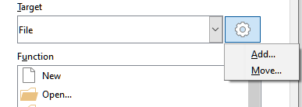
Figure 30: Location of command to add a new menu
- In the New Menu dialog, type a name for the new menu in the Menu name box.
- Use the up and down arrow buttons to move the new menu into the required position on the Menu bar. Click OK to save and return to the Customize dialog.
The new menu appears on the list of menus in the Customize dialog. It will appear on the Menu bar itself after you save your customization.
After creating a new menu, you need to add some commands to it.
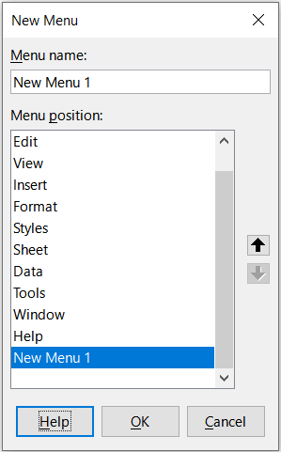
Figure 31: Adding a new menu

Creating an accelerator
You can allocate a letter in a custom menu’s name to be used as a keyboard shortcut. (That letter will become underlined.) When you press Alt+that letter, that menu or command will be invoked. Existing sub-menus can also be edited to change the letter which is used to select them using the keyboard when the menu is open.
To create an accelerator:
- On the Customize dialog, select a menu item in the Assigned Commands list.
- Click the Modify button and select Rename.
- Add a tilde (~) in front of the letter to use as an accelerator.
- Click OK to save the change.
For example. if you enter ~Art, the A in the menu item Art is now underlined. Press Alt+A and the Art menu opens.
- Caution
When assigning an accelerator, be careful not to use a letter that is already assigned to a menu or command associated with a menu item. The same letter-key combinations can be used for commands associated with different menu items but not for those associated with the same menu or menu item.

Toolbars
You can customize toolbars in several ways, including choosing which icons are visible and locking the position of a docked toolbar, as described in the Getting Started Guide. This section describes how to create new toolbars and add or delete icons (commands) on a toolbar.
To get to the toolbar customization dialog (Figure 32), do any of the following:
- On the toolbar, right-click in the toolbar and choose Customize Toolbar.
- Choose View > Toolbars > Customize on the Menu bar and go to the Toolbars tab.
- Choose Tools > Customize on the Menu bar and go to the Toolbars tab.
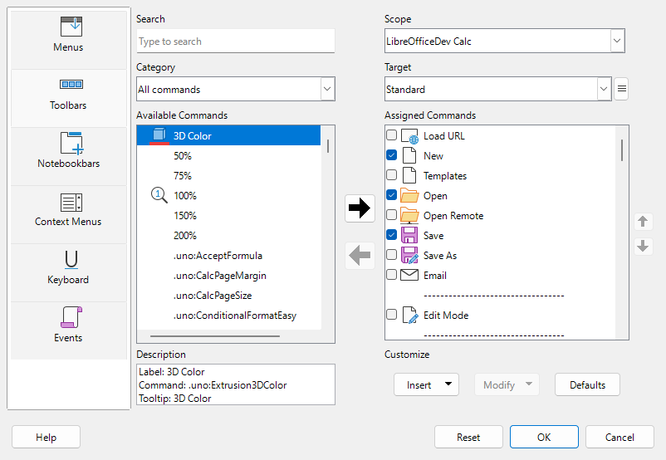
Figure 32: The Toolbars tab of the Customize dialog
To customize a toolbar:
- In the Scope drop-down list on the upper right of the Customize dialog, choose whether to save this changed toolbar for Calc or for a selected document.
- In the Target drop-down list, select the toolbar that you want to customize. The current toolbar content is displayed in the Assigned Commands list.
- Select the command to be added in the Available Commands list. You can narrow your search by using the Search box on the top left or choosing a category in the drop-down list just below.
- Click on the large right arrow to add the command to the Assigned Commands list for the toolbar. Use the up and down arrows in the far right to position the command in the toolbar.
- To remove a command from a toolbar, select it in the Assigned Commands list and click the large left arrow.
- To show or hide a command assigned to a toolbar, mark or clear the checkbox next to its icon in the Assigned Commands list.
- To insert a separator, use the command in the Insert drop-down under Customize at the bottom right.
- To rename a toolbar item, select it in the Assigned Commands list and choose Rename in the Modify drop-down.
- Use the Reset button to reset Calc’s toolbar configuration to the default settings.
- When you have finished making all your changes, click OK to save them.

Creating a new toolbar
To create a new toolbar:
- Choose Tools > Customize on the Menu bar.
- On the Toolbars tab of the Customize dialog, click the button next to the Target field and select Add in the drop-down list, to display the Name dialog.
- On the Name dialog, type the new toolbar's name and choose in the Save In drop-down list where to save this new toolbar – for Calc or for the open document.
The new toolbar now appears on the list of toolbars in the Customize dialog.
To add commands to the new toolbar, follow the instructions earlier for modifying a toolbar.

Choosing icons for toolbar commands
Toolbar buttons can be displayed with Icon only, Text only, or Icon and text. This selection is made through the menu that drops down from the button to the right of the Target field. However, not all of the commands have associated icons.
To choose an icon for a command, select the command and click Modify > Change Icon. On the Change Icon dialog (Figure 33), scroll through the available icons, select one, and click OK to assign it to the command.
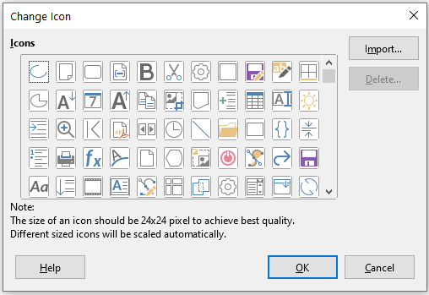
Figure 33: Change Icon dialog
To use a custom icon, create it in a graphics program and import it into LibreOffice by clicking the Import button on the Change Icon dialog. For best quality, custom icons should be 24 x 24 pixels in size; other sizes will be scaled automatically.
Select Modify > Reset Icon to revert to the option’s default icon.

Tabbed interface
By default, Calc’s commands are grouped in cascading menus and in toolbars filled with icons. In addition, LibreOffice provides other user interface variants, displaying contextual groups of commands and contents. You can find more information about these variants and how to switch between them in Chapter 17, User Interface Variants.
Three of LibreOffice’s user interface variants utilize a notebook bar: The Tabbed, Tabbed Compact, and Groupedbar Compact options. In these variants, the area at the top of the workspace is divided into tabs, where each tab displays a set of icons grouped by context. The context can change depending on the object selected in the document, for example a table or an image.
Use the checkboxes on the Notebookbar tab of the Customize dialog (Figure 34) to show and hide the individual options on the various tabs that are provided in the most recently selected of the three tabbed user interfaces (with Tabbed being the initial default).
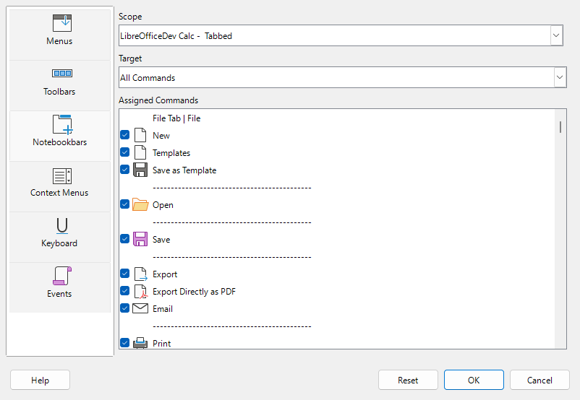
Figure 34: The Notebookbar tab of the Customize dialog
Use the Reset button to reset the displayed configuration to the default settings.

Keyboard shortcuts
In addition to the built-in keyboard shortcuts (see Appendix A), you can create your own custom shortcuts. You can assign shortcuts to standard LibreOffice functions or your custom macros, and save them for use across the entire LibreOffice suite or exclusively for Calc.
- Caution
Avoid reassigning your operating system’s predefined shortcut keys.
- Note
Shortcut keys that are grayed out in the listing on the Customize dialog, such as F1 and F10, are not available for reassignment.
To adapt shortcut keys to your needs, use the Customize dialog, as described below.
- Select Tools > Customize on the Menu bar and select the Keyboard tab. (Figure 35).
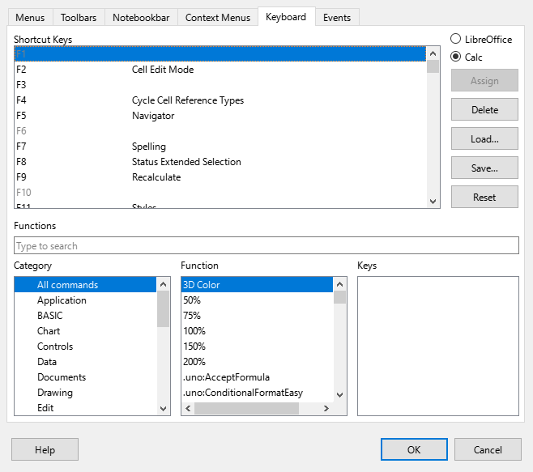
Figure 35: Customizing a keyboard shortcut
- To have the shortcut key assignment available only with Calc, select Calc in the upper right corner of the page; otherwise select LibreOffice to make it available to every component.
- Next select the required function in the Category and Function lists.
- Now select the desired shortcut keys in the Shortcut Keys list and click the Assign button at the upper right.
- Click OK to accept the change. Now the chosen shortcut keys will execute the function chosen in step 3) above whenever they are pressed.
- Note
All existing shortcut keys for the currently selected Function are listed in the Keys selection box. If the Keys list is empty, it indicates that the chosen key combination is free for use. If it were not, and you wanted to reassign a shortcut key combination that is already in use, you must first delete the existing key.

Saving changes to a file
Changes to the shortcut key assignments can be saved in a keyboard configuration file for use at a later time, thus permitting you to create and apply different configurations as the need arises, or to create a standard keyboard configuration file to be distributed among many users.
To save keyboard shortcuts to a file:
- After making your keyboard shortcut assignments, click the Save button on the right of the Customize dialog (Figure 35).
- In the Save Keyboard Configuration dialog, enter a name for the keyboard configuration file in the File name box, or select an existing file (the file extension is .cfg for Configuration).
- Click Save. A confirmation dialog appears if you are about to overwrite an existing file, otherwise there will be no feedback and the file will be saved.

Loading a saved keyboard configuration
To load a saved keyboard configuration file and replace your existing configuration, click the Load button on the right of the Customize dialog, and then select the configuration file from the Load Keyboard Configuration dialog.

Resetting the shortcut keys
To reset all of the keyboard shortcuts to their default values, click the Reset button on the right of the Customize dialog (adjacent to the Load and Save buttons). Use this feature with care as no confirmation dialog will be displayed; the defaults will be set without any further notice or user input.

Running macros from key combinations
You can also define shortcut key combinations that will run macros. These shortcut keys are strictly user-defined; none are built in. For more information on macros, see Chapter 14, Macros.

Assigning macros to events
In LibreOffice, when something happens, we say that an event occurred. For example, a document was opened, a key was pressed, or the mouse moved. You can associate a macro with an event, so the macro is run when the event occurs. A common use is to assign the “open document” event to run a macro that performs certain setup tasks for the document.
To associate a macro with an event, use the Events tab of the Customize dialog. For more information, see the Getting Started Guide.

Adding functionality with extensions
An extension is a package that can be installed into LibreOffice to add new functionality.
Although individual extensions can be found in different places, the official LibreOffice extension repository is at https://extensions.libreoffice.org/. These extensions are free of charge. Extensions from other sources may be free or may be available for a fee. Check the description to see what licenses and fees apply to the extensions that interest you.

Installing extensions
To install an extension that is listed in the repository, follow these steps:
- In LibreOffice, select Tools > Extensions on the Menu bar, or press Ctrl+Alt+E. In the Extension Manager dialog, click the Get more extensions online link.
- A browser window will open. Find the extension you want and download it to your computer.
- After the extension is downloaded and saved, return to the Extensions dialog and click Add. Find and select the extension you want to install and click Open. The extension starts to install. You may be asked to accept a license agreement.
- When the installation is complete, the extension is listed in the Extensions dialog.
To install an extension that is not listed in the repository, download the extension, then continue with step 3) above.

Updating extensions
Click the Check for Updates button on the Extensions dialog to check for updates to installed extensions.
- Note
Not all extensions include update methods that interact with LibreOffice.

Removing and disabling extensions
To uninstall an extension that you have installed, select the extension in the main window of the Extensions dialog and click the Remove button. To disable an extension without uninstalling it, select the extension in the main window of the Extensions dialog and click the Disable button, which will then change to Enable.
- Tip
Extensions can be installed from some other places in Calc, such as the Gallery on the Sidebar, the Templates dialog, the Languages and Locales > Writing Aids page of the Tools > Options dialog and the Icon Style section in the View page of the Tools > Options dialog. In each of these places you will find a small button leading to a filtered view of the items in the Extensions dialog.
- Note
In some cases, the Remove and Disable buttons may be unavailable, for example when you have selected one of the extensions that was bundled with your LibreOffice installation.
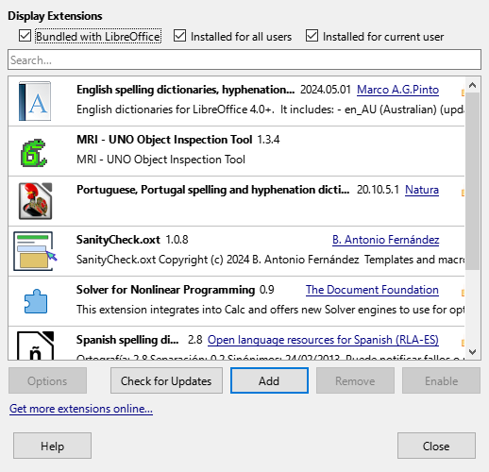
Figure 36: The Extensions dialog

Adding custom colors
The method for defining a custom color is as follows:
- Insert any drawing object, such as a square, into any document.
- Right-click on the object and choose Area in the context menu.
- Click on the Color button on the Area tab (Figure 37). In the Palette drop-down in the Colors area, choose which palette you wish to add the new color to. Under New, define the new color using RGB or Hex notation, or click the Pick button to select the color on the Pick a Color dialog (Figure 38).
- Click Add in the lower left corner, enter a name for the new color in the pop-up dialog, and click OK to save.
- Delete the drawing object from the document, if it is not needed.

Figure 37: Defining a new color

Figure 38: Defining a color by picking it from a color chart

Setting up document themes
Document themes collect various format selections into a set that can be applied and changed rapidly. Theme colors are implemented in the current release. Font and format settings are planned for later releases.
Calc supplies several sets of theme colors. To define your own set:
- Choose Format > Theme on the Menu bar. In the Theme dialog (Figure 39), select a theme to use as a starting point and click Add.
- In the Theme Color Edit dialog (Figure 40), name the new theme and select colors from any available palette.
- Click OK to save the new theme, which will now appear in the Theme dialog.
See Chapter 4, Using Styles and Templates, for instructions on using document themes.
- Note
User-defined theme color sets are saved only in the document; to use them in other documents, you need to make a template.
Themes enhance compatibility with Microsoft Word. However, they are not yet part of the ODF (OpenDocument Format), so you need to save to ODF 1.3 Extended or later to use them.
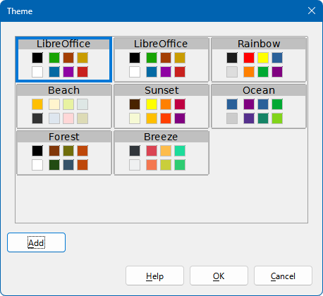
Figure 39: Theme dialog
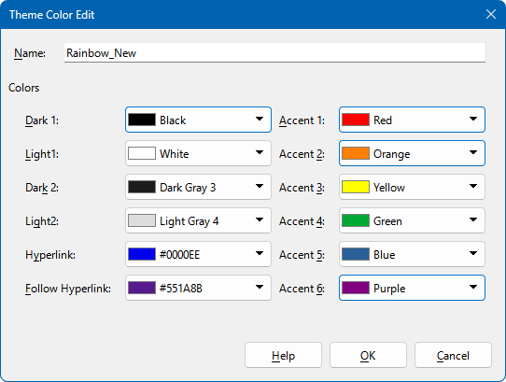
Figure 40: Theme Color Edit dialog

