
Draw Guide

Chapter 4,
Changing Object Attributes

Copyright
This document is Copyright © 2021 by the LibreOffice Documentation Team. Contributors are listed below. This document maybe distributed and/or modified under the terms of either the GNU General Public License (https://www.gnu.org/licenses/gpl.html), version 3 or later, or the Creative Commons Attribution License (https://creativecommons.org/licenses/by/4.0/), version 4.0 or later.
All trademarks within this guide belong to their legitimate owners.

Contributors
To this edition.
Peter Schofield | Elzett Kotze | Jean Hollis Weber
To previous editions.
Martin Fox | Jean Hollis Weber | John A Smith
Hazel Russman | John Cleland | Peter Schofield
Claire Wood

Feedback
Please direct any comments or suggestions about this document to the Documentation Team’s mailing list: documentation@global.libreoffice.org
- Note
Everything sent to a mailing list, including email address and any other personal information that is written in the message, is publicly archived and cannot be deleted.

Publication date and software version
Published July 2021. Based on LibreOffice 7.1 Community. Other versions of LibreOffice may differ in appearance and functionality.

Using LibreOffice on macOS
Some keystrokes and menu items are different on macOS from those used in Windows and Linux. The table below gives some common substitutions for the instructions in this document. For a detailed list, see the application Help.
Windows or Linux | macOS equivalent | Effect
Tools > Options  menu selection | LibreOffice > Preferences | Access setup options
Right-click | Control +click and/or right-click depending on computer setup | Open a context menu
Ctrl (Control) | ⌘ (Command) | Used with other keys
F11 | ⌘+T | Open the Styles deck in the Sidebar
Contents
Copyright 2
Contributors 2
Feedback 2
Publication date and software version 2
Using LibreOffice on macOS 2
Formatting lines 5
Line and Filling toolbar 5
Sidebar 5
Line dialog 6
Line page 7
Line properties 7
Arrow styles 8
Corner and cap styles 8
Shadow page 9
Line styles 9
Creating line styles 9
Saving line styles 10
Loading line styles 11
Deleting line styles 11
Arrow styles 11
Creating arrow styles 11
Saving arrow styles 13
Loading arrow styles 13
Deleting arrow styles 13
Formatting area fills 13
Line and Filling toolbar 14
Sidebar 16
Area dialog 17
Working with area fills 18
Color fills 18
Selecting color fill 18
Creating custom colors using Area dialog 19
Creating custom colors using Pick a Color dialog 19
Deleting custom colors 20
Gradient fills 20
Selecting and modifying gradient fills 20
Creating and saving custom gradients 22
Modifying custom gradients 22
Deleting custom gradients 23
Advanced gradient controls 23
Bitmap fills 24
Selecting bitmaps 24
Editing bitmaps 26
Adding or importing bitmaps 26
Deleting bitmaps 27
Pattern fills 27
Selecting pattern fills 27
Creating custom and saving patterns 28
Modifying custom patterns 29
Deleting custom patterns 29
Hatching fills 29
Selecting hatching fills 29
Creating and saving custom hatching 30
Modifying custom hatchings 31
Deleting custom hatching 31
Shadows 32
Default shadows 32
Formatting shadows 32
Transparencies 33
Drawing styles 34
Style categories 34
Selecting styles 35
Creating new or custom styles 36
Using Styles deck 36
Using New Style from Selection 37
Modifying styles 37
Editing hierarchical or parent styles 37
Updating styles 38
Applying styles 38
Deleting styles 38
Special effects 39
Rotating objects 39
Manual rotation 39
Sidebar rotation 40
Position and Size dialog 41
Flipping objects 41
Quick flipping 41
Flip tool 42
Mirror copies 43
Distorting images 43
Set in circle (perspective) 43
Set to circle (slant) 43
Distort 45
Dynamic gradients 45

Formatting lines
In LibreOffice the term Line indicates a freestanding segment (line), the outer edge of a shape (border), or an arrow. In most cases, the properties of the line that can be modified are its style (solid, dashed, invisible, and so on), its width, its color and the type of arrowhead.
- Tip
Hovering the cursor over a tool icon on a toolbar or in the Sidebar, a pop up displays the name of the tool.
- Note
For more information on using color when formatting lines, line styles, arrows, and arrow styles, see “Working with area fills” on page 18.

Line and Filling toolbar
Format a line using the Line and Filling toolbar (Figure 1) as follows:
- Make sure the line is selected in a drawing.
- Select the line style required from the Line Style drop-down list.
- Either type the line width in the Line Width text box, or use the up and down arrows to change the line width.
- Click on the small triangle ▼ to the right of Line Color and select a color from one of the available color palettes.
- Click on the small triangle ▼ to the right of Line Style and select a line style from one of the options in the drop-down list.
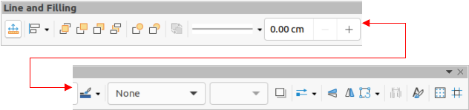Figure 1: Line and Filling toolbar

Sidebar
Format a line using the Line section in the Properties deck on the Sidebar (Figure 2) as follows:
- Make sure the line is selected in a drawing.
- Click on Properties on the Sidebar to open the Properties deck.
- Click on the down arrowhead ˅ on the left of the Line title bar to open the Line section.
- In Line, select from the Arrow Style drop-down lists the type of arrowhead for each end of the line and change the line into an arrow. The left drop-down list adds an arrowhead to the beginning of the line. The right drop-down list adds an arrowhead to the end of the line.
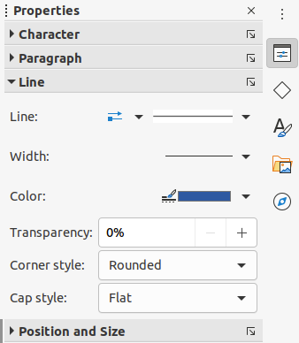Figure 2: Line section in Properties deck on Sidebar
- In Line, select the type of line required from the Line Style drop-down list.
- In Width, select the line width from the Width drop-down list or enter a width in the Custom Line Width text box.
- In Color, click on the small triangle ▼ to the right of Line Color and select a color from one of the available color palettes.
- In Transparency, enter a percentage for the amount of transparency for the line.
- In Corner style, select a corner style from the drop-down list.
- In Cap style, select a cap style from the drop-down list.

Line dialog
To fully change the appearance of a line, use the Line dialog.
- Select the line in a drawing and open the Line dialog (Figure 3) using one of the following methods:
- Go to Format > Line on the Menu bar.
- Right-click on the line and select Line from the context menu.
- Click on More Options on the right of the Line section title on the Sidebar.
- Use the options available in the pages of the Line dialog to format the line. The pages are Line, Shadow, Line Styles and Arrow Styles. The options are explained in the following sections. The preview box at the bottom of the dialog shows the effect of the changes on a line.
- Click OK to save the changes and close the dialog.
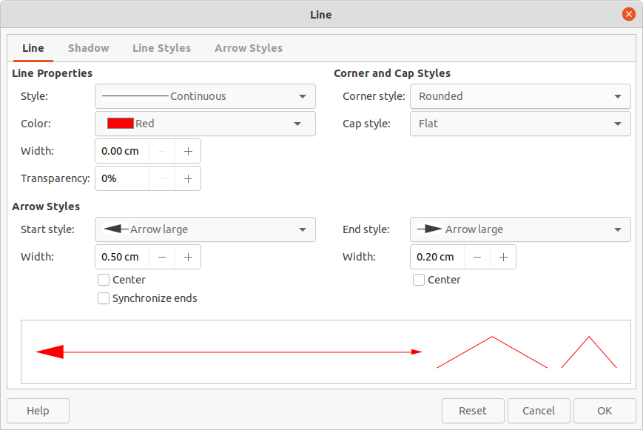Figure 3: Line dialog - Line page

Line page
The Line page in the Line dialog is where the basic parameters of the line are set. It is divided into three sections as follows.

Line properties
Use Line Properties to set the following parameters:
- Style – select a line style from the drop-down list.
- Color – select a predefined color from one of the available color palettes.
- Width – specifies the thickness of the line.
- Transparency – sets the transparency of a line. Figure 4 shows the effects of different percentages in transparency levels to lines when placed over an object.
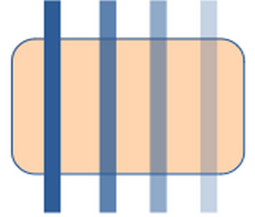Figure 4: Line transparency (0%, 25%, 50%, 75%)

Arrow styles
Use Arrow Styles to set the following parameters when creating arrows in a drawing.
- Start style and End style – select from the drop-down list an arrow style or arrowhead for the start and end of a line.
- Width – specifies the thickness of the arrow endings
- Center – moves the center of the arrow endings to the end point of the line. Figure 5 shows the effects of selecting this option.
- Synchronize ends – makes the two line ends identical.
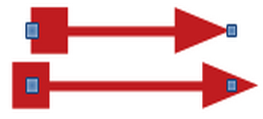Figure 5: Default arrow top; centered arrow bottom
- Note
Arrowheads are only applicable to lines. They have no effect on the border of an object.

Corner and cap styles
Corner and Cap Styles determine how the connection between two segments looks. To appreciate the difference between these styles, choose a thick line style and observe how the preview changes.
- Corner style – select the shape to be used at the corners of the line. For a small angle between lines, a mitered shape is replaced with a beveled shape.
- Cap style – select the style of the line end caps. The caps are added to inner dashes as well.
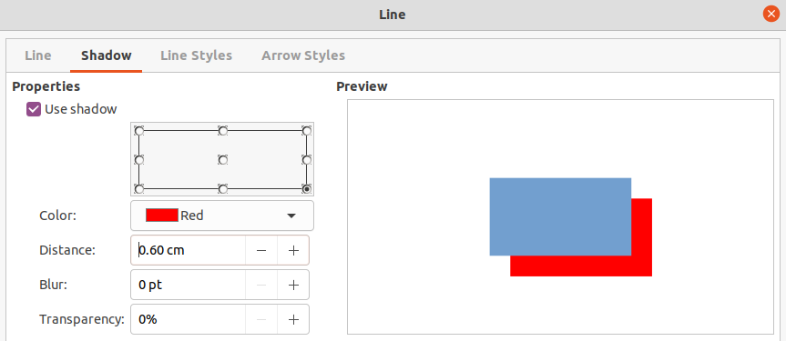Figure 6: Line dialog - Shadow page

Shadow page
The Shadow page (Figure 6) of the Line dialog provides the options to add and format a shadow to a selected line. The settings on this dialog page are the same as those for shadows applied to other objects, described in “Shadows” on page 32.
A quick way to apply a shadow to a line is using the Shadow tool on the Line and Filling toolbar. The disadvantage of using the Shadow tool is that the shadow created uses the shadow settings for the default graphics style.

Line styles
Line styles are useful in a drawing when adding several lines of similar types. This reduces the need to format individual lines. LibreOffice provides standard line styles that can be used in a drawing. Also, line styles can be created, saved, and deleted.

Creating line styles
- Create a line in a drawing.
- Open the Line dialog and click on the Line Styles tab to open the Line Styles page (Figure 7).
- In the Line style drop-down list, select a line style similar to the style to be created. An example of the line style selected is displayed at the bottom of the dialog page. This example changes as changes are made to the line style.
- Click on Add and type a name for the new line style in the dialog that opens, then click OK. The name of the new style appears in the Line style box.
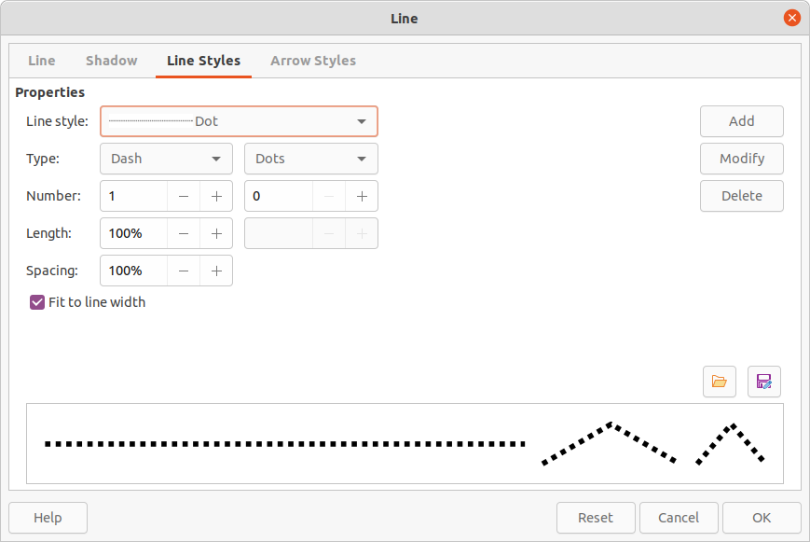Figure 7: Line dialog - Line Styles page
- In the Type drop-down menus, select either Dots or Dash. To use only one type for the line, select the same type in both Type boxes. To alternate the two line types within a single line, select different types in the two Type boxes.
- In the Number boxes, specify the number of each line type selected in Type.
- In the Length boxes, specify the Dash length as a percentage of the line. The Length option is not available for Dots.
- In the Spacing box, specify the spacing between the dashes and dots as a percentage of the line. The Spacing option is not available when the option Fit to line width is selected.
- If necessary, select Fit to line width so that the new style fits the line width when that line is created in a drawing.
- To create a new line style for the current drawing only:
- Click on Add to open the Name dialog and enter a unique name for the new line style.
- Click on OK to save the new line style and close the Name dialog.
- To modify an existing line style and create a new line style for the current drawing only:
- Click on Modify to open the Name dialog and enter a unique name for the new line style.
- Click on OK to save the new line style and close the Name dialog.
- Click on OK to close the Line dialog and the new line style is ready for use in the current drawing only.
- Note
When creating a line style, it is recommended to use a unique name for the line style. This prevents one of the standard line styles in LibreOffice from being overwritten and causing formatting problems in other drawings or documents that use the standard line styles.
- Note
To use the new line style in other drawings, the line style must be saved using Save Line Styles option. See "Saving line styles" below for more information.

Saving line styles
Saving a line style allows for a newly created line style to be used in other LibreOffice drawings.
- Create a new line style, described in “Creating line styles” above, but do not close the Line dialog.
- Click on the Save Line Styles icon at the bottom right of the Line Styles page to open a file browser window at the correct location for line styles.
- Enter a unique filename using the extension .sod for the line style in the Name box.
- Click on Save to save the line style and close the file browser window. The new line style is now available for use in new drawings and documents.

Loading line styles
LibreOffice provides standard line styles when installed on a computer. However, compatible line styles can loaded and used in LibreOffice. Any line styles loaded into LibreOffice must use the file extension .sod.
- Create a line in a drawing.
- Open the Line dialog and click on the Line Styles tab to open the Line Styles page (Figure 7).
- Click on the Load Line Styles icon at the bottom right of the Line Styles page to open a file browser window at the correct location for line styles.
- Select a style from the list of saved styles in the file browser window. The file extension for line styles is .sod.
- Click Open to load the line style into LibreOffice. The line style becomes available for other LibreOffice drawings and documents.
- Click OK to close the Line dialog and save any changes made.

Deleting line styles
- Create a line in a drawing.
- Open the Line dialog and click on the Line Styles tab to open the Line Styles page (Figure 7).
- Select the line style for deletion from the Line style drop-down list.
- Click on Delete and confirm the deletion by clicking on Yes in the confirmation dialog that opens.
- Click OK to close the Line dialog and save any changes made.
- Note
Before deleting line styles, make sure that the line style is not used in another drawing or document.

Arrow styles
Use the Arrow Styles page (Figure 8) in the Line dialog to create new arrow styles, modify existing arrow styles, or load previously saved arrow styles.
- Note
The part of the shape required for the point of the arrowhead must be at the top of the shape created. If necessary, rotate the shape until the point is at the top of the shape. If the shape is already a curve, then the conversion option To Curve will not be available.

Creating arrow styles
- Draw a shape to use for an arrowhead, or create a shape using one of the basic shapes that are available in Draw.
- Select the shape and convert to a curve using one of the following methods:
- Right-click on the shape and select Convert > To Curve from the context menu.
- Go to Shape > Convert > To Curve on the Menu bar.
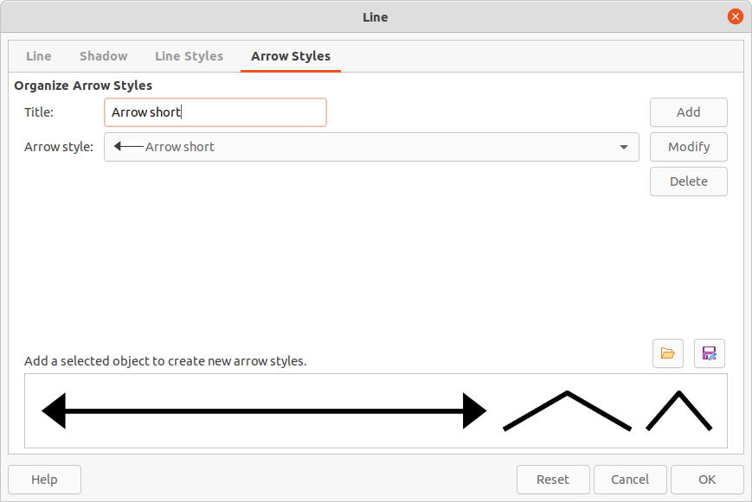Figure 8: Line dialog - Arrow Styles page
- With the shape selected, open the Arrow Styles page in the Line dialog.
- Click on Add and type a unique name for the new arrow style in the Name dialog that opens.
- Click OK and the new arrowhead style is displayed in the preview box of the Line dialog.
- Click OK to save the changes and close the Line dialog. The new arrow style appears at the bottom of the Arrow style drop-down list on the Arrow Styles page in the Line dialog.
- Note
Some shapes cannot be used as an arrowhead. This is indicated by rectangular blocks appearing at each end of the line in the preview box on the Line Styles page in the Line dialog.
- Note
When creating an arrow style, it is recommended to use a unique name for the arrow style. This prevents one of the standard arrow styles in LibreOffice from being overwritten and causing formatting problems in other drawings that use the standard arrow styles.
- Note
The new arrow style created is available only for use in the current drawing. To use the new arrow style in other drawings, the arrow style must be saved using the Save Arrow Styles option.

Saving arrow styles
Saving an arrow style allows for the newly created style to be used in other LibreOffice documents.
- Create a new arrow style as described in “Creating arrow styles” above, but do not close the Line dialog.
- Click on the Save arrow styles icon at the bottom right of the Arrow Styles page to open a file browser window at the correct location for arrow styles.
- Enter a unique filename using the extension .soe for the arrow style.
- Click on Save to save the arrow style and close the file browser window. The new arrow style is now available for use in new documents.

Loading arrow styles
LibreOffice provides standard arrow styles when installed on a computer. However, compatible arrow styles can be loaded and used in LibreOffice. Any arrow styles loaded into LibreOffice must use the file extension .soe.
- Create an arrow or line in a drawing.
- Open the Line dialog and click on the Arrow Styles tab to open the Arrow Styles page (Figure 8).
- Click on the Load arrow styles icon at the bottom right of the Arrow Styles page to open a file browser window at the correct location for arrow styles.
- Select an arrow style from the list of saved styles in the file browser window
- Click Open to load the arrow style into the drawing. The arrow style also becomes available for other LibreOffice documents.
- Click OK to close the Line dialog and save any changes made.

Deleting arrow styles
- Create an arrow or line in a drawing.
- Open the Line dialog and click on the Arrow Styles tab to open the Arrow Styles page (Figure 8).
- Select the arrow style for deletion from the Arrow style drop-down list.
- Click on Delete and confirm the deletion by clicking on Yes in the confirmation dialog that opens.
- Click OK to close the Line dialog and save any changes made.
- Note
Before deleting arrow styles, make sure that the arrow style is not used in another drawing or document.

Formatting area fills
The term area fill refers to the inside of an object. An area fill can be none, a uniform color, gradient, hatching, bitmap or pattern, as shown in Figure 9. Also, an area fill can be made partly or wholly transparent and can throw a shadow.
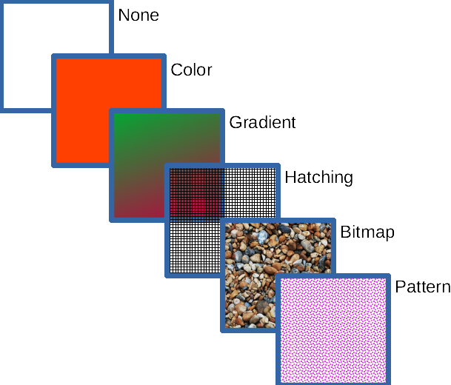Figure 9: Examples of area fill types

Line and Filling toolbar
Tools on the Line and Filling toolbar (Figure 1 on page 5) provide a range of default fills readily available to quickly format graphic objects. If this toolbar is not showing, go to View > Toolbars > Line and Filling on the Menu bar. To format the area of an object:
- Select an object so that the selection handles are displayed.
- Click on Area Style/Filling on the Line and Filling toolbar and select the type of fill required from the drop-down list (None, Color, Gradient, Hatching, Bitmap, Pattern) (Figure 10).
- Select one of the available options for the required type of area fill.
- Color (Figure 11) – select a color palette from the available options in the drop-down list, then select a color by clicking on the color. For more information on color fills, see “Color fills” on Page 18.
- Gradient (Figure 12) – select the required gradient from the drop-down list. For more information on gradient fills, see “Gradient fills” on Page 20.
- Hatching (Figure 13) – select the required hatching from the drop-down list. For more information on hatching fills, see “Hatching fills” on Page 29.
- Bitmap (Figure 14) – select the required bitmap from the drop-down list. For more information on bitmap fills, see “Bitmap fills” on Page 24.
- Pattern (Figure 15) – select the required pattern from the drop-down list in the Area section in the Properties deck on the Sidebar. For more information on pattern fills, see “Pattern fills” on Page 27.
- Deselect the object to save the changes to the object.
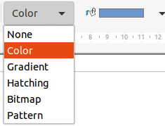Figure 10: Area fill types
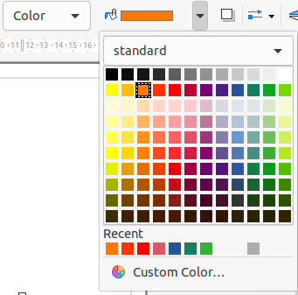Figure 11: Color area fills
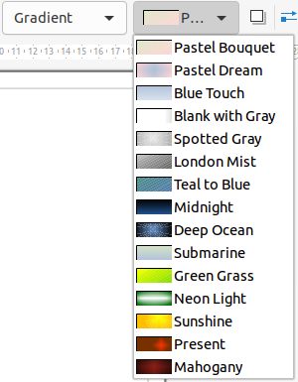Figure 12: Gradient area fills
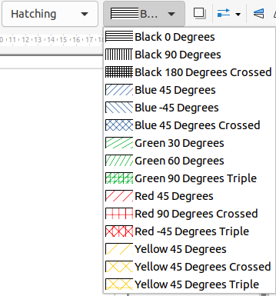Figure 13: Hatching area fills
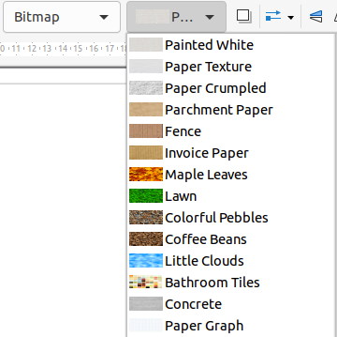Figure 14: Bitmap area fills
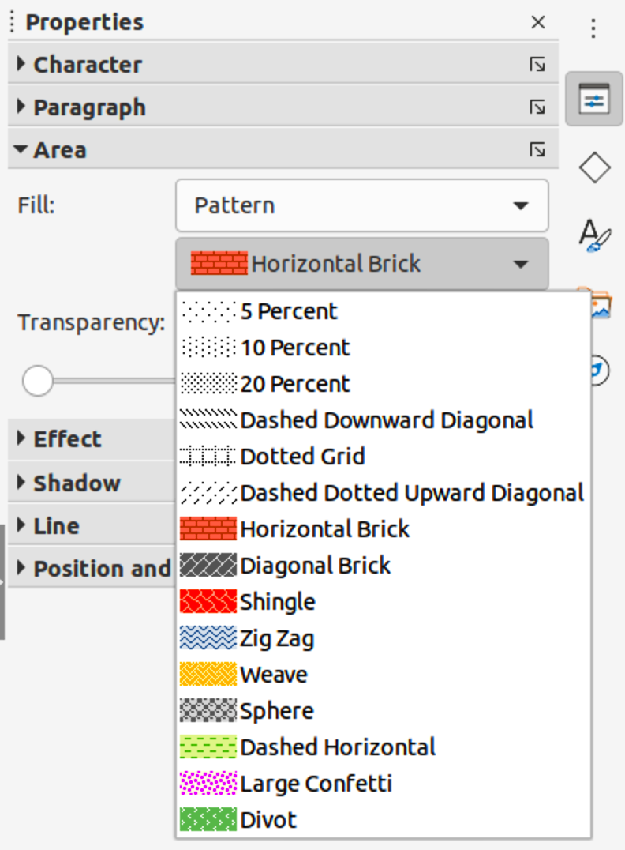Figure 15: Pattern area fills in Area section in Properties deck on Sidebar

Sidebar
Format the area of an object using the Sidebar (Figure 15) as follows:
- Make sure the object is selected in a drawing.
- Click on Properties on the Sidebar, then click on the down arrowhead ˅ on the left of the Area titlebar to open the Area section.
- Use the options in the Fill and Transparency drop-down lists to format the area of an object. For more information, see “Working with area fills” on page 18.
- Deselect the object to save the changes.

Area dialog
Format area fills with greater control using the Area dialog (Figure 17) as follows:
- Make sure the object is selected in a drawing.
- Open the Area dialog using one of the following methods:
- Go to Format > Area on the Menu bar.
- Click on Area in the Line and Filling toolbar.
- Right-click on the selected object and select Area from the context menu.
- Click on More Options on the right of the Area section title on the Sidebar.
- Click on the Area tab to open the Area page. For more information, see “Working with area fills” on page 18.
- Select the type of area fill from the options.
- Select the style of area fill from the options that become available for the type of area fill selected.
- Click OK to close the Area dialog and save the changes.
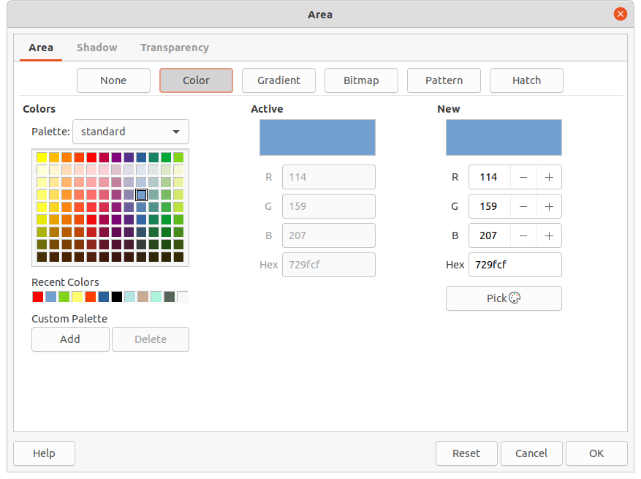Figure 16: Area dialog - Color page

Working with area fills

Color fills

Selecting color fill
The following procedure to select a color for an area fill uses the Area dialog. Using the tools on the Line and Filling Toolbar, and the Area section in the Properties deck on the Sidebar is a similar procedure, but the available options are reduced. All color fills are solid colors.
- Make sure the object is selected in a drawing.
- Open the Area page on the Area dialog, then click on Color (Figure 16) to open the options available for a color fill.
- In Colors, select the required palette from the available options in the Palette drop-down list.
- Click on the color required. The present color fill of a selected object is displayed In the Active preview box.. After selecting a new color, a preview of the selected color appears in the New preview box.
- Alternatively, enter the RGB values or the Hex value of a color in the New text boxes.
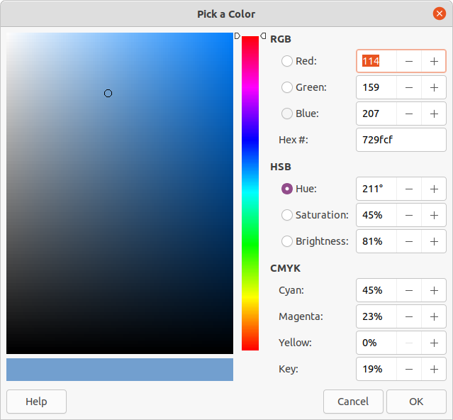Figure 17: Pick A Color dialog
- Alternatively, click on Pick to open the Pick a Color dialog (Figure 17). Select a color using one of the following methods:
- Enter the RGB, Hex, HSB or CMYK values for the color, then click OK to close the Pick a Color dialog and place the color in the New preview box.
- Click on the color range in the vertical color bar, then click and drag the small circle in the color box to select the color. Click OK to close the Pick a Color dialog and place the color in the New preview box.
- If necessary and to revert back to the original color, click on Reset and any changes made are removed.
- Click OK to close the Area dialog and save the changes. The color is then changed in the selected object.
- Tip
If a color has been used before, it appears in Recent Colors. It can be selected and used again from those colors available in Recent Colors.

Creating custom colors using Area dialog
To create a custom color so that the color is available for other drawings or documents, then the Colors page in the Area dialog must be used.
- Select a filled object to create a color.
- Open the Area page on the Area dialog, then click on Color to open the available options.
- Specify the RGB values or the Hex value of the custom color in the New text boxes.
- Alternatively, click on Pick to open the Pick a Color dialog. Select a color using one of the following methods:
- Enter values for the custom color in the boxes for RGB, Hex, HSB or CMYK values, then click OK to close the Pick a Color dialog and place the color in the New preview box.
- Click on the color range in the vertical color bar, then click and drag the small circle in the color box to select the color. Click OK to close the Pick a Color dialog and place the color in the New preview box.
- On the Area Color page of the Area dialog, under Custom Palette, click on Add and a Name dialog opens.
- Enter a unique name in the text box and click OK. The new custom color then appears in the Custom palette.
- Click OK to close the Area dialog and save the changes. The new custom color appears as a fill in the selected object and is available for use in other drawings or documents.

Creating custom colors using Pick a Color dialog
If a custom color for a drawing is only going to be used in that drawing, then use the Pick a Color dialog to create a custom color. A custom color using the following method is not available for other drawings or documents.
- Select a filled object to create a color.
- Open the Pick a Color dialog (Figure 17) using one of the following methods:
- Click on Pick on the Colors page of the Area dialog.
- Click on the triangle ▼ next to Fill Color on the Line and Filling toolbar.
- Click on the triangle ▼ next to Fill Color in the Area section of the Properties deck on the Sidebar.
- Create a custom color using one of the following methods.
- Enter the values for the custom color in the boxes for RGB, Hex, HSB or CMYK values.
- Click on the color range in the vertical color bar, then click and drag the small circle in the color box to select the color.
- Click OK to close the Pick a Color dialog and save the changes. The new custom color appears as a fill in the selected object and is only available for use in the drawing being created.

Deleting custom colors
Only custom colors that are available in the custom palette can be deleted using the Area dialog. Colors that are available in the color palettes provided by LibreOffice cannot be deleted.
- Select a filled object that uses the color fill for deletion.
- Open the Area dialog using one of the following methods:
- Go to Format > Area on the Menu bar.
- Right-click on the object and select Area from the context menu.
- Click on More Options on the right of the Area section title on the Sidebar.
- Click on Area, then click on Colors to open the Colors page.
- In Colors, select Custom from the Palette drop-down list.
- Select the color for deletion and click on the Delete button. There is no confirmation given when deleting a color.
- Click OK to save the changes and close the Area dialog.

Gradient fills
Several predefined gradients are included when LibreOffice is installed. It is recommended to create custom gradients that match the requirements rather than permanently modifying the installed predefined gradients. Predefined gradients may have been used in other objects in a drawing or other documents.
Custom gradients should be saved with a unique name allowing the custom gradient to be used in other drawings or documents. Custom gradients are placed at the end of the gradients displayed in the Gradient box on the Gradient page of the Area dialog (Figure 18).

Selecting and modifying gradient fills
The following procedure to select a gradient for an area fill uses the Area dialog. Using the tools on the Line and Filling Toolbar, and the Area section in the Properties deck on the Sidebar is a similar procedure, but the available options are reduced.
- Make sure the object to be filled is selected in a drawing.
- Open the Area page on the Area dialog, then click on Gradient.
- Select the required gradient from the Gradient box. The selected gradient appears in Preview.
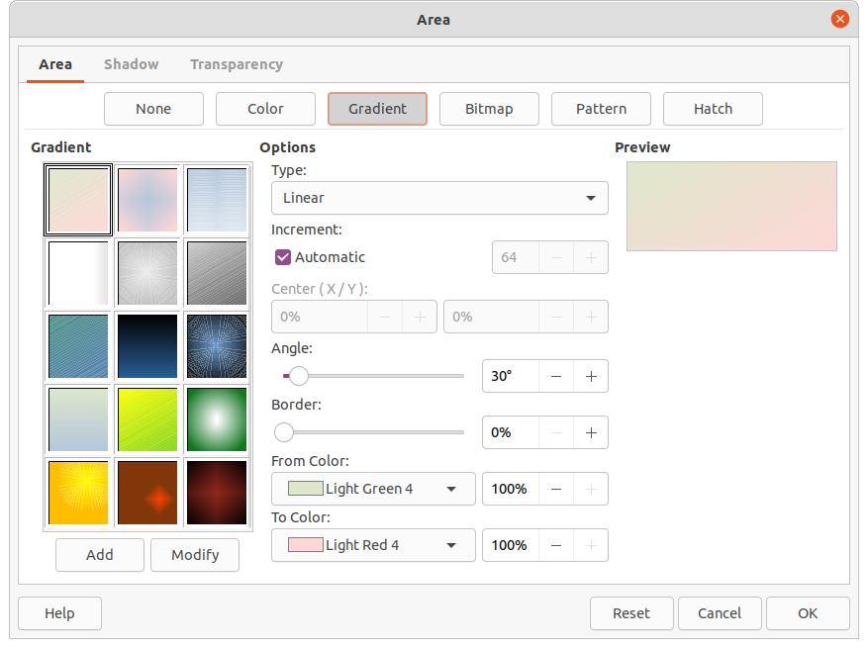Figure 18: Area dialog - Gradient page
- If necessary, change the values in the option boxes for Type, Increment, Center, Angle, Border, From Color and To Color to modify the gradient to the requirements. As changes are made, the gradient displayed in the Preview box also changes to indicate how it will look. For more information on gradient options, see “Table 1: Gradient options” below.
- If necessary, when making changes to the Increment value of a selected gradient, deselect Automatic and enter an increment value in the text box.
- If necessary and to revert back to the original gradient, click on Reset and any changes made are removed.
- Click OK to close the Area dialog and save the changes. The gradient fill then appears in the selected object.
- Note
Selecting and modifying a gradient using the above method only allows the gradient to be used in the drawing being created. If a modified gradient is to be used in other drawings or documents, then create a custom gradient and save it with a unique name. See “Creating and saving custom gradients” below.
Table 1: Gradient options
Gradient property | Meaning
Linear gradient | The color transitions from the starting color to the end color in a straight line.
Axial gradient | The color transitions from the starting color to the end color from the object center to the object edges in two opposite directions.
Radial gradient | The color transitions from the starting color to the end color in a circular pattern.
Ellipsoid gradient | The color transitions from the starting color to the end color in an elliptical pattern.
Quadratic gradient | The color transitions from the starting color to the end color from the object edges to the object center in four directions.
Square gradient | The color transitions from the starting color to the end color from the object edges to the object center in a square pattern.
Increment | Enter the number of steps for blending the two colors of the gradient. By default this is set to Automatic.
Center X | For Radial, Ellipsoid, Square and Rectangular gradients, modify these values to set the horizontal offset of the gradient center.
Center Y | For Radial, Ellipsoid, Square and Rectangular gradients, modify these values to set the vertical offset of the gradient center.
Angle | For all gradient types, modifies the angle of the gradient axis.
Border | Increase this value to make the gradient start further away from the border of the shape.
From Color | The start color for the gradient. In the edit box enter the intensity of the color: 0% corresponds to black, 100% to the full color.
To Color | The end color for the gradient. In the edit box enter the intensity of the color: 0% corresponds to black, 100% to the full color.

Creating and saving custom gradients
To use a modified gradient in other drawings or documents, a custom gradient has to be saved with a unique name.
- Make sure the object is selected in a drawing.
- Open the Area page on the Area dialog, then click on Gradient to open the options available for a gradient fill.
- Select a gradient and modify it using the options given in “Table 1: Gradient options” above. As changes are made, the gradient displayed in the Preview box also changes to give an indication of how the custom gradient will look.
- Click on Add to open a Name dialog.
- Enter a unique name for the new gradient, then click OK to close the Name dialog. The custom gradient is placed at the end of the gradient displayed in the Gradient preview box and becomes available for use in other drawings and documents.
- Click OK to close the Area dialog and save the changes.

Modifying custom gradients
Using the Modify option on the Gradient page in the Area dialog permanently changes a gradient and cannot be undone. It is recommended to only modify custom gradients and not the predefined gradients that were installed with LibreOffice.
- Make sure the object is selected in a drawing.
- Open the Area page on the Area dialog, then click on Gradient.
- Select a custom gradient from the Gradient box. Custom gradients appear below the 15 predefined gradients in the Gradient box.
- Make the necessary changes to the options given in “Table 1: Gradient options” above. As changes are made, the gradient displayed in the Preview box also changes to give an indication of how the custom gradient will look.
- If necessary and to revert back to the original gradient, click on Reset and any changes made are removed.
- Click on Modify to permanently change the selected custom gradient. There is no confirmation given when modifying a custom gradient.
- Click OK to close the Area dialog and save the changes.

Deleting custom gradients
- Select an object that uses a gradient fill.
- Open the Area page on the Area dialog, then click on Gradient.
- In the Gradient box, select the custom gradient for deletion.
- Right click on the gradient and select Delete from the context menu. Click on Yes to confirm the deletion.
- Click OK to save the changes and close the Area dialog.
- Note
It is recommended to only delete or rename custom gradients that have been created. Deleting or renaming one of the predefined gradients that are installed with LibreOffice may cause problems in drawings and documents that use one of the gradients.

Advanced gradient controls
LibreOffice provides advanced controls for gradients on the Transformations toolbar (Figure 19).
- Make sure the object is selected in a drawing.
- Open the Area page on the Area dialog, then click on Gradient.
- Go to View > Toolbars > Transformations on the Menu bar or click on the Transformations tool on the Line and Filling toolbar to open the Transformations toolbar.
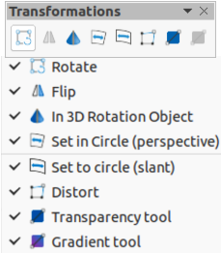Figure 19: Transformations toolbar
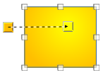Figure 20: Interactive gradient tool selected
- Click on Interactive gradient tool in the Transformations toolbar. This displays a dashed line connecting two colored squares (Figure 20). The colors show the From Color and To Color that are used for the selected gradient.
- Select the type of gradient required for the object from the options in the Type drop-down list. Properties available for adjustment depend on the gradient type selected, as explained below. Moving the squares will have different effects depending on the type of gradient.
- Linear – move the square corresponding to the From Color to change where the gradient starts (border value). Move the square corresponding to the To Color to change the orientation (angle value).
- Axial – move the To Color to change both the angle and border properties of the gradient. Only the square corresponding to the To Color can be moved.
- Radial – move the From Color to modify the border property to set the width of the gradient circle. Move the To Color to change the point where the gradient ends (Center X and Center Y values).
- Ellipsoid – move the From Color to modify the border property to set the size of the gradient ellipsoid. Move the To Color to change the angle of the ellipsoid axis and the axis itself.
- Quadratic and Square – move the From Color to modify the border property to set the size of the gradient square or rectangle and the angle of the gradient shape. Move the To Color to change the center of the gradient.
- Click OK to save the changes and close the Area dialog.

Bitmap fills
Several predefined bitmaps are included when LibreOffice is installed on a computer. The content of the supplied bitmaps cannot be edited, but the display settings can be changed and other bitmaps can be imported from other sources. A GIF is an example of a graphics image file that has a bitmap.

Selecting bitmaps
The following procedure to select a bitmap for an area fill uses the Area dialog. Using the tools on the Line and Filling Toolbar, and the Area section in the Properties deck on the Sidebar is a similar procedure, but the available options are reduced.
- Make sure the object is selected in a drawing.
- Open the Area page on the Area dialog, then click on Bitmap to open the options available for a bitmap fill (Figure 21).
- Select the required bitmap from the Bitmap box. The selected bitmap appears in Preview.
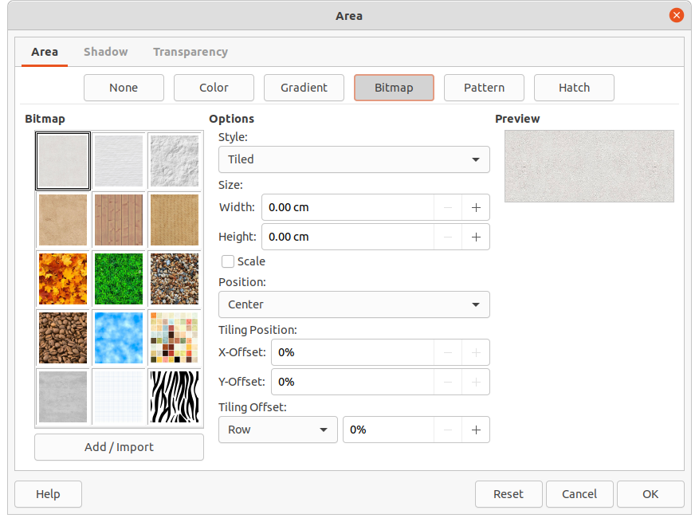Figure 21: Area dialog - Bitmap page
- If necessary, change the values in the option boxes for Style, Size, Position, Tiling Position, and Tiling Offset to modify the bitmap to the requirements. For more information on bitmap options, see “2” below.
- If necessary and to revert back to the original bitmap, click on Reset and any changes made are removed.
- Click OK to close the Area dialog and save the changes. The bitmap fill then appears in the selected object.
Table 2: Bitmap options
Bitmap option | Meaning
Style – Custom position/size | When this option is selected, the position of the bitmap in the object and the size of the bitmap can be specified.
Style – Tiled | When this option is selected, the bitmap is tiled to fill the area. The size of the bitmap used for the tiling is determined by the Size settings
Style – Stretched | When this option is selected, a bitmap is stretched to fill the object area.
Size – Width | Sets the width of the bitmap. For example, 100% means that the bitmap is resized to occupy the whole fill area width, 50% means that the width of the bitmap is half that of the fill area.
Size – Height | Sets the height of the bitmap. For example, 100% means that the bitmap is resized to occupy the whole fill area height, 50% means that the height of the bitmap is half that of the fill area.
Size – Scale | When selected, bitmap size is given as a percentage for Width and Height. When deselected, the actual size of the bitmap is given for Width and Height.
Position | Specifies the anchoring point of the bitmap.
Tiling Position – X-Offset | Sets the offset for the width of the bitmap in percentage values. 50% offset means that Draw will place the middle part of the bitmap width at the anchor point and start tiling from there.
Tiling Position – Y-Offset | Sets the offset for the height of the bitmap in percentage values. 50% offset means that Draw will place the middle part of the bitmap height at the anchor point and start tiling from there.
Tiling Offset | Offsets the columns of tiled bitmaps by the percentage entered in the box so that two subsequent columns of bitmaps are not aligned.
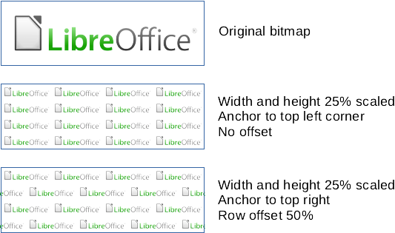Figure 22: Examples of bitmap fills

Editing bitmaps
- Make sure the object containing a bitmap fill is selected in a drawing.
- Open the Area page on the Area dialog, then click on Bitmap.
- Select a bitmap from the Bitmap box. The selected bitmap appears in Preview.
- Change the values in the option boxes for Style, Size, Position, Tiling Position, and Tiling Offset to the requirements. For more information on bitmap options, see “2” above. Examples of bitmap fills and the properties used are shown in Figure 22.
- If necessary and to revert back to the original bitmap, click on Reset and any changes made are removed.
- Click OK to save the changes and close the Area dialog.
- Note
Supplied bitmaps cannot be edited, but the display settings for placement and tiling can be changed.

Adding or importing bitmaps
- Make sure the object is selected in a drawing.
- Open the Area page on the Area dialog, then click on Bitmap.
- Click on Add/Import and a file browser window opens.
- Navigate to the directory containing the bitmap file, then select the file and click Open.
- Enter a unique name for the new bitmap in the Name dialog.
- Click OK to close the Name dialog. The imported bitmap is added at the end of the bitmaps in the Bitmap box.
- Click OK to save the changes and close the Area dialog. The imported bitmap fill appears in the selected object.
- Note
Bitmap images can be imported and used as area fills.

Deleting bitmaps
- Make sure the object containing a bitmap fill is selected in a drawing.
- Open the Area page on the Area dialog, then click on Bitmap.
- Right click on the bitmap being deleted and select Delete from the context menu. Click on Yes to confirm the deletion.
- Click OK to save the changes and close the Area dialog.
- Note
It is recommended to only delete or rename bitmaps that have been added or imported. Deleting or renaming one of the bitmaps installed with LibreOffice may cause problems in drawings and documents that use one of the bitmaps.

Pattern fills
Several predefined pattern fills are included when LibreOffice is installed on a computer. Custom patterns can also be created and modified in LibreOffice.

Selecting pattern fills
The following procedure to select a pattern for an area fill uses the Area dialog. Using the tools on the Line and Filling Toolbar, and the Area section in the Properties deck on the Sidebar is a similar procedure, but the available options are reduced.
- Make sure the object is selected in a drawing.
- Open the Area page on the Area dialog, then click on Pattern to open the options available for a pattern fill (Figure 23).
- Select the required pattern from the Pattern box and the selected pattern appears in Preview.
- If necessary, change the foreground and background colors, or the pattern itself, as described in “Creating custom and saving patterns” below. As changes are made, the pattern displayed in the Preview box also changes to indicate how it will look. Any changes will affect only the object being filled.
- If necessary and to revert back to the original pattern, click on Reset and any changes made are removed.
- Click OK to close the Area dialog and save the changes. The pattern fill then appears in the selected object.
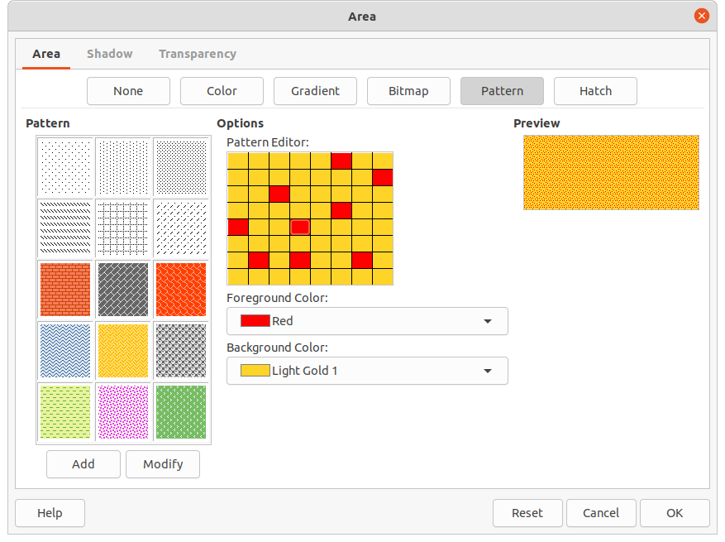Figure 23: Area dialog - Pattern page

Creating custom and saving patterns
- Make sure the object is selected in a drawing.
- Open the Area page on the Area dialog, then click on Pattern.
- Select the required pattern in Pattern to use as a starting point and the selected pattern appears in Preview.
- Optionally, select different colors for Foreground Color and Background Color. The pattern remains the same, but the colors change.
- Optionally, in Pattern Editor, click on individual squares to change the color from Foreground Color to Background Color, or from Background Color to Foreground Color to create a new pattern.
- Click on Add to open a Name dialog.
- Enter a unique name for the new pattern, then click OK to close the Name dialog. The custom pattern is placed at the end of the patterns displayed in the Pattern box and becomes available for use in other drawings and documents.
- If necessary and to revert back to the original pattern, click on Reset and any changes made are removed.
- Click OK to close the Area dialog and save the changes.
- Note
To use a modified pattern in other drawings or documents, the custom pattern has to be saved with a unique name.

Modifying custom patterns
Using the Modify option on the Pattern page in the Area dialog permanently changes a pattern and cannot be undone. It is recommended to only modify custom patterns and not the predefined patterns that were installed with LibreOffice.
- Make sure the object is selected in a drawing.
- Open the Area page on the Area dialog, then click on Pattern.
- Select a custom pattern from the Pattern box and the selected pattern appears in Preview. Custom patterns are located below the predefined patterns in the Pattern box.
- In Pattern Editor, click on each square to change the color from Foreground Color to Background Color, or from Background Color to Foreground Color to modify the selected pattern.
- If necessary and to revert back to the original pattern, click on Reset and any changes made are removed.
- Click on Modify to permanently change the selected custom pattern. There is no confirmation given when modifying a custom pattern.
- Click OK to close the Area dialog and save the changes.

Deleting custom patterns
- Select an object that uses a custom pattern as an area fill.
- Open the Area page on the Area dialog, then click on Pattern.
- In the Pattern box, select the custom pattern for deletion.
- Right click on the pattern and select Delete from the context menu. Click on Yes to confirm the deletion.
- Click OK to save the changes and close the Area dialog.
- Note
It is recommended to only delete or rename custom patterns that have been created. Deleting or renaming one of the predefined patterns that are installed with LibreOffice may cause problems in drawings and documents that use one of the gradients.

Hatching fills
Hatchings fills are similar to pattern fills, but use lines instead of squares. Several predefined hatching fills are included when LibreOffice is installed on a computer. Custom hatching fills can also be created and modified.

Selecting hatching fills
The following procedure to select a hatching for an area fill uses the Area dialog. Using the tools on the Line and Filling Toolbar, and the Area section in the Properties deck on the Sidebar is a similar procedure, but the available options are reduced.
- Make sure the object is selected in a drawing.
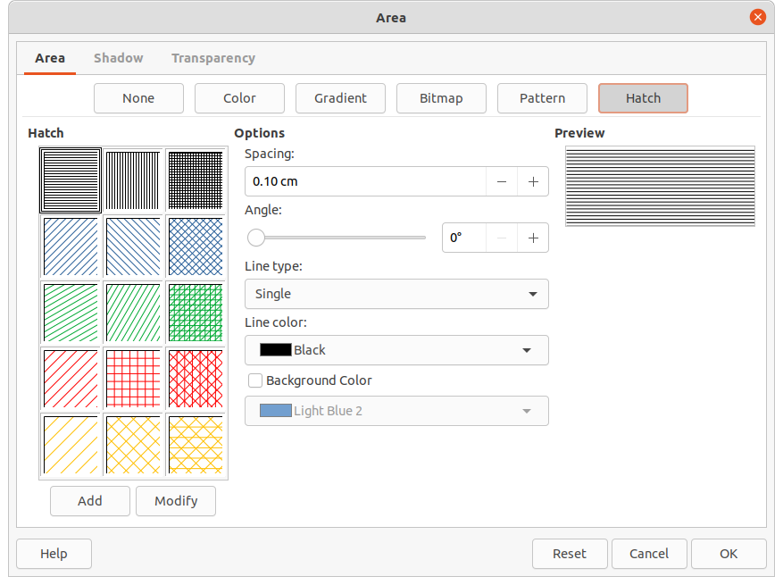Figure 24: Area dialog - Hatch page
- Open the Area page on the Area dialog, then click on Hatch to open the options available for a hatching fill (Figure 24).
- Select the required hatching from the Hatch box and the selected hatching appears in Preview.
- If necessary, change the colors or other options, as described in “Creating and saving custom hatching” below. As changes are made, the hatching displayed in the Preview box also changes.
- If necessary and to revert back to the original hatching, click on Reset and any changes made are removed.
- Click OK to close the Area dialog and save the changes. The hatching fill then appears in the selected object.

Creating and saving custom hatching
- Make sure the object is selected in a drawing.
- Open the Area page on the Area dialog, then click on Hatch.
- Select the required hatching in Hatch as a starting point and the selected hatching appears in Preview.
- Change the values in the option boxes for Spacing, Angle, Line type, Line color, and Background color to edit the hatching to the requirements. For more information on hatching options, see “3” below.
- Click on Add to open a Name dialog.
- Enter a unique name for the new hatching, then click OK to close the Name dialog. The custom hatching is placed at the end of the hatchings displayed in the Hatch box and becomes available for use in other drawings and documents.
- Click OK to close the Area dialog and save the changes.
Table 3: Hatching options
Hatching option | Meaning
Spacing | Determines the spacing between two lines of the hatching fill. As the value is changed, the preview window is updated.
Angle | Use the mini map below the numerical value to quickly set the angle formed by the line to multiples of 45 degrees. If the required angle is not a multiple of 45 degrees, enter the desired value in the edit box.
Line type | Set single, double, or triple line for the style of the hatching.
Line color | Use the list to select the color of the lines that will form the hatching.
Background color | When selected, adds a color fill behind the lines used for the hatching.

Modifying custom hatchings
Using the Modify option on the Hatch page in the Area dialog permanently changes a hatching and cannot be undone. It is recommended to only modify custom hatchings and not the predefined hatchings that were installed with LibreOffice.
- Make sure the object is selected in a drawing.
- Open the Area page on the Area dialog, then click on Hatch.
- Select a custom hatching from the Hatch box and the selected hatching appears in Preview. Custom hatchings are located below the predefined hatchings in the Hatch box.
- Change the values in the option boxes for Spacing, Angle, Line type, Line color, and Background color to edit the hatching. For more information on hatching options, see “3” above.
- If necessary and to revert back to the original hatching, click on Reset and any changes made are removed.
- Click on Modify to permanently change the selected custom hatching. There is no confirmation given when modifying a custom hatching.
- Click OK to close the Area dialog and save the changes.

Deleting custom hatching
- Select an object that uses the hatching fill for deletion.
- Open the Area page on the Area dialog, then click on Hatch.
- In the Hatch box, select the custom hatching for deletion.
- Right-click on the hatching and select Delete from the context menu. Click on Yes to confirm the deletion.
- Click OK to save the changes and close the Area dialog.
- Note
It is recommended to only delete or rename custom hatchings that have been created. Deleting or renaming one of the predefined hatchings that are installed with LibreOffice may cause problems in drawings and documents that use one of the gradients.
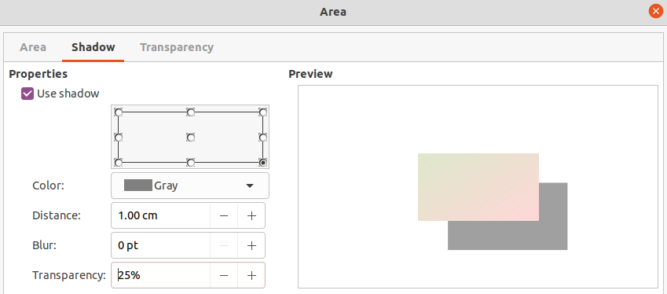Figure 25: Area dialog - Shadow page

Shadows

Default shadows
To quickly apply a shadow to an object, select the object and click on Shadow in the Line and Filling toolbar. The shadow applied to an object using this method is set to the default settings in LibreOffice.
- Note
To have more control when applying shadows to an object, use the Shadow page in Area or Line dialogs. The following describes the use of the Shadow page in the Area dialog (Figure 25), but can also be applied to the Shadow page in the Line dialog.

Formatting shadows
For a more control when adding shadows to an object, use the Shadow page on the Area dialog (Figure 25) as follows:
- Make sure the object is selected in a drawing.
- Open the Area dialog, then click on Shadow to the open the Shadow page.
- Select Use shadow for the shadow options to become active.
- Select an anchor point for the direction of the shadow cast in relation to the object.
- In Color, select the color palette and the color required for the shadow.
- In Distance, enter a distance to set spacing between the object and the shadow.
- In Blur, enter a value to soften the edges of the shadow.
- In Transparency, enter a percentage for the shadow transparency.
- Click OK to close the Area dialog and save the changes.

Transparencies
Transparencies can be applied to area fills as well as shadows and lines.
- To use transparencies on lines, refer to “Formatting lines” on page 5 for more information.
- To use transparencies on shadows, refer to “Shadows” above for more information.
To apply a transparency to an object area fill using the Area dialog (Figure 26) is as follows:
- Make sure the object is selected in a drawing.
- Open the Area dialog, then click on Transparency to the open the Transparency page and access the available options.
- To create a uniform transparency, select Transparency and enter a percentage in the text box.
- To create a gradient transparency so that the area becomes gradually transparent, select Gradient and select the type of gradient transparency from the drop-down list: Linear, Axial, Radial, Ellipsoid, Quadratic or Square. See “1” on page 21 for more information on gradient types.
- Set the parameters for the type of the gradient transparency selected above. Refer to “4” below for a description of the properties. The parameters available depends on the type of gradient transparency selected above.
- Click OK to close the Area dialog and save the changes.
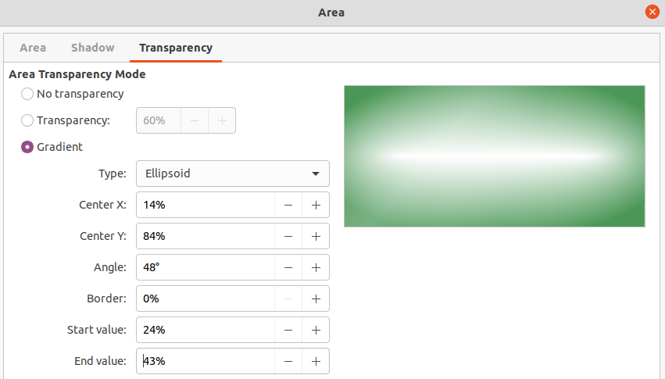Figure 26: Area dialog - Transparency page
Table 4: Transparency parameters
Transparency parameters | Meaning
Center X | For Radial, Ellipsoid, Quadratic and Square gradients. The values to set the horizontal offset of the gradient center.
Center Y | For Radial, Ellipsoid, Quadratic and Square gradients. The values to set the vertical offset of the gradient center.
Angle | For Linear, Axial, Ellipsoid, Quadratic and Square gradients. Specifies the angle of the gradient axis.
Border | Increase this value to make the gradient start further away from the border of the object.
Start value | Value for the starting transparency gradient. 0% is fully opaque, 100% means fully transparent.
End value | Value for the ending transparency gradient. 0% is fully opaque, 100% means fully transparent.

Drawing styles
Suppose that the same area fill, line thickness, and border is to be applied to a set of objects. This repetitive process can be greatly simplified by the use of styles. Styles allow a format to be defined and then applied to multiple objects. For more information on styles, see the Writer Guide.
- Note
The drawing styles included with LibreOffice Draw cannot be deleted or renamed. However, all drawing styles can be modified to the drawing requirements. Also, drawing styles can be hidden when not required, except for any drawing styles that have been used in a drawing.

Style categories
- All Styles – displays all the drawing styles available for use in Draw.
- Applied Styles – displays the drawing styles that have been used in the selected drawing.
- Hierarchical Styles – displays the drawing styles in a hierarchical list (also known as a linked or parent/child styles). To view the styles in a sub-level, click on the triangle ► next to the style name to list the styles available in the sub-level, as shown in Figure 27.
- Custom Styles – displays all the user created drawing styles that are available for use in Draw.
- Hidden Styles – displays all the drawing styles that a user has hidden when not required for use in Draw.
- Note
Hierarchical styles are used with multiple objects differ, for example, in color, but are otherwise identically formatted. Create a parent style for the objects including borders, area fill, font, and so on. Then create a hierarchical or child styles, which differ only in the fill color attribute. If the font size or the thickness of a border needs to be changed, it is sufficient to change the parent style and all the child styles are changed accordingly.
- Tip
At the bottom of the Styles deck on the Sidebar there is a drop-down list allowing selection of the style category. The style categories available are Hierarchical, All Styles, Hidden Styles, Applied Styles, and Custom Styles.
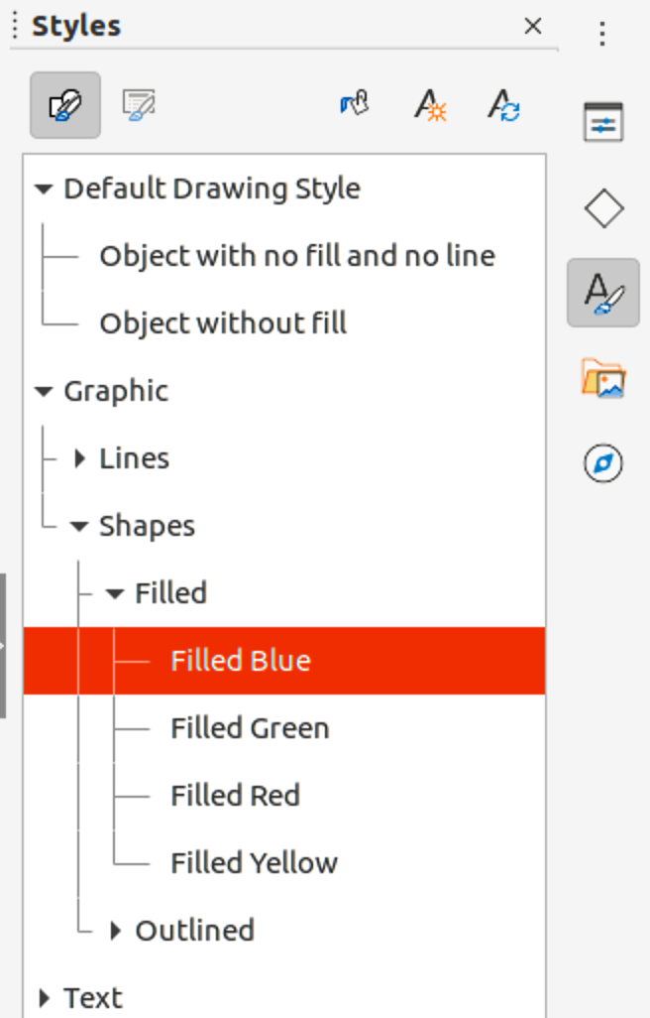Figure 27: Styles deck in Sidebar

Selecting styles
Styles can only be selected and applied to objects using the Styles deck on the Sidebar (Figure 27).
- Select the object for style application.
- Note
When an object is placed into a drawing, the Default Drawing Style is automatically applied.
- Open the Styles deck on the Sidebar using one of the following methods:
- Go to View > Sidebar on the Menu bar, then click on Styles at the right side of the Sidebar.
- Click on the Show the Styles Sidebar icon on the Line and Filling toolbar.
- Go to View > Styles on the Menu bar.
- Use the keyboard shortcut F11.
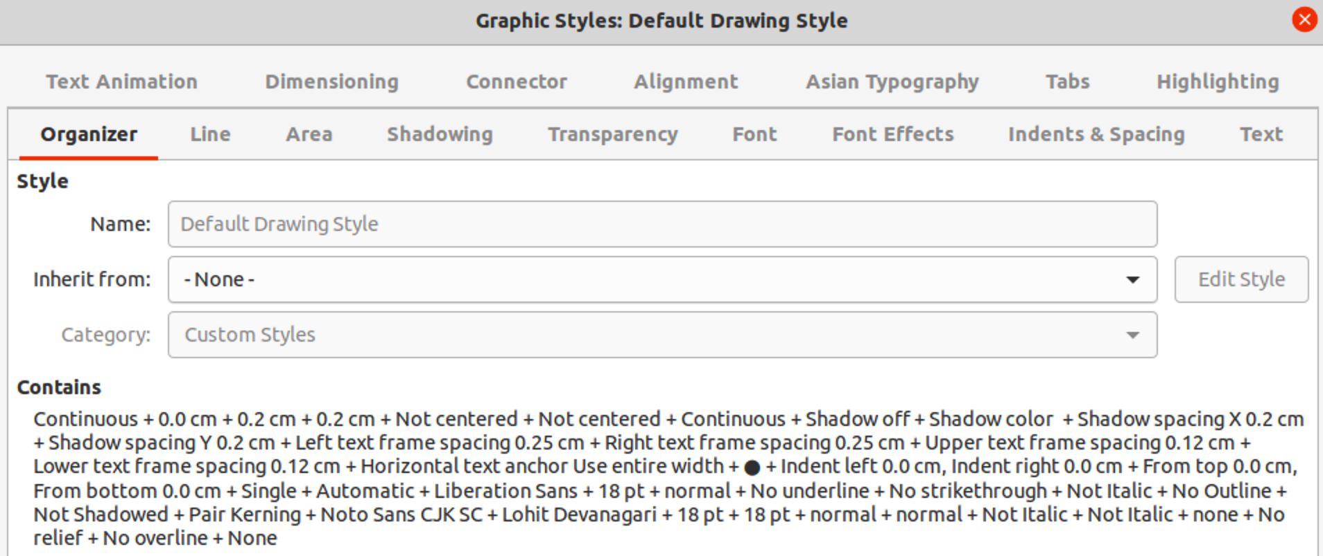Figure 28: Graphic Styles dialog - Organizer page
- Select a style category from the drop-down list at the bottom of the Styles deck.
- In the Styles deck, double-click on the style required for the selected object.
- If necessary, create a new (custom) style or modify the selected style to the requirements, as described below.
- Note
It is recommended to create new (custom) styles rather than modify the drawing styles installed with LibreOffice. Modifying drawing styles installed with LibreOffice may cause problems if the style has been used in other drawings.

Creating new or custom styles
After creating a new or custom style, it is placed in All Styles and Custom Styles categories in the Styles deck of the Sidebar. When the custom style is applied to an object, the custom style also appears in Applied Styles.

Using Styles deck
- Open the Styles deck on the Sidebar.
- Right click on the style required as a starting point to create a custom style and select New from the context menu to open the Graphic Styles dialog (Figure 28).
- Click on the Organizer tab to open the Organizer page in the Graphic Styles dialog.
- In the Name text box, enter a unique style name.
- If the new style is to inherit settings from an existing style, select a style from the Inherit from: drop-down list.
- Use the options on the various pages of the Graphic Styles dialog to format and categorize a new style.
- Organizer – contains a summary of the style and its hierarchical position.
- Font, Font Effects, Indents & Spacing, Alignment, and Tabs – sets the attributes of the text inserted into a text box or graphic object.
- Dimensioning – sets the style of dimension lines when used on an object.
- Text, Text Animation, Connector, Line, Area, Shadowing, Highlighting and Transparency – sets the attributes for the object format..
- Click OK when finished to save the new style and close the Graphic Styles dialog.

Using New Style from Selection
Using New Style from Selection allows all formatting to be made to an object first and then create a drawing style from that object.
- Select the object to create a new style from, or create a new object in a drawing.
- Format the object using the tools and options from the following dialogs and toolbars:
- Graphic Styles dialog.
- Area dialog.
- Line dialog
- Properties deck on the Sidebar.
- Line and Filling toolbar.
- Create the new style using one of the following methods:
- Open the Styles deck on the Sidebar and click on New Style from Selection at the top right of the deck.
- Go to Format > Styles > New Style from Selection on the Menu bar.
- In the Create Style dialog that opens, type a unique name for the new style. This dialog also shows existing custom styles.
- Click OK to save the new style and close the Create Style dialog.

Modifying styles
It is recommended to only modify styles that have been created. Modifying styles that are installed with LibreOffice may cause problems in other documents that use one of these styles.
- Select an object in a drawing.
- Open the Graphic Styles dialog using one of the following methods:
- Go to Format > Styles > Edit Style on the Menu bar.
- Right-click on the object and select Edit Style from the context menu.
- Right-click on the object style that is highlighted in the Styles deck on the Sidebar and select Modify from the context menu.
- Use the options on the pages of the Graphic Styles dialog to modify the object style.
- Click OK to save the changes and close the Graphic Styles dialog.

Editing hierarchical or parent styles
If an object in a drawing uses a style that is linked to a hierarchical or parent style, then it is possible to edit the hierarchical or parent style.
- Select an object in a drawing that uses a linked style.
- Open the Graphic Styles dialog and click on Organizer to open the Organizer page in the Graphic Styles dialog.
- Check that the style name in the Inherit from text box is the hierarchical or parent style for editing, use the various options on the pages in the Graphic Styles dialog to edit the style.
- If the hierarchical or parent style is NOT the one required:
- Click on Edit Style to the right of the Inherit from text box until the name of the style is displayed.
- Use the various options on the pages in the Graphic Styles dialog to edit the style.
- Click OK to save the changes and close the Graphic Styles dialog.
- Note
It is recommended to create custom hierarchical styles rather than modify the existing hierarchical styles available in LibreOffice. Modifying hierarchical styles installed with LibreOffice may cause problems if the style has been used in other drawings.

Updating styles
Using Update Style allows all the formatting to an object to be made first and then update the drawing style used by the object.
- Select the object to modify the drawing style the object uses.
- Format the object using the various tools and options from the following dialogs and toolbars:
- Graphic Styles dialog.
- Area dialog.
- Line dialog
- Properties deck on the Sidebar.
- Line and Filling toolbar.
- Update the drawing style using one of the following methods. There is no confirmation when updating a drawing style.
- Open the Styles deck on the Sidebar and click on Update Style at the top right.
- Go to Format > Styles > Update Selected Style on the Menu bar
- Note
Make sure to only update custom styles that have been created. Updating styles that are part of the default installation of LibreOffice could cause problems in other documents that use LibreOffice drawing styles.

Applying styles
Drawing styles are applied to an object using the Styles deck on the Sidebar as follows:
- Select the object to apply a drawing style.
- Click on Styles on the Line and Filling toolbar, or click on Styles on the Sidebar.
- Double click on the style name to apply the drawing style to the selected object.

Deleting styles
Predefined styles in LibreOffice cannot be deleted, even if they are not being used. Only user-defined (custom) styles can be deleted. However, before deleting a custom style, it is recommended to make sure the drawing style is not in use by checking the list of drawing styles in the Applied Styles category.
- To open a list of styles, use one of the following methods:
- Click on Styles on the Line and Filling toolbar.
- Click on Styles on the Sidebar.
- Select Applied Styles from the drop-down list at the bottom of the Styles deck on the Sidebar.
- Right click on the style name in the styles list and select Delete from the context menu.
- If the style is used on an object, a warning message will appear stating that the selected object will revert back to the default drawing style. Select Yes to confirm deletion of the style.
- If the style is not in use, select Yes to confirm deletion of the style and there is no confirmation message.

Special effects
As well as the basic actions of moving and resizing an object, a number of special effects can also be applied to objects in Draw. Several of these effects are readily available in the Transformations toolbar. If the Transformations toolbar (Figure 19 on page 23) is not showing, select it from View > Toolbars > Transformations on the Menu bar.
The tools on the Transformations toolbar are described in the following sections with the exception of the In 3-D Rotation Object tool, which is described in Chapter 7, Working with 3D Objects.

Rotating objects
Rotation of an object can be carried out manually or using a dedicated dialog. This is similar to changing the position or size of an object.

Manual rotation
- Select the object for rotation so that the selection handles are displayed.
- Use one of the following methods to switch the selected object into rotation mode,. The selection handles change shape and color when in rotation mode (Figure 29).
- Click again on the selected object.
- Click on the triangle ▼ to the right of Transformations on the Line and Filling and select Rotate from the context menu.
- If the Transformations toolbar is displayed, click on Rotate.
- Move the cursor over one of the corner handles and the cursor changes shape.
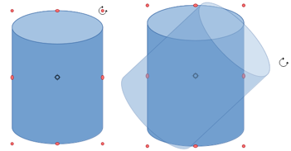Figure 29: Manually rotating objects
- Click and drag the object in the rotation direction. Only the corner selection handles are active for rotation.
- To restrict the rotation angles to multiples of 15 degrees, press and hold the Shift key while rotating the object. This is very handy for rotating objects through 90 deg, for example from portrait to landscape.
- When satisfied with the rotation, release the mouse button.
- By default, the rotation pivot point is a small circle in the center of the selected object. To change the center of object rotation, click and drag the rotation pivot point to a new position. This position for the rotation pivot point can be outside of the selected object.

Sidebar rotation
- Select the object for rotation so that the selection handles are displayed.
- Open the Position and Size section in the Properties deck on the Sidebar (Figure 30).
- Rotate the object using one of the following options:
- Click on and drag the rotation indicator in Rotation.
- Enter a rotation angle in the Rotation text box.
- When satisfied, click outside the object to deselect the object and deselect rotation mode.
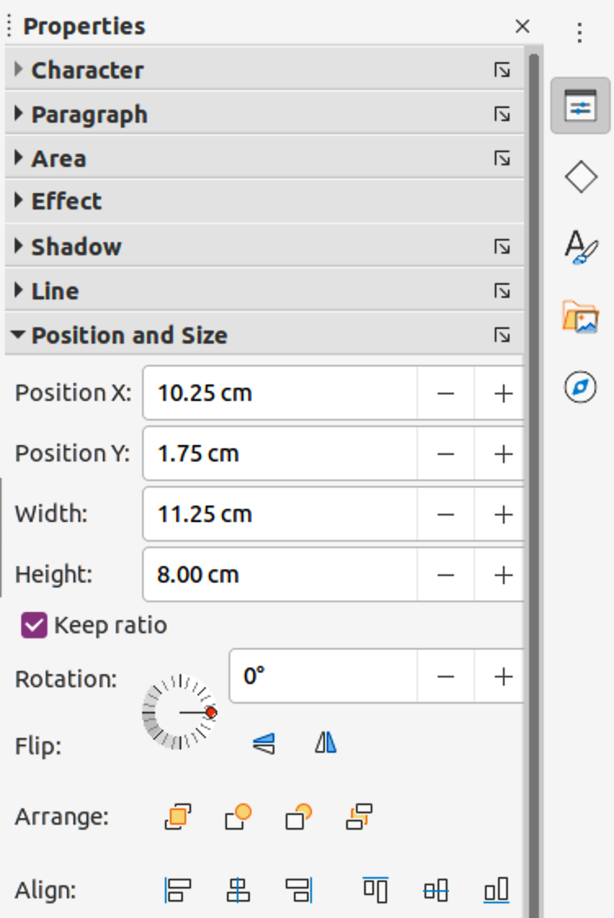Figure 30: Position and Size section in Properties deck on Sidebar
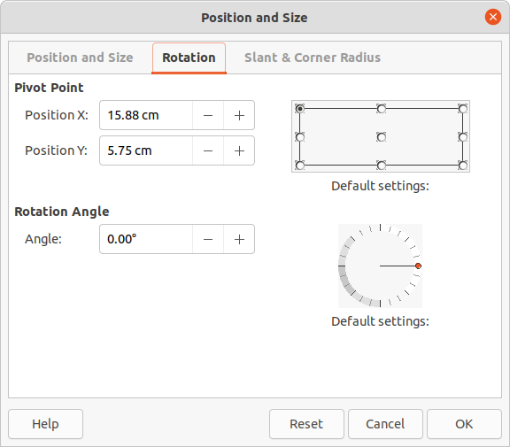Figure 31: Position and Size dialog - Rotation page

Position and Size dialog
- Select the object for rotation so that the selection handles are displayed.
- Open the Position and Size dialog (Figure 31) using one of the following methods:
- Use the keyboard shortcut F4.
- Select Format > Position and Size on the Menu bar.
- Right-click on the object and select Position and Size from the context menu.
- Click Rotation to open the Rotation page.
- Rotate the object using one of the following methods:
- In the Angle text box, enter the degrees of rotation required.
- Click on and drag the rotation indicator in Default settings.
- Click OK to save the changes and close the Position and Size dialog.

Flipping objects

Quick flipping
- Select the object for flipping so that the selection handles are displayed.
- Use one of the following methods to flip the object vertically or horizontally:
- Right click on the object and select Flip > Horizontally or Flip > Vertically from the context menu.
- In the Position and Size section of the Properties deck on the Sidebar, click on Flip Vertically or Flip Horizontally.
- In the Line and Filling toolbar, click on Vertically or Horizontally.
- Go to Shape > Flip > Vertically or Horizontally on the Menu bar.

Flip tool
Using the Flip tool on the Transformations toolbar, the position and angle that the object flips over can be changed, as shown in Figure 32.
- Select the object for flipping so that the selection handles are displayed.
- Click on the Flip tool on the Transformations toolbar and the symmetry axis appears as a dashed line through the middle of the object. The object will be flipped about this symmetry axis.
- Click and drag one or both ends of the symmetry axis to set the orientation of the axis.
- Place the cursor over one of the object selection handles until it changes shape.
- Click and drag the object across to the other side of the symmetry axis until the object appears flipped over. The angle and position of the flip depends on the angle and position of the symmetry axis.
- Release the mouse button and the object is flipped.
- Note
Pressing and holding the Shift key while moving the symmetry axis allows rotation in 45 degree increments.
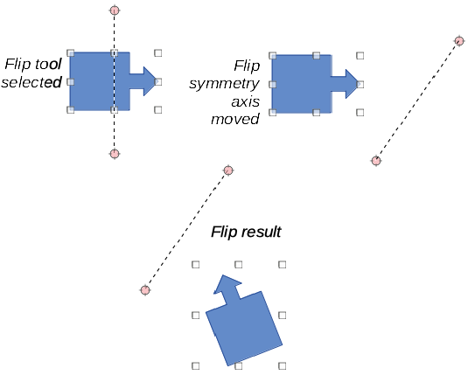Figure 32: Example of using Flip tool

Mirror copies
At the moment there is no mirror command existing in Draw. However, mirroring an object can be emulated by copying and flipping the object as follows:
- Select the object to make a mirror copy of and copy the object to the clipboard.
- Flip the object using the procedures in “Flipping objects” above.
- Click in an empty area on the drawing to deselect the object.
- Paste the copy of the original object back into its original location, creating a mirror copy.
- If necessary, select both objects and align them using one of the following methods:
- Go to Shape > Align on the Menu bar and use one of the alignment options.
- Right-click the selected objects and select Align from the context menu, then select one of the alignment options.

Distorting images
Three tools on the Transformations toolbar allow dragging on the corners and edges of an object to distort the image.
Before distorting an object, the object must be converted to a circle. Clicking on and dragging one of the object handles produces the desired effect. Examples of distortion are shown in the following figures.
- Note
Transforming an object into a curve is a safe operation, but cannot be reversed other than by clicking Format > Undo on the Menu bar.

Set in circle (perspective)
Select an object and click on Set in Circle (perspective) in the Transformations toolbar. After converting to a curve, click and drag one of the selection handles (Figure 33).
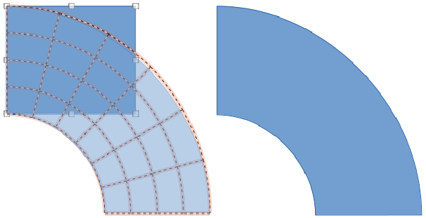Figure 33: Example of using Set in Circle (perspective) tool

Set to circle (slant)
Select an object and click on Set to Circle (slant) in the Transformations toolbar. After converting to a curve, click and drag one of the selection handles (Figure 34).
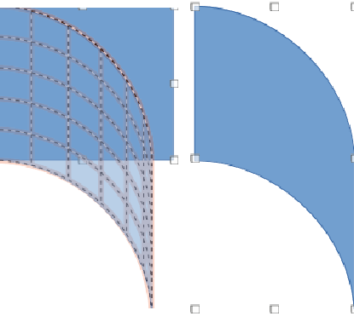Figure 34: Example of using Set in Circle (slant) tool
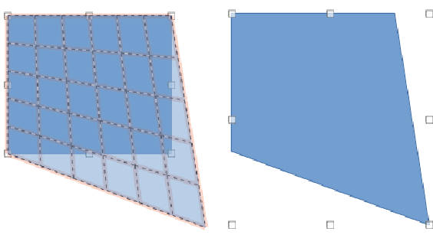Figure 35: Example of distortion using corner selection handle
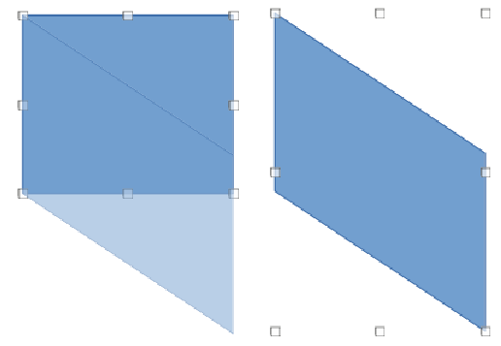Figure 36: Example of distortion using vertical selection handle
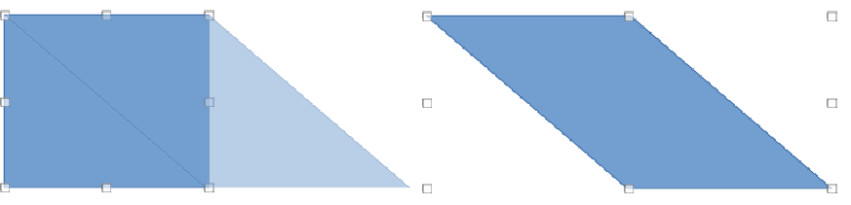Figure 37: Example of distortion using horizontal selection handle

Distort
Select an object and click on Distort on the Transformations toolbar. After converting to a curve, click and drag a selection handle to stretch the object. The corner handles distort the corners of the object (Figure 35), the vertical midpoint handles distort the object horizontally (Figure 36) and the horizontal midpoint handles distort the object vertically (Figure 37).

Dynamic gradients
Transparency gradients are controlled in the same manner as color gradients and both types of gradient can be used together. With a transparency gradient, the direction and degree of object fill color changes from opaque to transparent. In a color gradient, the fill changes from one color to another, but the degree of transparency remains the same.
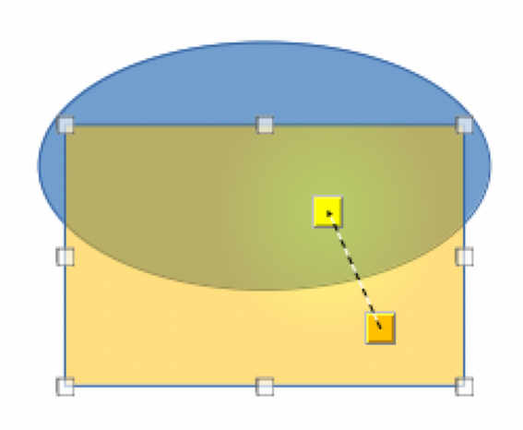Figure 38: Example of dynamic gradient
Two icons on the Transformations toolbar dynamically control transparency and color gradients. Even if an object with a color fill is not assigned transparency, the transparency can be controlled by clicking on Interactive transparency tool. This defines a transparency gradient and a dashed line connecting two squares appears on the object. Move the two squares to modify the gradient. Define the direction of the gradient (vertical, horizontal, or at any angle) and the spot at which the transparency begins.
A regular color gradient is defined in the same manner. Select an object, then select a gradient area fill (see “Gradient fills” on page 20 for more information). The Interactive gradient tool is now active on the Transformations toolbar. When clicking on Interactive gradient tool, a dashed line connecting two squares appears on the object, just as it does for a transparency gradient.
In both transparency gradient and gradient fill, click outside the object to set the gradient.
In the example shown in Figure 38 there is a single color object and a transparency gradient, covering part of the underlying object. This gradient transparency can be dynamically adjusted. Direction of transparency is changed by moving the white square and the distance over which it is applied by moving the green square.
- Note
Moving the squares has different effects, depending on the type of gradient. For example, for a linear gradient, the start and end squares of the gradient will always be situated to either side of the center point of the object.

