
Impress Guide 7.5

Chapter 1,
Introducing Impress
Presentations in LibreOffice

Copyright
This document is Copyright © 2023 by the LibreOffice Documentation Team. Contributors are listed below. This document may be distributed and/or modified under the terms of either the GNU General Public License (https://www.gnu.org/licenses/gpl.html), version 3 or later, or the Creative Commons Attribution License (https://creativecommons.org/licenses/by/4.0/), version 4.0 or later. All trademarks within this guide belong to their legitimate owners.

Contributors
Contributors for this edition:
Peter Schofield

Contributors for previous editions:
Claire Wood
Dimona Delvere
Gary Schnabl
Hazel Russman
Jean Hollis Weber
Kees Kriek
Linda Worthington
Michele Zarri
Peter Hillier-Brook
Peter Schofield
Rachel Kartch
T. Elliot Turner
Vasudev Narayanan

Feedback
Please direct any comments or suggestions about this document to the Documentation Team Forum at https://community.documentfoundation.org/c/documentation/loguides/ (registration is required) or send an email to: loguides@community.documentfoundation.org.
- Note
Everything sent to a forum, including email addresses and any other personal information that is written in the message, is publicly archived and cannot be deleted. Emails sent to the forum are moderated.

Publication date and software version
Published June 2023. Based on LibreOffice 7.5 Community.
Other versions of LibreOffice may differ in appearance and functionality.

Using LibreOffice on macOS
Some keystrokes and menu items are different on macOS from those used in Windows and Linux. The table below gives some common substitutions used in this document. For a detailed list, see LibreOffice Help.
Windows or Linux | macOS equivalent | Effect
Tools > Options  menu selection | LibreOffice > Preferences | Access setup options
Right-click | Control+click, Ctrl+click, or right-click depending on computer setup | Open a context menu
Ctrl or Control | ⌘ and/or Cmd or Command, depending on keyboard | Used with other keys
Alt | ⌥ and/or Alt or Option depending on keyboard | Used with other keys
F11 | ⌘+T | Open the Styles deck in the Sidebar

Contents
Copyright 2
Contributors 2
Feedback 2
Publication date and software version 2
Using LibreOffice on macOS 2
Introduction 5
Starting Impress 5
Main Impress window 7
Menu bar 7
Workspace 7
Slides pane 8
Sidebar 8
Properties 9
Styles 9
Gallery 9
Navigator 9
Shapes 9
Slide transition 9
Animation 9
Master slides 10
Rulers 10
Status bar 11
Navigator 12
Toolbars 13
Workspace views 14
Normal view 15
Outline view 15
Notes view 16
Slide Sorter view 16
Customizing Slide Sorter view 16
Changing slide order 16
Selecting a group of slides 17
Working in Slide Sorter view 17
Creating presentations 18
New presentation 18
Inserting new slide 19
Duplicating slides 19
Slide format 20
Slide layout 20
Selecting slide layout 20
Changing slide layout 21
Slide contents 21
Modifying slide elements 22
Moving contents box 22
Resizing contents box 22
Removing elements 22
Adding text 22
Adding images or objects 23
Modifying slide appearance 23
Modifying presentations 24
Slide order 25
Animations 25
Slide transitions 25
Running a presentation 25
Single displays 25
Multiple displays 26

Introduction
Impress is the presentation (slide show) module included in LibreOffice. Impress creates presentations using the Open Document Presentation (ODP) format, which can be opened by other presentation software, or exported in different presentation formats.
Slides created can contain many different elements, including text, bulleted and numbered lists, tables, charts, and a wide range of graphic objects such as clipart, drawings and photographs. Impress also includes a spelling checker, a thesaurus, text styles, and background styles.
This chapter introduces the Impress user interface. The remaining chapters in this user guide explain features available in Impress that are used to create more sophisticated slide shows.
To use Impress for more than very simple presentations requires some knowledge of the elements which are used in slides. Slides containing text use styles to determine the appearance of text. Creating drawings in Impress is similar to the Draw module included in LibreOffice. It is recommended to consult the Draw Guide for more details on how to use drawing tools.

Starting Impress
Impress can be started in several ways:
- From the LibreOffice Start Center that opens when LibreOffice is opened and no other LibreOffice module is open.
- Click on Impress Presentation to create a new presentation.
- Click on Open File and navigate to the folder that contains an existing presentation.
- Click on Remote Files and navigate to the remote server and folder that contains an existing presentation.
- From the system menu using a standard menu from which most applications are started. Details vary with the operating system. See the Getting Started Guide for more information, some examples are listed below:
- Start menu in Windows.
- Applications menu in Linux with a Gnome desktop.
- Applications menu in macOS.
- From any open module of LibreOffice.
- Go to File > New > Presentation on the Menu bar.
- Click on the triangle ▼ next to New on the Standard toolbar and select Presentation from the drop-down menu.
- Notes
When LibreOffice is installed on a computer, a menu entry for each component is normally added to the system menu. The exact name and location of these menu entries depend on the operating system and graphical user interface.
The New icon displayed on the Standard toolbar depends on which LibreOffice module is open when creating a new presentation.
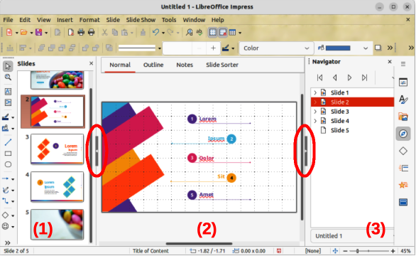
Figure 1: Main Impress window
- Slides pane
- Workspace
- Sidebar
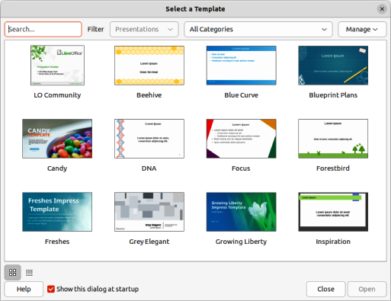
Figure 2: Select a Template dialog
When starting Impress, the main Impress window (Figure 1) opens and, as default, with the Select a Template dialog displayed (Figure 2). Templates included with Impress are designed to fit the two standard sizes of presentation slides: 4:3 and 16:9 ratios. However, templates will adapt to other sizes that are available and can be selected by going to Slide > Slide Properties > Paper Format on the Menu bar, or Format in the Slide panel in the Properties deck on the Sidebar.
- Tips
To start Impress without the Select a Template dialog opening, deselect the option Show this dialog at startup in the lower left of the dialog. Alternatively, go to Tools > Options > LibreOffice Impress > General (macOS LibreOffice > Preferences > LibreOffice Impress > General)on the Menu bar and deselect Start with Template Selection in New Document.

Main Impress window
The main Impress window (Figure 1) has three main sections: Slides pane, Workspace, and Sidebar. At the top of the main window is the Menu bar and toolbars. Toolbars can be displayed or hidden during the creation of a presentation.
- Tips
The Slides pane and/or Sidebar can be closed by clicking the X in the upper right corner of each pane, or go to View > Slide Pane or View > Sidebar on the Menu bar to deselect. To reopen a pane, select View > Slides pane or View > Sidebar on the Menu bar.
To maximize the Workspace area click on the Hide/Show marker in the middle of the vertical separator line (highlighted in Figure 1). Using the Hide/Show marker hides the Slides pane or Sidebar, but does not close them. To restore the Slides pane or Sidebar, click again on its Hide/Show marker.

Menu bar
The Impress Menu bar, at the top of the main window, provides several menus common to all LibreOffice modules. The commands may differ between each LibreOffice module for File, Edit, View, Insert, Format, Tools, Window, and Help. Impress has two extra menus for Slide and Slide Show. When a menu is selected, a submenu drops down to show commands. The Menu bar can be customized and for more information, see the Getting Started Guide.

Workspace
The Workspace (normally the center of the main window) opens in the Normal view. It has four standard views of Normal, Outline, Notes, and Slide Sorter (Figure 3). For more information on workspace views, see “Workspace views” page 14.
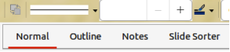
Figure 3: Workspace view tabs
If master slides are being used, then master views become available: Master Slide, Master Notes and Master Handout. There are no tabs for master views and these are selected by going to View on the Menu bar. For more information on master slides, see Chapter 2, Using Slide Masters, Styles, and Templates.

Slides pane
The Slides pane displays thumbnail images of slides in a presentation in the order in which the slides are shown. The slide show order can be changed and is described in Chapter 9, Slide Shows & Photo Albums. Clicking on a slide image in the Slides pane selects it and places the slide in the Workspace where changes are made to the displayed slide.
- To display or close the Slides pane, go to View > Slide Pane on the Menu bar.
- To close the Slides pane, click on the X in the right top corner of the Slides pane.
- To display or hide the Slides pane, use the Hide/Show marker on the left of the Workspace.
Several additional operations can be carried out on one or more slides in the Slides pane. Also, these additional operations are available from a context menu when right-clicking on a slide in the Slides pane.
- Add new slides to a presentation.
- Duplicate a slide.
- Rename a slide.
- Hide a slide so that it will not show in a presentation.
- Delete a slide from a presentation.
- Move a slide to another position in the slide order by dragging and dropping it to the desired position.
- Change the layout for a slide, or a group of slides.
- Navigate to select slides in the presentation.
- Move a slide to another position in the slide sequence.
- Change slide properties by opening the Slide Properties dialog.

Sidebar
The Impress Sidebar, normally located on the right side of the Workspace, is similar to the Sidebar in the other LibreOffice module and consists of eight decks. To display or hide the Sidebar, use one of the following methods:
- Go to View > Sidebar on the Menu bar.
- Use the keyboard shortcut Ctrl+F5 (macOS ⌘+F5).
- Use the Hide/Show marker on the right of the Workspace (Figure 1 on page 6).
- To hide the Sidebar, click on the X in the right top corner of the Sidebar.
- To display the Sidebar, click on one of the Sidebar icons to open a deck.
To open a Sidebar deck, use one of the following methods:
- Click on its icon on the right side of the Sidebar.
- Click on Sidebar Settings at the top of the Sidebar and select a deck from the drop-down list.
- Use one of the available keyboard shortcuts for Sidebar decks.

Properties
The Properties deck has ten panels, allowing the slide layout to be changed and objects formatted on a slide (keyboard shortcut Ctrl+Alt+1, macOS ⌘+⌥+1).
- When a slide is selected and appears in the Workspace, the Properties deck opens with the Slides and Layouts panels available.
- When an object on a slide is selected, the Properties deck has the following panels available: Character, Lists, Paragraph, Area, Shadow, Line, Position and Size, Columns, Effect, and Image. Actual panels displayed depends on the type of object selected.

Styles
On the Styles deck, drawing and presentation styles are applied to a selected object, new styles created for drawing and presentation, and both types of styles can be modified. When saving changes to a style, the changes are applied to all of the elements formatted with that style in the presentation. For more information on styles, see Chapter 2, Using Slide Masters, Styles, and Templates (keyboard shortcut Ctrl+Alt+2, macOS ⌘+⌥+2).

Gallery
On the Gallery deck, an object is inserted into a presentation either as a copy or as a link. A copy of an object is independent of the original object. Changes to the original object have no effect on the copy. A link remains dependent on the original object. Changes to the original object are also reflected in the link (keyboard shortcut Ctrl+Alt+3, macOS ⌘+⌥+3).

Navigator
The Navigator deck displays all objects contained in a presentation. It provides a convenient way to move between slides in a presentation or select an object on a slide. It is recommended to give slides and objects in a presentation meaningful names for easy identification when using the Navigator (keyboard shortcut Ctrl+Alt+4, macOS ⌘+⌥+4). For more information, see “Navigator” on page 12.

Shapes
The Shapes deck provides panels for quick selection of basic shapes that are available on the Drawing toolbar: Lines and Arrows, Curves and Polygons, Connectors, Basic Shapes, Symbol Shapes, Block Arrows, Flowchart, Callout Shapes, Stars and Banners, and 3-D Objects (keyboard shortcut Ctrl+Alt+5, macOS ⌘+⌥+5).

Slide transition
The Slide Transition deck provides a selection of slide transitions used in a slide show. There are controls to adjust transition speed, automatic or manual transition, and how long a selected slide is shown (automatic transition only) (keyboard shortcut Ctrl+Alt+6, macOS ⌘+⌥+6). For more information on transitions, see Chapter 9, Slide Shows & Photo Albums.

Animation
The Animation deck is used to add, change, or remove animations for different elements or objects on a slide and adjust how they appear during a slide show (keyboard shortcut Ctrl+Alt+7, macOS ⌘+⌥+7). For more information on animation, see Chapter 9, Slide Shows & Photo Albums.

Master slides
The Master Slides deck provides access to slide designs for slide shows and several designs of master slides are available. The default master slide is blank, but the remaining master slides have backgrounds and styled text (keyboard shortcut Ctrl+Alt+8, macOS ⌘+⌥+8). For more information on master slides, see Chapter 2, Using Slide Masters, Styles, and Templates.

Rulers
Rulers are positioned on the upper and left-hand sides of the Workspace. If the rulers are not visible, go to View > Rulers in the Menu bar. Rulers show the size of a selected object on the slide using double lines (highlighted in Figure 4). Also, rulers are used to manage object handles and guide lines when positioning objects.
To change the measurement units of the rulers, right-click on a ruler and select the measurement unit from the drop-down list, as shown in Figure 5 for the horizontal ruler. The horizontal and vertical rulers can be set to different measurement units.
The page margins in the drawing area are also represented on the rulers. The margins can be changed directly on the rulers by dragging them with the cursor. The margin area is indicated by either a grayed out area on the rulers or borders around the unused area of the ruler. This margin indication depends on computer setup and operating system.
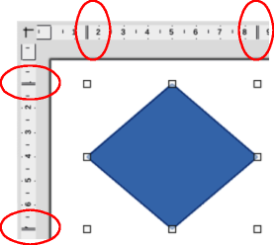
Figure 4: Rulers showing object size
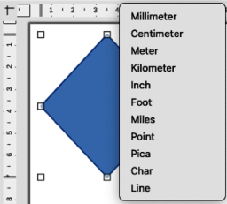
Figure 5: Changing ruler units
- Note
The sizes are given in the current measurement unit and might not be the same as the ruler units. The measurement unit on the Status bar is defined in Tools > Options > LibreOffice Impress > General (macOS LibreOffice > Preferences > LibreOffice Impress > General.
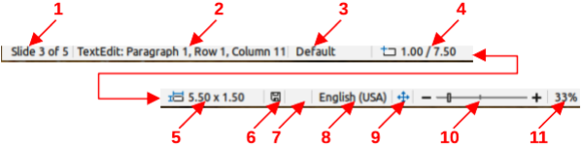
Figure 6: Status Bar
Legend for Figure 6
- Slide number
- Information area
- Master slide
- Cursor position
- Object size
- Unsaved changes
- Digital signature
- Text language
- Fit slide
- Zoom slider
- Zoom percentage

Status bar
The Status Bar (Figure 6), located at the bottom of the Impress main window, contains information that may be useful when working on a presentation. To hide the Status Bar, go to View on the Menu bar and deselect Status Bar.
Slide number
The slide number currently displayed in the Workspace and the total number of slides in the presentation.
Information area
This changes depending on the object selected on the slide. Examples of the information displayed are shown in Table 1.
Table 1: Examples of information on Status Bar
Example selection | Examples of information shown
Text area | Text Edit: Paragraph x, Row y, Column z
Charts, spreadsheets | Embedded object (OLE) “ObjectName” selected
Graphics | Bitmap with transparency selected
Master slide
The master slide associated with the slide or notes page currently displayed in the Workspace. Right-click to open a list of available master slides and select one to apply it to the selected slide. Double-click to open the Available Master Slides dialog. For more information on master slides, see Chapter 2, Using Slide Masters, Styles and Templates.
Cursor position/Object size
Shows different information depending on whether objects are selected or not.
When no object is selected, the position numbers show the current position (X and Y coordinates) of the cursor.
When an object is selected and being resized with the cursor, the object size numbers show the size of the object (width and height).
If an object is selected, the position numbers shows X and Y coordinates of the upper-left corner and the object size number pair displays the size of the object. These numbers do not relate to the object itself, but to the selection outline, which is the smallest possible rectangle that can contain the visible part or parts of the object.
When an object is selected, clicking in either of these areas opens the Position and Size dialog.
Unsaved changes
Indicates if there are any unsaved changes in the presentation. Clicking this icon saves the document. If the presentation has not been saved before, the Save As dialog opens giving the opportunity to save the presentation.
Digital signatures
Indicates if the presentation has a digital signature.
Text language
Indicates the language used for any text on a presentation.
Fit slide
When this icon is clicked on, the slide in the Workspace zooms to fit in the Workspace.
Zoom slider
When moved, the slide changes its viewing zoom in the Workspace.
Zoom percentage
Indicates the zoom level of the slide displayed in the Workspace. Clicking on zoom percentage opens the Zoom & View Layout dialog where the settings for zoom factor and view layout are adjusted.

Navigator
The Navigator displays all objects contained in a presentation providing a convenient way of moving within a presentation and locating objects in the presentation.
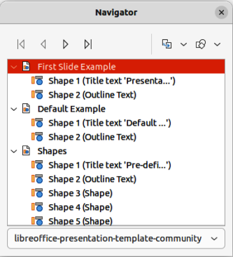
Figure 7: Navigator dialog
To open the Navigator dialog (Figure 7) go to View > Navigator on the Menu bar, or use the keyboard shortcut Ctrl+Shift+F5 (macOS ⌘+Shift+F5). Alternatively, click on Navigator in the Sidebar to open the Navigator deck that is similar in appearance and function as the Navigator dialog.
The Navigator is more useful if slides and objects (pictures, spreadsheets, and so on) are given meaningful names, instead of leaving them with default names, such as “Slide 1” and “Shape 1” and so on (as shown in Figure 7). Using meaningful names allows for slides or objects to be easily identified and located in a presentation.

Toolbars
Impress toolbars provide several tools that are used for creating slides for a presentation. To display or hide the various toolbars in Impress, go to View > Toolbars on the Menu bar and select the required toolbar from the submenu that appears. For example, Standard and Drawing toolbars are displayed by default, but the Line and Filling, and Text Formatting toolbars are not displayed and have to be selected.
To change the tools available on any toolbar, right-click in an empty area on the toolbar and select Visible Buttons from the context menu. Installed tools are indicated by a check mark next to the tool name, or the tool icon is highlighted, depending on the computer operating system. Click on a tool name to hide or show it in the toolbar. For more information, see Chapter 11, Setting Up and Customizing Impress, Appendix B, Toolbars, and the Getting Started Guide.
- Note
The appearance of the toolbar icons varies depending on the computer operating system, and the selection of icon size and style in Tools > Options > LibreOffice > View (macOS LibreOffice > Preferences > Options > LibreOffice > View). For more information about working with toolbars, see Appendix B, Toolbars and the Getting Started Guide.
The following toolbars are widely used when creating a presentation:
Standard toolbar
The Standard toolbar (Figure 8) is similar for all LibreOffice modules and is not described in detail in this user guide. By default, it is docked and located just under the Menu bar at the top of the Workspace.
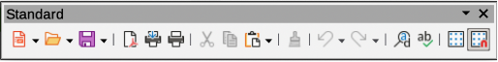
Figure 8: Standard toolbar
Drawing toolbar
The Drawing toolbar (Figure 9) contains all the necessary functions for drawing various geometric and freehand shapes, and for organizing them in a slide. By default, the Drawing toolbar is docked and located on the left of the Workspace. For more information on using drawing tools, see Chapter 5, Managing Graphic Objects.
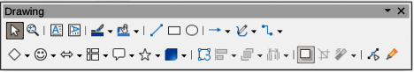
Figure 9: Drawing toolbar
Line and Filling toolbar
The Line and Filling toolbar (Figure 10) provides the tools for modifying the properties of an object, for example line color, line style, line width, fill color and style, and other properties of a selected object. If the selected object is a text frame, the Line and Filling toolbar is automatically replaced by the Text Formatting toolbar.
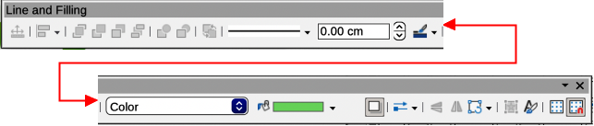
Figure 10: Line and Filling toolbar
Text Formatting toolbar
The Text Formatting toolbar (Figure 11) is similar to the Formatting toolbar in LibreOffice Writer and only appears when a text object has been selected in a presentation, automatically replacing the Line and Filling toolbar.
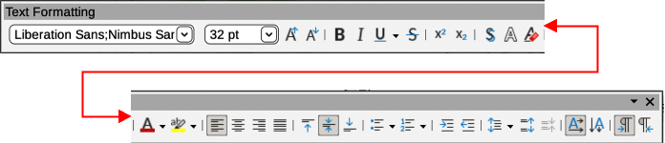
Figure 11: Text Formatting toolbar

Workspace views
The Impress workspace has four standard views Normal, Outline, Notes, and Slide Sorter. Each workspace views is designed to make it easier to complete certain tasks. The different views can be selected using one of the following methods:
- Click on a tab at the top of the Workspace (Figure 3 on page 7). If the tabs are not displayed, then go to View > Views Tab Bar on the Menu bar.
- Go to View on the Menu bar and select a workspace view from the options in the submenu.
The Impress workspace also has three master views available for creating master slides in a presentation. There are no tabs for master views and are selected by going to View on the Menu bar. The options available are Master Slide, Master Notes, and Master Handout. For more information on master slides, see Chapter 2, Using Slide Masters, Styles, and Templates.
- Note
Each workspace view displays a different set of toolbars when selected. To customize these toolbar sets, go to View > Toolbars on the Menu bar, then select or deselect a toolbar to open or close toolbars.

Normal view
Normal view is the main standard view for creating individual slides in a presentation. In Normal view slides are designed, text or graphics added and formatted, and any animation effects added to text or graphics.
To place a slide in Normal view of the Workspace, either click on the slide thumbnail in the Slides pane or click on the slide name in the Navigator dialog or Navigator deck in the Sidebar.

Outline view
Outline view in the Workspace (Figure 12) contains all of the slides of a presentation in a numbered sequence. It shows topic titles, bulleted lists, and numbered lists for each slide in outline format. Only the text contained in the default text boxes in each slide is shown. If text boxes or graphic objects have been added to the slides, then these objects are not displayed. Slide names are not included.
Outline view can be used for the following:
- Making changes in the text of a slide.
- Adding or deleting text in a slide as in Normal view.
- Moving a paragraph in a slide up or down by using the movement arrows on the Outline toolbar (Figure 13).
- Changing the outline level of a paragraph in a slide using the left and right arrow buttons on the Outline toolbar.
- Comparing slides with an outline, if an outline has been prepared in advance. If another slide is required, it can be created directly in Outline view, or Normal view.
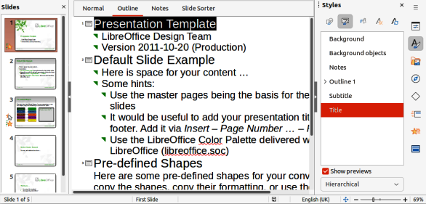
Figure 12: Example of Workspace Outline view
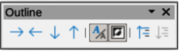
Figure 13: Outline toolbar
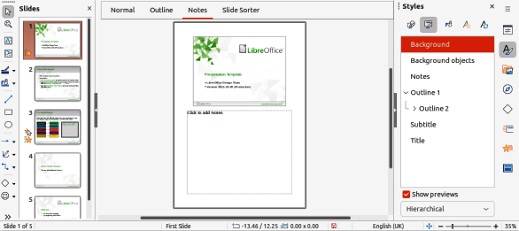
Figure 14: Example of Workspace Notes view

Notes view
Use Notes view in the Workspace (Figure 14) to add notes to a slide. These notes are not seen when the presentation is shown to an audience on an external display connected to a computer.
- Click on Notes in the Workspace to open Notes view.
- Select a slide in the Slides pane so that the slide appears in the Workspace.
- In the text box below the slide, click on the words Click to add notes and begin typing the required notes for the selected slide.
The Click to add notes text box can be resized using the resizing handles which appear when the border of the notes box is selected. Move or change the size of the box by clicking and dragging on the box border.
When text is inserted in the Click to add notes text box, it is automatically formatted using the predefined Notes style in Presentation Styles in the Styles deck on the Sidebar. The Notes style can be formatted to the presentation requirements. For more information, see Chapter 8, Adding and Formatting Slides, and Notes.

Slide Sorter view
The Slide Sorter view in the Workspace (Figure 15) contains thumbnails of the slides used in a presentation. Use this view to work with one slide or a group of slides.

Customizing Slide Sorter view
- Go to View > Toolbars > Slide View on the Menu bar to show the Slide View toolbar (Figure 16).
- Adjust the number of slides in the Slides per Row box, up to a maximum of 15.

Changing slide order
To change the slide order in a presentation of a single slide or a group of slides using Slide Sorter view is as follows:
- Select a slide or a group of slides.
- Drag and drop the slide or group of slides at the new position in the presentation.
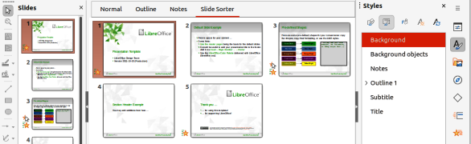
Figure 15: Example of Slide Sorter view
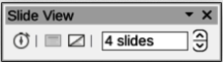
Figure 16: Slide View toolbar

Selecting a group of slides
To select a group of slides in Slide Sorter view, use one of the following methods:
- Ctrl key (macOS ⌘) — click on the first slide and, while holding the Ctrl key, select the required slides. The selected slides do not have to be next to each other.
- Shift key — click on the first slide, and while pressing the Shift key, select the final slide for the group. This selects all of the slides between the first and the last slide selected.
- Click and drag — position the cursor slightly to one side and outside the first slide, then click and hold dragging the cursor until all of the slides required for the group are selected.

Working in Slide Sorter view
Working with slides in Slide Sorter view is similar to working with slides in the Slides pane. To make changes, right-click on a slide in Slide Sorter view and choose one of the following from the context menu:
Cut
Removes the selected slide and saves it to the clipboard.
Copy
Copies the selected slide to the clipboard without removing it.
Paste
Inserts a slide from the clipboard after the selected slide.
New Slide
Adds a new slide after the selected slide.
Duplicate Slide
Creates a duplicate of the selected slide and places the new slide immediately after the selected slide.
Rename Slide
Renames the selected slide.
Hide Slide
Any slides that are hidden are not shown in the presentation.
Delete Slide
Deletes the selected slide.
Layout
Allows changes to the layout of the selected slide.
Move
Allows moving or repositioning of the slide in the presentation order.

Creating presentations
By default, Impress opens with the Select a Template dialog displayed to select a template for a new presentation. To create a new presentation without a template, click on Cancel in the Select a Template dialog and a blank slide opens in the Workspace and Slides pane.
To prevent the Select a Template dialog from opening, go to Tools > Options > LibreOffice Impress > General (macOS LibreOffice > Preferences > LibreOffice Impress > General) on the Menu bar to open Options LibreOffice Impress General dialog (Figure 17) and deselect the option Start with Template Selection.
For more information on creating presentations, slide show options, and presentation settings, see Chapter 9, Slide Shows & Photo Albums and Chapter 11, Setting Up and Customizing Impress.
- Tip
Decide on the purpose of a presentation and plan accordingly. Having an idea of the audience type, the structure, the content, and how the presentation will be delivered saves a lot of time from the start.

New presentation
When creating a new presentation, Impress shows only one slide in the Slides pane and Workspace.
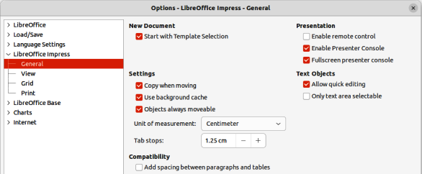
Figure 17: Options LibreOffice Impress dialog — General page
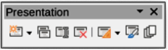
Figure 18: Presentation toolbar

Inserting new slide
A new slide is inserted into a presentation using one of the following methods.
- Go to Slide > New Slide on the Menu bar.
- Right-click in the Slides pane and select New Slide from the context menu.
- Use the keyboard shortcut Ctrl+M (macOS ⌘+M).
- Go to Slide Sorter view in the Workspace, right-click on a slide and select New Slide from the context menu.
- Click on New Slide in the Presentation toolbar (Figure 18). If the Presentation toolbar is not visible, go to View > Toolbars on the Menu bar and select Presentation from the submenu.
- Note
A new slide is inserted after the selected slide in the presentation. If a slide is not selected, then the new slide is inserted as the last slide in the presentation.

Duplicating slides
To duplicate a slide, select a slide for duplication in the Slides pane and use one of the following methods. A duplicate slide is inserted after the selected slide in the presentation.
- Right-click on a slide in the Slides pane and select Duplicate Slide from the context menu.
- Go to Slide Sorter view in the Workspace, right-click on a slide and select Duplicate Slide from the context menu.
- Go to Slide > Duplicate Slide on the Menu bar.
- Click on Duplicate Slide on the Presentation toolbar.
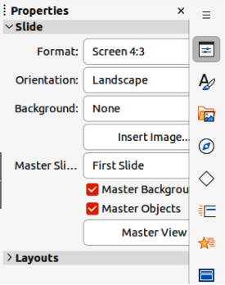
Figure 19: Slide panel in Properties deck on Sidebar

Slide format
Click on Properties on the Sidebar and open the Slide panel (Figure 19) to display the format options available for a presentation. The Slide panel allows for quick formatting of all slides included in a presentation and selecting master slides for a presentation. For more information on formatting slides and using master slides, see Chapter 2, Using Slide Masters, Styles, and Templates and Chapter 8, Adding and Formatting Slides and Notes.

Slide layout
By default in Impress, the Title Slide layout is used for the first slide when a new presentation is created. The layouts included in Impress range from a blank slide to a slide with six contents boxes and a title. For more information on slide layouts, see Chapter 8, Adding and Formatting Slides, and Notes.
The first slide in a presentation is normally a title slide. The layouts Title Slide, which also contains a section for a subtitle, or Title Only are the most suitable layouts for the first slide in a presentation. For the remaining slides, select the most suitable layout to use for the slide contents.
Impress does not have the functionality to create custom layouts. However, the different elements in a slide layout can be resized and moved. For more information, see “Modifying slide elements” on page 22.

Selecting slide layout
The available layouts are shown in the Layouts panel on the Properties deck on the Sidebar. After selecting a slide, select the slide layout using one of the following methods:
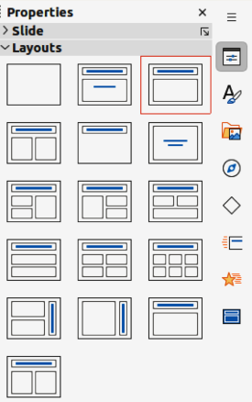
Figure 20: Layouts panel in Properties deck on Sidebar
- Go to the Properties deck on the Sidebar to open the Layouts panel (Figure 20).
- Click on Slide Layout on the Presentation toolbar to open the Layouts panel on the Properties deck on the Sidebar.
- Click on Slide > Layout on the Menu bar to open a submenu showing the layouts by name.
- Right-click on the selected slide and select Layouts in the context menu.

Changing slide layout
After selecting a slide in a presentation, change the slide layout using one of the following methods:
- Select a slide in the presentation.
- Select a new layout for the slide using one of the methods described in “Selecting slide layout” above.

Slide contents
Several layouts can contain one or more content boxes. Each of these content boxes can be configured to contain the following elements:
Slide title
Click on Click to add Title and type a title in the text box. Impress enters text editing mode and the Text Formatting toolbar automatically opens. For more information on formatting text, see Chapter 3, Adding and Formatting Text.
Text
Click on Click to add Text and type the contents into the text box. Impress enters text editing mode and the Text Formatting toolbar automatically opens. For more information on formatting text, see Chapter 3, Adding and Formatting Text.
Table
Go to Insert > Table on the Menu bar and the Insert Table dialog opens. Enter the number of columns and rows, then click OK. The dialog closes and a table is inserted into the slide. Impress enters text editing mode and the Text Formatting toolbar automatically opens. For more information on using tables, see Chapter 3, Adding and Formatting Text.
Chart
Go to Insert > Chart on the Menu bar and the Impress default chart is placed in the slide. The Chart Type panel opens in the Properties deck on the Sidebar allowing editing of the chart to the presentation requirements. For more information on using charts, see Chapter 7, OLE, Spreadsheets, Charts, and Other Objects.
Image
Go to Insert > Image on the Menu bar and a file browser opens. Navigate to where the required image is located. Select the file and click on Open. The image is placed into the slide and the file browser closes. The Image panel opens in the Properties deck on the Sidebar allowing editing of the image file. For more information on using images, see Chapter 4, Adding and Formatting Images, and Chapter 7, OLE, Spreadsheets, Charts, and Other Objects.
Audio or Video
Go to Insert > Audio or Video on the Menu bar and a file browser opens. Navigate to where the required audio or video file is located. Select the file and click on Open. The audio or video file is placed into the slide and the file browser closes. The Media Playback toolbar opens allowing operation of the audio or video file. For more information, see Chapter 7, OLE, Spreadsheets, Charts, and Other Objects.
- Note
Text and graphic elements can be readjusted at any time when creating a presentation. However, changing slide layout that already has contents can have a dramatic effect. If the layout is changed after contents have been added, the contents are not lost, but they may need to be reformatted.

Modifying slide elements
When a slide is inserted into a presentation, it contains elements that were included in the selected slide layout. However, it is unlikely that the predefined layouts suit all requirements for a presentation. Elements required maybe removed or objects inserted such as text and/or graphics.
Although Impress does not have the functionality to create new layouts, it allows for the resizing and moving of the slide elements. It is also possible to add slide elements without being limited to the size and position of content boxes.
- Note
It is recommended that changes to slide elements in the layouts included in Impress are only made using Normal view. Attempting any changes to a slide element when in Master Slide view is possible, but may result in unpredictable results and requires extra care as well as a certain amount of trial and error.

Moving contents box
- Click on the outer frame of the contents box so that the selection handles are displayed.
- Place the cursor on the frame so that the cursor changes shape. This is normally a clenched hand, but depends on the computer setup and operating system.
- Click and drag the contents box to its new position on the slide, then release.

Resizing contents box
- Click on the outer frame so that the selection handles are displayed.
- Place the cursor on a selection handle the frame so that the cursor changes shape.
- Click and drag the selection handle on the frame to resize the contents box, then release.
- Top and bottom selection handles change the height of a contents box.
- Left and right selection handles change the width of a contents box.
- Corner selection handles change width and height of a contents box.

Removing elements
- Click a contents box or an element to highlight it and the selection handles are displayed.
- Press the Delete (macOS Ctrl+D) or Backspace key to remove the contents box or element.

Adding text
There are two ways of adding text to a slide – contents box or text box. For more information on text, see Chapter 3, Adding and Formatting Text.
Contents box
Click Click to add Text in the contents box and type the text. Outline styles are automatically applied to the text as it is inserted. If required, change the outline level of each paragraph as well as its position within the contents box by switching to Outline view and using the arrow buttons on the Outline toolbar.
Text box
Click on Insert Text Box on the Standard toolbar or Drawing toolbar to select text mode, then click on the slide. A text box is created and the Text Formatting toolbar automatically opens. Type the text and click outside the text box to end text mode.

Adding images or objects
To add images or objects to a slide, for example a picture, clipart, drawing, photograph, or spreadsheet, click on Insert on the Menu bar and select in the drop-down menu the image or object type required. For more information on adding objects, see the following chapters:
Chapter 4, Adding and Formatting Images
Chapter 5, Managing Graphic Objects
Chapter 6, Formatting Graphic Objects
Chapter 7, OLE, Spreadsheets, Charts, and Other Objects

Modifying slide appearance
To change the background and other characteristics of all slides in a presentation, the master slide has to be modified, or a different master slide selected.
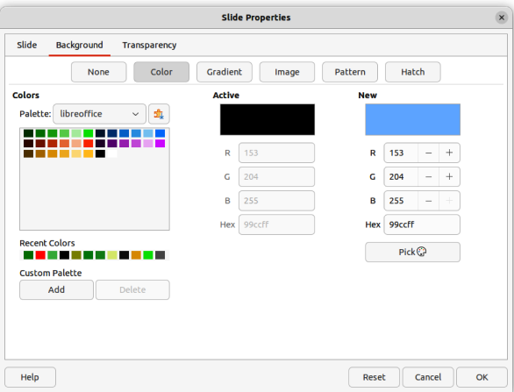
Figure 21: Slide Properties dialog — Background page
A master slide has a specified set of characteristics that acts as a template and is used as the starting point for creating other slides. These characteristics include slide background, objects in the background, formatting of any text used, and any background graphics.
Impress has a range of master slides, found in the Master Slides deck on the Sidebar. Additional master slides can be created or and saved, or added from other sources. See Chapter 2, Using Slide Masters, Styles, and Templates for information on creating and modifying master slides.
For example, to change the background of an individual slide or a master slide:
- Right click on a slide or master slide and select Slide Properties from the context menu to open the Slide Properties dialog (Figure 21).
- Select Background and then select the type of background to use from None, Color, Gradient, Bitmap, Pattern, and Hatch.
- Make a selection from the various properties available for each type of background.
- Click OK to apply save the changes and close the dialog.
- Note
Inserting and correctly formatting background is beyond the scope of this chapter. For more information, see Chapter 6, Formatting Graphic Objects.

Modifying presentations
By default, a presentation displays all the slides in the same order as they appear in Slide Sorter view on the Workspace. It is recommended to review the entire presentation and answer some questions. Run the presentation at least once (see “Running a presentation” on page 25), then answer the following questions. Also there maybe more questions after running a presentation for the first time.
- Are the slides in the correct order? If not, position of some of slides has to be changed.
- Is the information well spaced and visible to all members of an audience in a large room? The audience may not be able to see information at the bottom of a slide, so redesign the presentation to fit the top three-quarters of a screen.
- Would an additional slide make a particular point clearer? If so, create another slide.
- Are some of the slides unnecessary? Hide or delete the slides not required.
- Would animations help some of the slides? This is considered an advanced technique.
- Should some of the slides have a different slide transition than others? The transition of those slides should be changed.
Once the questions have been answered, make the necessary changes. Making changes can be carried out in Slide Sorter view on the Workspace.
- Tip
If one or more slides seem to be unnecessary, hide the slide or slides, then view the slide show a few more times to make sure they are not required. To hide a slide, right-click the slide in the Slides pane and select Hide Slide from the context menu. Do not delete a slide until this is done or the slide may have to be created again.

Slide order
Change the slide order in a presentation using one of the following methods:
- In Slide Sorter view, click on the slide that has to be moved and drag it to its new position in the presentation.
- In the Slides pane, click on the slide that has to be moved and drag it to its new position in the presentation.

Animations
If animations are going to be added to slides in a presentation, click on Animation on the Sidebar to open the Animation deck giving access to the various animation options as follows:
Animation category.
Animation effect.
How the animation starts.
Animation direction, duration and delay.
Automatic preview.
Animation is an advanced technique and is beyond the scope of this chapter. For more information on animation, see Chapter 9, Slide Shows & Photo Albums.

Slide transitions
To give a presentation a professional look, it is recommended to add transitions between each slide in a presentation. Click on Slide Transition on the Sidebar to open the Slide Transition deck giving access to the various transition options as follows:
Transition type.
Modify the transition.
How the slide advances in the presentation.
Automatic preview.
Adding slide transitions is an advanced technique and is beyond the scope of this chapter. For more information on slide transitions, see Chapter 9, Slide Shows & Photo Albums.

Running a presentation
When a presentation is completed, it is recommended to test run the presentation and make sure that everything is correct before showing the presentation in front of an audience. To display a presentation in front of an audience, a Presenter Console is available in LibreOffice Impress. However, the Presenter Console does require multiple displays to be connected to the computer for it to function.
For more information and details about running a presentation and showing it to an audience, see Chapter 9, Slide Shows & Photo Albums.

Single displays
- Start the slide using one of the following methods:
- Go to Slide Show on the Menu bar and select Start from First Slide from the submenu or use the keyboard shortcut F5.
- Go to Slide Show on the Menu bar and select Start from Current Slide from the submenu or use the keyboard shortcut Shift+F5.
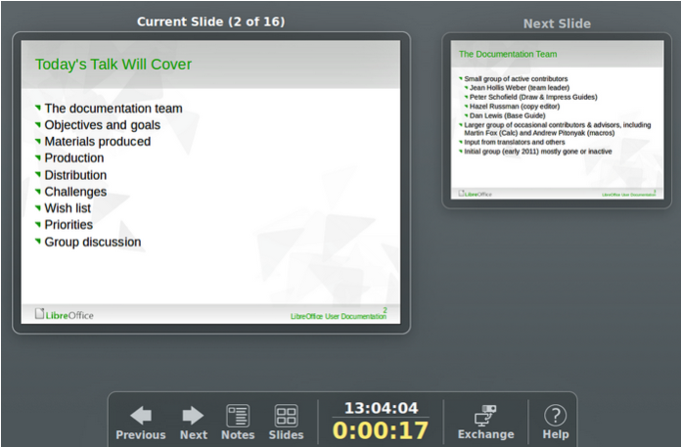
Figure 22: Presenter Console
- To display each slide in the presentation during the slide show, use one of the following methods:
- Press the spacebar to advance to the next slide in the presentation.
- Press the arrow keys to show the next or previous slide in the presentation.
- If the option Change slide by clicking on background has been selected in Slide Show Settings, position the cursor on the slide and click to move to the next slide.
- When the slide show has ended or to exit the slide show before it has finished, press the Esc key to close the slide show and return to Impress.

Multiple displays
When multiple displays are connected to a computer, the Presenter Console (Figure 22) in LibreOffice Impress becomes available providing extra control over a presentation as follows:
- On multiple displays, the audience sees the current slide in the presentation.
- The current slide, next slide in the presentation, any slide notes, and a presentation timer are displayed on the computer display providing control of how the slide show is presented to the audience.
- Starting a slide show using Presenter Console and multiple displays is similar to running a slide show on a single display. For more information and details about using the Presenter Console, see Chapter 9 Slide Shows & Photo Albums.

