
Impress Guide 7.5

Chapter 5,
Managing Graphic Objects

Copyright
This document is Copyright © 2023 by the LibreOffice Documentation Team. Contributors are listed below. This document may be distributed and/or modified under the terms of either the GNU General Public License (https://www.gnu.org/licenses/gpl.html), version 3 or later, or the Creative Commons Attribution License (https://creativecommons.org/licenses/by/4.0/), version 4.0 or later. All trademarks within this guide belong to their legitimate owners.

Contributors
Contributors for this edition:
Peter Schofield

Contributors for previous editions:
Jean Hollis Weber
Kees Kriek
Low Song Chuan
Michele Zarri
Peter Schofield
Rachel Kartch
Samantha Hamilton
T. Elliot Turner
Vasudev Narayanan

Feedback
Please direct any comments or suggestions about this document to the Documentation Team Forum at https://community.documentfoundation.org/c/documentation/loguides/ (registration is required) or send an email to: loguides@community.documentfoundation.org.
- Note
Everything sent to a forum, including email addresses and any other personal information that is written in the message, is publicly archived and cannot be deleted. Emails sent to the forum are moderated.

Publication date and software version
Published June 2023. Based on LibreOffice 7.5 Community.
Other versions of LibreOffice may differ in appearance and functionality.

Using LibreOffice on macOS
Some keystrokes and menu items are different on macOS from those used in Windows and Linux. The table below gives some common substitutions used in this document. For a detailed list, see LibreOffice Help.
Windows or Linux | macOS equivalent | Effect
Tools > Options  menu selection | LibreOffice > Preferences | Access setup options
Right-click | Control+click, Ctrl+click, or right-click depending on computer setup | Open a context menu
Ctrl or Control | ⌘ and/or Cmd or Command, depending on keyboard | Used with other keys
Alt | ⌥ and/or Alt or Option depending on keyboard | Used with other keys
F11 | ⌘+T | Open the Styles deck in the Sidebar

Contents
Copyright 2
Contributors 2
Feedback 2
Publication date and software version 2
Using LibreOffice on macOS 2
Introduction 6
Drawing toolbar 6
Creating lines and shapes 12
Drawing regular shapes 12
Regular shape adjustment 13
Basic Shapes 13
Symbol Shapes 13
Block Arrows 14
Callout Shapes 14
Stars and Banners 15
Drawing curves, polygons and freeform lines 15
Curves 15
Polygons and Polygons 45° 15
Freeform lines 16
Drawing lines and arrows 16
Straight lines 16
Arrows 16
Grouping objects 17
Temporary grouping 17
Permanent grouping 18
Editing or formatting groups 18
Ungrouping 19
Positioning and resizing graphic objects 19
Using the cursor 19
Positioning 19
Resizing 19
Position and Size dialog 20
Positioning 20
Resizing 21
Sidebar Position and Size panel 22
Positioning 22
Resizing 22
Applying special effects 23
Rotating graphic objects 23
Quick rotation 23
Position and Size dialog rotation 23
Sidebar rotation 24
Flipping objects 25
Quick flipping 25
Flip tool 25
Mirror copies 26
Distorting images 26
Distort tool 26
Set in Circle (perspective) tool 27
Set to circle (slant) tool 27
Aligning objects 28
Using grid or snap functions 28
Configuring grid and snap 28
Snap to grid 30
Using Snap to Grid 30
Displaying grid 30
Changing color of grid points 31
Snap points and lines 31
Inserting snap points and lines 31
Displaying snap points and lines 32
Editing snap points 32
Editing snap lines 32
Deleting snap points and lines 33
Configuring snap range 33
Using Helplines 33
Arranging objects 34
Connectors and gluepoints 35
Connectors 35
Connector types 36
Drawing connectors 36
Formatting connectors 37
Gluepoints 38
Gluepoint types 39
Inserting gluepoints 40
Customizing gluepoint exit direction 40
Customizing gluepoint position 41
Deleting gluepoints 41
Working with 3D objects 41
Converting objects 43
Interaction with objects 44
Fontwork 45
Creating Fontwork 45
Fontwork toolbar 45
Modifying Fontwork 48
Animations 48
Creating an animation 48
Animation tools and options 49
Effect Options dialog 50
Effect page 50
Timing page 51
Text Animation page 52
Animated images 53
Creating animated image 53
Animation dialog controls 54

Introduction
This chapter describes how to rotate, distort, arrange, and position graphic objects on a slide using the available tools in Impress. However, some of the techniques described in this chapter are also applicable to images imported into slides.

Drawing toolbar
The Drawing toolbar (Figure 1) contains the majority of the tools normally used to create graphic objects. If this toolbar is not visible, select View > Toolbars > Drawing from the Menu bar. By default, the Drawing toolbar is docked vertically at the left side of the Impress window.
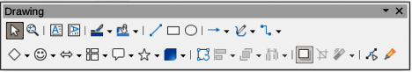
Figure 1: Drawing toolbar
- Note
The Drawing toolbar shown in Figure 1 may differ between computer operating systems and setup. Also, the Drawing toolbar displayed depends on how many drawing tools have been installed on the toolbar. Right-click in an empty area of the Drawing toolbar, then select Visible Buttons from the context menu to display, install and remove available tools. See Appendix B, Toolbars and the Getting Started Guide for more information on customizing toolbars in Impress.
From left to right, the drawing tools shown in Figure 1 are as follows:
Select
Used to select objects. To select a group of objects, position the cursor above the top left object, then click, hold and drag the cursor below the bottom right object of the intended selection. A rectangle identifying the selection area is displayed (also known as a marquee). Several objects also can be selected by holding down the Shift key while selecting the individual objects.
Zoom & Pan
Used to zoom out and pan the selected slide in the Workspace. Hold down the Ctrl key (macOS ⌘) and select the tool to zoom out and reduce the screen display of a slide in LibreOffice. The current zoom factor is displayed as a percentage value on the Status bar. Hold down the Shift key and select the tool to move the displayed slide without changing the zoom percentage.
Insert Text Box
Creates a text box with text aligned horizontally. See Chapter 3, Adding and Formatting Text for more information on working with text.
Insert Vertical Text
Creates a text box with text aligned vertically. This tool is available only when Asian language support has been enabled in Tools > Options > Language Settings > Languages (macOS LibreOffice > Preferences > Language Settings > Languages). See Chapter 3, Adding and Formatting Text for more information on working with text.
Line Color
Click on the triangle ▼ next to Line Color to open a color palette and select a color for the line. More colors are available by selecting a different color palette from the drop-down list at the top of the color palette.
Fill Color
Click on the triangle ▼ next to Fill Color to open a color palette and select a color for the area fill. More colors are available by selecting a different color palette from the drop-down list at the top of the color palette.
Insert Line
Draws a straight line from the point where the cursor is dragged to the point where the cursor is released. Press the Shift key to restrict the angle of the line to multiples of 45°. Press the Alt key (macOS ⌥) to draw a line from its center. Release the cursor before releasing the Shift or Alt (macOS ⌥) keys.
Rectangle
Draws a rectangle when the cursor is dragged from the top left to the bottom right corner. Press the Shift key to draw a square. Press the Alt key (macOS ⌥) to draw a shape from its center. Press the Shift+Alt keys (macOS ⌥+Shift) to draw a square from the center. Release the cursor before releasing the Shift or Alt (macOS ⌥) keys.
Ellipse
Draws an ellipse. Press the Shift key to draw a circle. Press the Alt key (macOS ⌥) to draw a shape from its center. Press the Shift+Alt keys (macOS ⌥+Shift) to draw a circle from the center. Release the cursor before releasing the Shift or Alt (macOS ⌥) keys.
Line and Arrows
Draws a straight line ending with an arrowhead. The arrowhead is placed at the end of the line where the cursor is released. Click the triangle ▼ next to Line and Arrows to show the available options for lines and arrows (Figure 2). The Shift and Alt (macOS ⌥) keys have the same effect as the Insert Line tool. Actual icon displayed depends on the tool that had previously been selected.
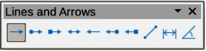
Figure 2: Lines and Arrows sub-toolbar
Curves and Polygons
Draws a shape depending on the option that has been selected. Click the triangle ▼ next to Curves and Polygons to show the available options for curves and polygons (Figure 3). Actual icon displayed depends on the tool that had previously been selected.
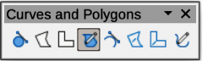
Figure 3: Curves and Polygons sub-toolbar
Connectors
Draws a connector line between two figures. Click the triangle ▼ next to Connectors to show the available options for connectors (Figure 4). Actual icon displayed depends on the tool that had previously been selected. For more information see “Connectors and gluepoints” on page 35.
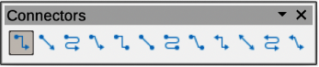
Figure 4: Connectors sub-toolbar
Basic Shapes
Click the triangle ▼ next to Basic Shapes to show the available options for basic shapes (Figure 5). The Shift and Alt (macOS ⌥) keys have the same effect as the Rectangle tool. Actual icon displayed depends on the tool that had previously been selected.
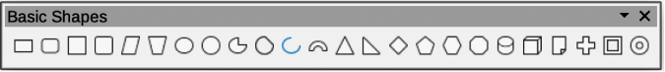
Figure 5: Basic Shapes sub-toolbar
Symbol Shapes
Click the triangle ▼ next to Symbol Shapes to show the available options for symbol shapes (Figure 6). The Shift and Alt (macOS ⌥) keys have the same effect as the Rectangle tool. Actual icon displayed depends on the tool that had previously been selected.
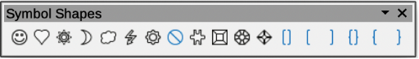
Figure 6: Symbol Shapes sub-toolbar
Block Arrows
Click the triangle ▼ next to Block Arrows to show the available options for block arrows (Figure 7). The Shift and Alt (macOS ⌥) keys have the same effect as the Rectangle tool. Actual icon displayed depends on the tool that had previously been selected.
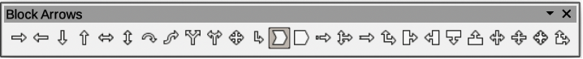
Figure 7: Block Arrows sub-toolbar
Flowchart
Click the triangle ▼ next to Flowchart to show the available options for flowchart shapes (Figure 8). The Shift and Alt (macOS ⌥) keys have the same effect as the Rectangle tool. Actual icon displayed depends on the tool that had previously been selected.
Figure 8: Flowchart sub-toolbar
Callout Shapes
Click the triangle ▼ next to Callout Shapes to show the available options for callouts (Figure 9). The Shift and Alt (macOS ⌥) keys have the same effect as the Rectangle tool. Actual icon displayed depends on the tool that had previously been selected.
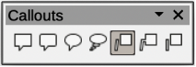
Figure 9: Callouts sub-toolbar
Stars and Banners
Click the triangle ▼ next to Stars and Banners to show the available options for stars and banners (Figure 10). The Shift and Alt (macOS ⌥) keys have the same effect as the Rectangle tool. Actual icon displayed depends on the tool that had previously been selected.
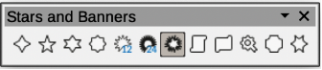
Figure 10: Stars and Banners sub-toolbar
3D-Objects
Click the triangle ▼ next to 3D-Objects to show the available options for 3D objects (Figure 11). The Shift and Alt (macOS ⌥) keys have the same effect as the Rectangle tool. Actual icon displayed depends on the tool that had previously been selected. Alternatively, go to View > Toolbars > 3D-Objects on the Menu bar to open the 3D-Objects toolbar. For more information on 3D objects, see “Working with 3D objects” on page 41.
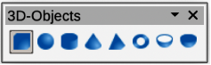
Figure 11: 3D-Objects sub-toolbar
Rotate
Select an object then click on this tool to switch the object in rotation mode. The selection handles change color and pivot point appears in the center of the object.
Align Objects
Click the triangle ▼ next to Align Objects to show the available options for alignment tools (Figure 12) for two or more objects. Alternatively, go to View > Toolbars > Align Objects on the Menu bar to open the Align Objects toolbar. See “Aligning objects” on page 28 for more information.
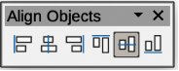
Figure 12: Align Objects sub-toolbar
Left, Centered, Right
Determines the horizontal alignment of selected objects.
Top, Center, Bottom
Determines the vertical alignment of selected objects.
Arrange
Changes the stack level of an object. Click the triangle ▼ next to Arrange to show the available options to arrange the position of selected objects (Figure 13). Alternatively, select the required positioning tool on the Standard toolbar. See “Arranging objects” on page 34 for more information.
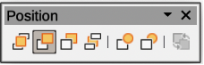
Figure 13: Position sub-toolbar
Bring to front
Selected object is moved in front of all other objects.
Bring forward
Selected object is moved one level up in the stack.
Send backwards
Selected object is moved one level down in the stack.
Send to back
Selected object is moved behind all other objects.
In front of object
Moves the first selected object in front of the second selected object.
Behind object
Moves the first selected object behind the second selected object.
Reverse
Swaps the stacking order of two selected objects.
Distribute Selection
Changes the distribution between objects by using the horizontal and vertical spacing between objects. Click the triangle ▼ next to Select at least three objects to distribute to show the available distribution tools (Figure 14). Alternatively, go to View > Toolbars > Distribute Selection on the Menu bar to open the Distribute Selection toolbar. A minimum of three objects have to be selected for the distribution tools to be active.
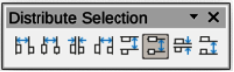
Figure 14: Distribute Selection sub-toolbar
Horizontally Left
Distributes the selected objects to make the left edges of the objects evenly spaced from one another.
Horizontally Centre
Distributes the selected objects to make the horizontal centers of the objects evenly spaced from one another.
Horizontally Spacing
Distributes the selected objects horizontally to make the objects evenly spaced from one another.
Horizontally Right
Distributes the selected objects to make the right edges of the objects evenly spaced from one another.
Vertically Top
Distributes the selected objects to make the top edges of the objects evenly spaced from one another.
Vertically Centre
Distributes the selected objects to make the vertical centers of the objects evenly spaced from one another.
Vertically Spacing
Distributes the selected objects vertically to make the objects evenly spaced from one another.
Vertically Bottom
Distributes the selected objects to make the bottom edges of the objects evenly spaced from one another.
Shadow
Applies a shadow to a selected object using the shadow settings from the Area or Line dialog.
Crop Image
This tool only becomes active when an image is selected that can be cropped.
Filter
This tool only becomes active when an image is selected and opens the available filter options on the Image Filter sub-toolbar (Figure 15) for application to an image. For more information on image filters, see the Draw Guide.
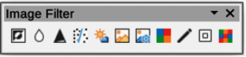
Figure 15: Image Filter sub-toolbar
Invert
Inverts the color values of a color image, or the brightness values of a grayscale image. Apply the filter again to reverse the effect.
Smooth
Softens or blurs the image by applying a low pass filter.
Sharpen
Sharpens the image by applying a high pass filter.
Remove Noise
Removes noise by applying a median filter.
Solarization
Opens a dialog for defining solarization. Solarization refers to an effect that looks like what can happen when there is too much light during photo development.
Aging
All pixels are set to their gray values. The green and blue color channels are then reduced by the amount you specify. The red color channel is not changed.
Posterize
Opens a dialog to determine the number of poster colors. This effect is based on the reduction of the number of colors. It makes photos look like paintings.
Pop Art
Converts an image to a pop-art format.
Charcoal Sketch
Displays the image as a charcoal sketch. The contours of the image are drawn in black, and the original colors are suppressed.
Relief
Displays a dialog for creating reliefs. You can choose the position of the imaginary light source that determines the type of shadow created, and how the graphic image looks in relief.
Mosaic
Joins small groups of pixels into rectangular areas of the same color. The larger the individual rectangles are, the fewer details the graphic image has.
Points
Select this tool and then select an object to edit the individual points in the object. The object must be converted to a curve or polygon first before editing the object points. Clicking on the keyboard shortcut F8 also selects this tool.
Show Gluepoints Functions
Opens the Gluepoints toolbar (Figure 16) for editing the gluepoints of a graphic object. Glue points are the positions where connector lines terminate or start. See “Gluepoints” on page 38 for more information.
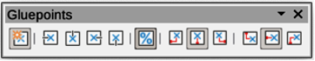
Figure 16: Gluepoints toolbar

Creating lines and shapes
This section is an introduction to creating lines and shapes for use in presentations. For more information on working with lines and shapes, see the Draw Guide.

Drawing regular shapes
Regular shapes that are available on the Drawing toolbar are as follows:
Rectangle
Ellipse
Basic Shapes
Symbol Shapes
Block Arrows
Flowchart
Callouts Shapes
Stars and Banners
3D Objects
Some icons for regular shapes have a triangle ▼ next to the icon that gives access to several different types of regular shapes. Also, the icons for some of the regular shapes displayed on the Drawing toolbar show the last tool used for each of these regular shapes.
- Select the required tool from the Drawing toolbar or a sub-toolbar after selecting the triangle ▼ next to the tool icon.
- Place the cursor on the slide, then click and drag to define an enclosing rectangle.
- Release the cursor and the selected shape is drawn on the slide.
- Press and hold the Shift key when creating a shape to maintain the ratio between height and width. For example, using Rectangle or Ellipse to draw a square or a circle. Release the cursor before releasing the Shift key.
- Press and hold the Alt key (macOS ⌥) to draw a shape from its center. Release the cursor before releasing the Alt key (macOS ⌥).
- Press and hold the Shift and Alt (macOS ⌥) keys when creating a shape to maintain equal height and width and draw the shape from the center. For example, when using Rectangle or Ellipse tool to draw a square or a circle. Release the cursor before releasing the Shift and Alt (macOS ⌥) keys.
- Press and hold the Ctrl key (macOS ⌘) when creating a shape to snap the top left corner of the shape selection box to the nearest grid point.
- Note
If the Snap to Grid option in Tools > Options > LibreOffice Impress > Grid (macOS LibreOffice > Preferences > LibreOffice Impress > Grid) has been selected, pressing and holding the Ctrl key (macOS ⌘) prevents the top left corner of the shape selection box snapping to the nearest grid point.

Regular shape adjustment
When creating shapes that are included in Impress, one or more dots maybe displayed in a different color to the selection handles. These dots perform a different adjustment depending on the shape and are listed below.

Basic Shapes
Basic shape | Shape adjustment function
Rectangle, Rounded | Changes the radius of the curve used for corners on a rounded rectangle or square.
Square, Rounded | Changes the radius of the curve used for corners on a rounded rectangle or square.
Parallelogram | Changes the internal angles between the sides.
Trapezoid | Changes the internal angles between the sides.
Circle Pie | Changes the size of the filled sector.
Block Arc | Changes both internal diameter and size of the filled area.
Isosceles Triangle | Changes the shape and type of the triangle.
Hexagon | Changes the internal angles between the sides.
Octagon | Changes the internal angles between the sides.
Cylinder | Changes the perspective.
Cube | Changes the perspective.
Folded Corner | Changes the size of the folded corner.
Cross | Changes the thickness of the four arms of the cross.
Frame | Changes the thickness of the frame.
Ring | Changes the internal diameter of the ring.

Symbol Shapes
Symbol shape | Shape adjustment function
Smiley Face | Changes the smile on the face.
Sun | Changes the shape of the symbol.
Moon | Changes the shape of the symbol.
Prohibited | Changes the thickness of the ring and the diagonal bar.
Square Bevel | Changes the thickness of the bevel.
Octagon Bevel | Changes the thickness of the bevel.
Diamond Bevel | Changes the thickness of the bevel.
Double Bracket | Changes the curvature of the bracket.
Left Bracket | Changes the curvature of the bracket.
Right Bracket | Changes the curvature of the bracket.
Double Brace | Changes the curvature of the bracket.
Left Brace | Changes the curvature of the brace and the position of the point.
Right Brace | Changes the curvature of the brace and the position of the point.

Block Arrows
Block arrows | Shape adjustment function
Right Arrow | Changes the shape and thickness of the arrow.
Left Arrow | Changes the shape and thickness of the arrow.
Down Arrow | Changes the shape and thickness of the arrow.
Up Arrow | Changes the shape and thickness of the arrow.
Left and Right Arrow | Changes the shape and thickness of the arrow.
Up and Down Arrow | Changes the shape and thickness of the arrow.
Circular Arrow | Changes the shape and thickness of the arrow.
4-way Arrow | Changes the shape and thickness of the arrow.
Chevron | Changes the angle between the sides and the shape.
Pentagon | Changes the angle between the sides and the shape.
Striped Right Arrow | Changes the shape and thickness of the arrow.
Up, Right and Down Arrow | Changes the shape and thickness of the arrow.
Notched Right Arrow | Changes the shape and thickness of the arrow.
Up and Right Arrow | Changes the shape and thickness of the arrow.
Right Arrow Callout | Changes the shape and thickness of the callout.
Left Arrow Callout | Changes the shape and thickness of the callout.
Down Arrow Callout | Changes the shape and thickness of the callout.
Up Arrow Callout | Changes the shape and thickness of the callout.
Left and Right Arrow Callout | Changes the shape and thickness of the callout.
Up and Down Arrow Callout | Changes the shape and thickness of the callout.
4-way Arrow Callout | Changes the shape and thickness of the callout.
Up and Right Arrow Callout | Changes the shape and thickness of the callout.

Callout Shapes
All Callouts use shape adjustment dots to change the length, position and angle of the pointer.

Stars and Banners
Stars and banners | Shape adjustment function
4-Point Star | Changes the thickness and shape of the star points.
8-Point Star | Changes the thickness and shape of the star points.
24-Point Star | Changes the thickness and shape of the star points.
Vertical Scroll | Changes the width and shape of the scroll.
Horizontal Scroll | Changes the width and shape of the scroll.
Doorplate | Changes the inward curvature of the corners.

Drawing curves, polygons and freeform lines
Curves, polygons and lines on the Drawing toolbar have a triangle ▼ next to the icon. Clicking on this triangle ▼ opens a sub-toolbar giving access to several different types of curves, polygons and lines. The icons on the Drawing toolbar show the last tool used for each of these curves, polygons and lines. If a filled curve, filled polygon, or filled freeform line was selected, Impress draws the line connecting the last point to the start point and fills the inside area with the default fill color.

Curves
- Click the triangle ▼ next to Curves and Polygons on the Drawing toolbar to open the Curves and Polygons sub-toolbar.
- Select either Curve or Curve Filled.
- Place the cursor on the slide, then click and drag to create the starting point of a curve.
- Release the cursor and drag the cursor to draw a curve on the slide, bending the line into a curve.
- Click to set the end point of the curve and fix the curve on the slide.
- Drag the cursor to continue drawing a straight line. Each click sets a corner point and allows drawing of another straight line from the corner point.
- Double-click to end the drawing of the curve. If Curve Filled was selected, Impress automatically fills the curve with the default fill color.
- Note
Holding down the Shift key when drawing lines with the curve or polygon tools restricts the angles between lines to 45 or 90 degrees.

Polygons and Polygons 45°
- Click the triangle ▼ next to Curves and Polygons on the Drawing toolbar to open the Curves and Polygons sub-toolbar.
- Select either Polygon, Polygon Filled, Polygon (45°) or Polygon Filled (45°).
- Place the cursor on the slide, then click and drag to draw the first line from the start point. Release the cursor and a line between the first and second points is drawn.
- Move the cursor to draw the next line. Each click sets a corner point and allows drawing of another line.
- Double-click to end the drawing of a polygon. If Polygon Filled or Polygon Filled (45°) was selected, Impress automatically fills the polygon with the default fill color.
- Note
If Polygon (45°) or Polygon Filled (45°) were selected, the movement of the cursor and the angles between lines is restricted to increments of 45°.

Freeform lines
Using Freeform Line or Freeform Line Filled tools is similar to drawing with a pencil on paper.
- Click the triangle ▼ next to Curves and Polygons on the Drawing toolbar to open the Curves and Polygons sub-toolbar.
- Select either Freeform Line or Freeform Line Filled.
- Click and drag the cursor to the line shape required.
- When finished drawing a freeform line, release the cursor and the drawing is completed. If Freeform Line Filled was selected, Impress automatically fills the drawing between the start and end points with the default fill color.

Drawing lines and arrows

Straight lines
A straight line is the simplest element or object in Impress to create.
- Use one of the following methods to draw a line:
- Click Insert Line in the Drawing toolbar.
- Click the triangle ▼ on the right of Lines and Arrows on the Drawing toolbar and select Insert Line from the Lines and Arrows sub-toolbar.
- Click at the start position for the line and drag the cursor.
- Release the cursor at the end position of the line. A selection handle appears at each end of the line. The selection handle at the starting point of the line is larger than the selection handle at the end point.
- Keep the Ctrl key (macOS ⌘) pressed while drawing a line to enable the end of the line to snap to the nearest grid point.
- Keep the Shift key pressed while drawing a line to restrict the drawing angle of a line to multiple of 45 degrees.
- Keep the Alt key (macOS ⌥) pressed while drawing a line to cause the line to extend outwards symmetrically in both directions from the start point. This draws lines by starting from the middle of the line.

Arrows
Arrows are drawn like lines and are classified as a subgroup of lines, that is lines with arrowheads. Hovering the cursor over each type of arrow that is available shows the type of endings each tool will draw.
- Click the triangle ▼ on the right of Lines and Arrows on the Drawing toolbar and select the type of arrow from the Lines and Arrows sub-toolbar.
- Click at the starting position for drawing the arrow, then drag the cursor. The arrowhead(s) is drawn at the end of the line when the cursor is released.
- Keep the Ctrl key (macOS ⌘) pressed while drawing an arrow to enable the end of the arrow to snap to the nearest grid point.
- Keep the Shift key pressed while drawing an arrow to restrict the drawing angle of an arrow to multiple of 45 degrees.
- Keep the Alt key (macOS ⌥) pressed while drawing an arrow to cause the arrow to extend outwards symmetrically in both directions from the start point. This draws arrows by starting from the middle of the arrow.
- Note
If the Snap to Grid option in Tools > Options > LibreOffice Impress > Grid (macOS LibreOffice > Preferences > LibreOffice Impress > Grid) has been selected, pressing and holding the Ctrl key (macOS ⌘) whilst drawing a line or arrow has the opposite effect and prevents the line or arrow snapping to the nearest grid point.

Grouping objects
This section gives only a brief introduction to grouping of objects. An example of grouping two objects together is shown in Figure 17. For more information on working with grouped objects, see the Draw Guide.
Grouping of objects is similar to putting objects into a container. Objects within a group are moved together as one object and any changes made are applied globally to the objects within the group. A group can always be undone and the objects that make up the group can always be manipulated separately.

Temporary grouping
Temporary grouping is when several objects are selected together. Any changes to the objects are applied to all of the objects within the temporary group. For example, a temporary group of objects can be rotated in its entirety.
A temporary group is created using one of the following methods:
- Hold down the Shift key whilst clicking multiple objects on a slide.
- Click and drag the cursor to create a marquee around multiple objects. Release the cursor and all the objects within the marquee are selected.
To cancel a temporary grouping of objects, simply click outside of the selection handles displayed around the objects.
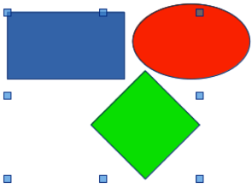
Figure 17: Example of grouping objects

Permanent grouping
- Objects are grouped together using one of the following methods:
- Hold down the Shift key whilst clicking multiple objects on a slide.
- Click and drag the cursor to create a marquee around multiple objects. Release the cursor and all the objects within the marquee are selected.
- To select all the objects on the slide, go to Edit > Select All on the Menu bar, or use the keyboard shortcut Ctrl+A (macOS ⌘+A).
- With selection handles displayed, use one of the following methods to create a group of selected objects:
- Go to Format > Group > Group on the Menu bar.
- Use the keyboard shortcut Ctrl+Shift+G (macOS ⌘+Shift+G).
- Right-click on an object within the selected group and select Group from the context menu.

Editing or formatting groups
- Click on an object in the group to select the group. Any editing or formatting can then be carried out on all the objects within the group or on individual objects within the group.
- To edit an individual object within a group, enter the group using one of the following methods:
- Use the keyboard shortcut F3.
- Go to Format > Group > Enter Group on the Menu bar.
- Right-click and select Enter Group from the context menu.
- Select individual objects within the group for editing or formatting. An example of editing individual objects in a group is shown in Figure 18.
- When editing or formatting is completed, use one of the following methods to exit the group and the whole group then becomes selected:
- Use the keyboard shortcut Ctrl+F3 (macOS ⌘+F3).
- Go to Format > Group > Exit Group on the Menu bar.
- Right-click and select Exit Group from the context menu.
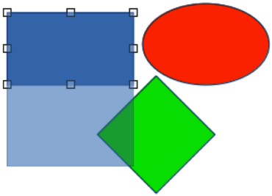
Figure 18: Example of editing inside a group

Ungrouping
- Click on any one of the objects in the group to select the group.
- With selection handles displayed, use one of the following methods to ungroup a group of objects:
- Go to Format > Group > Ungroup on the Menu bar.
- Use the keyboard shortcut Ctrl+Alt+Shift+G (macOS ⌘+⌥+Shift+G).
- Right-click on the group and select Ungroup from the context menu.
- Tip
If group and ungroup commands are regularly used, or any other command, commands can be added to a toolbar so that they are readily available. See Chapter 11, Setting Up and Customizing Impress; Appendix B, Toolbars; and the Getting Started Guide for more information on customizing the user interface.

Positioning and resizing graphic objects

Using the cursor

Positioning
- Click on an object or a group of objects to display the selection handles.
- Move the cursor over a selected graphic object until the cursor changes shape. The cursor shape depends on the computer setup and the computer operating system.
- Click and drag the object to the desired position. During movement, a ghost image of the object appears to help with repositioning (Figure 19).
- Release the cursor when the object is in the desired position.
- Note
The arrow keys can also be used to quickly move a selected object or group to a new position.

Resizing
- Click on an object or a group of objects to display the selection handles.
- Move the cursor over a selection handle.
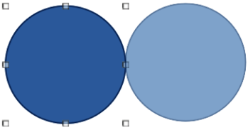
Figure 19: Example of moving objects
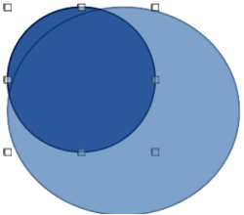
Figure 20: Example of resizing objects
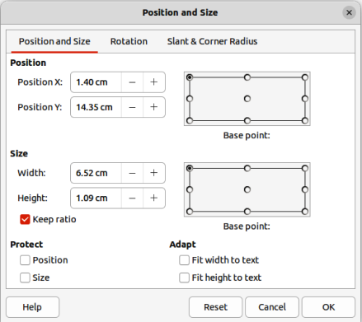
Figure 21: Position and Size dialog
- Click and drag the selection handle to resize the graphic object. During resizing, a ghost image of the object appears to help with resizing (Figure 20).
- To maintain the width to height ratio, hold down the Shift key before clicking and dragging on a selection handle. Remember to release the cursor before releasing the Shift key.
- Release the cursor when the object is at the desired size.

Position and Size dialog

Positioning
For a more accurate placement of a graphic object on a slide, use the Position and Size dialog (Figure 21) as follows:
- Select an object to display the selection handles and open the Position and Size dialog using one of the following methods:
- Use the keyboard shortcut F4.
- Go to Format > Text Box and Shape > Position and Size on the Menu bar.
- Right-click on the selected object and select Position and Size from the context menu.
- Click on More Options on the right of the title bar for the Position and Size panel in the Properties deck on the Sidebar.
- Click on the Position and Size tab to open the Position and Size page.
- In the Position section, specify Position X (horizontal) and Position Y (vertical) position of the object. The values represent the distance from the selected Base point. The default selection for Base point is relative to the top left corner of the slide.
- If necessary, in the Protect section of the dialog, select the Position option to prevent the object from being repositioned.
- Click OK to save the changes and to close the dialog.
- Note
The units of measurement used in this dialog and other Impress dialogs are set in Tools > Options > LibreOffice Impress > General (macOS LibreOffice > Preferences > LibreOffice Impress > General).

Resizing
- Select an object to display the selection handles and open the Position and Size dialog using one of the following methods:
- Use the keyboard shortcut F4.
- Go to Format > Text Box and Shape > Position and Size on the Menu bar.
- Right-click on the selected object and select Position and Size from the context menu.
- Click on More Options on the right of the title bar for the Position and Size panel in the Properties deck on the Sidebar.
- Click on the Position and Size tab to open the Position and Size page.
- In Size, select a Base point to use as an anchor when resizing the object. The default selection of top left corner means that the top left corner of the object will not change position when resizing.
- To maintain the proportions between width and height, in the Size section select the Keep ratio option before changing the Width or Height. When Keep ratio is selected, changing the value of one dimension automatically changes the other dimension maintaining the ratio between object width and height.
- To specify the object width or height independently, make sure Keep ratio is deselected, then, in the Size section, enter a value for the Width and/or Height of the object.
- If necessary, in the Protect section of the dialog, select the Size option to prevent the object from being resized.
- Click OK to save the changes and to close the dialog.
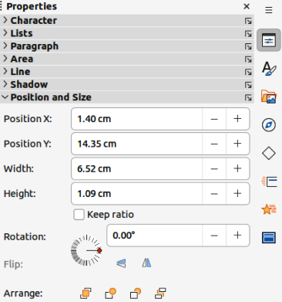
Figure 22: Position and Size panel in Properties deck on Sidebar

Sidebar Position and Size panel
Use the Position and Size panel in the Properties deck on the Sidebar (Figure 22) to position and resize a graphic object.

Positioning
- Select an object to display the selection handles.
- Click on Properties in the Sidebar to open the Properties deck.
- Click on Position and Size to open the panel.
- Specify Position X (horizontal) and Position Y (vertical) position of the object. The values represent the distance from the Base point that has been selected in the Position and Size dialog.
- Press the Enter key to make the changes.

Resizing
- Select an object to display the selection handles.
- Click on Properties in the Sidebar to open the Properties deck.
- Click on Position and Size to open the panel.
- To maintain the proportions between width and height, select the Keep ratio option before changing the Width or Height. When Keep ratio is selected, changing the value of one dimension automatically changes the other dimension maintaining the ratio between object width and height.
- To specify the object width or height independently, make sure Keep ratio is deselected, then, enter a value for the Width and/or Height of the object.
- Press the Enter key to make the changes.

Applying special effects
As well as the basic actions of moving and resizing an object, a number of special effects can also be applied to objects in Impress. This section describes how to rotate, flip, and distort an object.

Rotating graphic objects

Quick rotation
- Select an object to display the selection handles.
- On the Line and Filling toolbar, click on the triangle ▼ next to Transformations then click on Rotate on the Transformations sub-toolbar. The selection handles change shape and color as shown in Figure 23. A pivot point indicating the rotation center also appears in the center of the object.
- Move the cursor over one of the corner handles and the cursor changes shape indicating the movement direction.
- Click on a corner selection handle and move in the direction required to rotate the object. Only the corner selection handles are active for rotation.
- When satisfied with the rotation, release the cursor.
- To change the rotation center of the object, click and drag the pivot point to the desired position before rotating. The pivot point can be moved to any position on the slide, even outside of the object boundaries.
- To restrict the rotation angles to multiples of 15 degrees, press and hold the Shift key while rotating the object. This is useful for rotating pictures through a right angle, for example from portrait to landscape. Remember to release the Shift key before releasing the cursor.

Position and Size dialog rotation
Instead of rotating an object manually, use the Rotation page of the Position and Size dialog (Figure 24) to accurately rotate an object.
- Select an object to display the selection handles, then open the Position and Size dialog using one of the following methods:
- Use the keyboard shortcut F4.
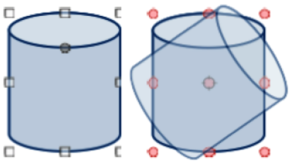
Figure 23: Example of rotating objects
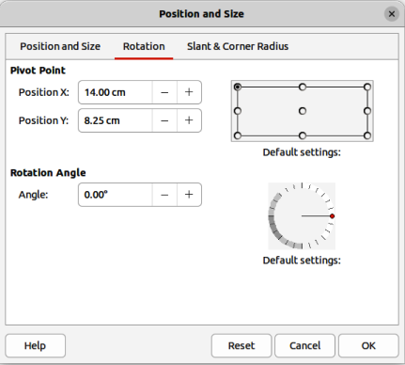
Figure 24: Position and Size dialog — Rotation page
- Go to Format > Text Box and Shape > Position and Size on the Menu bar.
- Right-click on the selected object and select Position and Size from the context menu.
- Click on More Options on the right of the title bar for the Position and Size panel in the Properties deck on the Sidebar.
- Click on the Rotation tab to open the Rotation page.
- If necessary, in Pivot Point enter a measurement for Position X and Position Y to move the position of the pivot point. The default position of the pivot point is the center of the object. Alternatively, select a pivot point from one of the 9 positions in Default settings.
- In Rotation Angle, enter the degree amount for rotation in the Angle text box. Alternatively, in Default settings, click on the rotation angle indicator and drag it to a new angle. The angle of rotation is displayed in the Angle text box.
- Click OK to save the changes and to close the dialog.

Sidebar rotation
Use the Position and Size panel in the Properties deck on the Sidebar (Figure 22 on page 22) to rotate an object as follows:
- Select an object to display the selection handles.
- Click on Properties in the Sidebar to open the Properties deck.
- Click on Position and Size to open the panel.
- In Rotation, enter the degree amount for rotation in the text box or click on the rotation angle indicator and drag it to a new angle. The angle of rotation is displayed in the Rotation text box.
- Press the Enter key to make the changes.

Flipping objects

Quick flipping
- Click on an object to display the selection handles.
- Quickly flip a selected object so it faces the other direction using one of the following methods:
- Right-click on the selected object and select Flip > Vertically or Horizontally from the context menu.
- Click on Vertically or Horizontally flip tool on the Standard toolbar.
- Go to Format > Flip > Vertically or Horizontally on the Menu bar.
- Click on Flip Vertically or Flip Horizontally in the Position and Size panel on the Properties deck of the Sidebar (Figure 22 on page 22).

Flip tool
To change the position and angle that an object flips over, the Flip tool on the Transformations toolbar (Figure 25) is used as shown by the example in Figure 26.
- Click on an object to display the selection handles.
- Go to View > Toolbars > Transformations to open the Transformations toolbar.
- Click on Flip on the Transformations toolbar and a symmetry axis appears as a dashed line through the center of the object (Item (1) in Figure 26). The object is flipped about this axis of symmetry.
- Click and drag the symmetry axis to a new position, or position the cursor in one of the circles at each end of the symmetry axis and drag with the cursor to change the angle (Item (2) in Figure 26).
- Place the cursor over one of the selection handles for the object.
- Click and drag the cursor across the symmetry axis to flip the object. The new position of the object is shown faintly until the cursor is released.
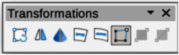
Figure 25: Transformations toolbar
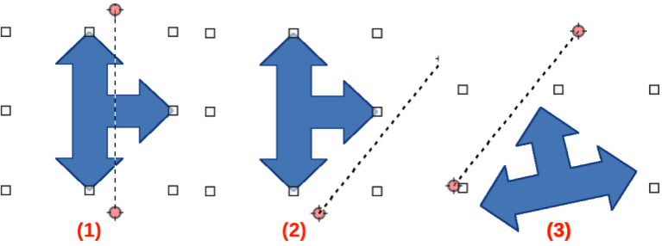
Figure 26: Example of using the Flip tool
- Release the cursor and the object appears flipped over. Angle and position of the flip depends on the angle and position of the symmetry axis (Item (3) in Figure 26).
- Note
Press and hold the Shift key while moving the symmetry axis to rotate it in 45 degree increments.

Mirror copies
Impress does not include a mirror command. However, mirroring an object can be emulated by flipping the object:
- Select the object to make a mirror copy and copy the object to the clipboard.
- Flip the object using one of the methods in “Quick flipping” on page 25, then move the flipped object to one side.
- Click in an empty area of the slide to deselect the object.
- Paste the copied object from the clipboard into the slide.
- Select both objects, then right-click and select Alignment from the context menu.
- Select the type of alignment required. Top, Center, or Bottom if a horizontal mirror copy is being created. Left, Centered, or Right if a vertical mirror copy is being created.

Distorting images
Three tools on the Transformations toolbar allow an object to be distorted.
- Distort – distorts an object in perspective.
- Set to circle (slant) and Set in Circle (perspective) – both create a pseudo 3D effect.
- Note
When using these tools, an object has to be converted to a curve before distorting. Converting an object into a curve cannot be reversed and can only be undone by using the Undo function.

Distort tool
Examples of corner, vertical, and horizontal distortion of an object using the Distort tool are shown in Figure 27.
- Select an object and click on Distort on the Transformations toolbar.
- Click Yes to convert the object to a curve. If the object is already a curve, this dialog does not appear.
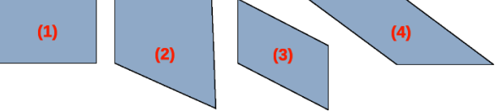
Figure 27: Example of object distortion
- Original shape
- Corner distortion
- Vertical distortion
- Horizontal distortion
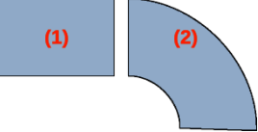
Figure 28: Example of perspective distortion
- Original object
- Set in Circle (perspective) distortion
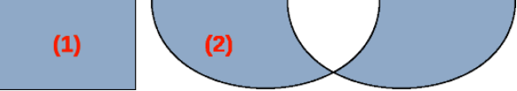
Figure 29: Example of slant distortion
- Original object
- Set in Circle (slant) distortion
- Click and drag a corner selection handle to distort the object using the opposite corner selection handle as an anchor point for the distortion.
- Click and drag the vertical selection handles to distort the object using the opposite vertical side as an anchor point for the distortion.
- Click and drag the horizontal selection handles to distort the object using the opposite horizontal side as an anchor point for the distortion.

Set in Circle (perspective) tool
Example of distorting an object using the Set in Circle (perspective) tool is shown in Figure 28.
- Select an object and click on Set in Circle (perspective) in the Transformations toolbar.
- Click Yes to convert the object to a curve. If the object is already a curve, this dialog does not appear.
- Click and drag one of the selection handles to give a pseudo 3D perspective using the opposite side as an anchor point. A ghosted image appears as the object is distorted to give an indication of how the resulting object will look.

Set to circle (slant) tool
Example of distorting an object with the Set to circle (slant) tool is shown in Figure 29.
- Select an object and click on Set to circle (slant) in the Transformations toolbar.
- Click Yes to convert the object to a curve. If the object is already a curve, this dialog does not appear.
- Click and drag one of the selection handles to give a pseudo 3D perspective using the opposite side as an anchor point. A ghosted image appears as the object is distorted to give an indication of how the resulting object will look.

Aligning objects
Use the alignment tools in LibreOffice to adjust the relative position of an object compared to another object. These alignment tools are only active if two or more objects are selected. The alignment options are as follows:
- Left, Centered, Right — determines the horizontal alignment of selected objects.
- Top, Center, Bottom — determines the vertical alignment of selected objects.
Select two or more objects for alignment and use one of the following methods to access the align options:
- Click on the triangle ▼ next to Align Objects on the Line and Filling toolbar. Select an alignment option from the tools available. The Align Objects icon shown on the Line and Filling toolbar depends on the last tool used.
- Go to View > Toolbars > Align Objects on the Menu bar to open the Align Objects toolbar. Select an alignment option from the tools available.
- Right-click on the group of selected objects and select Align Objects and then one of the alignment options from the context menu.

Using grid or snap functions
In Impress, objects can be positioned accurately and consistently using grid points, snap points and lines, object frames, individual points on objects, or page edges. This function is known as Snap and allows positioning of an object in exactly the same place on multiple slides.
It is easier to use snap functions at the highest practical zoom value for a presentation. Two different snap functions can be used at the same time. For example, snapping to a guide line and the slide edge. It is recommended to activate only those snap functions that are really required.

Configuring grid and snap
To configure the grid and snap in a presentation, go to Tools > Options > LibreOffice Impress > Grid (macOS LibreOffice > Preferences > LibreOffice Impress > Grid) on the Menu bar to display the Grid dialog (Figure 30).
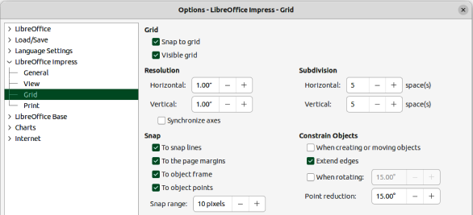
Figure 30: Options LibreOffice Impress dialog — Grid page
Grid
Specifies the settings for the grid used in Impress. This grid helps to determine the exact position of objects. Also, the grid can be set in line with the snap grid. If the snap grid is activated, to move or create individual objects without snapping to the grid, keep the Shift key pressed to deactivate this function for as long as necessary.
Snap to grid
Specifies how frames, drawing elements, and controls are moved between grid points. To change the status of Snap to grid only for the current action, drag an object while holding down the Ctrl key (macOS ⌘).
Visible grid
Specifies how the grid is displayed.
Resolution
Horizontal
Defines the unit of measure for the spacing between grid points on the X-axis.
Vertical
Defines the grid points spacing in the desired unit of measurement on the Y-axis.
Subdivision
Horizontal
Specify the number of intermediate spaces between grid points on the X-axis.
Vertical
Specify the number of intermediate spaces between grid points on the Y-axis.
Synchronize axes
Specifies how the current grid settings are changed symmetrically. The resolution and subdivision for the X and Y axes remain the same.
Snap
To snap lines
Snaps the edge of a dragged object to the nearest snap line when the cursor is released. Also, this setting can be defined by using Snap to Snap Guides on the Options toolbar (Figure 31).
To the page margins
Specifies whether to align the contour of the graphic object to the nearest page margin. The cursor or a contour line of the object must be in the snap range. In a presentation, this function can also be accessed with Snap to page Margins in the Options toolbar.
To object frame
Specifies whether to align the contour of the object to the border of the nearest object. The cursor or a contour line of the object must be in the snap range. In a presentation, this function can also be accessed with Snap to Object Border in the Options toolbar.
To object points
Specifies whether to align the contour of the object to the points of the nearest object. This only applies if the cursor or a contour line of the object is in the snap range. In a presentation, this function can also be accessed with Snap to Object Points in the Options toolbar.
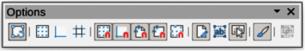
Figure 31: Options toolbar
Snap range
Defines the snap distance between the cursor and the object contour. Snaps to a snap point if the cursor is closer than the distance selected.
Constrain Objects
When creating or moving objects
Specifies that objects are restricted vertically, horizontally or diagonally (45°) when creating or moving them. This setting can be temporarily deactivated by pressing and holding the Shift key.
Extend edges
Specifies that a square is created based on the longer side of a rectangle when the Shift key is pressed before releasing the cursor. This also applies to an ellipse (a circle will be created based on the longest diameter of the ellipse). When Extend edges is not selected, a square or a circle is created based on the shorter side or diameter.
When rotating
Specifies that objects can only be rotated within the rotation angle that is selected. To rotate an object outside the defined angle, press the Shift key when rotating. Release the Shift key when the desired rotation angle is reached.
Point reduction
Defines the angle for point reduction. When working with polygons, this is useful in reducing the editing points.
The grid and snap functions can also be displayed and switched on or off using one of the following methods:
- Go to Tools > Options > LibreOffice Impress > Grid (macOS LibreOffice > Preferences > LibreOffice Impress > Grid) on the Menu bar to display the Grid dialog.
- Right-clicking on a slide and using the options in the context menu.
- Using the tools in the Options toolbar.

Snap to grid

Using Snap to Grid
Use the Snap to Grid function to move an object exactly onto a grid point in a slide. This function can be switched on and off using one of the following methods:
- Go to View > Snap Guides > Snap to Grid on the Menu bar.
- Right-click on a slide and select Snap Guides > Snap to Grid from the context menu.
- Click on Snap to Grid on the Options toolbar.

Displaying grid
To display or turn off the grid in a presentation using one of the following methods:
- Go to View > Grid and Helplines > Display Grid on the Menu bar.
- Click on Display Grid on the Options toolbar.
- Right-click on a slide and select Grid and Helplines > Display Grid from the context menu.
- Select Visible grid option in Tools > Options > LibreOffice Impress > Grid (macOS LibreOffice > Preferences > LibreOffice Impress > Grid).
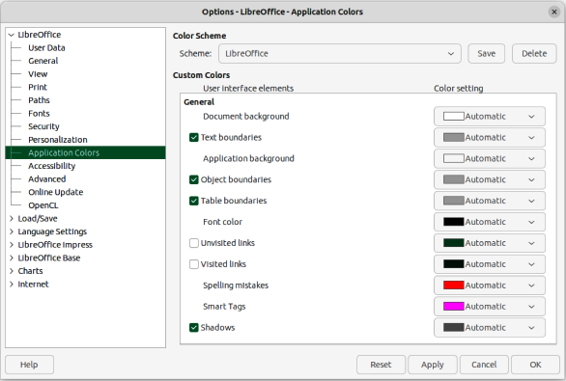
Figure 32: Options LibreOffice dialog — Application Colors page

Changing color of grid points
By default and depending on the display and computer setup, the grid points are gray and are not always easy to see. To change the color of the grid points, go to Tools > Options > LibreOffice > Application Colors (macOS LibreOffice > Preferences > LibreOffice > Application Colors) to open the Options LibreOffice Application Colors dialog (Figure 32). Select a more suitable color for the grid from the drop-down list in the Drawing/Presentation section to make the grid points more prominent against the color scheme being used.

Snap points and lines
Unlike the grid, snap lines and snap points are inserted when positioning an object to a specific position on a slide. Snap lines can either be horizontal or vertical and appear as dashed lines. Snap points appear as small crosses with dashed lines. Snap points and snap lines do not appear in printed output.

Inserting snap points and lines
To insert a snap point or line use one of the following methods to open the New Snap Object dialog (Figure 33):
- Go to Insert > Snap Guide on the Menu bar.
- Right-click in an empty space on a slide and select Insert Snap Guide from the context menu.
The options available in the New Snap Object dialog are as follows:
Position
Sets the position of a selected snap point or line relative to the top left corner of the page.
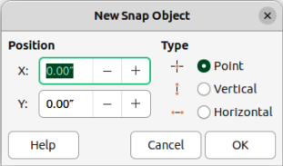
Figure 33: New Snap Object dialog
X:
Enter the amount of space required between the snap point or line and the left edge of the page.
Y:
Enter the amount of space required between the snap point or line and the top edge of the page.
Type
Specifies the type of snap object required.
Point
Inserts a snap point. Both X: and Y: text boxes are active.
Vertical
Inserts a vertical snap line. Only X: text box is active.
Horizontal
Inserts a horizontal snap line. Only Y: text box is active.
- Tip
When positioning snap lines, it is useful to display the rulers by selecting View > Rulers on the Menu bar. Click on the horizontal or vertical ruler and drag a snap line onto the slide.

Displaying snap points and lines
Display or turn off snap points and lines in a presentation using one of the following methods:
- Go to View > Snap Guides > Display Snap Guides on the Menu bar.
- Click on Display Snap Guides on the Options toolbar.
- Right-click on a slide and select Snap Guides > Display Snap Guides from the context menu.

Editing snap points
- Right-click on a snap point and select Edit Snap Point from the context menu to open the Edit Snap Point dialog (Figure 34).
- Enter new X: and Y: coordinate settings for the snap point and click OK.
- Alternatively, click on the snap point and drag it to a position on the slide.

Editing snap lines
- Right-click on a snap line and select Edit Snap Line from the context menu to open the Edit Snap Line dialog (Figure 35).
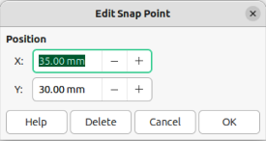
Figure 34: Edit Snap Point dialog
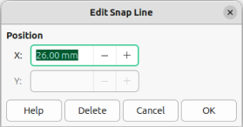
Figure 35: Edit Snap Line dialog
- Enter a new X: coordinate setting for vertical snap lines or a new Y: coordinate setting for horizontal snap lines and click OK.
- Alternatively, click on a snap line and drag it to a new position on the slide.

Deleting snap points and lines
- Right-click on a snap point or line.
- Select Delete Snap Point or Delete Snap Line from the context menu.
- Note
Clicking on Delete in the Edit Snap Point dialog or Edit Snap Line dialog also deletes a snap point or snap line.

Configuring snap range
The default snap range of when an object snaps to a snap point or line can be configured as follows:
- Go to Tools > Options > LibreOffice Impress > Grid (macOS LibreOffice > Preferences > LibreOffice Impress > Grid) on the Menu bar to open the Options LibreOffice Impress Grid dialog.
- Enter the number of pixels to set the proximity of when the object snaps into position in the Snap range text box. The default setting is 5 pixels.
- Click OK to set the new snap range and close the dialog.

Using Helplines
Helplines are a function in Impress to help position objects and can be displayed while an object is being moved. They extend from the edges of the object to the rulers at the top and left side of a workspace and do not have a snap function (Figure 36).
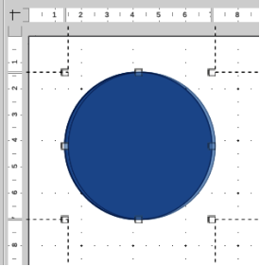
Figure 36: Example of using helplines
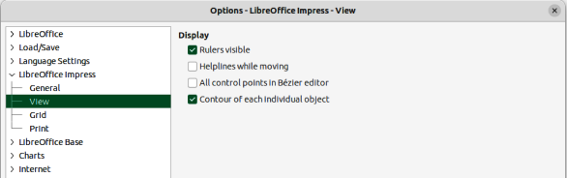
Figure 37: Options LibreOffice Impress dialog — View page
Use one of the following methods to display helplines while moving an object:
- Go to Tools > Options > LibreOffice Impress > View (macOS LibreOffice > Preferences > LibreOffice Impress > View) to open the Options LibreOffice Impress View dialog (Figure 37) on the Menu bar and select Helplines while moving.
- Click on Helplines While Moving on the Options toolbar.
- Right-click in an empty area on a slide and select Grid and Helplines > Helplines While Moving from the context menu.

Arranging objects
Impress organizes objects in a stack so that the objects on the top level of the stack cover the objects on lower levels, if any overlapping occurs. The stack level of each object can be changed by arranging shapes on a slide. Select an object or objects and use one of the following methods to change the stack level:
- Click on the required arrange tool on the Line and Filling toolbar.
- Right-click on selected objects and select Arrange from the context menu, then select the required arrange option from the sub-context menu.
- Go to Format > Arrange on the Menu bar and select an option from the submenu.
The options available for arranging the object stack level on a slide are as follows:
Bring to Front
Selected object is moved in front of all other objects.
Keyboard shortcut Ctrl+Shift++ (macOS ⌘+Shift++).
Bring Forward
Selected object is moved one level up in the stack.
Keyboard shortcut Ctrl++ (macOS ⌘++).
Send Backward
Selected object is moved one level down in the stack.
Keyboard shortcut Ctrl+– (macOS ⌘+–).
Send to Back
Selected object is moved behind all other objects.
Keyboard shortcut Ctrl+Shift+– (macOS ⌘+Shift+–).
In Front of Object
Moves the first selected object in front of the second selected object. Select the first object, then click on the second object and the objects swap position.
Behind Object
Moves the first selected object behind the second selected object. Select the first object, then click on the second object and the objects swap position.
Reverse
Swaps the stacking order of two selected objects.

Connectors and gluepoints
Connectors are lines that can be anchored to gluepoints and by default are positioned on the border of an object. When an object with a connector attached is moved or resized, the connector automatically adjusts to the change. When creating a flowchart, organization chart, schematics, or diagrams, it is highly recommended to use connectors instead of simple lines.

Connectors
When a connector is drawn or selected, Impress displays selection handles that are different to the selection handles for normal lines. The termination points of a connector are round at each end of a connector. The square selection handles on a connector line are used to change the routing of a connector where applicable.
Impress offers a wide variety of predefined connectors, which differ in the termination shape (none, arrow, circle) and in the way the connector is drawn (straight, line, curved). The connector types that are installed on the Connectors sub-toolbar (Figure 38) are normally indicated by a check mark or highlighting, depending on the computer operating system and setup.
The full range of predefined connectors can be accessed by clicking on the triangle ▼ on the title bar of the Connectors sub-toolbar and selecting Visible Buttons. For more information on installing connectors onto the Connectors sub-toolbar, see Appendix B, Toolbars.
Figure 38: Connectors sub-toolbar
The connector types are numbered to indicate the installation position from left to right on the sub-toolbar.
- Connector Ends with Arrow
- Straight Connector Ends with Arrow
- Curved Connector Ends with Arrow
- Line Connector Ends with Arrow
- Connector
- Straight Connector
- Curved Connector
- Line Connector
- Connector with Arrows
- Straight Connector with Arrows
- Curved Connector with Arrows
- Line Connector with Arrows
- Connector Starts with Arrow
- Straight Connector Starts with Arrow
- Curved Connector Starts with Arrow
- Line Connector Starts with Arrow
- Connector Ends with Circle
- Straight Connector Ends with Circle
- Line Connector Ends with Circle
- Curved Connector Ends with Circle
- Connector Starts with Circle
- Straight Connector Starts with Circle
- Line Connector Starts with Circle
- Curved Connector Starts with Circle
- Connector with Circles
- Straight Connector with Circles
- Line Connector with Circles
- Curved Connector with Circles

Connector types
Standard
Connector name starts with Connector. Line segments run vertically and horizontally creating a connector with one or more 90-degree angle bends.
Line
Connector name starts with Line. Consists of a line segment with two smaller segments at the ends and creates a connector that bends near a gluepoint. To adjust the length of the line segment between a bend point and a gluepoint, click the connector and drag the bend point.
Straight
Connector name starts with Straight. Consists of a single line and draws a straight line connector.
Curved
Connector name starts with Curved. Based on Bézier curves and curves around objects, creating a curved line connector.

Drawing connectors
- Click on the triangle ▼ next to Connectors on the Drawing toolbar to open the Connectors sub-toolbar.
- Select the type of connector required from the Connectors sub-toolbar.
- Move the cursor over one of the objects to be connected and small crosses appear around the object edges, normally in the same position as selection handles. These crosses are gluepoints to which a connector attaches, as shown in Figure 39.
- Click on the required gluepoint to attach one end of the connector, then click, hold and drag the connector to another object.
- When the cursor is over the gluepoint of the target object release the cursor and the connector is drawn.
- The selection handles that appear on the connector are used to adjust the path of the connector so that the connector can be adjusted not to cover another object in its path, as shown by the example in Figure 40.
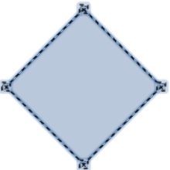
Figure 39: Example of connector gluepoints
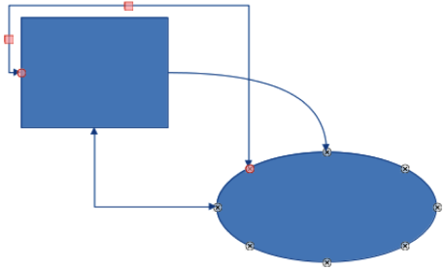
Figure 40: Example of connectors between objects
- Note
The ends of the connector cannot be swapped, that is start point cannot become the end point and the end point cannot become the start point. To swap the ends of a connector, a new connector has to be created in the opposite direction.

Formatting connectors
To detach or reposition a connector, click on a round selection handle at either end of the connector and drag to a different location, as shown in Figure 40.
To change the connector route between objects avoiding any objects on the route, click on a square control handle on the connector line and drag it to a new position, as shown in Figure 40.
To change a connector type, right-click on the connector and select Connector from the context menu to open the Connector dialog (Figure 41). Use this dialog to select a connector type and change the connector properties.
Type
Select the connector type from the drop-down list.
Line skew
Defines the skew of the line and the dialog preview displays the result.
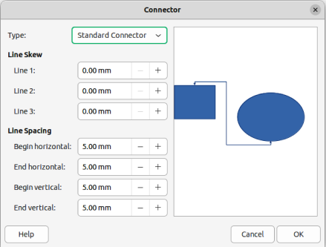
Figure 41: Connector dialog
Line spacing
Sets the spacing for the connectors.
Begin horizontal
Amount of horizontal space required at the beginning of the connector.
Begin vertical
Amount of vertical space required at the beginning of the connector.
End horizontal
Amount of horizontal space required at the end of the connector.
End vertical
Amount of vertical space required at the end of the connector.
Preview window
A left click zooms in on the preview and a right-click zooms out.

Gluepoints
Glue points are not the same as the selection handles of an object. The selection handles are for moving or changing the shape of an object. Glue points are used to fix or glue a connector to an object so that when the object moves, the connector stays fixed to that object. All objects have gluepoints, which are not normally displayed and only become visible when Connectors on the Drawing toolbar is selected.
To insert, customize or delete gluepoints on an object, open the Gluepoints toolbar (Figure 42) using one of the following methods:
- Go to View > Toolbars > Gluepoints on the Menu bar.
- Go to Edit > Gluepoints on the Menu bar.
- Click on Show Gluepoint Functions on the Drawing toolbar.
Figure 42: Gluepoints toolbar

Gluepoint types
When the Gluepoints toolbar opens, only the six tools on the left of the toolbar are active. The remaining six tools on the right of the toolbar only become active when Gluepoint Relative is deselected.
The six tools on the left of the Gluepoints toolbar are as follows:
Insert Gluepoint
Inserts a gluepoint when clicking twice on an object. See “Inserting gluepoints” on page 40 for more information.
Exit Direction Left
Connector attaches to the left edge of the selected gluepoint.
Exit Direction Top
Connector attaches to the top edge of the selected gluepoint.
Exit Direction Right
Connector attaches to the right edge of the selected gluepoint.
Exit Direction Bottom
Connector attaches to the bottom edge of the selected gluepoint.
Gluepoint Relative
Maintains the relative position of a selected gluepoint to an object when that object is resized. This tool is selected by default when the Gluepoint toolbar opens.
The six tools on the right of the Gluepoints toolbar only become active when Gluepoint Relative is deselected.
Gluepoint Horizontal Left
When applied to a gluepoint in an object and the object is resized, the horizontal position of the gluepoint remains fixed at the same distance from the left edge of the object. The vertical position of the gluepoint changes with the resizing of the object.
Gluepoint Horizontal Center
When applied to a gluepoint in an object and the object is resized, the horizontal position of the gluepoint remains fixed at the same distance from the horizontal center of the object. The vertical position of the gluepoint changes with the resizing of the object.
Gluepoint Horizontal Right
When applied to a gluepoint in an object and the object is resized, the horizontal position of the gluepoint remains fixed at the same distance from the right edge of the object. The vertical position of the gluepoint changes with the resizing of the object.
Gluepoint Vertical Top
When applied to a gluepoint in an object and the object is resized, the vertical position of the gluepoint remains fixed at the same distance from the top edge of the object. The horizontal position of the gluepoint changes with the resizing of the object.
Gluepoint Vertical Center
When applied to a gluepoint in an object and the object is resized, the vertical position of the gluepoint remains fixed at the same distance from the vertical center of the object. The horizontal position of the gluepoint changes with the resizing of the object.
Gluepoint Vertical Bottom
When applied to a gluepoint in an object and the object is resized, the vertical position of the gluepoint remains fixed at the same distance from the bottom edge of the object. The horizontal position of the gluepoint changes with the resizing of the object.
- Note
Glue points inserted into an object can only have one horizontal position and one vertical position. Only one horizontal position and/or one vertical position can be selected on the Gluepoints toolbar and used to customize a gluepoint.

Inserting gluepoints
By default, most objects normally have four gluepoints. Insert additional gluepoints into an object as follows:
- Make sure no objects are selected and use one of the following methods to open the Gluepoints toolbar:
- Go to View > Toolbars > Gluepoints on the Menu bar.
- Go to Edit > Gluepoints on the Menu bar.
- Click on Show Gluepoint Functions on the Drawing toolbar.
- Select the object, then click on Insert Gluepoint on the Gluepoints toolbar. Alternatively, right-click on a gluepoint previously inserted and select Insert Gluepoint from the context menu.
- Move the cursor to a position where the gluepoint is to be inserted into an object and click to insert the gluepoint.
- To insert more gluepoints, move the cursor to a new position and click to insert another gluepoint.
- With the gluepoint selected, select the type of gluepoint required from the options on the Gluepoints toolbar.
- To move a gluepoint to another position, click on the gluepoint and drag it to its new position.
- When inserting gluepoints is complete, make sure Insert Gluepoint on the Gluepoints toolbar is deselected.
- Tip
When inserting, moving or customizing gluepoints, it is recommended to use the zoom function to make it easier to work with gluepoints. Also, gluepoints snap to the grid making it easier to position a gluepoint.
- Note
Only gluepoints that have been inserted onto an object can be customized or deleted. The default gluepoints included with an object cannot be customized or deleted.

Customizing gluepoint exit direction
- Make sure no objects are selected and use one of the following methods to open the Gluepoints toolbar:
- Go to View > Toolbars > Gluepoints on the Menu bar.
- Go to Edit > Gluepoints on the Menu bar.
- Click on Show Gluepoint Functions on the Drawing toolbar.
- Double-click on a gluepoint that has been inserted to select the gluepoint for customization.
- Select an exit direction for the connector from the options available on the Gluepoints toolbar, or right-click on the gluepoint and select the exit direction from the context menu.
- When customizing exit direction is complete, make sure Insert Gluepoint on the Gluepoints toolbar is deselected.

Customizing gluepoint position
- Make sure no objects are selected and use one of the following methods to open the Gluepoints toolbar:
- Go to View > Toolbars > Gluepoints on the Menu bar.
- Go to Edit > Gluepoints on the Menu bar.
- Click on Show Gluepoint Functions on the Drawing toolbar.
- Double-click on a gluepoint that has been inserted to select the gluepoint for customization.
- Click on Gluepoint Relative on the Gluepoints toolbar to deselect this tool, or right-click on the gluepoint and deselect Gluepoint Relative from the context menu.
- Select the horizontal and vertical positioning tools required for the gluepoint. Only one horizontal positioning tool and one vertical positioning tool can be used on a gluepoint at any one time.
- When customizing gluepoint position is complete, make sure Insert Gluepoint on the Gluepoints toolbar is deselected.

Deleting gluepoints
- Make sure no objects are selected and use one of the following methods to open the Gluepoints toolbar:
- Go to View > Toolbars > Gluepoints on the Menu bar.
- Go to Edit > Gluepoints on the Menu bar.
- Click on Show Gluepoint Functions on the Drawing toolbar.
- Select the gluepoint that has been previously inserted.
- Press the Delete, or Backspace key, or go to Edit > Cut on the Menu bar.

Working with 3D objects
Although Impress offers advanced functions to manipulate 3D objects, this guide describes only the 3D settings applicable to an object. For additional information on how to use advanced 3D effects such as geometry and shading, refer to the Draw Guide.
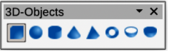
Figure 43: 3D-Objects toolbar
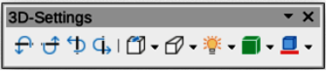
Figure 44: 3D-Settings toolbar
3D objects can be created in Impress in any of the following ways:
- Click on the triangle ▼ next to 3D Objects on the Drawing toolbar and select a 3D object from the drop-down list. After selection, draw a 3D object in exactly the same way as any other object. The icon shown on the Drawing toolbar depends on the 3D object that had been previously selected and used.
- Go to View > Toolbars > 3D-Objects on the Menu bar to open the 3D-Objects toolbar (Figure 43). This toolbar is the same as the 3D-Objects sub-toolbar that is available on the Drawing toolbar.
- Right-click on an object already drawn on a slide and select Convert > To 3D or To 3D Rotation Object from the context menu. To 3D adds thickness to the object to create a 3D object. To 3D Rotation Object creates a 3D object by rotating the object around an axis.
- Select an object and click on Toggle Extrusion on the Drawing toolbar to apply a basic 3D effect and open the 3D-Settings toolbar (Figure 44). Select one of the options on the 3D-Settings toolbar to apply a different 3D effect.
The options available on the 3D-Settings toolbar are as follows:
Toggle Extrusion
Adds thickness to an object and activates the 3D properties.
Tilt Down
Tilts the object downwards around a horizontal axis.
Tilt Up
Tilts the object up around a horizontal axis.
Tilt Left
Tilts the object left around a vertical axis.
Tilt Right
Tilts the object right around a vertical axis.
Depth
Determines the thickness of the shape. An extended toolbar opens where some default values are given. If none of the values are satisfactory, select Custom and then enter the desired thickness.
Direction
Clicking on the triangle ▼ next to Direction opens a sub-toolbar to select the direction of the perspective as well as the type (parallel or perspective).
Lighting
Clicking on the triangle ▼ next to Lighting opens a sub-toolbar to specify the direction and intensity of light.
Surface
Clicking on the triangle ▼ next to Surface opens a sub-toolbar to specify the type of surface from Wire Frame (useful when manipulating the object), Matt, Plastic, or Metal.
3D–Color
Clicking on the triangle ▼ next to 3D–Color opens a color palette to select a color for object thickness when an object is extruded to 3D.
- Note
Most of the Fontwork shapes (see “Fontwork” on page 45) have 3D properties and can be manipulated with the 3D-Settings toolbar.

Converting objects
Objects are converted into different types using one of the following methods:
- Right-click on the object and select Convert from the context menu, then select a conversion option from the context menu.
- Select an object and go to Format > Convert on the Menu bar and select a conversion option from the submenu.
The options for converting objects to another type are as follows:
To Curve
Converts the selected object to a Bézier curve. Click on Points on the Drawing toolbar to edit the points after conversion to a Bézier curve.
To Polygon
Converts the selected object to a polygon. Click on Points on the Drawing toolbar to edit the object after conversion to a polygon. A polygon always consists of straight segments.
To Contour
For basic shapes and is equivalent to converting to polygon. For more complex shapes (or for text objects) this conversion creates a group of polygons that can be manipulated by entering the group.
To 3–D
Converts the selected object to a 3D object.
To 3–D Rotation Object
Creates a three-dimensional shape by rotating the selected object around its vertical axis.
To Bitmap
Converts the selected object to a bitmap.
To Metafile
Converts the selected object to Windows Metafile Format (WMF), containing both bitmap and vector graphic data.
- Note
In most cases the conversion to a different type of object does not immediately produce visible results.
To Curve, To Polygon, To 3–D, and To 3–D Rotation Object are additional tools that can be added to the Drawing toolbar. See Appendix B, Toolbars for more information.
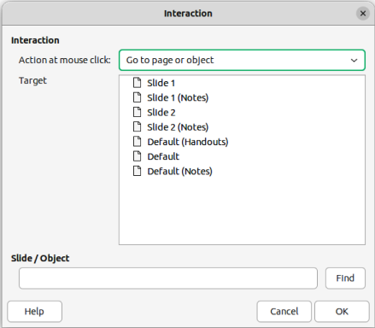
Figure 45: Interaction dialog

Interaction with objects
Associating an object to an action that is performed when the object is clicked is called an interaction.
- Select an object for interaction and open the Interaction dialog (Figure 45) using one of the following methods:
- Click on Interaction on the Line and Filling toolbar.
- Right-click on the object and select Interaction from the context menu.
- Go to Format > Interaction on the Menu bar.
- Select the interaction from the available options in Action at mouse click and any parameters (if applicable) that maybe available. The Interaction dialog changes depending on the type of interaction selected. The interactions and parameters are explained in Table 1.
- Click OK to save the changes and close the dialog.
- To remove an interaction from an object, repeat the procedure and select No action as the interaction type at Step 2.
Table 1: Interaction types and parameters
Interaction | Parameters
No action | No parameters.
Go to previous slide | No parameters.
Go to next slide | No parameters.
Go to first slide | No parameters.
Go to last slide | No parameters.
Go to page or object | Specify the target from the list in the Target box. Search for a specific target in the Slide/Object box at the bottom of the screen.
Go to document | Select the document in the Document box. Use Browse to open a file browser. If the document to be opened is in ODP format, the target list is populated allowing selection of the specific target.
Play sound | Select the file containing the sound to be played. Use Browse to open a file browser.
Run program | Select the program to execute. Use Browse to open a file browser.
Run macro | Select a macro that runs during the presentation. Use Browse to open the Macro Selector dialog.
Exit presentation | When the cursor is clicked over the object, the presentation terminates.

Fontwork
With Fontwork, graphical text art objects can be created to make a presentation more attractive. There are many different settings for text art objects (line, area, position, size, and more) giving a large selection of effects. Fontwork is also available with the Writer, Calc, and Draw modules of LibreOffice, but there are small differences in the way that each module displays it. For more information about Fontwork, see the Getting Started Guide.

Creating Fontwork
- Go to Insert > Fontwork on the Menu bar to open the Fontwork Gallery dialog (Figure 46).
- Select a Fontwork style from the dialog and click OK. The selected Fontwork appears centrally on the slide and the dialog closes.
- Double-click on the Fontwork text graphic to switch on editing mode.
- Type in the required text to replace the default text in the Fontwork graphic and the text appears over the default text as shown by the example in Figure 47.
- Press the Esc key or click outside the Fontwork graphic and the text replaces default text.

Fontwork toolbar
The Fontwork toolbar (Figure 48) becomes visible and active when a Fontwork object is selected. If the toolbar is not visible, go to View > Toolbars > Fontwork on the Menu bar. Also, the Fontwork panel opens in the Properties deck on the Sidebar (Figure 49) and contains the same tools as the Fontwork toolbar.
The Fontwork toolbar contains the following tools:
Insert Fontwork Text
Opens the Fontwork Gallery dialog.
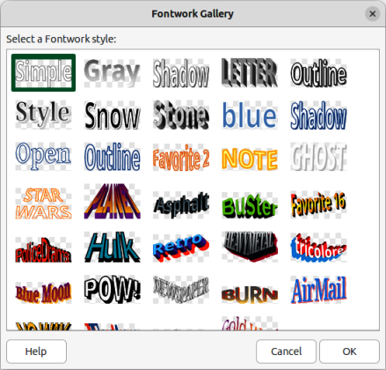
Figure 46: Fontwork Gallery dialog

Figure 47: Example of creating Fontwork
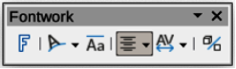
Figure 48: Fontwork toolbar
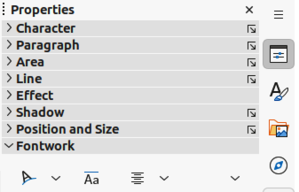
Figure 49: Fontwork panel in Properties deck on Sidebar
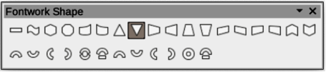
Figure 50: Fontwork Shape sub-toolbar
Fontwork Shape
Changes the shape of the selected object. Clicking on the triangle ▼ next to Fontwork Shape opens the Fontwork Shape sub-toolbar (Figure 50) allowing selection of different Fontwork shapes.
Fontwork Same Letter Heights
Changes the height of characters in the selected Fontwork object. Toggles between normal height where the characters have different heights to where all characters have the same height.
Fontwork Alignment
Specifies the text alignment within the frame. Options available are Left Align, Center, Right Align, Word Justify, and Stretch Justify. The effects of the text alignment can only be seen if the text spans over two or more lines. In the Stretch Justify mode, all lines are filled completely.
Fontwork Character Spacing
Selects the spacing between characters and whether kerning pairs are used. Options available are Very Tight, Tight, Normal, Loose, Very Loose, and Custom Spacing. For Custom Spacing, input a percentage value: 100% is normal character spacing, less than 100% character spacing is tighter, and more than 100% character spacing is looser.
Toggle Extrusion
Converts the Fontwork object into a 3D shape using extrusion. See the Draw Guide for more information.

Modifying Fontwork
It is possible to treat Fontwork text as an object and apply all the formatting that has been described in this chapter. Assign line properties only to Fontwork which does not have a 3D effect, otherwise the changes will not be visible. Also, modify some of the Fontwork shapes by moving the dot that is displayed along with the selection handles. This is similar to modification of the angles of trapezoid and parallelogram basic shapes.

Animations
Animated slide transitions can be added between slides to give presentations a more professional look when changing to the next slide (see Chapter 9, Slide Shows for more information on transitions). However, Impress also allows animations to be added onto the slides to create more interest in a presentation.
An animation consists of a sequence of images or objects called frames that are displayed in succession when the animation runs. Each frame may contain one or more objects. For example, bullet points appearing one by one; pictures, shapes or other objects appearing singly or as a group onto a slide. Animations can be controlled using the keyboard, a click, or automatically in a timed sequence.
- Note
Anything that can be placed onto a slide is an object. For example, an object can be an image, clip art drawing, text, and so on.
- Tip
Animations can look great in a presentation, but overuse of animations can make a good presentation into a poor presentation. Always use discretion when adding animations to a presentation.

Creating an animation
- Select an object on a slide and open the Animation deck on the Sidebar (Figure 51) using one of the following methods:
- Click on Animation on the Sidebar.
- Right-click on a selected object and select Animation from the context menu.
- Go to View > Animation on the Menu bar.
- Click on Add Effect to add the selected object into the Animation preview box.
- Select a category type from the options available in the Category drop-down list.
- Select an animation effect from the options available in the Effects list.
- Select how the animation starts from the options available in the Start drop-down list.
- Select how the animation appears from the options available in the Direction drop-list. Available options are specific to the effect selected in the Effects list.
- Enter a time in seconds for how long the animation lasts in the Duration box.
- Enter a timing delay in seconds for when the animated object appears in the presentation in the Delay box.
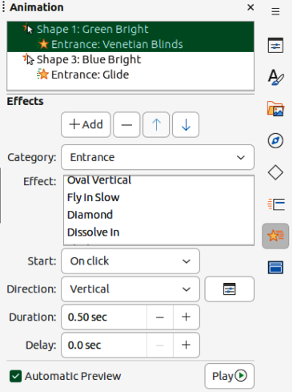
Figure 51: Animation deck on Sidebar
- If necessary, click on Options to open the Effect Options dialog to set any effect options required for the animation, then click OK to close the Effect Options dialog.
- If necessary, change the order of when the selected object appears in the animation using Move Up or Move Down below the Animation preview box.
- Click on Play to preview the animation effect.
- If necessary, select Automatic Preview so that each time the animation is changed, there is a preview of the effect.
- When satisfied, run the slide show to check the presentation.

Animation tools and options
The available tools and options on the Animation deck on the Sidebar provides control over how an animation is applied to an object on a slide.
Add Effect
Adds a selected object to the Animation preview box and add animation effects to the object.
Remove Effect
Removes a selected object and its animated effects from the Animation preview box.
Move Up
Moves the selected object and its animation effect up the order of animation effects that have been applied to an object.
Move Down
Moves the selected animation effect down the order of animation effects that have been applied to an object.
Category
Select a category from the options available in the drop-down list.
Effect
Select an animation effect from the options available in the list.
Start
Select from the drop-down list how an animation effect starts when running an animation:
On click
Animation stops at this effect until the next click.
With previous
Animation runs immediately.
After previous
Animation runs as soon as the previous animation ends.
Direction
Select from the drop-down list how an animation effect appears on the slide. The options available depend on the animation effect selected.
Options
Opens the Effect Options dialog for adjusting and applying options to the animation effect and timing.
Duration
Select the duration, in seconds, of the selected animation effect.
Delay
Select the delay, in seconds, of when the animation effect starts.
Automatic Preview
Select this option to automatically preview an animation effect when it is applied to an object.
Play
Test run the animation.

Effect Options dialog

Effect page
The Effect page (Figure 52) contains options that match the animation effect selected:
Settings
Direction
Specify the direction of the animation effect from the options available in the drop-down list.
Enhancement
Sound
Select a sound from the drop-down list that plays when the animation effect is run.
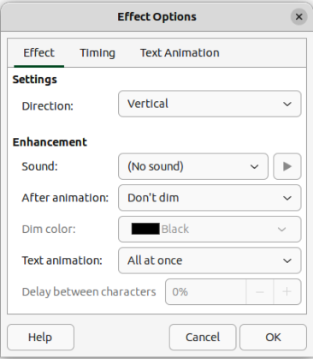
Figure 52: Effect Options dialog — Effect page
After animation
Select from the drop-down list what happens after an animation effect ends.
— Don't dim – no after-effect runs.
— Dim with color – after the animation a dim color fills the shape.
— Hide after animation – hides the shape after the animation ends.
— Hide on next animation – hides the shape on the next animation.
Dim color
Select a dim color from the available color palettes.
Text animation
Select the animation mode for the text in an object:
— All at once – animates the text all at once.
— Word by word – animates the text word by word.
— Letter by letter – animates the text letter by letter.
Delay between characters
Specifies the percentage of delay between animations of words or letters.

Timing page
The Timing page on the Effect Options dialog (Figure 53) contains the following options:
Timing
Start
Displays the start property of the selected animation effect.
— On click – animation stops at this effect until the next click.
— With previous – animation runs immediately.
— After previous – animation runs as soon as the previous animation ends.
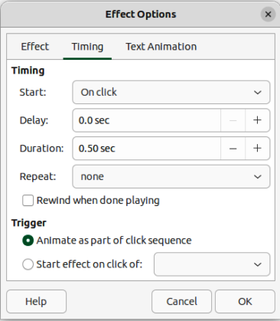
Figure 53: Effect Options dialog — Timing page
Delay
Specifies a delay in seconds before the effect starts.
Duration
Specifies the duration in seconds of the effect.
Repeat
Specifies whether and how to repeat the current effect. Enter the number of repeats, or select from the list:
— none – effect is not repeated.
— Until next click – animation is repeated until the next click.
— Until end of slide – animation repeats as long as the slide is displayed.
Rewind when done playing
Specifies whether to let the animated object returns to its starting state after the animation ends.
Trigger
Animate as part of click sequence
Specifies whether to let the animation start in the normal click sequence.
Start effect on click of
Specifies whether to let the animation start when a specified shape is clicked. Select the shape by its name from the drop-down list.

Text Animation page
The Text Animation page on the Effect Options dialog (Figure 54) contains the following options:
Group text
Specifies how the text is animated.
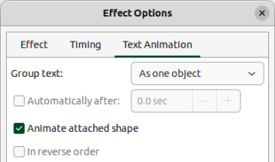
Figure 54: Effect Options dialog — Text Animation page
As one object
Whole text object is animated.
All paragraphs at once
All text paragraphs are animated.
By XX level paragraphs
Text for the outline level selected is animated. The options available depends on how many outline levels there are in the animated text.
Automatically after
Specifies a delay in seconds before the text animation effect starts.
Animate attached shape
Animates an object that contains text.
In reverse order
Text paragraphs are animated in reverse order.

Animated images
Animation of drawing objects, text objects, and graphic objects (images) on slides can make a presentation more interesting. LibreOffice Impress provides a simple animation editor where animation images (frames) can be created by assembling objects from a slide. The animation effect is achieved by rotating through static frames that are created.

Creating animated image
The following is an example of how to create an animated image.
- Select an object or group of objects for inclusion in an animation and go to Insert > Media > Animated Image to open the Animation dialog (Figure 55).
- Add an object or objects using one of the following methods:
- Click on Apply Object to add a single object or a group of objects to the current animation frame.
- Click on Apply Objects Individually to create a separate animation frame for each of the selected objects.
- In Animation Group, select Bitmap object.
- Enter the frame (image) number in the Image Number box to setup the image.
- In Duration specify the duration time in seconds for displaying a frame.
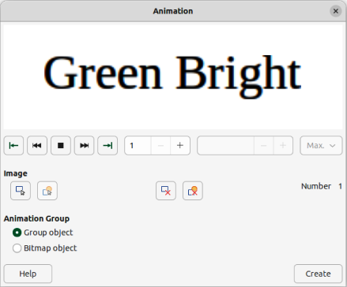
Figure 55: Animation dialog
- Specify the number of times a frame is displayed in the animation sequence in Loop Count. This is called looping.
- Repeat Steps 4 thru 6 for each image or object used for the animated image.
- Click on Create and the animated image appears centrally on the slide.
- Note
If the image to be copied consists of several objects, each object can be treated as a separate frame. In this case, click on Apply Objects Individually. Remember that each object is centered in the animation.

Animation dialog controls
First Image
Jumps to the first image in the animation sequence.
Backwards
Plays the animation backwards.
Stop
Stops playing the animation.
Play
Plays the animation.
Last Image
Jumps to the last image in the animation sequence.
Image Number
Indicates the position of the current image in the animation sequence. To view another image, enter its number or click the up and down arrows.
Duration
Enter the number of seconds to display the current image. This option is only available if Bitmap object is selected in Animation group.
Loop Count
Sets the number of times that animation will play. If the animation is to play continuously, select Max. This option is only available if Bitmap object is selected in Animation group.
Apply Object
Adds selected object or objects as a single image.
Apply Objects Individually
Adds an image for each selected object. If a grouped object is selected, an image is created for each object in the group.
Delete Current Image
Deletes the current image from the animation sequence.
Delete All Images
Deletes all images in the animation.
Number
Total number of images in the animation.
Group object
Assembles images into a single object so that they can be moved as a group. Individual objects can still be edited by double-clicking the group in the slide.
Bitmap object
Combines images into a single image.
Create
Inserts the animation into the current slide.
- Note
An animation, such as an animated GIF, can be selected. Click Apply Objects Individually to open it for editing. When finished editing the animation, click Create to insert a new animation into a slide.

