
Impress Guide 7.5

Appendix B,
Toolbars

Copyright
This document is Copyright © 2023 by the LibreOffice Documentation Team. Contributors are listed below. This document may be distributed and/or modified under the terms of either the GNU General Public License (https://www.gnu.org/licenses/gpl.html), version 3 or later, or the Creative Commons Attribution License (https://creativecommons.org/licenses/by/4.0/), version 4.0 or later. All trademarks within this guide belong to their legitimate owners.

Contributors
Contributors for this edition:
Peter Schofield

Contributors for previous editions:
Dave Barton
Felipe Viggiano
Kees Kriek
Peter Schofield

Feedback
Please direct any comments or suggestions about this document to the Documentation Team Forum at https://community.documentfoundation.org/c/documentation/loguides/ (registration is required) or send an email to: loguides@community.documentfoundation.org.
- Note
Everything sent to a forum, including email addresses and any other personal information that is written in the message, is publicly archived and cannot be deleted. Emails sent to the forum are moderated.

Publication date and software version
Published June 2023. Based on LibreOffice 7.5 Community.
Other versions of LibreOffice may differ in appearance and functionality.

Using LibreOffice on macOS
Some keystrokes and menu items are different on macOS from those used in Windows and Linux. The table below gives some common substitutions used in this document. For a detailed list, see LibreOffice Help.
Windows or Linux | macOS equivalent | Effect
Tools > Options  menu selection | LibreOffice > Preferences | Access setup options
Right-click | Control+click, Ctrl+click, or right-click depending on computer setup | Open a context menu
Ctrl or Control | ⌘ and/or Cmd or Command, depending on keyboard | Used with other keys
Alt | ⌥ and/or Alt or Option depending on keyboard | Used with other keys
F11 | ⌘+T | Open the Styles deck in the Sidebar

Contents
Copyright 2
Contributors 2
Feedback 2
Publication date and software version 2
Using LibreOffice on macOS 2
Introduction 5
Using toolbars 5
Displaying toolbars 5
Closing toolbars 5
Moving toolbars 5
Docked toolbars 5
Floating toolbars 6
Floating sub-toolbars 6
Docking toolbar 7
Locking toolbars 7
Docked toolbars 7
Locking sub-toolbars 7
Editing toolbars 8
Adding tools 8
Deleting tools 8
Customizing toolbars 8
Toolbars 8
3D-Objects 9
3D-Settings 9
Align Objects 10
Comments 10
Distribute Selection 11
Drawing 11
Edit Points 12
Find 13
Fontwork 13
Form Controls 13
Form Design 14
Form Navigation 14
Glue Points 15
Image 15
Insert 16
Legacy Circles and Ovals 16
Legacy Rectangles 16
Line and Filling 17
Master View 17
Media Playback 18
Options 18
Outline 18
Presentation 19
Slide Sorter 19
Slide View 19
Standard 20
Standard (Single Mode) 20
Standard (Viewing Mode) 21
Table 22
Text 22
Text Formatting 22
Transformations 23
TSCP Classification 24
Zoom 24
Sub-toolbars 24
3D-Objects 24
Basic Shapes 25
Block Arrows 25
Callouts 25
Color 26
Connectors 27
Curves and Polygons 27
Flowchart 27
Image Filter 28
Lines and Arrows 29
Stars and Banners 29
Symbol Shapes 29

Introduction
In Impress there are several toolbars available to help in creating a presentation. Each toolbar has a default set of tools and an option to add additional tools to a toolbar.
- Note
The icons displayed in the Impress toolbars illustrated in this appendix may differ from what is displayed on a computer screen. Toolbar icons depend on the computer operating system being used and how LibreOffice has been set up. For more information on customizing LibreOffice and the toolbars, see the Getting Started Guide.

Using toolbars

Displaying toolbars
There are two methods of opening toolbars in Impress, which are as follows:
- Go to View > Toolbars on the Menu bar. A submenu opens with an alphabetical list of toolbars available for creating presentations in LibreOffice Impress. Click on a toolbar name to display it and make it active. Active toolbars are indicated by highlighting or a check mark next to the toolbar name.
- When selecting some tools on a toolbar, a toolbar may open providing more tools to edit an object. For example, clicking on Color in the Image toolbar opens the Color toolbar to adjust the color settings of an image.
- Note
Some toolbars when selected do not display until an object of the correct type is selected in a presentation. For example, the Image toolbar only displays when an image is selected.

Closing toolbars
To close a toolbar, use one of the following methods:
- Go to View > Toolbars on the Menu bar and deselect the toolbar.
- Right-click in a blank area on a toolbar and select Close Toolbar from the context menu.
- Click on the X in the right corner of the title bar of a floating toolbar.

Moving toolbars

Docked toolbars
By default, some toolbars are docked into position in the Impress main window. For example, the Standard toolbar is docked at the top of the main window. Docked toolbars can be undocked and moved to a new docked position on the main window or left as a floating toolbar.
- Move the cursor over the small vertical handle at the left end of the toolbar (highlighted in Figure 1). The cursor changes to the moving cursor used for the computer system and setup.
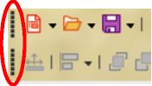
Figure 1: Toolbar moving handles
- Click and drag the toolbar to a new location. This can be a new docked position, or a floating toolbar. A hashed border appears around the toolbar indicating the toolbar position as it is dragged.
- Release the cursor when the required position is reached.
- Note
If the small vertical bar is not visible at the left end of a docked toolbar, then the toolbar is locked into position. A docked toolbar must be unlocked before it can be moved to a new position in the Impress main window. See “Locking toolbars” on page 7 for more information.

Floating toolbars
- To move a floating toolbar, click on its title bar and drag it to a new floating location.
- Release the cursor when the toolbar is in the required position.
- Note
A floating toolbar does not have to be positioned on the Impress main window for it to function.

Floating sub-toolbars
Some tools on a toolbar have a triangle ▼ to the right of the tool indicating that more tools are available on a sub-toolbar, for example Basic Shapes on the Drawing toolbar. Sub-toolbars can be turned into floating toolbars and moved into a new position as follows:
- Move the cursor over the horizontal handle at the top of the toolbar (highlighted in Figure 2). The cursor changes to the moving cursor used for the computer system and setup.
- Click and drag the toolbar to a new location to create a floating sub-toolbar.
- Release the cursor when the required position is reached.
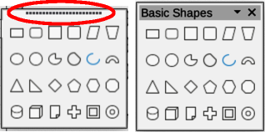
Figure 2: Creating floating sub-toolbar
- To close the floating sub-toolbar, right-click on the triangle ▼ in the sub-toolbar title bar and select Close Toolbar from the context menu, or click on the X at the right end of the sub-toolbar title bar.

Docking toolbar
To dock a floating toolbar, use one of the following methods:
- Click on the title bar and drag it to the top, bottom, left side, or right side of the main window. When the toolbar reaches a docking position, a hashed border appears at the docked position. Release the cursor and the toolbar is docked.
- Right-click on the toolbar and select Dock Toolbar from the context menu. The toolbar moves into a docked position. If the position is not suitable, move the toolbar to a new docked position.
- To dock all floating toolbars that are active, right-click on the toolbar and select Dock All Toolbars from the context menu.

Locking toolbars

Docked toolbars
When a toolbar has been docked into position on the Impress main window, the toolbar can also be locked into position preventing the toolbar from becoming a floating toolbar.
- To lock a toolbar into a docked position, right-click in a blank area on the toolbar and select Lock Toolbar Position from the context menu. A check mark appears against this option indicating the toolbar is now locked. A small vertical or horizontal bar disappears from the left end or top of the toolbar indicating that the toolbar is locked.
- To unlock a toolbar, right-click in a blank area on the toolbar and click on Lock Toolbar Position in the context menu. The check mark next to this option disappears indicating the toolbar is now unlocked. A small vertical or horizontal bar appears at the left end or top of the toolbar indicating that the toolbar is unlocked. This bar is also is used to move the toolbar.
- Note
Some toolbars cannot be docked or locked into position. This is indicated by the options Dock Toolbar and/or Lock Toolbar Position being grayed out, making the options unavailable.

Locking sub-toolbars
To prevent sub-toolbars from becoming floating sub-toolbars, sub-toolbars have to be locked as follows:
- Save the presentation that is open in Impress, then go to View > Toolbars on the Menu bar and select Lock Toolbars from the submenu.
- Select Restart Now in the Restart LibreOffice dialog that opens to activate the Lock Toolbars option.
- To unlock sub-toolbars so they can become floating sub-toolbars, repeat Steps 1 thru 3. The Lock Toolbars option is an on/off switch.
- Note
Using the Lock Toolbars option affects ALL toolbars and sub-toolbars available in all LibreOffice modules.

Editing toolbars
When LibreOffice is installed on a computer, it includes a set of toolbars suitable for each LibreOffice component. Each toolbar has a default set of visible tools. Tools can be added or deleted, and toolbars can be customized.

Adding tools
- Right-click in a blank area on a toolbar, or click on the triangle ▼ on the right of the toolbar title bar.
- Select Visible Buttons from the context menu to display a list of available tools.
- Click on the tool required and the tool appears in the toolbar. The list of available tools closes automatically. If there is a highlight or check mark next to the tool, then that tool is already installed on the toolbar.
- Note
When adding tools using Visible Buttons, the tool is added to the toolbar at the same position as the tool appears in the Visible Buttons list. That is, the top tool in Visible Buttons appears at the left end of the toolbar and the bottom tool appears at the right end of the toolbar. Tool positions on a toolbar cannot be changed.

Deleting tools
- Right-click in a blank area on a toolbar, or click on the triangle ▼ on the right of the toolbar title bar.
- Select Visible Buttons from the context menu to display a list of available tools.
- Click on the tool no longer required and the tool is removed from the toolbar. The highlight or check mark next to the tool is also removed. The list of available tools closes automatically.

Customizing toolbars
Extra tools and commands that are not available in Visible Buttons can be added to a toolbar using customization. Customization also allows the creation of new toolbars if a specific set of tools are required for a specific task. For information on customizing toolbars, see the Getting Started Guide.

Toolbars
The following bullet points provide information on the toolbars available for creating presentations in Impress:
- The number of tools visible on a toolbar depend on the computer setup that is being used to create a presentation.
- The tools displayed on the toolbars in this chapter are examples only
- The tools already installed on a toolbar are indicated in Visible Buttons either by the tool icon being highlighted or by a check mark. This install indication depends on computer setup and computer operating system being used.
- On some toolbars, tool icons may have a triangle ▼ to the right of the icon. Click on this triangle to open a list of options, a toolbar, or a sub-toolbar.
- Some tools also have the option of using a keyboard shortcut instead of clicking on the tool. For a full list of keyboard shortcuts that are available in Impress, see Appendix A, Keyboard Shortcuts.

3D-Objects
The 3D-Objects toolbar (Figure 3) provides tools to create 3D objects in a slide. It is activated by going to View > Toolbars > 3D-Objects on the Menu bar. Alternatively, click on the triangle ▼ next to 3D-Objects on the Drawing toolbar to open a sub-toolbar giving access to the same 3D tools.
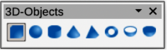
Figure 3: 3D-Objects toolbar
The tools available on the 3D-Objects toolbar in Visible Buttons are numbered from left to right when installed on the toolbar.
- Cube
- Sphere
- Cylinder
- Cone
- Pyramid
- Torus
- Shell
- Half Sphere
- Note
The 3D-Objects toolbar is also available as a sub-toolbar on the Drawing toolbar. See “Drawing” on page 12 for more information.

3D-Settings
The 3D-Settings toolbar (Figure 4) and its tools only become active when an object has been converted to 3D using the tool Toggle Extrusion and the converted object is selected.
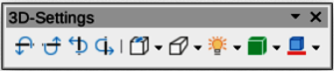
Figure 4: 3D-Settings toolbar
The tools available on the 3D-Settings toolbar in Visible Buttons are numbered from left to right when installed on the toolbar.
- Toggle Extrusion
- Tilt Down
- Tilt Up
- Tilt Left
- Tilt Right
- Depth
- Direction
- Lighting
- Surface
- 3D Color
The following tools on the 3D-Settings toolbar have a triangle ▼ on the right of the icon. Click on this triangle to open a drop-down menu giving access to various options as follows:
Depth
3D extrusion depth — 0cm; 1cm; 2.5cm; 5cm; 10cm; Infinity; Custom. The measurement unit depends on the ruler settings in Tools > Options > LibreOffice Impress > General (macOS LibreOffice > Preferences > LibreOffice Impress > General).
Direction
3D extrusion direction and type — Parallel; Perspective.
Lighting
Lighting direction and lighting level of 3D extrusion — Bright; Normal; Dim.
Surface
Surface type of 3D extrusion — Wire Frame; Matt; Plastic; Metal.
3D Color
Color of 3D extrusion. Select a color from one of the available color palettes.

Align Objects
The Align Objects toolbar (Figure 5) provides tools for aligning several objects in a slide to improve the visual impact of objects on a slide.
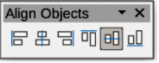
Figure 5: Align Objects toolbar
The tools available on the Align Objects toolbar in Visible Buttons are numbered from left to right when installed on the toolbar.
- Left
- Centered
- Right
- Top
- Center
- Bottom
The tools available on the Align Objects toolbar are as follows:
- Left — aligns the left edges of the selected objects. If only one object is selected in Draw or Impress, the left edge of the object is aligned to the left page margin.
- Centered — horizontally centers the selected objects. If only one object is selected in Draw or Impress, the centre of the object is aligned to the horizontal centre of the page.
- Right — aligns the right edges of the selected objects. If only one object is selected in Impress or Draw, the right edge of the object is aligned to the right page margin.
- Top — vertically aligns the top edges of the selected objects. If only one object is selected in Draw or Impress, the top edge of the object is aligned to the upper page margin.
- Centre — vertically centers the selected objects. If only one object is selected in Draw or Impress, the centre of the object is aligned to the vertical centre of the page.
- Bottom — vertically aligns the bottom edges of the selected objects. If only one object is selected in Draw or Impress, the bottom edge of the object is aligned to the lower page margin.

Comments
The Comments toolbar (Figure 6) provides tools for adding, deletion, and navigation of comments in a presentation. To use comments, it is recommended to add the name and initials of all users in Tools > Options > LibreOffice > User Data (macOS LibreOffice > Preferences > LibreOffice > User Data) so that comments can be easily identified.
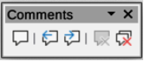
Figure 6: Comments toolbar
The tools available on the Comments toolbar in Visible Buttons are numbered from left to right when installed on the toolbar.
- Comment
- Previous Comment
- Next Comment
- Delete Comment
- Delete All Comments

Distribute Selection
The Distribute Selection toolbar (Figure 7) provides tools to distribute three or more selected objects evenly along the horizontal axis or vertical axis. Also, the spacing between objects can be evenly distributed.
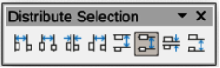
Figure 7: Distribute Selection toolbar
The tools available on the Distribute Selection toolbar in Visible Buttons are numbered from left to right when installed on the toolbar.
- Distribute Horizontally Left
- Distribute Horizontally Center
- Distribute Horizontally Spacing
- Distribute Horizontally Right
- Distribute Vertically Top
- Distribute Vertically Center
- Distribute Vertically Spacing
- Distribute Vertically Bottom
The tools available on the Distribute Selection toolbar provide the following options:
- Distribute Horizontally Left — distributes the selected objects, so that the left edges of the objects are evenly spaced from one another.
- Distribute Horizontally Center — distributes the selected objects, so that the horizontal centers of the objects are evenly spaced from one another.
- Distribute Horizontally Spacing — distributes the selected objects horizontally, so that the objects are evenly spaced from one another.
- Distribute Horizontally Right — distributes the selected objects, so that the right edges of the objects are evenly spaced from one another.
- Distribute Vertically Top — distributes the selected objects, so that the top edges of the objects are evenly spaced from one another.
- Distribute Vertically Center — distributes the selected objects, so that the vertical centers of the objects are evenly spaced from one another.
- Distribute Vertically Spacing — distributes the selected objects vertically, so that the objects are evenly spaced from one another.
- Distribute Vertically Bottom — distributes the selected objects, so that the bottom edges of the objects are evenly spaced from one another.

Drawing
The Drawing toolbar (Figure 8) provides the majority of the tools normally used to create graphic objects on slides in a presentation. By default, this toolbar is normally docked on the left side of the Workspace.
Some tool shapes on the Drawing toolbar change depending on the last tool that was previously selected and used.
- Where available, click on the triangle ▼ to the right of a tool to open a sub-toolbar, then select the required shape to add to a drawing. For more information on sub-toolbars, see “Sub-toolbars” on page 24.
- To create a floating sub-toolbar, click on the handle (Figure 2 on page 6) at the top of the pop-up toolbar and drag to an empty area on the main window.
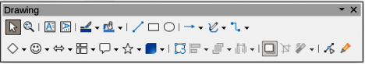
Figure 8: Drawing toolbar
The tools available on the Drawing toolbar in Visible Buttons are numbered from left to right when installed on the toolbar.
- Select
- Zoom & Pan
- Zoom
- Text Box
- Vertical Text
- Insert Fontwork
- Line Color
- Fill Color
- Line
- Rectangle
- Ellipse
- Line Ends with Arrow
- Lines and Arrows
- Curves and Polygons
- Connectors
- Basic Shapes
- Symbol Shapes
- Block Arrows (Arrow Shapes in Visible Buttons))
- Flowchart (Flowchart Shapes in Visible Buttons)
- Callouts (Callout Shapes in Visible Buttons)
- Stars and Banners (Star Shapes in Visible Buttons)
- 3D Objects
- Position and Size
- Rotate
- Flip
- Align Objects
- Arrange
- Select at least three objects to distribute (Distribution in Visible Buttons)
- Shadow
- Crop Image (Crop in Visible Buttons)
- Filter
- Points F8 (Edit Points in Visible Buttons)
- Show Gluepoint Function (Gluepoints in Visible Buttons)
- To Curve
- To Polygon
- To 3D
- T0 3D Rotation Object
- Toggle Extrusion
- Insert
- Controls

Edit Points
The Edit Points toolbar (Figure 9) provides tools for editing the points of a curve or polygon, or an object that has been converted to a curve or polygon. The toolbar only becomes active when an object is selected and one of the following methods is used to open the toolbar:
- Click on Edit Points on the Drawing or Standard toolbar.
- Use the keyboard shortcut F8.
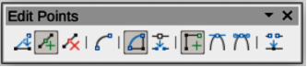
Figure 9: Edit Points toolbar
The tools available on the Edit Points toolbar in Visible Buttons are numbered from left to right when installed on the toolbar.
- Edit Points
- Move Points
- Insert Points
- Delete Points
- Convert to Curve
- Close Bezier
- Split Curve
- Corner Point
- Smooth Transition
- Symmetric Transition
- Eliminate Points

Find
The Find toolbar (Figure 10) opens by default and is docked in the bottom left corner of the Impress main window above the Status bar. However, it can be undocked and made into a floating toolbar.
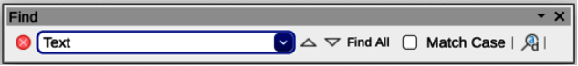
Figure 10: Find toolbar
The tools available on the Find toolbar in Visible Buttons are numbered from left to right when installed on the toolbar.
- Close Find Bar
- Find Text
- Find Previous
- Find Next
- Find All
- Match Case
- Find and Replace

Fontwork
The Fontwork toolbar (Figure 11) is used to create graphical text objects in a slide and provide the tools for editing the graphical text object. This toolbar only becomes active when a Fontwork graphical text object in a slide has been selected.
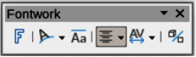
Figure 11: Fontwork toolbar
The tools available on the Fontwork toolbar in Visible Buttons are numbered from left to right when installed on the toolbar.
- Insert Fontwork Text
- Fontwork Shape
- Fontwork Same Letter Heights
- Fontwork Alignment
- Fontwork Character Spacing
- Toggle Extrusion
Some tools on the Fontwork toolbar have a triangle ▼ to the right of the tool. Click on the triangle to open a pop-up toolbar, or drop-down option list.
Fontwork Shape
Select the required shape for the Fontwork graphical text object from the options available.
Fontwork Alignment
Select the paragraph alignment from the options available.
Fontwork Character Spacing
Select the required character spacing from the options available.

Form Controls
The Form Controls toolbar (Figure 12) provides the tools required to create an interactive form. This allows controls to be added to a form in a text, drawing, spreadsheet, presentation, or HTML document (for example a button that opens another presentation or slide).

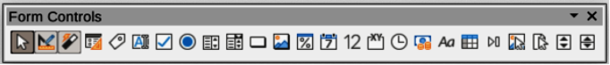
Figure 12: Form Controls toolbar
The tools available on the Form Controls toolbar in Visible Buttons are numbered from left to right when installed on the toolbar.
- Select
- Design Mode
- Toggle Form Control Wizards
- Form Design
- Control Properties
- Form Properties
- Label
- Text Box
- Check Box
- Option Button
- List Box
- Combo Box
- Push Button
- Image Button
- Formatted Field
- Date Field
- Numerical Field
- Group Box
- Time Field
- Currency Field
- Pattern Field
- Table Control
- Navigation Bar
- Image Control
- File Selection
- Spin Button
- Scrollbar

Form Design
The Form Design toolbar (Figure 13) opens a form in Design Mode so that it can be edited. Controls of the form cannot be activated or its contents edited when in Design Mode. However, the position and size of the controls can be changed, other properties edited, and added or deleted controls in Design Mode.
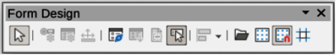
Figure 13: Form Design toolbar
The tools available on the Form Design toolbar in Visible Buttons are numbered from left to right when installed on the toolbar.
- Select
- Control Properties
- Form Properties
- Position and Size
- Form Navigator
- Activation Order
- Add Field
- Automatic Control Focus
- Bring to Front
- Send to Back
- Group
- Ungroup
- Enter Group
- Exit Group
- Align Objects
- Open in Design Mode
- Display Grid
- Snap to Grid
- Helplines While Moving

Form Navigation
The Form Navigation toolbar (Figure 14) provides tools to edit a database table or control the data view. The toolbar is normally displayed at the bottom of a document that contains fields that are linked to a database. This toolbar is only active when forms are connected to a database, which is why an inactivate toolbar is shown in Figure 14.
The Form Navigation toolbar also allows movement within records as well as inserting and deleting records. If data is saved in a form, the changes are transferred to the database. This toolbar also provides tools providing sort, filter, and search functions for data records.
Figure 14: Form Navigation toolbar
The tools available on the Form Navigation toolbar in Visible Buttons are numbered from left to right when installed on the toolbar.
- Find Record
- Record
- Absolute Record
- Text -> Record
- Total No. of Records
- First Record
- Previous Record
- Next Record
- Last Record
- New Record
- Save Record
- Undo: Data entry
- Delete Record
- Refresh
- Refresh Control
- Sort
- Sort Ascending
- Sort Descending
- AutoFilter
- Apply Filter
- Form-Based Filters
- Reset Filter/Sort
- Data source as Table

Glue Points
The Gluepoints toolbar (Figure 15) provides tools to insert a glue point or modify the properties of a glue point. A glue point is a point where a connector is attached to an object. By default, LibreOffice automatically places a glue point at the center of each side of the bounding rectangle for every object created.
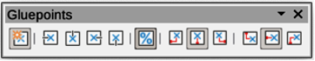
Figure 15: Gluepoints toolbar
The tools available on the Gluepoints toolbar in Visible Buttons are numbered from left to right when installed on the toolbar.
- Insert Glue Point
- Exit Direction Left
- Exit Direction Top
- Exit Direction Right
- Exit Direction Bottom
- Glue Point Relative
- Glue Point Horizontal Left
- Glue Point Horizontal Center
- Glue Point Horizontal Right
- Glue Point Vertical Top
- Glue Point Vertical Center
- Glue Point Vertical Bottom

Image
The Image toolbar (Figure 16) provides tools to edit, modify, align, reposition and resize images. The toolbar only becomes active and available when an image is selected in a presentation. The Image toolbar automatically replaces the Line and Filling toolbar when it becomes active.
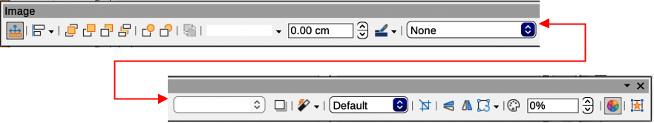
Figure 16: Image toolbar
The tools available on the Image toolbar in Visible Buttons are numbered from left to right when installed on the toolbar.
- Position and Size
- Align Objects
- Left
- Centered
- Right
- Top
- Center
- Bottom
- Arrange
- Bring to Front
- Bring Forward
- Send Backward
- Send to Back
- In Front of Object
- Behind Object
- Reverse
- Line Style
- Line Width
- Line Color
- Area Style/Filling
- Fill Color
- Shadow
- Filter
- Image Mode
- Crop
- Vertically
- Horizontally
- Transformations
- Transparency
- Color
- Line
- Area
- Animation
- Interaction

Insert
The Insert toolbar (Figure 17) provides tools to insert different types of objects into a slide.
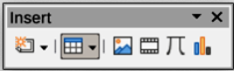
Figure 17: Insert toolbar
The tools available on the Insert toolbar in Visible Buttons are numbered from left to right when installed on the toolbar.
- New Page
- Floating Frame
- Insert Page from File
- Table
- Image
- Insert Audio or Video (Media in Visible Buttons)
- Formula Object
- Chart
- OLE Object

Legacy Circles and Ovals
The Legacy Circles and Ovals toolbar (Figure 18) provides tools to insert different types of circles and ovals into a drawing.
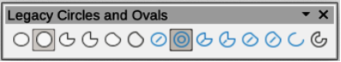
Figure 18: Legacy Circles and Ovals toolbar
The tools available on the Legacy Circles and Ovals toolbar in Visible Buttons are numbered from left to right when installed on the toolbar.
- Insert Ellipse
- Circle
- Ellipse Pie
- Circle Pie
- Ellipse Segment
- Circle Segment
- Ellipse, Unfilled
- Circle, Unfilled
- Ellipse Pie, Unfilled
- Circle Pie, Unfilled
- Ellipse Segment, Unfilled
- Circle Segment, Unfilled
- Arc
- Circle Arc

Legacy Rectangles
The Legacy Rectangles toolbar (Figure 19) provides tools to insert different types of rectangles and squares into a slide.
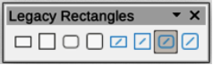
Figure 19: Legacy Rectangles toolbar
The tools available on the Legacy Rectangles toolbar in Visible Buttons are numbered from left to right when installed on the toolbar.
- Insert Rectangle
- Square
- Rectangle, Rounded
- Rounded Square
- Rectangle, Unfilled
- Square, Unfilled
- Rounded Rectangle, Unfilled
- Rounded Square, Unfilled

Line and Filling
The Line and Filling toolbar (Figure 20) provides tools and drop-down lists for editing lines, arrows, and object borders. The tools available vary depending on the type of object selected for editing.
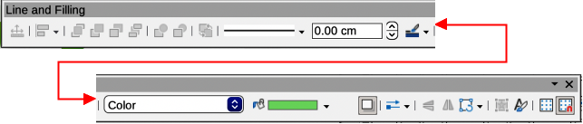
Figure 20: Line and Filling toolbar
The tools available on the Line and Filling toolbar in Visible Buttons are numbered from left to right when installed on the toolbar.
- Position and Size
- Align Objects
- Left
- Centered
- Right
- Top
- Center
- Bottom
- Arrange
- Bring to Front
- Bring Forward
- Send Backward
- Send to Back
- In Front of Object
- Behind Object
- Reverse
- Line Style
- Line Width
- Line Color
- Area Style/Filling
- Fill Color
- Shadow
- Arrow Style
- Vertically
- Horizontally
- Transformations
- Line
- Area
- 3D Effects
- Image Map
- Animation
- Interaction
- Show the Styles Sidebar
- Display Grid
- Helplines While Moving

Master View
The Master View toolbar (Figure 22) provides tools to create a new master slide, rename a master slide, delete a master slide, and close master view. This toolbar is only active when Impress is in master view.
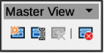
Figure 21: Master View toolbar
The tools available on the Master View toolbar in Visible Buttons are numbered from left to right when installed on the toolbar.
- New Master
- Rename Master
- Delete Master
- Close Master View

Media Playback
The Media Playback toolbar (Figure 23) provides the tools required to insert, view, play, and listen to audio and video files. The toolbar only becomes active when an audio or video file is selected. Impress supports many different media formats depending on the computer operating system being used.
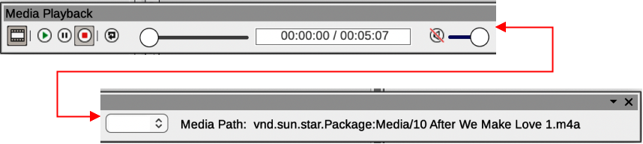
Figure 22: Media Playback toolbar
The tools available on the Media Playback toolbar in Visible Buttons are numbered from left to right when installed on the toolbar.
- Insert Audio or Video
- Play
- Pause
- Stop
- Repeat
- Position
- Mute
- Volume
- View

Options
The Options toolbar (Figure 24) provides tools for editing various settings for newly created presentations, for example how objects snap to the grid when being moved or resized.
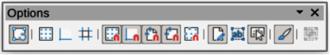
Figure 23: Options toolbar
The tools available on the Options toolbar in Visible Buttons are numbered from left to right when installed on the toolbar.
- Rotation Mode after Clicking Object
- Display Grid
- Display Snap Guides
- Helplines While Moving
- Snap to Grid
- Snap to Snap Guides
- Snap to Page Margins
- Snap to Object Borders
- Snap to Object Points
- Allow Quick Editing
- Select Text Area Only
- Double-click to edit Text
- Modify Object with Attributes
- Exit All Groups

Outline
The Outline toolbar (Figure 25) provides tools for working with outlines.
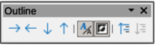
Figure 24: Outline toolbar
The tools available on the Outline toolbar in Visible Buttons are numbered from left to right when installed on the toolbar.
- Demote
- Promote
- Move Down
- Move Up
- Show Formatting
- Black & White View
- Show Only First Level
- Show All Levels
- Hide Subpoints
- Show Subpoints

Presentation
The Presentation toolbar (Figure 26) provides tools for working with presentations.
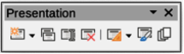
Figure 25: Presentation toolbar
The tools available on the Presentation toolbar in Visible Buttons are numbered from left to right when installed on the toolbar.
- New Slide
- Duplicate Slide
- Rename Slide
- Delete Slide
- Slide Layout
- Change Slide Master
- Expand Slide
- Go to First Slide
- Go to Previous Slide
- Go to Next Slide
- Go to Last Slide
- Move Slide to Start
- Move Slide Up
- Move Slide Down
- Move Slide to End

Slide Sorter
The Slide Sorter toolbar (Figure 27) allows selection of slides in the current presentation and start a presentation from the first slide.
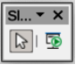
Figure 26: Slide Sorter toolbar
The tools available on the Slide Sorter toolbar in Visible Buttons are numbered from left to right when installed on the toolbar.
- Select
- Start from First Slide

Slide View
The Slide View toolbar (Figure 28) opens with the Slide Sorter view and provides tools to rehearse timings of a slide show; hide and show slides, and change the number of slides displayed in Slide Sorter view.
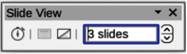
Figure 27: Slide View toolbar
The tools available on the Slide View toolbar in Visible Buttons are numbered from left to right when installed on the toolbar.
- Rehearse Timings
- Show Slide
- Hide Slide
- Slides per Row

Standard
The Standard toolbar (Figure 29) is common to all LibreOffice modules and provides tools for creating and editing documents using LibreOffice. The Standard toolbar differs between different LO modules to allow for different toolsets used in creating the different types of documents.
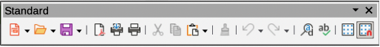
Figure 28: Standard toolbar
The tools available on the Standard toolbar in Visible Buttons are numbered from left to right when installed on the toolbar.
- Load URL
- New
- Templates
- Open
- Open Remote
- Save
- Save As
- Email
- Edit Mode
- Export Directly as PDF
- Print Directly
- Print
- Cut
- Copy
- Paste
- Clone Formatting (Clone in Visible Buttons)
- Clear
- Undo
- Redo
- Find and Replace
- Spelling)
- Auto Spellcheck
- Zoom & Pan
- Zoom
- Display Grid (Grid in Visible Buttons)
- Helplines While Moving
- Display Views
- Views Tab Bar
- Format Slide
- Master Slide
- Start from First Slide
- Start from Current Slide
- Table
- Insert Image (Image in Visible Buttons)
- Insert Audio or Video (Media in visible Buttons)
- Insert Chart (Chart in Visible Buttons)
- Text Box
- Insert Special Characters (Symbol in Visible Buttons)
- Vertical Text
- Insert Fontwork Text
- Insert Hyperlink (Hyperlink in Visible Buttons)
- Show Draw Functions (Draw Functions in Visible Buttons)
- Interaction
- LibreOffice Help
- What’s That

Standard (Single Mode)
The Standard (Single Mode) toolbar (Figure 29) can be used instead of the Standard toolbar if necessary. The Standard (Single Mode) toolbar is normally used when the user interface is switched to single mode. For more information on selecting and using user interface variants, see Chapter 12, User Interface Variants.
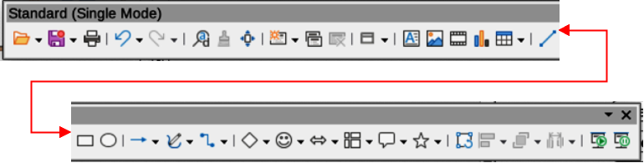
Figure 29: Standard (Single Mode) toolbar
The tools available on the Standard (Single Mode) toolbar in Visible Buttons are numbered from left to right when installed on the toolbar.
- New
- Open
- Save
- Export Directly as PDF
- Print
- Print Preview
- Undo
- Redo
- Find and Replace
- Clone Formatting (Clone in Visible Buttons)
- Spelling
- Entire Page
- New Slide
- Duplicate Slide
- Rename Slide
- Delete Slide
- Slide Layout
- Display Views
- Text Box
- Vertical Text
- Insert Image (Image in Visible Buttons)
- Insert Audio or Video (Media in visible Buttons)
- Insert Chart (Chart in Visible Buttons)
- Table
- Insert Fontwork
- Insert Line (Line in visible Buttons)
- Rectangle
- Ellipse
- Lines and Arrows
- Curves and Polygons
- Connectors
- Basic Shapes
- Symbol Shapes
- Block Arrows (Arrow Shapes in Visible Buttons)
- Flowchart (Flowchart Shapes in Visible Buttons)
- Callouts (Callout Shapes in Visible Buttons)
- Stars and Banners (Star Shapes in Visible Buttons
- 3D Objects
- Position and Size
- Rotate
- Flip
- Align Objects
- Arrange
- Select at least three objects to distribute (Distribution in Visible Buttons)
- Group
- Ungroup
- Enter Group
- Exit Group
- Select
- Entire Page
- Zoom & Pan
- Zoom
- Start from First Slide
- Start from Current Slide

Standard (Viewing Mode)
The Standard (Viewing Mode) toolbar (Figure 30) provides tools to save, edit and distribute a document.
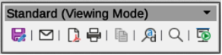
Figure 30: Standard (Viewing Mode) toolbar
The tools available on the Standard (Viewing Mode) toolbar in Visible Buttons are numbered from left to right when installed on the toolbar.
- Save As
- Edit Mode
- Read Only Mode
- Attach to Email (Email in Visible Buttons)
- Export Directly as PDF
- EPUB
- Print Directly
- Print
- Copy
- Find and Replace
- Zoom
- Start from First Slide

Table
The Table toolbar (Figure 31) provides tools and options to edit and format a table placed on a slide. This toolbar only becomes active when a table is selected.
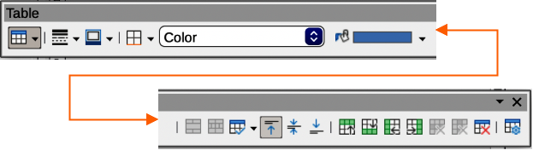
Figure 31: Table toolbar
The tools available on the Table toolbar in Visible Buttons are numbered from left to right when installed on the toolbar.
- Table
- Border Style
- Border Color
- Borders (Shift to overwrite)
- Area Style/Filling
- Fill Color
- Merge Cells
- Split Cells
- Optimize
- Align Top (Top in Visible Buttons)
- Center Vertically (Center in Visible Buttons)
- Align Bottom (Bottom in Visible Buttons)
- Insert Row Above
- Insert Row Below
- Insert Column Before
- Insert Column After
- Delete Row
- Delete Column
- Delete Table
- Select Table
- Select Column
- Select Row
- Table Design
- Table Properties

Text
The Text toolbar (Figure 32) provides tools to insert text boxes and callouts into a slide.
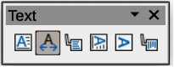
Figure 32: Text toolbar
The tools available on the Text toolbar in Visible Buttons are numbered from left to right when installed on the toolbar.
- Insert Text Box (Text Box in Visible Buttons)
- Fit Text in Textbox Size
- Callouts
- Insert Vertical Text (Vertical Text in Visible Buttons)
- Fit Vertical Text to Frame
- Vertical Callouts

Text Formatting
The Text Formatting toolbar (Figure 33) provides tools for formatting text and alignment commands. This toolbar becomes active when text in a text box or graphic object has been selected and it automatically replaces the Line and Filling toolbar.
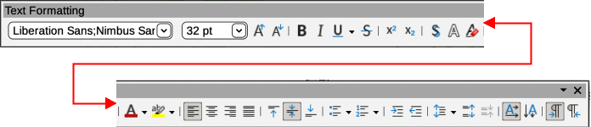
Figure 33: Text Formatting toolbar
The tools available on the Text Formatting toolbar in Visible Buttons are numbered from left to right when installed on the toolbar.
- Font Name
- Font Size
- Increase Font Size (Increase in Visible Buttons)
- Decrease Font Size (Decrease in Visible Buttons)
- Bold
- Italic
- Underline
- Double Underline
- Strikethrough
- Overline
- Superscript
- Subscript
- Toggle Shadow (Shadow in Visible Buttons)
- Apply outline attribute to font (Outline Font Effect in Visible Buttons)
- Clear Direct Formatting (Clear in Visible Buttons)
- lowercase
- UPPERCASE
- small capitals
- Font Color
- Character Highlighting Color
- Toggle Unordered List (Unordered List in Visible Buttons)
- Toggle Ordered List (Ordered List in Visible Buttons)
- Outline Format
- Align Left (Left in Visible Buttons)
- Align Center (Center in Visible Buttons)
- Align Right (Right in Visible Buttons)
- Justified
- Align Top (Top in Visible Buttons)
- Center Vertically (Center in Visible Buttons)
- Align Bottom (Bottom in Visible Buttons)
- Set Line Spacing (Line Spacing in Visible Buttons)
- Character Spacing
- Increase Paragraph Spacing (Increase in Visible Buttons)
- Decrease Paragraph Spacing (Decrease in Visible Buttons)
- Text direction from left to right
- Text direction from top to bottom
- Left-To-Right
- Right-To-Left
- Select All
- Character
- Paragraph

Transformations
The Transformations toolbar (Figure 34) provides tools to modify the shape, orientation, or fill of selected objects.
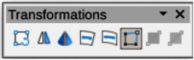
Figure 34: Transformation toolbar
The tools available on the Transformations toolbar in Visible Buttons are numbered from left to right when installed on the toolbar.
- Rotate
- Flip
- In 3D Rotation Object
- Set in Circle (perspective)
- Set to circle (slant)
- Distort
- Interactive transparency tool (Transparency tool in Visible Buttons)
- Interactive gradient tool (Gradient tool in Visible Buttons)

TSCP Classification
The TSCP Classification toolbar (Figure 35) provides tools to help in selecting the security of a document. LibreOffice adds custom fields in the document properties (File > Properties > Custom Properties on the Menu bar) to store the classification policy as document metadata. TSCP stands for Transglobal Secure Collaboration Participation.
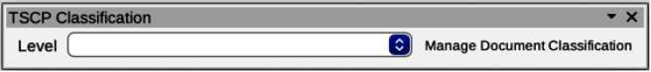
Figure 35: TSCP Classification toolbar
The tools available on the TSCP Classification toolbar in Visible Buttons are numbered from left to right when installed on the toolbar.
- Apply document classification (Level)
- Manage Document Classification

Zoom
The Zoom toolbar (Figure 36) provides tools to reduce or enlarge the screen display of the current presentation.
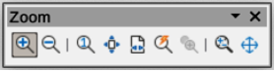
Figure 36: Zoom toolbar
The tools available on the Zoom toolbar in Visible Buttons are numbered from left to right when installed on the toolbar.
- Zoom In
- Zoom Out
- 100%
- Zoom Previous
- Zoom Next
- Entire Page
- Page Width
- Optimal View (Optimal in Visible Buttons)
- Object Zoom
- Zoom & Pan
- Shift

Sub-toolbars

3D-Objects
Click on the triangle ▼ to the right of 3D-Objects on the Drawing toolbar to open the 3D-Objects sub-toolbar (Figure 37), then select the required 3D object to add to a drawing.
- Note
The 3D-Objects sub-toolbar is identical to the 3D-Objects toolbar available at View > Toolbars on the Menu bar.
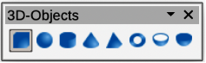
Figure 37: 3D-Objects sub-toolbar
The tools available on the 3D-Objects sub-toolbar in Visible Buttons are numbered from left to right when installed on the toolbar.
- Cube
- Sphere
- Cylinder
- Cone
- Pyramid
- Torus
- Shell
- Half Sphere

Basic Shapes
Click on the triangle ▼ to the right of Basic Shapes on the Drawing toolbar to open the Basic Shapes sub-toolbar (Figure 38), then select the required basic shape to add to a drawing.
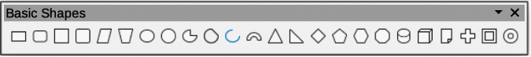
Figure 38: Basic Shapes sub-toolbar
The tools available on the Basic Shapes sub-toolbar in Visible Buttons are numbered from left to right when installed on the toolbar.
- Rectangle
- Rectangle, Rounded
- Square
- Square, Rounded
- Parallelogram
- Trapezoid
- Ellipse
- Circle
- Circle Pie
- Circle Segment
- Arc
- Block Arc
- Isosceles Triangle
- Right Triangle
- Diamond
- Regular Pentagon
- Hexagon
- Octagon
- Cylinder
- Cube
- Folded Corner
- Cross
- Frame
- Ring

Block Arrows
Click on the triangle ▼ to the right of Block Arrows on the Drawing toolbar to open the Block Arrows sub-toolbar (Figure 39), then select the required block arrow to add to a drawing.
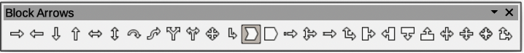
Figure 39: Block Arrows sub-toolbar
The tools available on the Block Arrows sub-toolbar in Visible Buttons are numbered from left to right when installed on the toolbar.
- Right Arrow
- Left Arrow
- Down Arrow
- Up Arrow
- Left and Right Arrow
- Up and Down Arrow
- Circular Arrow
- S-shaped Arrow
- Split Arrow
- Right or Left Arrow
- 4-way Arrow
- Corner Right Arrow
- Chevron
- Pentagon
- Striped Right Arrow
- Up, right and Down Arrow
- Notched Right Arrow
- Up and Right Arrow
- Right Arrow Callout
- Left Arrow Callout
- Down Arrow Callout
- Up Arrow Callout
- Left and Right Arrow Callout
- Up and Down Arrow Callout
- 4-way Arrow Callout
- Up and Right Arrow Callout

Callouts
Click on the triangle ▼ to the right of Callouts on the Drawing toolbar to open the Callouts sub-toolbar (Figure 40), then select the required callout to add to a drawing.
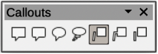
Figure 40: Callouts sub-toolbar
The tools available on the Callouts sub-toolbar in Visible Buttons are numbered from left to right when installed on the toolbar.
- Rectangular Callout
- Rounded Rectangular Callout
- Round Callout
- Cloud
- Line Callout 1
- Line Callout 2
- Line Callout 3

Color
The Color sub-toolbar (Figure 41) provides tools to edit the color properties of a selected object. After selecting an image or graphic to open the Image toolbar, click on Color on the Image toolbar.
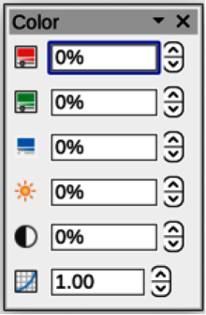
Figure 41: Color sub-toolbar
The tools available on the Color sub-toolbar are as follows:
- Red — specifies the proportion of red RGB color components for the selected graphic object. Values from -100% (no red) to +100% (full red) are possible.
- Green — specifies the proportion of green RGB color components for the selected graphic object. Values from -100% (no green) to +100% (full green) are possible.
- Blue — specifies the proportion of blue RGB color components for the selected graphic. Values from -100% (no blue) to +100% (full blue) are possible.
- Brightness — specifies the brightness for the selected graphic object. Values from -100% (only black) to +100% (only white) are possible.
- Contrast — specifies the contrast for viewing the selected graphic image. Values from -100% (no contrast at all) to +100% (full contrast) are possible.
- Gamma — specifies the gamma value for the view of the selected object, which affects the brightness of the mid-tone values. Values from 0.10 (minimum Gamma) to 10 (maximum Gamma) are possible.

Connectors
Click on the triangle ▼ to the right of Connectors on the Drawing toolbar to open the Connectors sub-toolbar (Figure 42), then select the required connector to add to a drawing.
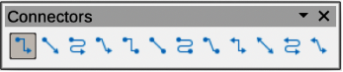
Figure 42: Connectors sub-toolbar
The tools available on the Connectors sub-toolbar in Visible Buttons are numbered from left to right when installed on the toolbar.
- Connector Ends with Arrow
- Straight Connector Ends with Arrow
- Curved Connector Ends with Arrow
- Line Connector Ends with Arrow
- Connector
- Straight Connector
- Curved Connector
- Line Connector
- Connector Starts with Arrow
- Straight Connector starts with Arrow
- Curved Connector Starts with Arrow
- Line Connector Starts Arrow
- Connector Ends with Circle
- Straight Connector Ends with Circle
- Curved Connector Ends with Circle
- Line Connector Ends with Circle
- Connector Starts with Circle
- Straight Connector starts with Circle
- Curved Connector Starts with Circle
- Line Connector Starts with Circle
- Connector with Circles
- Straight Connector with Circle
- Curved Connector with Circle
- Line Connector with Circle

Curves and Polygons
Click on the triangle ▼ to the right of Curves and Polygons on the Drawing toolbar to open the Curves and Polygons sub-toolbar (Figure 43), then select the required curve or polygon to add to a drawing.
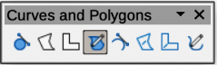Figure 43: Curves and Polygons sub-toolbar
The tools available on the Curves and Polygons sub-toolbar in Visible Buttons are numbered from left to right when installed on the toolbar.
- Curve, Filled
- Polygon, Filled
- Polygon (45°), Filled
- Freeform Line, Filled
- Curve
- Polygon
- Polygon (45°)
- Freeform Line

Flowchart
Click on the triangle ▼ to the right of Flowchart on the Drawing toolbar to open the Flowchart sub-toolbar (Figure 44), then select the required flowchart shape to add to a drawing.
Figure 44: Flowchart sub-toolbar
The tools available on the Flowchart sub-toolbar in Visible Buttons are numbered from left to right when installed on the toolbar.
- Flowchart: Process
- Flowchart: Alternate Process
- Flowchart: Decision
- Flowchart: Data
- Flowchart: Predefined Process
- Flowchart: Internal Storage
- Flowchart: Document
- Flowchart: Multidocument
- Flowchart: Terminator
- Flowchart: Preparation
- Flowchart: Manual Input
- Flowchart: Manual Operation
- Flowchart: Connector
- Flowchart: Off-page Connector
- Flowchart: Card
- Flowchart: Punched Tape
- Flowchart: Summing Junction
- Flowchart: Or
- Flowchart: Collate
- Flowchart: Sort
- Flowchart: Extract
- Flowchart: Merge
- Flowchart: Stored Data
- Flowchart: Delay
- Flowchart: Sequential Access
- Flowchart: Magnetic Disc
- Flowchart: Direct Access Storage
- Flowchart: Display

Image Filter
Click on the triangle ▼ to the right of Filter on the Drawing or Image toolbar to open the Image Filter sub-toolbar (Figure 45), then select the required filter to change how an image appears on the display.
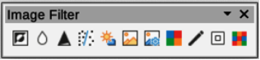
Figure 45: Image Filter sub-toolbar
The filters available on the Image Filter sub-toolbar are as follows:
- Invert — inverts the color values of a color image, or the brightness values of a greyscale image. Apply the filter again to revert the effect.
- Smooth — softens or blurs the image by applying a low pass filter.
- Sharpen — sharpens the image by applying a high pass filter.
- Remove Noise — removes noise by applying a median filter.
- Solarization — opens a dialogue box for defining solarization. Solarization refers to an effect that looks like what can happen when there is too much light during photo development. The colors become partly inverted.
- Aging — all pixels are set to their gray values, and then the green and blue color channels are reduced by the amount specified. The red color channel is not changed.
- Posterize — opens a dialogue box to determine the number of poster colors. This effect is based on the reduction of the number of colors. It makes photos look like paintings.
- Pop Art — converts an image to a pop-art format.
- Charcoal Sketch — displays the image as a charcoal sketch. The contours of the image are drawn in black, and the original colors are suppressed.
- Relief — displays a dialogue box for creating reliefs. Selecting the position of the imaginary light source determines the type of shadow created, and how the graphic image looks in relief.
- Mosaic — joins small groups of pixels into rectangular areas of the same color. The larger the individual rectangles are, the fewer details the graphic image has.

Lines and Arrows
Click on the triangle ▼ to the right of Lines and Arrows on the Drawing toolbar to open the Lines and Arrows sub-toolbar (Figure 46), then select the required line or arrow to add to a drawing.
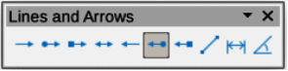
Figure 46: Lines and Arrows sub-toolbar
The tools available on the Lines and Arrows sub-toolbar in Visible Buttons are numbered from left to right when installed on the toolbar.
- Line Ends with Arrow
- Line with Circle/Arrow
- Line with Square/Arrow
- Line with Arrows
- Line Starts with Arrow
- Line with Arrow/Circle
- Line with Arrow/Square
- Insert Line
- Dimension Line
- Line (45°)

Stars and Banners
Click on the triangle ▼ to the right of Stars and Banners on the Drawing toolbar to open the Stars and Banners sub-toolbar (Figure 47), then select the required star or arrow to add to a drawing.
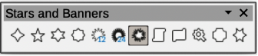
Figure 47: Stars and Banners sub-toolbar
The tools available on the Stars and Banners sub-toolbar in Visible Buttons are numbered from left to right when installed on the toolbar.
- 4-Point Star
- 5-Point Star
- 6-Point Star
- 8-Point Star
- 12-Point Star
- 24-Point Star
- Explosion
- Vertical Scroll
- Horizontal Scroll
- Signet
- Doorplate
- 6-Point Star, Concave

Symbol Shapes
Click on the triangle ▼ to the right of Symbol Shapes on the Drawing toolbar to open the Symbol Shapes sub-toolbar (Figure 48), then select the required symbol shape to add to a drawing.
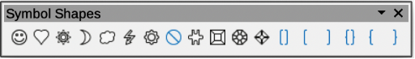
Figure 48: Symbol Shapes sub-toolbar
The tools available on the Symbol Shapes sub-toolbar in Visible Buttons are numbered from left to right when installed on the toolbar.
- Smiley Face
- Heart
- Sun
- Moon
- Cloud
- Lightning Bolt
- Flower
- Prohibited
- Puzzle
- Square Bevel
- Octagon Bevel
- Diamond Bevel
- Double Bracket
- Left Bracket
- Right Bracket
- Double Brace
- Left Brace
- Right Brace

